Physical Experiment

Adjustment and Using of Spectrometer

Instructor: 谢芳
Office:

Email:
The spectrometer is generally used for accurate measurement of deflection angle of incident light, so, the spectrometer is also called goniometer. When light beam passes through optical components for reflection or refraction, the propagation direction is changed. There is an angle between the incident and reflection or refraction beam. By measuring this angle using the spectrometer, the Brewster angle, refractive index and the optical wavelength can be obtained.
Spectrometer is a typical optical instrument, therefore, operating spectrometer must be strictly in several adjusting steps. Adjustment and using of spectrometer is an important reference for further learning of more optical instruments.

Purposes
- To understand the structure of spectrometer, learn the correct using method of spectrometer;
- To observe the dispersion of the incandescent and mercury lamp due to the prism;
- To measure the top angle of prism;
- To measure the refractive index by measuring the minimum deviation angle.

Configuration of JJY spectrometer
JJY spectrometer consists of four main parts including telescope, load platform, parallel light pipe and reading system, which is illustrated in Fig. 1.

1. Telescope
The telescope is used to observe the direction of the light beam. Telescope consists of object lens, ocular, reticule and the bulb.
Abbe ocular is employed in the JJY spectrometer.

2. Load platform
The optical elements can be located at the load platform. There are three screws for tuning the horizontal of the whole platform.

3. Parallel light pipe
The parallel light pipe is used to generate the parallel light beams. There are a converging lens and a sleeve between the two ends of the light pipe. By adjusting the distance from the narrow gap of sleeve to the lens, the incident light beam can be operated to be parallel.

4. Reading system
The reading system consists of a scale disk and a vernier disc, which are synchronous in telescope and load platform, respectively.

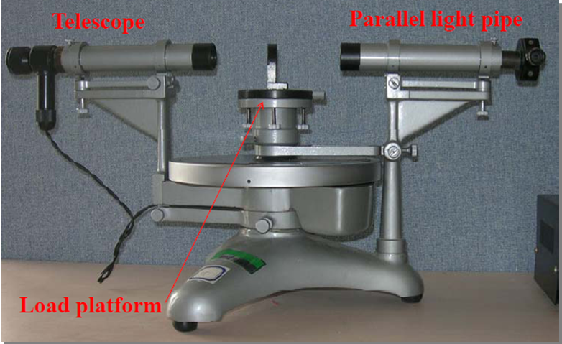
Fig. 1. Configuration of Spectrometer.

Adjustment of spectrometer
The exact measurement of angle between the incident and output light beams by the spectrometer requires two conditions as follows
- Incident and output light beams are the parallel beams;
- Incident and output light beams are parallel with the scale disk plane.
In order to achieve the two conditions above, it is necessary to adjust the spectrometer before the measurement.
After adjusting the spectrometer, the next several points can be realized:
- The telescope is focused on the infinitude beyond;
- The height of telescope and parallel light pipe is equal;
- The telescope and parallel light pipe are vertical to the central rotating shaft;
- The output light beam from the parallel light pipe is parallel.

Attentions:
Before adjusting, it is necessary to be familiar with the screws for different parts of spectrometer.

1. Coarse adjustment
Adjust the telescope and parallel light pipe to be parallel to each other by visual observing. Keep the load platform to be horizontal.
Open the power and adjust the distance from ocular to reticule to make the reticle and “+” to be clear (Fig. 2).
Put the double sided mirror on the load platform. Turn the platform 180° then keep the “+” to be seen as in the same height.
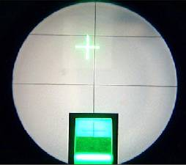
Fig. 2. View of the telescope ocular.

2. Adjust the telescope to be focused on the infinitude beyond
To tune the distance from reticule to the objective lens to obtain a clear reflected imaging of “+”.

3. Adjust the axis of telescope to be vertical to the central rotating shaft
- Put the double sided mirror on the load platform, keep the mirror at the vertical plane of two of the tuning screws of the platform.
- Turn the platform to make the output light beam of the mirror to be through the telescope. In this case, the imaging of “+” in the telescope is usually not at the correct position and with a distance h. Turn the screw of telescope and make h to be a half. Next turn the screws B or C to eliminate the h/2. In addition, turn the platform carefully to make the imaging of “+” to be coincidence with the reticule (Fig. 3).
- Turn the platform and make the mirror to be tuned by 180°. Then repeat the operation of 2.
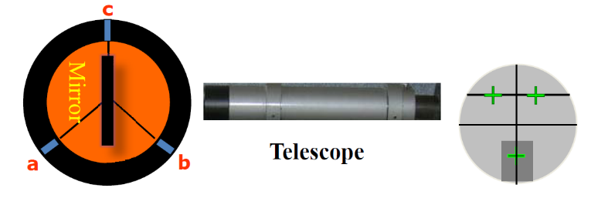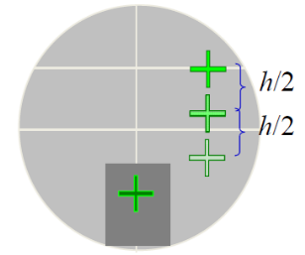
Fig. 3. Process of the adjustment by the “h/2” method.

4. Adjust the parallel light pipe
The adjusting of parallel light pipe can be realized by finishing the adjusting of telescope.
Move the mirror and close the power of the ocular. Make the narrow gap to aim at the lamp, then adjust the distance from the pipe to the narrow gap to obtain a clear imaging. In this case, the output light beam from parallel light pipe is parallel beam. Next tune the pipe’s screw to keep the imaging at the centre of the reticule.

Principle of measuring the top angle of prism
1. Self-collimation Method
The principle of the self-collimation Method of measuring the top angle of the prism is shown in Fig. 1. The telescope is in perpendicularity to AB, then the imaging of “+” can be seen at the cross point of reticle. The azimuth angles of telescope θ₁ and θ₂ can be read by the vernier. Furthermore, by tuning the telescope to be in perpendicularity to AC, another couple of azimuth angles θ₁’ and θ₂’ can be read. Then, the top angle α can be calculated by
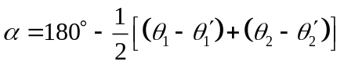 (1)
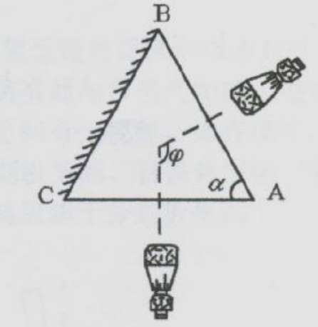
Fig. 4. Self-collimation Method of measuring the top angle of the prism.

2. Reflection Method
Put the prism on the load platform, then, tune the parallel pipe to make the light beam out of it to arrive at both planes of AB and AC. Turn the telescope to receive the reflected light beam from planes AB and AC, respectively. Read the azimuth angles of telescope, accordingly, θ₃ and θ₄, θ₃’ and θ₄’, so, we get that
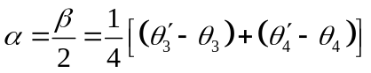 (2)

Apparatus
Spectrometer, prism, double sided mirror, Sodium lamp, Mercury lamp and incandescent lamp.

Procedures

1. Adjustment of spectrometer
- Be familiar with the configuration and adjustment of spectrometer;
- Achieve the adjustment of spectrometer by the method described above.

2. Measurement of top angle of the prism
- Adjustment of the prism: Put the prism on the load platform as shown in Fig. 1. Turning the screws a, b and c of the platform to make the planes AB and AC to be perpendicularity to the axis of the telescope.
- Measuring the top angle of the prism by the method of self-collimation for 6 times. Design the table for record of results. Calculate the top angle α.
- Measuring the top angle of the prism by the method of reflection for 6 times. Design the table for record of results. Calculate the top angle α.
3. Measurement of minimum deflection angle of prism for monochromatic light δ_{min}, calculating the refractive index n
Put the prism on the platform and make the parallel light pipe is illuminated by the sodium lamp as the light source. The parallel light beam out of the parallel light pipe propagates through the plane AB by the direction of D, then, the output light beam propagates in the direction of G after twice refraction. This output light beam can be observed by the telescope. When observing the light beam by telescope, turn the platform and read the azimuth angles θ and θ’ in the time when the displacement of the imaging of narrow gap change its direction. Move the prism, make the telescope to aim at the parallel light pipe and record θ₀ and θ₀’in the case of that the imaging of narrow gap is at the position of reticle. Then, δ_{min} can be calculated by
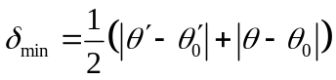 (3)
Repeat the operation 6 times. Design the result record table.
The refractive index of the prism can be obtained by
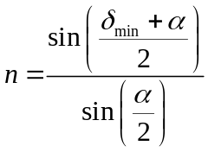 (4)

