Physical Experiment

V-I Characteristic of Slider Rheostat and Diode

Instructor: 梁生
Office: 7-318

Email: shliang@bjtu.edu.cn

A rheostat is an electrical component that has an adjustable resistance. The symbol for a rheostat is a resistor symbol with an arrow diagonally across it, which is shown in Fig. 1. Rheostats are used in many different applications, from light dimmers to the motor controllers in large industrial machines.
Slider rheostats are usually utilized for adjusting voltage and current, as a potentiometer or a current limiter, respectively, in electronics experiments. In order to achieve the experiment, it is necessary to choose an appropriate slider rheostat with proper parameters including resistance value and rated current due to the requirements of the experiment.
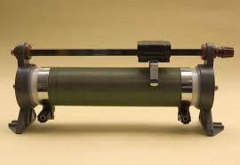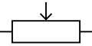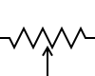
Fig. 1. Photo, International and US symbols for a slider rheostat.

Purposes
- To learn the method of using electrical power, voltage and current meters and slider rheostat;
- To learn the technique of connecting electric circuit;
- To learn the method of measuring V-I characteristic of the diode.

Principle

1. Slider rheostat as a potentiometer
In electric experiment, slider rheostats are usually used as a potentiometer, which is illustrated in Fig. 2. Here R_{L} is the load resistance, and the voltage between the two end of R_{L} is V_{AC}. When ignoring the errors due to influences of voltage meter, V_{AC} can be expressed as
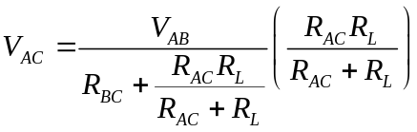 (1)
(1) is divided by V_{AC}, we get
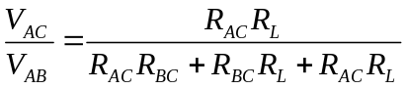 (2)
When divided by R (R= R_{AC}+R_{BC}+R_{AB}), the curve of V_{AC}/V_{BC} to R_{AC}/R can be obtained and shown in Fig. 1.
It can be found that from Fig. 2 as follows
- In the case of R_{AC}=0, V_{AC}=0; When R_{AC}=R, V_{AC}= V_{AB}≈E, the range of voltage adjusting is 0~E.
- The smaller ratio between R to R_{L}, the better adjusting linearity.

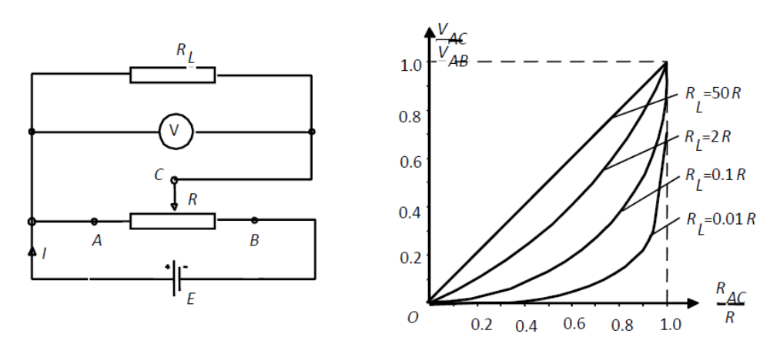
Fig. 2. Slider rheostat as a potentiometer.
2. Slider rheostat as a current limiter
Another main application of slider rheostats is the current limiter, which is shown in Fig. 3. For analyzing the current limiter, the errors due to influences of current meter is ignored. When slider terminal C is operated to be at the end of B, the minimum current of the circuit can be written as
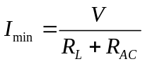 (3)
where V is the voltage of power.
Similarly, when the slider terminal C is operated to be at the end of A, the maximum current can be obtained as
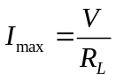 (4)

Then, we get

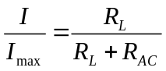 (5)

Using (5) the relationship between I/I_{max} and R_{AC}/R can be shown by the curve in Fig. 3.

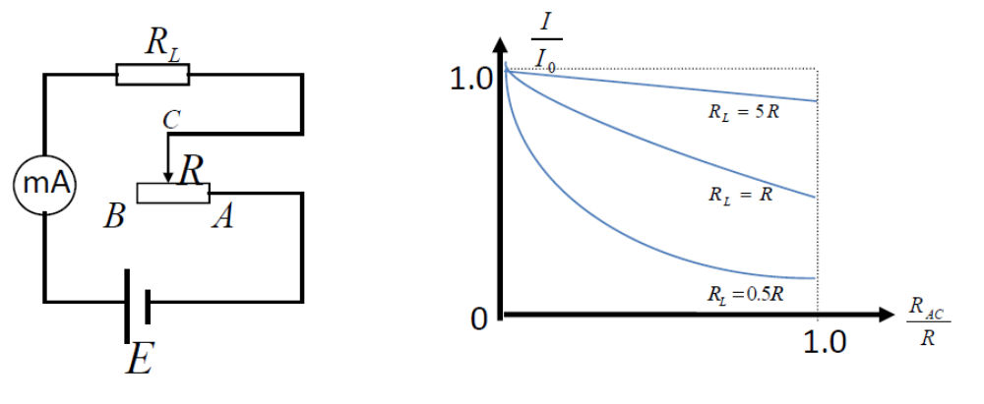

Fig. 3. Slider rheostat as a current limiter.

It can be seen from Fig. 2 that for different valuse of R_{L}, adjusting current can be realized in different ways due to different value of R_{AC}.

3. Measurement of V-I characteristic of diode

In the case of operating a voltage between a electric element, there is a current through this element. And the relationship between the current and the driving voltage can be described by the V-I characteristic of the element.

The circuit for measuring V-I characteristic of a diode is illustrated in Fig. 4.

As shown in Fig. 3, when the switch is tuned in “1”, the circuit is for current meter internal connecting; and “2” for current meter external connecting. For both of the two circuits, the voltage and current of diode (V_{D} and I_{D}) can not be measured accurately. Therefore, the measured results need to be corrected as follows
- For the internal circuit, the voltage measured by the voltage meter is the voltage between resistance of diode and current meter (R_{D} and R_{A}), then, the corrected voltage can be calculated by

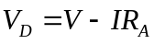 (6)

Internal circuit is effective in the case of 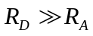.
- For the external circuit, the current measured by the current meter is the current through the resistance of diode and voltage meter (R_{D} and R_{A}), then, the corrected current can be calculated by

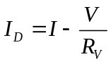 (7)

External circuit is for the condition of 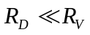.

When a digital voltage meter is used, the external circuit is often used due to that .

Apparatus
DC power, slider rheostat, current and voltage meters, resistance box and diode.

Procedures
- Slider rheostat as a potentiometer.

Connect the circuit as shown in Fig. 2. The resistance box is used as the load resistance R_{L}. The value of R_{L}/R is operated as 10, 1 and 0.1, respectively. Measure the voltage V_{AC} due to different positions of slider terminal and finish the curve in Fig. 2.

Attentions
- When connecting the circuit, attention should be paid on the polarity of the DC meters.
- When changing the position of slider terminal, DO NOT change the voltage of the power.
- DO keep careful to avoid exceeding the dynamic range of the meters.
- DO NOT open the power until the connected circuit is checked.

- Slider rheostat as a current limiter.
Connect the circuit as shown in Fig. 3. The value of R_{L}/R is operated as 5, 1 and 0.5, respectively. Adjust the maximum current by changing the voltage of power. Measure the current I due to different positions of slider terminal and finish the curve in Fig. 3.

- Measurement of V-I characteristic of diode.
Connect the circuit as shown in Fig. 4. Measure the voltage and current of diode due to different positions of slider terminal and finish the V-I curve in Fig. 4.

Attentions
- In the case of small voltage and current, the resistance of diode is high and it is better to use the internal circuit. With the improvement of voltage, current of diode is increased and the external circuit should be used then.
- Tables should be designed for this experiment.

