What is Programming?
the process of creating a set of instructions (a program) that tells a computer what to do.
In his words (explained simply), a program is:
- a sequence of instructions
- written in a programming language
- that directs the computer to perform a specific task
So, Programming = writing those instructions in a logical order to solve a problem.
__________________________________________________________________________________

Java
Java is a high-level, object-oriented programming language that has been a staple of the technology world since its release in 1995. Created by James Gosling at Sun Microsystems (now owned by Oracle), it was built with a revolutionary philosophy: "Write Once, Run Anywhere" (WORA).
__________________________________________________________________________________
- Write and Compile: A programmer writes Java source code in a file with a .java extension. The Java compiler (javac) converts this source code into platform-independent bytecode, which is stored in a .class file.
- Run Anywhere: This same bytecode file (.class) can be transferred to any other system (e.g., Windows, macOS, Linux, Android).
- Execution via JVM: Each operating system has its own specific implementation of the JVM. The JVM acts as an interpreter and runtime engine, translating the generic bytecode into the native machine code that the specific hardware and operating system can understand and execute.
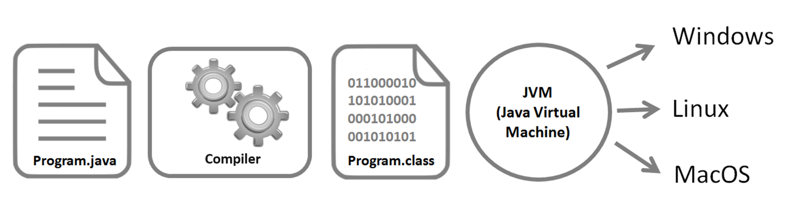

__________________________________________________________________________________

Features of Java
- Simple: Clean syntax (derived from C++) that removes complex features like explicit pointers and operator overloading for easier development.
- Platform Independent: Compiled into Bytecode, allowing programs to "Write Once, Run Anywhere" (WORA) on any system with a JVM.
- Secure: Protects systems using a sandbox execution environment and a bytecode verifier to prevent unauthorized memory access or viruses.
- Robust: Ensures reliability through automatic garbage collection, strong type checking, and powerful exception handling to prevent crashes.
- Portable: Architecture-neutral design ensures that Java applications run identically across different hardware and operating systems without modification.

__________________________________________________________________________________

Difference between JDK, JRE, JVM
- Java's Key Components:
  - JDK (Java Development Kit): The toolkit for developers.
  - JVM (Java Virtual Machine): The core that runs Java programs.
  - JRE (Java Runtime Environment): The runtime environment for executing
- Why Learn About Java Architecture?
  - Understanding these components will help in developing efficient and
  - platform-independent Java applications.
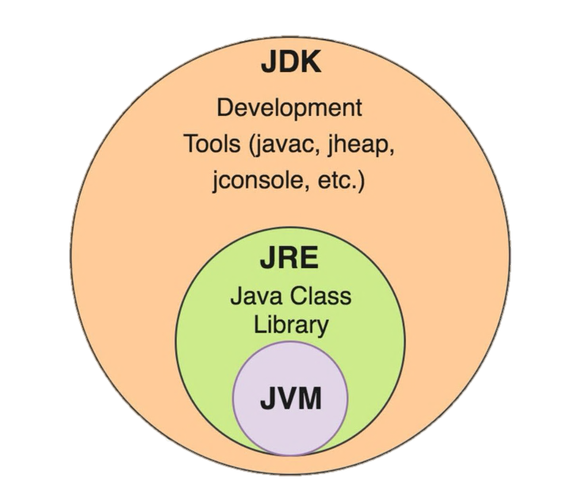
Aspect | JDK | JRE | JVM
Purpose | To develop, compile, and run Java programs. | To provide an environment to run Java programs. | To execute Java bytecode into machine code.
Includes | JRE + Development Tools (compiler, debugger, etc.) | JVM + Class Libraries and supporting files | Core Execution Engine (interpreter, JIT, GC)
Platform | Platform-dependent (OS-specific installer) | Platform-dependent (OS-specific installer) | Platform-independent (bytecode runs on any JVM)

Java program execution model
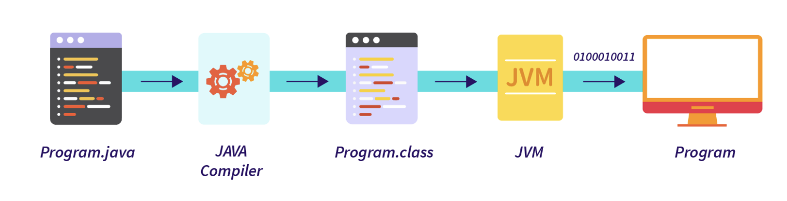

- Write code in .java file
- Compile using javac → creates .class file (bytecode)
- Run using java → JVM converts bytecode to machine code
- Output is displayed

__________________________________________________________________________________

First Java Program (Hello World)
public class HelloWorld {
public static void main(String[] args) {
System.out.println("Hello World!");
}
}

- class name should match file name
- main() is the entry point
- System.out.println() prints output

