Title: StarCi

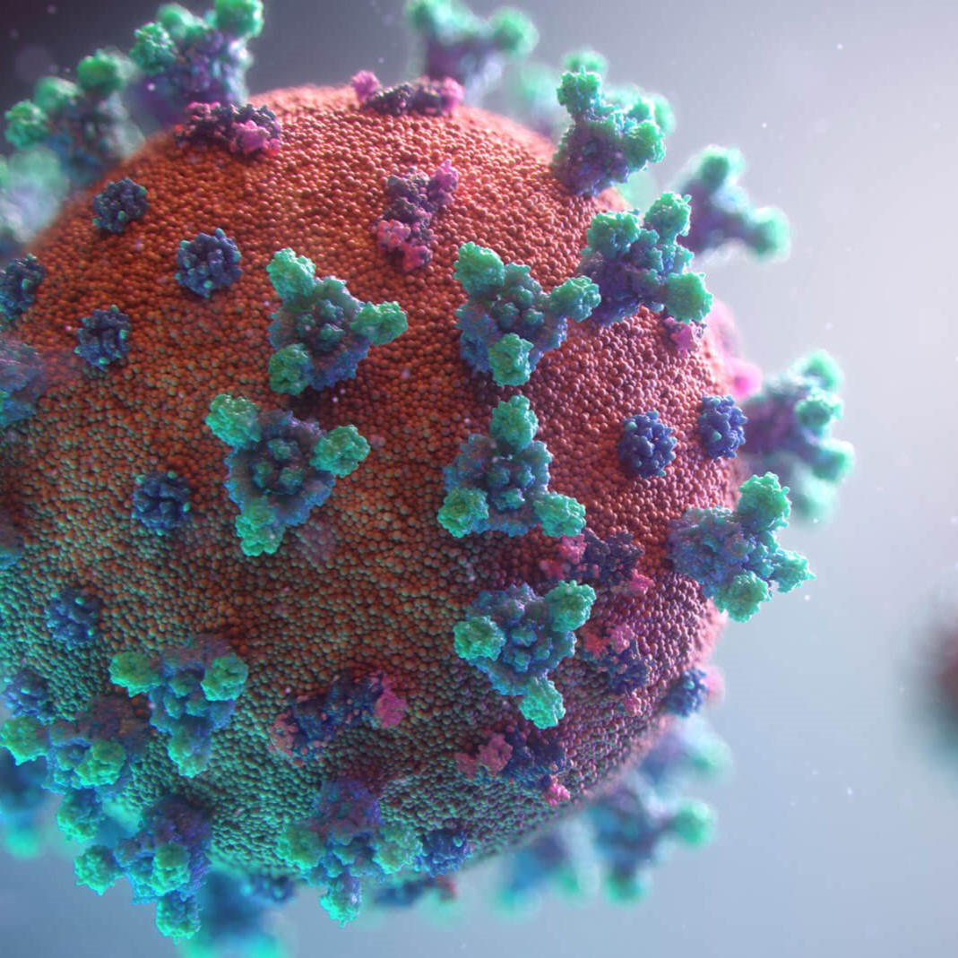

Author: starci

Topic: Mathematics

Description: ublic class Test {
public static void main(String[] args)
throws SQLException, ClassNotFoundException{
Date date1 = new Date(2012-3-2);
Date date2 = null;
PaperDTO paper = new PaperDTO(PaperDAO.getNextID(), "Zugi", "12", "Mathematics", "non", "non", date1, null, "starci", "ds", true);
// System.out.println(PaperDAO.addPaper(paper));
System.out.println(PaperDAO.addPaper(pap

Content: ublic class Test {
public static void main(String[] args)
throws SQLException, ClassNotFoundException{
Date date1 = new Date(2012-3-2);
Date date2 = null;
PaperDTO paper = new PaperDTO(PaperDAO.getNextID(), "Zugi", "12", "Mathematics", "non", "non", date1, null, "starci", "ds", true);
// System.out.println(PaperDAO.addPaper(paper));
System.out.println(PaperDAO.addPaper(pap