Title: ewrtertsgdfgdfgdfggvfbdvb rgdfgd sfgdfsgsd fg

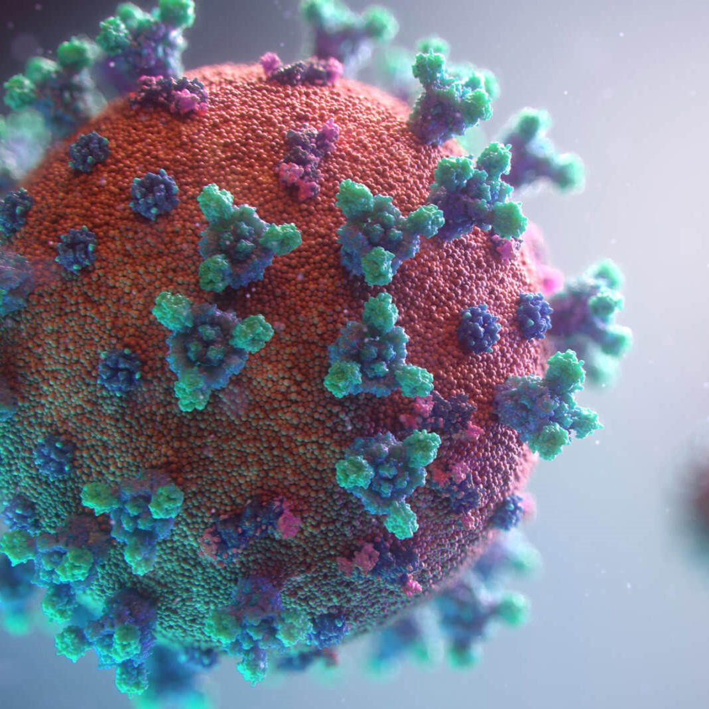

Author: starci

Topic: Mathematics

Description: gvfbdvb rgdfgd sfggvfbdvb rgdfgd sfgdfsgsd fggvfbdvb rgdfgd sfgdfsgsd fggvfbdvb rgdfgd sfgdfsgsd fggvfbdvb rgdfgd sfgdfsgsd fgdfsgsd fg

Content: dfg sefrqw gsfgd fgdasfsdfdsaffdfg sefrqw gsfgd fgdasfsdfdsaffdfg sefrqw gsfgd fgdasfsdfdsaffADa fsdf