Title: Tarra

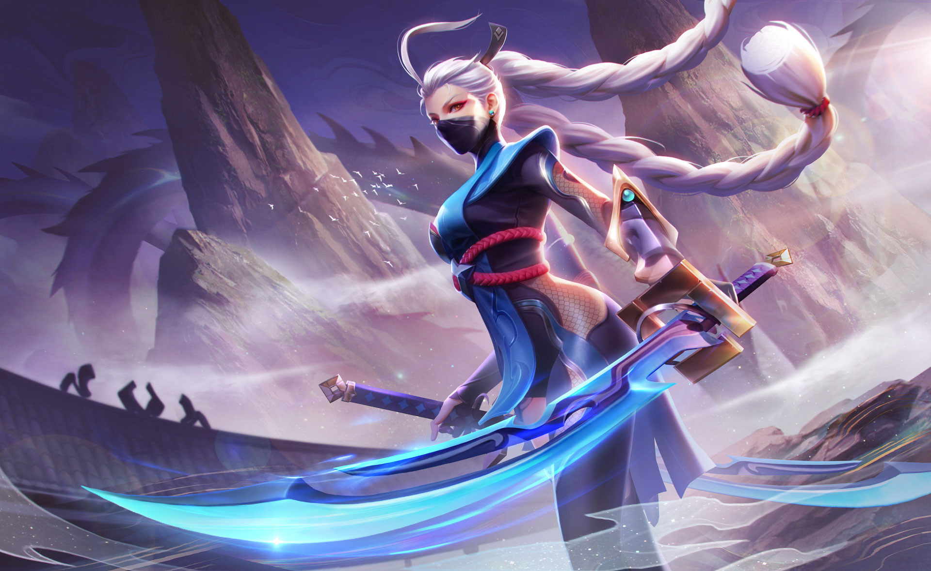

Author: starci

Topic: starci

Description: yet

Content: sos