Title: An Introduction To Butterfly Theorem

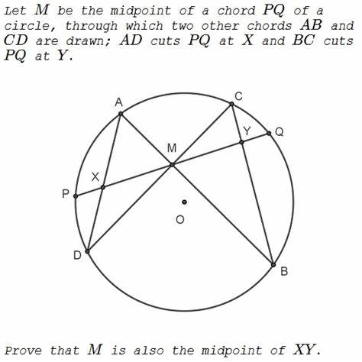

Author: nhoc_dddADMIN

Topic: Mathematics

Description: Let M be the midpoint of a chord PQ of a circle, through which two other chords AB and CD are drawn; AD cuts PQ at X and BC cuts PQ at Y. Prove that M is also the midpoint of XY.

Content: Let O be the center of the given circle. Since OM ? XY, in order to show that XM = MY, we have to prove that ?XOM = ?YOM.
Drop perpendiculars OK and ON from O onto AD and BC, respectively. Obviously, K is the midpoint of AD and N is the midpoint of BC. Further,
?DAB = ?DCB and ?ADC = ?ABC,
as angles subtending equal arcs. Triangles ADM and CBM are therefore similar, and AD/AM = BC/CM, or AK/AM = CN/CM. In other words, in triangles AKM and CNM two pairs of sides are proportional. Also, the angles between the corresponding sides are equal. We infer that the triangles AKM and CNM are similar. Hence, ?AKM = ?CNM.