Title: CuongDEPTRAIQUA

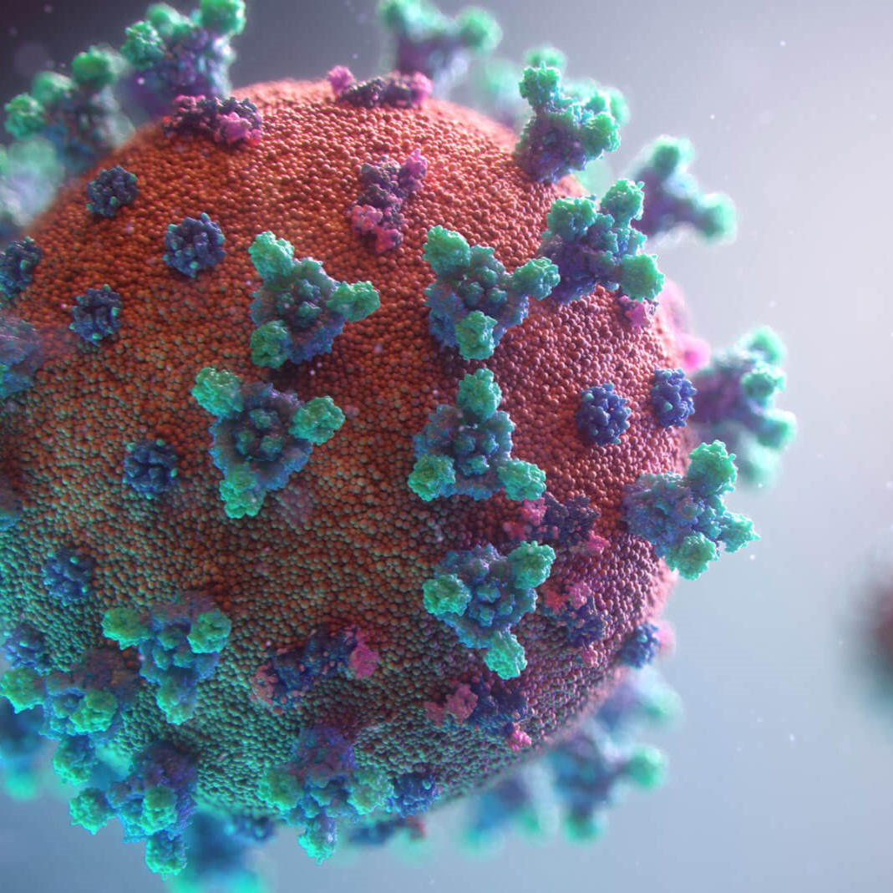

Author: starci

Topic: starci

Description: Co GiOA

Content: Fdfsdf