Title: An Introduction To Stolz-Cesaro Theorem

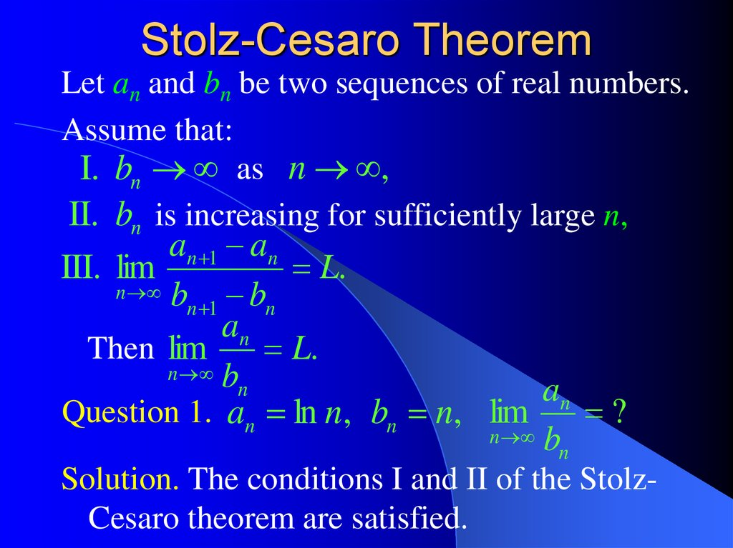

Author: nhoc_dddADMIN

Topic: Mathematics

Description: In mathematics, the Stolz–Cesaro theorem is a criterion for proving the convergence of a sequence. The theorem is named after mathematicians Otto Stolz and Ernesto Cesaro, who stated and proved it for the first time.
The Stolz–Cesaro theorem can be viewed as a generalization of the Cesaro mean, but also as a L'Hopital rule for sequences.

Content: Let {\displaystyle (a_{n})_{n\geq 1}}(a_{n})_{n\geq 1} and {\displaystyle (b_{n})_{n\geq 1}}(b_{n})_{n\geq 1} be two sequences of real numbers. Assume that {\displaystyle (b_{n})_{n\geq 1}}(b_{n})_{n\geq 1} is a strictly monotone and divergent sequence (i.e. strictly increasing and approaching {\displaystyle +\infty }+\infty , or strictly decreasing and approaching {\displaystyle -\infty }-\infty ) and the following limit exists:
{\displaystyle \lim _{n\to \infty }{\frac {a_{n+1}-a_{n}}{b_{n+1}-b_{n}}}=l.\ }{\displaystyle \lim _{n\to \infty }{\frac {a_{n+1}-a_{n}}{b_{n+1}-b_{n}}}=l.\ }
Then, the limit
{\displaystyle \lim _{n\to \infty }{\frac {a_{n}}{b_{n}}}=l.\ }{\displaystyle \lim _{n\to \infty }{\frac {a_{n}}{b_{n}}}=l.\ }
//This Is LaTex, Please Use Latex Complier To See Result Clearly