Title: Research On Bacteria In The Mainstream Of Biology

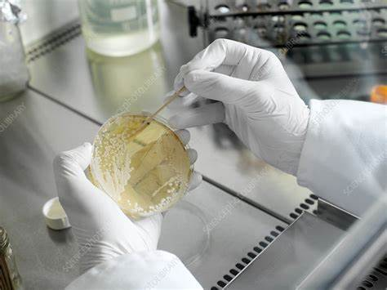

Author: starci

Topic: Bacteria

Description: The study of the genetics, biochemistry, and physiology of bacteria during the last 40 years has provided the concepts and methods for the study of cells of all types at the molecular level. Although much is already known about the mechanisms bacteria use to regulate the expression of their genes, a great deal more remains to be discovered that will have relevance to both prokaryotic and eukaryotic cells.

Content: The study of the genetics, biochemistry, and physiology of bacteria during the last 40 years has provided the concepts and methods for the study of cells of all types at the molecular level. Although much is already known about the mechanisms bacteria use to regulate the expression of their genes, a great deal more remains to be discovered that will have relevance to both prokaryotic and eukaryotic cells. Similarly, the study in bacteria of the transactions of DNA, of the synthesis and function of the cell membrane, of differentiation, and of the interaction with eukaryotic cells will undoubtedly produce results of general importance. The advantages of using bacteria for these studies include their simple noncompartmented structure, the accessibility of their genetic material, and the possibility of correlating the expression of a gene in the intact cell with its expression in a system composed of highly purified components. Finally, the comparative study of a wide variety of microorganisms may result in a better understanding of the evolution of prokaryotes and eukaryotes and lead to a comprehensive theory of cell biology.