Title: A fresh cow is a dairy term for a cow or first-calf heifer

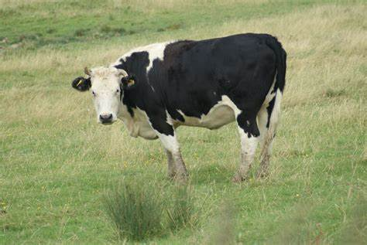

Author: starci

Topic: Animal

Description: Cattle are commonly raised as livestock for meat (beef or veal, see beef cattle), for milk (see dairy cattle), and for hides, which are used to make leather. They are used as riding animals and draft animals (oxen or bullocks, which pull carts, plows and other implements).
//REVIEWEW

Content: Different types of cattle are common to different geographic areas. Taurine cattle are found primarily in Europe and temperate areas of Asia, the Americas, and Australia. Zebus (also called indicine cattle) are found primarily in India and tropical areas of Asia, America, and Australia. Sanga cattle are found primarily in sub-Saharan Africa. These types (which are sometimes classified as separate species or subspecies) are further divided into over 1000 recognized breeds.
Around 10,500 years ago, taurine cattle were domesticated from as few as 80 wild aurochs progenitors in central Anatolia, the Levant and Western Iran.[1] A separate domestication event occurred in the Indian subcontinent, which gave rise to zebu. According to the Food and Agriculture Organization (FAO), there are approximately 1.5 billion cattle in the world as of 2018.[2] Cattle are the main source of greenhouse gas emissions from livestock, and are responsible for around 10% of global greenhouse gas emissions.[3][4] In 2009, cattle became one of the first livestock animals to have a fully mapped genome.[5]
//EDITED