Title: C2H5OH And Its Application

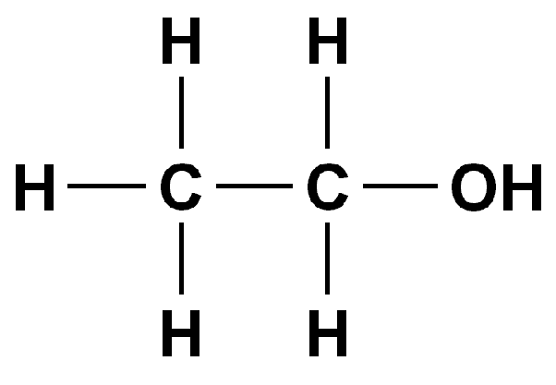

Author: starci

Topic: Chemistry

Description: C2H5OH or Ethanol can simply be called or termed alcohol and it is an organic chemical compound. The compound can also be represented as CH3-CH2-OH.

Content: C2H5OH Lewis Structure, Molecular Geometry, Hybridization, and Polarity
C2H5OH
C2H5OH or Ethanol can simply be called or termed alcohol and it is an organic chemical compound. The compound can also be represented as CH3-CH2-OH.
Ethanol is a colorless liquid with a distinct odor and a pungent taste. It has flammable properties; when burnt, the compound gives a blue color flame.
Here are some ways in which ethanol is prepared:
C2H4+H2SO4 ——-> CH3CH2SO4H
CH3CH2SO4H + H20 ———-> CH3CH2OH + H2SO4
C6H12O6 ——–> 2CH3CH2OH + 2CO2
C12H22O11 + H20 ——-> 4CH3CH2OH + 4CO2