Title: Brocolli Good For Your Health

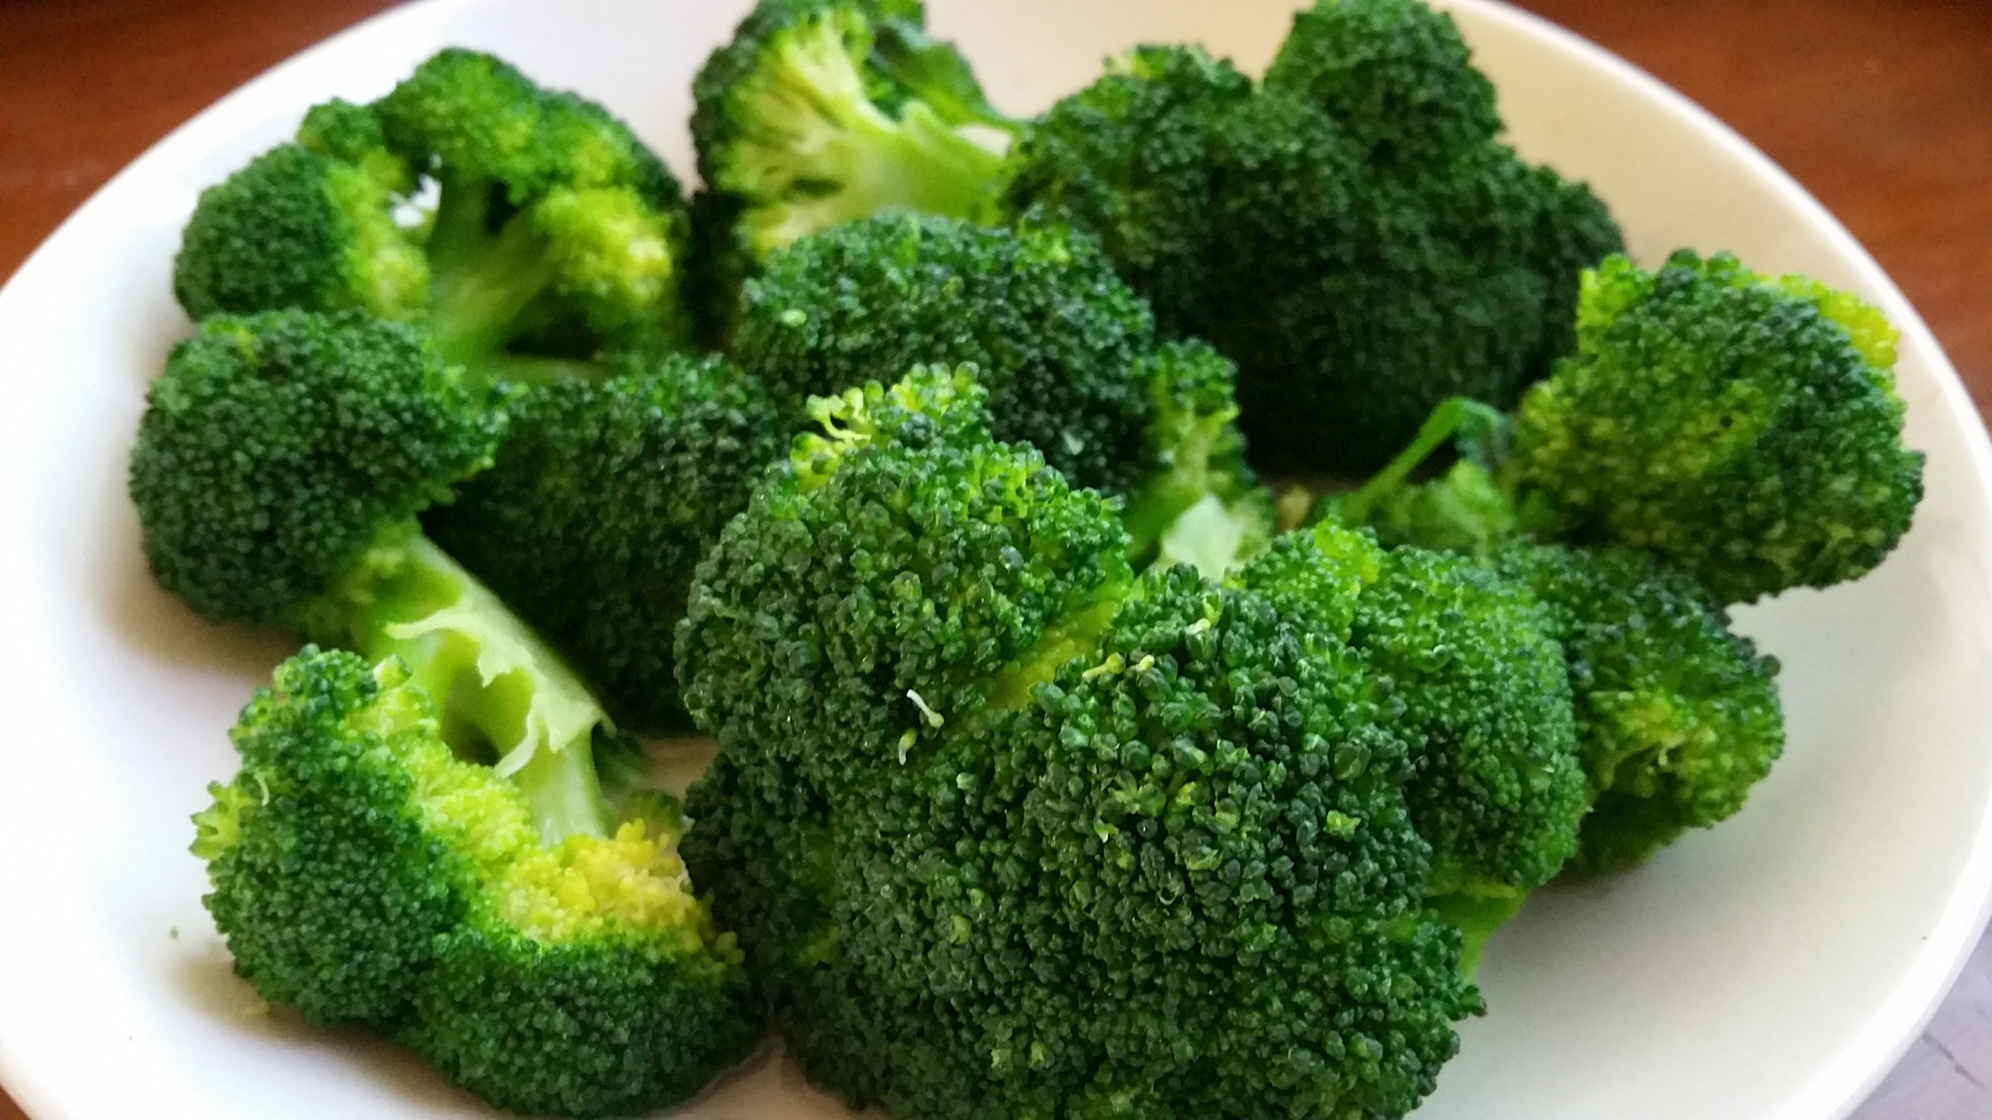

Author: starci

Topic: Plant

Description: Broccoli (Brassica oleracea var. italica) is an edible green plant in the cabbage family (family Brassicaceae, genus Brassica) whose large flowering head, stalk and small associated leaves are eaten as a vegetable. Broccoli is classified in the Italica cultivar group of the species Brassica oleracea.

Content: Broccoli (Brassica oleracea var. italica) is an edible green plant in the cabbage family (family Brassicaceae, genus Brassica) whose large flowering head, stalk and small associated leaves are eaten as a vegetable. Broccoli is classified in the Italica cultivar group of the species Brassica oleracea. Broccoli has large flower heads, usually dark green, arranged in a tree-like structure branching out from a thick stalk which is usually light green. The mass of flower heads is surrounded by leaves. Broccoli resembles cauliflower, which is a different but closely related cultivar group of the same Brassica species.
It is eaten either raw or cooked. Broccoli is a particularly rich source of vitamin C and vitamin K. Contents of its characteristic sulfur-containing glucosinolate compounds, isothiocyanates and sulforaphane, are diminished by boiling but are better preserved by steaming, microwaving or stir-frying.[3]