 **MINISTRY OF EDUCATION AND TRAINING**



**FPT UNIVERSITY**

SWR302 Project Document

____________________________________________

**Dissovery**

The platform supports the delivery of near-expired foods

|  |  |
| --- | --- |
| **Group 1 – SE1609** | |
| **Group Members** | Nguyen Van Tu Cuong – SE160875 (Team Leader) |
| **Supervisor** | Mr. Lai The Hung |

- Ho Chi Minh City, 15 July 2022 –

*The page is intentionally left blank*

**Use Case Diagram**

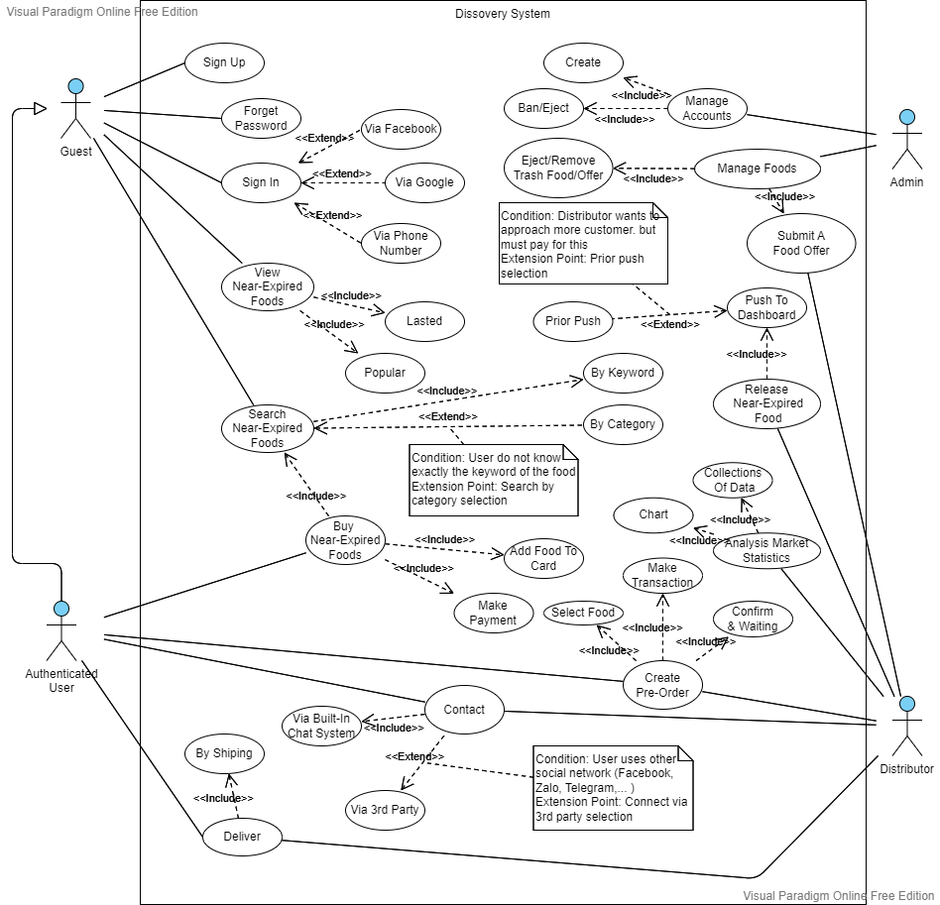

**Use Case**

Creator: CuongNVT

|  |  |  |  |
| --- | --- | --- | --- |
| **ID and Name:** | **UC-01: Create Pre-Order** | | |
| Created By: | CuongNVT | Date Created: | 18/10/2022 |
| Primary Actor: | Authenticated User | Secondary Actors: | N/A |
| Priority: | Medium | Frequency of Use: | Occasionally |
| Trigger: | The actor wants to create an Pre-Order | | |
| Description: | This feature help users create pre-order of a specific type of foods, to get the foods when they become available. | | |
| Preconditions: | The actor Sign In to Dissovery as Authenticated User. | | |
| Post-conditions: | Success: The system shows message: “Your Pre-Order has been created successfully.”  Fails: The system shows message: “Your Pre-Order has not been created. Try again later.” | | |
| Normal Flow: | |  |  |  | | --- | --- | --- | | Step | Actor Action | System Response | | 1 | Actor clicks on the “Pre-Order” of the certain type of food | System shows a message: “Do you want to create a Pre-Order of this food?”. An notification will be sent to the owner Yes/No” | | 2 | Actor clicks on the “Yes” button | System shows a message: “Your Pre-Order has been created successfully. A Distributor will contact you when that food becomes available.” | | | |
| Alternative Flow: | |  |  |  | | --- | --- | --- | | Step | Actor Action | System Response | | 1 | Actor clicks on the “Pre-Order” of the certain type of food | System shows a message: “Do you want to create a Pre-Order of this food?”. An notification will be sent to the owner Yes/No” | | 2 | Actor clicks on the “No” button | System shows a message: “Your Pre-Order has not been created.” | | | |
| Exceptions: | N/A | | |
| Business Rules: | * Actor can view the brief of the food before creating Pre-Order * Actor can view history of his/her Pre-Orders. | | |
| Assumptions: | Actor’s internet connection is available | | |

|  |  |  |  |
| --- | --- | --- | --- |
| **ID and Name:** | **UC-02: Contact Via Built-In Chat System** | | |
| Created By: | CuongNVT | Date Created: | 18/10/2022 |
| Primary Actor: | Authenticated User, Distributor | Secondary Actors: | N/A |
| Priority: | Medium | Frequency of Use: | Occassionally |
| Trigger: | The actor wants to contact via built-in chat system | | |
| Description: | This feature help users and distributors connect to each other, to give users more information about delivery date, payment information,… | | |
| Preconditions: | The actor Sign In to Dissovery as Authenticated User/ Distributor. | | |
| Post-conditions: | Success: The system shows message: “You and your customer/distributor have been connected successfully.”  Fails: The system shows message: “You and your customer/distributor have not been connected successfully.” | | |
| Normal Flow: | |  |  |  | | --- | --- | --- | | Step | Actor Action | System Response | | 1 | Actor clicks on the “Chatting” button, then start by sending a message | System sends the message to the other, then makes connection. | | | |
| Alternative Flow: | N/A | | |
| Exceptions: | N/A | | |
| Business Rules: | * Actor can view history of the messages that he/she sended or received. * Actor can view the online/ offline status of partner, plus the amount of time when partner offline. | | |
| Assumptions: | Actor’s internet connection is available | | |

|  |  |  |  |
| --- | --- | --- | --- |
| **ID and Name:** | **UC-03: Contact Via 3rd Party Contact System (Zalo In This Case)** | | |
| Created By: | CuongNVT | Date Created: | 18/10/2022 |
| Primary Actor: | Authenticated User, Distributor | Secondary Actors: | N/A |
| Priority: | High | Frequency of Use: | Often |
| Trigger: | The actor wants to contact via Zalo rather than Built-In Chat System | | |
| Description: | This feature help users and distributors connect to each other via Zalo foundation, since users tend to notice at Zalo notification than other contact systems. | | |
| Preconditions: | The actor Sign In to Dissovery as Authenticated User/ Distributor. | | |
| Post-conditions: | Success: The system shows message: “You and your customer/distributor have been connected in Zalo successfully.”  Fails: The system shows message: “You and your customer/distributor have not been connected in Zalo successfully.” | | |
| Normal Flow: | |  |  |  | | --- | --- | --- | | Step | Actor Action | System Response | | 1 | Actor clicks on the “Chatting” button, then select “Contact By Zalo” extension. | System sends the message to partner via Zalo. | | | |
| Alternative Flow: | N/A | | |
| Exceptions: | N/A | | |
| Business Rules: | N/A | | |
| Assumptions: | Actor’s internet connection is available | | |

**Database**

* ERD

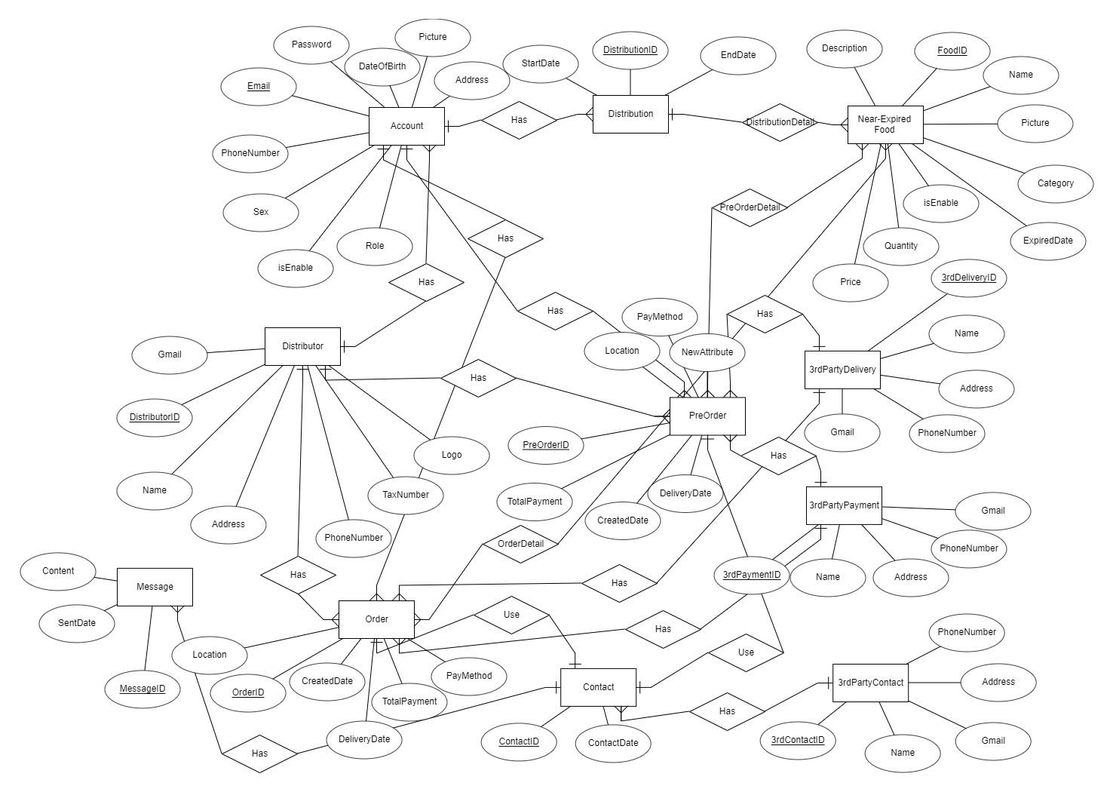

**Full-Resolution**: [Here](https://drive.google.com/file/d/1mpGuvahTOy_O52gdaQuY7k-2RMKHiKNq/view?usp=sharing)

* Relational Diagram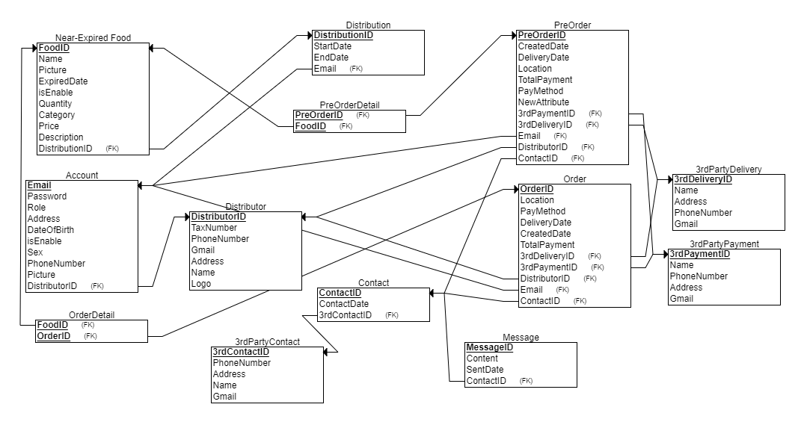

**Full-Resolution**: [Here](https://drive.google.com/file/d/1uxbV7o7V1MfyEuOc2nYMaxsSwSC7WhUU/view?usp=sharing)

Table of contents