**Difference Makers**

*Data science shows which techniques most lead to winning quarters*

*For every team, against every team.*

The DataScience "Difference Makers" project uses predictive modeling on every available game-by-game statistic to identify precisely how one team can beat another most reliably. All teams, even the worst, have winning quarters against even the best teams. Difference Makers looks at quarter-by-quarter data on matchups to see how teams can predictably rack up points differentials.

## Clippers Keys to the Warriors: Rebounds, Turnovers and Efficiency

**Conclusion:** The Clippers reliably score the most points per quarter when they score from turnovers, grab boards, and are keenly efficient with their shots.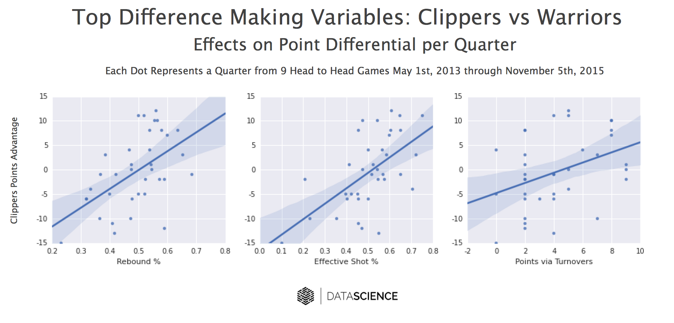

### Details:

The Difference Maker algorithm analyzed scores of play types from paint points to steals to blocks. The algorithm then checked each type to see which had the most reliable impact on the Clippers ability to score more points than the Warriors.

While many algorithms measure only wins or losses, or only measure individual player performances, the Difference Maker measures exactly *how strong* and *how reliable* a particular play type is on the most important metric: scoring differential.

Each quarter performance is shown as a dot in the graph above, with the resulting effect and confidence interval shown.

While they may have had a losing record (1 to 3) against the Warriors last season, quarter-by-quarter, the Clippers had ample moments of dominating their state rivals. Using "Difference Maker", the Clippers can focus on doing what makes the most difference in putting together a winning quarter.

## Algorithm Background

The Difference Makers algorithm pulls in quarter by quarter data for a given match up across seasons. It looks at data across multiple areas to identify the most predictive ways to win. Areas of data processed include:

* assists
* blocks
* offensive rebounds
* defensive rebounds
* 3 point shots
* Free throws
* Steals
* Turnovers
* Second chance points
* Points in the paint

By focusing on head-to-head matchups, we can discover how the Clippers are effective *specifically* against the Warriors — or how any team is effective against any other. Looking at the quarter by quarter data gives us a granularity deeper than the overall game. Furthermore, we look at the effects on points differential on an continuous basis. Rather than just looking at who won or lost the quarter (or, worse, who won or lost the game), we look at *how much* each quarter was won or lost by. The resulting statistical power shows us the most effective play types that have an impact on a) putting points on the board, while b) preventing a team’s opponent from scoring.

**Method: Data Exploration**

Initially, the algorithm looks for significant quarter-by-quarter correlations for points-differentials across a variety of variables. Then, significance tests illustrate which variables most influence a particular target. In the example below, the target was a statistic called “Net Rating”, which measures the performance on a play-by-play basis of a team. Each variable with significant effect on quarterly Net Rating is recorded, with the values per quarter shown along with the quarterly net rating. Linear regression is then performed on the data set and a ‘best-fit’ line is drawn along with a confidence interval. The resulting matrix, shown below, gives access to at-a-glance analyses of the impact of multiple play types.

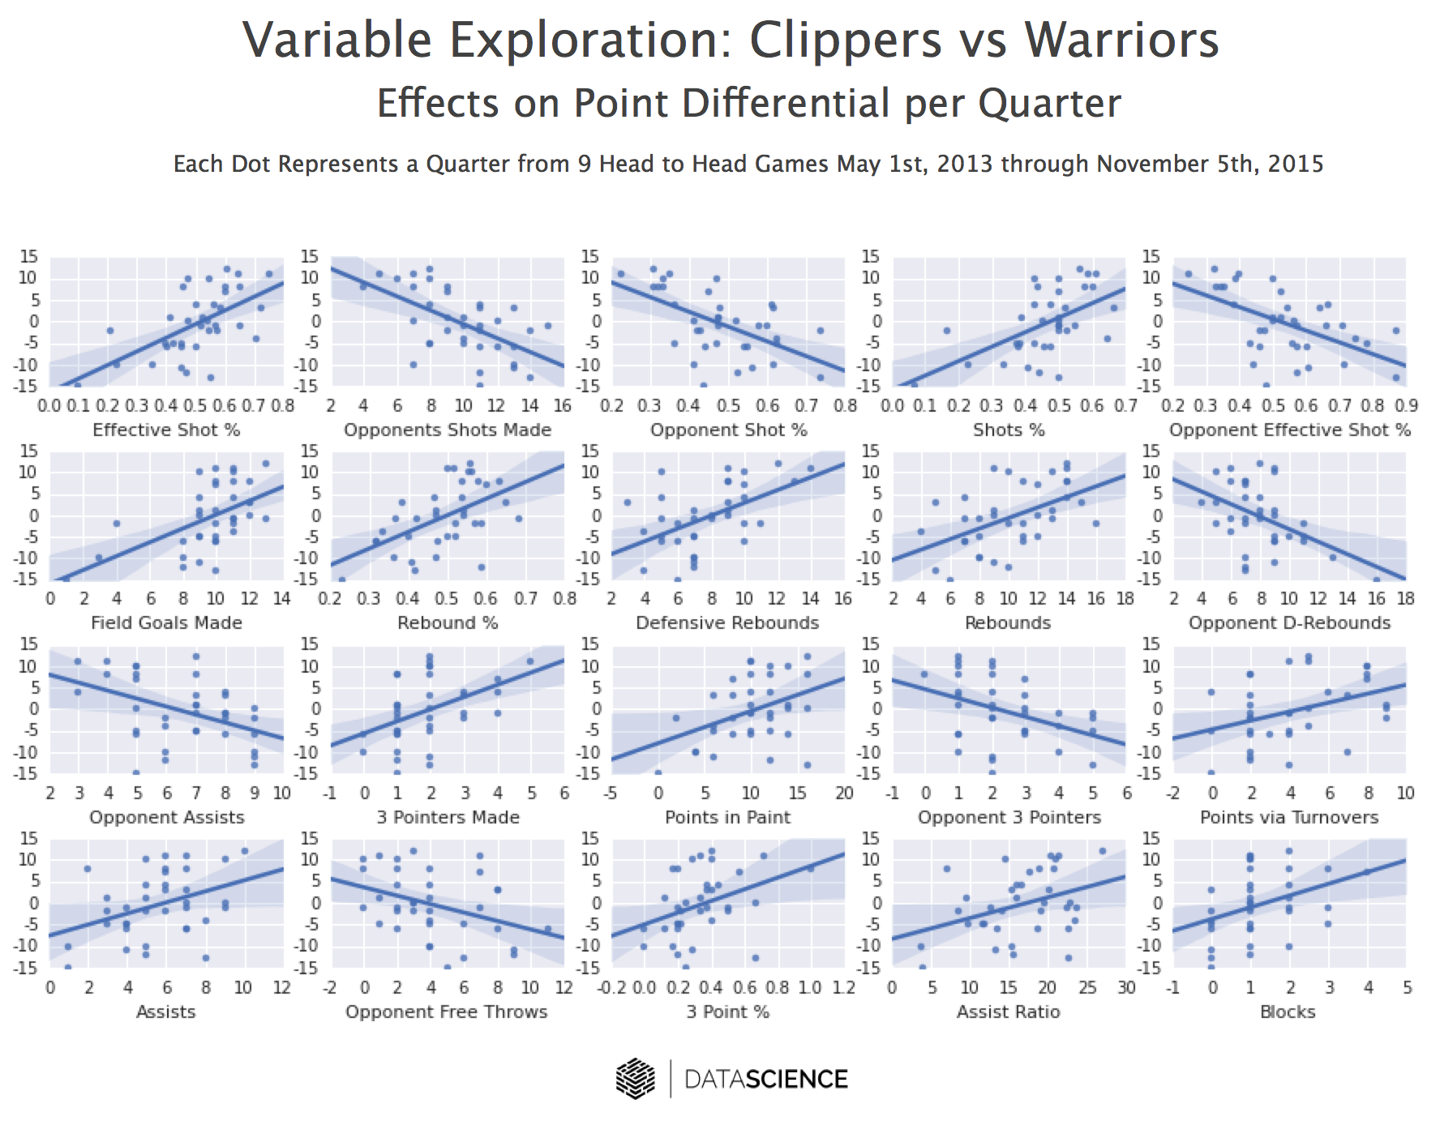

**Discovery through Correlation Plots**

As part of the difference_makers process, correlations for each variable are visualized to identify bundles of similar variables or hidden relationships. Here’s an example from the history of the Clippers and Warriors:

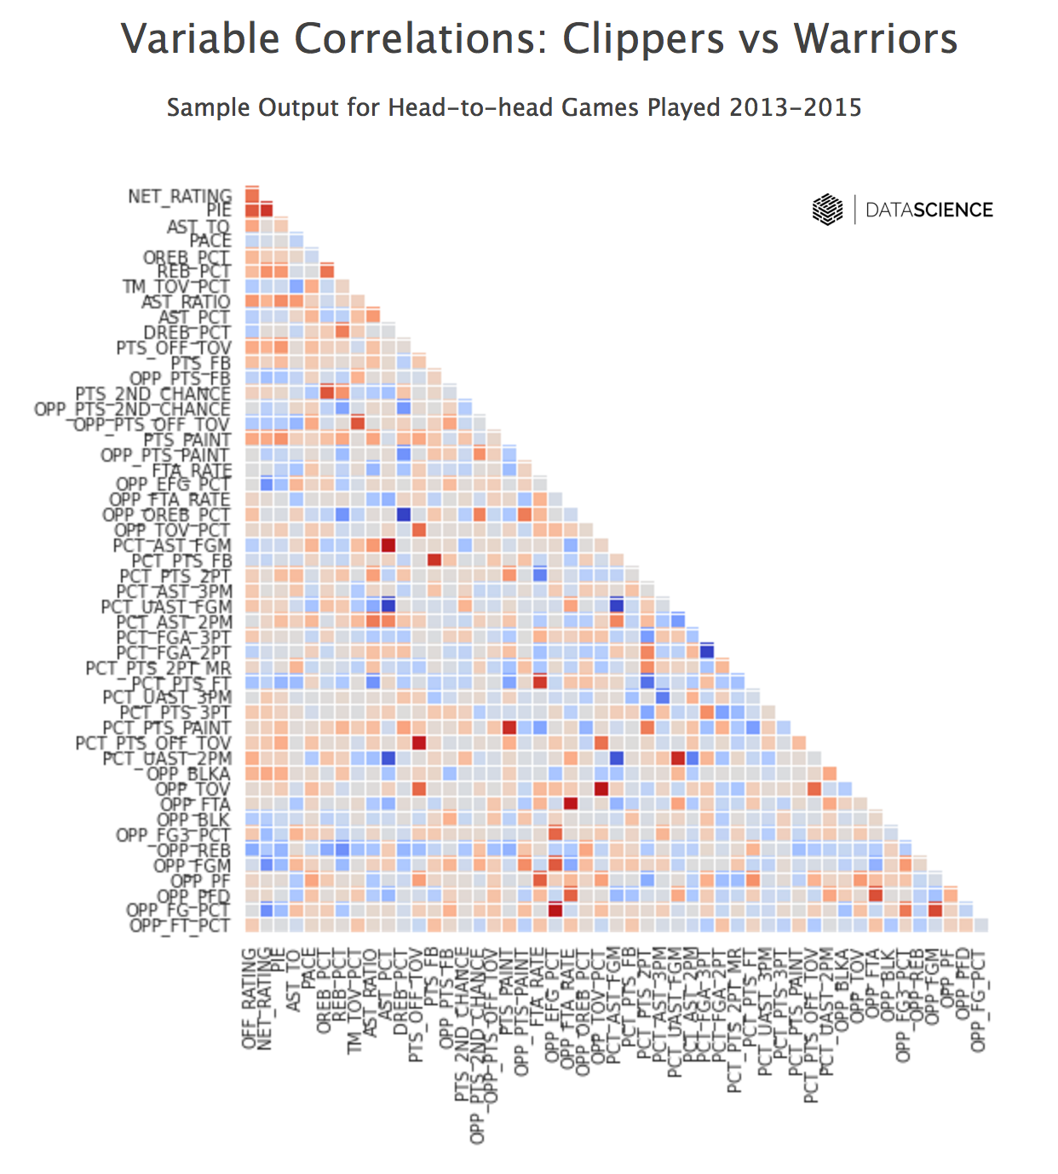

## Client Applications

DifferenceMakers uses a variety of data science techniques, most importantly, predictive modeling. Modeling is a crucial component of how we achieve growth and savings for our clients. Benefits of predictive modeling for our clients include:

**Market Forecasting**

Detailed behavioral data -- like that from NBA players -- can be combined with publically available datasets to anticipate and prepare for market shifts.

**Strategic Clarity**

Complex collections of variables, such as those collected by the NBA, can be reduced to core components to focus strategy and tactics.

**CLTV**

Customer lifetime value models use these same techniques to accurately predict customer behavior based on their ongoing data streams

**Product Recommendations**

Advanced modeling can identify behavioral patterns most likely to lead to sales in other areas.