UML Diagrams:
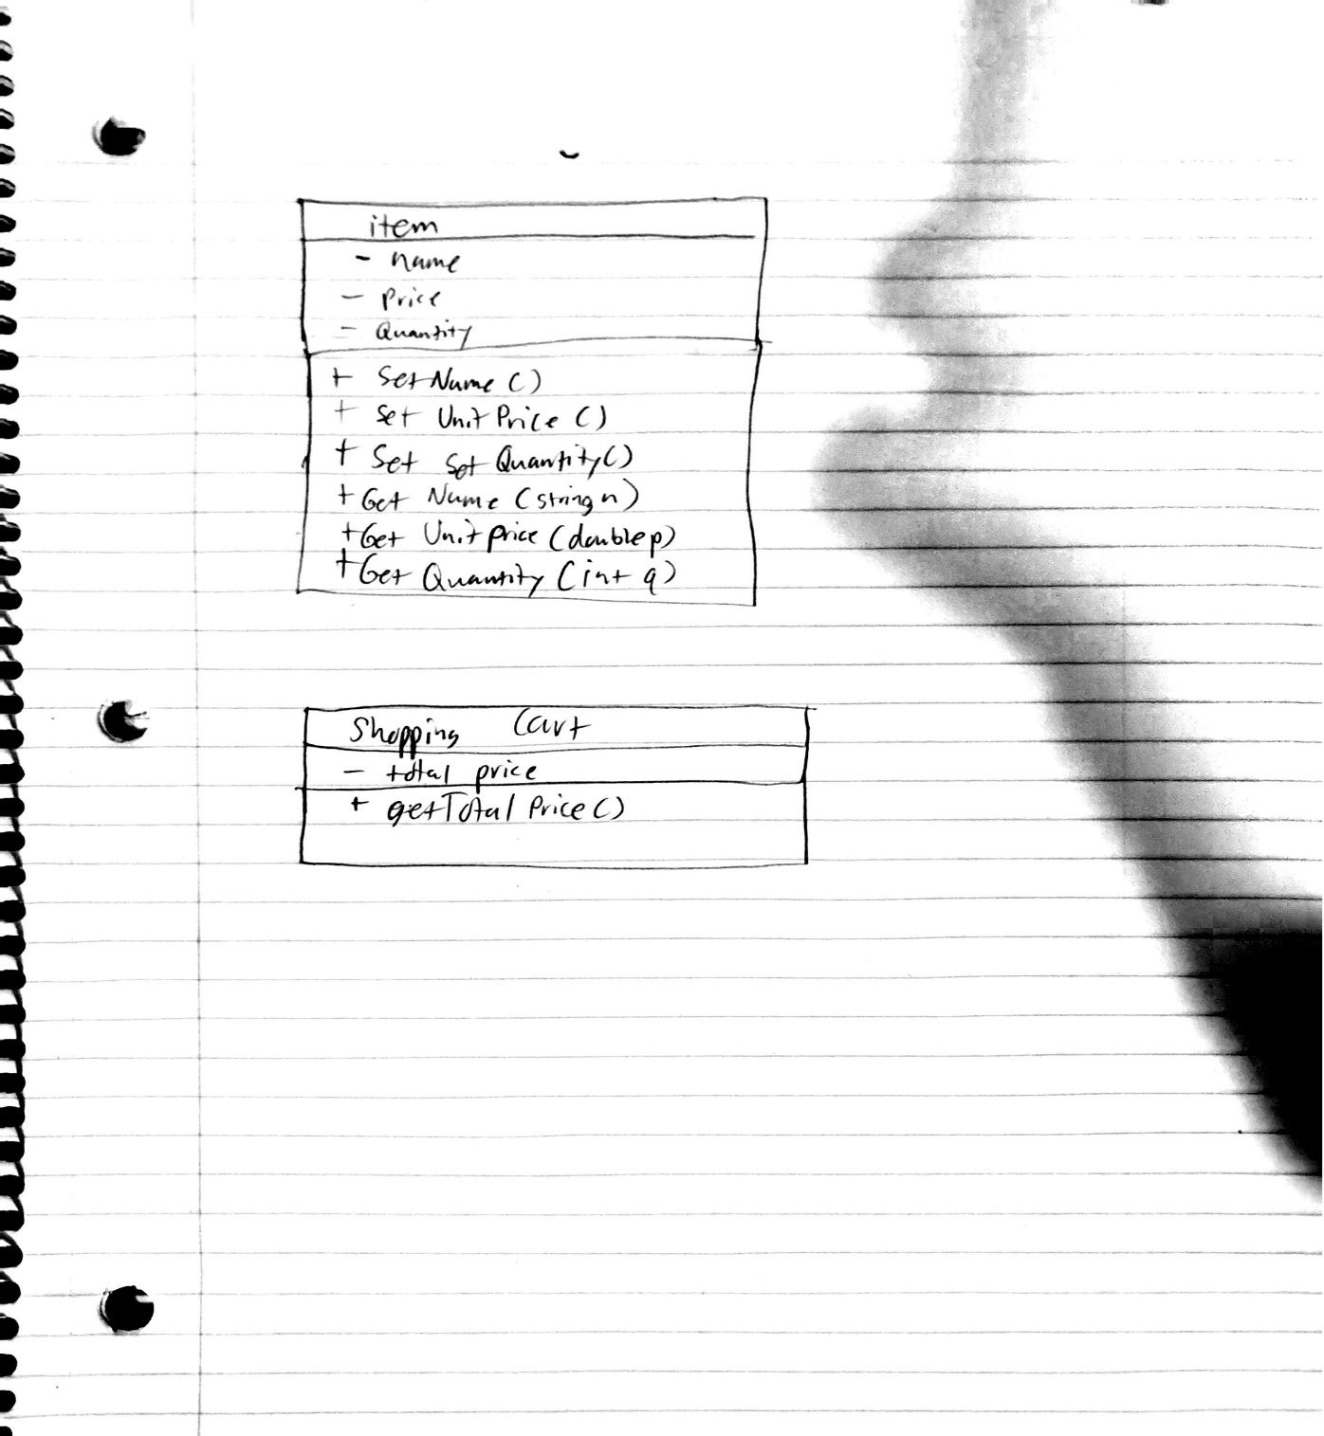

User Information:
The problem at hand was making a program that would allow a user to start adding items into a shopping cart. The user would be able to name what the item was, what it cost, and how many they were buying. It would then show all of the items in a list which also showed the user the final cost off all the items they wanted to buy. It would then allow the user to be able to add, remove, or modify the quantity of each item before choosing to be happy with their list.
The files for all the code would be located on GitHub. Once you have opened GitHub the files will be located on the left-hand side of the screen. In order to compile the program, you would need to open the terminal with shift+control+`. From there enter g++ project2Test.cpp. To run this program, you can go to the project2Test.cpp file and look to the right-hand side of the screen where you will find a play button. Once you click this you can hit run code. This will bring up the terminal once again allowing you to run the program.

