Energy Grid Telemetry Platform
CSCI 414/514 Final Practical Exam — Option 09 final report
Chidera Izuora · Teagen Lee · Yohannes Nigusse Instructor: Dr. Adriano Cavalcanti November 2026

Summary
Our project is an energy telemetry platform built with four Docker containers and three separate IP networks. A smart-meter simulator on 10.10.1.0/24 sends readings through a Linux router to a FastAPI service on 10.10.2.0/24. The API stores and retrieves the readings in MongoDB on 10.10.3.0/24. We use historical household electricity data from UCI for consumption readings and a separate simulated solar model for generation readings.
We tested the main parts of the system: creating, reading, and updating records through the routed network; TLS 1.3 certificate verification between the meter and API; firewall rules that allow the API connection but block direct meter access to MongoDB; and packet captures that match the application logs. We also measured performance under delay, packet loss, and bandwidth limits, and tested database and network-link failures with scripted recovery.
Table 1. Rubric coverage map. Page numbers refer to the Lecture 23 project brief [R1].
Rubric area (23.pdf p. 33) | Pts | Module requirement | Where we address it
Network architecture & routing | 20 | Module A, p. 13 | §2; Figures 1–2; Table 2; Listing 2
NoSQL service integration | 15 | Module B, p. 14 | §3; Tables 3–6
Security implementation | 15 | Module C, p. 15; p. 30 | §4; Figures 3–4
Observability & packet evidence | 15 | Module D, p. 16 | §5; Tables 7–8; Figure 5; Appendix A
Performance experiments | 15 | Module E, p. 17; pp. 27–28 | §6; Table 9; Figure 6
Automation & recovery | 10 | Module F, p. 18; p. 31 | §7; Listing 12; Table 10; Figure 7
Documentation & demonstration | 10 | pp. 29, 34–35 | §8–§10; Appendices; evidence index

1 Application scope and data source
Option 09 requires simulated electricity generation and consumption data, recent-reading queries, and a test of how uplink throttling affects reading freshness [R1, pp. 58–59]. Our platform includes a meter simulator, an HTTPS API for single and batch uploads, latest and recent reading queries, operator notes, summary counts, and a flag for consumption readings above 6.0 kW. Meters must use the API to access stored data.
Consumption comes from the UCI Individual Household Electric Power Consumption dataset (Hebrail and Berard; DOI 10.24432/C58K54; CC BY 4.0) [R3–R4]: 2,075,259 minute-level readings from one household near Paris, used here as a telemetry proxy rather than live grid data. api/import_uci.py imports the first 20,000 usable rows as meter uci-house-1, skipping rows with a missing-value marker (?) or the wrong column count; the import record confirms 20,000 imported and 4 skipped. The simulator replays up to 5,000 rows, keeping each historical timestamp in ts while stamping a fresh sent_at so that freshness can be measured. The data pipeline parses numeric fields, records ISO-formatted measurement timestamps, distinguishes replay time from measurement time, and generates simulated solar readings separately from consumption data.
We use UTC timestamps throughout the report unless a time is marked Pacific (UTC−8 on the dates tested). The results come from three sets of tests: November 10, with packet captures, benchmarks, and logs; November 12, with benchmarks, recovery tests, and deployment checks on a Mac; and November 13, with additional checks on the same Mac between 06:20 and 08:02 UTC. The November 13 checks include test readings, a packet capture, terminal screenshots (Figures 2–4), and traceroutes (Listing 2).

2 Network architecture and routing (Module A)
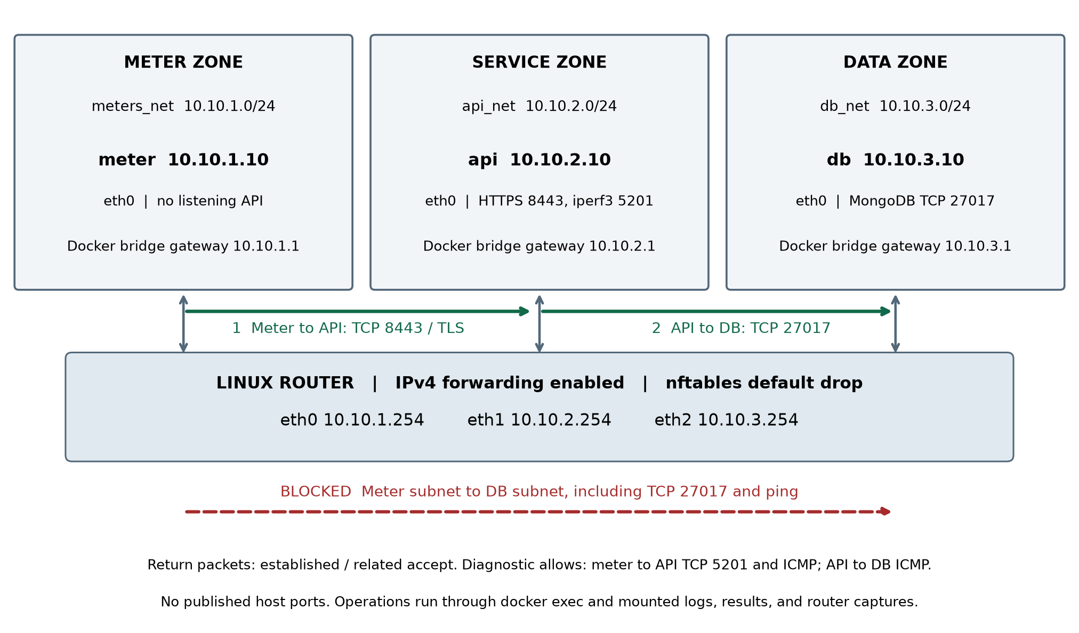
Figure 1. Topology from docker-compose.yml and the live interface checks. Green arrows are the two permitted application connections; each crosses the Linux router as a separate TCP connection. The red path is denied by policy.
Table 2. Addressing plan. Interface names are taken from the live router output in Figure 2.
Segment | Endpoint | Router interface | Docker bridge gateway | Services
meters_net 10.10.1.0/24 | meter 10.10.1.10 | eth0 10.10.1.254 | 10.10.1.1 | client / load generator
api_net 10.10.2.0/24 | api 10.10.2.10 | eth1 10.10.2.254 | 10.10.2.1 | HTTPS 8443, iperf3 5201
db_net 10.10.3.0/24 | db 10.10.3.10 | eth2 10.10.3.254 | 10.10.3.1 | MongoDB 27017

Docker Compose places each endpoint on one bridge network and connects the router to all three, with net.ipv4.ip_forward=1. Each endpoint's startup command installs specific /24 routes to the other two segments via its local .254 router address, so inter-segment traffic is forwarded by our router rather than by the Docker bridge gateway (.1). Because the 10.10.2.0/24 route is more specific than the default route, the meter sends API traffic to 10.10.1.254; the API's route back to 10.10.1.0/24 via 10.10.2.254 provides the symmetric return path, and the same reasoning applies to the API–DB hop. No service publishes a host port, so we run client commands inside the meter container with docker exec.
SOURCE Listing 1 · docker-compose.yml lines 21 (router), 41–42 (db), 60–61 (api), 81–82 (meter)
21 net.ipv4.ip_forward: "1"
41 sh -c "ip route replace 10.10.1.0/24 via 10.10.3.254 &&
42 ip route replace 10.10.2.0/24 via 10.10.3.254 &&
60 sh -c "ip route replace 10.10.1.0/24 via 10.10.2.254 &&
61 ip route replace 10.10.3.0/24 via 10.10.2.254 &&
81 sh -c "ip route replace 10.10.2.0/24 via 10.10.1.254 &&
82 ip route replace 10.10.3.0/24 via 10.10.1.254 &&

Figure 2 shows live terminal captures from the running deployment: all four containers running, the meter's and router's interfaces and routes, forwarding enabled, and the API and DB return routes. In the docker ps output, the 27017/tcp entry for db is the port that the MongoDB image declares for use on the container networks; it is not a host mapping. No container publishes a port to the host, which docker ps would show as an address mapping such as 0.0.0.0:27017->27017/tcp.
(a) Running containers
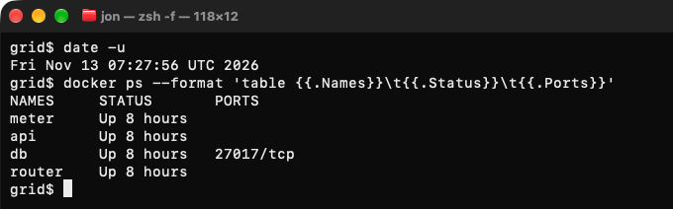
(b) Meter and router interfaces, routes, and forwarding
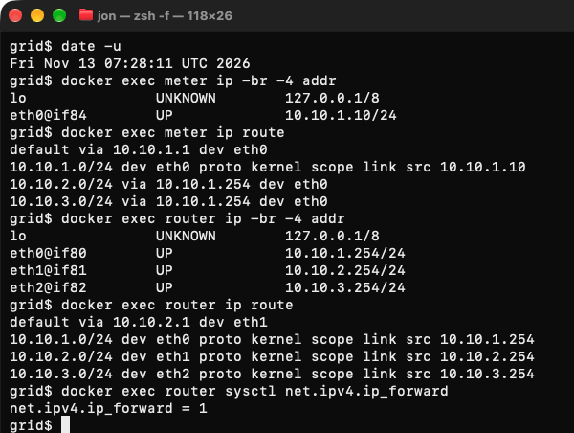
Figure 2. Live terminal screenshots of the running deployment, 13 Nov 2026 07:27:56 and 07:28:11 UTC (terminal output captured during verification). (a) All four containers running. (b) The meter routes both remote /24s via 10.10.1.254; the router holds 10.10.1.254, 10.10.2.254, and 10.10.3.254 on eth0–eth2 with net.ipv4.ip_forward = 1. Panel (c) follows.
(c) API and DB interfaces and routes
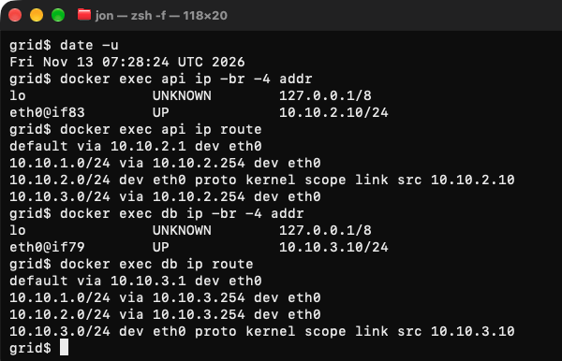
Figure 2 (continued). (c) Live terminal screenshot, 07:28:24 UTC. The API reaches 10.10.1.0/24 and 10.10.3.0/24 via 10.10.2.254; the DB returns via 10.10.3.254.
The healthcheck in Figure 4 also passes meter-to-router ping, routed meter-to-API ping, routed API-to-DB ping, and API-to-DB TCP 27017. These positive checks show that the blocked database path in Section 4 is a policy result, not a broken route.
We also used traceroute to check the routes and firewall behavior [R1, p. 13]. At 08:02 UTC on November 13, we ran two ICMP traceroutes from the meter with the firewall enabled (Listing 2). The API was reached in two hops, with 10.10.1.254 as the first hop. For the database, the first hop replied, but hops 2–5 did not. This matches the firewall rule that drops forwarded traffic from the meter to the database subnet. The drop counter increased by four packets during the test. The router can still answer the first hop because the rule applies to forwarded packets, not packets addressed to the router itself.
OUTPUT Listing 2 · traceroute_20261113.txt, recorded commands and output from the meter (13 Nov, 08:02 UTC; counter lines shortened with …)
$ docker exec meter traceroute -n -I -m 5 -q 1 -w 1 10.10.2.10
traceroute to 10.10.2.10 (10.10.2.10), 5 hops max, 60 byte packets
1 10.10.1.254 1.022 ms
2 10.10.2.10 0.052 ms
$ docker exec meter timeout 30 traceroute -n -I -m 5 -q 1 -w 1 10.10.3.10
traceroute to 10.10.3.10 (10.10.3.10), 5 hops max, 60 byte packets
1 10.10.1.254 0.121 ms
2 *
3 *
4 *
5 *
# router rule "DENY meters to DB", before and after the two traces:
… ip daddr 10.10.3.0/24 counter packets 20 bytes 1200 drop …
… ip daddr 10.10.3.0/24 counter packets 24 bytes 1440 drop …

Result Three routed /24 segments place the client, service, and data zones on separate subnets. Ping and traceroute show that cross-segment traffic passes through the router, and the database is not reachable from the meter (Module A, p. 13).

3 NoSQL service integration (Module B)

3.1 Data model, placement, and API contract
The API stores each reading as a document in MongoDB's grid.readings collection at 10.10.3.10:27017. A named Docker volume keeps the data, and Pydantic checks incoming requests before the database is used. Since MongoDB is on a separate subnet, database requests travel from the API through the router to MongoDB. In the transaction examined in Section 5.1, the MongoDB insert and reply took 1.46 ms on the network, compared with 28.9 ms of API server time for the POST. Server time includes more than database work, and may include time spent receiving the request body (Section 6.1).
Table 3. Reading document schema (api/app.py).
Field(s) | Meaning and validation
meter_id, ts | Meter identity (1–40 chars); measurement or replay timestamp string.
sent_at, received_at | Client send time and API receipt time, epoch seconds.
global_active_power, voltage, global_intensity | Consumption context: kW ≥ 0, V > 0, A ≥ 0; reactive power and sub-metering 1–3 carried from the dataset.
reading_type, generation_kw | consumption (default) or generation; generation records require generation_kw ≥ 0.
freshness_ms, anomaly | (receipt − sent_at) in ms, before the insert; anomaly = active power > 6.0 kW.
source; flagged, note | uci-historical or synthetic-replay; optional operator annotations written by PATCH.

Table 4. API operations. Indexes: (meter_id, ts desc) and (anomaly).
Operation | Contract
POST /readings; POST /readings/batch | Create one document, or 1–1,000 in a batch; HTTP 201. Batch reply includes inserted, db_ms, max_freshness_ms, anomalies.
GET /meters/{id}/latest | Most recent document by received_at; 200, or 404 if the meter has no readings.
GET /meters/{id}/readings | Recent documents by received_at; limit 1–500; optional reading_type filter.
PATCH /readings/{id} | $set flagged/note; 400 for a malformed ID or empty change, 404 for an absent ID.
GET /health; /stats; /anomalies | MongoDB ping health (503 when down), per-source/type counts, recent anomalies.

SOURCE Listing 3 · api/app.py lines 118–126 and 145–149 (receipt metadata and single insert)
def to_doc(r: Reading) -> dict:
now = time.time()
d = r.model_dump()
d["received_at"] = now
d["freshness_ms"] = round((now - r.sent_at) * 1000, 2)
d["anomaly"] = r.global_active_power > ANOMALY_KW
if d["anomaly"]:
log.warning("ANOMALY meter=%s power=%.2fkW ts=%s", r.meter_id, r.global_active_power, r.ts)
return d

@app.post("/readings", status_code=201) # CREATE (single)
def create_reading(r: Reading):
d = to_doc(r)
res = readings.insert_one(d)
return {"id": str(res.inserted_id), "freshness_ms": d["freshness_ms"], "anomaly": d["anomaly"]}

3.2 Create, read, and update over the routed path
To test the API, we ran a Python client (ops/results/evidence/report_checks_20261113/report_client.py) inside the meter container at 06:20:14 UTC on November 13. The client checked the API certificate, created a 2.5 kW test reading, read it back, added a note, and retrieved it again. It also checked that the returned record ID stayed the same and tested six invalid-request cases.
COMMAND Listing 4 · client invocation and the request sequence it executes (excerpt of report_client.py)
$ docker exec -i meter python - < ops/results/evidence/report_checks_20261113/report_client.py
s=requests.Session(); s.verify="/certs/api.crt"; s.trust_env=False
r=req("POST","/readings",reading); r.raise_for_status(); rid=r.json()["id"]
r=req("GET","/meters/"+meter+"/latest"); r.raise_for_status()
r=req("PATCH","/readings/"+rid,{"flagged":True,"note":"report demonstration"}); r.raise_for_status()
r=req("GET","/meters/"+meter+"/latest"); r.raise_for_status()
assert r.json()["id"]==rid and r.json()["flagged"] is True

OUTPUT Listing 5 · recorded responses, report_transaction.txt (final GET body abbreviated with …)
HTTP 201 {"id":"6af6ac1e1dd9bfba6656b461","freshness_ms":9.24,"anomaly":false}
HTTP 200 {"meter_id":"report-demo-20261112","ts":"2026-11-13T06:20:14.049442+00:00", … }
HTTP 200 {"updated":"6af6ac1e1dd9bfba6656b461","changes":{"flagged":true,"note":"report demonstration"}}
HTTP 200 {"meter_id":"report-demo-20261112", … ,"reading_type":"consumption","generation_kw":null,
"received_at":1794550814.0586936,"freshness_ms":9.24,"anomaly":false,
"flagged":true,"note":"report demonstration","id":"6af6ac1e1dd9bfba6656b461","age_s":0.041}
DEMO_ASSERTIONS_PASS 6af6ac1e1dd9bfba6656b461
SHELL_EXIT=0

Table 5. Error responses from the same run; each status was asserted by the client. The API log records the same 422/404/400 sequence between 06:20:14.102 and .112 UTC.
Request (same client session) | HTTP | Recorded response
POST /readings with global_active_power = −5 and voltage omitted | 422 | greater_than_equal on global_active_power; missing voltage
GET /meters/report-demo-absent-20261112/latest | 404 | {"detail":"no readings for meter report-demo-absent-20261112"}
PATCH /readings/not-an-id | 400 | {"detail":"invalid reading id"}
GET …/readings?limit=9999 | 400 | {"detail":"limit must be 1..500"}
POST /readings, reading_type = generation, no generation_kw | 422 | generation_kw is required when reading_type is 'generation'
GET …/readings?reading_type=invalid | 400 | reading_type must be one of ['consumption', 'generation']

3.3 Synthetic generation readings
Generation readings use a separate field, generation_kw; they do not reuse the consumption values. The solar model uses a 5.0 kW capacity and calculates C·sin(π(h − 6)/12) between 06:00 and 18:00. It produces zero outside those hours. This is a simple model of a clear day, not actual solar production data.
SOURCE Listing 6 · meter/meter_sim.py lines 67–73
def solar_kw(hour_of_day: float, capacity_kw: float = GEN_CAPACITY_KW) -> float:
if hour_of_day <= GEN_SUNRISE_HOUR or hour_of_day >= GEN_SUNSET_HOUR:
return 0.0
span = GEN_SUNSET_HOUR - GEN_SUNRISE_HOUR
phase = (hour_of_day - GEN_SUNRISE_HOUR) / span # 0..1 across the daylight window
shape = math.sin(phase * math.pi) # 0 at sunrise/sunset, 1 at noon
return round(capacity_kw * shape, 3)

Table 6. Generation records written and read back on 13 Nov. Filtering that meter with reading_type=generation returned all three IDs, newest receipt first; filtering it with reading_type=consumption returned an empty list.
Command (in meter) | POST | generation_kw (kW) | Returned id
meter_sim.py generate --meter report-demo-pv-20261112 --hour 12 | 201 | 5.000 | 6af6ac2f1dd9bfba6656b462
… --hour 9 | 201 | 3.536 | 6af6ac2f1dd9bfba6656b463
… --hour 2 | 201 | 0.000 | 6af6ac301dd9bfba6656b464

4 Security implementation (Module C)

4.1 TLS on the meter-to-API connection
Uvicorn terminates TLS on port 8443. ops/deploy.sh generates a self-signed RSA-2048 certificate with the subject alternative names IP:10.10.2.10 and DNS:api whenever the certificate or key file is missing or empty. The meter trusts exactly this certificate (--cacert for curl and Session.verify for Python), so the tested clients verify certificate trust and the API address. The verification requests do not disable certificate checking.
SOURCE Listing 7 · ops/deploy.sh lines 17–21 and the API command in docker-compose.yml
if [ ! -s certs/api.crt ] || [ ! -s certs/api.key ]; then
openssl req -x509 -newkey rsa:2048 -nodes -days 365 \
-keyout certs/api.key -out certs/api.crt \
-subj "/CN=grid-api" -addext "subjectAltName=IP:10.10.2.10,DNS:api"
fi
exec uvicorn app:app --host 0.0.0.0 --port 8443 --ssl-keyfile /certs/api.key --ssl-certfile /certs/api.crt

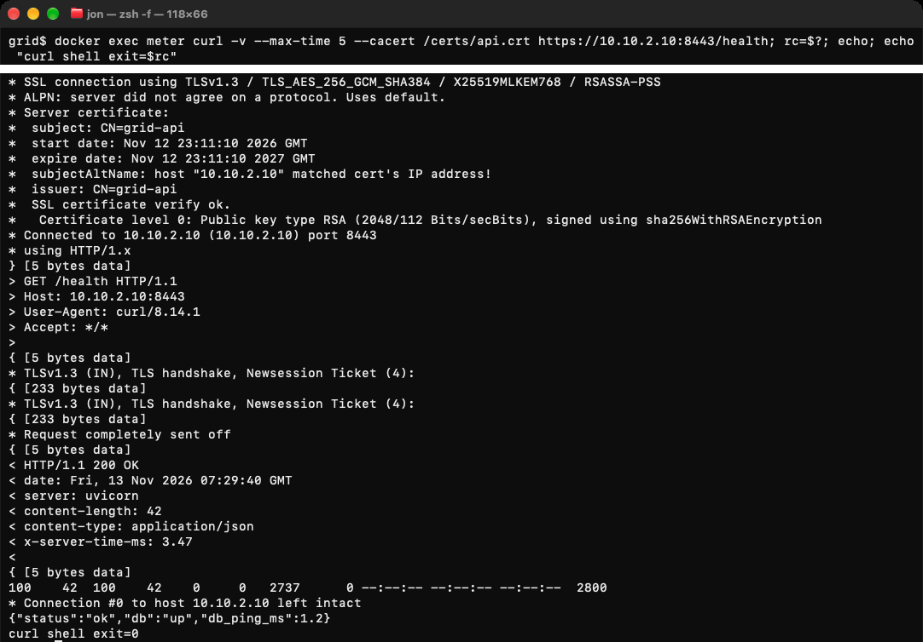
Figure 3. Live terminal screenshot of a verified TLS request from the meter, 13 Nov 2026 07:29:40 UTC (from the HTTP date header). The upper strip is the command line; the lower crop of the same window shows TLS 1.3 with TLS_AES_256_GCM_SHA384, the SAN match for 10.10.2.10, SSL certificate verify ok, HTTP 200, the health JSON, and curl exit status 0.
The deployment certificate was issued on 12 November 2026 at 23:11:10 UTC. The TLS verification checks confirm certificate trust and the correct server-address match; the secure deployment also passes all 13 health checks (ops/results/evidence/deploy_verify_20261112/).

4.2 Access control: allowed and denied paths
The router's inet grid forward chain defaults to drop. Established and related packets are accepted first, so replies to admitted connections return. New meter traffic may reach only the API's HTTPS port, the iperf3 test port, and ICMP echo. New MongoDB connections are accepted only from the API host, and an explicit, counted rule drops meter-subnet traffic to the DB subnet.
SOURCE Listing 8 · router/firewall.nft (forward chain)
table inet grid {
chain forward {
type filter hook forward priority 0; policy drop;
ct state established,related accept
ip saddr 10.10.1.0/24 ip daddr 10.10.2.10 tcp dport 8443 counter accept comment "meters to API over TLS"
ip saddr 10.10.1.0/24 ip daddr 10.10.2.10 tcp dport 5201 counter accept comment "iperf3 throughput tests"
ip saddr 10.10.1.0/24 ip daddr 10.10.2.0/24 icmp type echo-request counter accept comment "ping meters to API"
ip saddr 10.10.2.10 ip daddr 10.10.3.10 tcp dport 27017 counter accept comment "API to MongoDB"
ip saddr 10.10.2.0/24 ip daddr 10.10.3.0/24 icmp type echo-request counter accept comment "ping API to DB"
ip saddr 10.10.1.0/24 ip daddr 10.10.3.0/24 counter drop comment "DENY meters to DB"
counter comment "other dropped traffic"
}
}

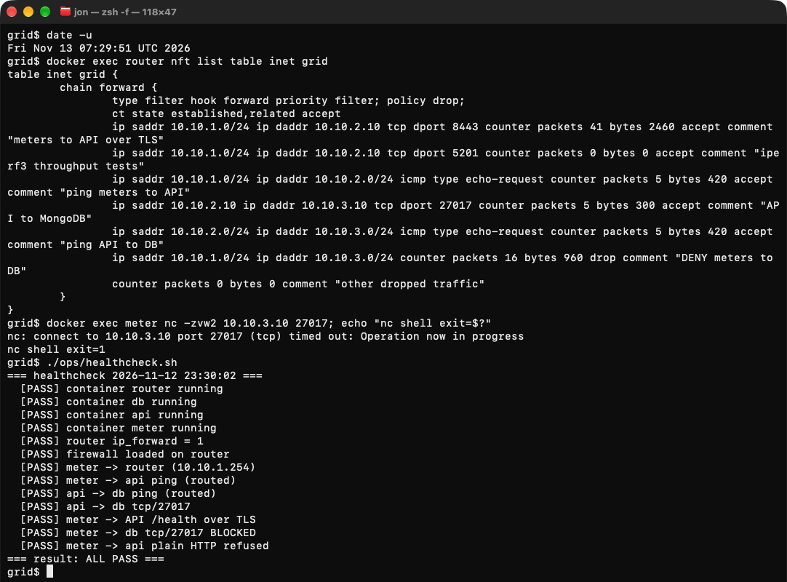
Figure 4. Live terminal screenshot, 13 Nov 2026 07:29:51 UTC. The ruleset is loaded on the router; a direct meter → DB TCP 27017 connection times out (nc exit status 1); the healthcheck then passes all 13 checks, including verified TLS from meter to API, API → DB TCP 27017, meter -> db tcp/27017 BLOCKED, and refusal of plain HTTP. Cropped to remove empty rows below the output.
We checked the blocked meter-to-database path in four ways. The firewall rules include a packet counter on the drop rule (Figure 4). A direct nc connection from the meter to 10.10.3.10:27017 timed out with exit status 1. During that attempt, the drop counter increased from 4 packets/240 bytes to 6 packets/360 bytes (firewall_before.txt and firewall_after.txt). The router capture report_demo.pcap also recorded the meter's SYN packet and one retransmission at 06:20:14.195 and 06:20:15.202 UTC (frames 149–150), without a forwarded copy or a reply. The separate November 10 capture, deny_test.pcap, shows the same blocked behavior for TCP 27017 and ping (Appendix A, Figure A3). The counter values given here are from the November 13 test. At the same time, the permitted API-to-database connection worked, and the meter could reach the API over verified TLS. The firewall controls which connections are allowed, while TLS protects the meter-to-API traffic [R1, p. 30].
Result Allowed: meter → API over TLS 1.3 with certificate and SAN verification (HTTP 200). Blocked: meter → MongoDB TCP 27017, dropped by a counted forward rule, while API → MongoDB succeeds.

5 Observability and packet evidence (Module D)
We used four sources of monitoring evidence: tcpdump captures on the router, examined with Wireshark/TShark 4.6.8; API logs containing request methods, paths, status codes, and server time; client logs and CSV files containing latency and status; and the health-check and recovery-script output. The next two examples connect events seen in the network captures with what happened in the application.

5.1 One transaction traced across both routed hops
During the run in Section 3.2 we captured on the router. The meter opened TCP port 41356 to 10.10.2.10:8443, and the API used its pooled MongoDB connection from 10.10.2.10:40440 to 10.10.3.10:27017. Each forwarded packet appears twice in the capture (router ingress and egress), so Table 7 lists the first observation of each.
OUTPUT Listing 9 · report_demo_api.log, API log lines for the four successful requests (13 Nov UTC)
2026-11-13 06:20:14.085 INFO 10.10.1.10 POST /readings 201 28.9ms
2026-11-13 06:20:14.091 INFO 10.10.1.10 GET /meters/report-demo-20261112/latest 200 4.4ms
2026-11-13 06:20:14.095 INFO 10.10.1.10 PATCH /readings/6af6ac1e1dd9bfba6656b461 200 2.3ms
2026-11-13 06:20:14.099 INFO 10.10.1.10 GET /meters/report-demo-20261112/latest 200 1.4ms

Table 7. Router capture report_demo.pcap aligned with the API log and client transcript (166 observations, 0 kernel drops).
Frames | Time (UTC, 13 Nov) | Hop | Observation
1, 3, 5 | 06:20:14.050321–.050388 | meter ↔ API | TCP SYN, SYN/ACK, ACK to port 8443
7, 11, 15 | 06:20:14.053108–.054895 | meter ↔ API | TLS 1.3 Client Hello, Server Hello, encrypted handshake
19, 21 | 06:20:14.055785–.057240 | meter → API | Encrypted request records (POST per API log)
25, 27 | 06:20:14.083750–.085210 | API ↔ DB | MongoDB insert request and response (TCP 27017)
31, 33 | 06:20:14.085997–.086663 | API → meter | Encrypted response records; API logs POST 201 at .085
39, 41 | 06:20:14.087791–.091290 | API ↔ DB | MongoDB find for the first read-back; API logs GET 200 at .091
55, 57 | 06:20:14.094217–.095673 | API ↔ DB | MongoDB update for the annotated ID; API logs PATCH 200 at .095

OUTPUT Listing 10 · tshark -V decode of frame 55, selected lines from report_demo_decoded_mongodb.txt
Internet Protocol Version 4, Src: 10.10.2.10, Dst: 10.10.3.10
OpCode: Extensible Message Format (2013)
Element: update Value: readings
Element: $db Value: grid
Element: q _id ObjectID: 6af6ac1e1dd9bfba6656b461
Element: u $set flagged: True note: report demonstration

The ObjectId 6af6ac1e1dd9bfba6656b461 links the client's POST response, the PATCH path in the API log, and the decoded database update in frame 55. On the meter hop, TLS hides the HTTP method, path, and JSON, so there the match rests on timing and connection identity, and the operation names come from the API log. The MongoDB hop is plaintext, which gives content-level confirmation and also shows that this hop is not encrypted. The timings show roughly where the time went: from the meter's SYN to the encrypted response took about 36 ms, including TCP and TLS setup; the API recorded 28.9 ms of server time for the POST; and the MongoDB insert took 1.46 ms on the wire. Most of the server time therefore lies outside the database round trip, but a single trace does not show how it divides between receiving the request and application processing.

5.2 Network event matched to application effect: API-side link failure
During the November 10 link-failure experiment, the router interface holding 10.10.2.254 was disabled while a client watcher sent a reading every 0.5 s. Figure 5 shows the corresponding Wireshark capture from link_failure.pcap. Table 8 aligns the router capture with the script console, the client watch, and the API log.
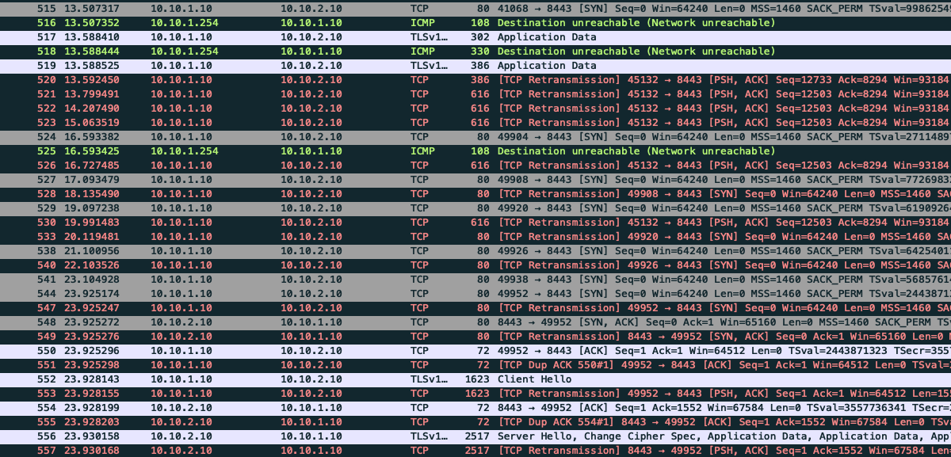
Figure 5. Wireshark, link_failure.pcap (10 Nov), filter ip.addr == 10.10.1.10 && ip.addr == 10.10.2.10 && tcp.port == 8443; relative time zero is 20:50:44.508 UTC. Frames 516, 518, and 525 are ICMP Network Unreachable messages sent by the router (10.10.1.254) in reply to meter → API packets. Repeated SYNs and retransmissions follow. Frames 544–550 complete a new handshake at 23.925 s (20:51:08.433 UTC), and frames 552 and 556 resume TLS. Additional capture frames appear in Appendix A.
Table 8. Correlated link-failure timeline (November 10 set) from failure_link.txt, the November 10 watch_failure_link.log, the matched API log, and the router capture.
Time (UTC) | Source | Event
20:50:57.599 | API log | Last watch POST /readings 201 before the fault
20:50:57.789 | fail_recover console | >>> INDUCING FAILURE: link — API-side router interface set down
20:50:58.016 | Packets, frame 516 | Router returns ICMP Network Unreachable to the meter
20:50:58.028 | fail_recover console | >>> DETECTED: /health failing
20:51:01.100 | Client watch | seq=20 FAIL status=0 ReadTimeout; then ConnectionError and ConnectTimeout (5 failures)
20:51:08.230 | fail_recover console | >>> RECOVERING — interface set up
20:51:08.434 | Packets, frames 544–550 | New TCP handshake to 8443 completes; TLS resumes
20:51:09.024–.027 | API log | GET /health 200; first watch POST /readings 201 after the fault
20:51:09.029 | Client watch | SERVICE RECOVERED after 7.9 s (first failure to first later success)

The capture and logs show how the link failure affected the application. After the router interface went down, the router reported that the API network was unreachable within 0.23 s. The health check failed, and client requests timed out before reaching the API. No requests appeared in the API log during that gap. Once the interface was restored, a new TCP connection began within about 0.2 s, and the API recorded a successful health check and POST within 0.8 s. Overall, 100 of the 105 watch requests succeeded. Appendix A shows packets from before and after the interruption.

6 Performance experiments (Module E)

6.1 Method
Each condition runs the same workload: five concurrent meter threads, each sending 20 batch POSTs of 50 readings with a latest-reading GET after every batch. That gives 100 POSTs, 100 GETs, and 5,000 readings per condition. ops/impair.sh applies tc/netem to the meter's uplink (egress on the meter's eth0), and ops/experiments.sh runs baseline, delay, loss, and throttle in that order. In the November 10 set we also recorded a 20-packet ping and a 10 s iperf3 run per condition; the November 12 Mac set has workload results only.
COMMAND Listing 11 · workload, impairments, and network probes (from ops/experiments.sh and ops/impair.sh). meter# = run inside the meter container; host$ = run on the host
# Inside the meter container (the scripts launch these through docker exec meter …)
meter# python meter_sim.py bench --meters 5 --batches 20 --batch-size 50 --label LABEL
meter# tc qdisc replace dev eth0 root netem delay 100ms 20ms # delay
meter# tc qdisc replace dev eth0 root netem loss 5% # loss
meter# tc qdisc replace dev eth0 root netem rate 256kbit # throttle
# On the host
host$ docker exec meter ping -c 20 -i 0.2 10.10.2.10
host$ docker exec meter iperf3 -c 10.10.2.10 -t 10

Metrics. POST and GET latency is the client's perf_counter time per request; p50 and p95 are taken over the 100 requests of each type. Server time is the API middleware's elapsed time, returned in the X-Server-Time-ms header and written to the API log; the server p50 in Table 9 is taken over the 100 POSTs only. The timer starts when the request enters the FastAPI application and stops when the response is ready, so it covers validation, application work, and MongoDB calls, and it can also include waiting for the request body to arrive over the network. It is not an isolated database execution time. Freshness is API receipt time minus the meter's sent_at, taken before the insert; the table reports p50/p95 of the per-batch maximum. Throughput is the number of readings acknowledged with HTTP 201 divided by wall time. Every detail CSV contains 100 POSTs with status 201 and 100 GETs with status 200, and p95 values recomputed from those files match the summary.

6.2 Results
Table 9. Performance measurements, one trial per condition (ms unless noted). Percentiles and throughput come from ops/results/summary.csv, computed from the per-request bench_*.csv files; ping and iperf3 come from net_*.txt (November 10 set only). All 200 requests in every run succeeded. Compare conditions within a set, not across sets.
Condition | Ping RTT avg, ms (loss) | iperf3 receive | POST p50 / p95 | GET p50 / p95 | Server p50 | Freshness p50 / p95 | Readings/s
November 10 set — original test host
Baseline | 0.094 (0/20) | 16.6 Gbit/s | 28.6 / 47.6 | 20.3 / 32.1 | 17.4 | 15.0 / 30.2 | 4,446.9
Delay 100 ± 20 ms | 97.755 (0/20) | 830 kbit/s | 125.0 / 219.4 | 109.5 / 127.6 | 25.2 | 121.3 / 216.1 | 858.0
Loss 5% | 0.092 (1/20) | 394 Mbit/s | 15.0 / 51.4 | 21.6 / 226.8 | 9.0 | 8.3 / 40.1 | 3,193.4
Rate 256 kbit/s | 3.221 (0/20) | 209 kbit/s | 1,493.7 / 2,454.9 | 1,022.7 / 1,981.0 | 483.2 | 1,490.1 / 2,451.1 | 98.6
November 12 Mac set — Mac-local deployment (no ping or iperf3 records)
Baseline | — | — | 6.2 / 10.7 | 4.6 / 6.5 | 4.2 | 3.3 / 7.2 | 18,427.6
Delay 100 ± 20 ms | — | — | 203.0 / 415.6 | 108.1 / 128.3 | 100.2 | 201.6 / 402.3 | 634.5
Loss 5% | — | — | 3.7 / 26.7 | 4.6 / 7.0 | 2.3 | 1.7 / 19.0 | 7,094.3
Rate 256 kbit/s | — | — | 1,504.3 / 2,465.5 | 1,010.3 / 1,976.1 | 487.1 | 1,499.2 / 2,460.1 | 98.6

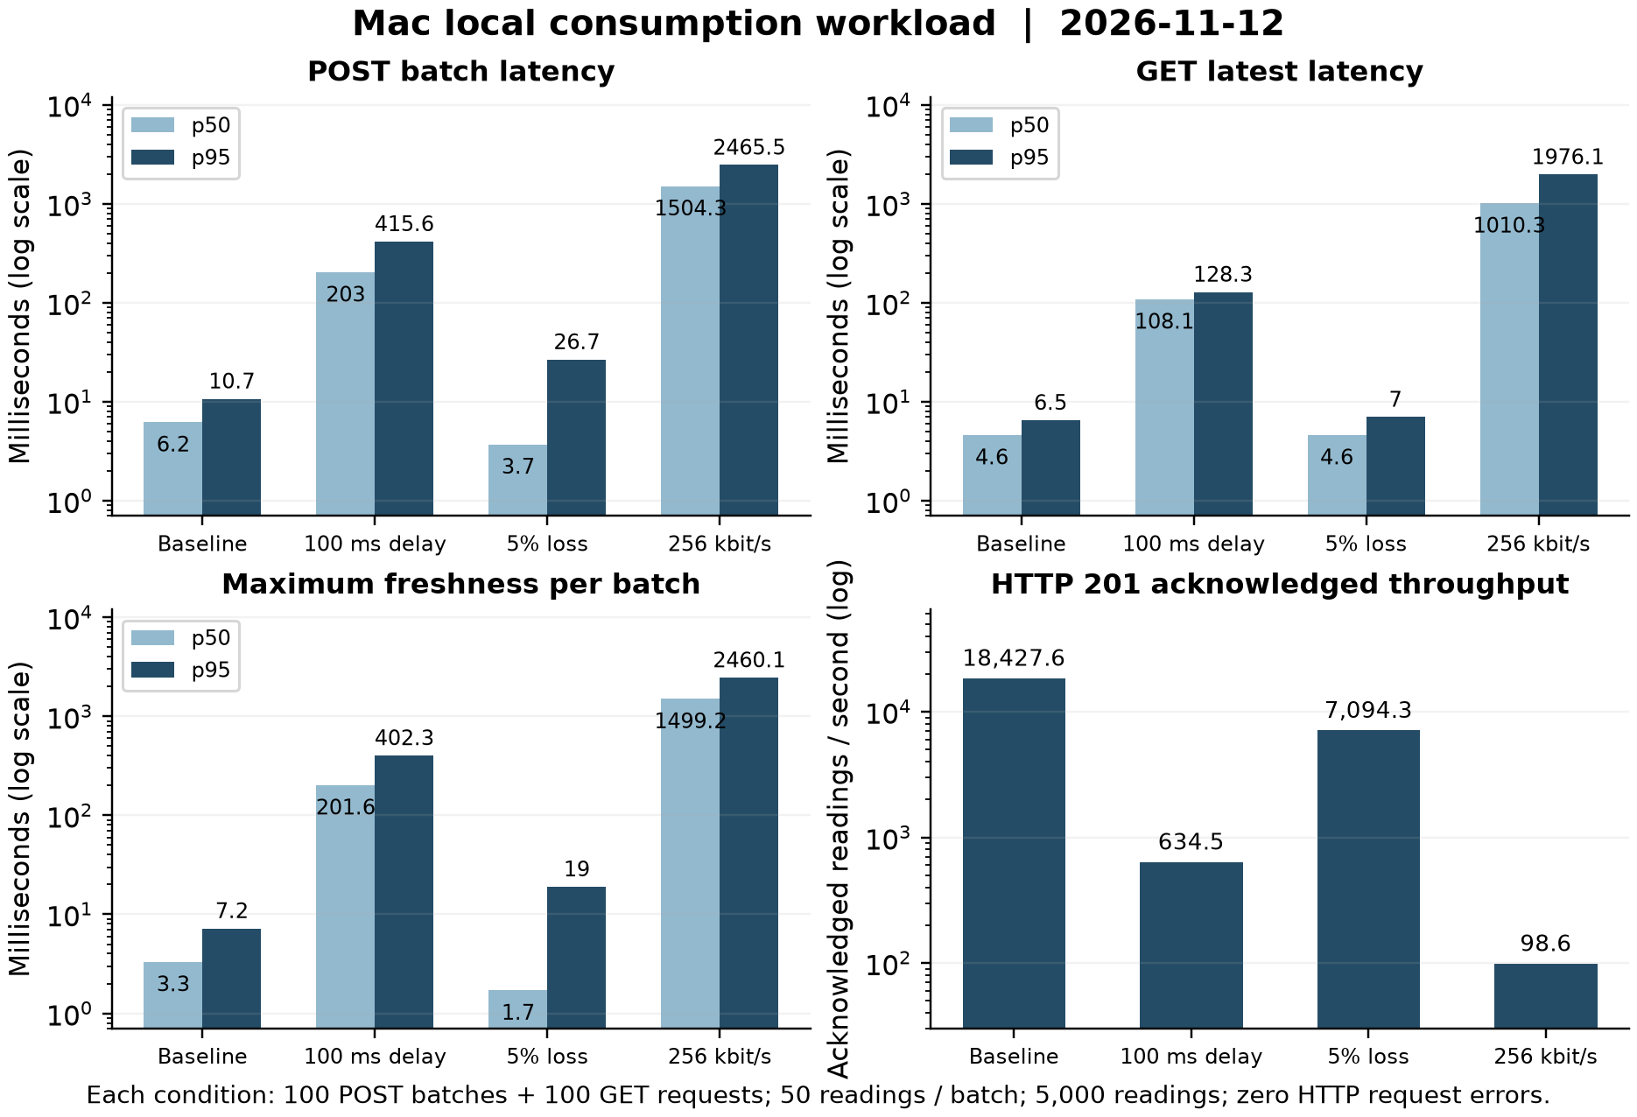
Figure 6. November 12 Mac-local results for the four conditions (log scales). The matching November 10 chart is Figure B1 in Appendix B.

6.3 Interpretation: network versus application bottlenecks
Delay. Adding 100 ms of uplink delay increased the November 10 average ping RTT from 0.094 to 97.8 ms. POST p95 increased from 47.6 to 219.4 ms in that test set and from 10.7 to 415.6 ms in the Mac test set. Freshness also increased. In November 10, server p50 changed from 17.4 to 25.2 ms, which suggests that most of the extra request latency came from the network. In the Mac tests, server p50 reached 100.2 ms. This can happen because the server timer may include receiving the request body over the delayed uplink. The impairment was applied only to the meter's uplink, so the API–MongoDB hop ran unimpaired; in the traced baseline transaction (Section 5.1) the MongoDB insert and reply took 1.46 ms on that hop, so the added time is network and request-receipt time rather than database processing. TCP and TLS exchanges can also make a POST take longer than one round trip.
Loss. With 5% configured packet loss, iperf3 recorded 17,492 sender retransmissions in the November 10 tests, but every application request still succeeded. TCP retransmissions can increase the time needed to finish a request. For example, GET p95 rose to 226.8 ms while GET p50 remained close to baseline (21.6 versus 20.3 ms). In the Mac tests, POST p50 under loss was 3.7 ms, compared with 6.2 ms at baseline. That does not mean packet loss improved performance. We ran only one short trial per condition, so normal timing variation could explain this median difference.
Throttle. The 256 kbit/s uplink limit had the largest effect on the workload. Both test sets measured 98.6 HTTP-acknowledged readings/s under this limit, even though their baseline throughput differed by about four times. Freshness p95 reached 2,451–2,460 ms, close to POST p95 at 2,455–2,466 ms. This suggests that much of the delay occurred while readings were being sent over the restricted uplink. Server p50 also rose to around 485 ms, which may partly reflect the time taken to receive request bodies. Because the API–MongoDB hop was not shaped, the extra time is on the meter uplink, not in the database. All 200 requests succeeded in each throttled run, but they took much longer and the overall throughput was much lower.
Result The evidence points to the shaped uplink as the dominant bottleneck under impairment: at 256 kbit/s, throughput fell 45× (November 10 set) and 187× (Mac set) to 98.6 readings/s in both, and freshness p95 rose to about 2.45 s. Missing data: no readings were missing under delay, loss, or throttling, because every run acknowledged all 5,000 readings with HTTP 201. Readings went missing only during the outages in Section 7: 5 during the database stop and 7 during the link cut, which the client did not resend.

7 Automation and recovery (Module F)
Our automation consists of ops/deploy.sh (certificate bootstrap, build, dataset import, optional firewall load), ops/healthcheck.sh (13 configuration and connectivity checks; exit 0 only if all pass), ops/firewall.sh, ops/impair.sh, ops/experiments.sh, and ops/fail_recover.sh. The recovery script takes a mode, db or link. It runs the healthcheck, starts a 60 s client watch, and injects one fault: docker stop db, or setting the router's API-side interface down. It then polls the verified /health endpoint until it fails, holds the fault for 10 s, reverses it (docker start db, or interface up), polls until health returns, and finally repeats the healthcheck and one client request. The fault, restore, and /health probe commands run under an 8 s watchdog, each polling loop is capped at 60 s, and a loop that reaches its cap sets a nonzero exit status (Listing 12). The before and after healthchecks, the client watch, and the final client request are not wrapped by the watchdog.
SOURCE Listing 12 · ops/fail_recover.sh lines 158–215 (… marks elided log/echo lines)
158 trap 'cleanup INT' INT
159 trap 'cleanup TERM' TERM
160 trap 'cleanup EXIT' EXIT
… # healthcheck; start client watch in background (WATCH=$!); sleep 10
170 T_FAIL_ISSUED=$(now)
171 FAILURE_INJECTED=1 # armed BEFORE the disruptive call so a signal mid-call still restores
172 if [ "$MODE" = db ]; then
173 run_with_timeout "$CMD_TIMEOUT_S" docker stop db >/dev/null
174 else
175 run_with_timeout "$CMD_TIMEOUT_S" docker exec router ip link set "$RIF" down
176 fi
…
184 if wait_for_state fail "$DETECT_CAP_S"; then
185 T_DETECTED=$(now)
… # log detection time
189 else
… # log DETECTION CAPPED OUT
191 EXIT_STATUS=4
192 fi
194 sleep 10 # leave it broken long enough to see in the watch log
…
197 T_RECOVER_ISSUED=$(now)
198 if [ "$MODE" = db ]; then
199 run_with_timeout "$CMD_TIMEOUT_S" docker start db >/dev/null
200 else
201 run_with_timeout "$CMD_TIMEOUT_S" docker exec router ip link set "$RIF" up
202 fi
…
204 if wait_for_state ok "$RECOVER_CAP_S"; then
205 T_HEALTH_RESTORED=$(now)
… # log recovery time
208 else
… # log RECOVERY CAPPED OUT
210 EXIT_STATUS=5
211 fi
213 wait $WATCH
214 echo "$(ts) AFTER: health check"; ./ops/healthcheck.sh | tail -1
215 echo "$(ts) same client request again:"; docker exec meter python meter_sim.py send --meter meter-001 | head -2
… # no explicit exit: the EXIT trap runs cleanup and exits with EXIT_STATUS

The script registers its INT, TERM, and EXIT traps before it injects the fault, and it sets FAILURE_INJECTED=1 immediately before the disruptive command. If a fault was injected, the cleanup function starts the DB container if it is not running, or sets the interface up, then re-verifies /health; if a signal caused the exit, it forces a nonzero exit status even when restoration succeeds. In both November 12 runs the EXIT-path cleanup ran after the normal recovery, re-verified health, and reported final_exit_status=0. We did not test interruption by INT or TERM.
Table 10. Recovery measurements from the two November 12 Mac-set runs of ops/fail_recover.sh (ops/results/evidence/recovery_20261112/). Detection is measured from the failure command to the first failing verified probe, restoration from the restore command to the first healthy probe, and client outage from the first failed watch request to the next success.
Measure | DB stop/start | API-side link down/up
Detection | 2.476 s | 5.316 s
Restoration verified | 1.529 s | 0.417 s
Client-observed outage | 11.9 s | 13.1 s
Watch requests succeeded | 93/98 (94.9%) | 89/96 (92.7%)
Failure seen by client | 5 × HTTP 503 {"error":"database unavailable"} | 1 ReadTimeout + 6 ConnectTimeout (status 0)
Healthcheck before / after; exit status | ALL PASS / ALL PASS; 0 | ALL PASS / ALL PASS; 0
Post-restoration client request | POST 201, GET 200 | POST 201, GET 200

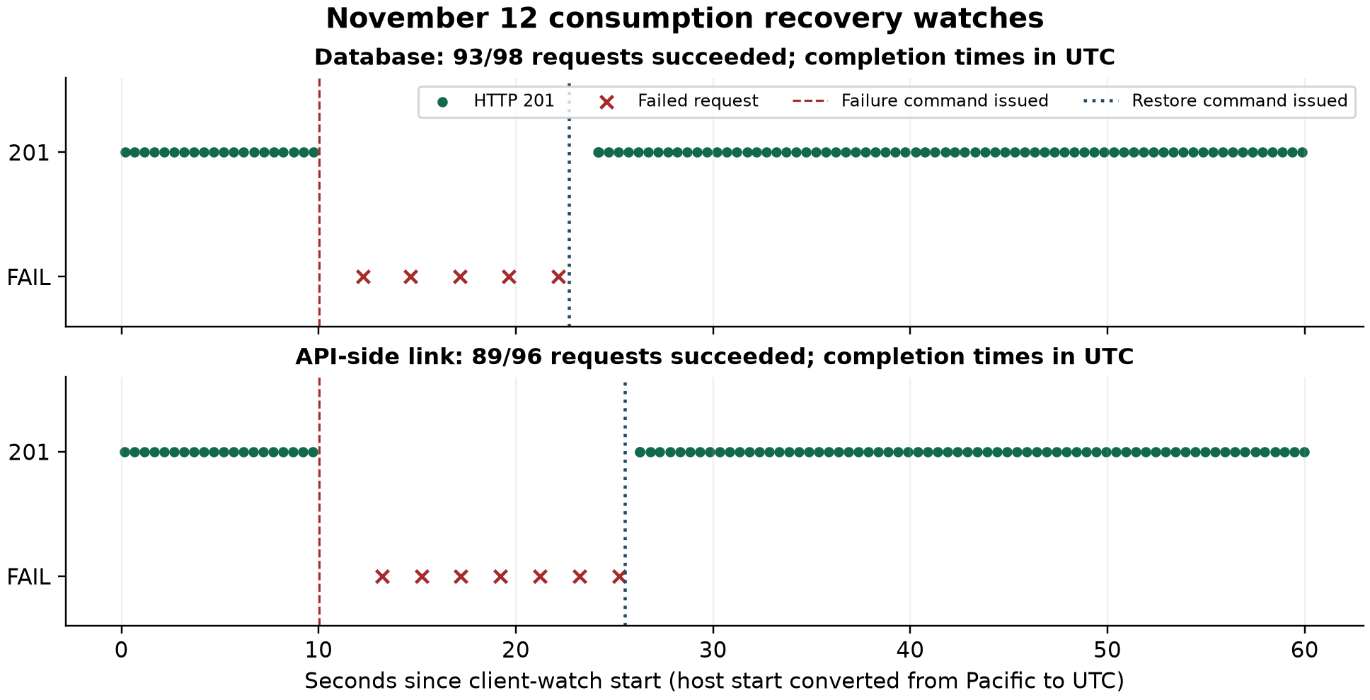
Figure 7. Client-watch request outcomes during the two November 12 recovery runs, with the failure and restore commands marked.
The two failure tests produced different client errors. When MongoDB was stopped, the API was still reachable but returned HTTP 503 because the database was unavailable. When the router link was disabled, client requests timed out before they could reach the API. Most of the 12–13 s observed outage came from the planned 10 s pause before restoring the connection. Once restoration started, the script confirmed healthy service within 0.4–1.5 s. Each watch request carried one reading, so 5 readings (database test) and 7 readings (link test) were not stored; the client has no retry queue, so they were not delivered later.

8 Reproducibility and deployment
The environment is defined by docker-compose.yml, four Dockerfiles (python:3.12-slim, mongo:7.0, ubuntu:24.04), and ops/deploy.sh. The host needs Docker with Linux containers and NET_ADMIN/NET_RAW, plus Bash, curl, unzip, and OpenSSL with req -addext. The deploy script downloads the dataset on first use. The repository README [R2] documents setup, API requests, performance experiments, and failure-recovery procedures.
COMMAND Listing 13 · secure launch and validation (README §3)
$ ./ops/deploy.sh --with-firewall # certs, build, import, nftables
$ ./ops/healthcheck.sh # 13 checks; exit 0 = ALL PASS
$ ./ops/firewall.sh show
$ ./ops/experiments.sh # baseline / delay / loss / throttle
$ ./ops/fail_recover.sh db # or: link

The November 12 secure deployment used --with-firewall and verified certificate availability, dataset and MongoDB volume access, the 20,000-row import, firewall activation, and all 13 health checks (deploy_verify_20261112/). Recorded runtime versions were macOS 27.0.1; Docker Engine 29.2.1 and Compose 5.0.2; FastAPI 0.115.14; Uvicorn 0.32.1; PyMongo 4.10.1; Pydantic 2.14.3; Requests 2.32.5; and MongoDB 7.0.48.
We used SHA-256 hashes to record which source files were used for the experiments. The copies of app.py, import_uci.py, and meter_sim.py inside the running containers matched the repository files. We also recorded hashes for docker-compose.yml, router/firewall.nft, and the deploy, recovery, impairment, and experiment scripts. The recovery evidence manifest includes the same fail_recover.sh hash (de1b2b5ed166…) for those tests. The hashes do not cover healthcheck.sh, firewall.sh, or capture.sh.

9 Limitations
These limits apply to the results above.
- Data. Consumption is historical household data used as a proxy. Generation is a modeled sine curve with no weather or measured output. The anomaly flag tests consumption power only.
- Security scope. TLS authenticates the server only (no client certificates). The API→MongoDB hop is plaintext and MongoDB has no authentication. The ACL covers router-forwarded traffic only, loads only with --with-firewall or ops/firewall.sh, and the private key is generated locally by deploy.sh, is git-ignored and was never committed, but is left at mode 644 rather than 600.
- Measurement design. Each condition was measured once, in a fixed order while the collection grew; these results do not establish statistical confidence intervals. The two sets ran on different hosts, and the Mac set has no ping or iperf3 records. Server time is not database time. The benchmark did not save per-request MongoDB time (the batch endpoint returns db_ms, but the client did not record it), so Section 6.3 separates database from network time using the traced 1.46 ms database exchange and the fact that only the meter uplink was impaired.
- Delivery guarantees. The client has no retry queue or idempotency key. The 12 readings that failed during the two outages (Section 7) were therefore lost rather than delivered late. HTTP 201 counts were not reconciled record by record against MongoDB. A single router is a single point of failure.
- Queries, deployment, and recovery. The (meter_id, ts) index serves lookups by measurement time; the latest and recent-reading endpoints sort by arrival time (received_at), which an additional (meter_id, received_at) index would serve. Deployment is one command (Listing 13); the verified 12 November run reused the existing dataset and MongoDB volume, and the importer deletes and reloads its records on every run, but a first run on an empty volume was not repeated. In both recovery runs the EXIT-path cleanup ran and verified restoration (exit status 0); the INT/TERM paths call the same cleanup but were not triggered. The fault, restore, and /health probe commands have an 8 s watchdog and each polling loop has a 60 s cap; the healthcheck, client-watch, and final-request steps are not individually bounded by that watchdog.

10 Lessons learned and team contributions
One thing we learned is that different tests prove different parts of the system. A successful ping shows that a network route works, but it does not prove the API is working. An HTTPS 200 response shows the service is reachable, but it does not prove that direct database access is blocked. Encrypted TLS packets also cannot show the HTTP request itself. We therefore used several sources of evidence together. For one reading, we matched the record ID in the client response, API log, and MongoDB update. For the link failure, we matched ICMP errors, failed health checks, client timeouts, and the gap in the API log. The throttling experiment also showed why freshness matters: readings can still be delivered successfully while taking much longer to reach the API.
There are several ways we could extend this project. We could add a sequence ID to each reading, support retries without creating duplicates, and store failed requests until the connection returns. We could also add MongoDB authentication and TLS, create an index for the received_at queries, measure database time separately, and repeat performance experiments in different orders to reduce the effect of run-to-run variation.
Contributions. Chidera Izuora, Teagen Lee, and Yohannes Nigusse contributed equally overall and worked together on choosing the application, planning, implementation, testing, analysis, and documentation. Following the three roles in the brief [R1, p. 32], each of us also led one area: Chidera Izuora was Network Lead (topology, routing, segmentation, and impairment experiments); Teagen Lee was Platform Lead (application, API, NoSQL data model, and TLS); and Yohannes Nigusse was Validation Lead (monitoring, automation, measurements, and evidence). Each of us understands and can explain the full architecture.
Acknowledgments. We credit the UCI dataset authors [R3] and the open-source projects we used: Docker, Python, FastAPI, Uvicorn, PyMongo/MongoDB, Pydantic, Requests, iproute2, nftables, tcpdump, traceroute, iperf3, OpenSSL, and Wireshark.

References
[R1] A. Cavalcanti, CSCI 414/514 Lecture 23, Final Practical Exam project brief (23.pdf): module requirements pp. 13–18; validation pp. 27–31; teamwork p. 32; rubric p. 33; submission p. 35; Option 09 pp. 58–59.
[R2] C. Izuora, T. Lee, and Y. Nigusse, Energy Grid Telemetry Platform project repository: source code, configuration, scripts, and saved evidence, 2026.
[R3] G. Hebrail and A. Berard, Individual Household Electric Power Consumption [Dataset], UCI Machine Learning Repository, 2006. DOI 10.24432/C58K54. https://archive.ics.uci.edu/dataset/235/individual+household+electric+power+consumption
[R4] Creative Commons Attribution 4.0 International. https://creativecommons.org/licenses/by/4.0/

Appendix A Wireshark packet evidence
All figures in this appendix are crops of genuine Wireshark windows opened on the November 10 router captures. Because tcpdump captured on the router's any interface, each forwarded packet appears twice (ingress and egress). Wireshark labels the second copy as a retransmission or duplicate ACK, so those labels alone do not indicate network loss.
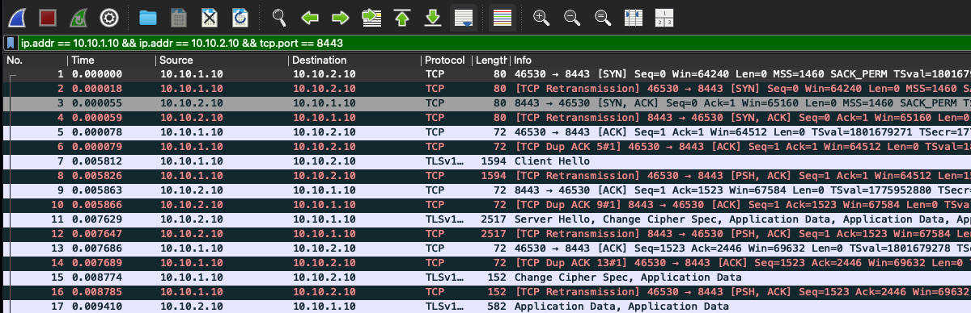
Figure A1. normal_txn.pcap, bidirectional TCP 8443 filter. Frames 1/3/5 are SYN, SYN/ACK, ACK; frame 7 is the TLS Client Hello; frame 11 is the Server Hello followed by encrypted records. Time zero is 20:01:11.410801 UTC.
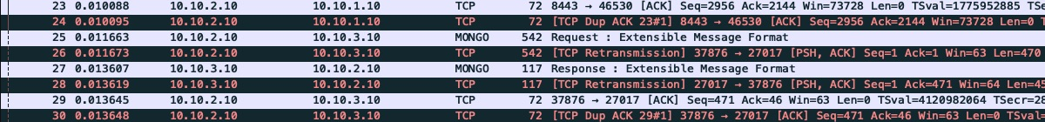
Figure A2. Same capture, unfiltered. Frames 25 and 27 are the API → DB request and DB → API response on TCP 27017 at 20:01:11.422 and .424 UTC. The matched API log records POST /readings 201 at .425, GET latest 200 at .444, and PATCH 200 at .459.
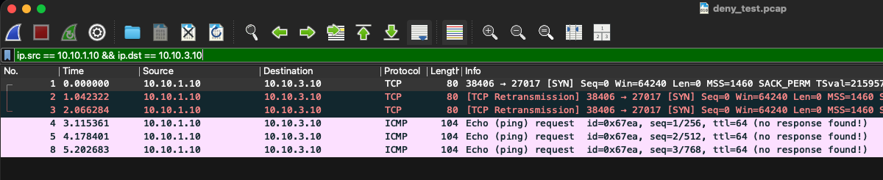
Figure A3. deny_test.pcap (November 10 set), filter meter → DB. The meter's SYNs to port 27017 (frames 1–3, retried at about 1 s and 2 s) and its echo requests (frames 4, 5, and 8) receive no reply. This capture is separate from the report-check denial in Section 4.2.
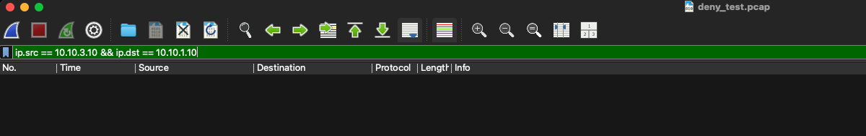
Figure A3 (continued). Reverse filter DB → meter on the same capture: 36 packets in the capture, 0 displayed. The DB never answered the meter. Two crops (filter bar and status bar) of the same window.
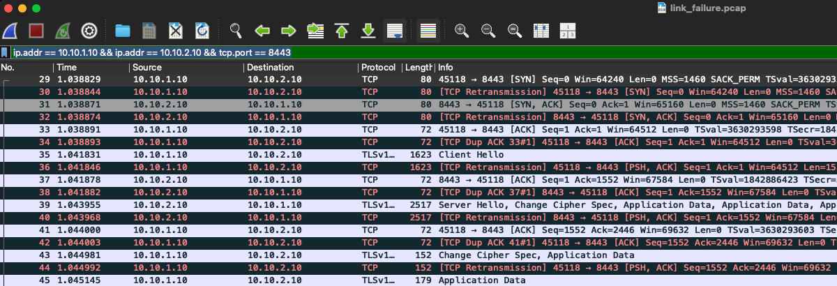
Figure A4. link_failure.pcap before the outage. Frames 29/31 establish TCP and frames 35/39 carry the Client Hello and Server Hello on the healthy path.
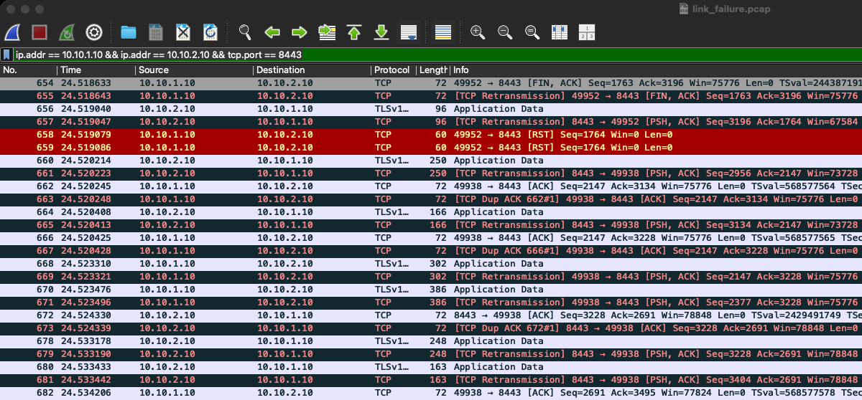
Figure A5. link_failure.pcap after restoration. Frames 660–680 show bidirectional encrypted traffic at 20:51:09.03–.04 UTC, matching the API log's GET /health 200 and POST 201 entries at .024–.040 (Table 8). Reset and close traffic from the interrupted connections appears alongside.

Appendix B November 10 performance chart
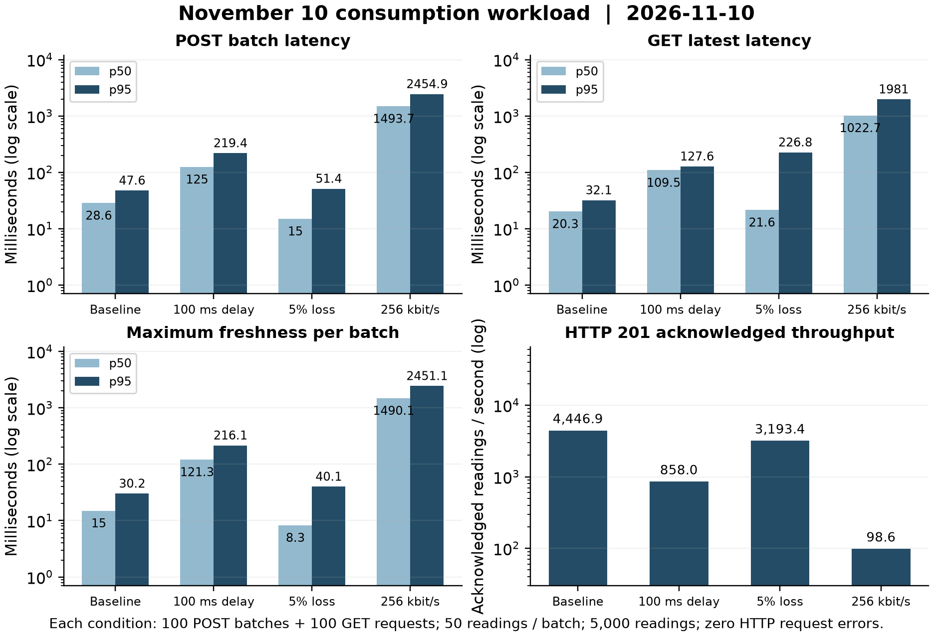
Figure B1. November 10 results for the same workload and metrics as Figure 6; the values are listed in Table 9.

Appendix C Evidence index
Table 11. Where to find the raw evidence for each claim. Paths are relative to the repository root; evidence/ means ops/results/evidence/.
Claim | Primary evidence files
Topology, routes, forwarding | docker-compose.yml; evidence/report_checks_20261113/interfaces_routes.txt, traceroute_20261113.txt; Figure 2
CRUD and error responses | evidence/report_checks_20261113/report_client.py, report_transaction.txt, report_demo_api.log
Generation readings | Listing 6, Table 6; evidence/generation_feature_20261112/
TLS | evidence/report_checks_20261113/verified_tls.txt; Figure 3; evidence/deploy_verify_20261112/03_cert_verification.log
ACL allow/deny | router/firewall.nft; report check: evidence/report_checks_20261113/firewall_before.txt, firewall_after.txt, database_denial.txt, report_demo.pcap; Figure 4; November 10: ops/captures/deny_test.pcap
Transaction correlation | evidence/report_checks_20261113/report_demo.pcap, report_demo_api.log, report_demo_decoded_mongodb.txt
Link-failure correlation | ops/captures/link_failure.pcap; evidence/link_failure_20261110/failure_link.txt, watch_failure_link.log, api_link_failure.log
Performance | ops/results/summary.csv, bench_*.csv, net_*.txt
Recovery | ops/results/evidence/recovery_20261112/ (logs, watch CSVs, manifest)
Deployment | ops/results/evidence/deploy_verify_20261112/ (00–06 logs, env_and_revision.txt)
Tested source identity | evidence/recovery_20261112/manifest.json; evidence/deploy_verify_20261112/env_and_revision.txt

