<https://morlina.cn:13333/doctors/find> GET UTF-8

批量参数添加

user_id=1621498552228US1116

Response Text

{"result":true,"retval":{"doctors":[{"doctor_id":"1621498552228US1116","name":"doctor1","doctor_profile":"null"}]},"info":"null"}

[https://morlina.cn:13333/messages/send POST UTF-8](https://morlina.cn:13333/messages/send%20POST%20UTF-8)

JOSN参数设置

{

"message_id":"123",

"sender_id":"1621264397923US8079",

"receiver_id":"1621498552228US1116",

"content":"hello",

"time":"2021-05-20 01:05:32",

"unread":true

}

Cookie设置

JSESSIONID=6608517966063B84FCEA353A2949BA11

Response Text

{

"result": true,

"retval": "",

"info": "null"

}

db result



[https://morlina.cn:13333/messages/delete POST UTF-8](https://morlina.cn:13333/messages/delete%20POST%20UTF-8)

JOSN参数设置

{

"messages": [

{

"message_id": "1621519624520ME9931",

"sender_id": "1621264397923US8079",

"receiver_id": "1621498552228US1116",

"content": "hello",

"time": "2021-05-20 01:05:32",

"unread": true

}

]

}

Cookie设置

JSESSIONID=9BFF000427D12F63D3234F15200EC084

Response Text

{

"result": true,

"retval": {

"messages": [

{

"message_id": "1621519624520ME9931",

"sender_id": "1621264397923US8079",

"receiver_id": "1621498552228US1116",

"content": "hello",

"time": "2021-05-20 01:05:32",

"unread": true

}

]

},

"info": "null"

}

db result

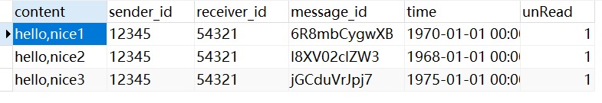

<https://morlina.cn:13333/messages/find>

批量参数添加

sender_id=12345&receiver_id=54321&timestart=1960-01-01%2000:00:00&timend=2001-01-01%2000:00:05

Cookie设置

JSESSIONID=6D031B72A08D8221E8F39387E9ADEE43

Reponse Text

{

"result": true,

"retval": {

"messages": [

{

"message_id": "6R8mbCygwXB",

"sender_id": "12345",

"receiver_id": "12345",

"content": "hello,nice1",

"time": "1970-01-0100:00:01.0",

"unread": false

},

{

"message_id": "I8XV02cIZW3",

"sender_id": "12345",

"receiver_id": "12345",

"content": "hello,nice2",

"time": "1968-01-0100:00:01.0",

"unread": false

},

{

"message_id": "jGCduVrJpj7",

"sender_id": "12345",

"receiver_id": "12345",

"content": "hello,nice3",

"time": "1975-01-0100:00:01.0",

"unread": false

}

]

},

"info": "null"

}

morlina.cn:13333/images/upload

json参数设置

{

"user_id":"1621436415203US3609",

"data":"iVBORw0KGgoAAAANSUhEUgA…"

}

Cookie设置

JSESSIONID=7706E890A53DDD972A11AB248DEF924F;

{

"result": true,

"retval": {

"result": {

"two_points": [

{

"x1": "-21.14",

"y1": "143.98",

"x2": "218.81",

"y2": "137.14"

},

……

],

"cobb_value": "1.5560"

},

"image_id": "1621587903776IM8353"

},

"info": "null"

}

db result

