# Model definition and implementation

The model that was implemented was a predator prey model between humans and mosquitos. Additionally the spread of malaria in a human population through mosquito bites was modelled.

For this model several assumptions were made. The first being that humans won’t be able to flee or move away from the mosquitos. As humans usually live in houses not suited for fleeing from or shutting out the plentyfull mosquito individuals. So only the moquitos will be able to move around in this model, while the humans will remain static. The mosquitos will wander around randomly along the map. Though moquitos would be able to find humans in the vicinity we assumed that the map would be big enough they would use those senses only when on the same location as the human to find its prey. Thus before then they will randomly walk around the map.To prevent our mosquitos randomly move out of the simulation, we have them bounce of the side instead of crossing it.

Additionally we assume that mosquitos only have a chance to bite humans that are in the same location as themselves. Not all bites would be succesfull and not every bite would transmit malaria [1]. Mosquitos only bite when hungry, so we also modelled a chance for mosquitos to become hungry after having eaten . So we implemented a chance of malaria transmission should a succesfull bite take place. As prevention measure that will be modelled, a insecticed net was chosen. This will make it more difficult for moquitos to reach the sleeping humans and bite them. It will be modelled by reducing the bitingsuccessrate to 20%[2].

Finally, A population is never constant. Individuals die and as disease transmission is simulated sick individuals have a bigger chance to pass. And ofcourse sick people have a chance to recover and become immune. Once immune the human won’t spread nor be affected by the disease. On top of that we assume that all the people only get bitten in their sleep. In reality ofcourse people still get bitten in the day if mosquitos are disturbed in their sleep for example. In this case the preventive measure of nets would not suffice.

**Pseudo-code of the model:**

for each step in time

1. move every mosquito random
2. if mosquito and human have the same location, and the mosquito is hungry, the mosquito has a chance of biteProb to bite the human.
   * For every bite ( if the malarianetsimulation is enabled, after the time set time the bite has a succesrate of 0.2, since 80% of the population is protected!)
     + When the Human is infected, the mosquito has a chance of mosquitoInfectionProb to get infected as well
     + When the mosquito is infected, the human has a chance of humanInfectionProb to get infected
     + The mosquito is not hungry anymore
3. Each mosquito has a chance of mosquitoHungryDieProb to die when hungry
4. Each mosquito has a chance of mosquitoHungryProb to get hungry
5. Every human
   * If a human is dead, respawn the human
   * has a chance of humanDieProb to die
   * If a human is infected
     + The human has a chance of humanCureProb to cure and thus become resistant
     + The human has a chance of humanSickDieProb to become dead

# Model Fitting

Our model was modelled after the data from the World Bank, which states that around 35% of the populace carries malaria[3]. With a population density of about 72 per square kilometer, that is the density we pick aswell[4]. We take 10 square kilometer to run our simulation and devide that in 2500 blocks where people can live and mosquitos can roam. That would leave the humans with 4m² as housing space, which fits a small room. To have a well fitted model, this is the expected state of the model.

For the fitting we used a variable amount of mosquitos, mainly because dicerning the mosquito density is tough so data is usually not present. But also as it is impossible to properly display a true mosquito density besides human population density in 4x4 grid squares. So the number of mosquitos will be a symbolic number that will mainly model the amount of interactions a human will have with mosquitos per chance. The death rate among mosquitos will them model the survivability of malaria in the mosquito population. As it won’t be passed onto new generations without humancarriers the disease would cease to be.

The parameters used are the following:

|  |  |
| --- | --- |
| **Initial parameters** | |
| Width | 50 |
| Height | 50 |
| nHuman | 720 |
| nMosquito | 925 |
| initMosquitoHungry | 0.5 |
| initHumanInfected | 0.35 |
| biteProb | 0.7 |

|  |  |
| --- | --- |
| **Human parameters** | |
| humanInfectionProb | 0.7 |
| humanCureProb | 0.002 |
| humanSickDieProb | 0.01 |
| humanDieProb | 0.005 |
| Human state | S (Susceptible), I (Infected), R (Resistant) or D (Dead) |

|  |  |
| --- | --- |
| **Mosquito parameters** | |
| mosquitoInfectionProb | 0.9 |
| mosquitoHungryProb | 0.1 |
| mosquitoHungryDieProb | 0.05 |

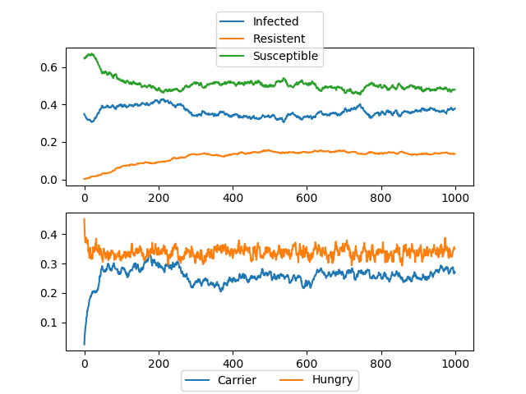  
Illustration 1: Stable population from Ivory Coast situation

# 

As can be seen from the images the situation always moves to an optimum which settles at about 35-40% infected humans. This is exactly the case for Ivory Coast in 2015, so the model fits reality.

# Experiments and analysis

Between 2010 and 2015, there was an 80% increase in the use of insecticide treated nets for all population risk of malaria in sub-Saharan Africa by 80%. To simulate the potential for such measures we implemented a function where the chance for succesful would reduce to 0.2 after its implementation. In the following plots you can see the results:

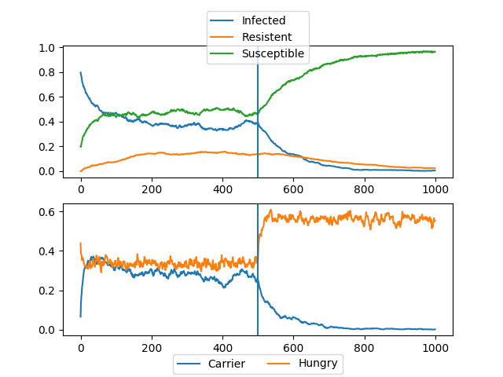  
Illustration 2: The vertical blue line indicating the introduction of the malaria prevention measure. It is shown that malaria is completely eradicated after reducing its interspecies spreading chance.

Similar results can be seen for preventive treatment and Early intervention.

For the interpretation of this result it is important that we assume that everyone in the human population has a net. The following plots show the results of when not everyone has nets:

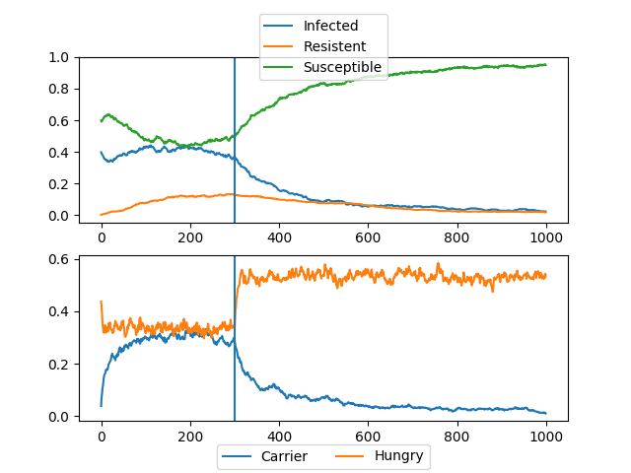  
Illustration 4: 90% of the people have nets.

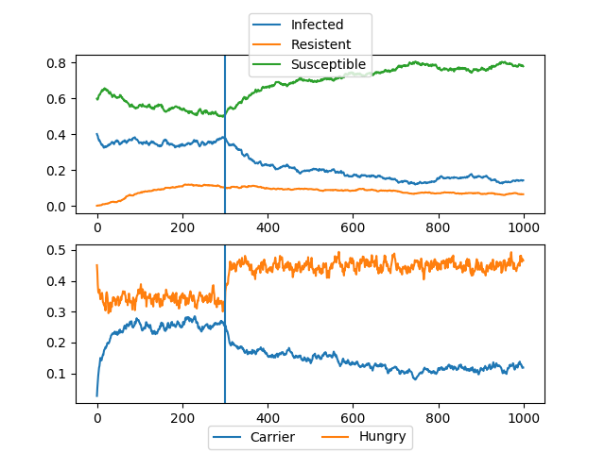  
Illustration 3: 60% of the people have nets

As can be seen from the figures malaria infections decrease but are not always completely reduced. To check for a turning point where the disease is erradicated we also implemented a function that removes the nets after a while. This was done to see if the malaria would return and thus has been erradicated or not.

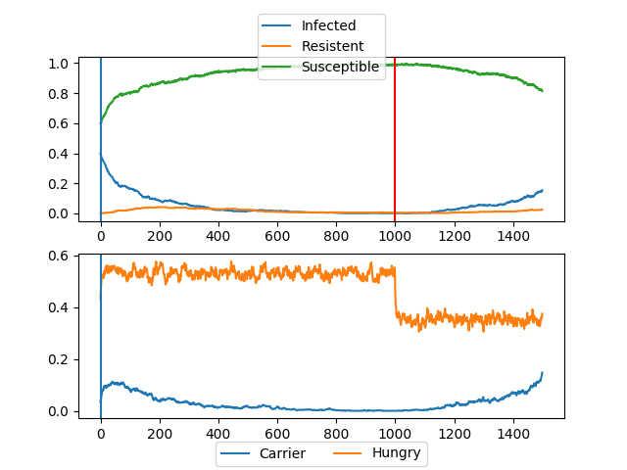  
Illustration 5: Removal of nets after stable new position with 90% of the people using them.

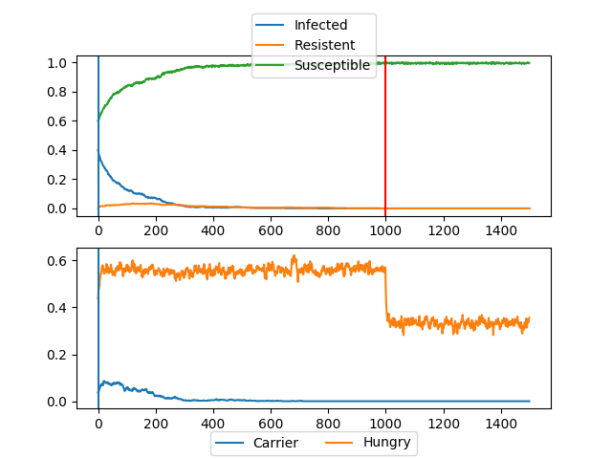  
Illustration 6: Removal after 95% of the people had nets. Disease is erradicated.

As can be seen, the disease would be erradicated in this model. After 95% of the people would use insecticide nets.

1. <https://www.imperial.ac.uk/news/176909/malaria-infection-depends-number-parasites-number/>
2. <http://www.who.int/features/factfiles/malaria/en/>
3. <https://data.worldbank.org/indicator/SH.MLR.INCD.P3?view=chart>
4. <http://worldpopulationreview.com/countries/ivory-coast-population/>