**Setting HC-05 for Uploading**

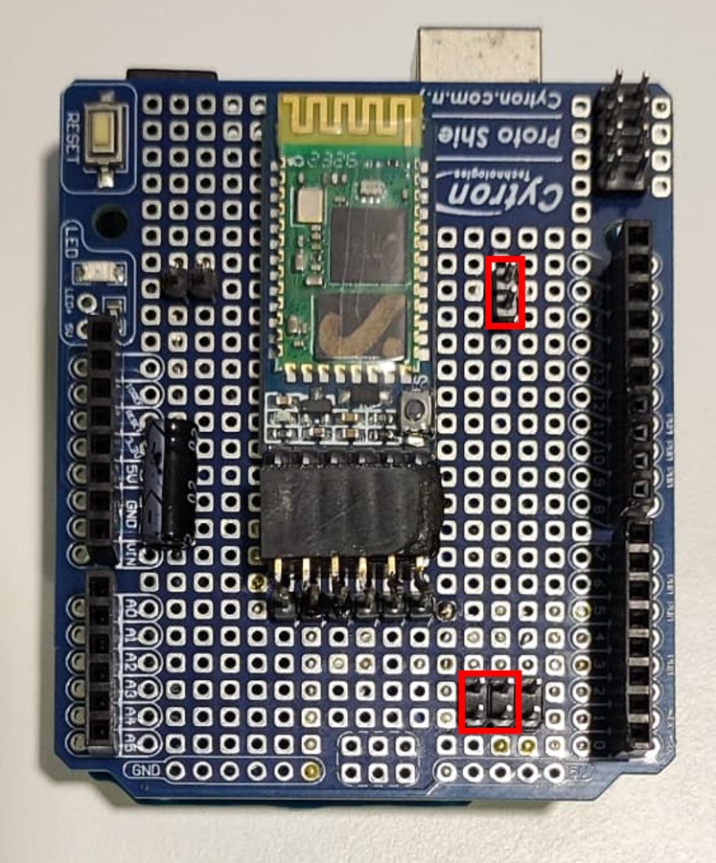

Place jumpers in the locations in Red

Upload the Arduino code via USB cable

Filename: “BTSetup”

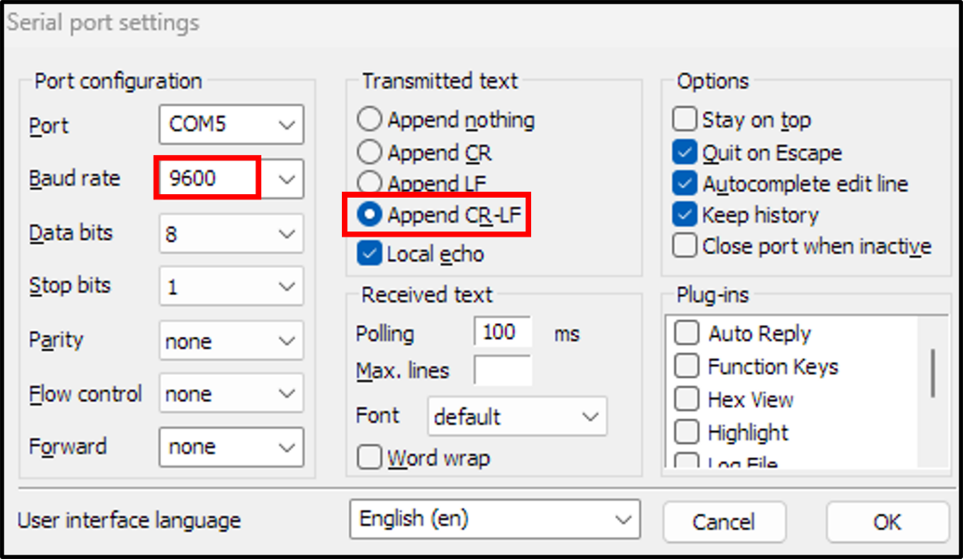

Port Setup for connection

The output should be as above,

Send **AT** to test connection, if **OK** send the command as shown in the serial Monitor.

If **Error** from **AT**, check jumper and restart.

**Uploading Mode**

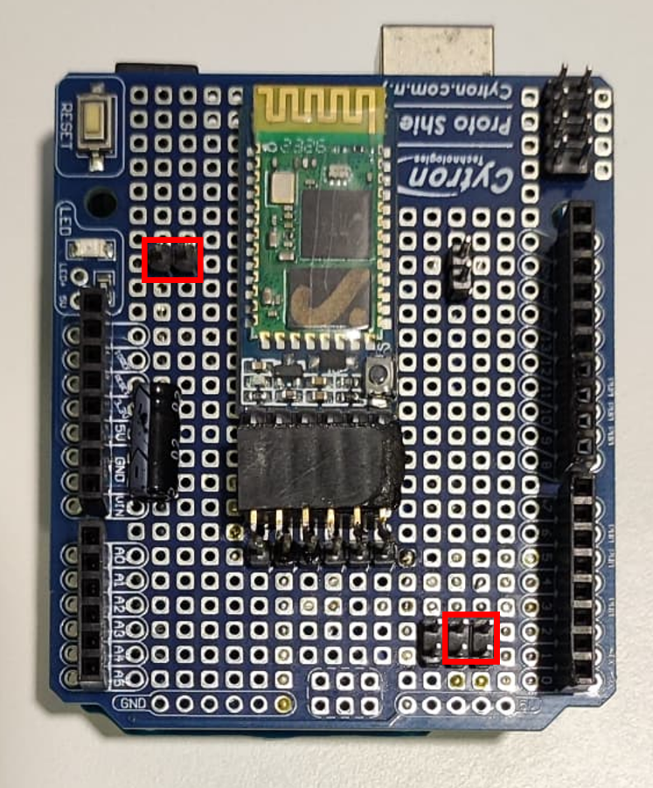

Place jumpers in the locations in Red

**To connect on Windows 11**

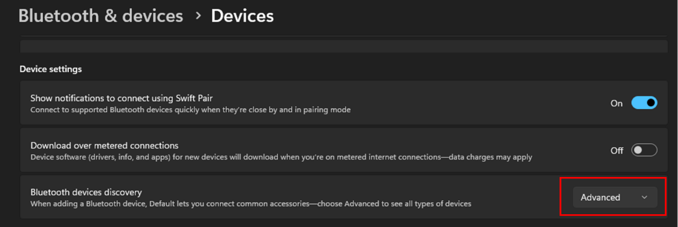

Must enable Advanced setting.

Connect to Bluetooth

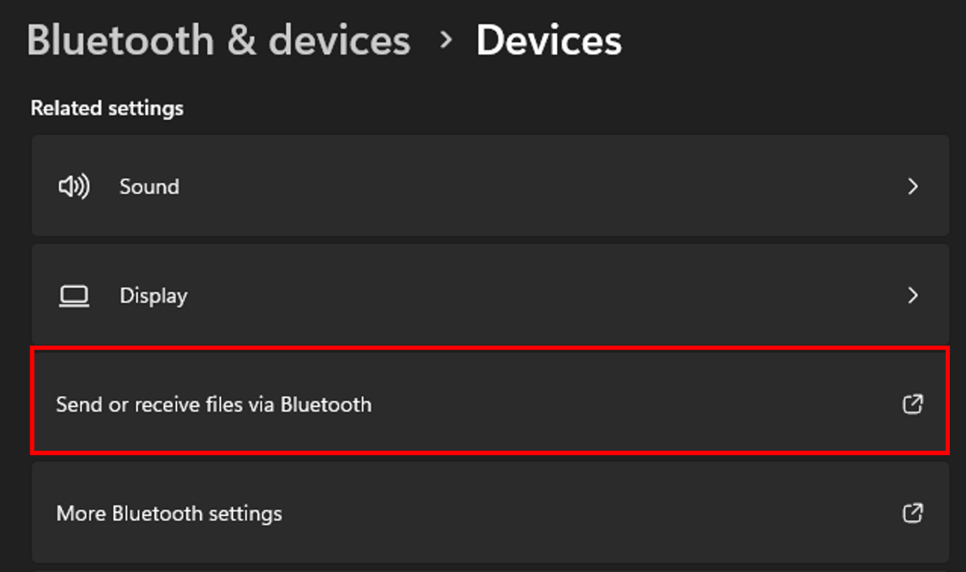

Open this to check the port.

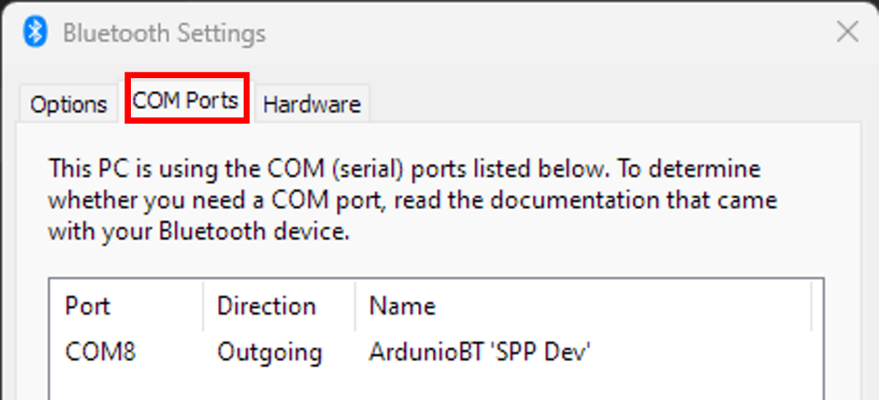

Find outgoing Port to Arduino

This is the port for the connection for uploading.