



Swinburne University of Technology

Faculty of Engineering, Computing and Science (Sarawak Campus)

Stemhat Documentation

Divyessh Sivakumar (101227402)

Date: 17/1/2025

**Table of Contents**

1. Raspberry Pi STEMHAT Extension Documentation 1

2. Introduction 1

3. Blocks Overview 1

3.1. Event Block 1

3.1.1. Button 1

3.2. Command Blocks 2

3.2.1. LED Control 2

3.2.2. Buzzer Control 2

3.2.3. Motor Control 3

3.2.4. Servo Control 4

3.2.5. OLED Display Control 4

3.3. Reporter Blocks 8

3.3.1. Button 8

3.3.2. Analog 8

3.3.3. AHT20 Sensor 9

3.3.4. Ultrasonic Sensor 9

# Raspberry Pi STEMHAT Extension Documentation

# Introduction

The Raspberry Pi STEMHAT extension adds hardware control and interaction capabilities to Scratch 3.0. It provides blocks to manage LEDs, buzzers, motors, servos, OLED displays, and sensors, enabling creative and functional projects.

# Blocks Overview

## Event Block

These blocks can trigger a script of blocks.

### Button

1. **When Button [BUTTON] is Pressed**

* + **Description:** Triggers an action when the specified button is pressed.
  + **Options:**
    - BUTTON:
      * **Items:** [Button 5', 'Button 6']
  + **Example:** Turn on an LED when button 5 is pressed.

## Command Blocks

These blocks perform actions such as controlling hardware or displaying data.

### LED Control

1. **Set LED [LED] to [COLOUR]**
   * **Description:** Sets the specified LED to a particular color.
   * **Options:**
     + LED:
       - **Items:** [Led 0', 'Led 1']
     + COLOUR: Select a color from the color picker.
   * **Example:** Set LED 0 to red.

### Buzzer Control

1. **Set Buzzer Frequency to [FREQ]**

* + **Description:** Sets the buzzer to produce a sound at the given frequency.
  + **Options:**
    - FREQ: Frequency in Hz (default: 50).
  + **Example:** Play a 50 Hz tone.

1. **Stop Buzzer**

* + **Description:** Turns off the buzzer.
  + **Example:** Stop the buzzer sound after playing a tone.

### Motor Control

1. **Set [MOTOR] to [POWER]%**

* + **Description:** Controls the power and direction of one or both motors.
  + **Options:**
    - MOTOR:
      * **Items:** [Left Motor', 'Right Motor', 'Both Motors']
    - POWER: Speed percentage (-100 to 100).
  + **Example:** Set the left motor to 50% power.

1. **Set Left Motor to [POWERM1]% and Right Motor to [POWERM2]%**

* + **Description:** Sets power levels individually for both motors.
  + **Options:**
    - POWERM1: Speed for the left motor (-100 to 100).
    - POWERM2: Speed for the right motor (-100 to 100).
  + **Example:** Set the left motor to 30% and the right motor to 60%.

1. **Stop [MOTOR]**

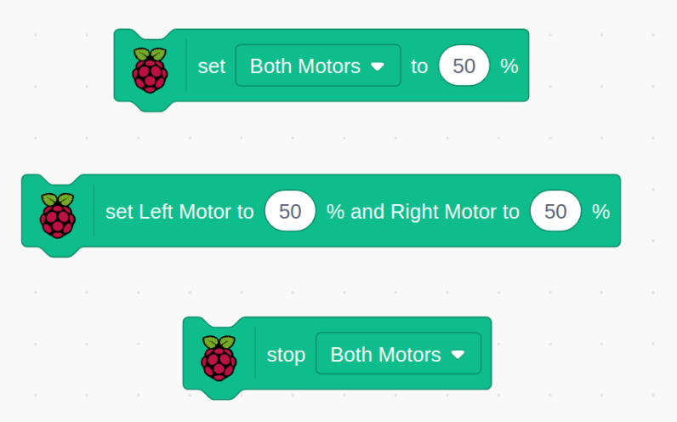

* + **Description:** Stops the specified motor(s).
  + **Options:**
    - MOTOR:
      * **Items:** ['Left Motor', 'Right Motor', 'Both Motors']
  + **Example:** Stop all motors when a button is pressed.

### Servo Control

1. **Set Servo [SERVO] Position to [DEGREE]°**
   * **Description:** Moves the specified servo to a specific angle.
   * **Options:**
     + SERVO:
       - **Items:** ['1', '2', '3', '4']
     + DEGREE: Angle in degrees (0–180).
   * **Example:** Set servo 1 to 90° for a neutral position.

### OLED Display Control

1. **Set OLED Text to [TEXT] at X[X1], Y[Y1] Size[SIZE] [WRAP]**
   * **Description:** Displays text on the OLED screen at the specified position.
   * **Options:**
     + SIZE:
       - **Items:** ['1', '2', '3', '4']
     + WRAP:
       - **Items:** ['Wrap', 'No Wrap']
   * **Example:** Display "Hello" at (0, 0) with wrapping enabled.
2. **Set OLED Pixel at X[X1], Y[Y1] to [STATE]**

* + **Description:** Turns a specific pixel ON or OFF.
  + **Options:**
    - STATE:
      * **Items:** ['ON', 'OFF']
  + **Example:** Turn on the pixel at (10, 10).

3. **Draw Line on OLED at X1[X1], Y1[Y1] to X2[X2], Y2[Y2]**

* **Description:** Draws a line between two points on the OLED display.
* **Options:**
  + X1, Y1: Starting point coordinates.
  + X2, Y2: Ending point coordinates.
* **Example:** Draw a diagonal line from (0, 0) to (10, 10).

4. **Draw Circle on OLED at Center X[X1], Y[Y1] with Radius [RADIUS] [SOLID]**

* **Description:** Draws a circle on the OLED screen.
* **Options:**
  + SOLID:
    - **Items:** ['Solid', 'Outline']
* **Example:** Draw a filled circle at (50, 50) with a radius of 20.

5. **Draw Rectangle on OLED at X1[X1], Y1[Y1] Height[HEIGHT] Width[WIDTH] [SOLID]**

* **Description:** Draws a rectangle on the OLED display.
* **Options:**
  + SOLID:
    - **Items:** ['Solid', 'Outline']
* **Example:** Draw a rectangle at (10, 10) with width 30 and height 20.

6. **Draw [SPRITE] on OLED at X[X], Y[Y] [SCALE]**

* **Description:** Displays a sprite on the OLED screen at the specified position.
* **Options:**
  + SCALE:
    - **Items:** ['Fit', 'Fill', 'No Scaling']
* **Example:** Display a sprite at (0, 0) scaled to fit the screen.

7. **Scroll OLED to [DIR] from Row [START] to Row [END]**

* **Description:** Scrolls the OLED display content in the specified direction.
* **Options:**
  + DIR:
    - **Items:** ['right', 'left']
  + START, END: Specify rows to scroll.
    - **Items:** ['1', '2', '3', '4', '5', '6', '7']
* **Example:** Scroll rows 1 to 3 to the right.

8. **Stop OLED Scroll**

* **Description:** Stops any active scrolling on the OLED display.
* **Example:** Stop a horizontal scroll in progress.

9. **Clear Specific Section in OLED X[X], Y[Y] Height[HEIGHT] Width[WIDTH]**

* **Description:** Clears a rectangular section of the OLED screen.
* **Options:**
  + HEIGHT, WIDTH: Dimensions of the section to clear.
* **Example:** Clear the section starting at (0, 0) with a width of 10 and a height of 10.

11. **Clear OLED**

* **Description:** Clears the entire OLED display.
* **Example:** Reset the display before showing new content.

## Reporter Blocks

These blocks return data for analysis.

### Button

1. **Get Button [BUTTON] State**

* + **Description:** Checks whether the specified button is pressed.
  + **Options:**
    - BUTTON:
      * **Items:** ['5', '6']
  + **Example:** Check if button 5 is pressed.

### Analog

1. **Get Analog [ANALOG]**

* + **Description:** Reads an analog value.
  + **Options:**
    - ANALOG:
      * **Items:** ['AN0', 'AN1', 'Light Sensor', 'Vin Voltage']
  + **Example:** Get the light sensor reading.

### AHT20 Sensor

1. **Get Temperature in Celsius**

* + **Description:** Returns the current temperature.
  + **Example:** Display the temperature on the OLED.

1. **Get Humidity in Percentage**

* + **Description:** Returns the current humidity level.
  + **Example:** Use humidity data to activate a fan.

### Ultrasonic Sensor

1. **Get Ultrasonic Sensor in cm**
   * **Description:** Measures the distance using an ultrasonic sensor.
   * **Example:** Trigger an alarm if an object is within 10 cm.