Tealium EPiServer Tag Management Plugin Specification

Version 1.0

Contents

1.0 Overview 3

1.1 Description 3

1.2 Compatibility 3

2.0 Installation 3

2.1 Package Contents 3

2.2 Installation Process 4

3.0 Configuration 4

3.1 Main Settings 4

3.2 Advanced Settings 5

3.3 Layout Injections 6

3.4 Utag Data Settings 6

3.4.1 Common Utag Data 6

3.4.2 Content Type Tags 7

3.4.3 Custom UDO and Computed Fields Mappings 8

# Overview

This document describes how to install, configure, customize and use the **Tealium Tag Management Plugin** for **EPiServer**.

## Description

The plugin represents an object-oriented framework that allows EPiServer developers to embed the **Tealium Tag Management** scripts into their solutions. The plugin is fully configurable and customizable.

## Compatibility

* EPiServer CMS 7 and higher
* .NET Framework 4.0, 4.5

# Installation

The **“Tealium.EPiServerTagManagement.nupkg”** NuGet package is a well-formed EPiServer plugin that can be installed on CMS sites with the Commerce module installed. If the Commerce module is not installed, the **“Tealium.EPiServerTagManagement.Commerce.nupkg”** NuGet package should be installed as well.

## Package Contents

The **“Tealium.EPiServerTagManagement.nupkg”** package installer adds the following files and items to the website:

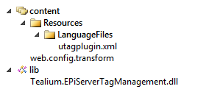

The **“Tealium.EPiServerTagManagement.Commerce.nupkg”** package installer adds one more library:



## Installation Process

The plugin can be installed from the EPiServer NuGet Feed (<http://nuget.episerver.com/>) by following the steps below:

> Install-Package Tealium.EPiServerTagManagement

> Install-Package Tealium.EPiServerTagManagement.Commerce

# Configuration

The plugin is available in the **“Tool Settings”** section in the **“Admin”** mode. Please see a screenshot below:

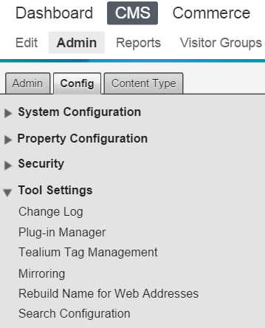

## Main Settings

The main settings can be changed on the **“Tool Settings -> Tealium Tag Management -> Main Settings”** screen. Please see a screenshot below:

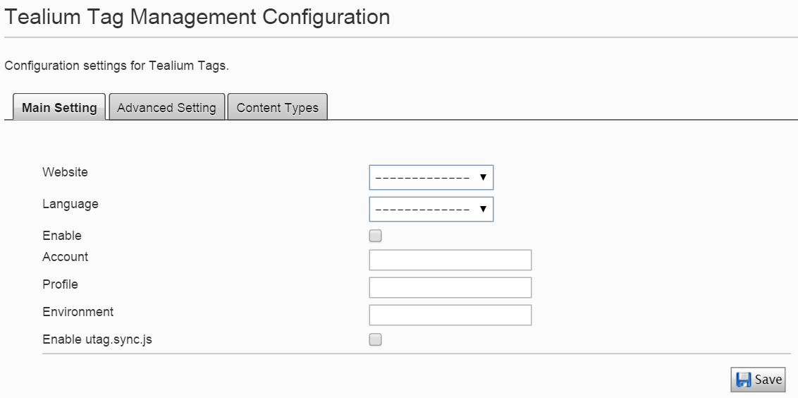

The following settings can be configured:

* **Website:** a list of available websites in the current instance of EPiServer (settings for each website can be configured separately)
* **Language:** a list of available languages in the current instance of EPiServer (settings for each language of a particular website can be configured separately)
* **Enable:** enables or disables the plugin on the whole website
* **Account:** your **“Tealium Account ID”** for connecting with Tealium
* **Profile:** your **“Tealium Profile ID”** for connecting with Tealium
* **Environment:** your **“Tealium Environment ID”** for connecting with Tealium
* **Enable utag.sync.js:** enables or disables the **“utag.sync.js”** script

Please save your changes after you enter all settings.

## Advanced Settings

The advanced settings can be changed on the **“Tool Settings -> Tealium Tag Management -> Advanced Settings”** screen. Please see a screenshot below:

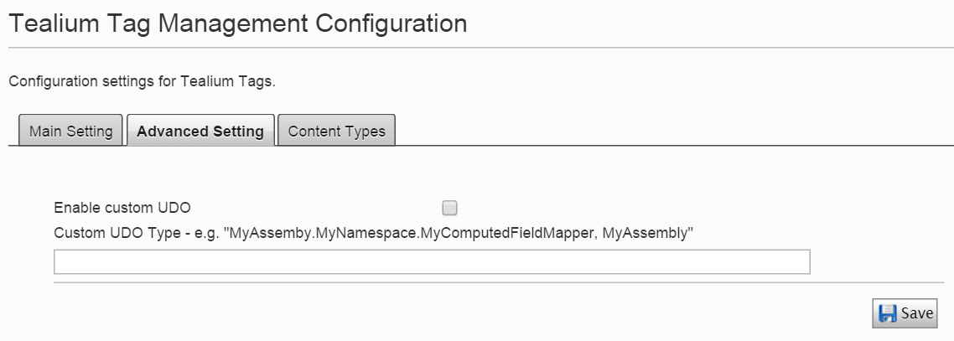

The following settings can be configured:

* **Enable Custom UDO:** enables or disables extending the UDO variable (utag_data) with additional name / value pairs without doing any modifications to the plugin library code
* **Custom UDO Type:** a qualified .NET assembly / type name of a custom computed fields mapping implementation

Please save your changes after you enter all settings.

Please see the “Custom UDO and Computed Fields Mappings” section for more information about dealing with Custom UDO properties.

## Layout Injections

In order to include Tealium scripts and the **“utag_data”** variable into your website pages, please add the following code to your layout files:

* @TealiumScripts.Head(Model.CurrentPage)

This piece of code should be included in the **“head”** section.

* @TealiumScripts.Body(Model.CurrentPage)

This piece of code should be included in the **“body”** section.

Note: **“Model.CurrentPage”** is your **“IContent”** item.

Please see an example below:

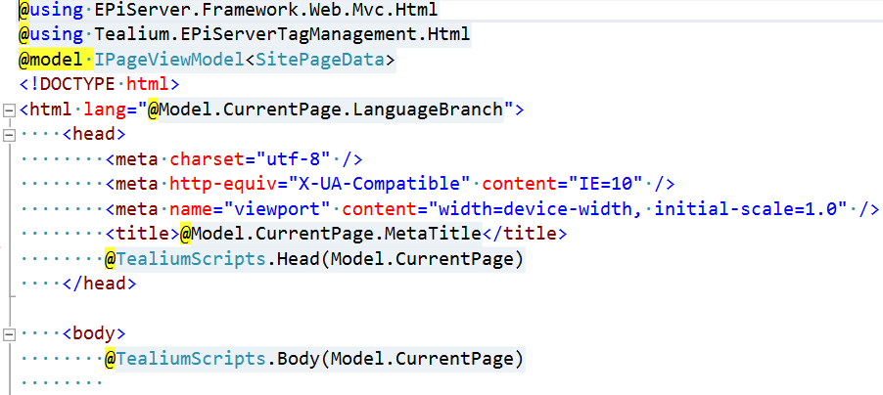

## Utag Data Settings

### Common Utag Data

In order to configure parameters that should be rendered on all website pages, please open **“Tool Settings -> Tealium Tag Management -> Main Settings”**. Please see a screenshot below:

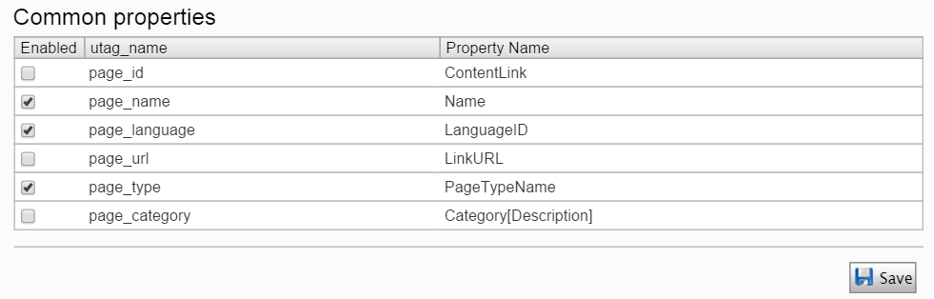

Please check all necessary check boxes and save your changes.

The final JS code might look like:

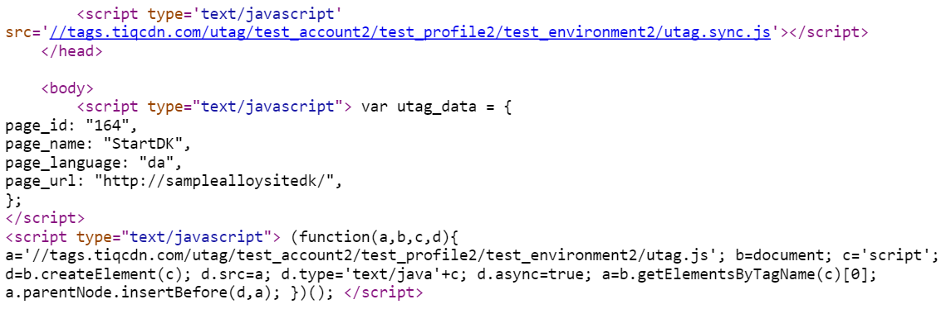

The **“Custom Tags”** section allows you configuring custom name / value pairs that should be added to the **“utag_data”** variable on all website pages. Please see an example below:

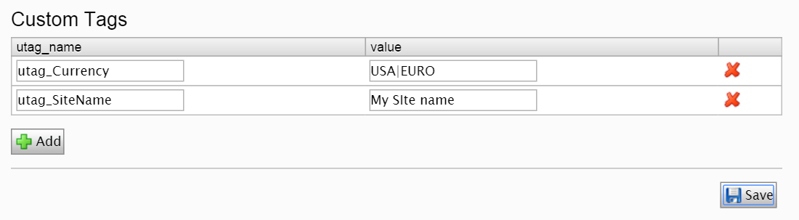

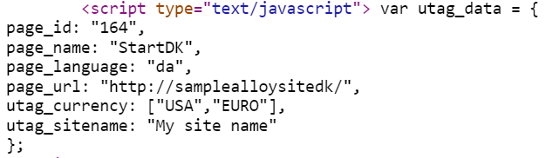

Note: In order to enter multiple values for a custom property, please separate those values with “|”; in this case, it will be rendered as a JS array.

Please save your changes after you finish configuring custom properties.

### Content Type Tags

The plugin allows configuring custom properties separately per each EPiServer page type or commerce meta class. The **“Page Type”** drop-down box on the “**Tool Settings -> Tealium Tag Management -> Content Types**” screen contains a list of available content types in the system (including the commerce ones). Please see a screenshot below:

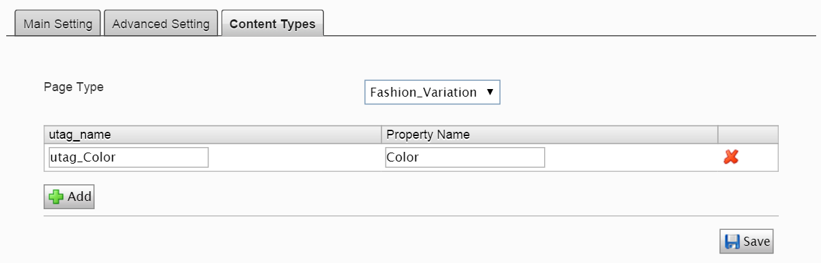

Note: In order to render a value of a particular property of a page type object, please use the following simple syntax: **“Object[Property]”**. For example, **“Category[Name]”**.

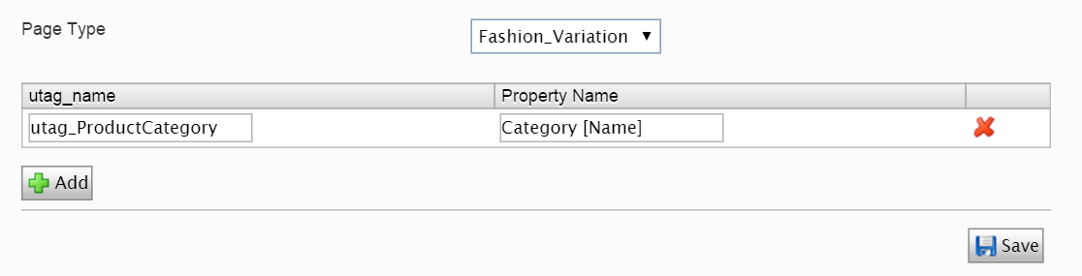

Please save your changes once you are done with configuring properties for a specific page type.

### Custom UDO and Computed Fields Mappings

The plugin allows EPiServer developers to implement a custom property mapping to render any kind of properties on a specific page or on all website pages.

First, you need to implement the **“IComputedFieldMappings”** interface, which is declared as follows:

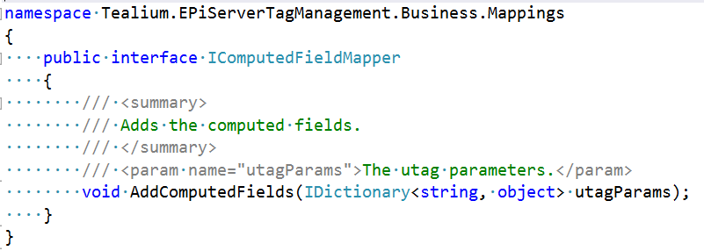

Please see below an example of how to render a search term on all website pages:

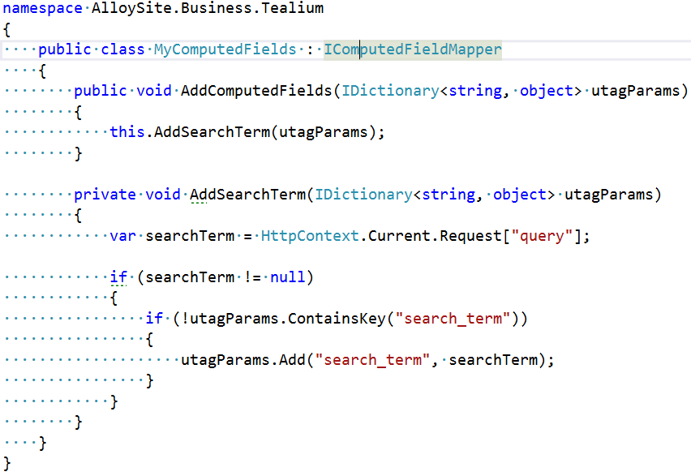

Second, you need to go to **“Tool Settings -> Tealium Tag Management -> Advanced Settings”**, check the **“Enable Custom UDO”** check box and specify a qualified type name of your custom fields mapping implementation. Please see a screenshot below:

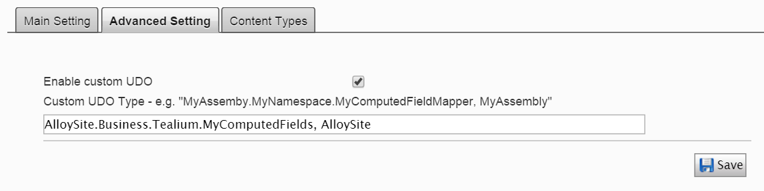

The result JS code might look like (if a query string parameter is **“?query=test”**):

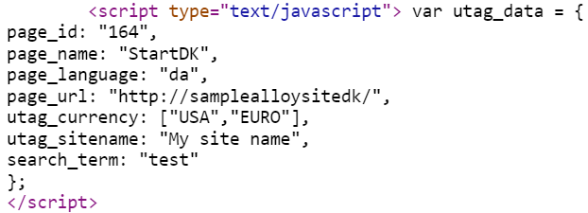

The plugin uses the following order while resolving values of each parameters to be rendered:

1. Common Parameters.
2. Custom Parameters.
3. Page Type Parameters.
4. Computed Fields.

Note: Custom Parameters override Common Parameters (if any conflicts), Page Type Parameters override Custom and Common Parameters, Computed Fields override all other parameters in case of any conflict.

For example, if you would like to override the **“page_type”** common parameter with a custom value for all instances of the **“Commerce Node”** page type, you might need to:

1. Create a new property (for example, **“PageTypeStaticValue”**):

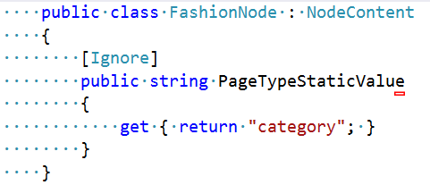

1. Configure a proper name / value property on the “**Tool Settings -> Tealium Tag Management -> Content Types**” screen.

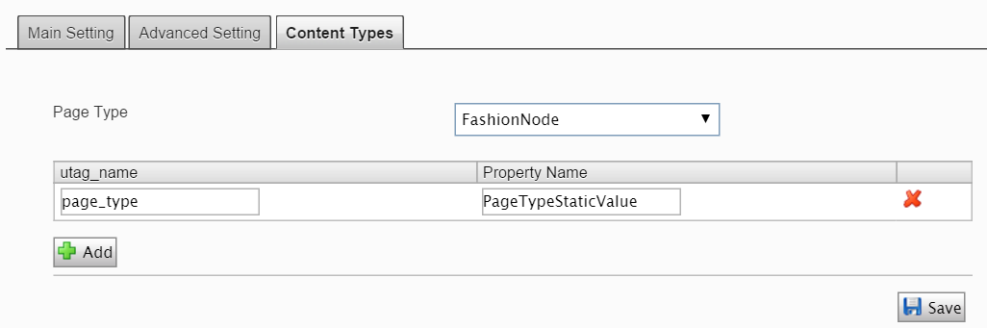

1. That’s it. The result JS code might look like:

