Tealium, inc.

Tealium Tag Management Magento Extension Specification

Prepared by: Chris Anderberg, Software Engineer, Integrations

June 9, 2016

Table of Contents

Overview 3

Purpose 3

Requirements 3

Solution Impact 3

Architecture 3

Sequence Diagram 4

Customization 4

Magento Events 5

Files 5

# Overview

## Purpose

The Tealium Tag Management Extension for Magento eases the integration of Tealium’s TiQ enterprise tag management system into an ecommerce site running Magento. It includes:

* Inclusion of the universal code snippet for loading Tealium logic and TiQ profile information on every page.
* Creation of a UDO on every page according to page type
* An ability to customize the UDO according to specific needs

## Requirements

The following are necessary to implement the Tealium Tag Management Extension

* A working Magento 1.x installation
* A TiQ profile
* Developer resources to implement customizations

## Solution Impact

Because the extension only adds code to the page to support tagging requirements, and does nothing to change the user experience or display any new content, the system as a whole is not widely unaffected. No new models are loaded, and the database remains unchanged.

The real change is in the layouts. Because the UDO and universal code snippet must be placed on each page to be tagged using TiQ, it is necessary to include the relevant blocks in the layout and define phtml files for each page type. These phtml files are what will access the models and define the UDO on each page.

# Architecture

There are two times throughout the process of responding to a request where the Tealium Tag Management extension runs and can modify the response. The first is in the process of compiling layouts and rendering HTML to the page. The Tealium Tag Management extension includes blocks for various page types to include the correct default UDO on the page, which in turn get rendered using the phtml files. Secondly on the “controller\_front\_response\_before” event by the front controller, an observer defined by the Tealium Tag Management module will check the query parameters of the request for a “tealium\_api=true”, which if exists, and if the feature is enabled in the configuration through the admin panel, will remove all html and only respond with the UDO. You’d never want to actually serve this to a customer; however for the purposes of debugging it’s very useful. With that said, it’s best to only enable this feature on development servers and leave it disabled on production servers.

## Sequence Diagram

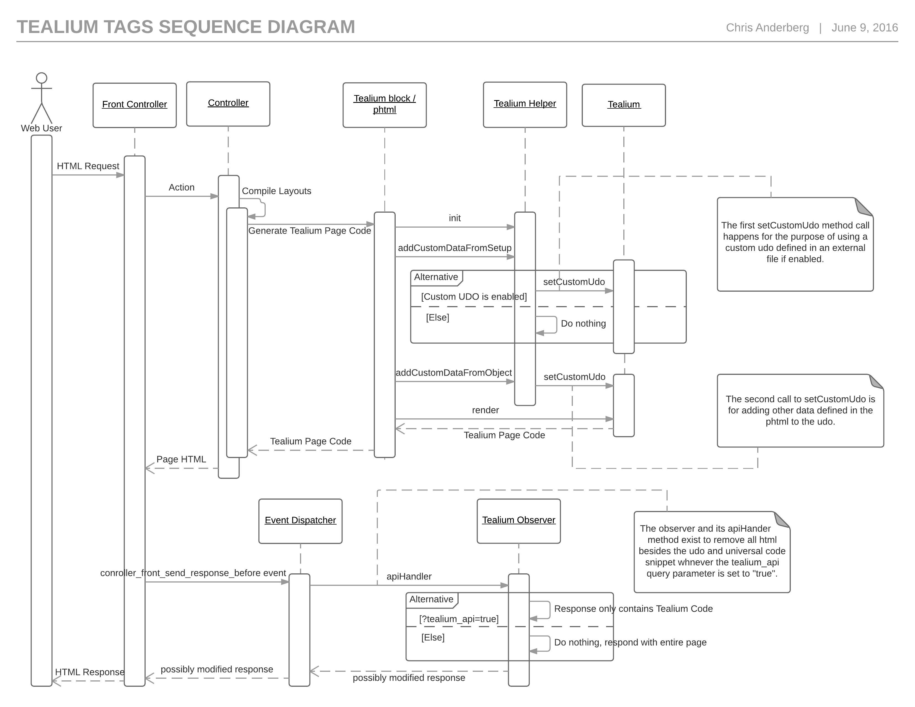

1. Sequence diagram of the Tealium Tag Management extension for Magento 1.x.

## Customization

If the goal is to create a differently formatted UDO for a new page type all together, it is important to make the respective changes to the layout to include the block that renders the UDO where needed, and to define a phtml file that renders the UDO.

In most cases however it will only be desirable to customize the existing UDO. In this scenario, a separate file is used to extend the default UDO for the specified page types. In the extension configuration through the admin panel, the file path of this php file containing the customizations to the default UDO is defined. It works by defining an associative array where the keys are the page types, and the values are functions that return an array of variables to be customized (also an associative array). The default UDO is not replaced by this custom UDO, but rather the variables defined in the custom UDO will extend or override the default ones. An example of such a customization file is included with the extension, and is named “TealiumCustomData.php”.

# Magento Events

Besides the layouts that will render on every page request to include Tealiums universal code snippet and a UDO on each page, as described in the “Architecture” section, there is an observer that listens to the “controller\_response\_listen\_before” event to handle cases where the “tealium\_api=true” query parameter exists as a development feature.

# Files

The Tealium Tag Management extension does not overwrite any core Magento files. Most of the logic exists in phtml files, a helper (“Data.php”), the Tealium class (“Tealium.php”), an observer (“Observer.php”), and if used the php file defining the customizations to the UDO.

|  |
| --- |
| Tealium_logo_2014.jpg  US Headquarters 11095 Torreyana Road Suite 200 San Diego, CA 92121 (858) 779-1344 [tealium.com](http://www.tealium.com) |
| Tealium has offices worldwide. Phone numbers and addresses are listed on the Tealium website at [tealium.com/contact](http://www.tealium.com/contact).  © 2016 Tealium, Inc. This is a placeholder for the copyright paragraph. Customized copyright content will be provided with editorial review. [Part number] |