Sravani Jagarlamudi

Progress Update Table for Case UML

|  |  |
| --- | --- |
| Date | Progress Description |
| 05-01-23 | All the blocks were updated and merged successfully and the final use case uml diagram is complete |
| 04-24-23 | Removed the unnecessary blocks and trying to merge all the blocks to create a final diagram |
| 04-17-23 | Modified the level difficulty for Practice Screen and updated the ads block to display some ads |
| 04-10-23 | Removed the App store block since we are not suggesting other apps |
| 04-03-23 | Updated the App store block by removing the block – Our Story, since we are not going to display similar apps |
| 03-20-23 | Removed some unnecessary blocks that are not being implemented from the diagram |
| 03-13-23 | Updated the Solve Block for all different kinds of operations – puzzle, fun and quiz |
| 03-06-23 | Updated the Settings block with the following.  YouTube, More apps, Basic Settings, and Worksheets |
| 02-27-23 | Updated the Select level for the Addition practice block.  Easy, medium, and hard |
| 02-20-23 | Updated two more operations and app store block.  Fun and practice |
| 02-13-23 | Updated the basic operations and a quit block.  Quiz and puzzle |
| 02-06-23 | Understood the functionality of original app game and created the basic blocks containing the user |

Uml diagram using tool – LUCID CHART 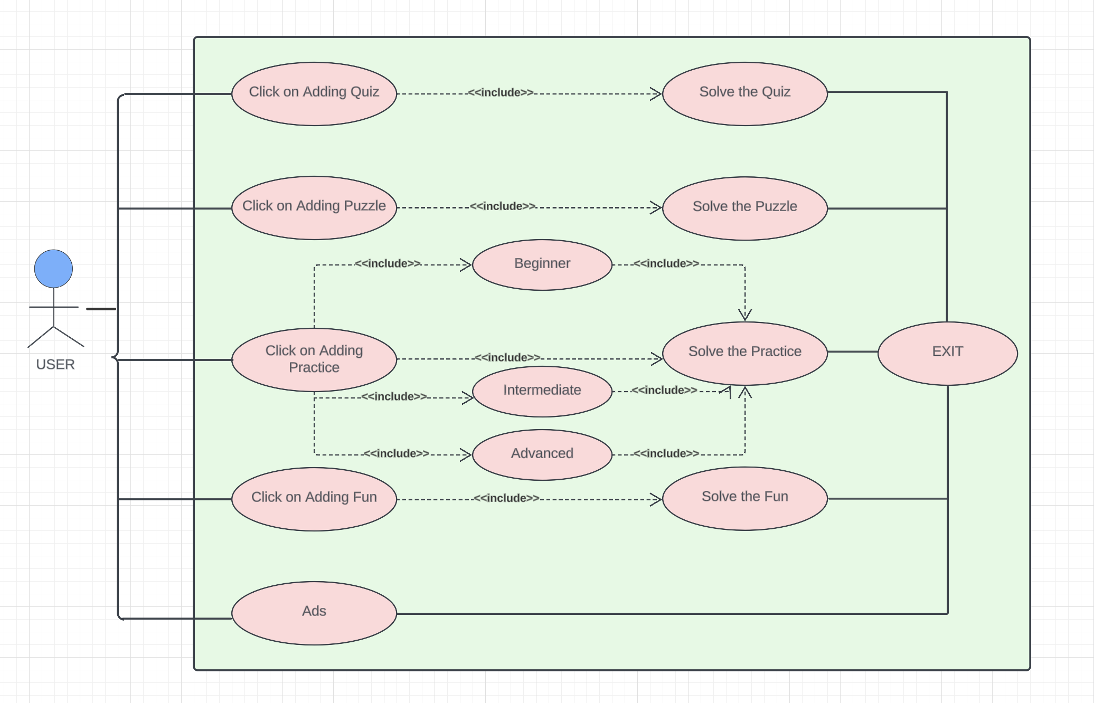

<<Include>>

<<Include>>

<<Include>> <<Include>>

USER

<<Include>>

<<Include>>

<<Include>>

<<Include>> <<Include>>

<<Include>>

Implementation of Addition practice screen

USER

Implementation of Addition Quiz Screen

USER

Implementation of Addition Fun screen

USER

Implementation of Addition Puzzle Screen

USER