Software Requirements Specification (SRS) - Bank Management System

Project: Bank Management System (Team 11)
Version: 1.0
Authors: PES1UG24CS703, PES1UG24CS707, PES1UG24CS711
Date: 28-09-2026
Status: Submitted for review (Mini-Project Deliverable Part-1)

Revision history
Version | Date | Author | Change summary | Approval
1.0 | 28-09-2026 | Team 11 (PES1UG24CS703/707/711) | First complete SRS (FRs, NFRs, security, diagrams, RTM)

Approvals
Role | Name | Signature / Email | Date
Course Coordinator

Table of Contents
1. Introduction
2. Overall description
3. External interfaces
4. System features (detailed)
5. Non-functional requirements (detailed)
6. Quality attributes & Acceptance tests
7. UML Use-Case Diagram
8. Requirements Traceability Matrix (RTM)

1. Introduction

1.1 Purpose
This document is the Software Requirements Specification (SRS) for the Bank Management System, a console application written in C/C++ by Team 11. It states the functional requirements (FRs), the non-functional requirements (NFRs), the external interfaces, the security objectives and security requirements, the acceptance criteria and the test cases that verify each requirement. Requirements are written in the IEEE style: every requirement is clear, unambiguous, concise, measurable and testable, and each one has an ID, a type, a priority, an acceptance criterion and a reference test case. The document is written for our team, our course instructor and the person who will test the program.

1.2 Scope
The system keeps bank account records in plain text files on one machine and lets a customer do the daily banking operations. In scope for version 1.0:
- Open a new bank account with a name, an opening balance and a 4-digit PIN
- Log in and log out with the account number and the PIN
- Deposit money into the logged-in account
- Withdraw money with a balance check and a minimum balance of Rs. 500
- Balance inquiry for the logged-in account
- Mini statement (last 10 transactions) and a statement between two dates
- Change the PIN of the account
- Admin functions: list all accounts and the total money, unlock a locked account, close a zero-balance account
- Maintenance: automatic backup of the data files and a data integrity check on start-up
Out of scope for version 1.0:
- Real money: only dummy accounts and dummy amounts are used
- Funds transfer between accounts, interest, loans, fixed deposits, cheques
- ATM card, UPI, net banking, mobile app or any online payment
- A graphical interface (the user interface is a text menu only)
- A database server (data is kept in plain files) and any network function

1.3 Audience
The development team (PES1UG24CS703, PES1UG24CS707, PES1UG24CS711), the course instructor and assessment evaluators, the students who will write the test plan and the design specification from this document, and any maintenance engineer who will change the program later. A reader is expected to know basic C/C++ and the banking terms defined in 1.4; no knowledge of the program internals is assumed.

1.4 Definitions and acronyms
- SRS: Software Requirements Specification (this document)
- FR: Functional requirement, written as BMS-F-### (a function the system does)
- NFR: Non-functional requirement, written as BMS-NF-### (a quality of the system)
- SR: Security requirement, written as PRJ-SR-###
- AC: Acceptance criterion, written as AC-BMS-F-### or AC-BMS-NF-###
- TC: Test case, written as TC-<group>-## (for example TC-Auth-01)
- RTM: Requirements Traceability Matrix (section 8)
- PIN: Personal Identification Number, a secret 4-digit number used to log in
- Account number: unique number given to an account at creation (starts at 1001)
- Balance: money in the account, stored as a whole number of paise
- Minimum balance: Rs. 500, which must remain in the account after a withdrawal
- Mini statement: the last 10 transactions of one account
- Admin: bank staff user with a separate admin password
- Data files: accounts.txt and transactions.txt in the data/ folder
- CLI / console: the text menu of the program in the terminal
1.5 References
- [1] IEEE Std 830-1998, IEEE Recommended Practice for Software Requirements Specifications (structure and style of this document)
- [2] Team_Info.md, Team 11, Bank Management System, stack C/C++ (SRNs PES1UG24CS703, PES1UG24CS707, PES1UG24CS711)
- [3] SE Mini-Project Deliverables Part-1, Software Engineering course, Semester 5 (ETA 28-09-2026)
- [4] Course notes on requirements engineering, use cases and quality attributes
1.6 Requirement conventions
- The word shall means the requirement is compulsory; may means it is optional.
- Every requirement has one unique ID and one row in the tables of sections 4, 5 and 5.1.2, and one row in the RTM of section 8.
- Every requirement is measurable: each row carries an acceptance criterion with a pass condition and a test case reference.
- Priority is High, Medium or Low. High = must be finished for version 1.0; Medium = needed but after the High items; Low = useful extra if time allows.
- Requirement counts in this document: 24 functional, 11 non-functional, 4 security objectives and 7 security requirements.

2. Overall description

2.1 Product perspective
The Bank Management System is a self-contained, single-machine console program. It is not connected to any other software and it does not use the network. One user works with the program at a time. All data is kept in two plain text files in the data/ folder next to the program: accounts.txt (one line per account) and transactions.txt (one line per deposit or withdrawal). We chose files instead of a database because the project is small, the college machines have compilers but no database server, and file handling in C/C++ is already known to the team. Money is stored as a whole number of paise in a long, so no rounding error is possible. The program is built from four modules: menu/user interface, accounts, transactions and file storage.

2.2 Major product functions (detailed)
- Create a new account with a name, an opening balance and a 4-digit PIN
- Authenticate the customer with the account number and the PIN
- Deposit money and record the deposit in the transaction log
- Withdraw money with a balance check, a minimum balance rule and a daily limit
- Balance inquiry for the logged-in account
- Mini statement (last 10 transactions) and a statement between two dates
- Change the PIN after verifying the old PIN
- Lock the account after three failed PIN attempts
- Admin login with an admin password
- Admin: list all accounts and the total money in the bank
- Admin: unlock a locked account
- Admin: close an account whose balance is exactly zero
- Maintenance: backup of the data files on start-up
- Maintenance: data integrity check with a warning for every damaged record
- Logout: end the customer session and return to the main menu

2.3 User roles and characteristics (expanded)
- Customer: a bank customer, not a programmer. Knows the account number and the PIN. Expects a short numbered menu, plain words, quick deposit/withdrawal and no data loss. Training needed: none, only reading the menu on the screen.
- Bank Admin: bank staff who knows the bank rules and has the admin password. Lists accounts, checks the total money in the bank, unlocks a locked account and closes a zero-balance account. Training needed: the bank rules only.
- Tester / Developer: the project team. Needs a clear error message for every wrong input and readable data files to check bugs. Runs the test cases of the test plan and fills the status column of the RTM.
- System (automatic, on start-up): not a human user. Creates the timestamped backup of the data files and runs the data integrity check before the menu is shown.
2.4 Operating environment
Operating system: Linux or macOS (any recent version). Compiler: gcc/g++ version 9 or newer, or clang. Build tool: make with a simple Makefile. Terminal: any standard terminal, no graphical display is needed. Hardware: any machine with at least 2 GB RAM and 10 MB free disk space. No network connection is required or used. One user and one copy of the program work on the data folder at a time.

2.5 Constraints
- Language: C/C++ with the standard library only; no external library, so the project builds on the college machine with one make command.
- Data storage: plain text files in the data/ folder, pipe-separated fields, one record per line; no database server is available.
- Money is stored as a whole number of paise in a long, never as a float, so no rounding error can change an amount.
- Secrets: the PIN and the admin password are stored only as hashes.
- Concurrency: the program is single-user and single-process; two copies must not open the same data folder at the same time.
- Offline: the program must work with no network connection.
- Build quality: the code must compile with -Wall -Wextra without warnings.
2.6 Assumptions and dependencies
- The user can read the screen and type on a keyboard.
- The data folder is not deleted or edited by hand while the program is closed.
- The machine has enough free disk space for the data files and their backups.
- Only the C/C++ standard library is available (no third-party library).
- One machine and one user; there is no network and no second machine.
- A calendar day is used as the period for the daily withdrawal limit.

3. External interface requirements

3.1 User interfaces
The user interface is a numbered text menu in the terminal. Each screen shows at most 7 choices, so it fits on one screen, and the active account number and name are shown on every customer screen. Money is always printed with two decimal places and the word Rs. Every input is validated: if the user types letters where a number is expected, the program prints "Please enter a number" and shows the menu again instead of crashing.
Main menu:
===== BANK MANAGEMENT SYSTEM (Team 11) =====
1. Create account
2. Customer login
3. Admin login
0. Exit
Enter your choice:
Customer menu after login:
===== CUSTOMER MENU - A/C 1003 - Ravi Kumar =====
1. Deposit
2. Withdraw
3. Balance inquiry
4. Mini statement
5. Statement between two dates
6. Change PIN
0. Logout
Enter your choice:
Admin menu after the admin password:
1. List all accounts and total money
2. Unlock a locked account
3. Close a zero-balance account
0. Back to main menu

3.2 Hardware interfaces
- Keyboard: all input (menu choice, amounts, account number, PIN)
- Screen / terminal: all output (menus, balances, statements, warnings)
- Local disk: the data/ folder with accounts.txt, transactions.txt and the backup folder data/backup/
No card reader, no cash dispenser, no printer, no biometric device and no network device is used, because version 1.0 is a simulation of the banking operations.
3.3 Software interfaces
- Operating system file system: standard C/C++ file functions (fopen, fgets, fprintf, fclose, rename, remove) to read and write accounts.txt, transactions.txt and the backup copies. Changes to an account are written to accounts.tmp and then renamed, so a crash cannot leave a half-written file.
- C/C++ standard library: stdio.h, stdlib.h, string.h, time.h and the C++ equivalents for input, parsing, memory, dates and sorting.
- Build toolchain: g++/gcc and make; the build command is a single make.
- No database, no network API, no external service and no configuration file other than the hashed admin password constant in the source code.

3.4 Communications
There are no communication interfaces in version 1.0. The program does not use the network, so there is no protocol, no port, no TLS and no remote service. All data stays on the same machine, which also removes the network as an attack path. If a network feature is added later, it must come with its own security requirements (transport encryption, authentication and audit logging).

<< Make sure overall there are at least 15 FRs for overall project, 5 NFRs, 2 security objectives and 5 Security requirements>>

4. System features (detailed)
Each requirement below includes a type, a priority, a source, acceptance criteria and a reference test case. Functional requirement IDs follow BMS-F-### and are grouped by feature. Every requirement is a shall statement and is measurable. Priority: High = required for version 1.0, Medium = required after the High items, Low = optional if time allows.

4.1 Authentication
Description: Authenticate the customer with the account number and a 4-digit PIN before any account operation, lock the account after three consecutive failed attempts, let the customer change the PIN, and end the session on logout. The PIN is never stored or displayed in plain text. Requirements: BMS-F-001 to BMS-F-005.
Req ID | Requirement | Type | Priority | Source/Stakeholder | Acceptance criteria / Test case ref | Comments / Dependencies
BMS-F-001 | The system shall authenticate the customer with the account number and the PIN before any account operation, and shall not allow any account function without a successful login. | Functional | High | Customer / Security | AC-BMS-F-001: the correct account number and PIN open the customer menu; a wrong PIN does not open it. Test: TC-Auth-01 | Reads accounts.txt; compares the PIN hash
BMS-F-002 | The system shall lock the account after 3 consecutive failed PIN attempts and shall refuse further logins until the admin unlocks the account. | Functional | High | Security | AC-BMS-F-002: after the 3rd wrong PIN the status becomes LOCKED, the next login is refused with a message. Test: TC-Auth-02 | bad_tries counter in the account record
BMS-F-003 | The system shall store the PIN only as a hash and shall never write the plain PIN to any file or the screen. | Functional | High | Security | AC-BMS-F-003: searching accounts.txt and the backup files for the known test PIN returns no match. Test: TC-Auth-03 | Hash function in the account module
BMS-F-004 | The system shall let the customer change the PIN after verifying the old PIN, and shall store only the hash of the new PIN. | Functional | Medium | Customer | AC-BMS-F-004: after the change the new PIN works and the old PIN fails; no plain-text PIN is present. Test: TC-Auth-04 | Old PIN check required
BMS-F-005 | The system shall end the customer session on logout and shall return to the main menu, so that any later operation asks for the login again. | Functional | Medium | Customer | AC-BMS-F-005: after logout, choosing a customer operation asks for the account number and PIN. Test: TC-Auth-05 | Session flag cleared on logout

4.2 Cash Withdrawal
Description: Withdraw money from the logged-in account only when the balance is sufficient and the minimum balance of Rs. 500 is kept after the withdrawal, enforce a daily withdrawal limit, and record every withdrawal in the append-only transaction log. Requirements: BMS-F-006 to BMS-F-008.

Req ID | Requirement (shall...) | Type | Priority | Source/Stakeholder | Acceptance criteria / Test case ref | Comments / Dependencies
BMS-F-006 | The system shall withdraw an amount only if balance - amount >= Rs. 500 (minimum balance) and shall refuse the operation otherwise. | Functional | High | Customer / Business | AC-BMS-F-006: a valid withdrawal lowers the balance by exactly the amount; a withdrawal that breaks the minimum balance rule shows "Insufficient balance" and changes nothing. Test: TC-WD-01 | Minimum balance constant in the account module
BMS-F-007 | The system shall enforce a daily withdrawal limit of Rs. 50,000 per account and shall refuse a withdrawal that would cross the limit for that calendar day. | Functional | High | Business | AC-BMS-F-007: the sum of the withdrawals of one day never exceeds Rs. 50,000; the attempt that would cross it is refused with a message. Test: TC-WD-02 | Uses the date field of the transaction log
BMS-F-008 | The system shall append one WITHDRAW line (transaction id, account number, amount, balance after, date-time) before it saves the new balance. | Functional | High | Audit | AC-BMS-F-008: every successful withdrawal adds exactly one log line, and the log line is written before the account file is renamed. Test: TC-WD-03 | Append-only transactions.txt

4.3 Cash/Check Deposit
Description: Deposit money into the logged-in account, validate the amount, and record the deposit in the transaction log. Cheque clearing and cash counting hardware are out of scope. Requirements: BMS-F-009 to BMS-F-011.
Req ID | Requirement | Type | Priority | Source/Stakeholder | Acceptance criteria / Test case ref | Comments / Dependencies
BMS-F-009 | The system shall deposit an amount greater than zero with at most two decimal places and shall refuse zero, negative or non-numeric amounts. | Functional | High | Customer | AC-BMS-F-009: the balance increases by exactly the amount; 0, -100 and "abc" are refused with a message and no file change. Test: TC-DP-01 | Amount parsed into paise
BMS-F-010 | The system shall refuse a single deposit above Rs. 2,00,000 and shall print the allowed limit. | Functional | Medium | Business | AC-BMS-F-010: Rs. 2,00,000 is accepted, Rs. 2,00,001 is refused with the limit in the message. Test: TC-DP-02 | Deposit limit constant
BMS-F-011 | The system shall append one DEPOSIT line (transaction id, account number, amount, balance after, date-time) for every deposit. | Functional | High | Audit | AC-BMS-F-011: one DEPOSIT line per deposit with the correct balance_after value. Test: TC-DP-03 | transactions.txt

4.4 Funds Transfer
Description: Funds transfer between two accounts is not part of version 1.0 (see 1.2 Scope). No functional requirements are defined in this group, and the design shall not contain a transfer menu option. If transfer is added in a later version, it will need its own functional requirements, a security review and test cases, because it moves money between two accounts in one operation.

4.5 Maintenance & Monitoring
Description: Administrative and maintenance functions: admin login with a password, listing all accounts and the total money in the bank, unlocking a locked account, closing a zero-balance account, automatic backup of the data files on start-up, and a data integrity check that skips damaged records and prints a warning. Requirements: BMS-F-012 to BMS-F-017.
Req ID | Requirement | Type | Priority | Source/Stakeholder | Acceptance criteria / Test case ref | Comments / Dependencies
BMS-F-012 | The system shall open the admin menu only after a correct admin password and shall never display a customer PIN or PIN hash to the admin. | Functional | High | Bank Admin / Security | AC-BMS-F-012: a wrong admin password does not open the admin menu; the account list shows no PIN or hash. Test: TC-ADM-01 | Admin password stored as a hash constant
BMS-F-013 | The system shall list all accounts (number, name, balance, status) and shall show the total money in the bank. | Functional | Medium | Bank Admin | AC-BMS-F-013: the number of rows equals the number of records in accounts.txt and the total equals the hand-computed sum of the balances. Test: TC-ADM-02 | Reads accounts.txt
BMS-F-014 | The system shall unlock a locked account by setting the status back to ACTIVE and clearing the failed-attempt counter. | Functional | Medium | Bank Admin | AC-BMS-F-014: the account can log in only after the unlock; the counter is 0 afterwards. Test: TC-ADM-03 | Requires an admin session
BMS-F-015 | The system shall close an account only when its balance is exactly zero and shall keep the record with the status CLOSED. | Functional | Low | Bank Admin / Audit | AC-BMS-F-015: closing an account with money is refused; a closed account cannot deposit or withdraw. Test: TC-ADM-04 | Status field in the account record
BMS-F-016 | The system shall create a timestamped backup copy of accounts.txt and transactions.txt on every start-up. | Functional | Medium | Operations | AC-BMS-F-016: after each start a file data/backup/accounts_YYYY-MM-DD_HHMM.txt exists with the same number of records as the original. Test: TC-MNT-01 | Needs free disk space; keeps the last 10 backups
BMS-F-017 | The system shall check the data files on start-up, skip a damaged record, print a warning with the line number, and continue with the remaining records. | Functional | High | Operations / Reliability | AC-BMS-F-017: with one garbage line inserted, the program starts, prints the line number and lists all other accounts. Test: TC-MNT-02 | Record parser validates field count and numeric fields

4.6 Account administration
Description: Open a new account with a unique account number, validate the input of the new account, show the details of one account to the admin, and enforce a simple PIN policy. Requirements: BMS-F-018 to BMS-F-021.
Req ID | Requirement | Type | Priority | Source/Stakeholder | Acceptance criteria / Test case ref | Comments / Dependencies
BMS-F-018 | The system shall create a new account with a name, an opening balance and a 4-digit PIN, and shall generate a unique account number for it. | Functional | High | Customer / Bank Admin | AC-BMS-F-018: the new account number is shown, the record is present after a restart, and no account number is repeated. Test: TC-ACC-01 | Next number = highest existing number + 1
BMS-F-019 | The system shall validate the input of a new account: non-empty name, opening balance zero or more, PIN exactly 4 digits. | Functional | High | Customer | AC-BMS-F-019: each wrong field is reported by name, the field is asked again, and no half-filled account is saved. Test: TC-ACC-02 | Input validation in the account module
BMS-F-020 | The system shall show the details of one account (number, name, status, balance) to the admin without changing any data. | Functional | Low | Bank Admin | AC-BMS-F-020: the shown values equal the record in accounts.txt and the file modification time does not change. Test: TC-ACC-03 | Read-only function
BMS-F-021 | The system shall refuse a weak PIN (all four digits the same, or 1234 or 4321) and shall ask for another PIN. | Functional | Medium | Security | AC-BMS-F-021: PINs 0000, 1111, 1234 and 4321 are refused with a message; 4829 is accepted. Test: TC-ACC-04 | PIN policy list in the account module

4.7 Inquiry and statements
Description: Read-only inquiry functions: balance inquiry, mini statement of the last 10 transactions, and a statement between two dates. None of these functions changes a data file. Requirements: BMS-F-022 to BMS-F-024.
Req ID | Requirement | Type | Priority | Source/Stakeholder | Acceptance criteria / Test case ref | Comments / Dependencies
BMS-F-022 | The system shall show the current balance of the logged-in account in rupees with two decimal places. | Functional | High | Customer | AC-BMS-F-022: the shown balance equals the value in accounts.txt and no file is modified. Test: TC-INQ-01 | Read-only
BMS-F-023 | The system shall show the last 10 transactions of the logged-in account (date, type, amount, balance after), newest first. | Functional | Medium | Customer | AC-BMS-F-023: with 11 transactions, the last 10 of this account are shown in reverse order and no other account is shown. Test: TC-INQ-02 | Reads transactions.txt
BMS-F-024 | The system shall show all transactions of the logged-in account between two dates and shall print the number of transactions found. | Functional | Low | Customer | AC-BMS-F-024: for a 3-day range the count equals the hand-counted number of lines; an empty range prints "No transactions in this period". Test: TC-INQ-03 | Date parsing; both dates inclusive

5. Non-functional requirements (detailed)
The NFRs below are measurable and each one is tied to a test case in the test plan. IDs follow BMS-NF-###. Category is the quality attribute the requirement belongs to, and the acceptance criterion gives the measurement method.

Req ID | Requirement | Category | Priority | Acceptance criteria / Measurement
BMS-NF-001 | Deposit, withdrawal and balance inquiry shall complete in 1 second or less when accounts.txt holds 10,000 accounts. | Performance | High | 100 timed operations on a 10,000-account file: average <= 1 s. Test: TC-Perf-01
BMS-NF-002 | Program start-up, including backup and the integrity check, shall complete in 2 seconds or less with 10,000 accounts and 100,000 transactions. | Performance | High | Measured start-up time <= 2 s on the test machine. Test: TC-Perf-02
BMS-NF-003 | The mini statement shall be shown in 1 second or less for an account with 1,000 transactions. | Performance | High | 100 mini statement calls: average <= 1 s. Test: TC-Perf-03
BMS-NF-004 | No amount shall be lost or created: a deposit followed by a withdrawal of the same amount shall return the exact balance, to the paisa. | Reliability / Correctness | High | Rs. 1,000.00 + Rs. 100.00 - Rs. 100.00 = Rs. 1,000.00 exactly. Test: TC-Rel-01
BMS-NF-005 | A data file shall stay readable if the program stops (Ctrl+C) in the middle of a write, because changes are written to a temporary file and then renamed. | Reliability | High | Kill during a deposit, restart: every account is readable and no partial line exists. Test: TC-Rel-02
BMS-NF-006 | The balance shall never become negative and a withdrawal shall never break the minimum balance rule, even under rapid repeated input. | Reliability / Safety | High | 50 rapid withdrawal attempts: no negative balance and no rule break. Test: TC-Rel-03
BMS-NF-007 | The PIN and the admin password shall be stored only as hashes; no plain-text secret shall appear in any file. | Security / Compliance | High | Search of all data and backup files for the known test secrets returns no match. Test: TC-Sec-01
BMS-NF-008 | An account shall be locked after 3 consecutive failed PIN attempts and only the admin shall be able to unlock it. | Security | High | Status is LOCKED after 3 failures; login stays refused until the admin unlocks. Test: TC-Sec-02
BMS-NF-009 | A first-time user shall be able to deposit money within 60 seconds without a manual, because every step is asked in plain words. | Usability | Medium | 5 test users complete a deposit unaided in <= 60 s each. Test: TC-UX-01
BMS-NF-010 | The source code shall build without warnings with -Wall -Wextra on Linux and macOS with one make command, and shall be split into one file per job. | Maintainability / Portability | High | 0 warnings on both systems; 4 modules (menu, accounts, transactions, file storage). Test: TC-Mnt-01
BMS-NF-011 | The system shall handle at least 10,000 accounts and 100,000 transaction lines without a functional error. | Capacity | Medium | Load run with 10,000 accounts and 100,000 transactions: all test cases pass and no record is lost. Test: TC-Cap-01

5.1. Security

5.1.1 Security Objectives
The security objectives below state what the system must protect and why. Each objective is supported by the security requirements of 5.1.2 and by the security use cases of Figure 2.
SO-1 Confidentiality of credentials: the customer PIN and the admin password must never be readable from the data files or the screen. Only hashes are stored, so a leaked data file does not reveal a credential.
SO-2 Integrity of money data: every balance change must be atomic (temporary file plus rename) and must be written together with its log line, so no amount is lost, created or duplicated after a crash or a power failure.
SO-3 Accountability and audit: every deposit, withdrawal and admin action must be traceable to a timestamped record, and the transaction log must be append-only so that history cannot be rewritten quietly.
SO-4 Availability of local data: the program must start with missing or damaged data files, warn the user with the line number, keep every readable record, and never destroy data while recovering.

5.1.2 Security Requirements
Req ID | Requirement (shall...) | Type | Priority | Acceptance criteria / Test case ref
PRJ-SR-001 | The system shall store the PIN and the admin password as hashes only, and shall never write a plain-text secret to any file. | Security | High | File search for the known test secrets returns no match. Test: TC-Sec-01
PRJ-SR-002 | The system shall lock an account after 3 consecutive failed PIN attempts and shall allow unlocking only from the admin menu. | Security | High | Status LOCKED after 3 failures; unlock needs the admin password. Test: TC-Sec-02
PRJ-SR-003 | The system shall write account changes to a temporary file and rename it, so that a crash cannot leave a half-written data file. | Security | High | Kill during a write, restart: the file is readable and the record count is unchanged or exactly one change applied. Test: TC-Sec-03
PRJ-SR-004 | The system shall keep the transaction log append-only and shall never edit or delete an existing log line. | Security | High | Code review shows no write or delete on existing lines; the line count only grows. Test: TC-Sec-04
PRJ-SR-005 | The system shall not display or log any PIN, PIN hash or admin password, including in error messages. | Security | High | Review of every screen and of all messages finds no secret. Test: TC-Sec-05
PRJ-SR-006 | The system shall allow admin functions only inside a session opened by the admin password and shall end that session on exit. | Security | Medium | The admin menu cannot be reached without the password; the session ends on exit. Test: TC-Sec-06
PRJ-SR-007 | The system shall validate every amount as a positive number with at most two decimals and shall reject values of Rs. 1,00,00,000 or more. | Security | Medium | Inputs 0, -5, 10000000 and "abc" are refused with a message and no file change. Test: TC-Sec-07

6. Quality attributes & Acceptance tests
- Exit criteria for acceptance: all High-priority functional requirements implemented and verified; every security requirement of 5.1.2 verified; no critical NFR failure (performance, reliability, capacity); the RTM of section 8 shows a test case and a passing status for every requirement; no open High-priority defect.
- Quality targets: performance NFRs measured on the test machine; reliability NFRs checked with kill tests and arithmetic checks; security NFRs checked by file search and by attempting the forbidden operation; usability checked with 5 first-time users.
- Test evidence kept: the test plan document with the test case results, the data files used for each run, and the RTM status column updated to P (pass) or F (fail).
- Acceptance test suites: Authentication, Withdrawal, Deposit, Transfer, Performance, Security, and Accessibility tests.

7. System models and diagrams

7.1 UML Use-Case diagram
Figure 1 shows the overall use-case diagram of the Bank Management System with the Customer, the Bank Admin and the automatic start-up actor. Figure 2 shows the security use cases with their <<include>> and <<extend>> relations. Both diagrams were drawn from the requirements of sections 4 and 5.1.2, so every use case maps to at least one requirement in the RTM of section 8.
Figure 1: Overall UML use-case diagram (Customer, Bank Admin, start-up actor).
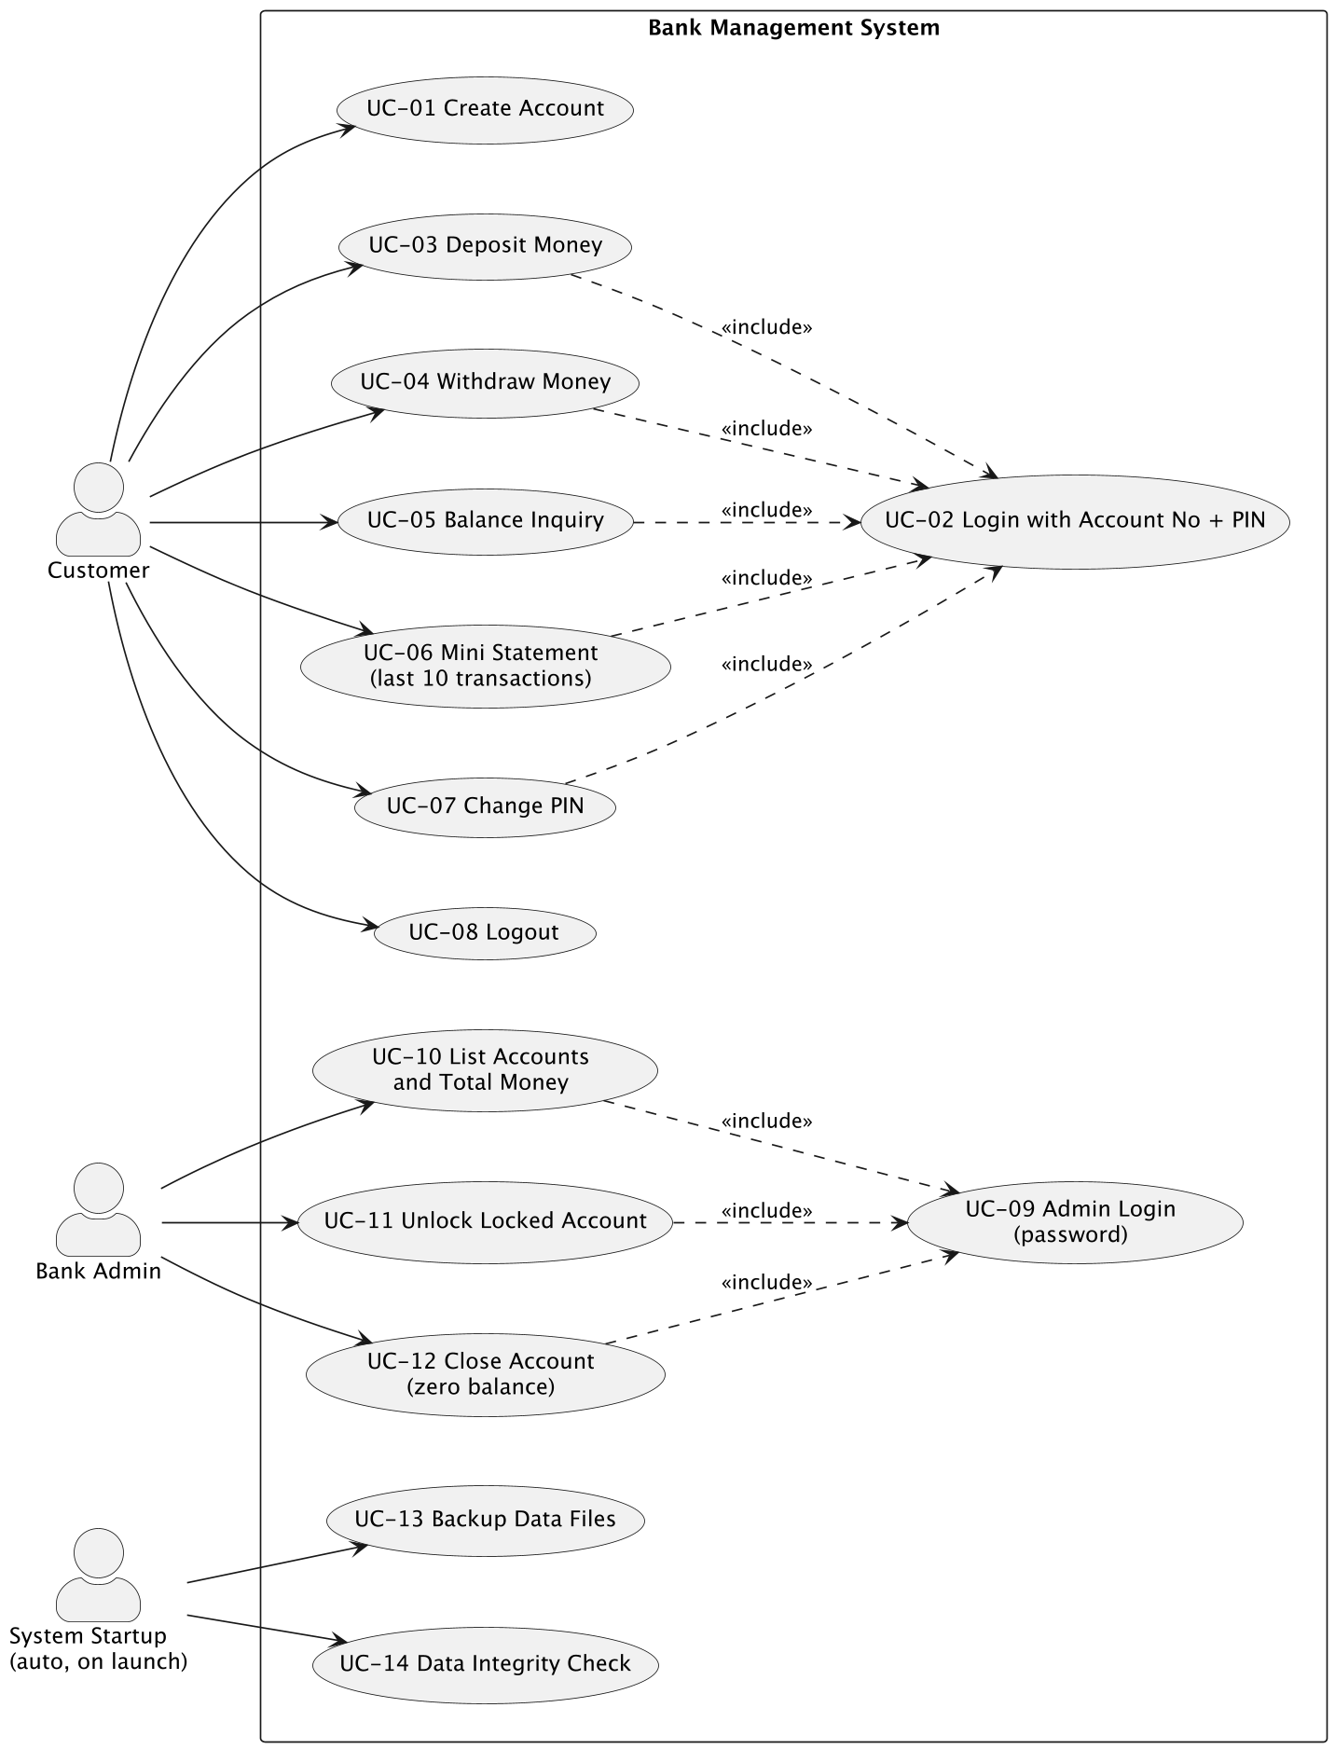
Figure 2: Security use cases with <<include>> and <<extend>> relations.
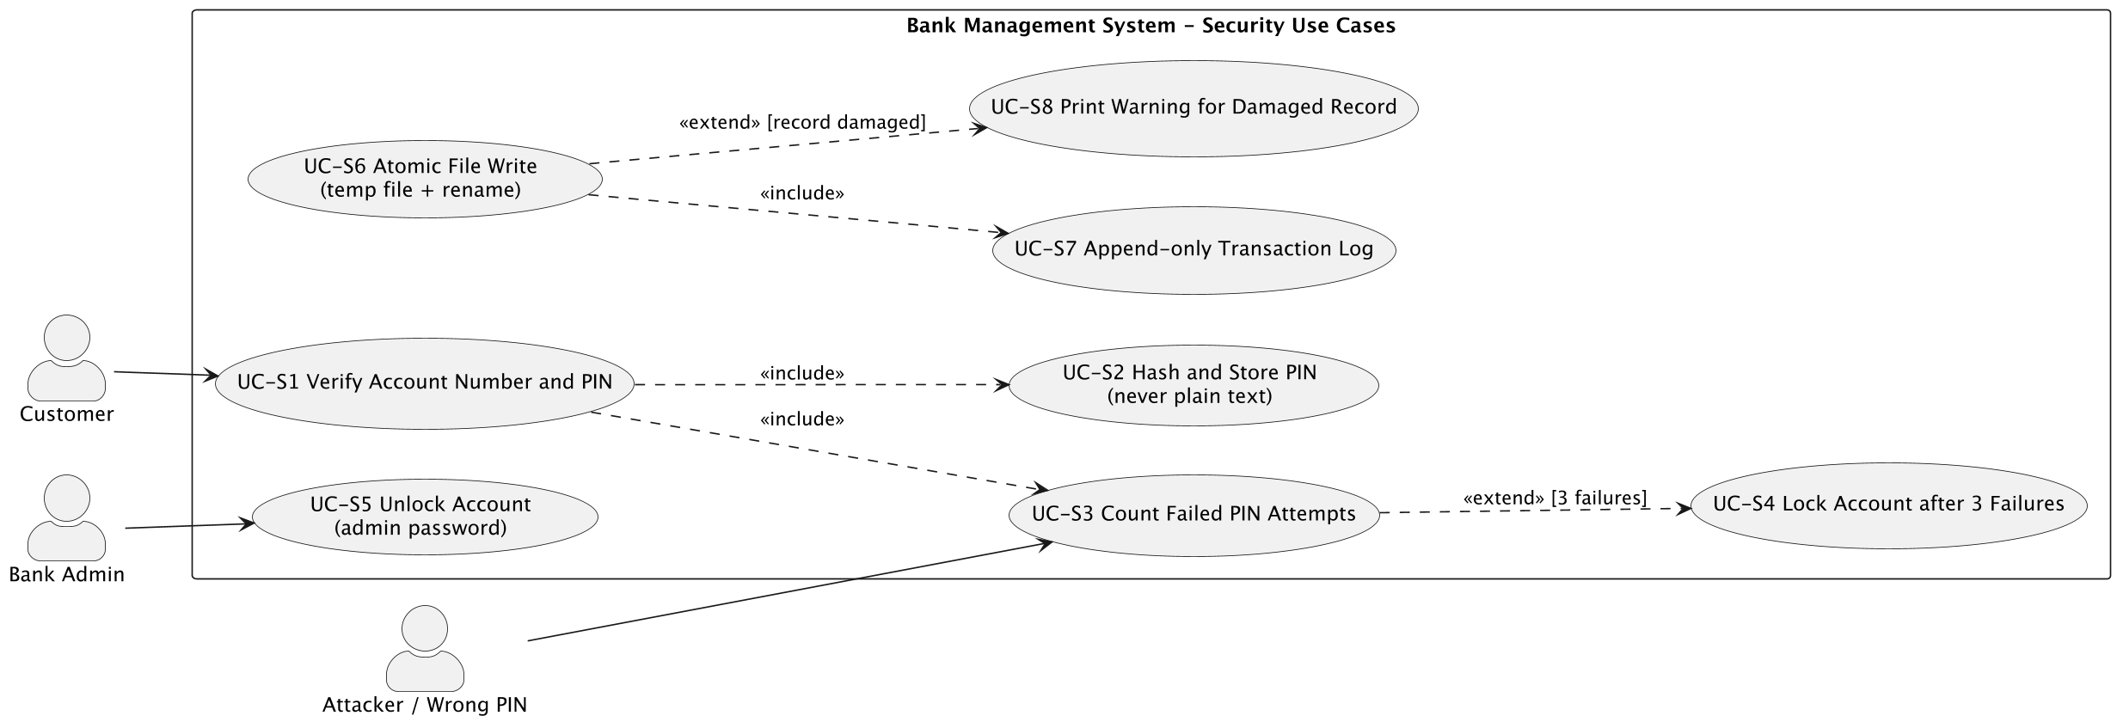

8. Requirements Traceability Matrix (RTM)

Req ID | Requirement short | Section ref / Design Spec | Module | Test case(s) | Status (N/P/A) | Comments
BMS-F-001 | Customer login with account number and PIN | 4.1 | AuthModule | TC-Auth-01 | N | Design spec to follow (SAD deliverable)
BMS-F-002 | Lock after 3 failed PIN attempts | 4.1 | AuthModule | TC-Auth-02 | N | Links to PRJ-SR-002
BMS-F-003 | PIN stored as hash only | 4.1 | AuthModule | TC-Auth-03 | N | Links to PRJ-SR-001
BMS-F-004 | Change PIN after old PIN check | 4.1 | AuthModule | TC-Auth-04 | N
BMS-F-005 | Logout ends the session | 4.1 | UiMenuModule | TC-Auth-05 | N
BMS-F-006 | Withdraw with minimum balance rule | 4.2 | AccountModule | TC-WD-01 | N | Rs. 500 minimum balance
BMS-F-007 | Daily withdrawal limit Rs. 50,000 | 4.2 | TxnModule | TC-WD-02 | N
BMS-F-008 | Withdrawal log line before balance save | 4.2 | FileStoreModule | TC-WD-03 | N | Links to PRJ-SR-004
BMS-F-009 | Deposit positive amount only | 4.3 | AccountModule | TC-DP-01 | N
BMS-F-010 | Single deposit limit Rs. 2,00,000 | 4.3 | AccountModule | TC-DP-02 | N
BMS-F-011 | Deposit log line | 4.3 | FileStoreModule | TC-DP-03 | N
BMS-F-012 | Admin login with password | 4.5 | AdminModule | TC-ADM-01 | N | Links to PRJ-SR-006
BMS-F-013 | List accounts and total money | 4.5 | AdminModule | TC-ADM-02 | N
BMS-F-014 | Unlock locked account | 4.5 | AdminModule | TC-ADM-03 | N
BMS-F-015 | Close zero-balance account | 4.5 | AdminModule | TC-ADM-04 | N
BMS-F-016 | Timestamped backup on start-up | 4.5 | BackupModule | TC-MNT-01 | N | Keeps last 10 backups
BMS-F-017 | Integrity check with line warning | 4.5 | FileStoreModule | TC-MNT-02 | N | Links to SO-4
BMS-F-018 | Create account with unique number | 4.6 | AccountModule | TC-ACC-01 | N
BMS-F-019 | Validate new-account input | 4.6 | AccountModule | TC-ACC-02 | N
BMS-F-020 | Show one account to admin | 4.6 | AdminModule | TC-ACC-03 | N
BMS-F-021 | Refuse weak PIN | 4.6 | AuthModule | TC-ACC-04 | N | Links to SO-1
BMS-F-022 | Balance inquiry | 4.7 | AccountModule | TC-INQ-01 | N
BMS-F-023 | Mini statement last 10 | 4.7 | ReportModule | TC-INQ-02 | N
BMS-F-024 | Statement between two dates | 4.7 | ReportModule | TC-INQ-03 | N
BMS-NF-001 | Response time <= 1 s (10,000 accounts) | 5 | AccountModule | TC-Perf-01 | N
BMS-NF-002 | Start-up <= 2 s | 5 | BackupModule | TC-Perf-02 | N
BMS-NF-003 | Mini statement <= 1 s | 5 | ReportModule | TC-Perf-03 | N
BMS-NF-004 | No money lost or created | 5 | AccountModule | TC-Rel-01 | N | Links to SO-2
BMS-NF-005 | Data file safe after a crash | 5 | FileStoreModule | TC-Rel-02 | N | Links to PRJ-SR-003
BMS-NF-006 | Balance never negative | 5 | AccountModule | TC-Rel-03 | N
BMS-NF-007 | No plain-text secret in files | 5.1.2 | AuthModule | TC-Sec-01 | N | Links to SO-1, PRJ-SR-001
BMS-NF-008 | Lock after 3 failures | 5.1.2 | AuthModule | TC-Sec-02 | N | Links to PRJ-SR-002
BMS-NF-009 | First-time user deposits in 60 s | 5 | UiMenuModule | TC-UX-01 | N
BMS-NF-010 | Warning-free build, 4 modules | 5 | All modules | TC-Mnt-01 | N
BMS-NF-011 | Capacity 10,000 accounts | 5 | FileStoreModule | TC-Cap-01 | N
PRJ-SR-001 | Hash-only secrets | 5.1.2 | AuthModule | TC-Sec-01 | N | SO-1
PRJ-SR-002 | Account lock and admin unlock | 5.1.2 | AuthModule | TC-Sec-02 | N | SO-1
PRJ-SR-003 | Atomic file write (temp + rename) | 5.1.2 | FileStoreModule | TC-Sec-03 | N | SO-2
PRJ-SR-004 | Append-only transaction log | 5.1.2 | FileStoreModule | TC-Sec-04 | N | SO-3
PRJ-SR-005 | No secret on screen or in logs | 5.1.2 | UiMenuModule | TC-Sec-05 | N | SO-1
PRJ-SR-006 | Admin session control | 5.1.2 | AdminModule | TC-Sec-06 | N | SO-3
PRJ-SR-007 | Amount validation and upper bound | 5.1.2 | AccountModule | TC-Sec-07 | N | SO-2

