Software Architecture and Design Specification
Project: Bank Management System (Team 11)
Version: 1.0
Authors: PES1UG24CS703, PES1UG24CS707, PES1UG24CS711
Date: 28-09-2026
Status: Submitted for review (Deliverable 3)

Revision History
Version | Date | Author | Change Summary
1.0 | 28-09-2026 | Team 11 | First architecture and design document, follows SRS version 1.0

Approvals
Role | Name | Signature/Date
Course Coordinator | (to be signed) | (date)
Team Lead, PES1UG24CS703 | (28/9/26)
Team Member, PES1UG24CS707 | (28/9/26)
Team Member, PES1UG24CS711 | (28/9/26)

1. Introduction
1.1 Purpose
This document gives the architecture and the design of the Bank Management System. The program is a console program in C/C++ written by Team 11, and it follows the SRS [1].
1.2 Scope
It covers version 1.0: the components, the layers, the traceability to requirements, the security design, two sequence diagrams, the C interfaces and the error handling. Funds transfer, interest, a database and the network are out of scope (SRS section 1.2).
1.3 Audience
This document is for the team, the instructor and the evaluator. The reader should know basic C/C++ and the terms of section 1.4.
1.4 Definitions
BMS: Bank Management System.
SAD: Software Architecture and Design Specification (this document).
SRS: Software Requirements Specification of the same project [1].
Component: one named part with one job, for example AuthModule.
Layer: one level of the architecture. A layer calls only the layer below it.
Module: one C file. The four modules are ui_menu.c, accounts.c, transactions.c and filestore.c.
Atomic write: write accounts.tmp, then rename it over accounts.txt.
Append-only: add lines at the end. Never edit or delete a line.
Paise: money is a whole number of paise in a long, never a float.
PIN hash: the value stored instead of the PIN.
Lockout: the state after 3 wrong PINs. Only the admin unlocks the account.
Mini statement: the last 10 transactions of one account.
FR, NFR, SR, RTM: as defined in the SRS.

2. Document Overview
2.1 How to use this document
Section 3 gives the architecture and section 4 gives the design. Section 5 has the glossary, the references and the tools. Every ID used here (BMS-F-###, BMS-NF-###, SO-#, PRJ-SR-###) is defined in the SRS [1].
2.2 Related Documents
SRS: SRS_Team11_Bank_Management_System.docx, deliverable 1 [1].
Test plan: Test plan of Team 11 for the Bank Management System, deliverable 2.
RTM: section 8 of the SRS. Its module column matches section 3.8 of this document.
Deliverable list: SE_Mini_Project_Delivereables_Part-1.pdf.

3. Architecture
3.1 Goals & Constraints
Goals:
1. Work offline on one machine. No network and no database.
2. Keep money correct: whole paise in a long, minimum balance Rs. 500, daily limit Rs. 50,000, deposit limit Rs. 2,00,000.
3. Keep the data safe: atomic writes, a start-up backup, a warning for a damaged line, and an append-only log.
4. Stay simple to build and to grade: four small modules, one make command.
Constraints:
1. C/C++ with the standard library only, built with gcc/g++ 9 or newer.
2. Plain text files, pipe separated, one record per line.
3. One make command, warning free with -Wall -Wextra.
4. One user and one copy of the program at a time.
5. Text menu only. No graphical interface.
3.2 Stakeholders & Concerns
Customer: short menu, correct amounts, no lost money.
Bank Admin: correct list of accounts and total money, simple unlock and close.
Tester / Developer: clear error messages, readable data files, easy build.
Instructor / Evaluator: every requirement traceable, simple structure.
Maintenance engineer: small modules, one job per function, no external dependency.

3.3 Component (UML) Diagram

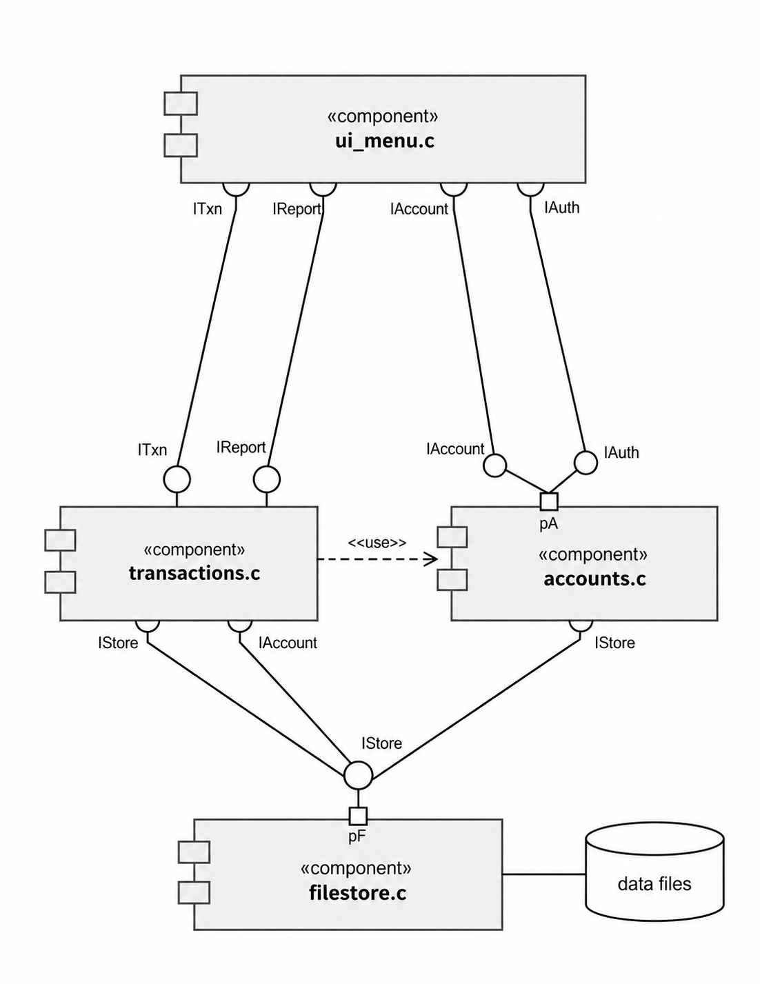
Figure 1: Components with provided interfaces (ball) and required interfaces (socket).
Each box is one C file and the components it holds. A layer calls only the layer below it, so the menu never touches a file.
IAuth and IAccount come from AuthModule and AccountModule inside accounts.c; ITxn and IReport come from TxnModule and ReportModule inside transactions.c; IStore comes from FileStoreModule inside filestore.c.

3.4 Component Descriptions
UiMenuModule: shows the three menus, reads the input and prints the result. Serves BMS-F-005, BMS-F-019, BMS-NF-009 and PRJ-SR-005.
AdminModule: admin login, list all accounts with the total money, unlock an account, close a zero-balance account, show one account. Serves BMS-F-012 to BMS-F-015, BMS-F-020 and PRJ-SR-006.
AuthModule: hashes and checks the PIN, counts the wrong tries, locks at 3, refuses a weak PIN, changes the PIN. Serves BMS-F-001 to BMS-F-004, BMS-F-021, BMS-NF-007, BMS-NF-008, PRJ-SR-001, PRJ-SR-002 and SO-1.
AccountModule: finds, creates, deposits, withdraws and reads the balance. It holds the money rules. Serves BMS-F-006, BMS-F-009, BMS-F-010, BMS-F-018, BMS-F-019, BMS-F-022, BMS-NF-004, BMS-NF-006 and PRJ-SR-007.
TxnModule: builds one transaction record for every deposit and withdrawal, and adds up one day of withdrawals. Serves BMS-F-007, BMS-F-008, BMS-F-011 and SO-3.
ReportModule: mini statement and statement between two dates. Both are read only. Serves BMS-F-023, BMS-F-024 and BMS-NF-003.
FileStoreModule: reads and writes both files, writes accounts.tmp and renames it, appends log lines, and reports a damaged line with its number. Serves BMS-F-008, BMS-F-011, BMS-F-017, BMS-NF-005, BMS-NF-010, BMS-NF-011, PRJ-SR-003, PRJ-SR-004, SO-2 and SO-4.
BackupModule: makes the timestamped copy of both files on start-up and keeps the last 10. Serves BMS-F-016, BMS-NF-002 and SO-4.
One file holds two components: ui_menu.c the two menu parts, accounts.c the auth and account parts, transactions.c the transaction and report parts, and filestore.c the file and backup parts (BMS-NF-010).

3.5 Chosen Architecture Pattern and Rationale
We use a layered architecture with three layers.
Layer 1, menu: UiMenuModule and AdminModule. It reads the input and prints the result.
Layer 2, business: AuthModule, AccountModule, TxnModule and ReportModule. All bank rules live here.
Layer 3, storage: FileStoreModule and BackupModule. It knows the file layout and the file operations.
A layer calls only the layer below it, so each rule sits in one place and is easy to test.
The table below compares this choice with the other patterns we thought about.
Pattern | Decision | Reason
Layered | Chosen | Three levels match the work: menu, bank rules, files.
Microservices | Rejected | They need many processes and network calls. Our program is one process.
Client-server | Rejected | It needs two programs and a protocol. Our data is on one machine.
Event driven | Rejected | One user acts at a time, so a queue would add code with no gain.

3.6 Technology Stack & Data Stores
Language: C/C++ (C11), standard library only: stdio.h, stdlib.h, string.h and time.h.
Compiler: gcc/g++ 9 or newer, or clang, with the flags -Wall -Wextra.
Build: one make command with a small Makefile. The program is named bankms, so the run command is ./bankms.
Storage: plain text files in the data/ folder. No database and no network service.
Log: transactions.txt is the append-only log of the money operations. There is no separate error log file.
Backup: data/backup/ keeps the last 10 start-up copies.
The table below gives the layout of each file.
File | Record layout (pipe separated) | Written by
data/accounts.txt | account_number|name|pin_hash|balance_paise|status|bad_tries  example: 1003|Ravi Kumar|9f2a4c|1000000|ACTIVE|0 | FileStoreModule. Written as accounts.tmp and then renamed.
data/transactions.txt | txn_id|account_number|type|amount_paise|balance_after|date_time  example: 1042|1003|DEPOSIT|50000|170000|2026-09-29 10:15:22 | FileStoreModule. Append only, one line per deposit or withdrawal.
data/accounts.tmp | Same layout as accounts.txt. | FileStoreModule. Temporary file of one atomic write.
data/backup/ | Copy of both files, with the date-time in the name. | BackupModule. The last 10 copies are kept.
status is ACTIVE, LOCKED or CLOSED. type is DEPOSIT or WITHDRAW. The money fields hold whole paise in a long, and pin_hash holds only a hash.

3.7 Risks & Mitigations
The table lists the risks we can see for an offline console program, and the step in the design that answers each one.
Risk | Effect | Mitigation | Requirements
Crash during a write | A half-written accounts file | Write accounts.tmp, then rename it over accounts.txt. | PRJ-SR-003, BMS-NF-005
Damaged data file | A wrong balance is read | The start-up check skips the bad line and prints its line number. | BMS-F-017, SO-4
Two copies on one data folder | One copy overwrites the other | The guide says one copy at a time. A lock file is future work (section 4.6). | BMS-NF-005, section 4.6
PIN guess attempts | Money taken without permission | 3 wrong PINs lock the account. Only the admin unlocks it. | BMS-F-002, PRJ-SR-002
Disk full | A write fails | Every write is checked, and the backup folder keeps only 10 copies. | BMS-F-016, SO-4
Secret read from a file | A PIN becomes known | Only hashes are stored, so no usable secret is in the file. | BMS-NF-007, PRJ-SR-001
Data file edited by hand | A wrong balance with no history | A backup is taken on start-up and the log is append only. | BMS-F-016, PRJ-SR-004

3.8 Traceability to Requirements
Every functional requirement (BMS-F-001 to BMS-F-024) and every non-functional requirement (BMS-NF-001 to BMS-NF-011) is mapped below to its component and to its C file. The component names are the names used in the SRS RTM of section 8.
Req ID | Requirement | Component | Code module
BMS-F-001 | Customer login with account number and PIN | AuthModule | accounts.c
BMS-F-002 | Lock the account after 3 failed PIN attempts | AuthModule | accounts.c
BMS-F-003 | PIN stored as a hash only | AuthModule | accounts.c
BMS-F-004 | Change PIN after the old PIN is verified | AuthModule | accounts.c
BMS-F-005 | Logout ends the customer session | UiMenuModule | ui_menu.c
BMS-F-006 | Withdraw with the minimum balance rule | AccountModule | accounts.c
BMS-F-007 | Daily withdrawal limit of Rs. 50,000 | TxnModule | transactions.c
BMS-F-008 | Withdrawal log line before the balance is saved | FileStoreModule | filestore.c
BMS-F-009 | Deposit a positive amount only | AccountModule | accounts.c
BMS-F-010 | Single deposit limit of Rs. 2,00,000 | AccountModule | accounts.c
BMS-F-011 | Deposit log line for every deposit | FileStoreModule | filestore.c
BMS-F-012 | Admin login with the admin password | AdminModule | ui_menu.c
BMS-F-013 | List all accounts and the total money | AdminModule | ui_menu.c
BMS-F-014 | Unlock a locked account | AdminModule | ui_menu.c
BMS-F-015 | Close a zero-balance account | AdminModule | ui_menu.c
BMS-F-016 | Timestamped backup on every start-up | BackupModule | filestore.c
BMS-F-017 | Integrity check with a line warning | FileStoreModule | filestore.c
BMS-F-018 | Create an account with a unique number | AccountModule | accounts.c
BMS-F-019 | Validate the input of a new account | AccountModule | accounts.c
BMS-F-020 | Show one account to the admin | AdminModule | ui_menu.c
BMS-F-021 | Refuse a weak PIN | AuthModule | accounts.c
BMS-F-022 | Balance inquiry | AccountModule | accounts.c
BMS-F-023 | Mini statement of the last 10 transactions | ReportModule | transactions.c
BMS-F-024 | Statement between two dates | ReportModule | transactions.c
BMS-NF-001 | Deposit, withdrawal and inquiry in 1 second or less | AccountModule | accounts.c
BMS-NF-002 | Start-up in 2 seconds or less | BackupModule | filestore.c
BMS-NF-003 | Mini statement in 1 second or less | ReportModule | transactions.c
BMS-NF-004 | No amount lost or created | AccountModule | accounts.c
BMS-NF-005 | Data file readable after a crash | FileStoreModule | filestore.c
BMS-NF-006 | Balance never negative | AccountModule | accounts.c
BMS-NF-007 | No plain-text secret in a file | AuthModule | accounts.c
BMS-NF-008 | Lock after 3 failed PIN attempts | AuthModule | accounts.c
BMS-NF-009 | First-time user deposits within 60 seconds | UiMenuModule | ui_menu.c
BMS-NF-010 | Warning-free build, four modules | All eight components | ui_menu.c, accounts.c, transactions.c, filestore.c
BMS-NF-011 | 10,000 accounts and 100,000 log lines | FileStoreModule | filestore.c
BMS-NF-010 is a build rule, so it covers all four files. Every other row names one component and one file.

3.9 Security Architecture
The first table maps the four security objectives (SO-1 to SO-4) and the seven security requirements (PRJ-SR-001 to PRJ-SR-007) to the part of the design that meets them. The second table lists the threats and the step that blocks each one.
ID | Objective or requirement | Design element that meets it
SO-1 | Confidentiality of credentials | Only a hash is stored. No plain secret is written, printed or logged.
SO-2 | Integrity of money data | accounts.tmp plus rename, and the log line before the new balance.
SO-3 | Accountability and audit | The log is append only and every line has a transaction id and a date-time.
SO-4 | Availability of local data | A backup on start-up, and a damaged line is skipped with its line number.
PRJ-SR-001 | Hash-only secrets | AuthModule stores and compares hashes only. The admin password is a hash constant.
PRJ-SR-002 | Lockout and admin unlock | bad_tries counts the wrong PINs, LOCKED at 3, and the admin unlock clears it.
PRJ-SR-003 | Atomic file write | fs_write_accounts_atomic() writes accounts.tmp and then calls rename().
PRJ-SR-004 | Append-only log | fs_append_txn() opens transactions.txt in append mode and writes one line.
PRJ-SR-005 | No secret on screen or in logs | The PIN is read without echo and no message prints a PIN or a hash.
PRJ-SR-006 | Admin session control | The admin menu opens only after the admin password. The flag is cleared on exit.
PRJ-SR-007 | Amount validation and upper bound | acc_parse_amount() refuses zero, negative, letters and Rs. 1,00,00,000 or more.
Threats and the step that blocks each one:
Threat | How it is blocked
Someone reads a PIN from accounts.txt | Only the hash is stored (SO-1, PRJ-SR-001).
Someone tries PINs until an account opens | 3 wrong PINs lock the account, and the counter is in the record (BMS-F-002).
A crash in the middle of a write | The new file is built as accounts.tmp and renamed (PRJ-SR-003).
Someone edits the log to hide a withdrawal | The log is append only and every money operation is written there (SO-3).
A rounded amount enters the account | Amounts are whole paise in a long, so no float rounding is possible.
A damaged line is read as a record | The parser needs 6 fields and numeric money fields (BMS-F-017).
A customer sees another account or the bank total | Both are inside the admin session only (PRJ-SR-006).

4. Design

4.1 Design Overview
main() does the start-up work, then loops on the menu. One menu choice becomes one path through the three layers.
Deposit: the customer types the amount, AccountModule adds it to the balance, TxnModule builds the record, and FileStoreModule appends the log line and then saves accounts.
Withdrawal: AccountModule checks the status, the minimum balance and the daily limit. If a check fails, no file is written.

4.2 UML Sequence Diagrams
At least 2 sequence diagrams covering 2 flows specific to your project
Two flows are drawn below: a deposit and a refused withdrawal. The rule that can refuse an operation is written in the message text or in the caption.
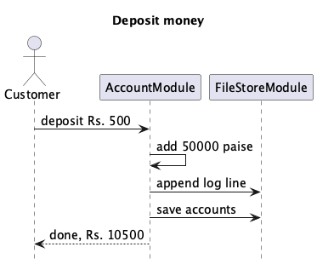
Figure 2: Deposit money (BMS-F-009, BMS-F-011). The log line is written first.
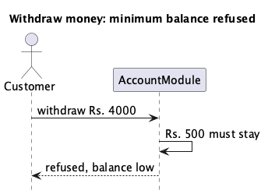
Figure 3: Withdrawal refused (BMS-F-006). Rs. 500 must stay in the account.

4.3 API Design
Interface definition for at least 2 components.
Version 1.0 has no network, so there is no HTTP endpoint and no web API. All components run in one process and call each other with C functions. Money values are whole paise in a long.
FileStoreModule (filestore.c, filestore.h). These are C functions, not HTTP endpoints.
Function | Parameters | Returns | Error codes
fs_open_accounts | path, mode ("r" or "a") | FILE * or NULL | E-FILE-01
fs_read_all | AccountList *out | number of records, or -1 | E-FILE-01, E-FILE-04
fs_write_accounts_atomic | const AccountList *list | 0 or -1 | E-FILE-02, E-FILE-06
fs_append_txn | const Txn *t | 0 or -1 | E-FILE-03
fs_read_all_txn | TxnList *out | number of records, or -1 | E-FILE-01, E-FILE-04
fs_backup | src, dst (in data/backup/) | 0 or -1 | E-FILE-05
fs_backup_rotate | keep (10) | number of old copies removed | none
fs_check_integrity | path, int *bad_lines | 0 or -1 | E-FILE-01, E-FILE-04
AccountModule (accounts.c, account.h). These are C functions, not HTTP endpoints. acc_find() and acc_balance() are read only.
Function | Parameters | Returns | Error codes
acc_parse_amount | text (rupees) | 1 or 0 | E-ACC-01
acc_find | list, acc_no, Account *out | 1 or 0 | E-ACC-07
acc_create | list, name, opening_paise, pin4 | 0 or -1 | E-ACC-01, E-ACC-08
acc_deposit | Account *a, amount_paise | 0 or -1 | E-ACC-01, E-ACC-05
acc_withdraw | a, amount_paise, today_total_paise | 0 or -1 | E-ACC-01 to E-ACC-04, E-ACC-06
acc_balance | const Account *a | 0 or -1 | E-ACC-07
acc_change_pin | a, old_pin, new_pin | 0 or -1 | E-ACC-08, E-ACC-09
acc_list_all | list, long *total_paise | number of accounts | none
acc_unlock | Account *a (admin) | 0 or -1 | E-ACC-07
acc_close | Account *a (admin) | 0 or -1 | E-ACC-07, E-ACC-10
Function: fs_write_accounts_atomic
File: filestore.c, declared in filestore.h
Parameters: const AccountList *list
Returns: 0 on success, -1 on failure
Side effect: write data/accounts.tmp, then rename it over data/accounts.txt
Errors: E-FILE-02, E-FILE-06
Note: an in-process C function. It is not an HTTP endpoint.

4.4 Error Handling, Logging & Monitoring
Version 1.0 keeps no separate log file, so log below means the append-only transaction log data/transactions.txt. Every failure has one code and one short message.
Code | Meaning | Message shown to the user | Written to the log
E-IN-01 | Invalid input or unknown menu choice | "Please enter a number." / "Invalid choice. Try again." | No line. Screen only.
E-ACC-01 | Amount is zero, negative, has more than 2 decimals, or is too large | "Please enter a valid amount." | No line.
E-ACC-02 | Insufficient balance | "Not enough balance for this withdrawal." | No line.
E-ACC-03 | Less than Rs. 500 would remain | "Minimum balance of Rs. 500.00 must remain." | No line.
E-ACC-04 | Daily withdrawal limit crossed | "Daily withdrawal limit of Rs. 50,000.00 crossed." | No line.
E-ACC-05 | Single deposit above Rs. 2,00,000 | "Single deposit limit is Rs. 2,00,000.00." | No line.
E-ACC-06 | Account is LOCKED or CLOSED | "Account is LOCKED. Contact the bank admin." | No line.
E-ACC-07 | Account number not found | "Account not found." | No line.
E-ACC-08 | Weak PIN | "Weak PIN. Do not use 0000, 1111, 1234 or 4321." | No line. No PIN is printed.
E-ACC-09 | Wrong old PIN | "Wrong PIN. PIN not changed." | No line.
E-ACC-10 | Close refused, balance not zero | "Account balance is not zero. Cannot close." | No line.
E-FILE-01 | Data file cannot be opened | "Cannot open data file. Please check the data folder." | No line.
E-FILE-02 | Temp file write failed | "Cannot write data file. Not saved." | No line. The old file is kept.
E-FILE-03 | Log write failed | "Cannot write the log. Not saved." | No line. The balance is not changed.
E-FILE-04 | Damaged record on start-up | "Warning: damaged record on line N, skipped." | No line. Warning on screen.
E-FILE-05 | Backup failed | "Warning: backup not created." | No line.
E-FILE-06 | Rename failed | "Cannot save the data file." | No line. The old file is kept.
Rules for every error:
1. No PIN, no PIN hash and no admin password is ever printed or logged (PRJ-SR-005).
2. A failed operation writes no log line and changes no account record.
3. If the log line cannot be written, the balance is not changed either.
4. transactions.txt is the only log. It holds money operations only.
5. Monitoring is manual: the admin menu shows the accounts and the total money, and the test plan measures the response times.

4.5 UX Design
1. Each screen shows at most 7 choices. The main menu has 4, the customer menu 7 and the admin menu 4.
2. Choice 0 means Exit, Logout or Back. The menus of SRS section 3.1 are used as written.
3. The menus and the messages use plain words. No abbreviation inside a menu.
4. Money is printed as Rs. with two decimals, for example Rs. 1700.00.
5. The account number and the holder name are shown on every customer screen.
6. A wrong input never crashes the program. Letters where a number is expected print "Please enter a number." and the menu is shown again.
7. The PIN is read without echo and shown as four stars.
8. Every operation ends with one short result line and waits for the Enter key (BMS-NF-009).

4.6 Open Issues & Next Steps
1. Funds transfer is out of scope for version 1.0. It needs its own requirements and a security review.
2. Interest, loans and fixed deposits are out of scope.
3. File locking is not implemented. One copy of the program runs at a time. A lock file data/.lock is the next small step.
4. There is no separate error log file. A small error log can be added later, with no secret written to it.
5. Moving the storage to SQLite would remove the manual line parsing. This is future work.
6. A graphical or web interface is out of scope. The menu layer is separate, so a second interface can be added later.
7. The PIN hash uses a simple hash of the standard library. A salted hash is an improvement for a later version.
8. The statements read the whole log. An index by account number is the first thing to add if the log grows much larger.

5. Appendices
5.1 Glossary: BMS, SRS, SAD, FR, NFR, SR, RTM, SO, PRJ-SR, PIN, PIN hash, account number, balance in paise, minimum balance, daily withdrawal limit, mini statement, admin, data files, layer, component, module, atomic write, append-only, lockout, integrity check, backup, console.
5.2 References: IEEE Std 42010-2011 (architecture description), IEEE Std 1016-2009 (software design descriptions), SRS_Team11_Bank_Management_System.docx, SE_Mini_Project_Delivereables_Part-1.pdf, course notes on software design, PlantUML user guide.
5.3 Tools: gcc/g++ and make, PlantUML with Graphviz for the diagrams, python-docx for this document, LibreOffice, pdftoppm and pdftotext, git.

