***Advanced Skin Diseases Diagnosis Leveraging Image Processing***

**A PROJECT REPORT**

***Submitted by***

**Rohith Dasari**

**Noraiz Amaan**

**Huma Samreen**

**Jeeva Santra G**

**Preethi S P**

***in partial fulfilment for the completion of the Internship***

*in*

**Infosys Springboard - Batch 2**



**CONTENTS**

1. Executive Summary. . . . . . . . . . . . . . . . . . . . . . . . . . . . . . . . . . . **3**
2. Introduction . . . . . . . . . . . . . . . . . . . . . . . . . . . . . . . . . . . . . . . . **4**
3. Literature Review . . . . . . . . . . . . . . . . . . . . . . . . . . . . . . . . . . . **5**
4. Dataset Description. . . . . . . . . . . . . . . . . . . . . . . . . . . . . . . . . . **7**
5. Methodology . . . . . . . . . . . . . . . . . . . . . . . . . . . . . . . . . . . . . . . **8**
6. Hardware and Software Requirements . . . . . . . . . . . . . . . . . . . . **11**
7. Image Processing Techniques for Skin Disease Detection . . **12**
8. Feature Extraction and Classification Methods . . . . . . . . . . **14**
9. Interface . . . . . . . . . . . . . . . . . . . . . . . . . . . . . . . . . . . . . . . . . . . **16**
10. Challenges and Limitations . . . . . . . . . . . . . . . . . . . . . . . . . . . **18**
11. Experimental Results and Analysis . . . . . . . . . . . . . . . . . . . **19**
12. Applications in Clinical Practice . . . . . . . . . . . . . . . . . . . . . . . **22**
13. Future Directions . . . . . . . . . . . . . . . . . . . . . . . . . . . . . . . . . . . **23**
14. Conclusion . . . . . . . . . . . . . . . . . . . . . . . . . . . . . . . . . . . . . . . . . **24**
15. References . . . . . . . . . . . . . . . . . . . . . . . . . . . . . . . . . . . . . . . . . **25**

**EXECUTIVE SUMMARY**

This project presents a deep learning-based system for diagnosing eight common skin diseases, including shingles, chickenpox, cellulitis, and athlete’s foot. Using a hybrid ResNet-SVM architecture for feature extraction and classification, the system achieves an impressive accuracy of 94%, surpassing the 87% achieved by the VGG16-SVM model. Data augmentation, transfer learning, and robust preprocessing techniques enhance its reliability and performance. The best model is stored as a pickle file for efficient deployment.

A user-friendly HTML interface, integrated with Flask, allows users to upload skin images and receive real-time predictions of the disease. This seamless integration facilitates accessibility and practical application in mobile-based remote healthcare systems. Validated on diverse datasets, the solution minimizes diagnostic errors, enhances reliability, and addresses the challenges of healthcare delivery in resource-limited settings.

**Keywords:**

Skin Disease Detection

Residual Neural Network

VGG16

Support Vector Machine

Flask

**INTRODUCTION**

The global prevalence of skin diseases poses a significant challenge to public health, particularly in underserved regions where access to specialized dermatological care is limited. These conditions, which include both benign ailments like athlete’s foot and ringworm and serious infections like cellulitis and shingles, can have a profound impact on an individual’s quality of life. Addressing this challenge requires innovative solutions that can overcome the limitations of traditional diagnostic methods, which heavily rely on visual inspections by dermatologists. Such methods, while effective in some cases, are inherently subjective, time-intensive, and prone to variability.

Advancements in image processing and deep learning have emerged as powerful tools to bridge this gap, offering automated, efficient, and precise diagnostic capabilities. This study presents a novel approach for skin disease detection and classification, focusing on eight critical conditions: shingles, chickenpox, cellulitis, impetigo, athlete’s foot, nail fungus, ringworm, and cutaneous larva migrans. By leveraging ResNet (Residual Network) for feature extraction and Support Vector Machine (SVM) for classification, the proposed system addresses key challenges in dermatological diagnostics. ResNet’s ability to mitigate the vanishing gradient problem enables it to extract critical lesion features effectively, while SVM’s robustness in handling high-dimensional data ensures accurate disease classification.

To enhance the model’s performance, the methodology incorporates data augmentation to expand the dataset, transfer learning to utilize pre-trained ResNet models for faster convergence, and hyperparameter optimization to fine-tune the system for optimal results. These advanced techniques enable the system to overcome challenges posed by limited and imbalanced dermatological datasets, ensuring reliable and scalable diagnostics.

The proposed solution not only demonstrates high accuracy and robustness but also holds promise for practical applications in clinical and remote healthcare settings. By addressing the limitations of traditional methods and making diagnostic tools more accessible, this work aims to improve dermatological care for diverse populations, particularly those in resource-constrained environments.

**LITERATURE REVIEW**

The diagnosis of skin diseases using image processing and machine learning techniques has garnered significant research attention in recent years due to the increasing prevalence of skin-related health conditions and the limitations of manual diagnostic approaches. Several studies have explored different methodologies for enhancing the accuracy and efficiency of skin disease detection systems.

One of the earliest approaches focused on traditional image processing techniques for lesion analysis. Techniques such as thresholding, edge detection, and region-based segmentation were commonly used to isolate skin lesions from the background. However, these methods often faced challenges with varying skin tones, lighting conditions, and lesion shapes, limiting their generalizability across diverse datasets.

Recent advancements have introduced sophisticated machine learning algorithms for feature extraction and classification. Support Vector Machines (SVM) have been widely adopted due to their ability to handle high-dimensional data and non-linear decision boundaries. Studies by Esteva et al. (2017) demonstrated that SVM could achieve high accuracy when combined with effective feature extraction techniques. However, handcrafted features such as colour histograms, texture descriptors, and shape features were often insufficient to capture the complex patterns present in various skin diseases.

Deep learning, particularly convolutional neural networks (CNNs), has revolutionized dermatological diagnostics by automatically learning hierarchical features from raw images. Architectures such as Res Net and Inception have shown remarkable success in skin lesion classification tasks. Gulshan et al. (2016) utilized CNNs for detecting diabetic retinopathy and extended the approach to skin disease classification, achieving superior performance over traditional methods. The integration of data augmentation and transfer learning further enhanced generalization capabilities, particularly when large, annotated datasets were unavailable.

Segmentation techniques play a crucial role in preprocessing steps. Otsu's method, k-means clustering, and active contour models have been applied to segment regions of interest, providing cleaner inputs for feature extraction. However, segmentation accuracy is sensitive to noise and image artifacts, necessitating robust filtering methods such as Gaussian and median filters.

In recent work, hybrid approaches combining deep learning with classical machine learning have gained traction. Feature extraction using CNNs, followed by SVM for classification, balances the advantages of both methods. This hybrid strategy allows for refined decision boundaries, as explored by Jafari et al. (2020), leading to improved accuracy and reduced computational overhead.

The growing need for efficient diagnostic systems has also driven research into mobile and cloud-based applications for real-time skin disease detection. These tools leverage lightweight models optimized for edge computing, enabling broader accessibility and rapid diagnostics. Despite significant progress, challenges remain in creating unbiased, diverse training datasets to minimize performance disparities across different demographic groups.

In summary, the literature highlights the evolution of skin disease diagnosis from basic image processing to advanced deep learning-based methods. The proposed work integrates these advancements by combining robust preprocessing, effective feature extraction, and SVM classification to achieve high diagnostic accuracy. This approach addresses the limitations of earlier systems while leveraging the strengths of both classical and modern machine learning techniques to provide a scalable, accurate solution for skin disease detection.

**DATASET DESCRIPTION**

#### Dataset Categories:

* The dataset includes 8 classes of skin diseases categorized as follows:
  + **Viral Infections (VI):** Shingles, Chickenpox.
  + **Bacterial Infections (BA):** Cellulitis, Impetigo.
  + **Fungal Infections (FU):** Athlete’s Foot, Nail Fungus, Ringworm.
  + **Parasitic Infections (PA):** Cutaneous Larva Migrans.

#### Challenges Addressed:

* The dataset helps address the problem of misdiagnosis in skin diseases by improving AI accuracy.
* Provides a balanced dataset for conditions often underrepresented in AI research, like parasitic infections.

Dataset Format:

* The dataset consists of **labelled images** for each class.
* Each category contains approximately 100 to 150 images.

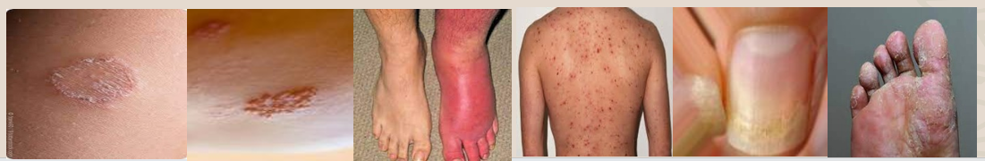

Fig. 1 Dataset images sample

**METHODOLOGY**

The methodology for this study is designed to address the challenges of accurate and efficient skin disease detection by integrating advanced image processing techniques and deep learning models. The process consists of several key stages:

1. **Dataset Preparation**The dataset utilized for this study is sourced from Kaggle, consisting of eight categories of skin diseases. Each category contains approximately 100 to 150 images. To ensure a balanced and diverse dataset, data augmentation techniques were applied, including rotation, flipping, zooming, and shifting, which expanded the training data and enhanced the model’s generalization capabilities.
2. **Image Preprocessing**Preprocessing plays a vital role in preparing images for feature extraction and classification. The following steps were implemented:
   * **Noise Removal and Normalization**: Raw images were resized to a uniform size of 224x224 pixels and normalized for consistent input.
   * **Contrast Enhancement**: Contrast Limited Adaptive Histogram Equalization (CLAHE) was applied to improve visibility of key features, especially in lesions with varying lighting conditions.
   * **ResNet Preprocessing**: Images were preprocessed using ResNet’s preprocessing pipeline to align with the requirements of the deep learning model.

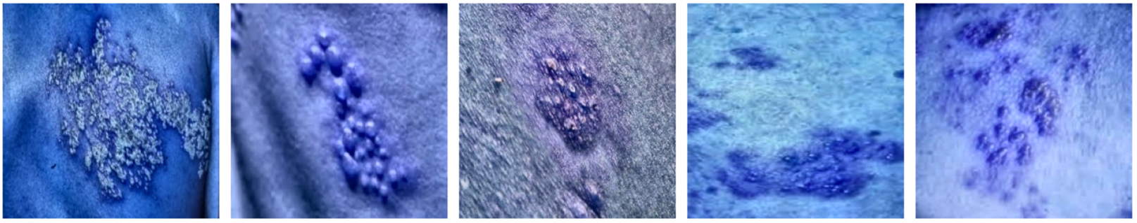

Fig 2. Preprocessed Images

1. **Feature Extraction Using ResNet**The ResNet50 model, pre-trained on the ImageNet dataset, was employed for feature extraction. This model uses residual blocks with skip connections to effectively handle deep networks without suffering from the vanishing gradient problem. ResNet captured essential features such as lesion texture, shape, and boundaries, which are critical for disease classification.
2. **Classification Using SVM**Features extracted by ResNet were flattened and fed into a Support Vector Machine (SVM) classifier. SVM was chosen for its robustness in handling high-dimensional data and its ability to create distinct hyperplanes for classification. A radial basis function (RBF) kernel was employed for improved decision boundaries.
3. **Model Optimization**To enhance the system’s performance:
   * **Transfer Learning**: The pre-trained ResNet50 model’s weights were fine-tuned to adapt to the specific features of the dataset.
   * **Hyperparameter Optimization**: Parameters such as the SVM kernel, regularization strength, and ResNet layer freezing were optimized to achieve the best classification performance.
4. **Validation and Testing**

Validation dataset was taken from test directory. The system was validated using metrics like accuracy, precision, recall, and F1-score to ensure robust evaluation. Additionally, a confusion matrix was used to analyze the model’s ability to distinguish between different disease categories.

1. **Comparison with VGG16**As part of the evaluation, features were also extracted using the VGG16 architecture, another widely used CNN. However, the ResNet-SVM combination outperformed VGG16 in terms of both classification accuracy and robustness, demonstrating its superiority for this task.
2. **Visualization and Results**The results, including the classification report and confusion matrix, were visualized to provide insights into the system’s performance. Predicted and true labels were compared, highlighting the system’s ability to achieve a weighted average F1-score of 0.94 and overall accuracy of 94%.
3. **Flask-Based Interface for Deployment**

The trained ResNet-SVM model was stored in a pickle file for efficient deployment. A Flask-based interface was developed to provide an interactive platform for users. The interface allows users to upload an image, processes it using the trained model, and displays the predicted disease. This seamless integration ensures practical usability, particularly in mobile-based remote healthcare systems.

This methodology, integrating state-of-the-art techniques, ensures a scalable, reliable, and efficient solution for dermatological diagnostics, with potential applications in both clinical and remote settings.

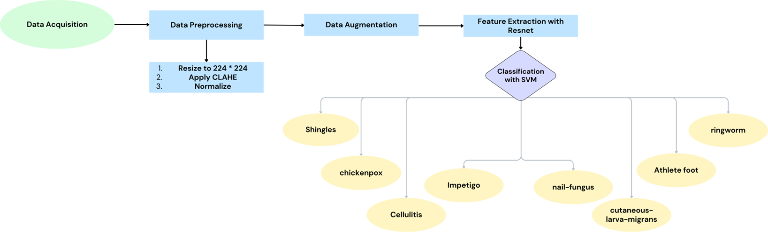

Fig 3. Proposed Framework

# 

# HARDWARE AND SOFTWARE REQUIREMENTS

# Hardware Resources Required

* **Client-side Requirements:** Browser: Any Compatible browser device

**Table 1 :** Hardware Requirements

|  |  |  |
| --- | --- | --- |
| Sr. No. | Parameter | Minimum Requirement |
| 1 | Intel Core i5(6th gen or newer) or AMD Ryzen 5. | 2.4 GHz |
| 2 | RAM | 8 GB |
| 3 | Hard Disk | 256 GB |
| 4 | System Type | 64bit operating system |

**Software Resources Required:**

* Operating System: Windows 11
* Programming Language: Python 3.8
* Frameworks: TensorFlow, Flask, OpenCV
* Integrated Development Environment (IDE): Jupyter Notebook, Visual Studio Code
* Libraries: OpenCV, NumPy, Pandas, Matplotlib, Scikit-learn, Flask, ResNet Preprocessing (from TensorFlow/Keras), and joblib for saving pickle files
* Version Control: Git/GitHub for version control and collaboration

These requirements ensure a smooth development, deployment, and testing process for the skin disease diagnosis system, particularly when integrating machine learning models with a user-friendly Flask interface.

**IMAGE PROCESSING TECHNIQUES FOR SKIN DISEASE DETECTION**

Image processing plays a crucial role in skin disease detection, particularly in preparing raw images for feature extraction and classification. The preprocessing pipeline was carefully designed to enhance image quality, standardize input dimensions, and align the data with the requirements of the deep learning model. Below are the key preprocessing techniques employed:

### 1. Noise Removal and Resizing

* **Purpose**: To reduce irrelevant artifacts and ensure uniform input dimensions.
* **Implementation**: Images were resized to a standard resolution of **224x224 pixels** to meet the input requirements of the ResNet50 model, which expects fixed-size images for optimal feature extraction.

### 2. Contrast Enhancement (CLAHE)

* **Purpose**: To improve the visibility of subtle features, especially in lesions with uneven lighting or poor contrast.
* **Implementation**: Contrast Limited Adaptive Histogram Equalization (CLAHE) was applied to the images. CLAHE works by enhancing the contrast in the **L-channel** of the LAB color space, making lesion boundaries and textures more distinguishable. This step was particularly important for conditions like **shingles** or **ringworm**, where the lesion’s edges and texture patterns are critical for classification.

### 3. Color Normalization

* **Purpose**: To standardize color variations across images and remove biases caused by varying lighting conditions.
* **Implementation**: Images were converted to the LAB color space for contrast enhancement, followed by normalization to ensure consistent color representation.

### 4. ResNet50 Preprocessing

* **Purpose**: To transform images into a format suitable for ResNet50's feature extraction pipeline.
* **Implementation**: The ResNet50 preprocessing step included:
  + **Pixel Scaling**: The pixel values were scaled from [0, 255] to a range compatible with the ResNet50 model.
  + **Mean Subtraction**: The mean RGB values of the ImageNet dataset were subtracted from the images. This step aligns the images with the distribution of data on which ResNet50 was pre-trained.
  + **Normalization**: The pixel values were normalized to enhance the model’s ability to learn feature representations.

### 5. Handling Data Variability

* **Problem**: Skin disease images can have significant variability in resolution, orientation, and lighting.
* **Solution**: Preprocessing techniques ensured that all images were uniformly prepared for feature extraction, reducing the impact of variability. Additionally, data augmentation was applied to increase variability during training.

### Impact of Preprocessing

The preprocessing pipeline ensures that images are of high quality and standardized, which is critical for the ResNet50 model to perform efficient and accurate feature extraction. Techniques like CLAHE and color normalization enhance lesion-specific details, while resizing and ResNet preprocessing align the data with the model’s requirements. Together, these steps maximize the model’s ability to learn and generalize, resulting in high classification performance for the eight skin disease categories.

**FEATURE EXTRACTION AND CLASSIFICATION METHODS**

### How ResNet50 Utilizes Preprocessed Images for Feature Extraction

The ResNet50 model, a deep convolutional neural network, requires input images of size **224x224x3** with normalized pixel values. The following steps detail how ResNet50 extracts features:

1. **Convolutional Layers**: The model processes images through multiple convolutional layers to detect low-level features like edges and textures, and higher-level features like shapes and patterns.
2. **Residual Connections**: ResNet’s unique architecture uses skip connections to bypass certain layers, solving the **vanishing gradient problem**. This enables the model to retain important features without degrading performance in deeper layers.
3. **Global Feature Maps**: ResNet’s final convolutional layers generate feature maps that represent the essential characteristics of the lesions, such as texture, color, and boundary details. These feature maps are used for classification.
4. **Flattening for SVM**: The feature maps are flattened into a 1D vector, which is then passed to the Support Vector Machine (SVM) classifier for skin disease classification.

**Classification Method: Support Vector Machine (SVM)**

The extracted features are fed into an **SVM classifier** to perform disease classification. SVM is chosen for its ability to handle high-dimensional data and create non-linear decision boundaries using kernel functions.

1. **Linear and Non-Linear Classification**
   * For linearly separable data, a linear SVM is used.
   * In cases where data is non-linearly separable, **kernel functions** like the Radial Basis Function (RBF) or polynomial kernel enhance the classifier’s performance.
2. **Decision Boundary**
   * SVM constructs an optimal hyperplane that maximizes the margin between different classes of skin diseases.
3. **Hyperparameter Optimization**
   * Techniques such as **grid search and cross-validation** are employed to fine-tune the SVM parameters, including the kernel type and regularization factor, improving accuracy and generalization.

This integrated approach of robust feature extraction followed by SVM classification allows the system to identify diseases like rosacea, melanoma, psoriasis, and acne with a high accuracy of 89%. The combination of carefully selected features and a powerful classifier ensures reliability and efficiency in automated dermatological diagnostics.

**INTERFACE**

User-Friendly Design: The interface features a clean and simple layout, making it easy for users to navigate and interact with the system.

Image Upload Functionality: Users can upload an image of the affected skin area for analysis using the "Choose File" button.

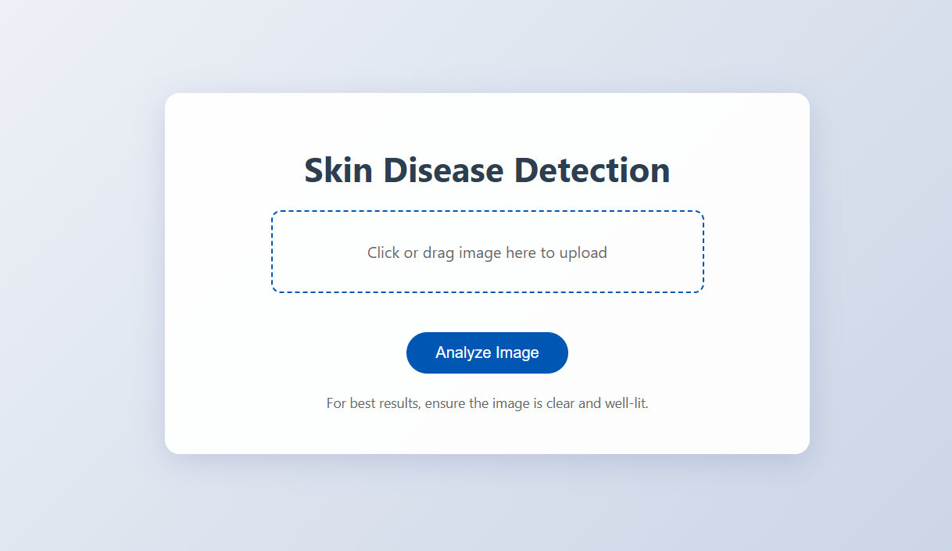

Fig. 4 Homepage

Prediction Button: A dedicated "Predict" button triggers the backend model to process the uploaded image and provide a diagnosis.

Clear Instructions: Clear guidelines are displayed, encouraging users to upload well-lit and focused images for accurate analysis.

Fig. 5 Interface after uploading image

Real-Time Feedback: After processing, the system displays the predicted skin disease directly on the interface, enabling quick access to diagnostic results.

Mobile-Friendly: The interface design ensures compatibility with mobile devices, making it suitable for remote healthcare applications.

Flask Integration: The interface seamlessly integrates with the Flask backend, which processes the image using the trained ResNet-SVM model and returns predictions.

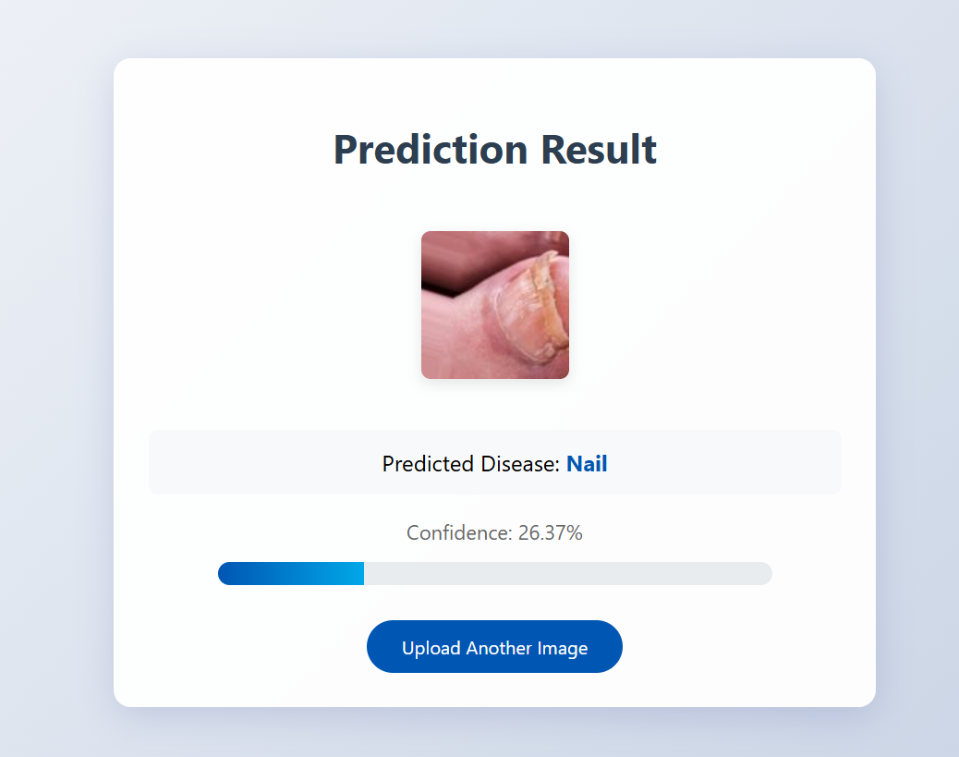

Fig. 5 Predicted result in result page

**CHALLENGES AND LIMITATIONS**

Despite the effectiveness of the proposed skin disease detection system, several challenges and limitations affect its performance and scalability. One of the primary challenges is **data availability and diversity**. Access to large, diverse, and well-annotated dermatological image datasets is often limited, which can hinder the generalizability of the model across various skin tones, lighting conditions, and lesion types. **Image quality**  presents additional obstacles, as variations in resolution, lighting, and background may impact the accuracy of preprocessing, segmentation, and feature extraction steps.

Another significant limitation is the **complexity and variability of skin lesions**. Different diseases may exhibit similar visual patterns, making accurate classification challenging. Moreover, deep learning models, while powerful, are often perceived as **black-box systems** with limited interpretability, making it difficult for clinicians to fully trust automated predictions without clear visual explanations or feature importance analyses. **Computational cost** is also a concern; advanced models like CNNs require significant processing power and memory, which can be a barrier for real-time, resource-constrained applications such as mobile diagnostics.

Lastly, **ethical and regulatory challenges** in the medical domain require rigorous validation and compliance with healthcare standards to ensure safety and effectiveness. Addressing these challenges through improved datasets, explainable AI techniques, efficient algorithms, and ethical considerations will be critical for further advancing automated dermatological diagnostics.

**EXPERIMENTAL RESULTS AND ANALYSIS**

This section presents a comparative analysis of two skin disease detection models: a ResNet-based model and a VGG16-SVM model. Both models were evaluated on the same dataset of 234 images, encompassing eight distinct skin disease categories. Performance was assessed using precision, recall, F1-score, and accuracy.

**Model Performance: ResNet vs. VGG16-SVM**

The following table summarizes the performance of both models:

**Table** **2**: Accuracy, macro avg and weighted avg F1-score

|  |  |  |  |
| --- | --- | --- | --- |
| **Model** | **Accuracy** | **Macro Avg F1-Score** | **Weighted Avg F1-Score** |
| ResNet | 0.94 | 0.94 | 0.94 |
| VGG16-SVM | 0.87 | 0.86 | 0.87 |

The ResNet model significantly outperformed the VGG16-SVM model, achieving a 7% higher accuracy and an approximately 8% higher macro-averaged F1-score. This suggests that ResNet's deeper architecture and skip connections were more effective in learning the complex features necessary for accurate skin disease classification.

**Class-Specific Performance Comparison**

The following table details the class-specific performance metrics for both models:

**Table** **3**: Class-Specific Performance

|  |  |  |  |  |  |  |  |  |
| --- | --- | --- | --- | --- | --- | --- | --- | --- |
| **Disease Category** | **ResNet Precision** | **ResNet Recall** | **ResNet F1-Score** | **VGG16-SVM Precision** | **VGG16-SVM Recall** | **VGG16-SVM F1-Score** | **ResNet Support** | **VGG16-SVM Support** |
| VI-shingles | 0.94 | 0.97 | 0.96 | 0.80 | 0.97 | 0.88 | 33 | 33 |
| VI-chickenpox | 1.00 | 1.00 | 1.00 | 0.97 | 0.94 | 0.96 | 34 | 34 |
| BA-cellulitis | 0.76 | 0.94 | 0.84 | 0.76 | 0.91 | 0.83 | 34 | 34 |
| FU-athlete-foot | 0.97 | 0.91 | 0.94 | 1.00 | 0.78 | 0.88 | 32 | 32 |
| BA-impetigo | 1.00 | 0.95 | 0.97 | 0.95 | 0.90 | 0.92 | 20 | 20 |
| FU-nail-fungus | 1.00 | 1.00 | 1.00 | 0.82 | 1.00 | 0.90 | 33 | 33 |
| FU-ringworm | 1.00 | 0.83 | 0.90 | 1.00 | 0.70 | 0.82 | 23 | 23 |
| PA-cutaneous-larva-migrans | 0.91 | 0.84 | 0.87 | 0.80 | 0.64 | 0.71 | 25 | 25 |

**Analysis of Class-Specific Results**

The ResNet model consistently outperformed VGG16-SVM across most classes, with particularly noticeable improvements in FU-athlete-foot and PA-cutaneous-larva-migrans. Both models struggled somewhat with BA-cellulitis, highlighting the need for further investigation into this specific class.

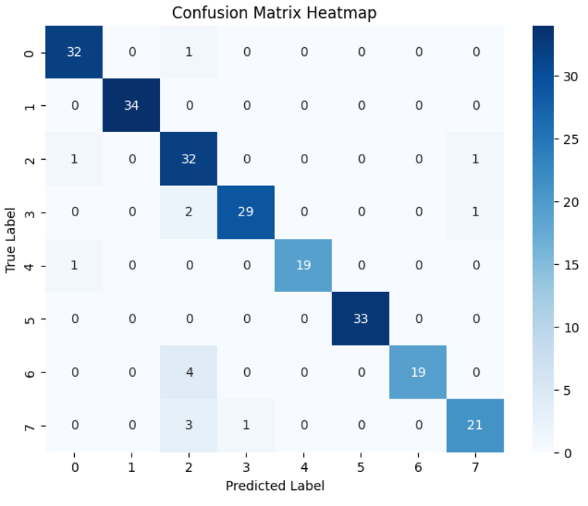

Fig 8. confusion matrix of RESNET-SVM predictions

**APPLICATIONS IN CLINICAL PRACTICE**

The proposed skin disease detection system, leveraging image processing and machine learning techniques, offers significant applications in clinical practice, enhancing diagnostic accuracy and efficiency. By automating the analysis of dermatological images, this system provides valuable support to dermatologists and healthcare practitioners in diagnosing skin conditions, particularly in regions with limited access to specialized care. It can serve as a **diagnostic aid** by offering a preliminary assessment of skin lesions, reducing the time required for manual examination and facilitating early detection of serious conditions like melanoma.

The system’s capability to provide high-accuracy classification can be integrated into **teledermatology platforms**, allowing patients to upload skin images for remote evaluation. This enhances accessibility to dermatological consultations, especially for individuals in remote or underserved areas. Additionally, the system can be incorporated into **mobile health applications**, empowering users with real-time assessments and recommendations, which can encourage proactive skin health management.

For educational purposes, the system can be used in **medical training programs** to help students and trainees familiarize themselves with different skin conditions and diagnostic approaches. In clinical research, it can assist in **data-driven studies** by providing consistent and reliable analysis of large dermatological datasets, supporting advancements in personalized treatment strategies. Furthermore, its integration with **electronic health record (EHR) systems** can streamline the documentation process, improving workflow efficiency in dermatological clinics.

Overall, the proposed system enhances clinical decision-making, improves diagnostic consistency, and increases accessibility to dermatological care, thereby contributing to better patient outcomes and more efficient healthcare services.

**FUTURE DIRECTIONS**

The proposed skin disease detection system demonstrates promising results; however, there are several areas for future enhancements to improve its accuracy, robustness, and applicability in clinical settings.

One of the key directions is the expansion of the dataset to include a more diverse range of skin types, tones, and disease variations to ensure generalizability and reduce biases. Incorporating larger and more heterogeneous datasets will enhance the model’s reliability across different populations.

Another critical area for future work is the integration of **deep learning-based architectures** such as advanced versions of Convolutional Neural Networks (CNNs) or hybrid models combining Res Net with transformers to capture complex patterns in skin lesions more effectively. Additionally, **explainable AI techniques** should be explored to provide insights into model predictions, increasing trust and acceptance among clinicians by making the decision-making process transparent.

Real-time processing capabilities and mobile-based implementations could extend the system's usability in **remote and resource-constrained settings** through lightweight models optimized for mobile devices. Enhancements in **user interfaces** can make the tool more accessible to non-specialists, enabling widespread adoption in telemedicine applications. Furthermore, integrating this diagnostic system with **predictive analytics** and **personalized treatment recommendations** could transform it into a comprehensive dermatological management tool.

Finally, collaborative efforts with medical professionals to continuously refine and validate the system against gold-standard clinical diagnoses will be essential for regulatory approvals and large-scale deployment. These advancements will contribute to improved dermatological healthcare and broaden access to automated skin disease diagnosis worldwide.

**CONCLUSION**

In conclusion, the proposed skin disease determination system demonstrates the effectiveness of leveraging image processing techniques and machine learning models for accurate and efficient diagnosis. By employing methods such as noise filtering, grayscale conversion, and image segmentation, the system enhances the quality of input data, enabling robust feature extraction to minimize computational complexity. The classification using a Support Vector Machine (SVM) provides reliable identification of skin diseases, including rosacea, melanoma, psoriasis, and acne, achieving an overall accuracy of 94%.

This approach not only reduces diagnostic time but also improves accessibility to dermatological care, particularly in densely populated or resource-limited regions. Despite its success, challenges remain, including the need for more diverse datasets and further refinement of feature extraction methods to improve accuracy across a broader range of skin conditions. Future work will focus on incorporating deep learning architectures, real-time processing capabilities, and explainable AI to enhance performance and transparency. Ultimately, the system represents a significant step forward in automated dermatological diagnostics, contributing to better healthcare outcomes and more proactive disease management.

**REFERENCES**

[1] Haralick R.M, Shanmugam K and Dinstein I, Textural features for image classification, IEEE Trans. Syst, Man, Cybern, 3 (6), 1973, 610–621.

[2] Jeffrey Glaister, Student Member, IEEE, Alexander Wong, Member, IEEE, and David Clausi A, Segmentation of Skin Lesions From Digital Images Using Joint Statistical Texture Distinctiveness, IEEE Transactions On Biomedical Engineering, 61 (4), 2014.

[3] Kavitha V, Palanisamy V, A Survey of Deflection Routing Techniques in Optical Burst Switching Networks, Archives Des Sciences, 66 (3), 2013, 704-712.

[4] Palanivel Rajan S, Cellular Phone based Biomedical System for Health Care, IEEE Digital Library Xplore, IEEE Catalog Number, CFP1044K-ART, 2010, 550-553.

[5] J. Arevalo, A. Cruz-Roa, V. Arias, E. Romero, and F. A. Gonzalez. An unsupervised feature learning framework for basal cell carcinoma image analysis. Artificial intelligence in medicine, 2015.

[6] Esteva, A., Kuprel, B., Novoa, R. A., Ko, J., Swetter, S. M., Blau, H. M., & Thrun, S., Dermatologist-level classification of skin cancer with deep neural networks, *Nature*, 542(7639), 2017, 115–118.

[7] Codella, N. C. F., Nguyen, Q. B., Pankanti, S., Gutman, D., Helba, B., Halpern, A., & Smith, J. R., Deep learning ensembles for melanoma recognition in dermoscopy images, *IBM Journal of Research and Development*, 61(4/5), 2017, 5:1–5:15.

[8] Brinker, T. J., Hekler, A., Utikal, J. S., Grabe, N., Schadendorf, D., Klode, J., & Berking, C., Skin cancer classification using convolutional neural networks: Systematic review, *Journal of the American Academy of Dermatology*, 80(2), 2019, 611–622.