ACE Design Study Summary
Subject
Configuration Management
Author |  | Date Prepared | A-Course Week # | A-Course Session
Student Name |  | Date | Week # | A-Course 2016-2017
Contents | 1. Problem/Purpose  2. References |  | 3. Assumptions  4. Results |  | 5. Conclusions
1. Problem/Purpose
This section of the DSS contains the background about the Design Study Summary, including brief statements of:
- The problem or purpose that precipitated the work (i.e.: its context)
- The specific objective or intention of this particular study.
- The general approach/method used in its solution.

2. References
A numbered list of references (textbooks, notes, Technical Memorandums, Design Practices, computer programs) having a direct bearing on the study.
Refer to the references by number as appropriate in the Analysis.

3. Assumptions
A numbered list of significant assumptions used in the course of the study. Justification(s) and/or pertinent reasons for each are documented in the Design Study Discussion. Use of complete sentences or phrases helps avoid ambiguity.

4. Results
Key results determined in the study.
Can refer to additional result detail (e.g. tables, plots, etc.) contained within the supporting analysis documentation but should contain enough information here to give the reader insight into the results of the report.

5. Conclusions
Overall findings, conclusions & recommendations.
This DSS Cover Sheet is designed to be a brief, but thorough synopsis of the entire report. Remember that many potential readers of your future reports and papers will decide whether it is worth the bother to read them based on the information content of the DSS Cover Sheet. (Your course reports will be read and graded in any case, but keep this point in mind for later.) Spend extra effort on your DSS Cover Sheets to make them clear, concise and informative. While it is usually the last part of the report that you write, the DSS is not the least important.

PROPRIETARY INFORMATION The information contained in this document is proprietary information and is disclosed in confidence. It shall not be used, disclosed to others, reproduced, or exported without the express written consent of Greenberry Inc. If consent is given for reproduction in whole or in part, this notice and the notice set forth on each page of this document shall appear in any such reproduction in whole or in part.

CONFIGURATION MANAGEMENT PLAN

COPYRIGHT © 2015 GREENBERRY INC.
ALL RIGHTS RESERVED
Revision History
Revision | Remarks | Approval
 | Author:  Date:
  Name
  Job Title
Table of Contents
1. INTRODUCTION 1
1.1 Purpose and Scope 1
1.2 Change Control 1
1.3 Relationship to Other Plans 1
2. REFERENCED DOCUMENTS 2
2.1 Non-Regulatory Documents 2
2.2 Regulatory Documents 2
2.2.1 Specifications 2
2.2.2 Standards 2
2.2.3 Drawings 2
2.2.4 Other Publications 2
3. GENERIC CONFIGURATION MANAGEMENT PLAN 3
3.1 CM Management and Roles 3
3.1.1 Roles 3
3.1.2 Organizations 3
3.2 CM Activities 4
3.2.1 Configuration Identification 4
3.2.2 Planning of Releases 4
3.2.3 Configuration Control during Development 4
3.2.3.1 Requesting Changes 4
3.2.3.2 Evaluating Changes 4
3.2.3.3 Dispositioning Changes 4
3.2.3.4 Implementing Changes 4
3.2.4 Configuration of COTS Tools 4
3.2.5 System Administration 4
3.3 CM Schedules 5
3.3.1 Database Synchronization 5
3.3.2 Backups 5
3.3.3 Archivals 5
3.3.4 Baselines 5
3.4 CM Resources 6
3.4.1 Software Resources 6
3.4.2 Hardware Resources 6
3.4.3 Human Resources 6
3.5 SYSTEMS CONFIGURATION MANAGEMENT PLAN 7
3.6 Scope of Life Cycle Data 7
3.6.1 Developmental Life Cycle Data 7
3.6.2 Acquired Life Cycle Data 7
3.7 CM Life Cycle 7
4. SOFTWARE CONFIGURATION MANAGEMENT PLAN 8
4.1 Scope of Life Cycle Data 8
4.1.1 Developmental Life Cycle Data 8
4.1.2 Acquired Life Cycle Data 8
4.2 CM Life Cycle 8
5. HARDWARE CONFIGURATION MANAGEMENT PLAN 9
5.1 Scope of Life Cycle Data 9
5.1.1 Developmental Life Cycle Data 9
5.1.2 Acquired Life Cycle Data 9
5.2 CM Life Cycle 9
5.3 Physical Hardware Configuration Management 9
Appendix A – PR Analysis Template 10
Appendix B – Means of Compliance to Industry Standards 11

INTRODUCTION

Purpose and Scope
This configuration management plan is created to support and manage the changes on our existing Aircraft Door System (ADS). The two customers Aering Boebus and Syrupwell have both signed a contract to be supplied with the system pending some modifications are made to the existing design. This plan is to ensure all configuration management tools are used within the development, including specific configuration plans for Hardware, Software and Systems’
The purpose of this plan is to ensure all components, documents and the structure remain identified correctly. Manage all of the changes and releases to all documentation, creating a record and reporting the status of these to the project management.
All changes shall be version controlled and shall be managed exclusively within the GitHub tool.

Change Control
The Document Management Configuration System tool will use revision control to ensure the traceability of all configurable items on the projects. This will require the identifier to be changed whenever the configurable item is changed. When a configurable item is released the version is maintained and controlled by the Production Configuration Management System. When An Item is released to production it shall ensure the item revision number is changed before release.
Changes being made to CC1 controlled items shall follow the problem report lifecycle.
This document shall be introduced in a draft stage until all party’s involved in its development sign off on the first revision. Following this the document shall be released on GitHub and shall be subject to change control. The following rules must be followed to change the CMP:
- Raise a Change Request (CR) or Problem Report (PR)
- Following the approval of the CR or PR create a Redline Mark-Up of the document you are wishing to change in your workspace.
- Have the mark-up be sent to the relevant Departments to review the changes you are wanting to make.
- Review decisions made by other departments and make the further changes if required.
- Have the relevant departments review the document if further changes are made.
- If all changes are agreed upon, upload the document(s) to GitHub and process the CR or PR to final approval.
- Once approved the documents will be uploaded to the relevant location Up-revving the previous document published in the folder pending approval from the Configuration Control Board.

Relationship to Other Plans
This Configuration Management Plan (CMP) is a part of the planning suite of documents for the GE Home Energy Monitor & Optimization project and is a supplement to the project development plans.

Abbreviations
DL | Developmental Library
CMP | Configuration Management Plan
IMA | Integrated Modular Avionics
SCI | Software Configuration Index
CSCI | Computer Software Configuration Item

REFERENCED DOCUMENTS

Non-Regulatory Documents
(TBD)

Regulatory Documents

Specifications
(TBD)

Standards
(TBD)

Drawings
(TBD)

Other Publications
(list any reference documents here)

GENERIC CONFIGURATION MANAGEMENT PLAN
The contents of this section are to be applied to all aspects of the development including hardware, software and systems.

CM Management and Roles

Roles
(Text goes here)

Organizations
(Text goes here)

CM Activities

Configuration Identification
All items shall be classified into a category and sub category, along with a uniquely identified number and a descriptive name. For Example:
Category: Mechanical Sub-category: Latch Mech
ADS126-00 Door Latching Mechanism assembly.prt

Planning of Releases
As part of the release process of documentation, SW or HW there is various stages to be covered to ensure all CI’s are flowing throughout the process.
There are three types of releases on this project – Prototype, Internal Releases and Customer Releases.
Prototype – These are internal to the team that created them and hold the least risk to the project. This release to the project would look at the requirements and the goal the prototype is trying to achieve. Design for the requirements and develop the idea and test within the team only releasing the information within the team that developed it. (Note: for larger more expensive prototypes documentation on the learning may be required by the project)
Internal Release - This release is internal to the project and the company. This will compose of a larger team creating a document intended to be uploaded to the CM system and used for the development of the project. For HW & SW items this would require testing before releasing the part/document.
Customer release – This is a formal release external to the company. For this level of release all documentation linked shall have to be stored on the CM system and have been internally released within the project. They will not be in the draft stage and shall be signed of by the relevant engineers in the departments as well as the chief engineer on the project. All CI related to this must be available for the customer to request if applicable.
State Chart:
(Identify the different stages of release, this could also mean various releases, stating what each requires).

Configuration Control during Development

Requesting Changes
Integrated into the system will be the ability to raise both a problem report and a change request. This will allow automatic association with the changes and the related documentation/parts.
Once a PR or CR has been selected the person raising the change will have to fill in the report to a set format on the internal system in this case TipQA shall be used.
(Text goes here – consider the types of changes which maybe encountered)

Evaluating Changes
All change requests are to be evaluated by all relevant parties.
Documentation Changes will result in a combination if not all the bellow parties:

Dispositioning Changes
Dispositioning of changes relies on the team lead for that department. After the change has been reviewed by the relevant parties and a decision has been made to accept or reject the request it is the team leads responsibility to disposition the request within the system allowing the change to progress or giving a valid reason as to why the change is not being allowed to progress.

Implementing Changes
(Text goes here)

Configuration of COTS Tools
(Detail how tool versions will be managed)

System Administration
(Administration of the CM system)

CM Schedules

Database Synchronization
(Text goes here)

Backups
(Text goes here)

Archivals
(Text goes here)

Baselines
(Text goes here)

CM Resources

Software Resources
(Text goes here)

Hardware Resources
(Text goes here)

Human Resources
(Text goes here)

SYSTEMS CONFIGURATION MANAGEMENT PLAN
This section identifies the systems domain specific configuration management requirements to be followed in addition to section 3.

Scope of Life Cycle Data

Developmental Life Cycle Data
(Text goes here)

Acquired Life Cycle Data
(Text goes here)

CM Life Cycle
(Diagram and Text go here identifying the stages of the configuration management lifecycle for the identified lifecycle data e.g. documents, requirements etc.)

SOFTWARE CONFIGURATION MANAGEMENT PLAN
This section identifies the software domain specific configuration management requirements to be followed in addition to section 3.

Scope of Life Cycle Data
This section identifies the means of uniquely naming and describing software life cycle data in order that each data item is under configuration control and is traceable to the relevant configuration items (for example part numbers and file names). The software configuration management plan shall follow section 3 (and subsections) unless identified specifically within this section. This section takes precedence if there exist conflicts with section 3.

Developmental Life Cycle Data

Software Development
This section concerns subsystems of the ADS that are developed in-house and are hence subject to the review and release lifecycle as defined in GE Aviation Software Engineering Process. All software items under development should include a variant identifier as part of the DL specification and filename. The “variant tag” shall identify the variant for which the item was created, although items from one variant many be used for another variant. “Variant tags” shall be a minimum of 2 characters – the first character is the major variant control and the second is the minor. “Variant tag” conventions shall be described in the SDP (Software Development Plan).

Software Items
For each software object under development made to fulfil a specific function, the following Design and Code items shall exist:
- Design Module Specification (MSP)
- Code interface / header file
- Code implementation file (s)
- Assembler files, if required
The following test items shall exist:
- Module Test Plan
- Module Test Results
The following scrutinies shall exist:
- MSP scrutiny
- Code scrutiny
- Module Test Plan Scrutiny
- Module Test Results Scrutiny

Software Baselines
Baselines are implemented at the beginning of development and maintained as updates are included during development of that release. All baselines shall contain references to artefacts under configuration control. The release baseline shall reference all the baselines that factor into that particular release, indicated by a specific release identifier. The parent baseline shall be referenced and the reason for its superseding in order to qualify its validity:
- Superseded due to implementation of change requests: parent baseline is technically correct and is therefore “valid”
- Superseded due to correction of problems: parent baseline contains errors and is therefore “invalid”

Software Version Control
Code development shall be managed throughout the development and build process using version control procedures. These shall include practices of check out, check in and merging using process-oriented tools that are shared under a common protocol by all the software developers.

Acquired Life Cycle Data

Software Acquisition
This section concerns subsystems of the ADS that are bought-in and thereby developed by external stakeholders. Computer Software Configuration Items (CSCIs) are aggregations of software that satisfy an end-use function and are designated for separate configuration management by the ADS system.

Software Items
Each CSCI must be tested and subjected to scrutiny and shall have the following items:
- CSCI Integration Test Plan
- CSCI Integration Test Results
- CSCI Integration Test Plan Scrutiny
- CSCI Integration Test Results Scrutiny
The software identification for each CSCI shall be identified in the SCI for each item, along with the designated part number, the production format for which is included in the SDP.

Software Baselines
The configuration items representing inputs to the software lifecycle process should be baselined prior to use in that stage of the lifecycle. Baselines should be captured in a document, and any changes to the established baseline controlled using a Change Request. The planning baseline shall be under PR control.

CM Life Cycle
The software development process at each stage implements:
- Version control
- Change control
- Problem tracking
- Build management
- Requirements tracking
- Activity management
- Document management
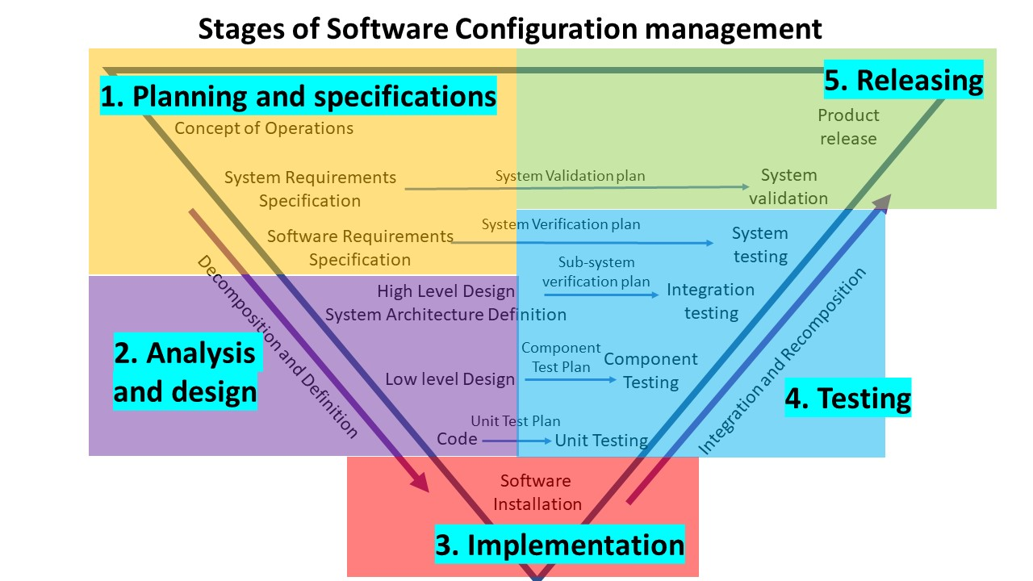

HARDWARE CONFIGURATION MANAGEMENT PLAN
This section identifies the hardware domain specific configuration management requirements to be followed in addition to section 3.

Scope of Life Cycle Data
Hardware configuration control for the ADS comprise both mechanical data items, electrical data items and electronic data items. All these items are in possession of unique hardware part identification numbers.

Developmental Life Cycle Data

Mechanical data items (e.g. drawings and models) shall be developed and retained under development configuration control. Once reviewed and approved for release, the data item shall be exported and placed under production configuration control. Acquired Life Cycle Data
(Text goes here)

CM Life Cycle
(Diagram and Text go here identifying the stages of the configuration management lifecycle for the identified lifecycle data e.g. documents, requirements etc.)

Physical Hardware Configuration Management
(Text goes here)

Appendix A – PR Analysis Template

Appendix B – Means of Compliance to Industry Standards
Discussion
The discussion is your opportunity to philosophize about the problem and the work you have done on it. It is also your opportunity to convince the reader of your expertise. Some important things to consider are whether or not your results are reasonable and usable, how the various assumptions that you made affected the results, other methods of solving the problem or extensions of the analysis that might pay off and practical applications of your results. Some problem statements may contain specific points to be discussed in the Analysis section. You should still cover any of the general areas mentioned that seem appropriate to expand upon in the Discussion section.
Some suggestions for Discussion topics are:
- Defend the validity of your assumptions
  - Is the assumption reasonable (preliminary vs. detailed study?)
  - If not met, what is the impact on the analysis and/or results?
- Discuss the method used to solve the problem and comment on other methods
- Explore new insights gained from the analysis
- Relate the problem to your work or other experiences (but keep it exportable)
- Make sure you cover all discussion points requested in the problem statement (but no need to limit yourself to them)
- Avoid filler material (restating the analysis, etc.)
The excellence of the discussion is measured by its content, not by its length.

Also include the other aspects required:
- Usage of OpenGE – print screens

