## What is Project Y?

We are the Los Alamos High School Robotics Team founded in 2012. Our mission is to increase Science, Technology, Engineering, and Mathematics (STEM) educational opportunities in Northern New Mexico. We have seen through 11 generations of students and built 10 generations of robots. Our organization is largely student run, with our mentors functioning as safety nets and knowledge sources. In 2022, we were the only team from New Mexico to compete in the *FIRST* Worlds Championship, which was the second time for Project Y. This past season, we were one of two Texas District Championship winners of the Engineering Inspiration Award, an award which recognizes a team that has worked to further STEM in their community.

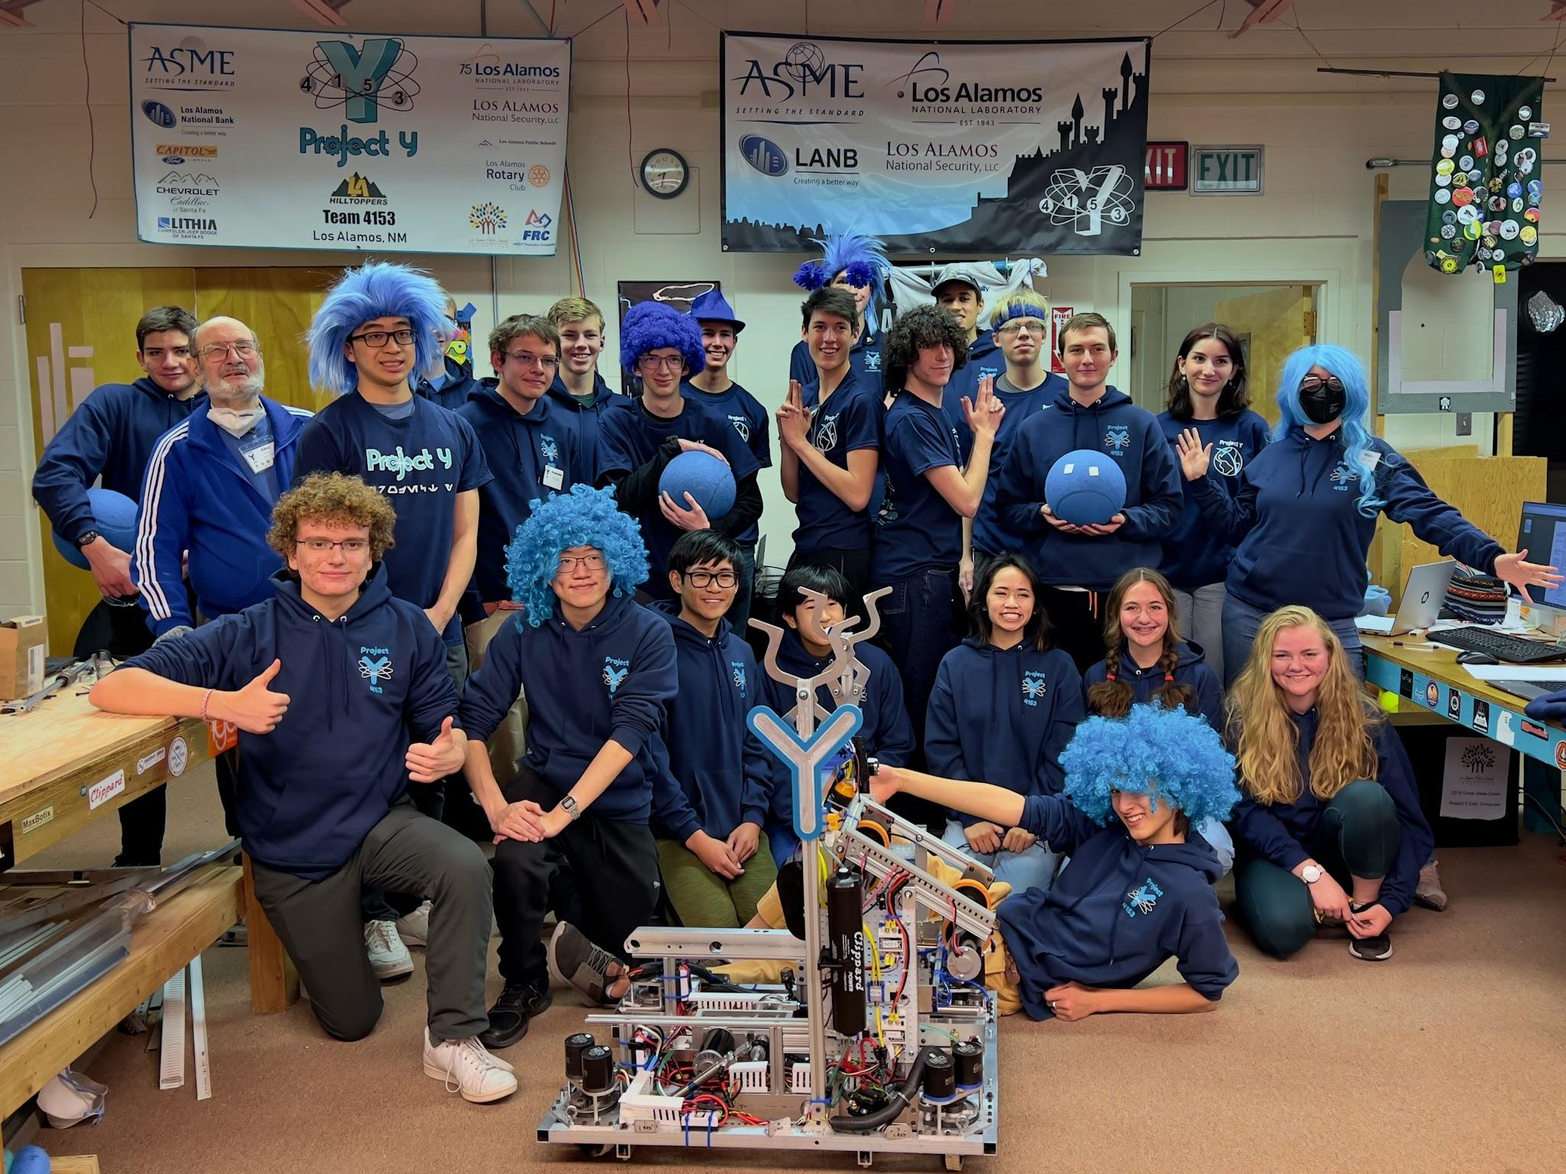

## 

## What is *FIRST*?

*FIRST* (For Inspiration and Recognition in Science and Technology) is a global non-profit organization that encourages involvement in STEM. *FIRST* does this through the graduated series of programs: 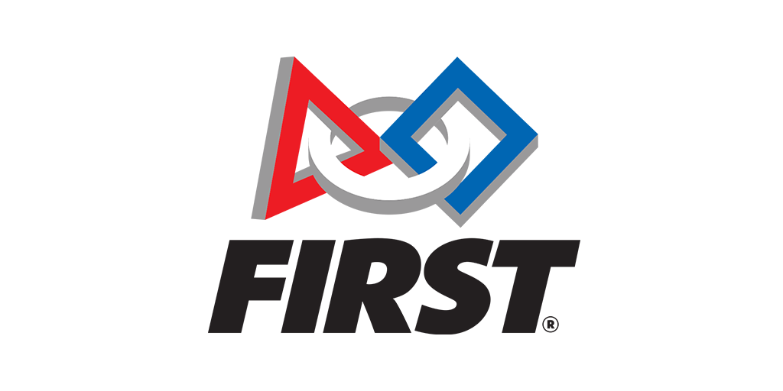

* FLL - *FIRST* LEGO League (4-16 years old)
* FTC - *FIRST* Tech Challenge (12-18 years old)
* FRC - *FIRST* Robotics Competition (14-18 years old)

*FIRST* provides students with additional opportunities in the form of networking, resumé building, and over $80 million in scholarships at a wide range of institutions.

## 

## What is FRC?

FRC stands for *FIRST* Robotics Competition. The competition season starts in early January with a kickoff event where the season’s game details are announced. Teams then have nominally six weeks to build a robot from scratch to compete in that year’s challenge. Throughout this time period, students learn and apply technical skills like computer-aided design, machining, and programming. Students also develop life skills like teamwork, communication, entrepreneurship, and leadership. After those six weeks, we head to competition. Because of the small number of teams in NM, NM teams compete in the Texas District events and attend 1-2 district competitions in order to qualify for District Championships. Depending on their overall rank after District Championships, teams can then qualify for the *FIRST* World Championships.

## 

## What do we really do?

In the words of *FIRST* founder Dean Kamen, “We don’t use students to build robots, we use robots to build students.” *FIRST* serves as a vehicle through which students learn skills that are not typically taught in school. By plunging students into real-life engineering scenarios that force them to think and work like engineers and entrepreneurs, they become college and career ready in a way that very few classes in school can teach. This program provides the experiential education and problem solving skills many employers, researchers, and colleges seek .

## 

## *FIRST* Culture

*FIRST'*s culture works to combine an exciting STEM environment with the energy and enthusiasm often found in sports. One of the core tenants is “Gracious Professionalism®.” Gracious Professionalism is, at its simplest, a more comprehensive version of sportsmanship. The idea is to foster a supportive and friendly environment while making sure everyone is contributing and competing at their highest level. Competitions are set up so that every team is given an opportunity to play with and against all the other teams. This leads to close “cooperation” (a combination of cooperation and competition), a friendly environment, and dynamics that go beyond “just building a robot”.

The culture of *FIRST* is what distinguishes it from other robotics competitions. Teams often help each other research ideas, understand concepts, and build mechanisms. Team members often become close to those within and outside of the team, creating friendships that cross cultural and socioeconomic boundaries.

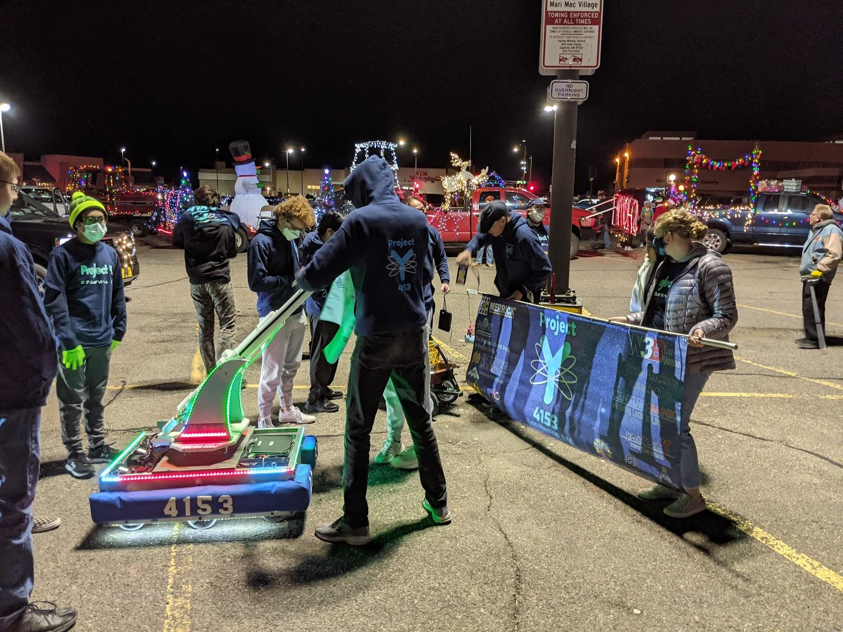

## Project Y’s impact in the community

Project Y established a STEM Center in Los Alamos in collaboration with Los Alamos Public Schools. The STEM Center provides workspace and tools for all ages of robotics programs, serving over 100 students per year. Project Y participates in outreach activities to promote STEM and generate interest and excitement in robotics. We have actively mentored teams in Española, Pojoaque , and Santa Fe to expand opportunities in our neighboring communities.

## 

## 

## Challenges of running an FRC Team

FRC is challenging long before kickoff and build season begins. Teams need tools, materials, a workshop and mentors who have skills ranging from machining to programming. To finance all of this, FRC teams usually seek sponsors, a challenge in and of its own. Finally, once a team has the capability to build a robot, they run into further challenges when they compete. You need additional funding to cover *FIRST* registration fees and travel. All these obstacles make it extremely difficult for new teams, especially in New Mexico to get a strong foothold, resulting in fewer opportunities for those new teams.

## Struggling through COVID

Unfortunately, running a team in New Mexico during the pandemic ranges from challenging to almost impossible. One example is a team in Santa Fe named Feles Numine. They were providing STEM education to impoverished areas of Sante Fe that typically didn’t receive those types of opportunities. However, they struggled gaining community support and received limited resources. The lack of interest, combined with the state lockdown, lead to their eventual collapse. Another example is a team in Española named The Botcats. Even though their team stayed together during quarantine, they lost their lead mentor and struggled to complete their robot. Fortunately, our team was able to help get them driving and playing so they could compete. These instances of struggling teams may be thought of as far and few between, but that is not the case. Almost every single team from this state faces similar challenges of support and funding. We want to change that.

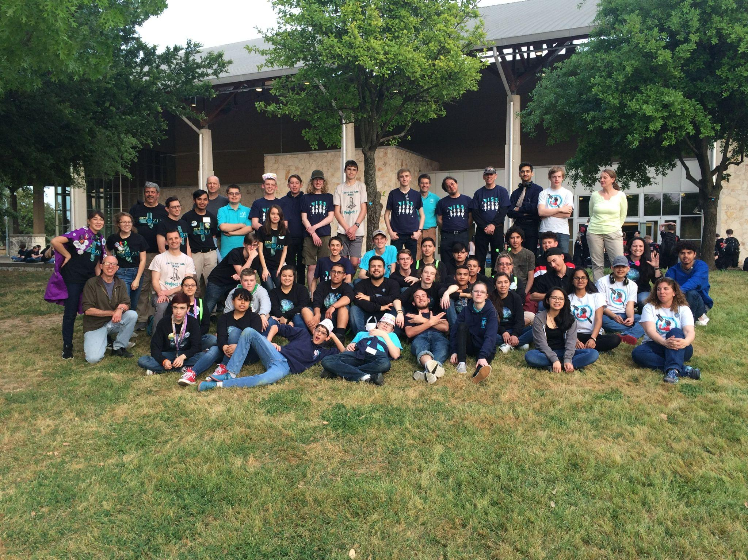

## Our goals

Project Y’s goal is to expand *FIRST* programs and increase access and overall awareness for STEM education to the rest of New Mexico. We currently only have 10 active FRC teams within the state, and we want to make that 100!

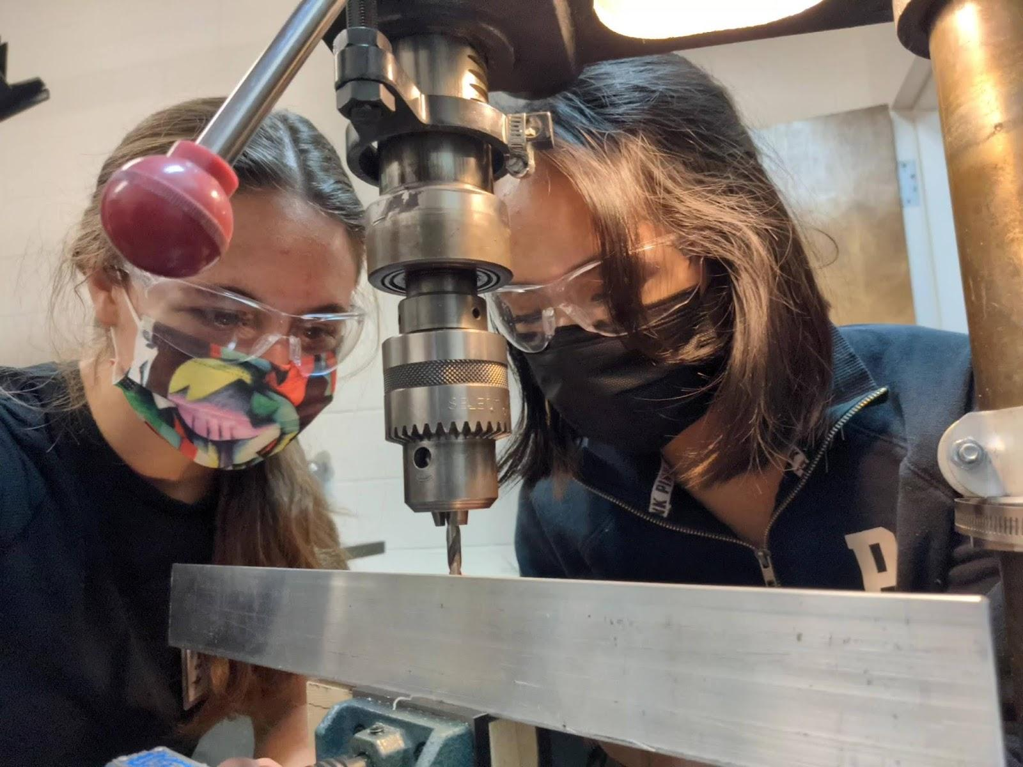

## How are we going to do this?

We believe that the best way to achieve this is through a public-private partnership with the State of New Mexico. Taking inspiration from the *FIRST* in Texas model, this would provide teams with initial funding to get basic materials and tools while also covering administrative fees such as the cost of registration, which will be $6,000 per team in 2023 (or more if qualifying for additional competition, like the world championship). Crucially, this provides teams with the necessary funds to operate, and still encourages teams to go out and garner support and funding from their community. Additionally, this plan would include funds to open more STEM Centers across New Mexico that would house all levels of *FIRST* Programs.

Another concern is finding mentors. We, here in Los Alamos, are fortunate to have mentors who spend their day at the laboratory applying principles of engineering and science on a daily basis. They also generously volunteer their time after work. This, unfortunately, is not feasible in many other areas of the state. Running an FRC Team can be a second job in itself, and it can be difficult to justify it without some kind of return. That is why we are also asking for support to provide teams with a budget for stipends that could compensate mentors for their time.

We are also concerned with increasing recognition in NM for robotics activities at the school level. We have been speaking with Secretary of Education Dr. Kurt Steinhaus and NMAA Board President Sally Marquez to initiate the process to recognize robotics under NMAA. We also plan to speak to the Legislative Education Study Group to help solidify *FIRST* Robotics as a viable solution for creating STEM education opportunities within the state.

Due to the geography of New Mexico, getting together in person isn’t always possible. That’s why we want to create an online learning network for students as well as to provide asynchronous learning opportunities. When we *can* get together, Project Y also wants to coordinate events with other teams. Events we plan to host include a “*FIRST* Steps” event (<http://team4153.org/first-in-nm-workshop/>) where we would coordinate with the state and with other teams to teach educators on how to start an FRC team. In addition, we plan to continue our outreach with our normal events which will return after the pandemic. We hope that our efforts eventually culminate in our co-hosting the first ever FRC competition in Albuquerque.

## 

## 

## Are you ready to help?

Sharing this information with others is a great start. Many people in New Mexico are not aware of these programs, and we are confident that many would be interested in participating. If any of the information above caught your attention, please consider becoming involved with a team near you. Teams are always looking for new members, mentors, and sponsors -- we would love to have you. If you are interested, email us at [info@team4153.org](mailto:info@team4153.org) or visit us at our website <http://team4153.org>.