University of Cape Town · Department of Information Systems
INF4027W Information Systems Honours: Systems Development Project 2026
FreightProof SA
Verified chain of custody for South African road freight
Iteration 4 Documentation
Team 05
Ciaran Formby (Product Owner) · [ADD STUDENT NUMBER]
Tim Gultig (Scrum Master) · [ADD STUDENT NUMBER]
Thomas Davis (Developer) · [ADD STUDENT NUMBER]
Chiko Kasongo (Developer) · [ADD STUDENT NUMBER]
Industry partner: Bruce van Wyk, Load Factor Group
Supervisors: Elsje Scott, Ammar Canani, Maureen Tanner, Ridewaan Hanslo
Submitted 23 October 2026

Table of Contents

Glossary 6
1. Project Background 8
1.1 Industry Setting 8
1.2 Industry Partner and Sponsorship 8
1.3 System Overview 9
2. Business Problems 10
3. Business, Project and System Objectives 11
3.1 Business Objectives 11
3.2 Project Objectives 11
3.3 System Objectives 12
3.4 Traceability from Problems to Objectives 13
4. Risk Assessment 14
5. Updated Project Plan and Revisions 16
5.1 Project Timeline 16
5.2 Delivery Against Iteration 3 Commitments 16
5.3 Iteration 4 Release Slice 17
5.4 Known Limitations 17
6. Analysis and Design Work Products 19
6.1 Package Diagram 19
6.2 Analysis Class Diagram 20
6.3 Use-Case Model and System Boundary 21
6.4 Business Rules 24
6.5 New and Changed Use-Case Narratives 26
6.6 State-Machine Diagram 29
6.7 Database Schema Changes 31
7. Architecture 33
7.1 Deployment Architecture 33
7.2 Integrity Model and Terminology 34
7.3 Configured Values and Their Rationale 34
7.4 Legal Standing of the Receiver's Signature 35
7.5 Integration Status 35
7.6 Quality Attributes 36
8. UI Mock-ups and Design Rationale 37
8.1 Design Approach 37
8.2 Live Trip List: the Summary of the Summary 37
8.3 Trip Timeline 38
8.4 Exception Inbox and Review 40
8.5 Analytics: Today and Trends 41
8.6 Driver App: Arrival and Receiver Handover 43
8.7 Precinct Set-up 44
8.8 Audit Pack and Client Portal 45
9. Testing Approach, Results and Plan 47
9.1 Kinds of Tests 47
9.2 Automated Test Evidence 47
9.3 Failure-Scenario and Load Testing 48
9.4 Risk-to-Test Matrix 49
9.5 Test Plan and Status 49
10. Development Approach, Scrum and Progress 51
10.1 Development Approach and Standards 51
10.2 Sprint 8 51
10.3 Sprint 9 53
10.4 Velocity and Capacity 54
10.5 Reflection on Scrum and Lessons Learnt 56
10.6 Use of AI Tools 56
References 58
Appendix A: Sample Test Cases 59
Appendix B: Addendum – Changes Since Iteration 3 61
Appendix C: Portfolio of Evidence and User Log 63

List of Figures

Figure 1: Package diagram 19
Figure 2: Analysis class diagram 21
Figure 2b: Iteration 4 additions to the analysis class diagram 21
Figure 3: Trip Lifecycle Management use-case diagram (unchanged from Iteration 3) 22
Figure 4: Custody Chain Capture use-case diagram (unchanged from Iteration 3) 23
Figure 5: Trip state-machine diagram 30
Figure 6: Entity relationship diagram 32
Figure 7: Deployment architecture diagram 33
Figure 8: Live trip list: every running trip at a glance 38
Figure 9: Trip timeline: in-transit phase with critical and warning exceptions 39
Figure 10: Trip timeline for a multi-stop trip, with the second leg in progress 40
Figure 11: Exception inbox with claims, and the review form 41
Figure 12: Analytics Today view: today's incidents on the map 41
Figure 13: Analytics Cost tab 42
Figure 14: Analytics headline tiles 42
Figure 15: Incident map in the Today view 42
Figure 16: Analytics for one vehicle 43
Figure 17: Driver app: seal number read from the photograph at Arrival 43
Figure 18: Driver app: QR code for the receiver 44
Figure 19: Driver app: receiver confirmation received 44
Figure 20: Precinct list with geofences 45
Figure 21: Precinct set-up by address search 45
Figure 22: Audit packs tab on the trip page 45
Figure 23: Client portal: verifying an audit pack 46
Figure 24: Summary output of the backend, driver-app and dispatcher test suites, 19 October 2026 48
Figure 25: Sprint 8 burndown chart 52
Figure 26: Sprint 8 task board 53
Figure 27: Sprint 9 task board 54
Figure 28: Sprint 9 burndown chart 54
Figure 29: Committed and completed story points, Sprints 1–9 55

List of Tables

Table 1: Glossary of terms and acronyms 6
Table 2: Existing systems and providers, and their final integration mode 8
Table 3: Business problems in summary 10
Table 4: Business objectives and how each will be measured 11
Table 5: Project objectives and final status 11
Table 6: System objectives, acceptance criteria and status 12
Table 7: Traceability from business problems to objectives and use cases 13
Table 8: Risk status legend 14
Table 9: Risk register, Iteration 4 (Δ = change in score since Iteration 3) 15
Table 10: Project timeline by iteration and sprint 16
Table 11: Iteration 3 commitments and their outcome 16
Table 12: Iteration 4 release slice by story-map activity 17
Table 13: Use-case retention and change index 23
Table 14: Business rules added in Iteration 4 24
Table 15: TLM 1.2 – Create a Trip from a Manifest (changed) 26
Table 16: TLM 1.9 – Review an Exception (changed) 26
Table 17: TLM 1.12 – Issue an Audit Pack (new) 27
Table 18: TLM 1.13 – Trace a Parcel (new) 28
Table 19: CC 1.11 – Record Arrival (new) 28
Table 20: Changed narratives: replacement steps for CC 1.8 and CC 1.10 29
Table 21: Schema changes in Iteration 4 31
Table 22: Deployment nodes and connections 33
Table 23: Configured values and their rationale 35
Table 24: Integration status at the end of Iteration 4 36
Table 25: Screen design rationale 37
Table 26: Test levels used in Iteration 4 47
Table 27: Continuous integration pipeline, run on every pull request 48
Table 28: Failure scenarios and expected behaviour 48
Table 29: Risk-to-test matrix 49
Table 30: Test plan and status at the end of Iteration 4 50
Table 31: Sprint 8 committed backlog (19 items, 84 points) 51
Table 32: Sprint 8 retrospective 53
Table 33: Sprint 9 new backlog (15 items, 77 points) 53
Table 34: Velocity normalised for sprint length 55
Table 35: Story points completed per member in Iteration 4 55
Table 36: Sample test cases 59
Table 37: Changes since Iteration 3 and the feedback they answer 61
Table 38: Contribution scores out of 5 63
Table 39: Sign-off of the user logs 63

Glossary
Acronyms are also written out in full the first time they appear in the text.
Table 1: Glossary of terms and acronyms
Term | Meaning in this document
Anchoring | Publishing the SHA-256 fingerprint of a record to the Hedera Consensus Service so that any later change to the record can be detected. Only the fingerprint leaves FreightProof, never the record.
API (Application Programming Interface) | The defined way one system requests data from another.
Arrival | The phase, new in Iteration 4, in which the driver records the seal as found at a stop before anything is opened.
Audit pack | A frozen, anchored evidence bundle for one trip or consignment, issued to an insurer or principal as a PDF and a verifiable web page.
BO, PO, SO | Business objective, project objective and system objective (§3).
BP | Business problem (§2).
CC | Custody Chain Capture: the driver- and receiver-side use cases.
CI (Continuous Integration) | Automated checks that build and test every change before it joins the shared code.
Client portal | The public web application where an audit-pack recipient views and independently verifies a pack.
Consignment | One waybill on a trip and the parcels it lists.
Corroboration | Comparing independent position sources (driver phone, horse tracker, trailer trackers, precinct) to support or question a recorded action.
"Could not check" | The recorded result when a comparison cannot be made, for example because a position is missing or stale. It is never treated as a match or a mismatch.
Dispatcher / Admin-Dispatcher | The operations users who create and monitor trips and review exceptions. Only an Admin-Dispatcher may change fleet and precinct records.
ECTA | Electronic Communications and Transactions Act 25 of 2002.
Exception | A recorded problem raised by a driver, a dispatcher or the system, with a severity of info, warning or critical.
Fingerprint | A SHA-256 (Secure Hash Algorithm, 256-bit) hash of a record. It is not a digital signature (§7.2).
Geofence | A circular boundary around a precinct used to check whether a position is inside it.
HCS | Hedera Consensus Service, the public ledger service that timestamps fingerprints.
Horse | The truck tractor unit that pulls one or more trailers.
IDV (Identity Verification) | A document-and-face check of a person, provided by Didit and used only for consignments that require it.
LFG | Load Factor Group, FreightProof's industry partner.
Manifest | The client's Parcel Perfect list of waybills for one departure. FreightProof creates a loaded trip from it.
MVP (Minimum Viable Product) | The smallest complete system that runs a trip end to end, with its limitations stated.
Organisation | One tenant of FreightProof: an operator, a principal or both. Users and data are isolated per organisation (§1.3).
OTP (One-Time Password) | A short code sent to a phone or e-mail address to confirm a sign-in or an access request.
Override | A dispatcher action that closes a phase the driver cannot complete. A reason is mandatory and the phase is shown as overridden, never as verified.
Phase | One step in a trip's custody sequence: trip creation, activation, loading, departure, in transit, arrival, unloading or confirmation.
POD (Proof of Delivery) | The evidence captured when cargo is handed over at the destination.
POPIA | Protection of Personal Information Act 4 of 2013.
Precinct | A depot, warehouse or client site where handovers take place, with a location and geofence.
Principal | The organisation, for example a courier, that owns the consignments and contracts the transporter.
PWA (Progressive Web App) | A web application that installs on a phone and keeps working with poor connectivity.
QR code (Quick Response code) | A scannable square barcode. The driver's phone shows one that the receiver scans to confirm delivery.
Receiver | The person at the destination who confirms delivery on their own phone.
TLM | Trip Lifecycle Management: the dispatcher-side use cases.
Waybill | The document identifying a consignment and its parcels.

1. Project Background

1.1 Industry Setting
South African road freight moves goods between depots, warehouses and customers over long corridors such as Johannesburg to Durban. A single movement involves several organisations. The principal, such as a courier, owns the consignment. The transporter supplies the truck and driver. The precinct operator controls the gates, and the receiver takes delivery. When something goes wrong, the insurer carries the consequence. Each time cargo passes from one party to another there is a handover, and responsibility for the cargo moves with it.
Cargo theft, short deliveries and disputed deliveries are a recognised operational risk. The South African Police Service (SAPS) recorded 1,589 truck hijackings during 2024/25, about 4.4 a day (South African Police Service [SAPS], 2025). When an incident occurs, the parties must reconstruct events, often weeks or months later, from records each of them keeps separately. Table 2 lists the systems operators already use and how FreightProof connects to each one at the end of Iteration 4.
Table 2: Existing systems and providers, and their final integration mode
System | What it records | Role for FreightProof | Iteration 4 mode
Pulsit (fleet telematics) | Positions of the horse and trailers from fitted trackers | A position source the driver cannot influence | Integration code complete; simulated feed, no partner credentials
Parcel Perfect (parcel management) | Manifests, waybills and parcel barcodes: what should be on the truck | Supplies the expected cargo when a trip is created from a manifest | Waybill interface built; manifest feed simulated
Warehouse scanning | Which parcels were physically scanned at a depot | The observed cargo, compared with the expected cargo | Simulated scan feed
Didit (identity verification) | Identity document and face checks | Optional receiver check on consignments that require it | Live in the deployed system; off by default
Hedera Consensus Service | Ordered, timestamped messages on a public ledger | Independent timestamp for record fingerprints | Live on the Hedera test network

Each system performs its own function well. The gap lies between them at the moment of handover. Each keeps a partial record keyed to its own reference: Parcel Perfect to the waybill, Pulsit to the vehicle and the gate to the entry event. No shared record ties them to one trip, and no single party owns the whole journey or all of its records.

1.2 Industry Partner and Sponsorship
FreightProof is a self-sponsored Honours project. It is designed as a product venture: an evidence service that road-freight operators would subscribe to. Its industry partner is Load Factor Group (LFG), a Gauteng-based operator that supplies vehicles, drivers and line-haul transport to principals on depot-to-depot routes. LFG uses Pulsit for fleet tracking and Parcel Perfect for waybills, and carries cargo that principals have already packed and manifested.
LFG's director, Bruce van Wyk, is the project's domain expert and LFG is the intended first customer. LFG does not commission, fund or own the system; the team sets the scope and is responsible for the design. Iteration 4 also drew on seven research interviews held in September 2026 with a freight operator, a logistics software provider, a cargo insurer, a legal and privacy specialist, a digital-forensics practitioner and two retail logistics groups. Their findings shaped the audit pack and the exception workflow (§6).

1.3 System Overview
FreightProof records evidence of each handover in a road-freight trip and makes it available, intact, to the people who later need it. It does not replace any system already in use. It sits between them and captures what none of them owns. It records what happened; it does not dispatch armed response, reroute drivers or schedule vehicles.
Trip and phases. A dispatcher creates a loaded trip by entering the client's Parcel Perfect manifest number and choosing the driver, horse and trailers. FreightProof imports every waybill and parcel on that manifest and generates a phase plan from the trip's stops. The driver completes each phase in the Driver PWA: activation, loading, departure, in transit, arrival, unloading and confirmation. At each stop phase FreightProof records the driver's phone position and the horse and trailer tracker positions, and compares them with each other and with the precinct. It also checks parcels and seals where the phase requires it. Disagreements become exceptions for review; they never stop the driver.
Delivery. At the final stop the receiver scans a rotating QR code shown on the driver's phone and confirms delivery on their own phone, with a typed name, a drawn signature and their position. A document-and-face check is requested only when the consignment is flagged as high value or dangerous.
Integrity. Every completed phase, every critical exception, every exception review, every cancellation and every issued audit pack is anchored. FreightProof calculates a SHA-256 fingerprint of the record and publishes only that fingerprint to the Hedera Consensus Service (HCS). A later change to the record no longer matches its anchored fingerprint. Identities, positions and photographs stay in FreightProof's database and file storage in the Supabase af-south-1 (Cape Town) region, in line with the Protection of Personal Information Act (POPIA).
Sharing evidence. A dispatcher can issue an audit pack: a frozen, anchored PDF and web page that an insurer or principal opens through a share link and an e-mailed one-time code. The recipient's own browser re-checks the pack against Hedera, so the recipient does not have to trust FreightProof's servers.
Organisations. FreightProof is multi-tenant. An organisation is one company using the system: an operator (such as LFG), a principal (such as a courier client) or both. Every user belongs to one organisation, and every read and write is limited to that organisation's records; another organisation's record reads as "not found". The one deliberate exception is precincts. A principal's depot can be shared with the operators that deliver to it, who may read it but not change it. Receivers and audit-pack recipients are not members of any organisation: they act through single-use links and never see other records.

2. Business Problems
Six business problems (BP) were identified with LFG in Iteration 2 and refined after each review. Table 3 summarises them; the paragraphs that follow give the detail. How each problem is addressed is traced in §3.4, after the objectives are defined.
Table 3: Business problems in summary
ID | Problem in one line | Who bears the loss
BP-1 | Evidence of each handover is split across parties and systems | Transporter and insurer, through slow and contestable investigations
BP-2 | Nobody can show reliably who performed or accepted a handover | Transporter, who cannot rebut a disputed delivery
BP-3 | Unplanned driver, vehicle or trailer substitution looks like a planned one | Transporter, who carries the theft or dispute
BP-4 | Expected and received quantities are compared on paper, if at all | Transporter, who usually absorbs short deliveries
BP-5 | Events must be reconstructed weeks or months later from incomplete records | Insurer and transporter, through claims settled on partial evidence
BP-6 | Unresolved theft and disputes raise costs and weaken commercial terms | Transporter, through higher premiums and lost contracts

BP-1 Fragmented evidence at handovers. Dispatchers, principals and insurers each hold part of the record of a handover. An investigator must find and connect records from transport systems, warehouse systems, trackers, cameras and documents. The research interviews confirmed that this assembly, not the absence of any single record, is what makes investigations slow.
BP-2 Uncertain identity at handovers. A driver is checked at registration, but nothing reliably shows that the same person was present at each later handover. Receivers are often identified only by a name on paper. The transporter therefore cannot confidently rebut or pursue a disputed handover.
BP-3 Undetected substitution. Planned driver changes and trailer swaps occur on long corridors, for example at the Harrismith exchange point on the Johannesburg–Durban route. Without a timestamped record, an unplanned substitution looks like a planned one.
BP-4 Quantity disputes at delivery. The expected quantity sits in Parcel Perfect and the received quantity on a paper proof of delivery. Without a neutral comparison, the transporter often absorbs the loss or the cost of the dispute.
BP-5 Late reconstruction. Insurers and investigators may ask for evidence long after a trip, when documents are lost, camera footage has expired and tracker history is no longer detailed enough.
BP-6 Business and insurance exposure. Unresolved theft and disputes cost money directly and weaken the operator's position with principals and insurers. Better insurance terms are a long-term outcome only, and FreightProof does not claim to deliver them.

3. Business, Project and System Objectives

3.1 Business Objectives
The business objectives (BO) belong to FreightProof as a venture. FreightProof succeeds as a business only if operators such as LFG adopt it, so each objective is stated as FreightProof's goal and measured by an outcome for its customers. Following Iteration 3 feedback, system capabilities have been removed from the business objectives; they appear only in §3.3.
BO-0 (parent): establish FreightProof as a sustainable evidence service for South African road-freight operators, with LFG as the reference customer.
Table 4: Business objectives and how each will be measured
ID | Business objective | Measure and baseline
BO-1 | Secure a reference customer by completing a pilot with LFG on the Johannesburg–Durban lane | A completed pilot with LFG's written acceptance of the evidence it produced. The project ends before a pilot can run, so this is the first post-project milestone.
BO-2 | Reduce the time customers spend assembling evidence for a dispute or claim | Hours from request to complete evidence pack. LFG's current figure will be measured at the start of the pilot; no figure is assumed.
BO-3 | Reduce the losses customers absorb from short deliveries, substitution and disputed handovers | Share of disputes resolved with FreightProof evidence, and value written off per quarter, compared with the operator's records for the previous year
BO-4 | Make customers' evidence acceptable to third parties | Audit packs accepted by an insurer or principal without further evidence requests; recipients able to verify a pack without FreightProof's help
BO-5 | Run the service at a cost per trip that an operator will pay | Hosting, ledger and identity-check cost per trip, from provider invoices, against a price agreed with the pilot customer

3.2 Project Objectives
The project objectives (PO) describe what this Honours project set out to deliver in support of the business objectives. Table 5 gives their status at the end of Iteration 4.
Table 5: Project objectives and final status
ID | Project objective | Status | Evidence
PO-1 | Capture handover evidence: record, at each phase, which registered account acted, where, when and with what supporting evidence | Achieved | Phase ledger, location corroboration and photo evidence (§6.5, §8)
PO-2 | Preserve evidence and detect changes, so that a later change to an anchored record can be detected | Achieved | Every phase, critical exception, review, cancellation and audit pack anchored (§7.2)
PO-3 | Detect discrepancies and substitution indicators by comparing independent sources. The aim is detection, not prevention | Achieved, with simulated feeds | Tracker, precinct, parcel and seal comparisons (§6.5); Pulsit and scan feeds simulated
PO-4 | Deliver a working MVP with stated limitations | Achieved | Deployed system (§7.1) and known limitations (§5.4)

3.3 System Objectives
Table 6 states the system objectives (SO), their acceptance criteria and their status at the end of Iteration 4. The configured values, such as distances and time limits, are explained in §7.3.
Table 6: System objectives, acceptance criteria and status
ID | System objective and acceptance criterion | Iteration 4 change | Status
SO-1 | Evidence anchoring. Every completed phase, critical exception, exception review, trip cancellation, phase override, audit pack and fleet or precinct change is fingerprinted and anchored, with a receipt targeted within 60 s. A ledger outage never stops a driver; failed submissions are retried. | Every phase anchored (FP-270); exceptions, reviews and cancellations anchored (FP-290) | Delivered and tested; [ADD: share of receipts within 60 s from the load test]
SO-2 | Location corroboration. At each stop phase the phone, horse tracker and every trailer tracker are compared with the precinct geofence, and the phone with the horse. A missing or stale position is recorded as "could not check", never as a mismatch. | Trailer trackers and on-road tracker check added (FP-270, FP-272) | Delivered with a simulated Pulsit feed
SO-3 | Manifest and parcel traceability. A loaded trip is created from a Parcel Perfect manifest; expected and scanned parcels are compared at loading and unloading; any parcel can be traced by barcode. | Manifest-first creation (FP-281); parcel search (FP-149) | Delivered with simulated Parcel Perfect and scan feeds
SO-4 | Receiver acknowledgement. Delivery is confirmed on the receiver's own phone through a single-use, rotating QR link, with a typed name, signature and position. An identity check is requested only for consignments that require it, and never prevents confirmation. The driver cannot close a delivery without the receiver's confirmation. | Identity check opt-in per consignment (FP-293); receiver confirmation enforced (FP-273); selfie stored (FP-316) | Delivered
SO-5 | Exception recording and review. Every exception, of every severity, is reviewed by a dispatcher, who claims it, records an outcome and contact method, and cannot alter the original report. | All exceptions reviewed; claim, release and batch review (FP-280) | Delivered
SO-6 | Seal integrity. The seal number and photograph are recorded at departure and inspected at arrival, before the doors open. A mismatch, damaged seal or missing seal raises a critical exception. | Arrival phase (FP-270); seal number read from the photo (FP-300) | Delivered
SO-7 | Operational analytics. Activity, timeliness, problems, evidence, routes, sites and cost are calculated from current records, and every figure states its source. | Cost analytics (FP-294); today's incident map and sources (FP-296); AI brief (FP-295) | Delivered
SO-8 | Evidence sharing. A dispatcher issues an audit pack that a named recipient can open with a share link and e-mailed code, and verify independently against the ledger. Access is logged and revocable. | New (FP-279, FP-291, FP-292) | Delivered

3.4 Traceability from Problems to Objectives
Table 7 traces each business problem to the business objectives it threatens, the system objectives that address it and the use cases in §6.5 where the evidence is captured.
Table 7: Traceability from business problems to objectives and use cases
Problem | BO | SO | Use cases | Remaining limitation
BP-1 Fragmented evidence | BO-2, BO-4 | SO-1, SO-2, SO-8 | TLM 1.12, TLM 1.5, CC 1.4 | Gate-security and camera records are not integrated
BP-2 Uncertain identity | BO-3, BO-4 | SO-4 | CC 1.10, CC 1.8 | Driver identity rests on phone sign-in; the receiver check is optional by design
BP-3 Undetected substitution | BO-3 | SO-2, SO-5 | CC 1.11, TLM 1.9, TLM 1.14 | Tracker positions are simulated; location supports an account but does not prove identity
BP-4 Quantity disputes | BO-2, BO-3 | SO-3, SO-6 | TLM 1.2, TLM 1.13, CC 1.11 | Scans come from a simulated feed; pallet-level counts are not modelled
BP-5 Late reconstruction | BO-2, BO-4 | SO-1, SO-8 | TLM 1.12, TLM 1.5 | Evidence held outside FreightProof, such as camera footage, is referenced but not preserved
BP-6 Business exposure | BO-1, BO-5 | SO-7 | TLM 1.10 | No pilot data; reductions in loss or premiums are not measured or claimed

4. Risk Assessment
Risks are scored as in Iteration 3: likelihood (L) and impact (I) each run from 1 to 5, and the score is L × I. Critical is 15–25, High 8–14, Medium 4–7 and Low 1–3 (Team05, 2026b, §5.1, p. 43). Each risk has one owner and one treatment, summarised as what reduces it (mitigate), the signal that it is happening (monitor) and the response (manage).
Following Iteration 3 feedback, the register is now a single table on one landscape page (Table 9), and items that were really unfinished features have been removed. They are listed as known limitations in §5.4. Five project risks have been added (R-19 to R-23). Every status uses the legend below.
Table 8: Risk status legend
Status | Meaning
New | First recorded in Iteration 4
Open | Unchanged since Iteration 3: same wording and score
Changed | The score has changed since Iteration 3; the arrow in the Δ column shows the direction
Realised | The risk has happened; the treatment describes how it is being handled
Closed | No longer applies; the reason is given below the register

Closed since Iteration 3. R-08 (guard resistance) remains closed: guards have no accounts. R-11 (delivery closed without a receiver confirmation) is closed because the server now refuses a confirmation phase that has no receiver handover (FP-273). R-17 (late or stalled trips not detected) was an unfinished feature rather than a risk: the live trip list now shows each trip's last update (FP-289), and the remaining gap, an automatic lateness alert, is listed in §5.4.

Table 9: Risk register, Iteration 4 (Δ = change in score since Iteration 3)
ID | Risk (cause → event → consequence) | Category | L×I | Δ | Status | Treatment: mitigate · monitor · manage | Owner
R-01 | No independent scan source → counts rely on a simulated feed → loading unproven | Integration | 4×4=16 | = | Open | Replaceable scan interface; seal and receiver evidence · phase waits for scans · override with reason | Tim Gultig
R-02 | Anchoring worker stops → receipts stay pending → no independent timestamp | Technical | 3×4=12 | ↓ | Changed | Retries and 5-minute recovery sweep · "receipt still owed" shown to all users · restart worker | Thomas Davis
R-03 | Positions inaccurate, stale or simulated → wrong verdicts → false alarms or missed substitution | Technical | 4×3=12 | = | Open | Phone, horse and trailer compared; age limits; "could not check" · review inbox · phone driver, record outcome | Thomas Davis
R-04 | Evidence altered before fingerprinting or while unanchored → change undetectable | Security | 1×4=4 | ↓ | Changed | Every phase, critical exception, review and pack anchored · failed verification · investigate as tampering | Chiko Kasongo
R-05 | Offline queue loses evidence (blocked item, app data cleared) → incomplete record | Technical | 2×4=8 | ↓ | Changed | Blocked items kept (FP-276) · automatic dispatcher alert on undeliverable items · recapture or override | Ciaran Formby
R-06 | Personal field added to an anchored payload → personal data on a public ledger | Legal | 1×5=5 | = | Open | Typed payload records; tests forbid personal fields in CI · failing test · block release | Ciaran Formby
R-07 | Hedera outage → new trips and fleet changes refused → delay | External | 2×4=8 | = | Open | Phases complete and anchor later · "trip not created" error · retry after outage | Tim Gultig
R-09 | Driver data processed beyond lawful scope → POPIA complaint | Legal | 3×4=12 | = | Open | Location only during trips; no driver scores · manual review · erasure and consent before real data | Chiko Kasongo
R-10 | Driver app fails on untested Android devices → silent evidence gaps | Operational | 3×3=9 | = | Open | Company-issued devices; failures visible · incomplete phases on live list · replace device; override | Chiko Kasongo
R-12 | Receiver identity check inaccurate or disproportionate → misleading evidence or POPIA complaint | Legal | 1×4=4 | ↓ | Changed | Check opt-in per consignment (FP-293); consent recorded · mismatch exceptions · follow up with receiver's company | Ciaran Formby
R-13 | QR link forwarded or opened by someone else → remote handover | Security | 3×4=12 | = | Open | Single-use link, 20 s rotation, browser bound, position recorded · distant confirmations · treat as disputed | Ciaran Formby
R-14 | Platform security weakness exploited → data exposed or altered | Security | 2×5=10 | ↓ | Changed | Database lockdown, per-user rate limits, upload limits (FP-271, 274, 308) · security review · fix before release | Ciaran Formby
R-15 | Analytics misread or slow as data grows → wrong conclusions | Operational | 2×3=6 | ↓ | Changed | Source stated on every figure (FP-296); small samples flagged · load time · pre-compute if slow | Thomas Davis
R-16 | Build or demonstration environment fails at the final presentation | Team | 3×4=12 | ↓ | Changed | Full suite in CI; deployment runbook; freeze from 19 Oct · red CI or failed health probe · local fallback | Thomas Davis
R-18 | Driver account used by someone else (shared phone, SIM swap) → evidence misattributed | Security | 3×4=12 | = | Open | OTP sign-in; one session per driver; idle time-out · reported misuse · deactivate; treat as disputed | Tim Gultig
R-19 | Work concentrated in two members → key-person dependency | Team | 3×4=12 | – | New | Per-person point limits; paired reviews · points per person · rebalance at planning | Tim Gultig
R-20 | Carry-over and new scope crowd out hardening and documentation | Schedule | 4×3=12 | – | New | Carry-over reported separately; pointed documentation tickets; freeze · completion below 70% · cut lowest priority | Ciaran Formby
R-21 | Members cannot explain AI-assisted code at code review → marks lost, defects missed | Team | 3×4=12 | – | New | Reviewed pull requests; author tests; module walk-throughs · unanswered review questions · pair on module | Tim Gultig
R-22 | Partner credentials never arrive → integrations simulated at the final demonstration | External | 5×3=15 | – | Realised | Realistic mock feeds; one switch per integration · partner status · state the limitation; show the switch | Ciaran Formby
R-23 | Large late merges break shared code → regressions near the deadline | Technical | 3×3=9 | – | New | CI checks migration head, layering and full suite · failed CI on dev · revert or fix before further merges | Ciaran Formby

5. Updated Project Plan and Revisions
This section is kept short, as the guidelines ask. Revisions made in Iteration 4 are marked Revised in the tables. The architecture revisions are described in §7 and the revised risks in §4.

5.1 Project Timeline
Table 10 shows every sprint in the project, taken from the Jira board. The gaps between sprints are the iteration reviews and the work that followed them: feedback analysis, research and backlog refinement.
Table 10: Project timeline by iteration and sprint
Iteration | Sprint | Dates (2026) | Focus
1 | 1–2 | 19 Apr – 17 May | Technical foundation: data model, ledger anchoring, sign-in, first trip flow
2 | 3–5 | 22 Jun – 10 Aug | Plan-driven phase lifecycle, Parcel Perfect interface, seal comparison, scan-driven loading
3 | 6–7 | 26 Aug – 17 Sep | Location corroboration, receiver handover, exception review, precincts, analytics
4 | 8 (Revised start) | 29 Sep – 12 Oct | Hardening after the Iteration 3 review, Arrival phase, manifest-first trips, exception inbox, audit packs
4 | 9 | 12 Oct – 23 Oct | Live operations view, critical-evidence anchors, cost analytics, receiver model, final submission
— | Review | 23 Oct; 26–28 Oct | Documentation submitted 23 Oct; presentation 26–27 Oct; code review 28 Oct

Revisions to the plan. Sprint 8 started on 29 September rather than straight after the Iteration 3 presentation, because the team first analysed the panel's feedback, held seven research interviews and verified the claims made on stage against the code. Sprint 9 ends on submission day, 23 October, and includes a structural code freeze from 19 October. Sprint lengths therefore vary; §10.4 shows how velocity is normalised for this.

5.2 Delivery Against Iteration 3 Commitments
Iteration 3 set out what Iteration 4 would deliver (Team05, 2026b, §2.4, p. 18). Table 11 reports each commitment.
Table 11: Iteration 3 commitments and their outcome
Commitment | Outcome | Evidence and remaining work
Live Pulsit and Parcel Perfect access, if possible | Not achieved | Partner introductions did not produce credentials in time. Both integrations remain simulated behind a configuration switch (R-22).
Live receiver identity-verification testing | Delivered, then re-scoped | Tested on the deployed system; after review feedback the check became opt-in per consignment (FP-293)
More detail on live trips | Delivered | Live trip list (FP-289), per-phase live timelines (FP-288) and photos appearing mid-phase (FP-287)
Parcel search by barcode (FP-149) | Delivered | Carried from Sprint 7 and completed in Sprint 8
Performance and resilience measurement | Delivered | Database timeouts (FP-275) and a load test (FP-299), reported in §9
POPIA controls | Partly delivered | Receiver biometrics off by default; database access locked down (FP-271). Driver data erasure is still a known limitation.
Johannesburg–Durban demonstration | Prepared | Demonstration trip and trip-following demo panel (FP-272); shown at the final presentation on 26–27 October

5.3 Iteration 4 Release Slice
The story-map backbone is unchanged: three user activities, prepare and plan, execute custody and assure and prove, with a hand over to receiver task column (Team05, 2026b, §2.2, Fig. 1, p. 17). Table 12 lists the Iteration 4 slice under each activity.
Table 12: Iteration 4 release slice by story-map activity
Activity | Iteration 4 stories
Prepare and plan | Create a trip from a manifest (FP-281); see vehicle and driver clashes before creating a trip (FP-139, FP-142); find precincts by address (FP-309)
Execute custody | Arrival phase and trailer geofence (FP-270); seal number read from the photo (FP-300); accept real seal formats (FP-278); breakdown affecting truck and trailer (FP-297); driver substitution (FP-83); offline evidence retained (FP-276)
Hand over to receiver | Receiver confirmation enforced (FP-273); identity check opt-in per consignment (FP-293); selfie stored (FP-316)
Assure and prove | Every exception reviewed (FP-280); anchored exceptions, reviews and cancellations (FP-290); live trip list and timelines (FP-287, FP-288, FP-289); audit packs and client portal (FP-279, FP-291, FP-292); parcel search (FP-149); cost analytics, today's incident map and AI brief (FP-294, FP-296, FP-295)

5.4 Known Limitations
These are stated limits of the final MVP, not risks. Several were listed as risks in Iteration 3.
- Pulsit tracker positions, Parcel Perfect manifests and warehouse scans come from simulated feeds. The integration code is complete and each feed is switched by one configuration setting.
- Geofences are circles; polygon precincts are not supported.
- There is no automatic lateness alert. Dispatchers see each trip's last update on the live trip list and act on it.
- Alerts reach dispatchers inside the application only. E-mail is used for audit-pack access codes, not for operational alerts.
- Driver data erasure and recorded driver consent are designed but not built.
- Exception follow-up notes and a separate evidence sign-off step were designed but not built; reviews record the outcome and the method of contact.
- Pallet or handling-unit counts are not modelled. Counts are at parcel and consignment level.
- Camera footage and gate-security records are not integrated.

6. Analysis and Design Work Products
This section presents the Iteration 4 versions of the package, class, use-case and state-machine diagrams, the business rules, the new and changed use-case narratives, and the database changes. Work products that did not change are referred to in the Iteration 3 document rather than reprinted.

6.1 Package Diagram
Figure 1 shows FreightProof's packages. Iteration 4 changed the structure in three ways. First, the backend's orchestration layer was split into one package per responsibility: trips, phases, consignments, parcel trace, substitutions, evidence, evidence anchors, exceptions, incidents, handover, audit packs, analytics, analytics chat, fleet, notifications and verification. The former 1,962-line phase service is now a package of small modules. Second, a fourth front end was added: the client portal, where an audit-pack recipient views and verifies a pack. Third, the layering rule (request handlers → orchestration → integrations and ledger client → database) is now enforced automatically: an import-linter check in CI fails any change that skips a layer.
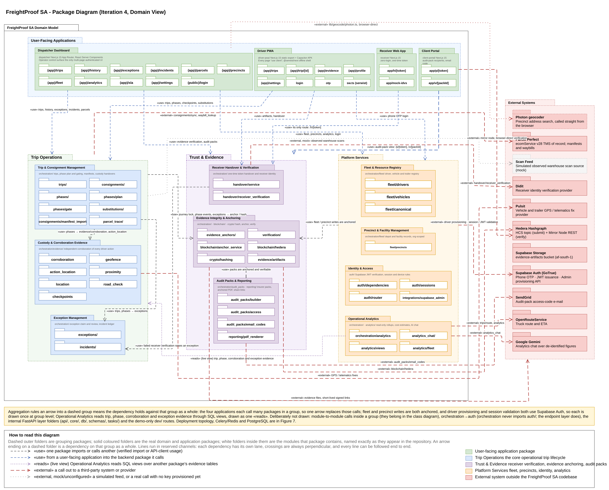
Figure 1: Package diagram
The dispatcher application, Driver PWA, receiver application and client portal depend on groups of packages rather than individual ones. The receiver application and the client portal each have only two routes, which is why they are drawn small. External systems remain behind interfaces with simulated and live implementations: Parcel Perfect supplies manifests and waybills, Pulsit supplies tracker positions, Didit performs optional receiver checks, SendGrid sends audit-pack access codes, OpenRouteService supplies planned routes, and Hedera receives fingerprints only. Figure 1 also shows two services used directly: Google Gemini answers analytics questions from de-identified figures, and Photon geocodes precinct addresses from the dispatcher's browser.

6.2 Analysis Class Diagram
Figure 2 shows the analysis class model. It remains centred on Trip, with its ordered TripStops, its PhaseEvent ledger and its Consignments. Iteration 4 made five changes, which answer the Iteration 3 comment that parcel detail was modelled at too high a level:
- Cargo hierarchy. A loaded Trip now carries the key of the client's Parcel Perfect manifest. The hierarchy is manifest → waybill (Consignment) → Parcel. Each Consignment names its pickup stop and delivery stop, so a multi-stop trip can drop off and collect different waybills at each intermediate stop. The manifest snapshot taken at creation is stored on the trip-creation phase and covered by the journey lock.
- Arrival. PhaseEvent gains the seal condition found at arrival (intact, damaged or missing) and how the seal number was entered (read from the photo and confirmed, read and corrected, or typed).
- Exception review. TripException gains the claiming dispatcher and claim time, alongside the existing reviewer, outcome, contact method and note.
- Evidence sharing. AuditPack, AuditPackAccessEvent, AuditPackEmailCode and IncidentDeclaration are new. Incident groups related exceptions and affected parcels for a trip, with an append-only IncidentUpdate ledger. EvidenceAnchorEvent records each anchored exception, review and cancellation with its own receipt.
- Operations. CostProfile holds an organisation's cost rates for cost analytics, and DriverSubstitution, present but unused in Iteration 3, now records driver handovers, each fulfilling a dispatcher-arranged DriverSubstitutionRequest.
Figure 2b shows the classes new in Iteration 4 and the existing classes they attach to; Figure 2 shows the full model.

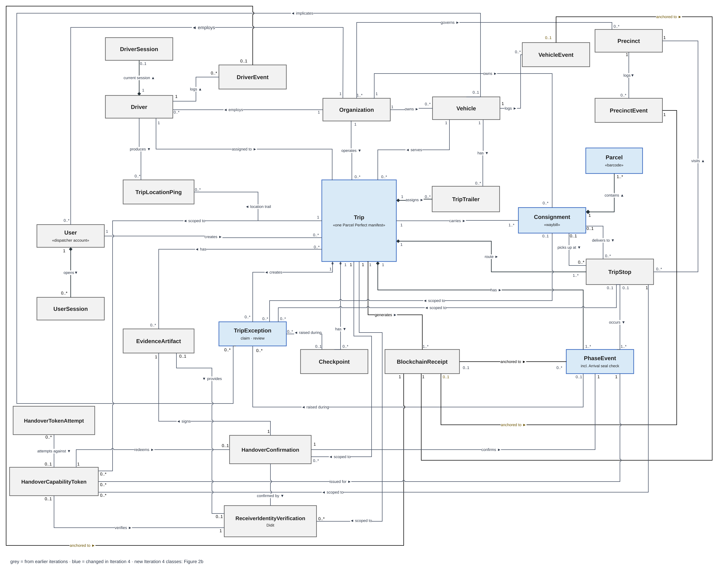
Figure 2: Analysis class diagram
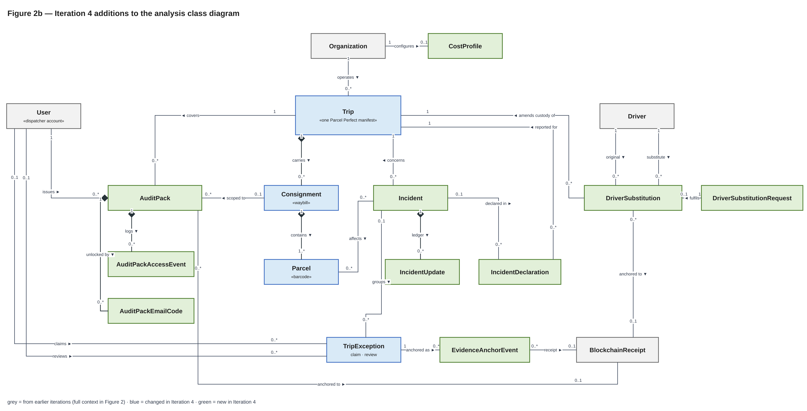
Figure 2b: Iteration 4 additions to the analysis class diagram
Damage in transit is recorded as an exception against the trip, the affected consignment and the affected vehicles, with photographs. Pallet or handling-unit counts are not modelled: the partner could not confirm whether a handling unit sits between waybill and parcel, so counts stay at parcel level (§5.4).

6.3 Use-Case Model and System Boundary
Figure 3 and Figure 4 show the two use-case diagrams, Trip Lifecycle Management (TLM, dispatcher side) and Custody Chain Capture (CC, driver and receiver side), redrawn for Iteration 4. Seven use cases are new: TLM 1.12 Issue an Audit Pack, TLM 1.13 Trace a Parcel, TLM 1.14 Arrange a Driver Substitution, TLM 1.15 Manage an Incident, TLM 1.16 Ask the Dispatcher Assistant, CC 1.11 Record Arrival and CC 1.12 Hand Over to Another Driver. TLM 1.12 introduces the Audit-pack recipient actor and is restricted to the Admin-Dispatcher. Cancel a Trip extends Manage an Incident because stopping an incident’s trip cancels it. TLM 1.5 is now drawn on the Dispatcher: every dispatcher can run the check, while the receipt and hash detail remain in TLM 1.6. In the CC diagram the six phase use cases specialise one abstract use case, Complete a Custody Phase, shown in italics, because Iteration 4 anchors and corroborates every phase and lets a dispatcher override any phase except activation. This replaces Iteration 3’s separate departure and delivery receipts. TLM 1.14, CC 1.12, TLM 1.16 and the analytics chat are switched on per deployment.
In both diagrams, dark orange marks a use case that is new in Iteration 4, light orange one that changed in Iteration 4, and white one that is unchanged since Iteration 3 (Table 13). A solid oval is a user goal with its own narrative. A dashed oval is supporting behaviour, reached through «include» or «extend» and covered inside its parent’s narrative; it is shaded on the same scale.
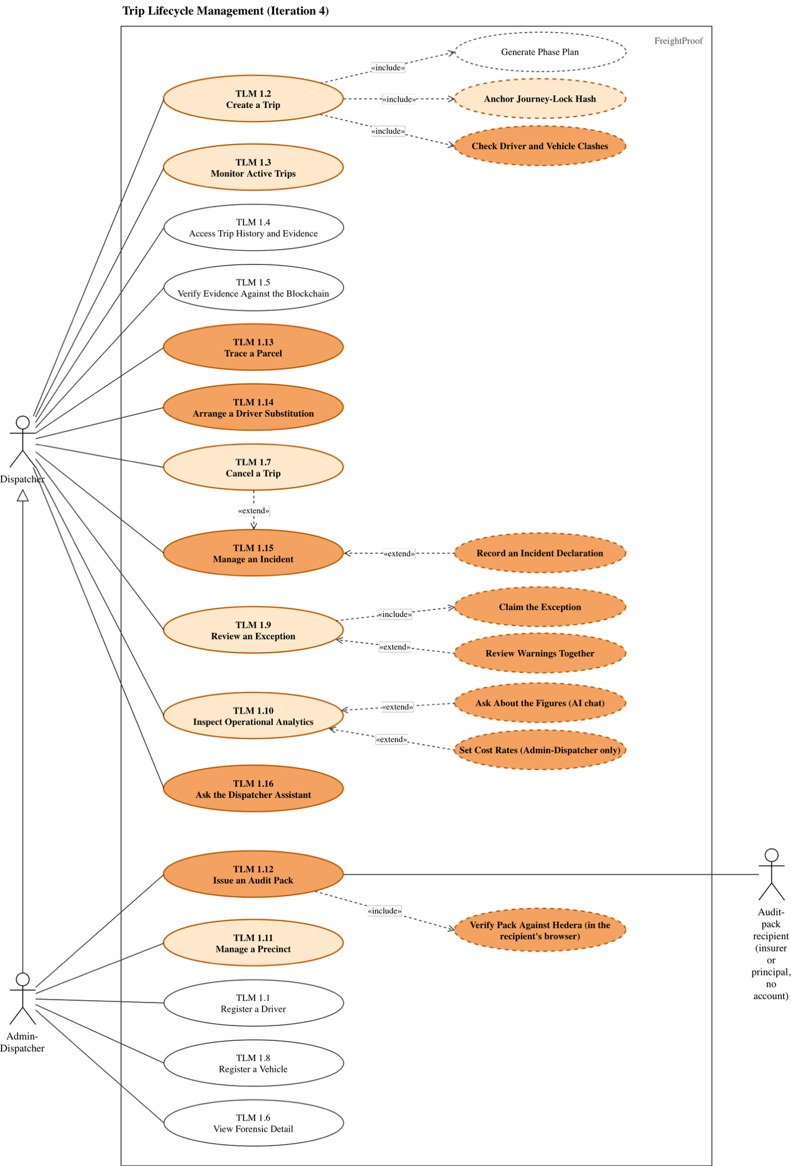
Figure 3: Trip Lifecycle Management use-case diagram

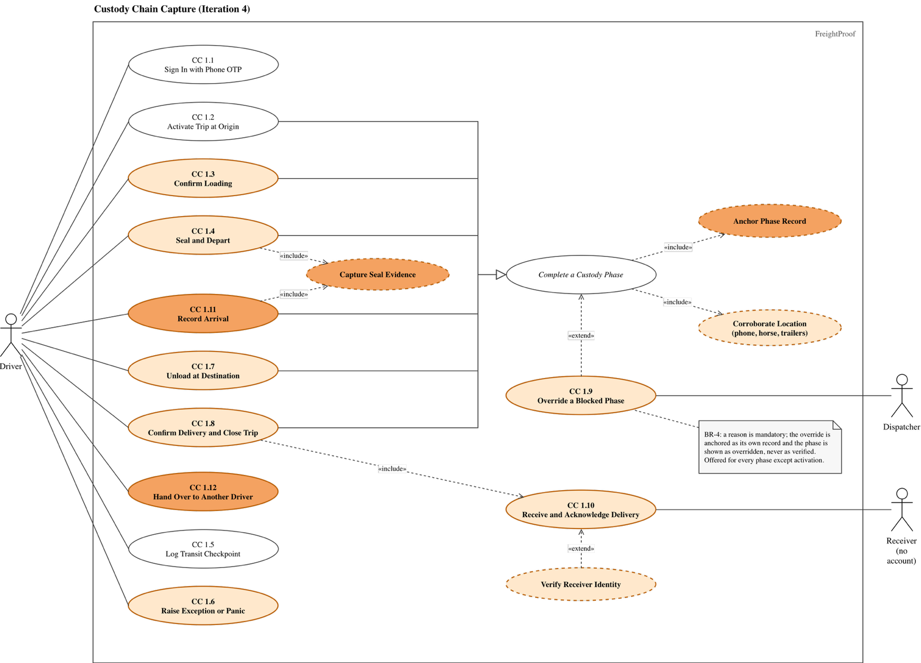
Figure 4: Custody Chain Capture use-case diagram
Table 13 shows how each use case is treated in this document. New and changed use cases are written in full in §6.5, given replacement steps there, or governed by the business rules in §6.4. Retained narratives are in the Iteration 2 document (Team05, 2026a) or the Iteration 3 document (Team05, 2026b, §3.4, pp. 27–35).
Table 13: Use-case retention and change index
ID | Use case | Treatment in Iteration 4
TLM 1.1, 1.8 | Register a Driver; Register a Vehicle | Retained (Iteration 2)
TLM 1.2 | Create a Trip | Changed: written in full. A trip is created from a Parcel Perfect manifest or as an empty leg, with a driver and vehicle clash check (FP-281, FP-139, FP-142)
TLM 1.3 | Monitor Active Trips | Changed: live trip list shows phase, last update, unreviewed exceptions and location check (FP-289); covered in §8.2
TLM 1.4, 1.6 | Access Trip History; View Forensic Detail | Retained (Iteration 2)
TLM 1.5 | Verify Evidence Against the Blockchain | Retained (Iteration 3, pp. 33–34); now also verifies exceptions, reviews and cancellations. Any dispatcher sees the result; receipt and hash detail remain with the Admin-Dispatcher (TLM 1.6)
TLM 1.7 | Cancel a Trip | Changed: cancellation is anchored (BR-8), and stopping an incident's trip cancels it (TLM 1.15)
TLM 1.9 | Review an Exception | Changed: written in full (FP-280, FP-290)
TLM 1.10 | Inspect Operational Analytics | Changed: cost view with Admin-Dispatcher-set cost rates, today's incident map, figure sources and an AI chat about the figures (FP-294, FP-296, FP-295); covered in §8.5
TLM 1.11 | Manage a Precinct | Changed: address search replaces typed coordinates (FP-309); otherwise retained (Iteration 3, pp. 29–30)
TLM 1.12 | Issue an Audit Pack | New: written in full (FP-279, FP-291); Admin-Dispatcher only
TLM 1.13 | Trace a Parcel | New: written in full (FP-149)
TLM 1.14 | Arrange a Driver Substitution | New: governed by BR-10 (FP-83)
TLM 1.15 | Manage an Incident | New: report a hijacking, parcel shortage or parcel damage, add follow-ups, record notifications as incident declarations, close or reopen with a reason, and optionally stop the trip; governed by BR-3 and BR-5 (PR #96)
TLM 1.16 | Ask the Dispatcher Assistant | New: answers questions from the organisation's live records without changing them; switched on per deployment (PR #101)
CC 1.1, 1.2, 1.5 | Sign In; Activate Trip; Log Transit Checkpoint | Retained (Iteration 2)
CC 1.3 | Confirm Loading | Changed: the paper linehaul sheet is scanned on the phone (FP-300)
CC 1.4 | Seal and Depart | Changed: seal number read from the photo and confirmed by the driver (FP-300)
CC 1.6 | Raise Exception or Panic | Changed: several photographs per report, queued offline; critical reports anchored (FP-290); severity per BR-1
CC 1.7 | Unload at Destination | Changed: the seal inspection moved to Arrival (CC 1.11)
CC 1.8 | Confirm Delivery and Close Trip | Changed: replacement steps below (FP-273)
CC 1.9 | Override a Blocked Phase | Changed: governed by BR-4; also applies to Arrival and is never offered at activation
CC 1.10 | Receive and Acknowledge Delivery | Changed: replacement steps below (FP-293, FP-316)
CC 1.11 | Record Arrival | New: written in full (FP-270)
CC 1.12 | Hand Over to Another Driver | New: the outgoing and incoming drivers each confirm the handover, including the seal, on their own phones; governed by BR-10 (FP-83)

6.4 Business Rules
The Iteration 3 shared rules SR-1 to SR-9 remain in force (Team05, 2026b, Table 6, pp. 26–27). Table 14 adds the business rules that Iteration 3's review asked for: what happens when something goes wrong, who must be told, and what evidence is required. The "Enforced by" column separates what the system enforces from what the operator's procedure requires, so that no rule is claimed as automated when it is not.
Table 14: Business rules added in Iteration 4
ID | Rule | Enforced by
BR-1 | Severity. An exception is critical if a person may be at risk, cargo may be lost or reached by someone outside the custody chain, goods went to the wrong party, or the trip cannot finish as planned. The system raises panic, a seal broken in transit, a seal mismatch, a damaged or missing seal at arrival and a trailer separated from its horse as critical; other exceptions start as warnings. When a reviewing dispatcher finds that a warning meets one of the criteria, for example cargo damage or a refused delivery, they handle it as critical under BR-3. Nobody may lower a severity. | System (severity by type); procedure (escalation)
BR-2 | Every exception is reviewed. Every exception starts unreviewed. A dispatcher claims it, which records who and when, and may release it. The review records an outcome, the contact method and a note; the first review is final, and the original report is never changed. Critical exceptions are reviewed one at a time; warnings on one trip may be reviewed together. Critical exceptions and every review are anchored. | System (FP-280, FP-290)
BR-3 | Who is told, and when. A critical exception appears immediately in every dispatcher's live inbox in the organisation, so the driver does not need to phone it in. The reviewing dispatcher informs the operations manager at once for theft, hijacking, collision or injury. The operations manager notifies the principal within 24 hours of a security incident, in line with TAPA TSR (Transported Asset Protection Association, 2023), notifies the insurer within the period the policy requires, and opens a SAPS case for theft or hijacking. Each notification is recorded as an incident declaration with its time and reference number, and appears in the audit pack. | System (live inbox, incident declarations); procedure (notifications)
BR-4 | Overriding a phase. Any dispatcher may override a phase the driver cannot complete, but must give a reason. The override is anchored as its own record and the phase is shown as overridden, never as verified. Overriding a departure, arrival or confirmation also requires an Admin-Dispatcher's approval, recorded in the reason, and any supporting document available (delivery note, photograph, SAPS case number) is attached to the trip. | System (reason, marking, anchoring); procedure (second approval, documents)
BR-5 | Disputed delivery. If the scanned count differs from the manifest, a parcel-count exception is raised; a shortfall is handled as critical under BR-1. If the receiver refuses to sign or disputes the goods, the driver records a delivery refused exception with a reason and photographs. The reviewing dispatcher then decides whether the delivery is completed, overridden under BR-4 or cancelled under BR-8, and the principal is notified under BR-3. The refusal stays on the record, and a later inspection result is recorded as an incident declaration, a new, attributed record, never by editing the original. | System (exceptions, receiver confirmation); procedure (decision, notification)
BR-6 | Lost, stolen or dead phone. The driver reports it to the dispatcher by any available means. Signing in on a replacement phone ends the old session automatically, and the dispatcher deactivates the account if the phone was stolen. Phases that cannot be completed are overridden under BR-4. Evidence captured between the loss and the deactivation is treated as disputed, and a theft is reported to SAPS. | System (single session); procedure (reporting)
BR-7 | Receiver identity. By default the receiver confirms with a typed name, a drawn signature and their position, through a single-use QR link. A document-and-face check is requested only for consignments the dispatcher flags as high value or dangerous goods, and it never blocks delivery. Pre-registered authorised receivers nominated by the receiving organisation were evaluated and are recommended for the pilot, because identity would then be established once at onboarding rather than at the door. | System (FP-293)
BR-8 | Cancellation. A reason is mandatory. The cancellation is anchored, the phases not reached stay pending as an honest record, and the manifest becomes available for a new trip. | System (FP-290)
BR-9 | Audit-pack access. Only a dispatcher may issue an audit pack, to a named recipient, for a stated purpose. Its contents are frozen and anchored at issue. The share link expires, requires an e-mailed one-time code before first view, logs every view, and can be revoked. | System (FP-279, FP-291)
BR-10 | Driver substitution. A substitution is a normal custody event, not an exception. A dispatcher arranges it; the outgoing and incoming drivers each record the handover, including the seal, on their own phones. The original driver's record is kept. A seal mismatch at the exchange is critical; an exchange outside the planned exchange point is a location warning. | System (FP-83)
BR-11 | Geofence size. An Admin-Dispatcher sets each precinct's radius to cover the yard where trucks stand and handovers happen. The 200 m default plus 50 m tolerance is a starting value only. | Procedure

6.5 New and Changed Use-Case Narratives
Each narrative below states the actor, pre- and post-conditions, the main success scenario and the alternative flows. Alternative flows now cover the failure cases raised in the Iteration 3 review: a dead, lost or stolen phone; cleared app data; no signal; partner systems or the server being unavailable; and a receiver who cannot or will not confirm.
Table 15: TLM 1.2 – Create a Trip from a Manifest (changed)
Actor | Dispatcher
Description | Create an evidence-bearing trip for one departure from the client's Parcel Perfect manifest, so that the cargo is imported rather than typed.
Pre / Post | Pre: dispatcher signed in; the manifest exists in Parcel Perfect. Post: one trip with its stops, consignments, parcels and phase plan; the manifest snapshot and journey lock anchored.
Main success scenario
Step | Actor action | System response
1 | Enters the manifest number. | Fetches the manifest and shows the client, route, planned times, waybills and parcel totals.
2 | Chooses the driver, horse and trailers. | Shows an availability strip for the week and names any trip that already holds a chosen driver or vehicle (FP-142).
3 | Reviews and confirms. | Checks again for clashes, creates the trip and phase plan, stores the manifest snapshot, and anchors the journey lock before saving.
Alternative and exception flows
1a | Manifest not found, or its waybills belong to different clients: the system refuses and names the reason.
1b | Parcel Perfect unavailable: the system refuses creation; no partial trip is saved.
1c | A non-cancelled trip already exists for this manifest: the system refuses a second trip and names the existing one.
2a | A precinct for the manifest's hub is not set up: the dispatcher chooses the precinct manually.
3a | A clash appears between steps 2 and 3, for example another dispatcher assigned the horse: creation is refused with the clashing trip named (FP-139).
3b | Hedera unavailable: creation is refused and nothing is saved (fail-closed), because the journey lock must be anchored.

Table 16: TLM 1.9 – Review an Exception (changed)
Actor | Dispatcher
Description | Assess every exception, record the conclusion and the contact made, and leave the original report unchanged.
Pre / Post | Pre: dispatcher signed in; the exception belongs to the organisation. Post: one immutable review with reviewer, time, outcome and contact method; critical exceptions and the review anchored (BR-2).
Main success scenario
Step | Actor action | System response
1 | Opens the unreviewed inbox, ordered by severity, or an exception from a trip timeline. | Shows type, severity, description, photographs, position, phase and stop.
2 | Claims the exception. | Records who claimed it and when, and shows the claim to other dispatchers live.
3 | Contacts the driver or site, then selects the outcome and contact method and writes a note. | Validates the review.
4 | Submits. | Stores the review without changing the report, anchors it, and removes the exception from the inbox.
Alternative and exception flows
2a | Another dispatcher has claimed it: the system shows who; this dispatcher may wait or ask them to release it.
2b | The dispatcher cannot finish: they release the claim and the exception returns to the inbox.
3a | Several warnings on one trip: the dispatcher reviews them together with one outcome and note; a review is stored for each. Critical exceptions cannot be batch-reviewed.
4a | Another dispatcher submitted first: the system refuses the second review and shows the first.
4b | Hedera unavailable: the review is saved, the receipt is marked owed and retried.
4c | The incident requires notification: the dispatcher follows BR-3 and records an incident declaration.

Table 17: TLM 1.12 – Issue an Audit Pack (new)
Actor | Dispatcher; Audit-pack recipient (insurer or principal, no account)
Description | Give an outside party a frozen, verifiable evidence record of a trip or consignment without giving them access to FreightProof.
Pre / Post | Pre: dispatcher signed in; the trip belongs to the organisation. Post: an anchored pack (PDF and web page); a share link issued to a named recipient; every access logged (BR-9).
Main success scenario
Step | Actor action | System response
1 | Previews the trip's audit trail and chooses scope, purpose, recipient and whether to include the location trail. | Builds the pack from current records, marking each item as anchored or recorded only, and lists missing evidence.
2 | Issues the pack. | Freezes the contents, renders the PDF, anchors the pack's fingerprint and shows the share link once.
3 | Sends the link to the recipient. | No further action.
4 | Recipient opens the link and enters the code sent to their e-mail address. | Logs the view and shows the evidence page: timeline, route map, photographs, exceptions and parties.
5 | Recipient selects Verify. | The recipient's browser recomputes the fingerprints and checks them against the Hedera mirror service, then reports a match or a mismatch for each item.
Alternative and exception flows
4a | Wrong code entered repeatedly: access is locked and the attempt logged.
4b | Link revoked or expired: the page states this and shows no evidence.
5a | Hedera mirror unavailable: the result is "could not check", never "verified".
5b | A record changed after issue: the item shows as a mismatch, and records added after issue are counted separately.

Table 18: TLM 1.13 – Trace a Parcel (new)
Actor | Dispatcher
Description | Find a parcel by its barcode and see where it has been, derived from the phase ledger.
Pre / Post | Pre: dispatcher signed in. Post: none; the use case is read-only.
Main success scenario
Step | Actor action | System response
1 | Enters or scans a parcel barcode. | Finds the parcel among the organisation's consignments.
2 | Opens the result. | Shows the parcel's waybill, current state and a timeline of every phase and scan that involved it, with exceptions and evidence.
Alternative and exception flows
1a | Barcode not found in this organisation: the system shows "not found" and does not reveal other organisations' parcels.
2a | Parcel never scanned at a stop: the timeline shows the gap rather than inferring a location.

Table 19: CC 1.11 – Record Arrival (new)
Actor | Driver
Description | Record the seal as found at a stop before anything is opened, so that a break in transit is detected at the moment custody arrives.
Pre / Post | Pre: the preceding in-transit phase is complete; the driver is at the Arrival phase. Post: Arrival completed once, with seal number, condition, photograph and positions stored and anchored.
Main success scenario
Step | Actor action | System response
1 | Confirms arrival at the stop. | Records the phone, horse and trailer positions and compares each with the precinct geofence.
2 | Photographs the seal. | Reads the seal number from the photograph and asks the driver to confirm or correct it (FP-300).
3 | Confirms the number and records the seal as intact, damaged or missing. | Compares the number with the seal applied at departure.
4 | Swipes to complete. | Stores the evidence, anchors the phase and opens the next phase (unloading, loading or confirmation).
Alternative and exception flows
1a | Truck or a trailer outside the precinct: a location exception is raised for review; the driver continues.
1b | No usable position, or no signal: recorded as "could not check"; the action is queued on the phone and sent when signal returns.
3a | Number differs from departure, or seal damaged or missing: a critical exception is raised (BR-1) and the dispatcher is alerted at once.
4a | Phone lost or dead before completion: handled under BR-6; the phase is overridden only under BR-4.
4b | App data cleared before the queued action was sent: the capture is lost on the phone, but nothing false is recorded. The phase stays pending on the server and on the live trip list, and the driver recaptures it.

Table 20: Changed narratives: replacement steps for CC 1.8 and CC 1.10
CC 1.8 – Confirm Delivery and Close Trip (Driver)
Replaces step 5 | The server completes the confirmation phase only if a receiver confirmation exists for that stop, and takes the signature from that confirmation. A signature uploaded by the driver is refused (FP-273).
Replaces alt. 3a | If the receiver has no suitable phone or connection, the driver cannot confirm; the dispatcher may override the confirmation only under BR-4, which requires an Admin-Dispatcher's approval and a signed paper delivery note photographed and attached.
New alt. 5a | If the receiver refuses to sign, the driver raises delivery refused under BR-5.
CC 1.10 – Receive and Acknowledge Delivery (Receiver)
Replaces step 3 | The system asks for an identity check only if the consignment is flagged as requiring one (BR-7). Otherwise the receiver goes straight to step 5.
Replaces step 4 | When a check is required, the receiver consents and completes it; the selfie is stored securely before a "selfie only" result is recorded (FP-316). A scanned document number is not typed again.
Unchanged | Steps 1–2 and 5–8 and the alternative flows remain as in Iteration 3 (Team05, 2026b, pp. 30–31).

6.6 State-Machine Diagram
Figure 5 shows the life of one trip. Iteration 4 made the following changes, answering the Iteration 3 comments that a refused activation had no drawn path, that the "more stops planned?" decision had no false branch, and that the current stop could not load.
- Created → Created on a refused activation. When the driver asks to activate, the guards are checked: the trip is not being started early, the driver and the vehicles are not on another live trip, and no earlier trip of the driver's is due. If any guard fails, the trip stays in Created and the driver is shown the reason. This is drawn as the [no] branch of the "Activation admissible?" choice, which returns the trip to Created.
- One loop per stop, in a fixed order. At each stop the order is: Arrival (every stop after the first), then Unloading [anything delivered here, or the final stop], then Loading [anything collected here]. A decision node then tests [more stops planned]: the [yes] branch goes to Departure and In Transit, and the [no] branch goes to Confirmation. The current stop therefore always loads before the vehicle departs.
- Arrival is a new state after every In Transit, where the seal is inspected (CC 1.11).
- Cancelled remains reachable from Created and Active, with a mandatory reason, and is now anchored (BR-8). Closed is reached only when every phase in the plan is resolved: completed, ended with a recorded exception, or overridden.

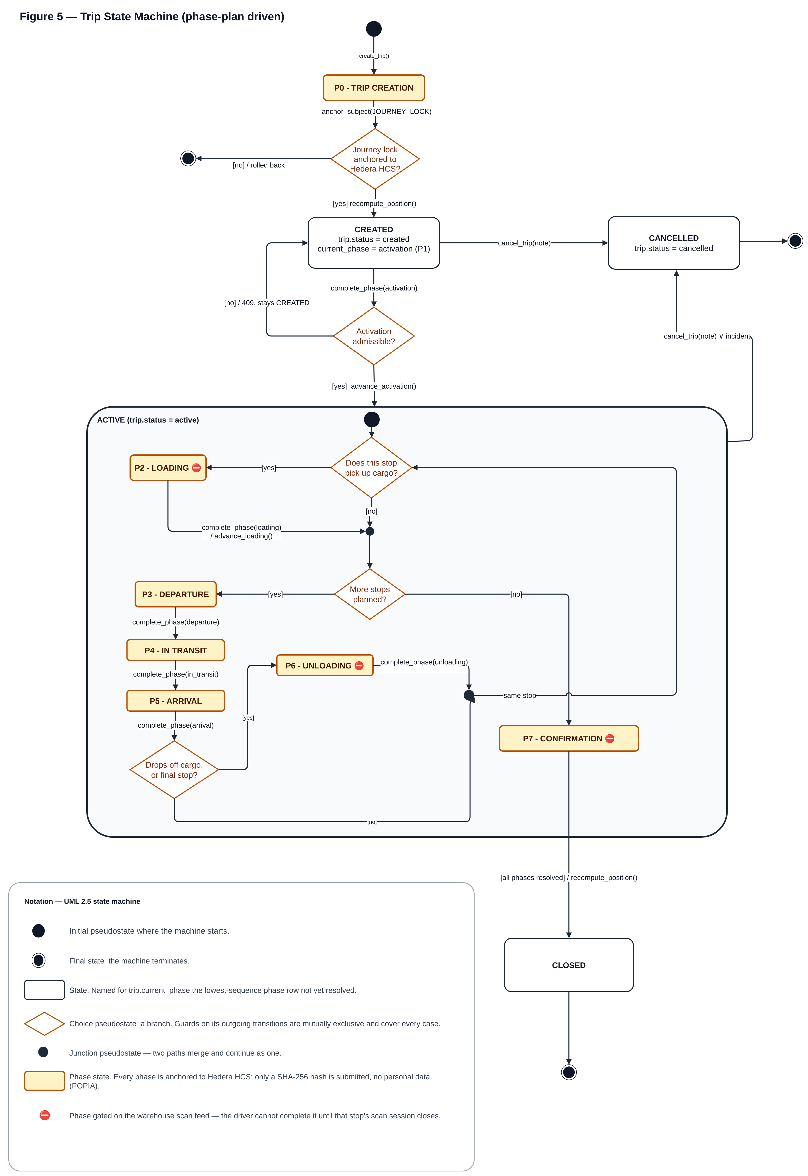
Figure 5: Trip state-machine diagram
Each exception also has a simple life cycle, enforced by BR-2: Unreviewed → Claimed (claim) → Reviewed (review). A claimed exception returns to Unreviewed when released, and a reviewed exception never changes state again.

6.7 Database Schema Changes
The relational schema is changed through versioned migrations only; CI applies the whole chain to an empty database on every change and checks that there is exactly one migration head. Table 21 lists the Iteration 4 changes. Tables that did not change are shown in the Iteration 3 entity relationship diagram (Team05, 2026b, Fig. 7, p. 39), and Figure 6 shows the diagram with the Iteration 4 tables.
Table 21: Schema changes in Iteration 4
Table | Change | Story
trips | Manifest key (issuer account, origin hub, manifest number), unique among non-cancelled trips; order number removed | FP-281
precincts | Parcel Perfect hub code, so a manifest's hubs resolve to precincts | FP-281
phase_events | Seal condition at arrival; seal-number entry method; manifest snapshot on the trip-creation row; arrival phase type | FP-270, FP-300
exceptions | Claiming dispatcher and claim time; review status for every severity | FP-280
exception_vehicles (new) | Links one exception to each affected horse or trailer | FP-297
evidence_anchor_events (new) | One row per anchored exception raise, review or cancellation, with its frozen payload and receipt | FP-290
audit_packs, audit_pack_access_events, audit_pack_email_codes (new) | Issued packs with their fingerprints, share-link hashes, access log and one-time codes | FP-279, FP-291
incident_declarations (new) | Notifications and declared facts for an incident (BR-3) | FP-279
cost_profiles (new) | Per-organisation cost rates for cost analytics | FP-294
driver_substitutions | Now written by the substitution workflow | FP-83
receiver_identity_verifications | Stored selfie reference before a "selfie only" result | FP-316

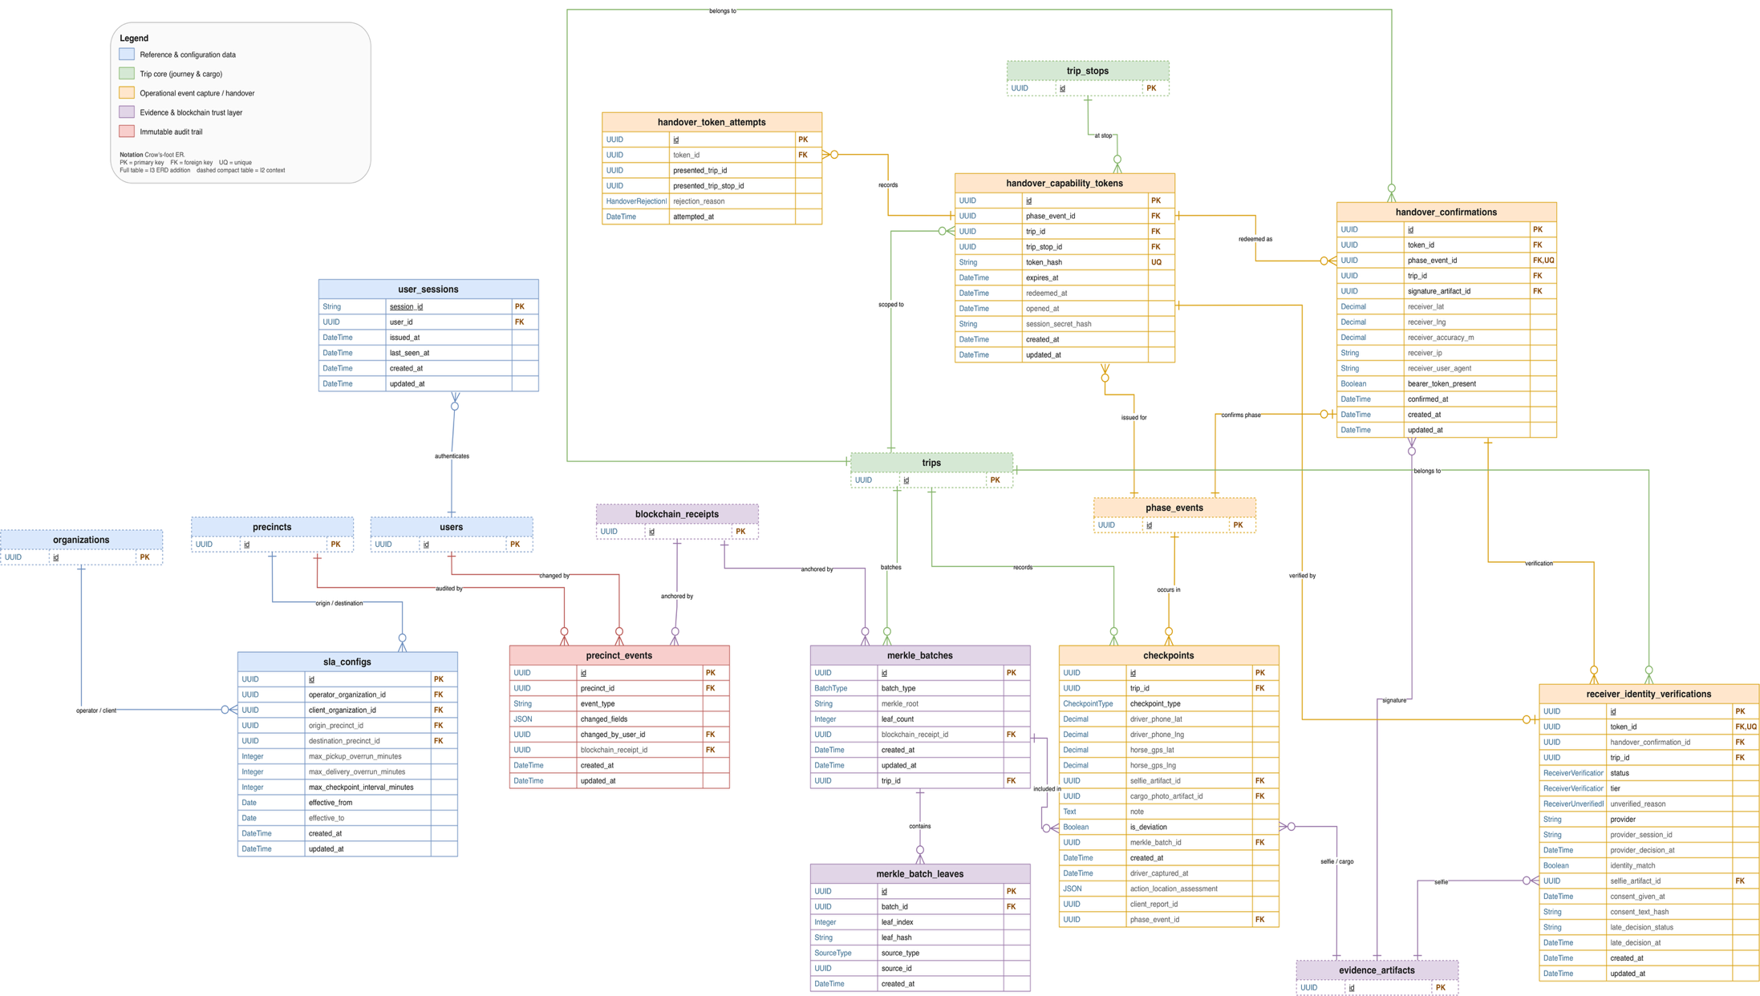
Figure 6: Entity relationship diagram
TEAM TO DO: This is the Iteration 3 ERD. Add the new tables and columns listed in the schema-changes table, highlighted in a different colour.
Every new table is created with row-level security enabled and direct access revoked, so it cannot be read through Supabase's data interface, following the database lockdown in FP-271. Personal data stays in PostgreSQL in af-south-1; only fingerprints are anchored.

7. Architecture

7.1 Deployment Architecture
The Iteration 3 architecture figure was criticised for looking like a package diagram. Figure 7 is therefore drawn as a deployment view: the devices people use, the services FreightProof runs, the external services it calls, and the protocol on each connection. The module structure is shown separately in the package diagram (§6.1). Table 22 lists the nodes.
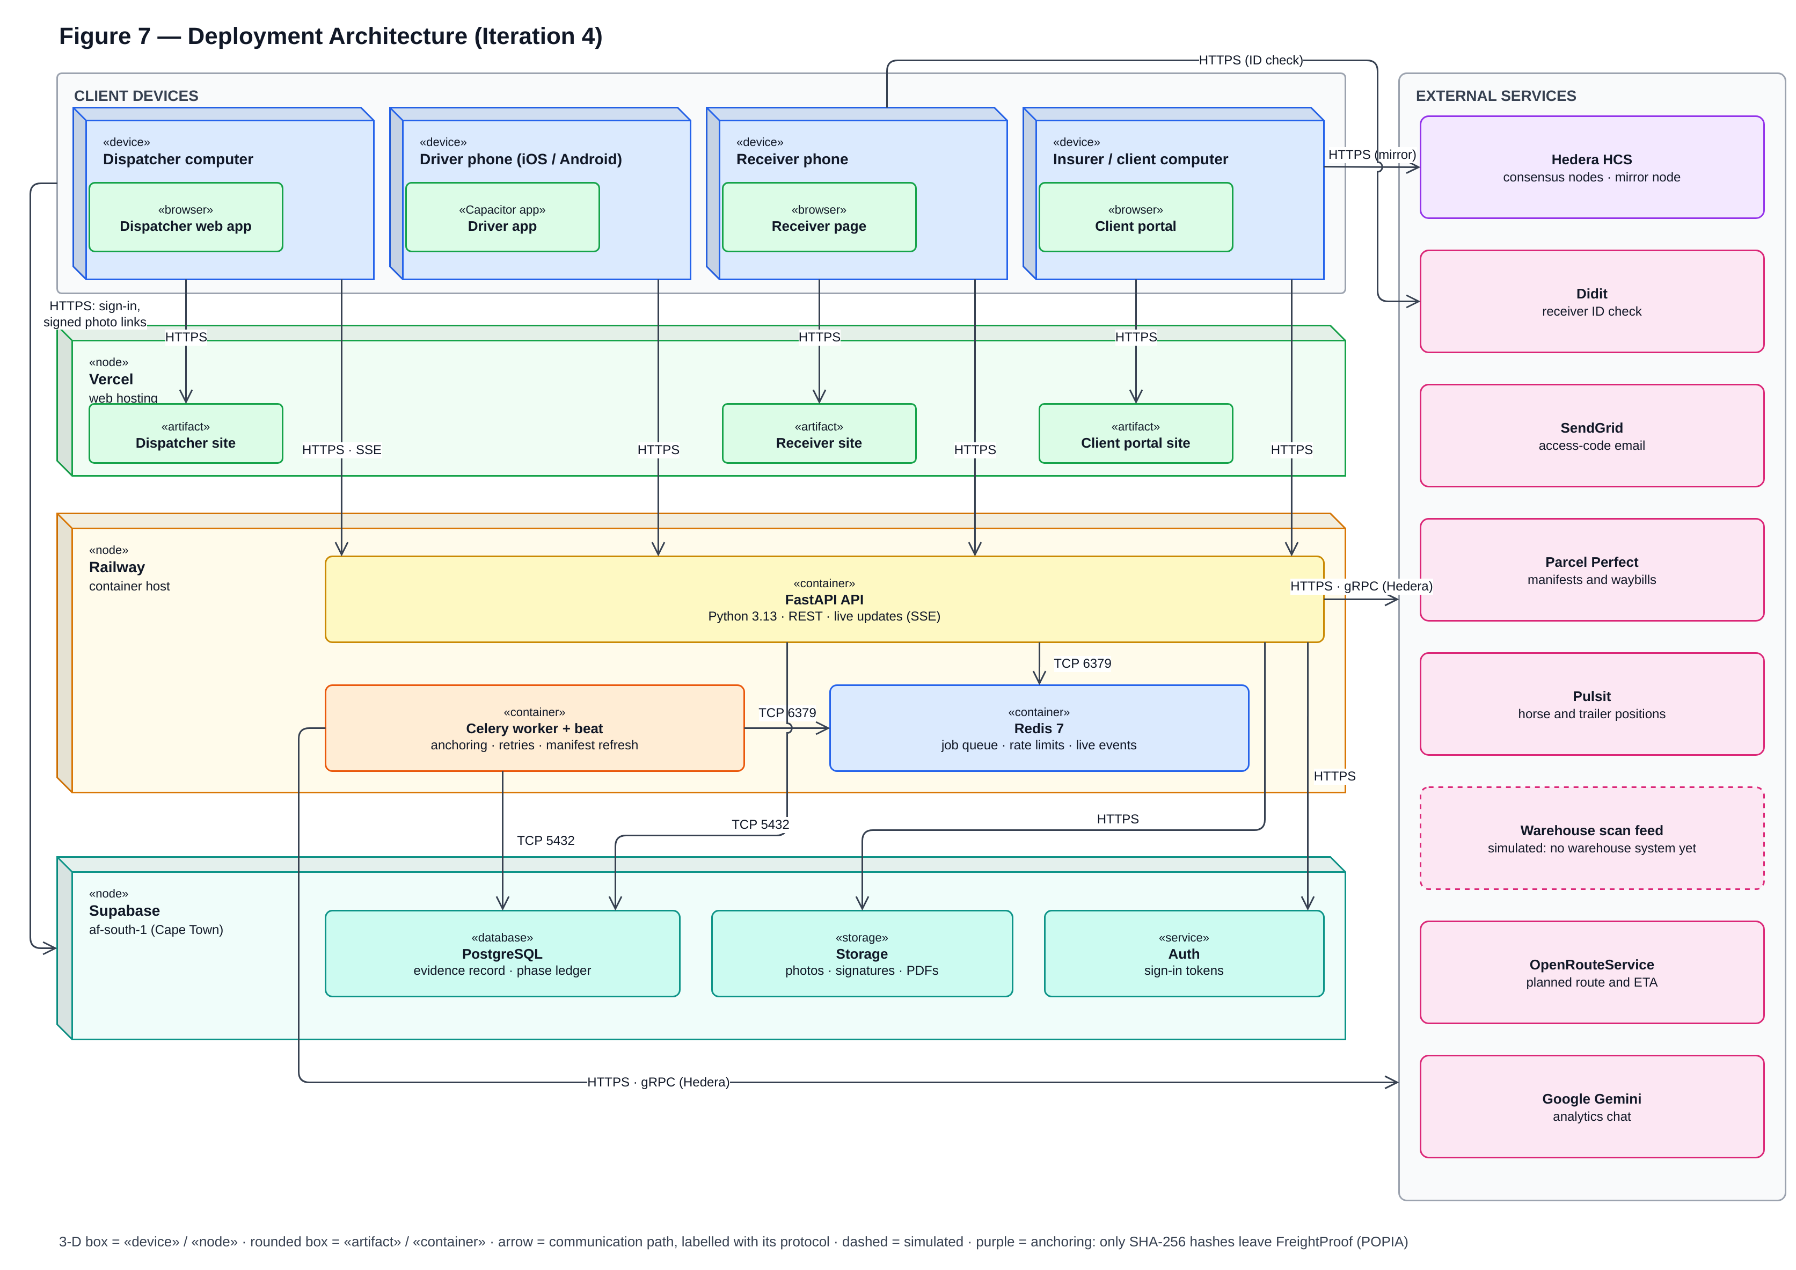
Figure 7: Deployment architecture diagram
Table 22: Deployment nodes and connections
Node | Runs on | Connections and purpose
Dispatcher application | Vercel (www.freightproof.co.za) | HTTPS/REST to the API; Server-Sent Events (SSE) for live trip and exception updates
Driver app | Driver's phone: iOS (TestFlight) and Android, in a Capacitor shell | HTTPS/REST to the API; actions queued on the phone when offline and sent when signal returns
Receiver application | Receiver's phone browser; Vercel (receiver.freightproof.co.za) | HTTPS to the API through a single-use link and a browser-binding cookie; Didit only when a check is required
Client portal | Recipient's browser; Vercel (portal.freightproof.co.za) | HTTPS to the API's public audit-pack endpoints; direct HTTPS to the Hedera mirror service for independent verification
API | Railway container (api.freightproof.co.za) | The only component that writes evidence; holds all business rules
Background worker and Redis | Railway | Anchoring jobs, retries and the recovery sweep; manifest refresh; rate limits; live-event fan-out
Supabase (af-south-1, Cape Town) | Managed PostgreSQL, file storage and authentication | Records, photographs, signatures and PDFs; dispatcher passwords and driver one-time passwords. The dispatcher and driver apps sign in with Supabase Auth directly, and photos load through short-lived signed links
External services | Hedera, Parcel Perfect, Pulsit, scan feed (simulated: no warehouse system yet), Didit, SendGrid, OpenRouteService, Google Gemini (analytics chat) | Fingerprints out and receipts in; manifests and waybills; tracker positions; parcel scans; receiver checks; access-code e-mail; planned routes; answers to analytics questions

Trust boundaries. Three boundaries matter. The receiver's browser and the recipient's browser are outside FreightProof's control, so what they submit is evidence, not proof. The API is the only writer of evidence. Hedera is outside FreightProof's control, which is exactly why it is used: an operator cannot rewrite a fingerprint after it has been published.

7.2 Integrity Model and Terminology
The Iteration 3 document used "fingerprinted" in a way that could be read as "digitally signed". The terms are now used precisely:
- A fingerprint is a SHA-256 hash of a record's committed values (National Institute of Standards and Technology [NIST], 2015). Any change to those values produces a different fingerprint. A fingerprint is not a digital signature: it shows that a record changed, not who created it.
- Anchoring publishes the fingerprint to a Hedera Consensus Service topic. Each submission is signed with FreightProof's Hedera account key, and Hedera's consensus assigns it an order and a timestamp (Hedera, n.d.). The receipt therefore proves that this exact set of values existed no later than the consensus time. It does not prove that the values were true.
- Verification rebuilds the record's committed values from the database, recalculates the fingerprint and compares it with the anchored one. The result is "matches", "does not match" or "could not check".

Iteration 4 extended anchoring from three phases to every phase (FP-270), and added anchored records for critical exceptions, every review and every cancellation (FP-290). Each action is a separate anchored event, so a later review never edits an earlier receipt. Free text, such as a description or review note, is committed only as its own SHA-256 hash, and positions are never committed, so no personal data reaches the public ledger.

7.3 Configured Values and Their Rationale
Iteration 3 stated several numbers without explaining them. Table 23 gives the reason for each. All are configuration settings, not constants in the code, and can be tuned in the pilot.
Table 23: Configured values and their rationale
Setting | Value | Why this value
QR code rotation | 20 s | A photograph or screenshot of the code stops working within 20 s, which limits a forwarded or remote handover. Scanning a code that is on screen takes a few seconds, so honest use is not affected. The code stops rotating once the receiver opens it, and the driver can always show a fresh one.
Handover link lifetime | 10 min | Long enough to complete a signature; extended once when an identity check starts, because a check can take several minutes.
Precinct geofence | 200 m + 50 m tolerance (default) | A starting value that covers a typical depot yard. It is set per precinct (BR-11); 200 m was a sample in the Iteration 3 screenshots. The 50 m tolerance absorbs normal phone and tracker inaccuracy.
Driver-to-truck separation | 100 m | A driver performing a handover stands at the truck. 100 m allows for a large yard and GPS error while still detecting a phone that is somewhere else.
Position freshness | 60 s age; 30 s between phone and tracker | Comparing positions taken at different times would produce false mismatches. Older positions are "could not check".
Trailer-to-horse separation | 500 m | A coupled trailer parked at the edge of a fence must not raise a critical alarm; a decoupled trailer on the road should.
Anchoring receipt target | 60 s | Submissions take four to six seconds; 60 s leaves room for retries without delaying the driver.
Manifest refresh | 60 s | Keeps expected cargo current while a trip is active, within Parcel Perfect's request limits.
Idle sign-out | 10 min | Limits misuse of an unattended dispatcher session or phone.

7.4 Legal Standing of the Receiver's Signature
The Iteration 3 review asked whether a signature differs legally from an image of one. Under the Electronic Communications and Transactions Act 25 of 2002 (ECTA), a drawn signature captured on a phone is an ordinary electronic signature: data attached to a record and intended by the user to serve as a signature. Where the law requires a signature but the parties have not required a particular type, an electronic signature is valid if the method identifies the person, indicates their approval and is as reliable as is appropriate for the purpose (Electronic Communications and Transactions Act, 2002, s. 13). An advanced electronic signature, which needs an accredited provider and face-to-face identification, is only required in specific cases and is not used by FreightProof.
FreightProof's design therefore focuses on reliability rather than on the signature image itself. The confirmation binds the typed name, the drawn signature, the time, the receiver's position and the single-use link to one stop, and its fingerprint is anchored. This makes the confirmation strong evidence of who acknowledged the delivery and when, but it is not proof of identity unless the optional check was used. This is the team's reading of the Act, not legal advice; a legal opinion would be needed before a pilot.

7.5 Integration Status
Table 24 gives the final state of each integration.
Table 24: Integration status at the end of Iteration 4
Component | Implemented capability | Mode | Failure behaviour
Supabase | Records, files, authentication, organisation scoping, row-level security | Live | Requests refused; nothing written
Redis and worker | Anchoring, retries, recovery sweep, manifest refresh, live events | Live | Receipts owed and retried
Hedera | Fingerprints out, receipts in, mirror verification | Live (test network) | Phases complete and anchor later; trip creation refused
Parcel Perfect | Manifest import, waybill lookup and refresh | Simulated manifest feed | Trip creation refused
Scan feed | Scan gating and parcel comparison | Simulated | Phase waits; override under BR-4
Pulsit | Horse and trailer positions; on-road tracker check | Simulated | "Could not check"; driver continues
Didit | Opt-in receiver identity check | Live; off by default | Recorded as unverified; delivery continues
SendGrid | Audit-pack access codes | Live | Code not sent; dispatcher re-issues
OpenRouteService | Planned truck route and expected arrival | Live | Falls back to the planned arrival time

7.6 Quality Attributes
Security. Every request needs a signed token except the health check, the receiver pages, the public audit-pack pages and the identity provider's signed callback. Data is scoped to each organisation, fleet changes need an Admin-Dispatcher, and production refuses to start with unsafe settings. Iteration 4 locked down direct database access (FP-271), keyed rate limits on the verified user (FP-274) and enforced upload limits (FP-308).
Maintainability. CI runs linting, type checking, a function- and file-size limit, the layering check, the full test suite and a migration check on every pull request. Each external system sits behind an interface with simulated and live implementations.
Scalability and performance. Database connection and pool-wait timeouts make a slow database fail fast instead of hanging requests (FP-275). A repeatable load test against a separate environment measures these limits and anchoring latency (FP-299; §9.3). Analytics are calculated from read-only views each time they are read.

8. UI Mock-ups and Design Rationale

8.1 Design Approach
The Iteration 3 review asked the team to design screens for use, not for display: to decide what a user must see at first glance every time, what they look for only occasionally, and how the design changes when a company runs 10 or 50 trucks. Each screen in Iteration 4 was therefore designed from three questions: who uses it, how often, and what decision they make on it. Table 25 summarises the answers. The dispatcher application is used on desktops and tablets, so screens were designed and checked at 1,440, 1,280, 1,024 and 768 pixels wide; the driver and receiver applications are designed for phones.
Table 25: Screen design rationale
Screen | User | Used | Must be visible at first glance
Live trip list (§8.2) | Dispatcher, operations room | Continuously | Which trips need attention now: current phase, time since last update, unreviewed exceptions, location check
Trip timeline (§8.3) | Dispatcher | When a trip needs attention | What happened in each phase, in order, and what is wrong; exceptions inside the phase where they occurred
Exception inbox and review (§8.4) | Dispatcher | Several times a day | Severity, what happened, who has claimed it, what must be decided
Analytics: Today and Trends (§8.5) | Operations manager | Today: daily; Trends: weekly or monthly | Today: incidents on a map. Trends: where problems and cost concentrate, with the source of every figure
Receiver handover (§8.6) | Driver and receiver | At every delivery | One clear instruction per screen; nothing that slows a delivery
Precinct set-up (§8.7) | Admin-Dispatcher | Rarely | The geofence on a map, placed by address
Audit pack and portal (§8.8) | Dispatcher; insurer or principal | Per incident or claim | What the pack contains, what is anchored, and whether it verifies

8.2 Live Trip List: the Summary of the Summary
The Iteration 3 demonstration centred on one trip, but nobody watches a single 48-hour trip. The dispatcher's home page is now the live list of every running trip (FP-289). Each row shows the date, trip, manifest, driver and horse, and route, followed by the three things that decide whether to look closer: the current phase and time since the last update, the number of unreviewed exceptions, and the latest location check. Rows update live without refreshing, every column can be sorted, and a trip that needs attention is flagged. A dispatcher watching 50 trucks therefore reads the page in seconds and opens only the trips that need attention. The single-trip timeline (§8.3) is the drill-down.
INSERT SCREENSHOT HERE
Live trip list on the dispatcher home page (FP-289), with several active trips, at least one flagged for attention
Figure 8: Live trip list: every running trip at a glance

8.3 Trip Timeline
Each phase on the trip page is a card with a one-line verdict ("Checks passed", "Needs attention" or "In progress"), followed by the acts inside the phase as a live mini-timeline: what was recorded, then what was checked (FP-288). Photographs appear as soon as they are uploaded, not when the phase completes (FP-287). The design answers each of the Iteration 3 comments:
- Exceptions are inside the phase where they happened, not in a corner panel. A phase with an unreviewed exception turns amber and shows its count in the verdict line (Figure 9). Each exception opens the review panel directly.
- Driver and vehicle details appear once, in the trip summary above the timeline, with a call link to the driver. They are not repeated on each phase card, so the most visible space carries the verdict lines.
- The current position on a multi-stop route is explicit: completed phases show a tick, the current phase pulses and names its stop, and future phases are dashed and labelled "Not started" (Figure 10).
- Order. Phases run oldest to newest, because a trip is read as a sequence of custody events and later phases depend on earlier ones. The "Jump to current phase" button and the live list (§8.2) give the newest state immediately, so the dispatcher never scrolls to find it.

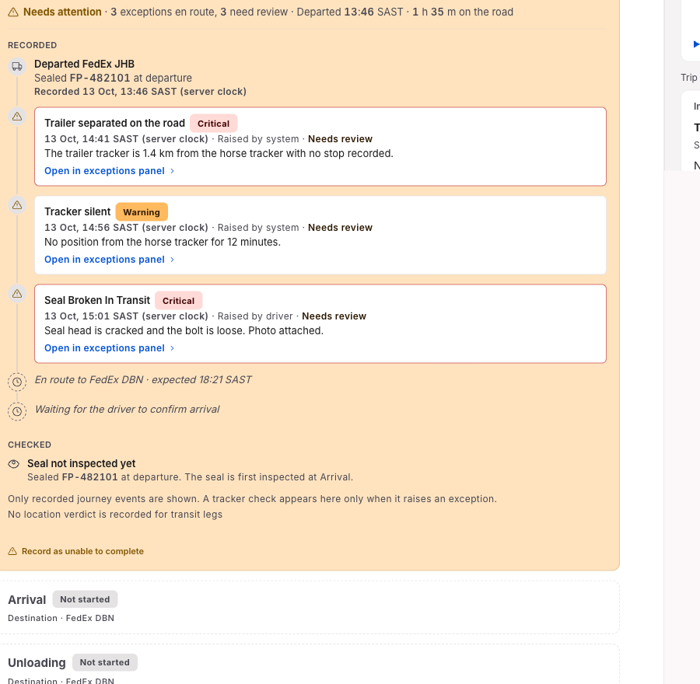
Figure 9: Trip timeline: in-transit phase with critical and warning exceptions
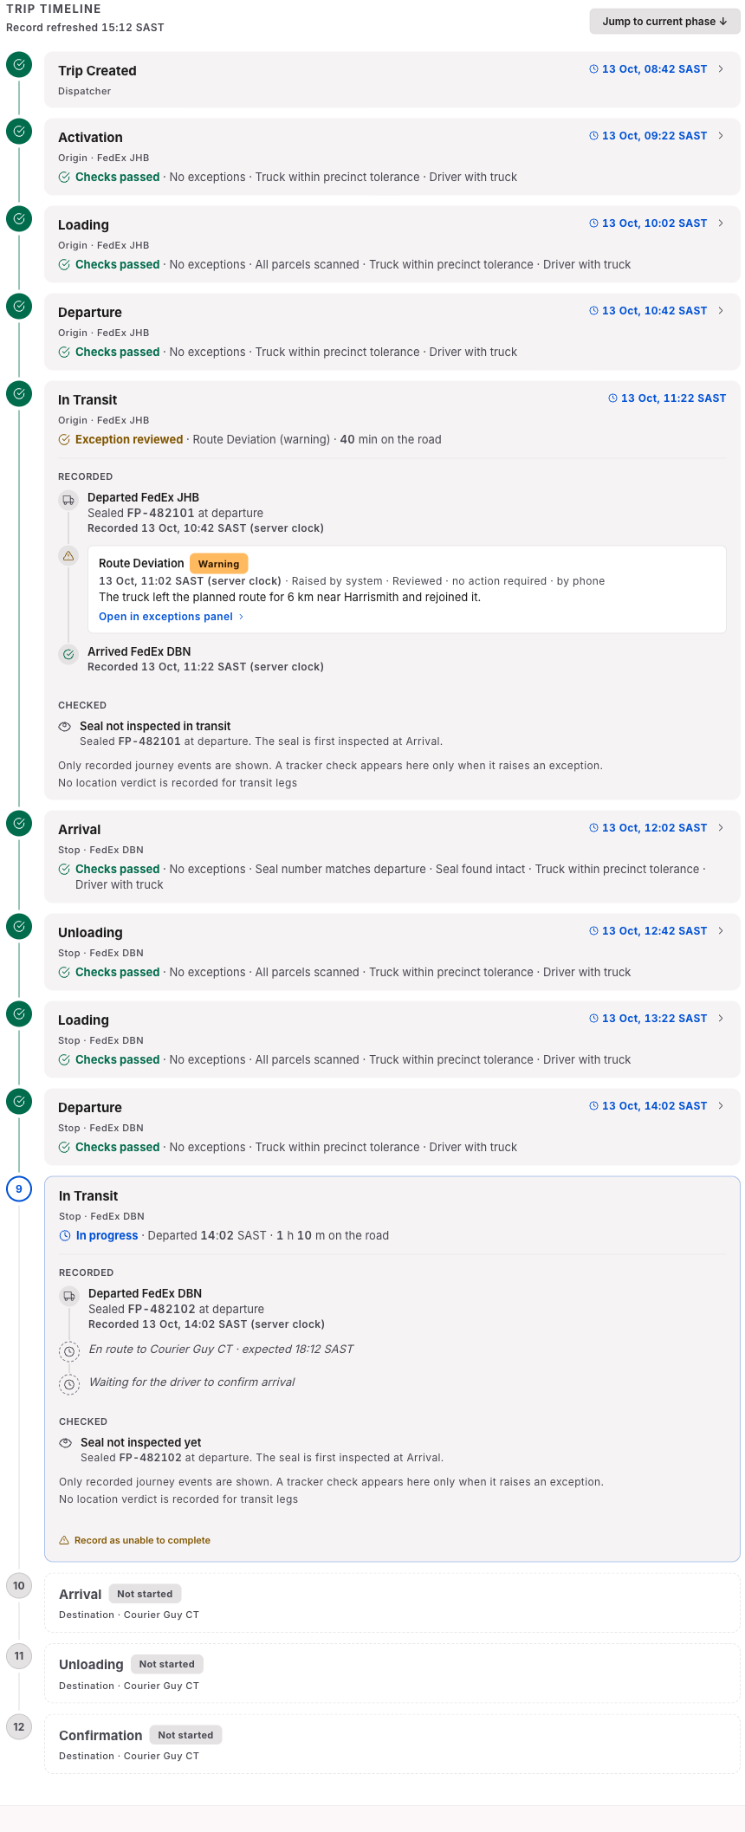
Figure 10: Trip timeline for a multi-stop trip, with the second leg in progress

8.4 Exception Inbox and Review
Every exception now reaches the dispatchers' shared inbox (FP-280), ordered by severity, with tabs for Unreviewed and All recorded. A dispatcher claims an exception before working on it, so two people do not phone the same driver, and the claim is visible to everyone live. The review form records the outcome, the contact method (phone, WhatsApp or in person) and a note. Several warnings on one trip can be reviewed together, which keeps a demonstration trip with 15 minor findings from flooding the inbox. Reviewing never alters the original report; the review is anchored (FP-290).
The Iteration 3 review asked for exception handling "beyond typing". The process around the form is now defined by business rules: who must be informed and when (BR-3), which overrides need an Admin-Dispatcher's approval and supporting documents (BR-4), and how a later inspection result is recorded as an incident declaration rather than an edit (BR-5). Notifications to the principal, the insurer and SAPS are recorded as incident declarations with their time and reference numbers, and appear in the audit pack. Figure 11 shows the exception inbox and review form.
INSERT SCREENSHOT HERE
Exception inbox (FP-280) showing the Unreviewed tab, one exception claimed by a dispatcher, and the review form with outcome and contact method. Replaces the Iteration 3 exception-detail screenshot
Figure 11: Exception inbox with claims, and the review form

8.5 Analytics: Today and Trends
Analytics were split by how often they are used. The Today view is the operations-room screen: today's incidents on a map, which update by themselves when a report is raised and can be opened directly from a link (FP-296). The Trends view is for weekly and monthly analysis: activity, on-time performance, problems, review workload, evidence, routes and sites, and a new Cost tab (FP-294). The Cost tab shows the declared value of cargo on trips that had a theft signal, and estimated operating and delay costs from rates an Admin-Dispatcher can edit.
Two rules make the figures defensible. Every chart states its source, including when a figure depends on the simulated Pulsit or Parcel Perfect feeds, and figures based on fewer than five trips are flagged as a small sample. Analytics describe patterns that need investigation; they are not driver scores. An AI insights brief summarises patterns from de-identified figures only, such as which lane and time of day had the most in-transit exceptions in the period, and names the figures each statement rests on (FP-295). Figure 12 and Figure 13 show the Today view and the Cost tab; Figure 14, Figure 15 and Figure 16 show the headline tiles, the incident map and a vehicle's analytics.
INSERT SCREENSHOT HERE
Analytics Today view: today's incidents on the map with a pin raised during the demo trip (FP-296)
Figure 12: Analytics Today view: today's incidents on the map
INSERT SCREENSHOT HERE
Analytics Cost tab: cargo value exposed and estimated trip and delay costs, with the Source line visible (FP-294)
Figure 13: Analytics Cost tab
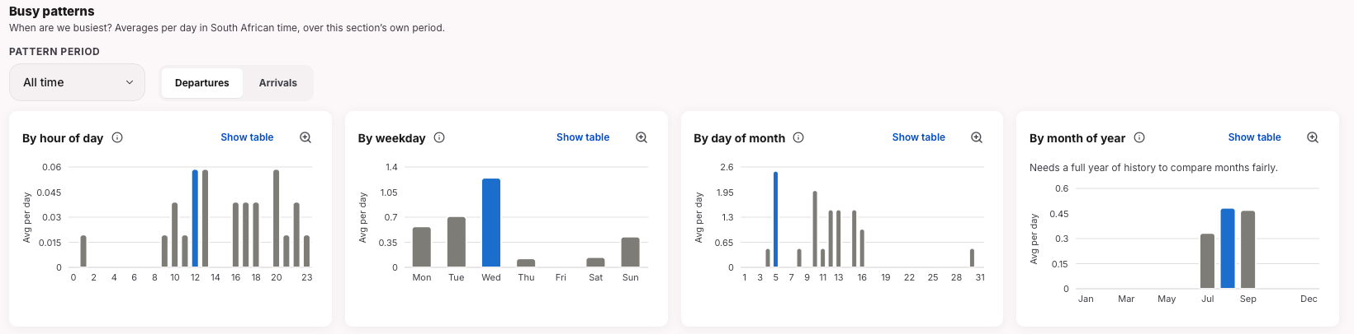
Figure 14: Analytics headline tiles
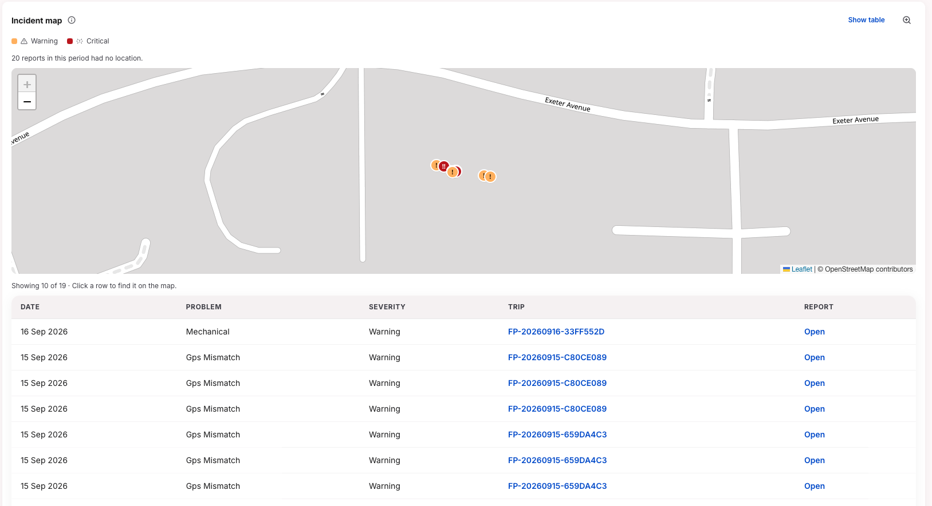
Figure 15: Incident map in the Today view
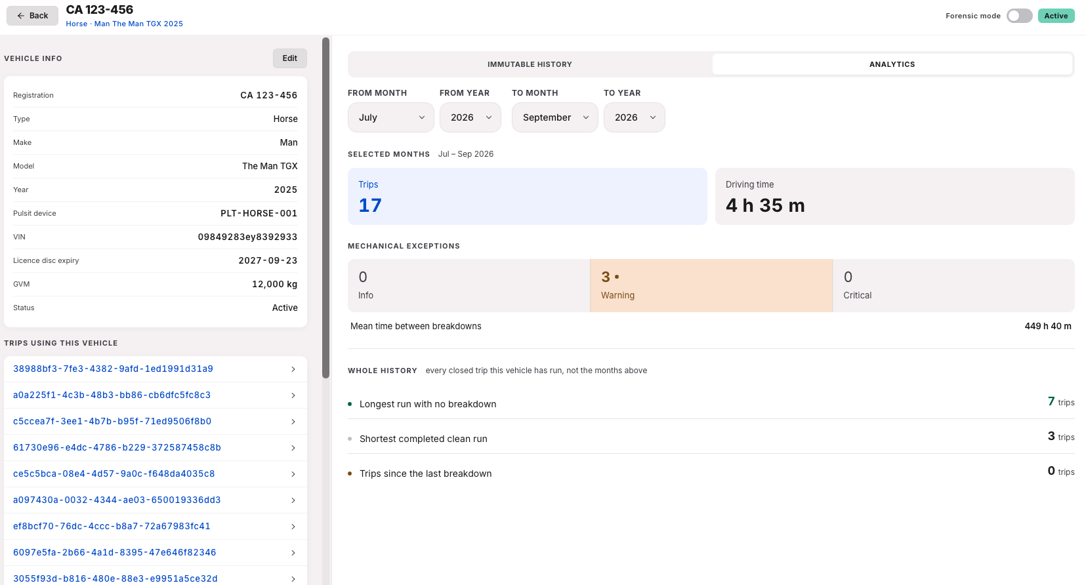
Figure 16: Analytics for one vehicle
TEAM TO DO: The tiles, incident map and vehicle analytics above are Iteration 3 screenshots. Retake them from the current build so that each chart's Source line is visible.

8.6 Driver App: Arrival and Receiver Handover
At Arrival the driver photographs the seal; the app reads the seal number from the photograph and asks the driver to confirm or correct it, instead of typing it (FP-300). The seal's condition is recorded as intact, damaged or missing (Figure 17).
INSERT SCREENSHOT HERE
Driver app Arrival screen: seal photograph with the number read from it and the confirm / correct buttons (FP-300)
Figure 17: Driver app: seal number read from the photograph at Arrival
The driver shows a QR code that rotates every 20 seconds (Figure 18). The receiver scans it with their own phone, types their name, signs and confirms; an identity check appears only for consignments that require it (BR-7). The driver's screen then shows that the receiver confirmed, at what time, and from their own device (Figure 19). The Iteration 3 receiver screenshots showed a real identity document and have been withdrawn; the screens shown here contain no personal data.
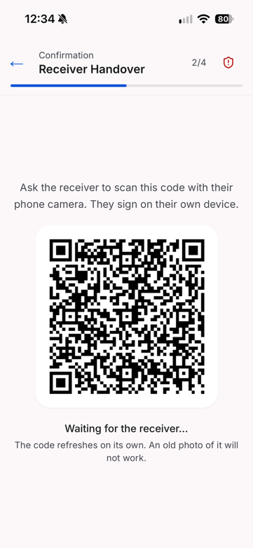  Figure 18: Driver app: QR code for the receiver | 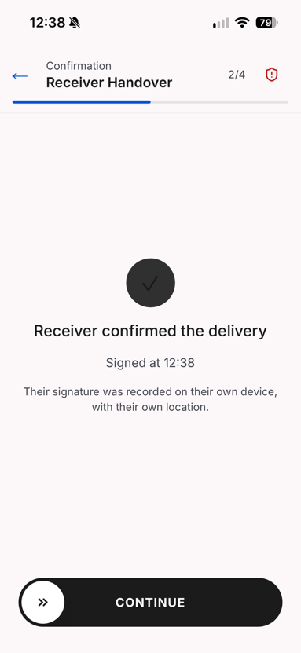  Figure 19: Driver app: receiver confirmation received

8.7 Precinct Set-up
An Admin-Dispatcher now finds a precinct by searching for its address, which places the pin on the map and fills in the coordinates (FP-309); a click on the map shows the address of that point. The geofence radius is drawn on the map and set per precinct (BR-11). Figure 20 shows the precinct list with each geofence and whether the precinct is owned or shared, and Figure 21 the address search.
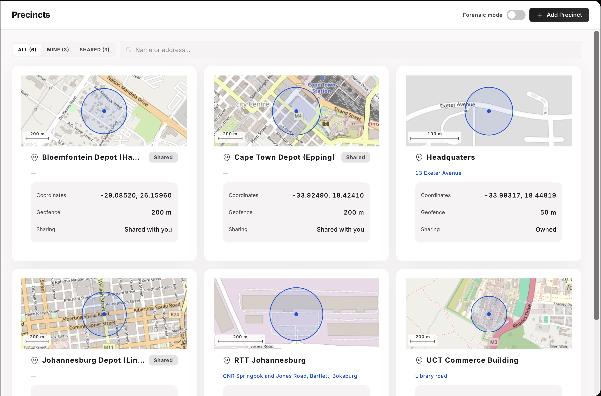
Figure 20: Precinct list with geofences
INSERT SCREENSHOT HERE
Precinct form with an address typed into the search box and the pin and geofence placed on the map (FP-309)
Figure 21: Precinct set-up by address search

8.8 Audit Pack and Client Portal
A new Audit packs tab on the trip page (Figure 22) lets a dispatcher preview a trip's audit trail, issue a pack to a named recipient, see each pack's status and access log, and revoke it (FP-279). The recipient's page in the client portal (Figure 23) presents the same content as the PDF: a timeline, a route map, photographs, exceptions, the parties involved, and an integrity section with a Verify button. Every item is labelled as anchored or recorded only, and missing evidence is listed rather than hidden, because an insurer must know what the pack does not prove.
INSERT SCREENSHOT HERE
Dispatcher trip page, Audit packs tab: list of issued packs with status, access log and the Issue button (FP-279)
Figure 22: Audit packs tab on the trip page
INSERT SCREENSHOT HERE
Client portal: an audit pack opened by a recipient, with the integrity section showing the result of Verify (FP-279, FP-291)
Figure 23: Client portal: verifying an audit pack

9. Testing Approach, Results and Plan
The testing approach is unchanged in principle from Iteration 3: automated unit and integration tests organised around the project risks, concurrency tests that hold two connections at a barrier so that they genuinely collide (Team05, 2026b, §7.1.1, pp. 57–58), and story acceptance walkthroughs. Iteration 4 added three things the Iteration 3 review asked for: the full test suite now runs automatically on every change, failure scenarios (lost signal, dead phones, cleared app data and outages) are tested deliberately, and load is measured.

9.1 Kinds of Tests
Table 26: Test levels used in Iteration 4
Level | Tool and scope | Iteration 4 focus
Backend unit | pytest; one piece of logic, no database or network | Phase-plan generation with Arrival; anchored payloads; corroboration limits; severity; cost calculations
Backend integration | pytest and httpx against a real PostgreSQL database and Redis | Manifest trips; Arrival; exception claims and batch review; anchored exceptions, reviews and cancellations; audit packs; parcel trace; vehicle clashes
Frontend unit and component | Vitest; screens, hooks and client logic in all four front ends | Offline queue and exception store; timeline phase cards; exception inbox; audit-pack panel; portal verification
Concurrency | Barrier-synchronised database connections | Two claims or reviews of one exception; two redemptions of one QR link; two trips for one manifest; simultaneous cancellations
Security | Integration tests per role and organisation | Organisation isolation, identical "not found" responses, locked-down database tables, per-user rate limits
Static and structural | ruff, mypy, import-linter, size limits | Layering rule enforced; no oversized functions or files
Migration | Alembic against an empty database in CI | Exactly one migration head; the whole chain applies cleanly
Load | Scripted concurrent clients against a separate environment (FP-299) | Concurrent phase completions and dashboard reads; database timeouts; anchoring latency
Device and connectivity | Manual, on Android and iPhone handsets | Airplane mode mid-phase, battery dies, app closed, app data cleared, API or partner service down
Story acceptance | Team walkthroughs on the deployed system | Each Sprint 8 and 9 story against its acceptance criteria

9.2 Automated Test Evidence
The repository contains 227 backend test files (109 unit and 112 integration) and 362 frontend test files across the dispatcher, driver, receiver and client-portal applications. Figure 24 shows the result of running the suites on the development branch on 19 October 2026: 3,411 backend tests, 1,448 driver-app tests and 2,900 dispatcher tests passed, with no failures. The 267 deselected backend tests are marked slow and are excluded from this run, as they are in the main CI step. Since Iteration 4, CI runs the complete backend suite on every pull request; in Iteration 3 it stopped at a style check (Team05, 2026b, p. 43). Table 27 lists the CI steps, all of which must pass before a change can be merged into the protected development branch.
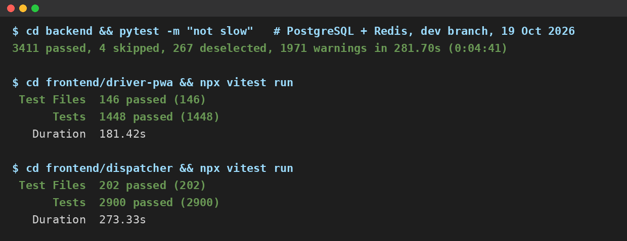
Figure 24: Summary output of the backend, driver-app and dispatcher test suites, 19 October 2026
Table 27: Continuous integration pipeline, run on every pull request
Step | What it checks
Lint (ruff) | Code style and common errors
Structure ratchet | No function or file grows beyond the agreed size limits
Layering (import-linter) | No module skips a layer, for example a request handler calling an integration directly
Type check (mypy) | Type consistency across the backend
Tests (pytest) | Full unit and integration suite against a throwaway PostgreSQL 17 database and Redis
Import check | Every module imports cleanly in a fresh interpreter, with no import cycles
Migrations | Exactly one migration head; the whole chain applies to an empty database
Frontend | ESLint, TypeScript type check and Vitest suites for the dispatcher, driver and receiver applications

9.3 Failure-Scenario and Load Testing
The Iteration 3 review asked for serious testing of location, connectivity and outages. Table 28 lists the scenarios tested and the expected behaviour, which is defined by the business rules in §6.4. Each scenario is also a test case in Appendix A where an automated test covers it.
Table 28: Failure scenarios and expected behaviour
Scenario | Expected behaviour
No signal during a phase | The action is queued on the phone and sent when signal returns; the server records it once, using the same identifier on every retry
A queued action is blocked because an earlier phase is incomplete | The item is kept and retried, not discarded (FP-276); the dispatcher is alerted if it cannot be delivered
App data or cache cleared before sync | Unsent captures are lost on the phone, but nothing false is recorded: the phase stays pending on the server and on the live trip list, and the driver recaptures it
Battery dies, phone lost or stolen | The phase stays pending; a sign-in on another phone ends the old session; overrides only under BR-4 (BR-6)
Tracker silent or position stale | "Could not check" is recorded, never a mismatch; the driver continues
Hedera unavailable | Phases complete and their receipts are marked owed and retried; trip creation is refused
Parcel Perfect unavailable | Trip creation is refused; an active trip keeps its last manifest
Didit unavailable | The receiver's check is recorded as unverified with a reason; delivery continues
API unavailable | The driver app queues actions and retries; the dispatcher application shows the failure rather than stale data
Slow database | Connection and pool-wait timeouts end the request quickly with an error, rather than hanging (FP-275)

The load test (FP-299) runs concurrent drivers completing phases, location updates and dashboard reads against a separate environment, never the shared development database. Its success criteria are no server errors or duplicate records under sustained load, database timeouts that fail fast, and 95% of anchor receipts within 60 seconds.
TEAM TO DO: Add the load-test results here: [number of simulated drivers and duration], [errors and duplicate records], [95th-percentile anchoring time], [slowest database request under load].

9.4 Risk-to-Test Matrix
Table 29 links each project risk to the tests that cover it. Layer B is backend and F is frontend.
Table 29: Risk-to-test matrix
Risk | What is tested | Layer | Test cases
R-02, R-04 | Every phase, critical exception, review and cancellation anchored; each action has its own receipt; tampering detected | B | TC-04, TC-05
R-03 | Phone, horse and trailer compared at every phase; a silent tracker gives "could not check" | B | TC-06
R-05 | Offline queue keeps blocked items and replays each item once | F, B | TC-12
R-06 | Anchored payloads contain no positions, names or free text | B | TC-05
R-13 | One redemption per link; a second browser cannot confirm; rotation pauses once the link is opened | B | TC-08, TC-09
R-12 | Identity check only when the consignment requires it; outcome recorded | B | TC-10
R-14 | Organisation isolation; locked-down tables; per-user rate limits | B | TC-11
R-16 | Full suite, layering and migrations in CI | B, F | §9.2
SO-3 | Manifest trip creation, duplicates refused, parcel trace | B | TC-01, TC-02, TC-03
SO-5 | Every exception reviewed; claims; concurrent reviews | B | TC-07
SO-6 | Seal mismatch, damage and absence at Arrival | B | TC-06
SO-8 | Audit pack issue, access code, revocation, verification | B, F | TC-13, TC-14

9.5 Test Plan and Status
Table 30 updates the Iteration 3 test plan (Team05, 2026b, Table 37, p. 60).
Table 30: Test plan and status at the end of Iteration 4
What | Environment | Status
Load and volume, including anchoring latency | Separate load-test environment | Done (FP-299); results in §9.3
Live identity verification and callback | Deployed system with the live provider | Done; the check is now opt-in per consignment
Live Parcel Perfect and Pulsit integration | Partner sandbox | Not possible: credentials not granted (R-22). Simulated feeds tested instead
Override and driver completion of the same phase at the same instant | Backend integration | Done: exactly one write succeeds
Device and connectivity scenarios (Table 28) | Android and iPhone handsets on the deployed system | [TO CONFIRM: date run, handsets used and result]
Acceptance testing with LFG users | Deployed system | Not done within the project; team story acceptance only. Planned as the first step of the pilot (BO-1)

10. Development Approach, Scrum and Progress

10.1 Development Approach and Standards
Team 05 developed FreightProof iteratively with Scrum, tracked on the Jira board FP. Roles were unchanged throughout the project: Ciaran Formby was Product Owner, Tim Gultig was Scrum Master, and all four members, with Thomas Davis and Chiko Kasongo, formed the Development Team. Each sprint opened with planning, in which every story was estimated in Fibonacci story points and assigned before work started. The team met in full every Wednesday, coordinated dependent work in the team channels, and closed each sprint with a review against Jira and a retrospective. Each iteration ended with a panel review, whose feedback became the next iteration's backlog.
The team followed these standards:
- Version control. The main and development branches are protected. Every change arrives through a pull request that a second member reviews, and commits reference their Jira key.
- Definition of done. A story is done when its acceptance criteria are met, its tests pass in CI, it has been reviewed and merged, and its Jira ticket links the pull request.
- Coding standards. The Python backend uses typed code, Pydantic v2 models and async database access, checked by ruff and mypy. The four front ends use TypeScript in strict mode with ESLint. The layering rule is checked by CI (§9.2).
- Database standards. Schema changes go through named, hand-reviewed migrations only. Every new table has row-level security enabled.
- UI standards. A shared design system (colours, type, spacing and status chips) is used by all front ends, and shared types come from one package so that a contract change fails at compile time.

10.2 Sprint 8
Sprint 8, 29 September to 12 October 2026 (13 days). Goal: complete the final features and begin preparing for final submission. Table 31 lists the committed backlog, written as user stories.
Table 31: Sprint 8 committed backlog (19 items, 84 points)
Key | User story | Assignee | Pts | Outcome
FP-281 | As a dispatcher, I want to create a trip from the client's manifest number, so that cargo is imported, not typed | Ciaran Formby | 11 | Done in sprint
FP-280 | As a dispatcher, I want every exception to reach a shared inbox where I can claim it, so that nothing is recorded and forgotten | Ciaran Formby | 8 | Done in sprint
FP-149 | As a dispatcher, I want to find a parcel by barcode and see everywhere it has been | Chiko Kasongo | 8 | Done in sprint (carried from Sprint 7)
FP-279 | As an insurer, I want an anchored audit pack that I can verify myself, so that I need not trust the operator's copy | Tim Gultig | 8 | Done in sprint
FP-270 | As a dispatcher, I want the seal inspected at Arrival and every phase anchored, so that a break in transit is detected when custody arrives | Ciaran Formby | 3 | Done in sprint
FP-272 | As a demonstrator, I want a demo panel that follows the trip, so that partner events can be simulated in order | Ciaran Formby | 2 | Done in sprint
FP-277 | As a developer, I want the identity-provider call inside the service layer, so that request handlers never call an integration directly | Tim Gultig | 2 | Done in sprint
FP-271 | As an operator, I want newer tables closed to direct database access, so that evidence cannot be read around the API | Ciaran Formby | 1 | Done in sprint
FP-295 | As an operations manager, I want a plain-language brief of patterns in my analytics, based on de-identified figures | Thomas Davis | 8 | Carried; done in Sprint 9
FP-286 | As the team, we want documentation and evidence captured during the sprint, so that the final document is assembly, not authoring | Unassigned | 5 | Carried; done in Sprint 9
FP-294 | As an operations manager, I want to see the cargo value exposed and the estimated cost of delays | Thomas Davis | 5 | Carried; done in Sprint 9
FP-296 | As an operations manager, I want today's incidents on a map and the source of every figure | Thomas Davis | 5 | Carried; done in Sprint 9
FP-300 | As a driver, I want the seal number read from my photo, so that I confirm it instead of typing it | Tim Gultig | 5 | Carried; done in Sprint 9
FP-273 | As a principal, I want delivery to close only after the receiver confirms, so that a driver cannot sign for the receiver | Tim Gultig | 3 | Carried; done in Sprint 9
FP-276 | As a driver, I want evidence captured offline to be kept until it is accepted, not discarded | Tim Gultig | 3 | Carried; done in Sprint 9
FP-274 | As an operator, I want request limits applied per user, so that one user cannot exhaust another's | Chiko Kasongo | 2 | Carried; done in Sprint 9
FP-275 | As a dispatcher, I want a slow database to fail fast rather than freeze my screen | Chiko Kasongo | 2 | Carried; done in Sprint 9
FP-297 | As a driver, I want to report a breakdown that affects both the horse and a trailer | Ciaran Formby | 2 | Carried; done in Sprint 9
FP-278 | As a driver, I want real seal numbers accepted, not only an invented format | Tim Gultig | 1 | Carried; done in Sprint 9

Outcome. Sprint 8 completed 43 of 84 points (51%) within the sprint and carried 41 points into Sprint 9; no scope was dropped. Figure 25 shows the burndown, drawn from the Jira resolution dates. The scope line stays at 84 points throughout because no stories were added after planning; the remaining work therefore never rises. It falls in steps rather than steadily because large stories close in one step: the 11-point manifest story and the 8-point exception inbox closed on 5 and 6 October.
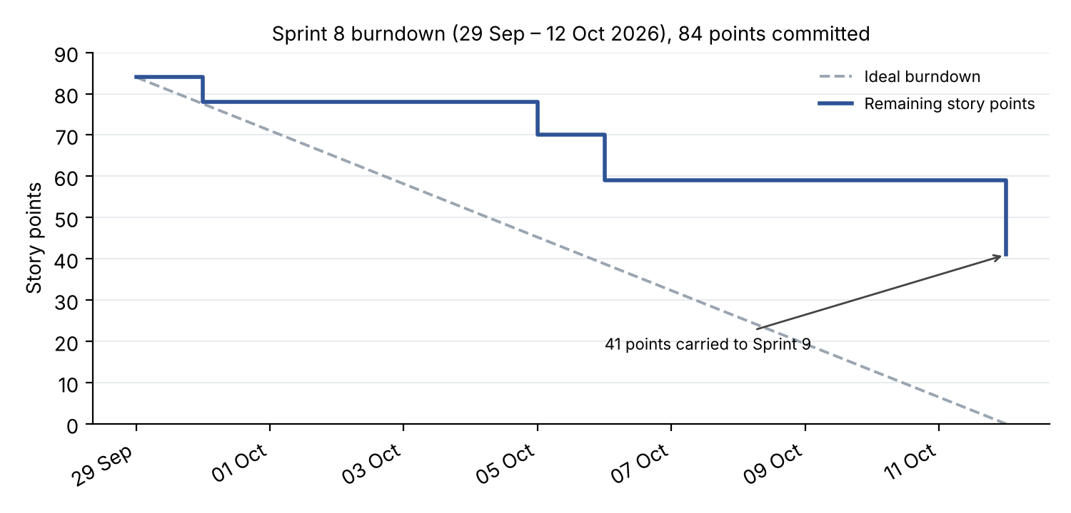
Figure 25: Sprint 8 burndown chart
INSERT SCREENSHOT HERE
Jira board FP, Sprint 8 task board (or sprint report) at sprint close, 12 October
Figure 26: Sprint 8 task board
TEAM TO DO: The Sprint 8 and Sprint 9 retrospectives below were drafted from the Jira data. Confirm or rewrite them with what the team actually discussed.
Table 32: Sprint 8 retrospective
What went well | What should improve | Action taken
The panel's feedback was turned into sized stories before the sprint started, and the largest items (manifest trips, exception inbox, audit packs) were delivered. | Only 51% of the commitment was completed within the sprint; several large stories were started late and finished early in Sprint 9. | Sprint 9 started with the carried stories, and carried work was listed separately from new work.
Carried items were reported separately from new work, as promised in Iteration 3. | Some points closed on 30 September for work already built on a branch before the sprint started, which overstated early progress. | Work is ticketed before it starts, even between sprints.
CI caught migration and layering problems before they reached the shared branch. | The documentation ticket had no owner and slipped again. | Documentation tasks were given owners and points in Sprint 9 (FP-303).

10.3 Sprint 9
Sprint 9, 12 to 23 October 2026 (11 days, including the code freeze from 19 October). Goal: close the Iteration 3 feedback, harden the system and deliver the final submission. Sprint 9 committed 118 points: the 41 points carried from Sprint 8 (Table 31) and 77 points of new work (Table 33).
Table 33: Sprint 9 new backlog (15 items, 77 points)
Key | User story | Assignee | Pts | Outcome
FP-303 | As the team, we want the final document, evidence and code packaged for submission | Ciaran Formby | 13 | Done
FP-288 | As a dispatcher, I want each phase on the timeline to show its acts live, so that I see what happened inside it | Ciaran Formby | 8 | Done
FP-290 | As an insurer, I want critical exceptions, reviews and cancellations anchored, so that the records a dispute questions are protected | Ciaran Formby | 8 | Done
FP-308 | As an operator, I want upload limits, artefact ownership and session checks enforced | Tim Gultig | 8 | Done
FP-287 | As a dispatcher, I want photographs to appear on the timeline as soon as they are uploaded | Ciaran Formby | 5 | Done
FP-289 | As a dispatcher, I want the trip list to show each trip's phase, last update, unreviewed exceptions and location check | Ciaran Formby | 5 | Done
FP-139 | As a dispatcher, I want a horse that is on a live trip to be refused for a second one | Thomas Davis | 5 | Done
FP-309 | As an Admin-Dispatcher, I want to place a precinct by searching for its address | Tim Gultig | 5 | Done
FP-83 | As a dispatcher, I want a driver substitution recorded by both drivers, so that each driver's custody stays on the record | Ciaran Formby | 5 | Done
FP-142 | As a dispatcher, I want to see a vehicle clash before I create a trip | Thomas Davis | 3 | Done
FP-291 | As an operator, I want audit-pack links to need an e-mailed code before first view | Tim Gultig | 3 | Done
FP-316 | As an insurer, I want a "selfie only" verification to exist only when the selfie is stored | Tim Gultig | 3 | Done
FP-292 | As an insurer, I want the client portal deployed, so that a share link works outside the team's machines | Tim Gultig | 2 | Done
FP-293 | As a receiver, I want an identity check only when the consignment requires it | Chiko Kasongo | 2 | Done
FP-299 | As the team, we want a load test that proves the database timeouts hold | Chiko Kasongo | 2 | Done

INSERT SCREENSHOT HERE
Jira board FP, Sprint 9 task board at sprint close, 23 October
Figure 27: Sprint 9 task board
INSERT SCREENSHOT HERE
Jira burndown chart for Sprint 9 (Reports → Burndown chart), with any scope changes visible
Figure 28: Sprint 9 burndown chart
Sprint 9 retrospective. Went well: the panel's two central requests, a multi-trip view and anchored incident evidence, were delivered, and the code freeze held. Should improve: the sprint carried 118 points, which only worked because 41 were already partly built; workload remained uneven, as Table 35 shows. Action: recorded in the project reflection below (§10.5).

10.4 Velocity and Capacity
Figure 29 shows committed and completed points for every sprint. Sprint lengths varied between 10 and 14 days because sprints were fitted around the iteration reviews and the submission date. To compare them, Table 34 also gives points per sprint day. Jira was used sparsely in Sprints 1, 3 and 4 (4, 7 and 4 issues), so their figures understate the work done and are not comparable.
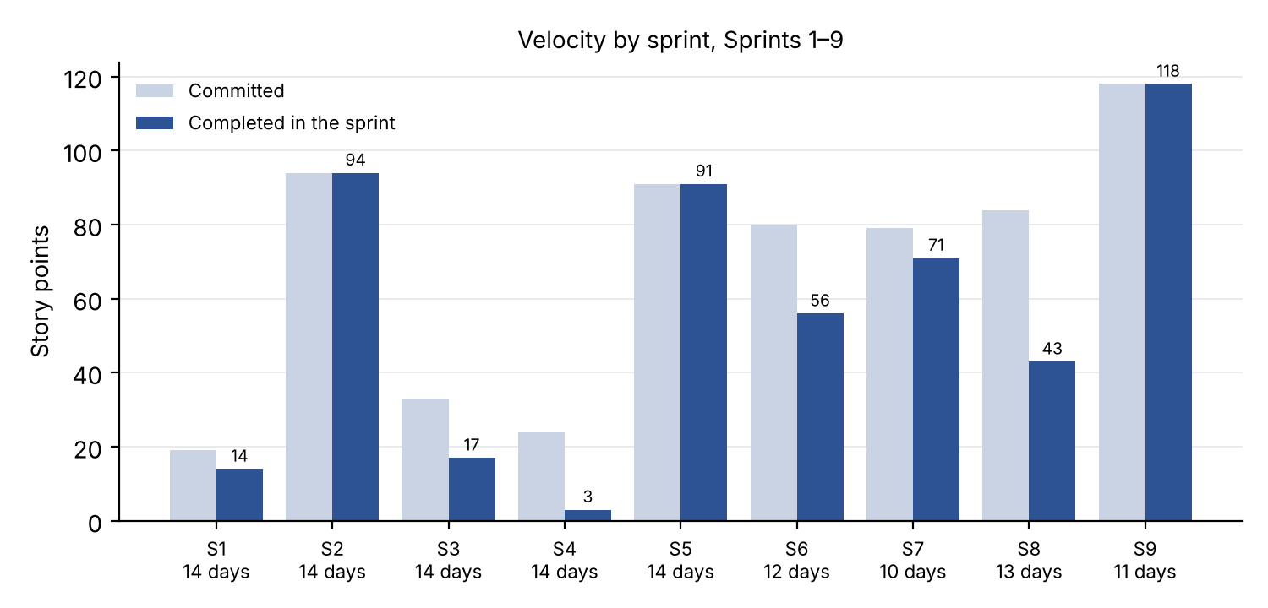
Figure 29: Committed and completed story points, Sprints 1–9
Table 34: Velocity normalised for sprint length
Sprint | Dates | Days | Committed | Completed | Points per day
2 | 3–17 May | 14 | 94 | 94 | 6.7
5 | 27 Jul – 10 Aug | 14 | 91 | 91 | 6.5
6 | 26 Aug – 7 Sep | 12 | 80 | 56 | 4.7
7 | 7–17 Sep | 10 | 79 | 71 | 7.1
8 | 29 Sep – 12 Oct | 13 | 84 | 43 | 3.3
9 | 12–23 Oct | 11 | 118 | 118 | 10.7

Across comparable sprints the team completed about 6.5 points per sprint day. Sprint 8 fell well below this and Sprint 9 well above it, because 41 points of Sprint 8 work were finished early in Sprint 9. Taken together, Sprints 8 and 9 delivered 161 points in 24 days, 6.7 points a day, which matches the team's earlier rate.
Table 35: Story points completed per member in Iteration 4
Member | Sprint 8 | Sprint 9 | Iteration 4 | Share
Ciaran Formby | 25 | 46 | 71 | 44%
Tim Gultig | 10 | 33 | 43 | 27%
Thomas Davis | 0 | 26 | 26 | 16%
Chiko Kasongo | 8 | 8 | 16 | 10%
Unassigned (documentation) | 0 | 5 | 5 | 3%
Total | 43 | 118 | 161 | 100%

Story points measure feature tickets, not all contributions: documentation, research interviews, meeting minutes, testing and presentation work are largely outside them. Contributions in those areas are described in the portfolio of evidence (Appendix C).

10.5 Reflection on Scrum and Lessons Learnt
How Scrum helped. Scrum's short cycles let the panel's feedback change the product each iteration. Iteration 2's review led to the plan-driven phase lifecycle; Iteration 3's led to location corroboration and the receiver's own confirmation; and Iteration 4's led to the live trip list, the exception inbox and the audit pack. Without fixed review points, these changes would have arrived too late to build. The rule that a story must be estimated and assigned before it starts, adopted after Iteration 2, made planning reliable from Sprint 6 onwards. Pull-request reviews and CI made four people working on one codebase safe, and Jira gave an honest record of what was and was not finished.
Lessons learnt.
- Keep sprints the same length. Varying lengths made velocity hard to compare and planning harder. A fixed two-week sprint, with reviews placed between sprints, would have been simpler.
- Treat documentation as sprint work. Documentation was under-counted in three iterations and done at the end. It only improved when it became pointed tickets with owners.
- Write smaller stories. Stories of 8 to 13 points closed in one step at the end of a sprint, which hid progress and made the burndown uninformative.
- Balance the workload deliberately. Points were concentrated in two members in every iteration despite being raised in each retrospective. It has to be addressed at sprint planning, when work is assigned, not only noted in the retrospective.
- Ticket work before doing it. Work done between sprints and later credited to a sprint distorted the sprint figures.
- Review AI-assisted code as carefully as your own. Code that works is not the same as code the team understands (§10.6).
- Talk to users early. The seven interviews and the meetings with LFG changed the product more than any technical decision: they produced the audit pack, the exception review workflow and the manifest-first trip.

10.6 Use of AI Tools
The team used AI tools throughout the project. Claude Code was the main tool, used to understand unfamiliar code, generate and refactor code, write tests, and draft design notes and specifications. Gemini was used to reconcile sprint records against the repository. AI was also used to check documentation against the code and to find merge conflicts across branches.
The team controlled this use in four ways. Repository instructions require a written plan before any non-trivial change and forbid AI tools from committing or merging. Every change passes through a pull request reviewed by a team member. CI enforces the tests, types and layering rule regardless of who wrote the code. Each design note records which decisions a team member made and signed off. The Iteration 3 code review showed that working code is not the same as understood code, so in Iteration 4 each member traces the data flow of their own modules ahead of the final code review on 28 October.
In the product, the AI insights brief (FP-295) summarises analytics from de-identified figures only, and names the figures each statement rests on. Severity and other evidence decisions are made by fixed rules, not by an AI model, because evidence must be reproducible.

References
Electronic Communications and Transactions Act 25 of 2002 (South Africa).
Hedera. (n.d.). Consensus service. Hedera documentation. https://docs.hedera.com/guides/docs/hedera-api/consensus-service
National Institute of Standards and Technology. (2015). Secure hash standard (SHS) (FIPS PUB 180-4). https://doi.org/10.6028/NIST.FIPS.180-4
Protection of Personal Information Act 4 of 2013 (South Africa).
Schwaber, K., & Sutherland, J. (2020). The Scrum guide. https://scrumguides.org/scrum-guide.html
South African Police Service. (2025). Annual report 2024/2025. https://www.saps.gov.za/about/stratframework/annual_report/2024_2025/2024-25-SAPS-Annual-Report.pdf
Team05. (2026a). FreightProof SA: Iteration 2 documentation [Unpublished project document]. INF4027W, University of Cape Town.
Team05. (2026b). FreightProof SA: Iteration 3 documentation [Unpublished project document]. INF4027W, University of Cape Town.
Transported Asset Protection Association. (2023). Trucking security requirements (TSR) 2023.

Appendix A: Sample Test Cases
Each case below is an automated test in the repository and runs in CI on every pull request. The evidence column names the test file and function. Results are from the full test run on 19 October 2026 shown in Figure 24.
Table 36: Sample test cases
ID | Requirement | Steps and test data | Expected result | Evidence | Result
TC-01 | SO-3, TLM 1.2 | Create a trip from a mock manifest; then request an unknown manifest number | Trip saved with its manifest key and verifies against its journey lock; unknown manifest returns 404 | test_trip_from_pp_manifest.py: test_create_persists_a_manifest_trip; test_unknown_manifest_is_404 | Pass
TC-02 | SO-3, TLM 1.2 alt. 1c | Two dispatchers create a trip from the same manifest at the same instant (barrier) | Exactly one trip is created; the other request is refused cleanly | test_creation_concurrency.py: test_concurrent_creation_from_one_manifest_creates_one_trip | Pass
TC-03 | SO-3, TLM 1.13 | Search a barcode belonging to another organisation, and an unknown barcode | Both return the same "not found" response | test_parcel_trace.py: test_foreign_and_unknown_records_are_indistinguishable | Pass
TC-04 | SO-1, BR-2 | Raise a critical exception, cancel the trip, then review the exception | Each action has its own anchored event and receipt; earlier receipts unchanged | test_fp290_incident_chain.py: test_each_action_has_its_own_event_and_receipts_stay_separate | Pass
TC-05 | SO-1, R-07 | Repeat TC-04 with Hedera unavailable | Events stored with anchor status "failed"; the evidence itself is intact | test_fp290_incident_chain.py: test_hedera_outage_leaves_failed_events_and_the_source_intact | Pass
TC-06 | SO-6, CC 1.11 | Arrival with a seal number different from the departure seal | Exactly one critical seal exception is raised | test_arrival_phase.py: test_arrival_seal_number_mismatch_raises_one_critical_exception | Pass
TC-07 | SO-5, BR-2 | Dispatcher B claims an exception already claimed by A; then A and B submit reviews simultaneously | Claim refused with 409; exactly one review recorded | test_exception_claims.py: test_claim_over_a_colleague_is_409; test_exception_review_concurrency.py: test_simultaneous_reviews_record_exactly_one_dispatcher | Pass
TC-08 | SO-4, R-13 | Two phones redeem the same QR link at the same instant | Exactly one confirmation succeeds | test_handover_token_concurrency.py: test_two_simultaneous_redemptions_of_the_same_token_produce_exactly_one_success | Pass
TC-09 | SO-4, R-13 | A second browser opens a link that the receiver's browser holds | The second browser is refused; the receiver's link still works | test_handover_endpoints.py: test_a_refused_binding_does_not_burn_the_real_receivers_token | Pass
TC-10 | SO-4, BR-7 | Receiver declines the identity check or has no document | Delivery is still confirmed; outcome recorded as unverified | test_handover_endpoints.py: test_full_walk_receiver_without_an_id_still_confirms | Pass
TC-11 | R-14 | Apply the database lockdown migration and query as the public API roles | Row-level security on; direct access revoked | test_data_api_lockdown.py: test_upgrade_enables_rls_and_revokes_api_roles | Pass
TC-12 | R-05 | Queue a phase offline and retry it after a lost response | The same idempotency key is sent on every attempt; the server records it once | useOfflineQueue.test.ts: "sends the same idempotency_key on a retry as on the first attempt" | Pass
TC-13 | SO-8, BR-9 | Open a revoked audit-pack link | 410 response; the attempt is logged | test_audit_pack_public.py: test_open_shared_pack_revoked_is_410_and_logged | Pass
TC-14 | SO-8, BR-9 | Open an e-mailed audit pack without entering the code | 401 response; the attempt is logged | test_audit_pack_email_codes.py: test_open_emailed_pack_without_grant_is_401_and_logged | Pass
TC-15 | BP-3, TLM 1.2 | Request availability for a horse already on an overlapping trip | The horse is listed as busy, naming the trip; other organisations' trips never appear | test_trip_availability_endpoint.py: test_availability_lists_the_busy_driver_horse_and_trailer | Pass

Appendix B: Addendum – Changes Since Iteration 3
Table 37 lists the main changes to this document since Iteration 3 and the feedback that prompted each. Codes A1 to A32 refer to the comments on the Iteration 3 document; "Marksheet" refers to the Iteration 3 marksheet.
Table 37: Changes since Iteration 3 and the feedback they answer
Feedback | Comment on Iteration 3 | Change in Iteration 4 (section)
A1, A2 | Acronyms not written out first; organisation citation not in APA style | Acronyms written out on first use; SAPS cited as an organisation in APA 7 style (§1.1); five sources added (References)
A3 | No short summary of the business problems | Summary table opens the section (Table 3, §2)
A4 | Problems traced to objectives before the objectives were defined | Traceability moved after the objectives (§3.4)
A5; Marksheet | Sponsorship unclear; business objectives framed for LFG | One sponsorship statement (§1.2); business objectives rewritten for FreightProof as a venture, with measures (§3.1)
A6, A17 | Parcel detail too high level: manifests, intermediate stops, damage, pallets | Manifest → waybill → parcel hierarchy; pickup and delivery stops per waybill; damage recorded against consignment and vehicles; pallets stated as out of scope (§6.2)
A7 | Override needs business rules, approvals, documents, insurer notification | Business rules BR-3 and BR-4 (§6.4)
A8, A13 | Dead, forgotten or stolen phone; connectivity and outage testing | BR-6 (§6.4); alternative flows (§6.5); failure-scenario testing (§9.3)
A9 | Who is informed; what the customer must do; a receiver who refuses | BR-3 and BR-5 (§6.4); CC 1.8 alt. 5a (§6.5)
A10 | "Organisation" and the system boundary unclear | Organisation defined (§1.3, Glossary); boundary and outside actors (§6.3)
A11, A12 | Receiver verification and access unclear; authorised receivers | BR-7 (§6.4); CC 1.10 replacement steps (§6.5); identity check opt-in (FP-293)
A14 | State machine: refused activation and missing false branch; current stop could not load | Guards and branches redrawn; Arrival added (§6.6)
A15 | Architecture looked like a package diagram | Deployment view with nodes and protocols (§7.1)
A16 | "Fingerprinted" confused with "digitally signed" | Terminology defined (§7.2)
A18, A22 | 20 s QR rotation and 200 m geofence not explained | Rationale for every configured value (§7.3); BR-11
A19 | Risk status unclear; register split over several pages | One landscape table with a status legend (Table 9, §4)
A20 | Driver expected to report offline-queue failures | Automatic dispatcher alert (R-05, §4)
A21 | Some risks were features; project risks missing | Feature gaps moved to known limitations (§5.4); project risks R-19 to R-23 (§4)
A23 | Trip timeline layout; summary view for many trucks | Live trip list (§8.2); redesigned timeline (§8.3)
A24 | Exception handling beyond typing | Claim and review workflow, rules and incident declarations (§6.4, §8.4)
A25 | Real identity document in screenshots | Screenshots withdrawn (§8.6)
A26 | Analytics not designed for daily use; incident map; patterns | Today and Trends views; sources stated; AI brief (§8.5)
A27 | Cleared app data or cache | Alternative flow 4b in CC 1.11 (§6.5); Table 28 (§9.3)
A28 | Legal standing of a signature image | ECTA analysis (§7.4)
A29 | Empty header in the risk-to-test matrix | Matrix rebuilt with risk IDs (§9.4)
A30 | Backlog story hard to follow (FP-144) | Backlog items written as user stories (§10.2, §10.3)
A31 | Sprint lengths differ | Velocity normalised per sprint day (§10.4)
A32 | Remaining work rose on the burndown | Burndown drawn from Jira with a fixed scope line and explained (§10.2)
Marksheet: testing | Add evidence of automated testing and results | CI pipeline and test counts (§9.2); test cases with results (Appendix A)
Marksheet: professional | One typing standard; empty headers; typos | UK English throughout; no empty headings; captions and cross-references regenerated

Appendix C: Portfolio of Evidence and User Log
Each member's contribution over the project is summarised below, followed by the contribution scores agreed by the team. Each log is reviewed and signed off by the other three members.
TEAM TO DO: The descriptions below were drafted from Jira assignments and design-note authorship. Each member must check and expand their own description (meeting minutes, research, presentation and testing work), agree the scores, and sign the table at the end.
Ciaran Formby (Product Owner). Code: manifest-first trip creation (FP-281), the exception inbox with claims and batch review (FP-280), the Arrival phase with every-phase anchoring and trailer geofences (FP-270), anchored critical exceptions, reviews and cancellations (FP-290), the live trip list and live phase timelines (FP-287, FP-288, FP-289), the database lockdown (FP-271), driver substitution (FP-83) and the demo panel (FP-272). Documentation: design notes for the Arrival phase and the exception workflow; owner of the final submission package (FP-303). Other: team contact for the Pulsit and Parcel Perfect partners; backlog ordering and sprint goals.
Tim Gultig (Scrum Master). Code: insurer audit packs, the client portal and incident declarations (FP-279, FP-291, FP-292), receiver confirmation enforcement (FP-273), offline evidence retention (FP-276), seal reading from photographs (FP-300), precinct address search (FP-309), selfie storage (FP-316), security hardening (FP-308) and the identity-check layering fix (FP-277). Documentation: the insurer audit-trail design, including research on claim forms, TAPA TSR and ECTA. Other: sprint ceremonies, Jira reconciliation and the sprint records.
Thomas Davis. Code: cost analytics (FP-294), today's incident map and figure sources (FP-296), the AI insights brief (FP-295), and the vehicle-clash guard and availability strip (FP-139, FP-142). Documentation: analytics specifications for cost and provenance; project context and plan sections. Other: architecture and package diagrams.
Chiko Kasongo. Code: parcel search by barcode (FP-149), per-user rate limits (FP-274), database timeouts (FP-275), the load test (FP-299) and the opt-in receiver identity check (FP-293). Documentation: UI evidence and state-machine sections. Other: sprint metrics, burndown and velocity reporting.
Table 38: Contribution scores out of 5
Member | Coding | Documentation | Presentation | Research | Meeting minutes | Communication
Ciaran Formby | [ ] | [ ] | [ ] | [ ] | [ ] | [ ]
Tim Gultig | [ ] | [ ] | [ ] | [ ] | [ ] | [ ]
Thomas Davis | [ ] | [ ] | [ ] | [ ] | [ ] | [ ]
Chiko Kasongo | [ ] | [ ] | [ ] | [ ] | [ ] | [ ]

For reference, the Iteration 3 scores were: Ciaran 5, 5, 4, 5, 4, 5; Tim 5, 5, 5, 4, 4, 5; Thomas 5, 5, 4, 4, 4, 5; Chiko 4, 5, 4, 4, 5, 5 (same column order).
Table 39: Sign-off of the user logs
Member's log | Reviewed and signed by | Reviewed and signed by | Reviewed and signed by
Ciaran Formby | Tim Gultig [sign, date] | Thomas Davis [sign, date] | Chiko Kasongo [sign, date]
Tim Gultig | Ciaran Formby [sign, date] | Thomas Davis [sign, date] | Chiko Kasongo [sign, date]
Thomas Davis | Ciaran Formby [sign, date] | Tim Gultig [sign, date] | Chiko Kasongo [sign, date]
Chiko Kasongo | Ciaran Formby [sign, date] | Tim Gultig [sign, date] | Thomas Davis [sign, date]

