University of Cape Town · Department of Information Systems
INF4027W Information Systems Honours: Systems Development Project 2026

FreightProof SA
Verified chain of custody for South African road freight
Iteration 4 Documentation
Team 05
Ciaran Formby (Product Owner)
Tim Gultig (Scrum Master)
Thomas Davis (Developer)
Chiko Kasongo (Developer)
Industry partner: Bruce van Wyk, Load Factor Group
Supervisors: Elsje Scott, Ammar Canani, Maureen Tanner, Ridewaan Hanslo
Iteration 4 final release · October 2026

Table of Contents
Glossary 4
1. Project Background 5
1.1 Industry Setting 5
1.2 Industry Partner and Sponsorship 6
1.3 System Overview 6
2. Business Problems 7
3. Business, Project and System Objectives 8
3.1 Business Objectives 8
3.2 Project Objectives 9
3.3 System Objectives 9
3.4 Traceability from Problems to Objectives 10
4. Risk Assessment 11
5. Updated Project Plan and Revisions 14
5.1 Project Timeline 14
5.2 Delivery Against Iteration 3 Commitments 14
5.3 Iteration 4 Release Slice 15
5.4 Prototype Boundaries and Pilot Preparation 16
6. Analysis and Design Work Products 16
6.1 Package Diagram 16
6.2 Analysis Class Diagram 17
6.3 Use-Case Model and System Boundary 19
6.4 Business Rules 23
6.5 New and Changed Use-Case Narratives 25
6.6 State-Machine Diagram 32
6.7 Database Schema Changes 34
7. Architecture 35
7.1 Deployment Architecture 36
7.2 Integrity Model and Terminology 37
7.3 Configured Values and Their Rationale 38
7.4 Legal Standing of the Receiver's Signature 39
7.5 Integration Status 39
7.6 Quality Attributes 40
8. User Interface (UI) Mock-ups and Design Rationale 40
8.1 Design Approach 40
8.2 Live Trip List: the Summary of the Summary 41
8.3 Trip Timeline 42
8.4 Exception Inbox and Review 43
8.5 Analytics 44
8.6 Driver App: Arrival and Receiver Handover 45
8.7 Precinct Set-up 46
8.8 Audit Pack and Client Portal 47
9. Testing Approach, Results and Plan 48
9.1 Kinds of Tests 48
9.2 Automated Test Evidence 49
9.3 Failure-Scenario and Load Testing 49
9.4 Risk-to-Test Matrix 50
9.5 Test Plan and Status 51
10. Development Approach, Scrum and Progress 52
10.1 Development Approach and Standards 52
10.2 Sprint 8 52
10.3 Sprint 9 55
10.4 Velocity and Capacity 56
10.5 Reflection on Scrum and Lessons Learnt 57
10.6 Use of AI Tools 58
References 58
Appendix A: Sample Test Cases 59
Appendix B: Addendum – Changes Since Iteration 3 65
Appendix C: Portfolio of Evidence and User Log 66

Glossary
The glossary lists terms that are new or changed in Iteration 4. Terms defined in the Iteration 3 glossary and unchanged since, such as anchoring, corroboration, horse, precinct and waybill, are not repeated (Team05, 2026b). Acronyms are also written out in full the first time they appear in the text.
Table 1: Glossary of terms and acronyms
Term | Meaning in this document
API (Application Programming Interface) | The defined way one system requests data from another.
Arrival | The phase, new in Iteration 4, in which the driver records the seal as found at a stop before anything is opened.
Audit pack | A frozen, anchored evidence bundle for one trip or consignment, issued to an insurer or principal as a PDF and a verifiable web page.
BO, PO, SO | Business objective, project objective and system objective (§3).
BP | Business problem (§2).
CI (Continuous Integration) | Automated checks that build and test every change before it joins the shared code.
Client portal | The public web application where an audit-pack recipient views and independently verifies a pack.
Dispatcher / Admin-Dispatcher | The operations users who create and monitor trips and review exceptions. Only an Admin-Dispatcher may change fleet and precinct records.
ECTA | Electronic Communications and Transactions Act 25 of 2002.
Exception | A recorded problem raised by a driver, a dispatcher or the system, with a severity of info, warning or critical.
Fingerprint | A SHA-256 (Secure Hash Algorithm, 256-bit) hash of a record. It is not a digital signature (§7.2).
FP-nnn (Jira issue key) | The key of one story or task on the team's Jira board (project FP), for example FP-281 (§10.1).
Geofence | The boundary around a precinct used to check whether a position is inside it: the outline of the yard when one is set, otherwise a circle of the precinct's radius.
IDV (Identity Verification) | A document-and-face check of a person, provided by Didit and offered to every receiver, who may decline it.
Manifest | The client's Parcel Perfect list of waybills for one departure. FreightProof creates a loaded trip from it.
MVP (Minimum Viable Product) | The smallest complete system that runs a trip end to end, with its limitations stated.
Organisation | One tenant of FreightProof: an operator, a principal or both. Users and data are isolated per organisation (§1.3).
OTP (One-Time Password) | A short code sent to a phone or e-mail address to confirm a sign-in or an access request.
Override | A dispatcher action that closes a phase the driver cannot complete. A reason is mandatory and the phase is shown as overridden, never as verified.
Phase | One step in a trip's custody sequence: trip creation, activation, loading, departure, in transit, arrival, unloading or confirmation.
POD (Proof of Delivery) | The evidence captured when cargo is handed over at the destination.
PWA (Progressive Web App) | A web application that installs on a phone and keeps working with poor connectivity.
QR code (Quick Response code) | A scannable square barcode. The driver's phone shows one that the receiver scans to confirm delivery.

1. Project Background
This section sets out the operating context, the industry partner and what the final system does.

1.1 Industry Setting
South African road freight moves goods between depots, warehouses and customers over long corridors such as Johannesburg to Durban. A single movement involves several organisations. The principal, such as a courier, owns the consignment. The transporter supplies the truck and driver. The precinct operator controls the gates, and the receiver takes delivery. When something goes wrong, the insurer carries the consequence. Each time cargo passes from one party to another there is a handover, and responsibility for the cargo moves with it.
Cargo theft, short deliveries and disputed deliveries are a recognised operational risk. The South African Police Service (SAPS) recorded 1,589 truck hijackings during 2024/25, about 4.4 a day (South African Police Service [SAPS], 2025). When an incident occurs, the parties must reconstruct events, often weeks or months later, from records each of them keeps separately. Table 2 lists the systems operators already use and how FreightProof connects to each one at the end of Iteration 4.
Table 2: Existing systems and providers, and their final integration mode
System | What it records | Role for FreightProof | Iteration 4 mode
Pulsit (fleet telematics) | Positions of the horse and trailers from fitted trackers | A position source the driver cannot influence | Integration code complete; simulated feed, no partner credentials
Parcel Perfect (parcel management) | Manifests, waybills and parcel barcodes: what should be on the truck | Supplies the expected cargo when a trip is created from a manifest | Waybill interface built; manifest feed simulated
Warehouse scanning | Which parcels were physically scanned at a depot | The observed cargo, compared with the expected cargo | Simulated scan feed
Didit (identity verification) | Identity document and face checks | Optional receiver check, offered to every receiver | Live in the deployed system; off by default
Hedera Consensus Service | Ordered, timestamped messages on a public ledger | Independent timestamp for record fingerprints | Live on the Hedera test network

Each system performs its own function well. The gap lies between them at the moment of handover. Each keeps a partial record keyed to its own reference: Parcel Perfect to the waybill, Pulsit to the vehicle and the gate to the entry event. No shared record ties them to one trip, and no single party owns the whole journey or all of its records.

1.2 Industry Partner and Sponsorship
FreightProof is a self-sponsored Honours project. It is designed as a product venture: an evidence service that road-freight operators would subscribe to. Its industry partner is Load Factor Group (LFG), a Gauteng-based operator that supplies vehicles, drivers and line-haul transport to principals on depot-to-depot routes. LFG uses Pulsit for fleet tracking and Parcel Perfect for waybills, and carries cargo that principals have already packed and manifested.
LFG’s director, Bruce van Wyk, is the project’s domain expert and LFG is the intended first customer. LFG does not commission, fund or own the system; the team sets the scope and is responsible for the design. Partner meetings, the distribution-facility visit and the iteration reviews informed the custody workflow, evidence requirements and final release priorities.

1.3 System Overview
FreightProof is delivered as a working prototype for recording and reviewing road-freight custody evidence. The dispatcher dashboard, driver application, receiver confirmation page and client portal support one connected workflow, from manifest-based trip creation to a verifiable audit pack. The final release extends the existing lifecycle with Arrival, live operational views, broader anchoring and evidence sharing.
Trip and phases. A dispatcher creates a loaded trip by entering the client's Parcel Perfect manifest number and choosing the driver, horse and trailers. FreightProof imports every waybill and parcel on that manifest and generates a phase plan from the trip's stops. The driver completes each phase in the Driver Progressive Web App (PWA): activation, loading, departure, in transit, arrival, unloading and confirmation. At each stop phase FreightProof records the driver's phone position and the horse and trailer tracker positions, and compares them with each other and with the precinct. It also checks parcels and seals where the phase requires it. Disagreements become exceptions for review; they never stop the driver.
Delivery. At the final stop the receiver scans a rotating QR (Quick Response) code shown on the driver's phone and confirms delivery on their own phone: they type their name and identity number and swipe to confirm, and the app records the time and their position. Every receiver is offered a document-and-face check, which they may decline; it never blocks delivery.
Integrity. Each completed phase and each supported evidence event has a canonical set of committed fields. FreightProof hashes those fields and publishes the fingerprint to Hedera Consensus Service (HCS). Verification detects changes to committed values; it does not prove that the original observation was true. Personal records and files remain in managed database and storage services; external processing and prototype privacy boundaries are described in §7.
Sharing evidence. An Admin-Dispatcher issues a frozen audit pack to a named recipient. A share link and e-mailed one-time code control access. The recipient’s browser checks committed evidence against Hedera, independently of the API’s verification response.
Organisations. FreightProof is multi-tenant. An organisation is one company using the system: an operator (such as LFG), a principal (such as a courier client) or both. Every user belongs to one organisation, and every read and write is limited to that organisation's records; another organisation's record reads as "not found". The one deliberate exception is precincts. A precinct, such as a principal's depot, can be marked as shared; a shared precinct is visible to every organisation, which may read it but not change it. Receivers and audit-pack recipients are not members of any organisation: they act through single-use links and never see other records.

2. Business Problems
Six business problems (BP) were identified with LFG in Iteration 2 and refined after each review. Table 3 summarises them; the paragraphs that follow give the detail. How each problem is addressed is traced in §3.4, after the objectives are defined.
Table 3: Business problems in summary
ID | Problem in one line | Who bears the loss
BP-1 | Evidence of each handover is split across parties and systems | Transporter and insurer, through slow and contestable investigations
BP-2 | Nobody can show reliably who performed or accepted a handover | Transporter, who cannot rebut a disputed delivery
BP-3 | Unplanned driver, vehicle or trailer substitution looks like a planned one | Transporter, who carries the theft or dispute
BP-4 | Expected and received quantities are compared on paper, if at all | Transporter, who usually absorbs short deliveries
BP-5 | Events must be reconstructed weeks or months later from incomplete records | Insurer and transporter, through claims settled on partial evidence
BP-6 | Unresolved theft and disputes raise costs and weaken commercial terms | Transporter, through higher premiums and lost contracts

BP-1 Fragmented evidence at handovers. Dispatchers, principals and insurers each hold part of the record of a handover. An investigator must find and connect records from transport systems, warehouse systems, trackers, cameras and documents. Assembling these separate records makes investigations slow and difficult to reproduce.
BP-2 Uncertain identity at handovers. A driver is checked at registration, but nothing reliably shows that the same person was present at each later handover. Receivers are often identified only by a name on paper. The transporter therefore cannot confidently rebut or pursue a disputed handover.
BP-3 Undetected substitution. Planned driver changes and trailer swaps occur on long corridors, for example at the Harrismith exchange point on the Johannesburg–Durban route. Without a timestamped record, an unplanned substitution looks like a planned one.
BP-4 Quantity disputes at delivery. The expected quantity sits in Parcel Perfect and the received quantity on a paper proof of delivery. Without a neutral comparison, the transporter often absorbs the loss or the cost of the dispute.
BP-5 Late reconstruction. Insurers and investigators may ask for evidence long after a trip, when documents are lost, camera footage has expired and tracker history is no longer detailed enough.
BP-6 Business and insurance exposure. Unresolved theft and disputes cost money directly and weaken the operator's position with principals and insurers. Better insurance terms are a long-term outcome only, and FreightProof does not claim to deliver them.

3. Business, Project and System Objectives
Objectives are stated at three levels and traced back to the business problems in §3.4.

3.1 Business Objectives
The business objectives (BO) describe FreightProof as an evidence-service venture. Customer outcomes provide the measures of business value. The project delivers the prototype through which these outcomes can be evaluated; commercial adoption, loss reduction and third-party acceptance remain pilot outcomes.
BO-0 (parent): establish FreightProof as a sustainable evidence service for South African road-freight operators, with LFG as the reference customer.
Table 4: Business objectives and how each will be measured
ID | Business objective | Measure and baseline
BO-1 | Secure a reference customer by completing a pilot with LFG on the Johannesburg–Durban lane | A completed pilot with LFG's written acceptance of the evidence it produced. The project ends before a pilot can run, so this is the first post-project milestone.
BO-2 | Reduce the time customers spend assembling evidence for a dispute or claim | Hours from request to complete evidence pack. LFG's current figure will be measured at the start of the pilot; no figure is assumed.
BO-3 | Reduce the losses customers absorb from short deliveries, substitution and disputed handovers | Share of disputes resolved with FreightProof evidence, and value written off per quarter, compared with the operator's records for the previous year
BO-4 | Make customers' evidence acceptable to third parties | Audit packs accepted by an insurer or principal without further evidence requests; recipients able to verify a pack without FreightProof's help
BO-5 | Run the service at a cost per trip that an operator will pay | Hosting, ledger and identity-check cost per trip, from provider invoices, against a price agreed with the pilot customer

3.2 Project Objectives
The project objectives (PO) describe what this Honours project set out to deliver in support of the business objectives. Table 5 gives their status at the end of Iteration 4.
Table 5: Project objectives and final status
ID | Project objective | Status | Evidence
PO-1 | Capture handover evidence: record, at each phase, which registered account acted, where, when and with what supporting evidence | Achieved | Phase ledger, location corroboration and photo evidence (§6.5, §8)
PO-2 | Preserve evidence and detect changes, so that a later change to an anchored record can be detected | Achieved | Every phase, critical exception, review, cancellation and audit pack anchored (§7.2)
PO-3 | Detect discrepancies and substitution indicators by comparing independent sources. The aim is detection, not prevention | Achieved, with simulated feeds | Tracker, precinct, parcel and seal comparisons (§6.5); Pulsit and scan feeds simulated
PO-4 | Deliver a working minimum viable product (MVP) with stated limitations | Working prototype delivered | Deployed system (§7.1) and known limitations (§5.4)

3.3 System Objectives
Table 6 states the system objectives (SO), their acceptance criteria and their status at the end of Iteration 4. The configured values, such as distances and time limits, are explained in §7.3. Codes such as FP-270 are Jira issue keys: each identifies one story on the team's Jira board (project FP).
Table 6: System objectives, acceptance criteria and status
ID | System objective and acceptance criterion | Iteration 4 change | Status
SO-1 | Evidence anchoring. Every completed phase, critical exception, exception review, trip cancellation, phase override, audit pack and fleet or precinct change is fingerprinted and anchored, with a receipt targeted within 60 s. A ledger outage never stops a driver; failed submissions are retried. | Every phase anchored (FP-270); exceptions, reviews and cancellations anchored (FP-290) | Implemented; 60 s receipt target not benchmarked under load
SO-2 | Location corroboration. At each stop phase the phone, horse tracker and every trailer tracker are compared with the precinct geofence, and the phone with the horse. A missing or stale position is recorded as "could not check", never as a mismatch. | Trailer trackers and on-road tracker check added (FP-270, FP-272) | Delivered with a simulated Pulsit feed
SO-3 | Manifest and parcel traceability. A loaded trip is created from a Parcel Perfect manifest; expected and scanned parcels are compared at loading and unloading; any parcel can be traced by barcode. | Manifest-first creation (FP-281); parcel search (FP-149) | Delivered with simulated Parcel Perfect and scan feeds
SO-4 | Receiver acknowledgement. Delivery is confirmed on the receiver's own phone through a single-use, rotating QR link, with a typed name and identity number, a swipe to confirm, the time and the position. An identity check is offered to every receiver, may be declined, and never prevents confirmation. The server refuses a delivery signature uploaded by the driver; it does not yet check that a receiver confirmation exists for the stop. | Driver-made signatures refused (FP-273); receiver selfie removed, so no document gives a typed-only result (FP-316); per-consignment check (FP-293) not built | Implemented; server-side confirmation-presence check remains a pilot hardening item
SO-5 | Exception recording and review. Every exception, of every severity, is reviewed by a dispatcher, who claims it, records an outcome and contact method, and cannot alter the original report. | All exceptions reviewed; claim, release and batch review (FP-280) | Delivered
SO-6 | Seal integrity. The seal number and photograph are recorded at departure and inspected at arrival, before the doors open. A mismatch, damaged seal or missing seal raises a critical exception. | Arrival phase (FP-270); seal number read from the photo (FP-300) | Delivered
SO-7 | Operational analytics. Activity, timeliness, problems, evidence, routes, sites and cost are calculated from current records, and every figure states its source. | Cost analytics (FP-294); today's incident map and sources (FP-296); "Ask about these figures" artificial intelligence (AI) chat, off by default (FP-295) | Delivered
SO-8 | Evidence sharing. A dispatcher issues an audit pack that a named recipient can open with a share link and e-mailed code, and verify independently against the ledger. Access is logged and revocable. | New (FP-279, FP-291, FP-292) | Delivered

3.4 Traceability from Problems to Objectives
Table 7 traces each business problem to the business objectives it threatens, the system objectives that address it and the use cases in §6.5 where the evidence is captured.
Table 7: Traceability from business problems to objectives and use cases
Problem | BO | SO | Use cases | Remaining limitation
BP-1 Fragmented evidence | BO-2, BO-4 | SO-1, SO-2, SO-8 | TLM 1.12, TLM 1.5, CC 1.4 | Gate-security and camera records are not integrated
BP-2 Uncertain identity | BO-3, BO-4 | SO-4 | CC 1.10, CC 1.8 | Driver identity rests on phone sign-in; the receiver check is optional by design
BP-3 Undetected substitution | BO-3 | SO-2, SO-5 | CC 1.11, TLM 1.9, TLM 1.14 | Tracker positions are simulated; location supports an account but does not prove identity
BP-4 Quantity disputes | BO-2, BO-3 | SO-3, SO-6 | TLM 1.2, TLM 1.13, CC 1.11 | Scans come from a simulated feed; pallet-level counts are not modelled
BP-5 Late reconstruction | BO-2, BO-4 | SO-1, SO-8 | TLM 1.12, TLM 1.5 | Evidence held outside FreightProof, such as camera footage, is referenced but not preserved
BP-6 Business exposure | BO-1, BO-5 | SO-7 | TLM 1.10 | No pilot data; reductions in loss or premiums are not measured or claimed

4. Risk Assessment
Risks use likelihood (L) and impact (I) scores from 1 to 5; score = L × I. Critical is 15–25, High 8–14, Medium 4–7 and Low 1–3 (Team05, 2026b, §5.1). Each risk identifies an owner, mitigation, monitoring signal and response.
The register combines product, integration and project-delivery risks. Only risks that are new, whose score changed (the Δ column shows the direction) or that have been realised are listed. Prototype scope boundaries are stated separately in §5.4.
Nine risks are unchanged since Iteration 3 and are not repeated (Team05, 2026b, §5.2): R-01 simulated scan source, R-03 inaccurate or stale positions, R-06 personal data in an anchored payload, R-07 Hedera outage, R-09 driver data beyond lawful scope, R-10 untested Android devices, R-11 missing confirmation-presence check, R-13 forwarded QR link and R-18 shared driver account. R-08 remains closed because guards have no accounts. R-17 is treated as a prototype boundary (§5.4).

Table 8: New, changed and realised risks, Iteration 4 (Δ = change in score since Iteration 3)
ID | Risk (cause → event → consequence) | L×I | Δ | Status | Treatment: mitigate · monitor · manage | Owner
R-02 | Anchoring worker stops → receipts stay pending → no independent timestamp | 3×4=12 | ↓ | Changed | Retries and a recovery sweep every 60 s for receipts owed over 5 min · "receipt still owed" shown to all users · restart worker | Thomas Davis
R-04 | Evidence altered before fingerprinting or while unanchored → change undetectable | 1×4=4 | ↓ | Changed | Every phase, critical exception, review and pack anchored · failed verification · investigate as tampering | Chiko Kasongo
R-05 | Offline queue loses evidence (blocked item, app data cleared) → incomplete record | 3×4=12 | ↓ | Changed | Blocked items kept (FP-276) · refused items shown to the driver on the phone, not to the dispatcher · recapture, resend or override | Ciaran Formby
R-12 | Receiver identity check inaccurate or disproportionate → misleading evidence or POPIA complaint | 1×4=4 | ↓ | Changed | Check offered to every receiver, optional and never blocking; consent recorded · mismatch exceptions · follow up with receiver's company | Ciaran Formby
R-14 | Platform security weakness exploited → data exposed or altered | 2×5=10 | ↓ | Changed | Database lockdown, per-token rate limits, upload limits (FP-271, 274, 308) · security review · fix before release | Ciaran Formby
R-15 | Analytics misread or slow as data grows → wrong conclusions | 2×3=6 | ↓ | Changed | Source stated on every figure (FP-296); small samples flagged · load time · pre-compute if slow | Thomas Davis
R-16 | Build or demonstration environment fails at the final presentation | 3×4=12 | ↓ | Changed | Full suite in CI; deployment runbook; freeze from 19 Oct · red CI or failed health probe · local fallback | Thomas Davis
R-19 | Work concentrated in two members → key-person dependency | 3×4=12 | – | New | Per-person point limits; paired reviews · points per person · rebalance at planning | Tim Gultig
R-20 | Carry-over and new scope crowd out hardening and documentation | 4×3=12 | – | New | Carry-over reported separately; pointed documentation tickets; freeze · completion below 70% · cut lowest priority | Ciaran Formby
R-21 | Members cannot explain AI-assisted code at code review → marks lost, defects missed | 3×4=12 | – | New | Reviewed pull requests; author tests; module walk-throughs · unanswered review questions · pair on module | Tim Gultig
R-23 | Large late merges break shared code → regressions near the deadline | 3×3=9 | – | New | CI checks migration head, layering and full suite · failed CI on dev · revert or fix before further merges | Ciaran Formby

5. Updated Project Plan and Revisions
Revisions made in Iteration 4 are marked Revised in the tables. The architecture revisions are described in §7 and the revised risks in §4.

5.1 Project Timeline
Table 9 shows every sprint in the project, taken from the Jira board. The gaps between sprints are the iteration reviews and the work that followed them: feedback analysis, research and backlog refinement.
Table 9: Project timeline by iteration and sprint
Iteration | Sprint | Dates (2026) | Focus
1 | 1–2 | 19 Apr – 17 May | Technical foundation: data model, ledger anchoring, sign-in, first trip flow
2 | 3–5 | 22 Jun – 10 Aug | Plan-driven phase lifecycle, Parcel Perfect interface, seal comparison, scan-driven loading
3 | 6–7 | 26 Aug – 17 Sep | Location corroboration, receiver handover, exception review, precincts, analytics
4 | 8 (Revised start) | 29 Sep – 12 Oct | Hardening after the Iteration 3 review, Arrival phase, manifest-first trips, exception inbox, audit packs
4 | 9 | 12 Oct – 23 Oct | Live operations view, critical-evidence anchors, cost analytics, receiver model, final submission
— | Review | 23 Oct; 26–28 Oct | Documentation submitted 23 Oct; presentation 26–27 Oct; code review 28 Oct

Sprint 8 started on 29 September after review feedback was analysed and the backlog refined. Sprint 9 completed the final release and is closed. Sprint lengths varied around review and submission dates, so §10.4 reports throughput per sprint day as well as raw story points.

5.2 Delivery Against Iteration 3 Commitments
Iteration 3 set out what Iteration 4 would deliver (Team05, 2026b, §2.4, p. 18). Table 10 reports each commitment.
Table 10: Iteration 3 commitments and their outcome
Commitment | Outcome | Evidence and remaining work
Live Pulsit and Parcel Perfect access, if possible | Not achieved | Partner introductions did not produce credentials in time. Both integrations remain simulated behind a configuration switch (R-22).
Live receiver identity-verification testing | Delivered | Live provider workflow implemented; verification is optional for every receiver. Per-consignment eligibility (FP-293) remains outside the final release.
More detail on live trips | Delivered | Live trip list (FP-289), per-phase live timelines (FP-288) and photos appearing mid-phase (FP-287)
Parcel search by barcode (FP-149) | Delivered | Carried from Sprint 7 and completed in Sprint 8
Performance and resilience measurement | Delivered | Database timeouts (FP-275) and a concurrent-load test showing that requests end within their limits and recover without a restart (FP-299, §9.3). Anchoring latency under load was not measured.
POPIA controls | Partly delivered | Receiver biometrics off by default; database access locked down (FP-271). Driver data erasure is still a known limitation.
Johannesburg–Durban demonstration | Prepared for the final presentation | Johannesburg–Durban scenario and trip-following demo panel (FP-272).

5.3 Iteration 4 Release Slice
The story-map backbone is unchanged: three user activities, prepare and plan, execute custody and assure and prove, with a hand over to receiver task column (Team05, 2026b, §2.2, Fig. 1, p. 17). Table 11 lists the Iteration 4 slice under each activity.
Table 11: Iteration 4 release slice by story-map activity
Activity | Iteration 4 stories
Prepare and plan | Create a trip from a manifest (FP-281); see vehicle and driver clashes before creating a trip (FP-139, FP-142); find precincts by address (FP-309)
Execute custody | Arrival phase and trailer geofence (FP-270); seal number read from the photo (FP-300); driver substitution (FP-83); offline evidence retained (FP-276). Closed in Jira but not in the release (§5.4): real seal formats (FP-278) and a breakdown naming several vehicles (FP-297)
Hand over to receiver | Driver-made delivery signatures refused (FP-273); receiver selfie removed (FP-316). Closed in Jira but not in the release (§5.4): identity check opt-in per consignment (FP-293)
Assure and prove | Every exception reviewed (FP-280); anchored exceptions, reviews and cancellations (FP-290); live trip list and timelines (FP-287, FP-288, FP-289); audit packs and client portal (FP-279, FP-291, FP-292); parcel search (FP-149); cost analytics, today's incident map and analytics chat (FP-294, FP-296, FP-295)

5.4 Prototype Boundaries and Pilot Preparation
The final prototype supports the complete custody-evidence workflow using the integration modes below. Operational deployment at LFG requires validation with partner feeds, representative devices and agreed business procedures.
- Pulsit tracker positions, Parcel Perfect manifests and warehouse scans use simulated feeds behind interfaces that isolate the source from the custody workflow; live partner compatibility is unproven.
- Alerts reach dispatchers inside the application only, and there is no automatic lateness alert. The live trip list does not show time since the last update; the trip timeline does (§8.3).
- Before a live pilot, driver consent, erasure and retention procedures need completion and approval. Camera footage and gate-security records are not integrated.
- A separate evidence sign-off step was designed but not built; reviews record outcome and contact method, and later information is added to an incident as an update (§8.4).
- Counts are at parcel and consignment level; pallets are not modelled. An exception names one vehicle (FP-297), and seal numbers must still match the AB-1234 pattern (FP-278).
- Receiver identity verification is optional for every receiver; consignment-specific eligibility (FP-293) is not built.
- A capture refused by the server stays on the phone for the driver to resend; the dispatcher is not alerted. The server refuses driver-made delivery signatures but does not separately check that a receiver confirmation exists for the stop (R-11).
- Database timeouts were load-tested (FP-299), but anchoring latency under load was not measured, so the 60 s receipt time is a target, not a guarantee.

6. Analysis and Design Work Products
The work products describe the final release’s structure, actors, custody rules, phase lifecycle and relational data. Table 12 identifies retained, changed and new use cases; Table 23 summarises the schema changes.

6.1 Package Diagram
Figure 1 shows FreightProof's packages. Iteration 4 changed the structure in three ways. First, the backend's orchestration layer was split into one package per responsibility: trips, phases, consignments, parcel trace, substitutions, evidence, evidence anchors, exceptions, incidents, handover, audit packs, analytics, analytics chat, assistant, fleet, notifications and verification. The assistant package serves the dispatcher assistant, a help panel in the dispatcher application that is off unless ASSISTANT_ENABLED and a provider key are set. The phase service, 1,962 lines at the Iteration 3 review, is now a package of small modules. Second, a fourth front end was added: the client portal, where an audit-pack recipient views and verifies a pack. Third, the layering rule (request handlers → orchestration → integrations and ledger client → database) is now enforced automatically: an import-linter check in CI fails any change that skips a layer.

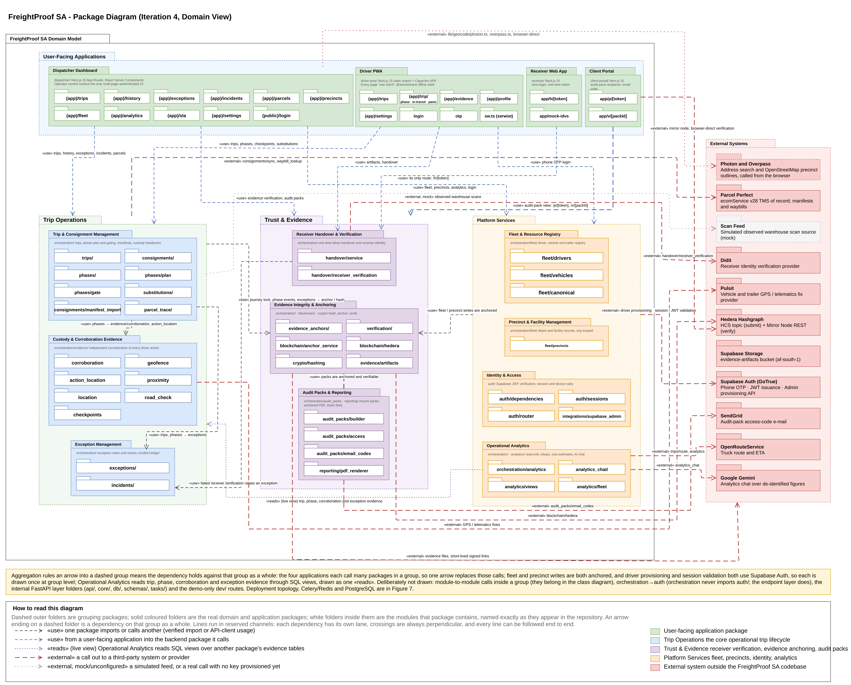
Figure 1: Package diagram

The dispatcher application, Driver PWA, receiver application and client portal depend on groups of packages rather than individual ones. The receiver application and the client portal each have only two routes, which is why they are drawn small. External systems remain behind interfaces with simulated and live implementations: Parcel Perfect supplies manifests and waybills, Pulsit supplies tracker positions, Didit performs optional receiver checks, SendGrid sends audit-pack access codes, OpenRouteService supplies planned routes, and Hedera receives fingerprints only. Figure 1 also shows three services used directly: Google Gemini answers analytics questions from de-identified figures, and, from the dispatcher's browser, Photon geocodes precinct addresses and Overpass supplies OpenStreetMap outlines of precinct properties.

6.2 Analysis Class Diagram
Figure 2 shows the analysis class model. It remains centred on Trip, with its ordered TripStops, its PhaseEvent ledger and its Consignments. Iteration 4 made five changes, which answer the Iteration 3 comment that parcel detail was modelled at too high a level:
- Cargo hierarchy. A loaded Trip now carries the key of the client's Parcel Perfect manifest. The hierarchy is manifest → waybill (Consignment) → Parcel. Each Consignment names its pickup stop and delivery stop, so a multi-stop trip can drop off and collect different waybills at each intermediate stop. The manifest snapshot taken at creation is stored on the trip-creation phase and covered by the journey lock.
- Arrival. PhaseEvent gains the seal condition found at arrival (intact, damaged or missing) and how the seal number was entered (read from the photo and confirmed, read and corrected, or typed).
- Exception review. TripException gains the claiming dispatcher and claim time, alongside the existing reviewer, outcome, contact method and note.
- Evidence sharing. AuditPack, AuditPackAccessEvent, AuditPackEmailCode and IncidentDeclaration are new. Incident groups related exceptions and affected parcels for a trip, with an append-only IncidentUpdate ledger. EvidenceAnchorEvent records each anchored exception, review and cancellation with its own receipt.
- Operations. CostProfile holds an organisation's cost rates for cost analytics, and DriverSubstitution, present but unused in Iteration 3, now records driver handovers, each fulfilling a dispatcher-arranged DriverSubstitutionRequest.

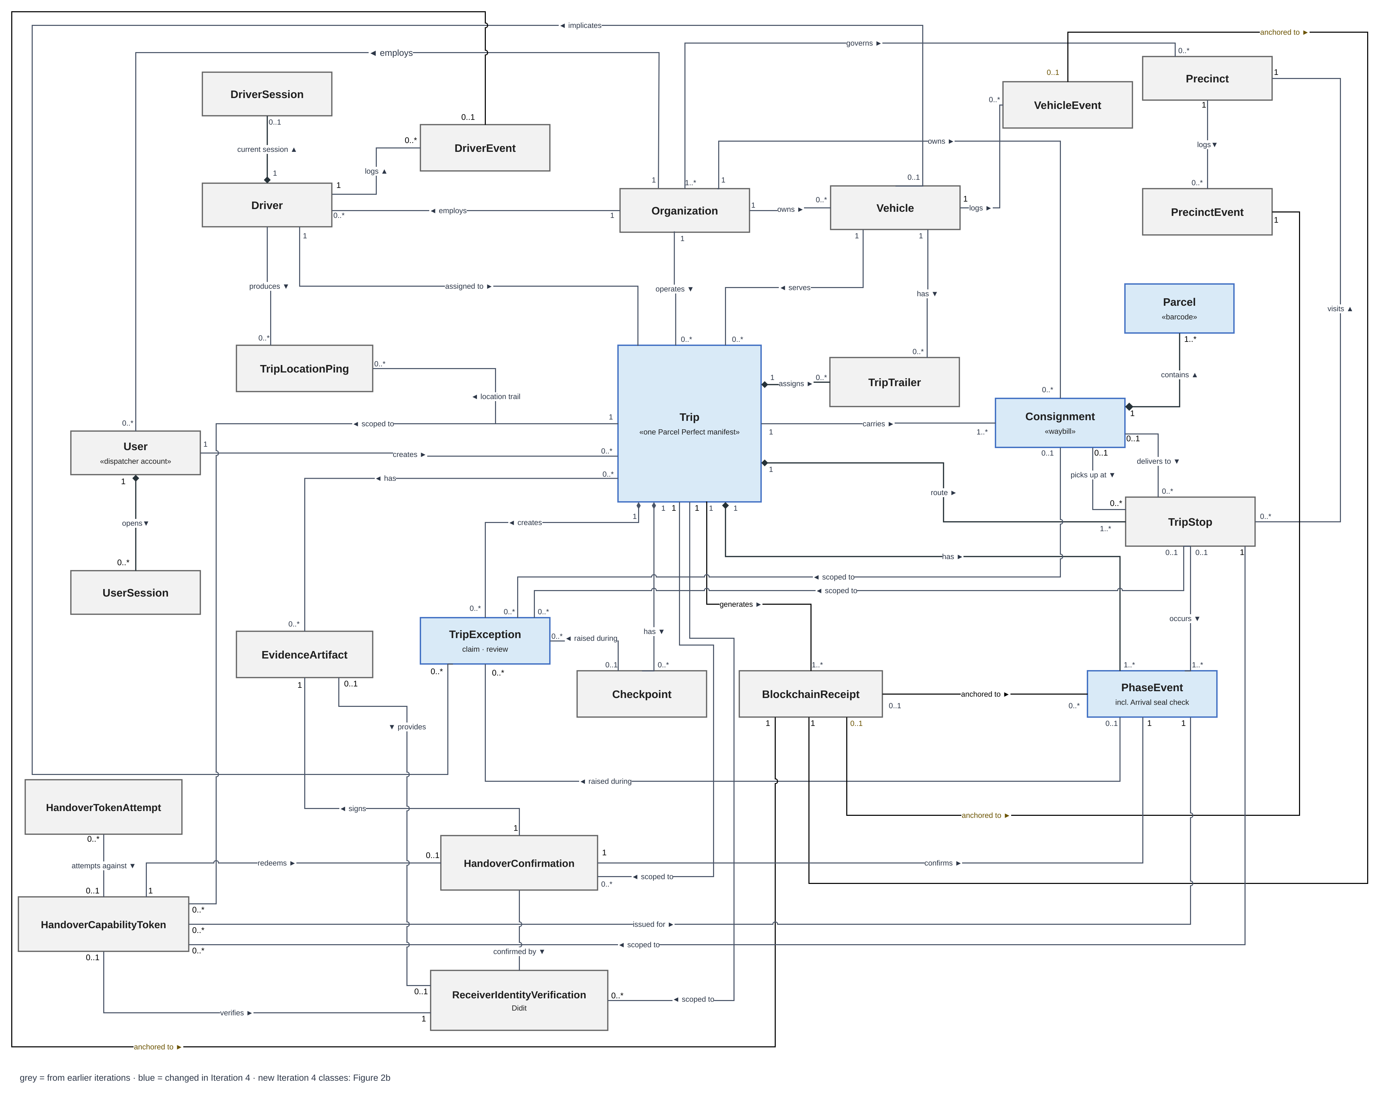
Figure 2: Analysis class diagram
Damage in transit is recorded as an exception against the trip, the affected consignment and the affected vehicle, with photographs; an exception names at most one vehicle (§5.4). Pallet or handling-unit counts are not modelled: the partner could not confirm whether a handling unit sits between waybill and parcel, so counts stay at parcel level (§5.4).

6.3 Use-Case Model and System Boundary
Figure 3 and Figure 4 show the two use-case diagrams, Trip Lifecycle Management (TLM, dispatcher side) and Custody Chain Capture (CC, driver and receiver side), redrawn for Iteration 4. Seven use cases are new: TLM 1.12 Issue an Audit Pack, TLM 1.13 Trace a Parcel, TLM 1.14 Arrange a Driver Substitution, TLM 1.15 Manage an Incident, TLM 1.16 Ask the Dispatcher Assistant, CC 1.11 Record Arrival and CC 1.12 Hand Over to Another Driver. TLM 1.12 introduces the Audit-pack recipient actor and is restricted to the Admin-Dispatcher. Cancel a Trip extends Manage an Incident because stopping an incident’s trip cancels it. TLM 1.5 is now drawn on the Dispatcher: every dispatcher can run the check, while the receipt and hash detail remain in TLM 1.6. In the CC diagram the six phase use cases specialise one abstract use case, Complete a Custody Phase, shown in italics, because Iteration 4 anchors and corroborates every phase and lets a dispatcher override any phase except activation. This replaces Iteration 3’s separate departure and delivery receipts. TLM 1.14, CC 1.12, TLM 1.16 and the analytics chat are switched on per deployment.
In both diagrams, dark orange marks a use case that is new in Iteration 4, light orange one that changed in Iteration 4, and white one that is unchanged since Iteration 3 (Table 12). A solid oval is a user goal with its own narrative. A dashed oval is supporting behaviour, reached through «include» or «extend» and covered inside its parent’s narrative; it is shaded on the same scale.
System boundary. FreightProof is the system under consideration. Organisation scoping is an access-control boundary within that system. Dispatchers, Admin-Dispatchers and drivers act on their organisation’s records. Receivers and audit-pack recipients participate through limited links without platform accounts. External providers support identity checks, notifications, ledger publication and operational data exchange.
Table 12 shows how each use case is treated in this document. New and changed use cases are written in full in §6.5, given replacement steps there, or governed by the business rules in §6.4. Retained narratives are in the Iteration 2 document (Team05, 2026a) or the Iteration 3 document (Team05, 2026b, §3.4, pp. 27–35).
Table 12: Use-case retention and change index
ID | Use case | Treatment in Iteration 4
TLM 1.1, 1.8 | Register a Driver; Register a Vehicle | Retained (Iteration 2)
TLM 1.2 | Create a Trip | Changed: written in full. A trip is created from a Parcel Perfect manifest or as an empty leg, with a driver and vehicle clash check (FP-281, FP-139, FP-142)
TLM 1.3 | Monitor Active Trips | Changed: live trip list shows phase, last update, unreviewed exceptions and location check (FP-289); covered in §8.2
TLM 1.4, 1.6 | Access Trip History; View Forensic Detail | Retained (Iteration 2)
TLM 1.5 | Verify Evidence Against the Blockchain | Retained (Iteration 3, pp. 33–34); now also verifies exceptions, reviews and cancellations. Any dispatcher sees the result; receipt and hash detail remain with the Admin-Dispatcher (TLM 1.6)
TLM 1.7 | Cancel a Trip | Changed: cancellation is anchored (BR-8), and stopping an incident's trip cancels it (TLM 1.15)
TLM 1.9 | Review an Exception | Changed: written in full (FP-280, FP-290)
TLM 1.10 | Inspect Operational Analytics | Changed: cost view with Admin-Dispatcher-set cost rates, today's incident map, figure sources and an AI chat about the figures (FP-294, FP-296, FP-295); covered in §8.5
TLM 1.11 | Manage a Precinct | Changed: address search replaces typed coordinates (FP-309); otherwise retained (Iteration 3, pp. 29–30)
TLM 1.12 | Issue an Audit Pack | New: written in full (FP-279, FP-291); Admin-Dispatcher only
TLM 1.13 | Trace a Parcel | New: written in full (FP-149)
TLM 1.14 | Arrange a Driver Substitution | New: written in full with CC 1.12; governed by BR-10 (FP-83)
TLM 1.15 | Manage an Incident | New: written in full; report a hijacking, parcel shortage or parcel damage, record follow-ups and notifications, close or reopen with a reason, and optionally stop the trip; governed by BR-3 and BR-5
TLM 1.16 | Ask the Dispatcher Assistant | New: written in full; reads the organisation's records without changing them; switched on per deployment
CC 1.1, 1.2, 1.5 | Sign In; Activate Trip; Log Transit Checkpoint | Retained (Iteration 2)
CC 1.3 | Confirm Loading | Changed: the paper linehaul sheet is scanned on the phone (FP-300)
CC 1.4 | Seal and Depart | Changed: seal number read from the photo and confirmed by the driver (FP-300)
CC 1.6 | Raise Exception or Panic | Changed: several photographs per report, queued offline; critical reports anchored (FP-290); severity per BR-1
CC 1.7 | Unload at Destination | Changed: the seal inspection moved to Arrival (CC 1.11)
CC 1.8 | Confirm Delivery and Close Trip | Changed: replacement steps below (FP-273)
CC 1.9 | Override a Blocked Phase | Changed: governed by BR-4; also applies to Arrival and is never offered at activation
CC 1.10 | Receive and Acknowledge Delivery | Changed: replacement steps below (FP-316)
CC 1.11 | Record Arrival | New: written in full (FP-270)
CC 1.12 | Hand Over to Another Driver | New: written in full with TLM 1.14; each driver confirms the handover, including the seal, on their own phone; governed by BR-10 (FP-83)
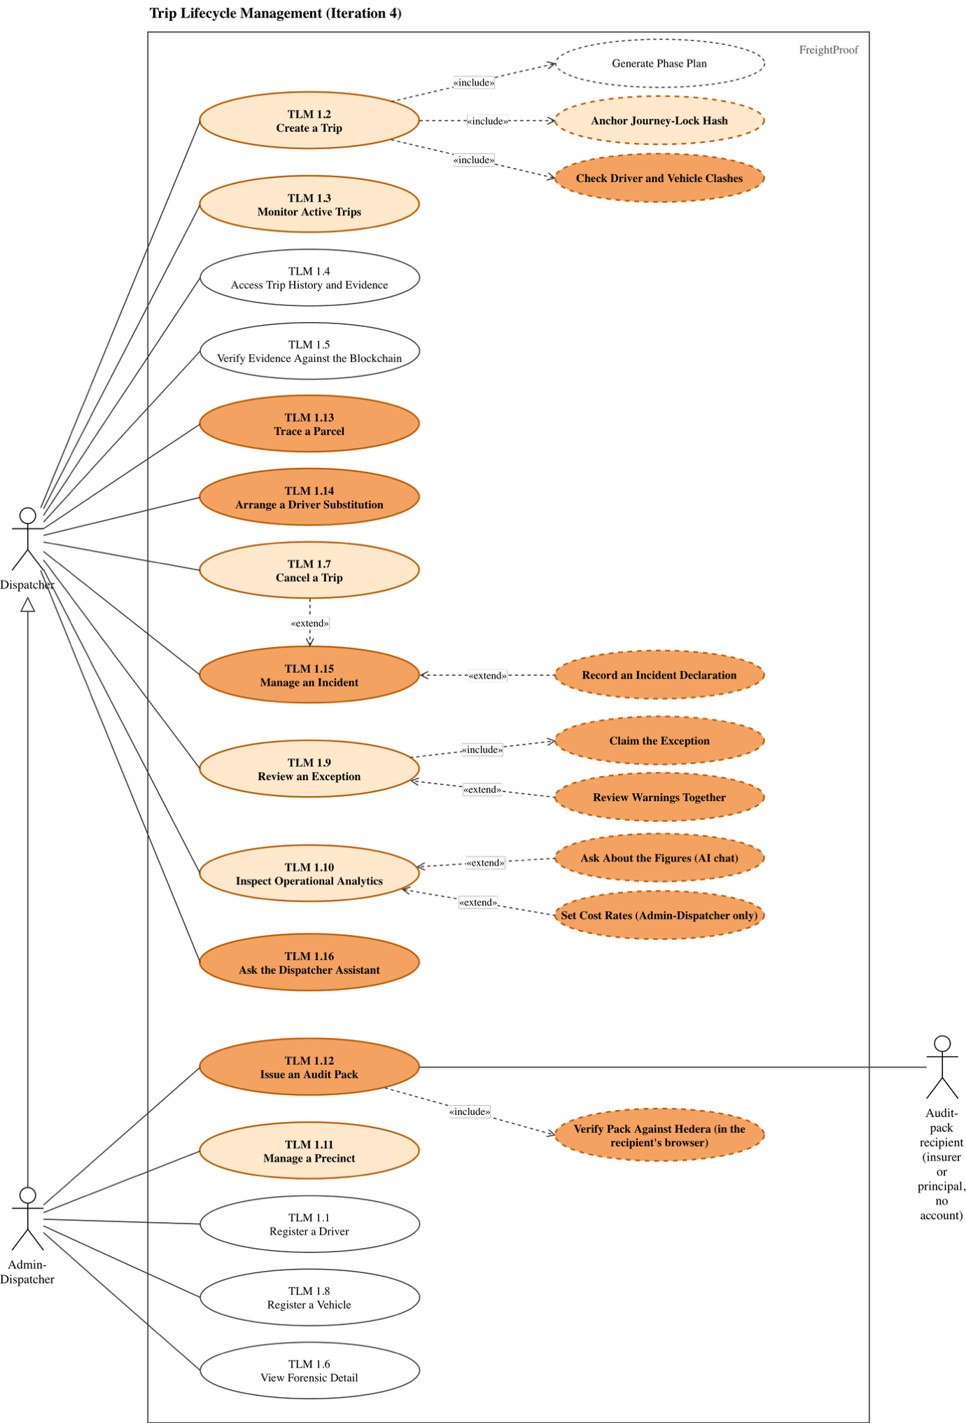
Figure 3: Trip Lifecycle Management use-case diagram
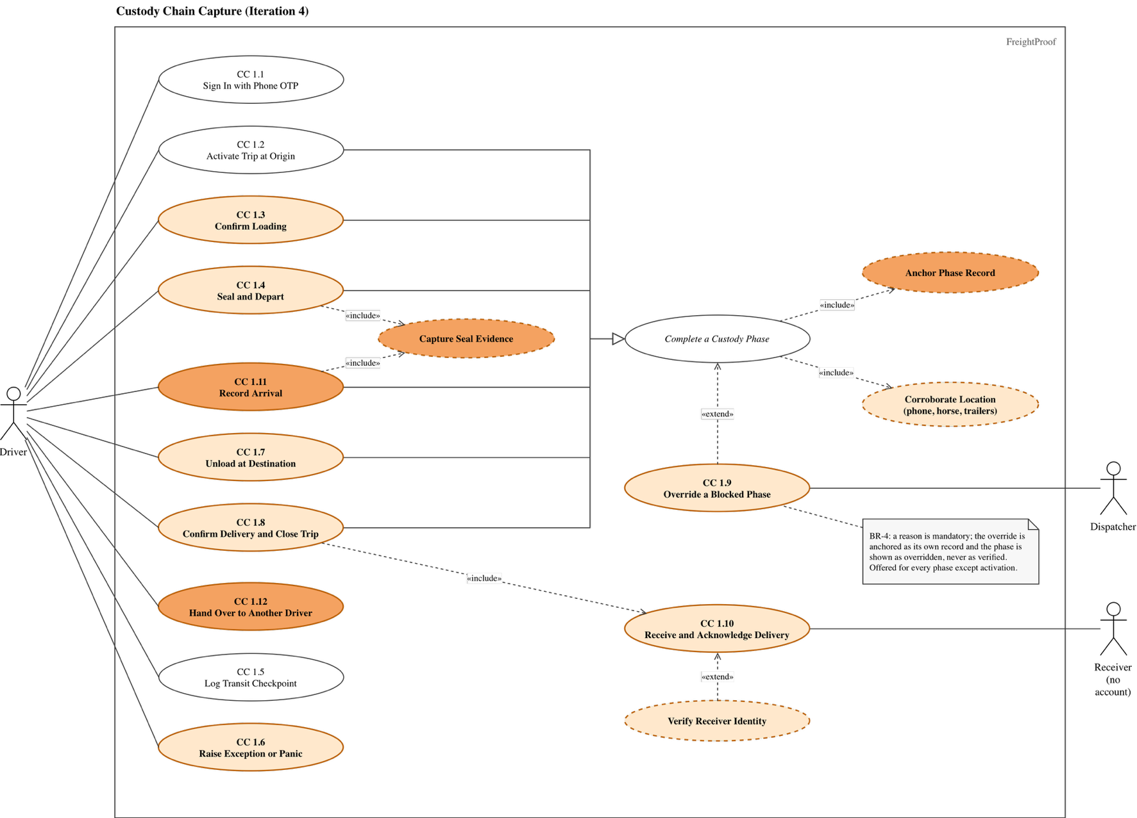
Figure 4: Custody Chain Capture use-case diagram

6.4 Business Rules
Shared rules SR-1 to SR-9 remain in force where not replaced below (Team05, 2026b, Table 6). Table 13 defines the final release’s exception, override and evidence-sharing rules. “System” identifies automated enforcement; “procedure” identifies an operator responsibility.
Table 13: Business rules added in Iteration 4
ID | Rule | Enforced by
BR-1 | Severity. An exception is critical if a person may be at risk, cargo may be lost or reached outside the custody chain, goods went to the wrong party, or the trip cannot finish as planned. The system raises panic, seal breaks, seal mismatches, damaged or missing seals, a trailer separated from its horse, a vehicle moved before departure, a missing departure seal (unless overridden) and seal findings at a driver handover as critical; all others start as warnings. A dispatcher who finds that a warning meets a criterion handles it as critical under BR-3. Nobody may lower a severity. | System (severity by type); procedure (escalation)
BR-2 | Every exception is reviewed. Exceptions start unreviewed, except a dispatcher's own override or cancellation notes. A dispatcher claims an exception, recording who and when, and may release it. The review records the outcome, contact method and a note; the first review is final and the report is never changed. Critical exceptions are reviewed singly; a trip's warnings may be reviewed together. Critical exceptions and every review are anchored. | System (FP-280, FP-290)
BR-3 | A critical report reaches the organisation's live inbox when it arrives at the server. The reviewing dispatcher promptly informs the operations manager of theft, hijacking, collision or injury; the manager notifies the principal and insurer and opens a SAPS case where appropriate. These are operator procedures; incident declarations record their times and reference numbers. | System (live inbox, incident declarations); procedure (notifications)
BR-4 | A dispatcher may override a blocked phase with a mandatory reason; the override is anchored and labelled as overridden. For departure, arrival and confirmation, procedure requires Admin-Dispatcher approval and supporting evidence, recorded in the reason rather than enforced as a separate step. | System (reason, marking, anchoring); procedure (second approval, documents)
BR-5 | Disputed delivery. A scanned count that differs from the manifest raises a parcel-count warning; the reviewing dispatcher escalates a shortfall as critical (BR-1, BR-3). If the receiver refuses or disputes the goods, the driver records a delivery-refused exception with a reason and photographs, and the dispatcher decides whether the delivery is completed, overridden (BR-4) or cancelled (BR-8). The refusal stays on the record; a later inspection is added as an incident update, never by editing the original. | System (exceptions, receiver confirmation); procedure (decision, notification)
BR-6 | Lost, stolen or dead phone. The driver tells the dispatcher by any available means. Signing in on a replacement phone ends the old session, and the dispatcher deactivates the account if the phone was stolen. Blocked phases are overridden under BR-4, and evidence captured between the loss and the deactivation is treated as disputed. | System (single session); procedure (reporting)
BR-7 | A receiver types their name and identity number and swipes to confirm through a single-use link. An optional document-and-face check never blocks delivery. Verification supports the recorded identity; it does not establish the person’s authority to receive for a company. Nominated authorised receivers are a pilot option. | System (handover link, optional check)
BR-8 | Cancellation. A reason is mandatory. The cancellation is anchored, the phases not reached stay pending as an honest record, and the manifest becomes available for a new trip. | System (FP-290)
BR-9 | Only an Admin-Dispatcher may issue an audit pack, for a stated purpose and named recipient. Contents are frozen and fingerprinted at issue. Access requires the share link and an e-mailed code; views are logged and access may be revoked. | System (FP-279, FP-291)
BR-10 | Driver substitution is a normal custody event, not an exception. A dispatcher arranges it; both drivers record the handover, including the seal, on their own phones, and the original driver's record is kept. A seal mismatch at the exchange is critical. The exchange point is free text and is not compared with positions; each driver's phone is compared with the truck's tracker. Off by default (DRIVER_SUBSTITUTIONS_ENABLED). | System (FP-83)
BR-11 | Geofence size. A precinct's fence follows the yard's outline from OpenStreetMap, adjusted on the satellite map by an Admin-Dispatcher. Without an outline, the Admin-Dispatcher sets a radius that covers where trucks stand; 200 m is only the default, and a 50 m tolerance absorbs normal position error. | System (outline or radius per precinct); procedure (choosing it)

6.5 New and Changed Use-Case Narratives
The narratives state actors, preconditions, outcomes, success steps and alternatives. Failure paths distinguish automatic system behaviour from dispatcher and operator procedures.
Table 14: TLM 1.2 – Create a Trip (changed)
Actor | Dispatcher
Description | Create an evidence-bearing trip for one departure from the client's Parcel Perfect manifest, so that the cargo is imported rather than typed.
Pre / Post | Pre: dispatcher signed in; the manifest exists in Parcel Perfect. Post: one trip with its stops, consignments, parcels and phase plan; the manifest snapshot and journey lock anchored.
Main success scenario
Step | Actor action | System response
1 | Enters the manifest number. | Fetches the manifest and shows the client, route, planned times, waybills and parcel totals.
2 | Chooses the driver, horse and trailers. | Shows, beside each driver and vehicle option, whether it is already on a trip in the chosen window and when it is free ("On TRIP-x, free after …"), and names any trip that already holds a chosen driver or vehicle (FP-142).
3 | Reviews and confirms. | Checks again for clashes, creates the trip and phase plan, stores the manifest snapshot, and anchors the journey lock before saving.
Alternative and exception flows
1a | Manifest not found, or its waybills belong to different clients: the system refuses and names the reason.
1b | Parcel Perfect unavailable: the system refuses creation; no partial trip is saved.
1c | A non-cancelled trip already exists for this manifest: the system refuses a second trip and names the existing one.
2a | A precinct for the manifest's hub is not set up: the dispatcher chooses the precinct manually.
3a | A clash appears between steps 2 and 3, for example another dispatcher assigned the horse: creation is refused with the clashing trip named (FP-139).
3b | Hedera unavailable: creation is refused and nothing is saved (fail-closed), because the journey lock must be anchored.

Table 15: TLM 1.9 – Review an Exception (changed)
Actor | Dispatcher
Description | Assess every exception, record the conclusion and the contact made, and leave the original report unchanged.
Pre / Post | Pre: dispatcher signed in; the exception belongs to the organisation. Post: one immutable review with reviewer, time, outcome and contact method; critical exceptions and the review anchored (BR-2).
Main success scenario
Step | Actor action | System response
1 | Opens the unreviewed inbox, ordered by severity, or an exception from a trip timeline. | Shows type, severity, description, photographs, position, phase and stop.
2 | Claims the exception. | Records who claimed it and when, and shows the claim to other dispatchers live.
3 | Contacts the driver or site, then selects the outcome and contact method and writes a note. | Validates the review.
4 | Submits. | Stores the review without changing the report, anchors it, and removes the exception from the inbox.
Alternative and exception flows
2a | Another dispatcher has claimed it: the system shows who; this dispatcher may wait or ask them to release it.
2b | The dispatcher cannot finish: they release the claim and the exception returns to the inbox.
3a | Several warnings on one trip: the dispatcher reviews them together with one outcome and note; a review is stored for each. Critical exceptions cannot be batch-reviewed.
4a | Another dispatcher submitted first: the system refuses the second review and shows the first.
4b | Hedera unavailable: the review is saved, the receipt is marked owed and retried.
4c | The incident requires notification: the dispatcher follows BR-3 and records an incident declaration.

Table 16: TLM 1.12 – Issue an Audit Pack (new)
Actor | Admin-Dispatcher; audit-pack recipient (insurer or principal, no account)
Description | Give an outside party a frozen, verifiable evidence record of a trip or consignment without giving them access to FreightProof.
Pre / Post | Pre: Admin-Dispatcher signed in; trip belongs to the organisation. Post: frozen evidence pack and share link for a named recipient; access logged and pack integrity checkable against Hedera.
Main success scenario
Step | Actor action | System response
1 | Previews the trip's audit trail and chooses scope, purpose, recipient and whether to include the location trail. | Builds the pack from current records, marking each item as anchored or recorded only, and lists missing evidence.
2 | Issues the pack. | Freezes the contents, renders the PDF, anchors the pack's fingerprint and shows the share link once.
3 | Sends the link to the recipient. | No further action.
4 | Recipient opens the link and enters the code sent to their e-mail address. | Logs the view and shows the evidence page: timeline, route map, photographs, exceptions and parties.
5 | Recipient selects Verify. | The recipient's browser recomputes the fingerprints and checks them against the Hedera mirror service, then reports a match or a mismatch for each item.
Alternative and exception flows
4a | Wrong code entered repeatedly: access is locked and the attempt logged.
4b | Link revoked or expired: the page states this and shows no evidence.
5a | Hedera mirror unavailable: verification reports “could not check”, never a successful integrity check.
5b | The frozen pack is checked against its committed fingerprint. An altered payload produces a mismatch. Changes in the current trip after issue do not rewrite the issued snapshot.

Table 17: TLM 1.13 – Trace a Parcel (new)
Actor | Dispatcher
Description | Find a parcel by its barcode and see where it has been, derived from the phase ledger.
Pre / Post | Pre: dispatcher signed in. Post: none; the use case is read-only.
Main success scenario
Step | Actor action | System response
1 | Enters or scans a parcel barcode. | Finds the parcel among the organisation's consignments.
2 | Opens the result. | Shows the parcel's waybill, current state and a timeline of every phase and scan that involved it, with exceptions and evidence.
Alternative and exception flows
1a | Barcode not found in this organisation: the system shows "not found" and does not reveal other organisations' parcels.
2a | Parcel never scanned at a stop: the timeline shows the gap rather than inferring a location.

Table 18: CC 1.11 – Record Arrival (new)
Actor | Driver
Description | Record the seal as found at a stop before anything is opened, so that a break in transit is detected at the moment custody arrives.
Pre / Post | Pre: the preceding in-transit phase is complete; the driver is at the Arrival phase. Post: Arrival completed once, with seal number, condition, photograph and positions stored and anchored.
Main success scenario
Step | Actor action | System response
1 | Confirms arrival at the stop. | Records the phone, horse and trailer positions and compares each with the precinct geofence.
2 | Photographs the seal. | Reads the seal number from the photograph and asks the driver to confirm or correct it (FP-300).
3 | Confirms the number and records the seal as intact, damaged or missing. | Compares the number with the seal applied at departure.
4 | Swipes to complete. | Stores the evidence, anchors the phase and opens the next phase (unloading, loading or confirmation).
Alternative and exception flows
1a | Truck or a trailer outside the precinct: a location exception is raised for review; the driver continues.
1b | No usable position, or no signal: recorded as "could not check"; the action is queued on the phone and sent when signal returns.
3a | A seal mismatch, damage or absence raises a critical exception. The dispatcher receives it when the capture reaches the server; offline reporting is delayed until synchronisation.
4a | Phone lost or dead before completion: handled under BR-6; the phase is overridden only under BR-4.
4b | App data cleared before the queued action was sent: the capture is lost on the phone, but nothing false is recorded. The phase stays pending on the server and on the live trip list, and the driver recaptures it.

Table 19: Changed narratives: replacement steps for CC 1.8 and CC 1.10
CC 1.8 – Confirm Delivery and Close Trip (Driver)
Replaces step 5 | The driver completes the confirmation phase with the delivery photograph and the receiver's signature attestation from CC 1.10. The server refuses a signature uploaded by the driver (FP-273); it does not yet check separately that a receiver confirmation exists for the stop (§5.4).
Replaces alt. 3a | If the receiver lacks a suitable phone or connection, the driver requests a dispatcher override. BR-4 requires a recorded reason, manual Admin-Dispatcher approval and available supporting evidence. A photographed paper delivery note can be attached when incident attachments are enabled.
New alt. 5a | If the receiver refuses to sign, the driver raises delivery refused under BR-5.
CC 1.10 – Receive and Acknowledge Delivery (Receiver)
Step 3 (clarified) | Every receiver is offered the identity check and may accept it, decline it or say that no document is available (BR-7). Declining never blocks confirmation.
Replaces step 4 | If the receiver consents and has a document, they complete Didit's document-and-face check, and the server compares the name and identity number the receiver typed with those read from the document (SR-6). With no document the result is recorded as typed only; the receiver selfie was removed (FP-316).
Replaces step 5 | The receiver types their name and identity number and swipes to confirm; no signature is drawn. The app records the time and, if permitted, the position, and generates an attestation image from the name, identity number, time and position, which is stored as the signature (Swipe.tsx, render-attestation.ts).
Unchanged | Steps 1–2 and 6–8 and the alternative flows remain as in Iteration 3 (Team05, 2026b, pp. 30–31).

Table 20: TLM 1.14 and CC 1.12 – Arrange and Record a Driver Substitution (new)
Actor | Dispatcher (TLM 1.14); outgoing and incoming drivers (CC 1.12)
Description | Hand custody of a running trip from one driver to another while keeping each driver's custody period on the record. A clean handover is a normal custody event, not an exception (BR-10).
Pre / Post | Pre: the trip is active and belongs to the organisation; substitutions are switched on for the deployment. Post: the original driver's record is kept, the incoming driver holds custody from the handover, and both confirmations with their seal evidence are stored and anchored.
Main success scenario
Step | Actor action | System response
1 | Dispatcher arranges the substitution, planned in advance or immediate, naming the incoming driver and the reason. | Notifies both drivers and shows the arrangement on the trip.
2 | Each driver opens the handover on their own phone, photographs each seal and confirms the vehicles handed over. | Records each confirmation with its position, seal condition (intact, missing or not applicable) and photographs.
3 | Dispatcher completes the substitution. | Transfers custody to the incoming driver, anchors the substitution and adds it to the trip timeline.
Alternative and exception flows
1a | The arrangement is no longer needed or names the wrong driver: the dispatcher cancels or replaces it with a reason before completion.
2a | The drivers' seal readings differ or a seal is missing: a critical exception is raised (BR-1, BR-10). The exchange point is free text and is not compared with positions.
3a | A driver cannot confirm (phone dead or no signal): the dispatcher may complete with a stated reason, and the record shows the confirmation as attested, not given.
3b | The outgoing driver adds evidence after the handover: it is stored as late evidence for the dispatcher to acknowledge and never changes the completed record. A wrongly recorded substitution is corrected with a reason; the original stays on the record.

Table 21: TLM 1.15 – Manage an Incident (new)
Actor | Dispatcher
Description | Bring the exceptions, parcels and follow-up actions of one serious event on a trip (a hijacking, a parcel shortage or parcel damage) into a single attributed record (BR-3, BR-5).
Pre / Post | Pre: dispatcher signed in; the trip belongs to the organisation. Post: an incident with an owner, linked exceptions and parcels and an append-only history of updates, eventually closed with an outcome and a reason.
Main success scenario
Step | Actor action | System response
1 | Reports the incident: type, summary, who reported it and how (for example the driver by phone), and how certain it is (suspected, reported or corroborated). | Creates the incident, assigns it to the reporting dispatcher and links the chosen exceptions and parcels; a hijacking defaults to all parcels.
2 | Records follow-ups as they happen: notes, parcel findings, further exceptions and notifications such as a SAPS case, the tracking company, the insurer or the client. | Appends each as an attributed, time-stamped update and records notifications as incident declarations; nothing earlier is changed.
3 | Closes the incident with an outcome (for example cargo recovered, shortage confirmed, theft reported or recording error) and a reason. | Records the closure and removes the incident from the open list.
Alternative and exception flows
1a | The trip must not continue, for example after a hijacking: the dispatcher stops the trip when reporting or later, which cancels it with the incident as the reason (TLM 1.7). A trip already completed or cancelled cannot be stopped.
2a | The incident is closed: follow-ups are refused until it is reopened.
3a | New information arrives after closure: the dispatcher reopens the incident with a reason and continues at step 2.

Table 22: TLM 1.16 – Ask the Dispatcher Assistant (new)
Actor | Dispatcher
Description | Ask a plain-language question about the organisation's own trips, drivers, vehicles, parcels and incidents, and receive a short answer with cards for the records it used.
Pre / Post | Pre: dispatcher signed in; the assistant is switched on for the deployment. Post: none; the assistant only reads records.
Main success scenario
Step | Actor action | System response
1 | Types a question, for example "Which trips have unreviewed critical exceptions?" | Looks the records up for this organisation only, using read-only tools, and answers with a card for each record used.
2 | Asks a follow-up that refers to an earlier answer ("and his last trip?"). | Resolves the reference to the same record and answers from a new look-up.
Alternative and exception flows
1a | The answer would need figures the assistant has not looked up: it does not state them; an answer that does is replaced.
1b | The monthly AI budget is spent or the provider fails: the assistant says it is unavailable; the rest of the application is unaffected.

6.6 State-Machine Diagram
Figure 5 shows the life of one trip. Iteration 4 made the following changes, answering the Iteration 3 comments that a refused activation had no drawn path, that the "more stops planned?" decision had no false branch, and that the current stop could not load.
- Created → Created on a refused activation. When the driver asks to activate, the guards are checked: the trip is not being started early, the driver and the vehicles are not on another live trip, and no earlier trip of the driver's is due. If any guard fails, the trip stays in Created and the driver is shown the reason. This is drawn as the [no] branch of the "Activation admissible?" choice, which returns the trip to Created.
- One loop per stop, in a fixed order. At each stop the order is: Arrival (every stop after the first), then Unloading [anything delivered here, or the final stop], then Loading [anything collected here]. A decision node then tests [more stops planned]: the [yes] branch goes to Departure and In Transit, and the [no] branch goes to Confirmation. The current stop therefore always loads before the vehicle departs.
- Arrival is a new state after every In Transit, where the seal is inspected (CC 1.11).
- Cancelled remains reachable from Created and Active, either directly or when a dispatcher reports an incident that stops the trip; a reason is mandatory and the cancellation is now anchored (BR-8). Closed is reached only when every phase in the plan is resolved: completed, ended with a recorded exception, or overridden.

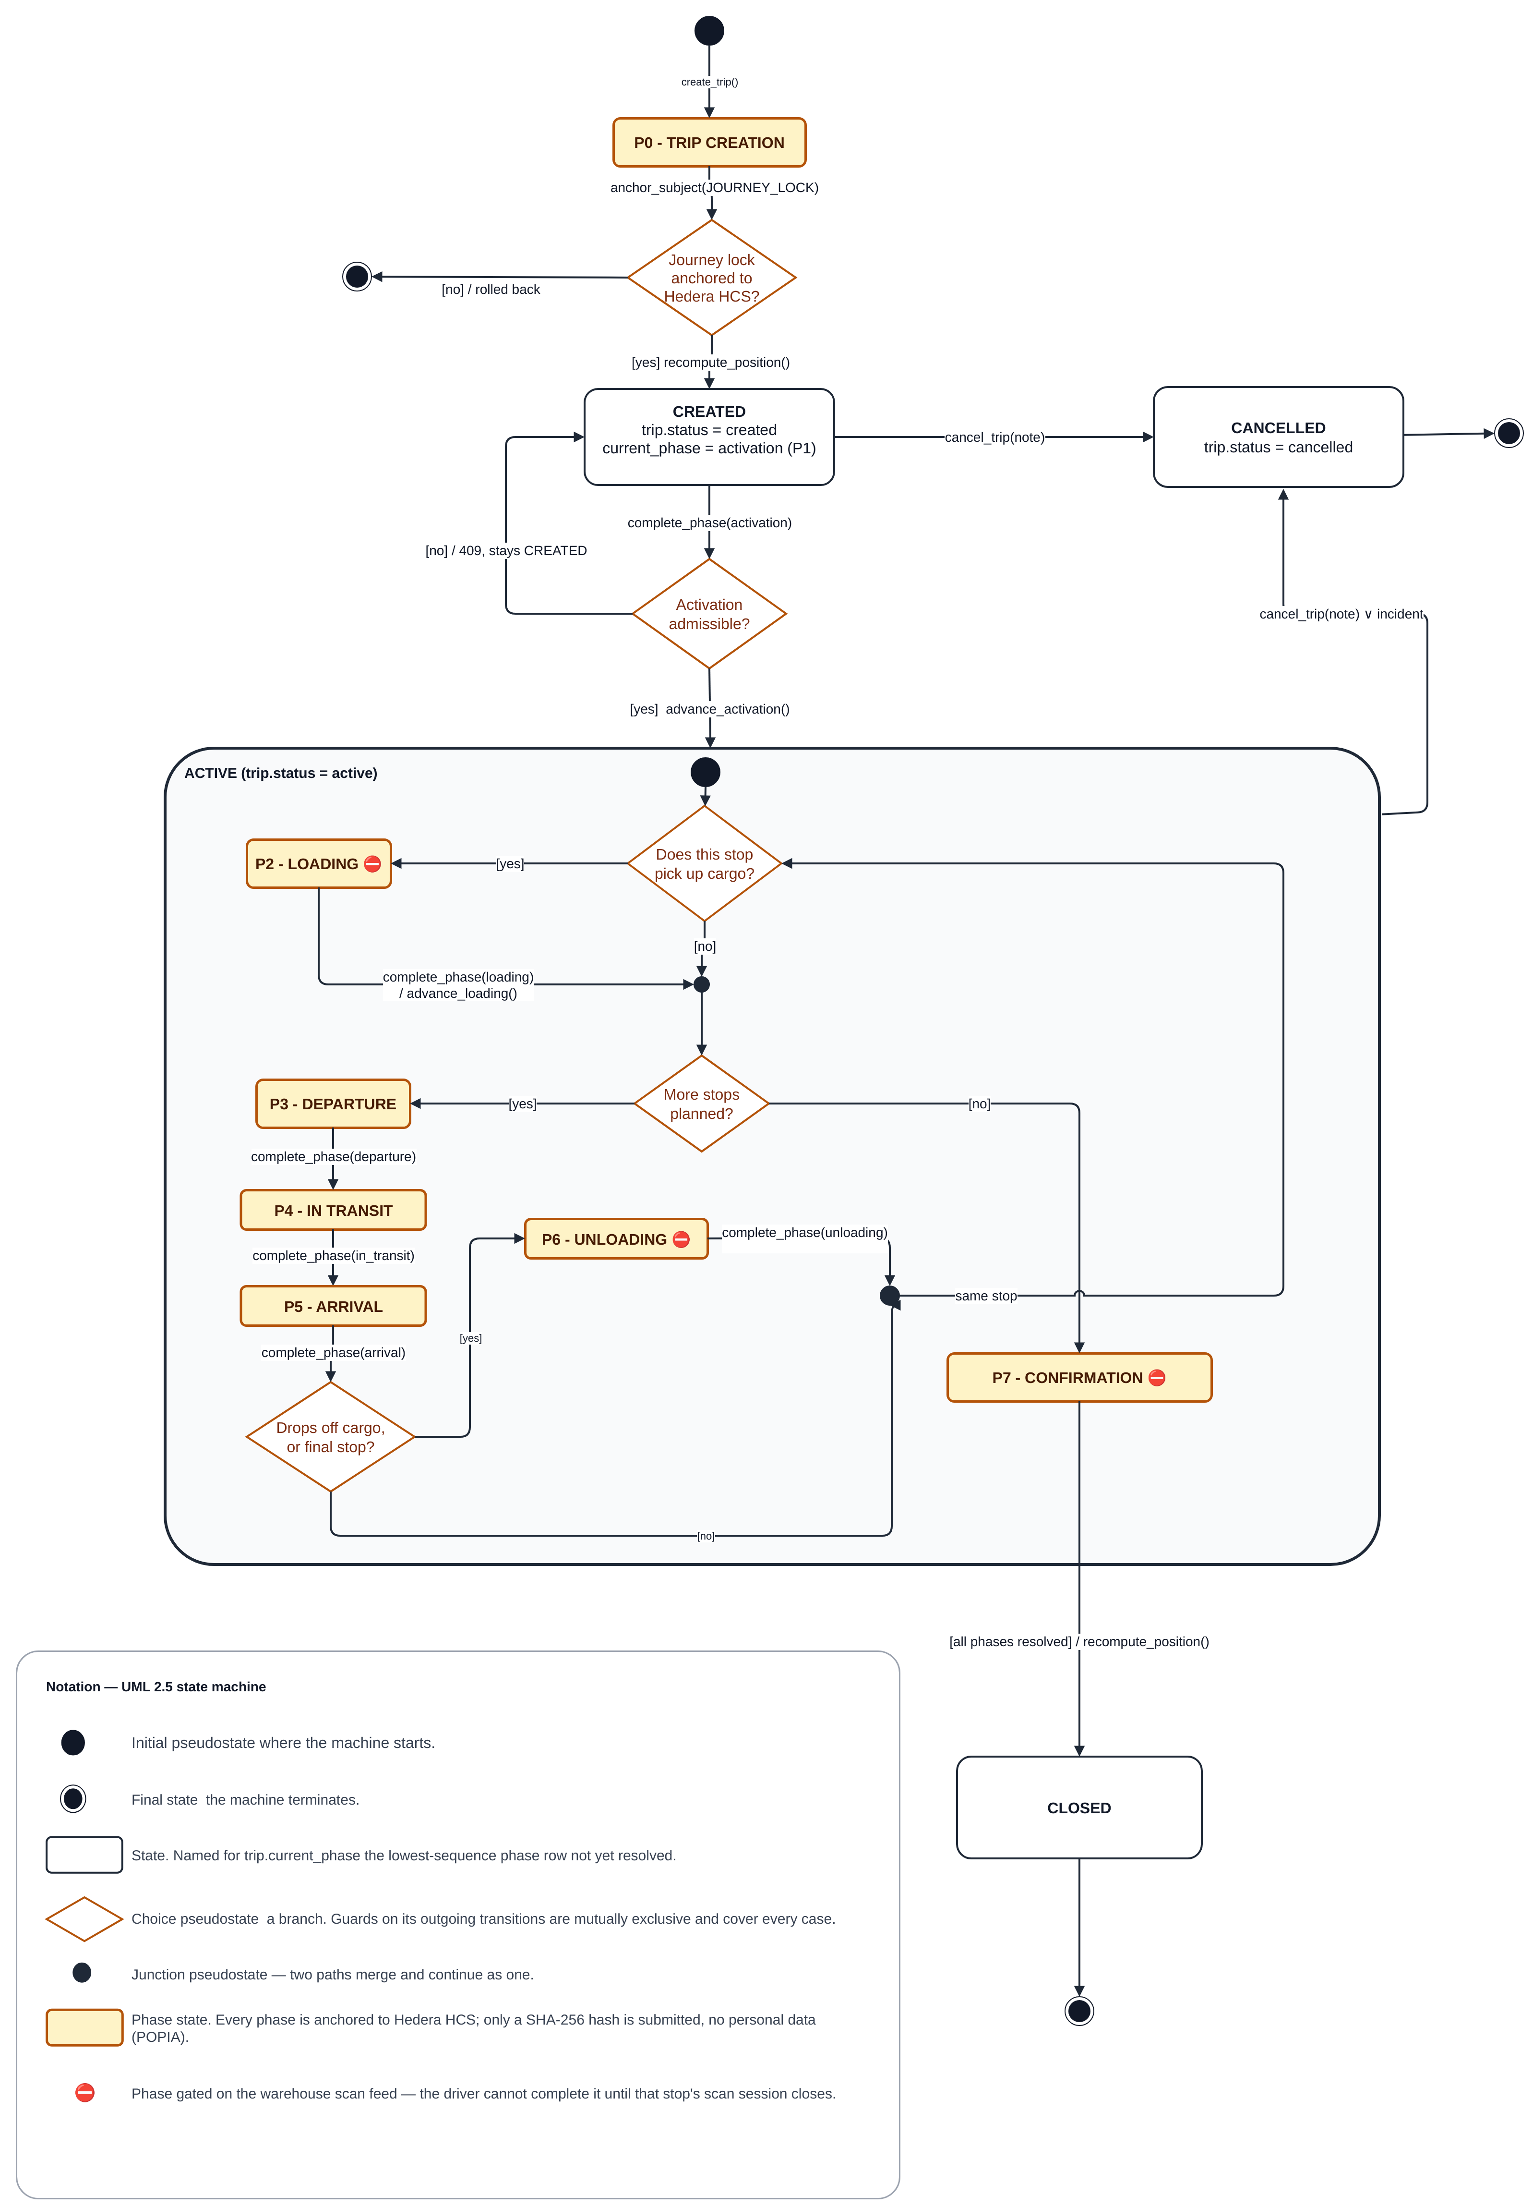
Figure 5: Trip state-machine diagram
Each exception also has a simple life cycle, enforced by BR-2: Unreviewed → Claimed (claim) → Reviewed (review). A claimed exception returns to Unreviewed when released, and a reviewed exception never changes state again.

6.7 Database Schema Changes
Schema changes are versioned through Alembic migrations. CI checks for a single migration head and applies the chain to a fresh test database. Table 23 identifies the final release’s new tables and changed columns; the relational model uses explicit keys and organisation scoping.
Table 23: Schema changes in Iteration 4
Table | Change | Story
trips | Manifest key (issuer account, origin hub, manifest number), unique among non-cancelled trips; order number made optional | FP-281
precincts | Parcel Perfect hub code, so a manifest's hubs resolve to precincts | FP-281
precincts | Geofence outline (geofence_polygon): the corners of the yard's outline; when set, it is the fence and the radius is not used | —
phase_events | Seal condition at arrival; seal-number entry method (seal_number_source); manifest snapshot on the trip-creation row; arrival phase type | FP-270, FP-300
exceptions | Claiming dispatcher and claim time; review status for every severity | FP-280
evidence_anchor_events (new) | One row per anchored exception raise, review or cancellation, with its frozen payload and receipt | FP-290
audit_packs, audit_pack_access_events, audit_pack_email_codes (new) | Issued packs with their fingerprints, share-link hashes, access log and one-time codes | FP-279, FP-291
incident_declarations (new) | Notifications and declared facts for an incident (BR-3) | FP-279
incidents, incident_updates, incident_exceptions, incident_parcels (new) | An incident groups related exceptions and affected parcels on a trip; incident_updates is its append-only log of later information | —
cost_profiles (new) | Per-organisation cost rates for cost analytics | FP-294
driver_substitutions | Now written by the substitution workflow | FP-83
driver_substitution_requests (new), with driver_substitution_confirmations, driver_substitution_confirmation_artifacts, driver_substitution_notices, driver_substitution_corrections, driver_substitution_operations, late_driver_evidence and late_driver_evidence_artifacts | Dispatcher-arranged substitution requests, each driver's confirmation and uploads, and evidence sent late | FP-83
receiver_identity_verifications | Receiver selfie no longer stored, so its column is unused (FP-316); resolved_at records when the receiver's own check recorded its final verdict | FP-316

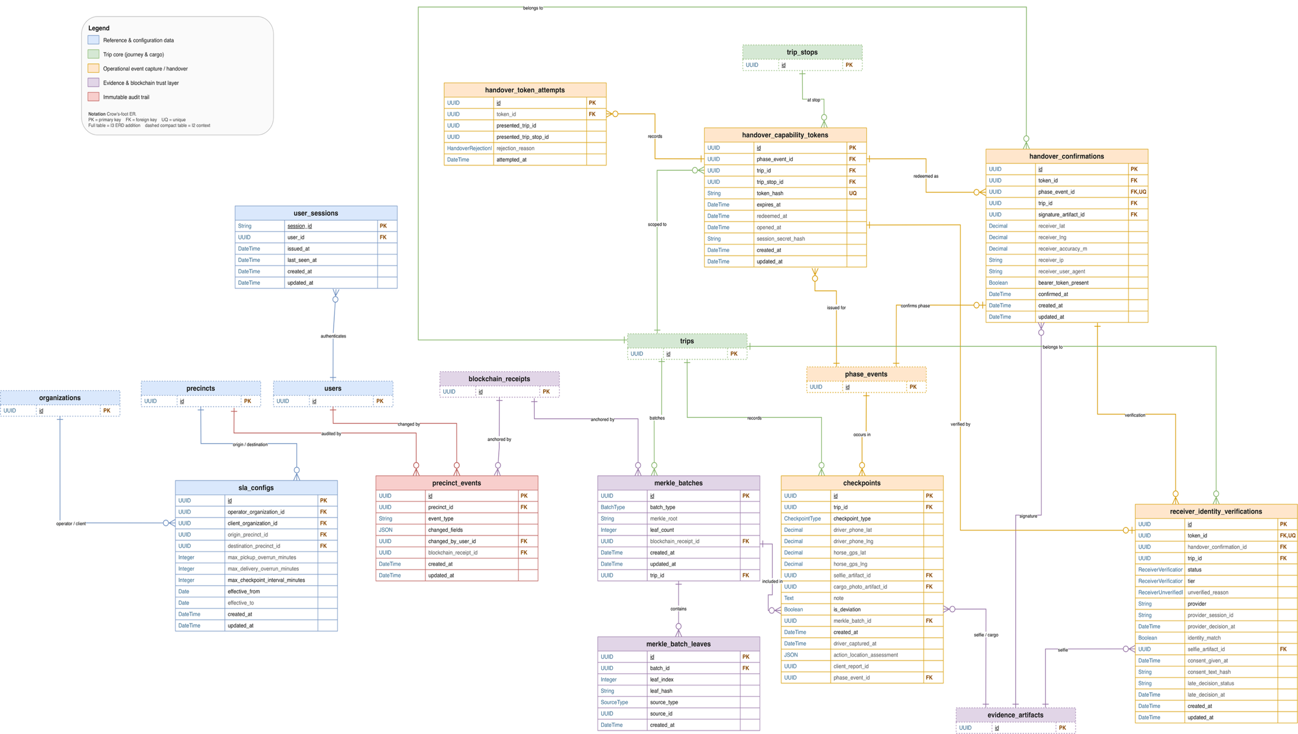
Figure 6: Entity relationship diagram
New evidence tables use row-level security and restricted direct access. Personal records remain in the managed database and file storage. Only the selected cryptographic commitments are published to Hedera; §7.2 distinguishes captured evidence from committed evidence.

7. Architecture
This section describes the deployed architecture, the integrity model behind anchoring and the state of each integration at the end of Iteration 4.

7.1 Deployment Architecture
The deployment view separates user devices, web hosting, the API, background processing, managed data services and external providers. The current container configuration targets Fly.io for the API, worker and scheduler. Application structure is shown separately in Figure 1.
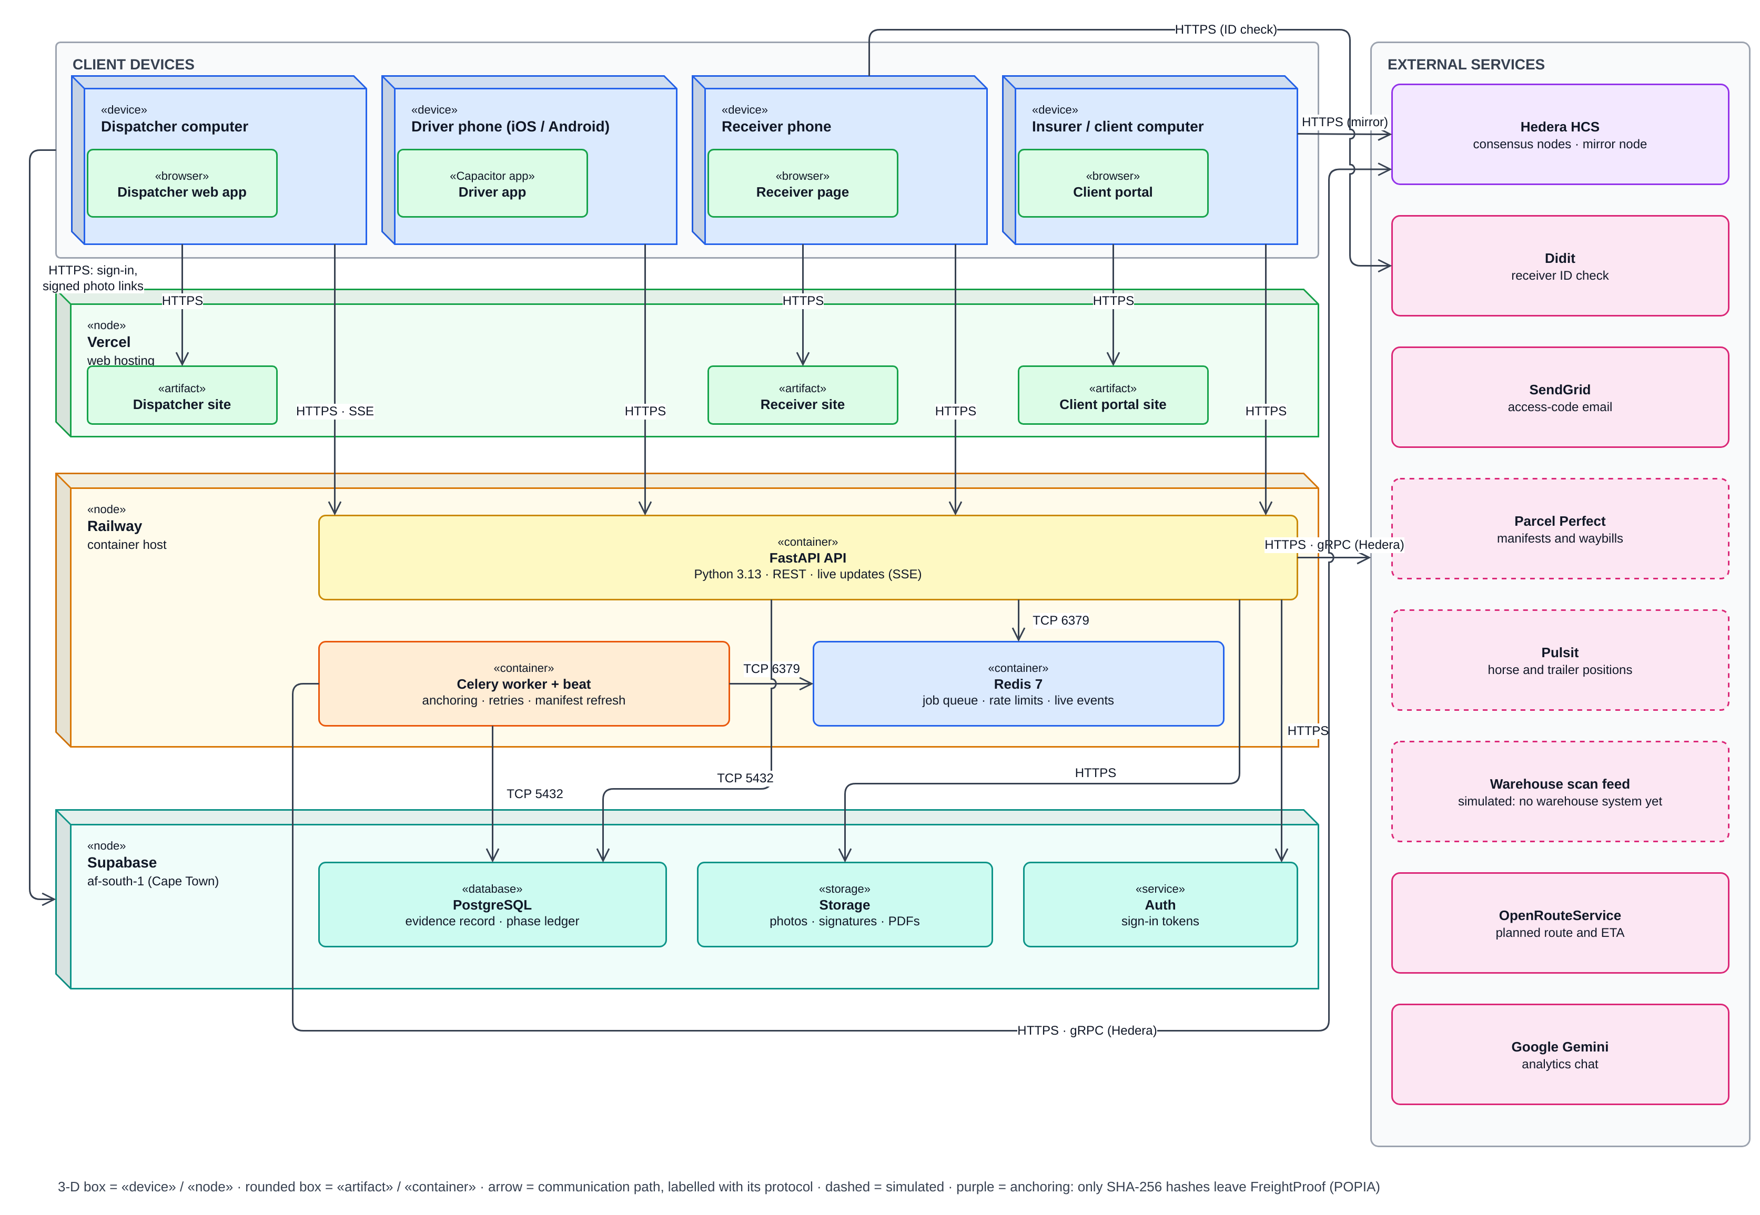
Figure 7: Deployment architecture diagram
Table 24: Deployment nodes and connections
Node | Runs on | Connections and purpose
Dispatcher application | Vercel (www.freightproof.co.za) | HTTPS/REST to the application programming interface (API); Server-Sent Events (SSE) for live trip and exception updates
Driver app | Driver's phone: iOS (TestFlight) and Android, in a Capacitor shell | HTTPS/REST to the API; actions queued on the phone when offline and sent when signal returns
Receiver application | Receiver's phone browser; Vercel (receiver.freightproof.co.za) | HTTPS to the API through a single-use link and a browser-binding cookie; Didit only when the receiver accepts a check
Client portal | Recipient's browser; Vercel (portal.freightproof.co.za) | HTTPS to the API's public audit-pack endpoints; direct HTTPS to the Hedera mirror service for independent verification
API | Fly.io container configuration (api.freightproof.co.za) | The only component that writes evidence; holds all business rules
Background worker and Redis | Fly.io process groups and configured Redis service | Anchoring jobs and retries; a recovery sweep every 60 s for receipts owed over 5 min; manifest refresh; rate limits; live-event fan-out
Supabase managed services | Managed PostgreSQL, file storage and authentication | Managed records, photographs, attestations and PDFs; authentication and short-lived file links. Database, authentication and storage residency follow the selected project region and provider processing arrangements.
External services | Hedera, Parcel Perfect, Pulsit, scan feed (simulated: no warehouse system yet), Didit, SendGrid, OpenRouteService, Google Gemini (analytics chat) | Fingerprints out and receipts in; manifests and waybills; tracker positions; parcel scans; receiver checks; access-code e-mail; planned routes; answers to analytics questions

Trust boundaries. Three boundaries matter. The receiver's browser and the recipient's browser are outside FreightProof's control, so what they submit is evidence, not proof. The API is the only writer of evidence. Hedera is outside FreightProof's control, which is exactly why it is used: an operator cannot rewrite a fingerprint after it has been published.

7.2 Integrity Model and Terminology
The Iteration 3 document used "fingerprinted" in a way that could be read as "digitally signed". The terms are now used precisely:
- A fingerprint is a SHA-256 hash of a record's committed values (National Institute of Standards and Technology [NIST], 2015). Any change to those values produces a different fingerprint. A fingerprint is not a digital signature: it shows that a record changed, not who created it.
- Anchoring publishes the fingerprint to a Hedera Consensus Service topic. Each submission is signed with FreightProof's Hedera account key, and Hedera's consensus assigns it an order and a timestamp (Hedera, n.d.). The receipt therefore proves that this exact set of values existed no later than the consensus time. It does not prove that the values were true.
- Verification rebuilds the record's committed values from the database, recalculates the fingerprint and compares it with the anchored one. The result is "matches", "does not match" or "could not check".

Anchoring covers selected canonical fields, not every column on an evidence row. Critical exception reports, reviews and cancellations have separate event commitments, so a review does not rewrite an earlier receipt. Free text is committed as a hash. Phase location observations remain outside the phase payloads; a frozen audit pack protects its included snapshot from its issue time.
Evidence | Phase or event commitment | Audit-pack snapshot
Seal and delivery artefacts | Role-labelled file hashes for supported phases. | Included evidence is represented in the frozen manifest.
Activation, transit and unloading | Phase identity; driver/custody envelope where applicable. | Included records are frozen at issue.
Location observations | Outside the phase canonical payload. | Included location trail is protected from pack issue time.
Critical exception, review, cancellation | Separate canonical event commitments. | Available events and protection states are included.
The frozen audit-pack manifest protects included evidence from issue time. A successful check establishes agreement with the ledger commitment; it does not prove the truth or completeness of the original observations.

7.3 Configured Values and Their Rationale
Iteration 3 stated several numbers without explaining them. Table 25 explains the values that most affect the evidence; the remaining settings are documented with the code. Most are configuration settings rather than constants in the code and can be tuned in the pilot. The exceptions are the 200 m radius, a default in the database schema that is changed per precinct, and the 60 s anchoring time, which is a target rather than a setting.
Table 25: Configured values and their rationale
Setting | Value | Why this value
QR code rotation | 20 s | A photograph or screenshot of the code stops working within 20 s, which limits a forwarded or remote handover. Scanning a code that is on screen takes a few seconds, so honest use is not affected. The code stops rotating once the receiver opens it, and the driver can always show a fresh one.
Precinct geofence | Yard outline, or 200 m radius (default); 50 m tolerance | A precinct can follow its yard's own outline, traced from OpenStreetMap and adjusted on the map; the outline is then the fence and no radius is used. The 200 m radius is only the default for a precinct without an outline, set per precinct (BR-11); 200 m was a sample in the Iteration 3 screenshots. The 50 m tolerance absorbs normal phone and tracker inaccuracy.
Driver-to-truck separation | 100 m | A driver performing a handover stands at the truck. 100 m allows for a large yard and Global Positioning System (GPS) error while still detecting a phone that is somewhere else.
Trailer-to-horse separation | 500 m | A coupled trailer parked at the edge of a fence must not raise a critical alarm; a decoupled trailer on the road should.
Anchoring receipt time | 60 s (target, not a setting) | Submissions take four to six seconds; 60 s leaves room for retries without delaying the driver.

7.4 Legal Standing of the Receiver's Signature
The receiver’s confirmation is the deliberate action associated with the delivery record: a typed identity and swipe through a single-use link. The stored attestation image represents that action; the image alone is not evidence that a particular person performed it. ECTA recognises electronic signatures and sets reliability conditions where the parties require a signature without agreeing its type (Electronic Communications and Transactions Act, 2002, s. 13). FreightProof is designed to preserve the action and supporting context; legal sufficiency depends on the transaction and the reliability of the method.
ECTA section 15 is also relevant: evidential weight considers how a data message was generated, stored and communicated, how integrity was maintained and how the originator was identified. FreightProof supplies records for that assessment. A matching fingerprint establishes integrity of committed values, not truth, authority to receive or automatic acceptance by an insurer. Operational use requires agreed receiving and evidence procedures.

7.5 Integration Status
Table 26 gives the final state of each integration.
Table 26: Integration status at the end of Iteration 4
Component | Implemented capability | Mode | Failure behaviour
Supabase | Records, files, authentication, organisation scoping, row-level security | Implemented managed services | Requests refused; nothing written
Redis and worker | Anchoring, retries, recovery sweep, manifest refresh, live events | Configured worker and scheduler | Receipts owed and retried
Hedera | Fingerprints out, receipts in, mirror verification | Hedera test network | Phases complete and anchor later; trip creation refused
Parcel Perfect | Manifest import, waybill lookup and refresh | Simulated manifest feed | Trip creation refused
Scan feed | Scan gating and parcel comparison | Simulated | Phase waits; override under BR-4
Pulsit | Horse and trailer positions; on-road tracker check | Simulated | "Could not check"; driver continues
Didit | Optional receiver identity check, offered to every receiver | Live provider integration; optional and off by default | Recorded as unverified; delivery continues
SendGrid | Audit-pack access codes | Access-code integration | Code not sent; dispatcher re-issues
OpenRouteService | Planned truck route and expected arrival | Live | Falls back to the planned arrival time
Google Gemini | "Ask about these figures" analytics chat, answering from de-identified figures (FP-295) | Built; off unless AI_CHAT_ENABLED and an API key are set | The chat is unavailable; the figures are unaffected
Dispatcher assistant | Help panel in the dispatcher application that looks up the organisation's records and answers questions, using the same provider and key; record details, including driver names, are sent to the provider | Built; off unless ASSISTANT_ENABLED and the provider key are set | The assistant is unavailable; nothing else is affected

7.6 Quality Attributes
Requests use signed tokens except public capability endpoints and the health check; data is scoped by organisation, and fleet changes and audit-pack issuance are restricted to Admin-Dispatchers. Rate limits, upload limits and database access restrictions reduce misuse. CI enforces style, typing, structural limits, layering, tests and migrations (§9.2).
Scalability and performance. Database connection and pool-wait timeouts make a slow database fail fast instead of hanging requests (FP-275). A concurrent-load test with injected database faults showed that no request hung and that the pool recovered without a restart (FP-299; §9.3); it did not measure anchoring latency or production-sized data. Analytics are calculated from read-only views each time they are read.

8. User Interface (UI) Mock-ups and Design Rationale
The mock-ups are screenshots of the working prototype. §8.1 gives the design approach; each screen then has a one-line note on what changed in Iteration 4.

8.1 Design Approach
Screens are organised around the user's task, how often it is used and the decision it supports (Table 27). This answers the Iteration 3 questions about what each user must see at first glance and whether each page is designed for daily use rather than for its own sake. Dispatcher screenshots show the local prototype at 1,600 × 1,000 with demonstration data.
Table 27: Screen design rationale
Screen | User | Used | Must be visible at first glance
Live trip list (§8.2) | Dispatcher, operations room | Continuously | Which trips need attention now: status and current phase, plan position, unreviewed exceptions
Trip timeline (§8.3) | Dispatcher | When a trip needs attention | What happened in each phase, in order, and what is wrong; exceptions inside the phase where they occurred
Exception inbox and review (§8.4) | Dispatcher | Several times a day | Severity, what happened, who has claimed it, what must be decided
Analytics (§8.5) | Operations manager | Daily for today's incidents; weekly or monthly for the rest | Today's incidents on a map (Routes & sites tab); where problems and cost concentrate, with the source of every figure
Receiver handover (§8.6) | Driver and receiver | At every delivery | One clear instruction per screen; nothing that slows a delivery
Precinct set-up (§8.7) | Admin-Dispatcher | Rarely | The geofence on a map, placed by address and following the yard's outline
Audit pack and portal (§8.8) | Dispatcher; insurer or principal | Per incident or claim | What the pack contains, what is anchored, and whether it verifies

8.2 Live Trip List: the Summary of the Summary
Trips that need attention come first: each row shows the phase, plan position and unreviewed exceptions, and the list updates live (FP-289). Time since the last update and the latest location check are not list columns; they are on the trip timeline (§8.3).
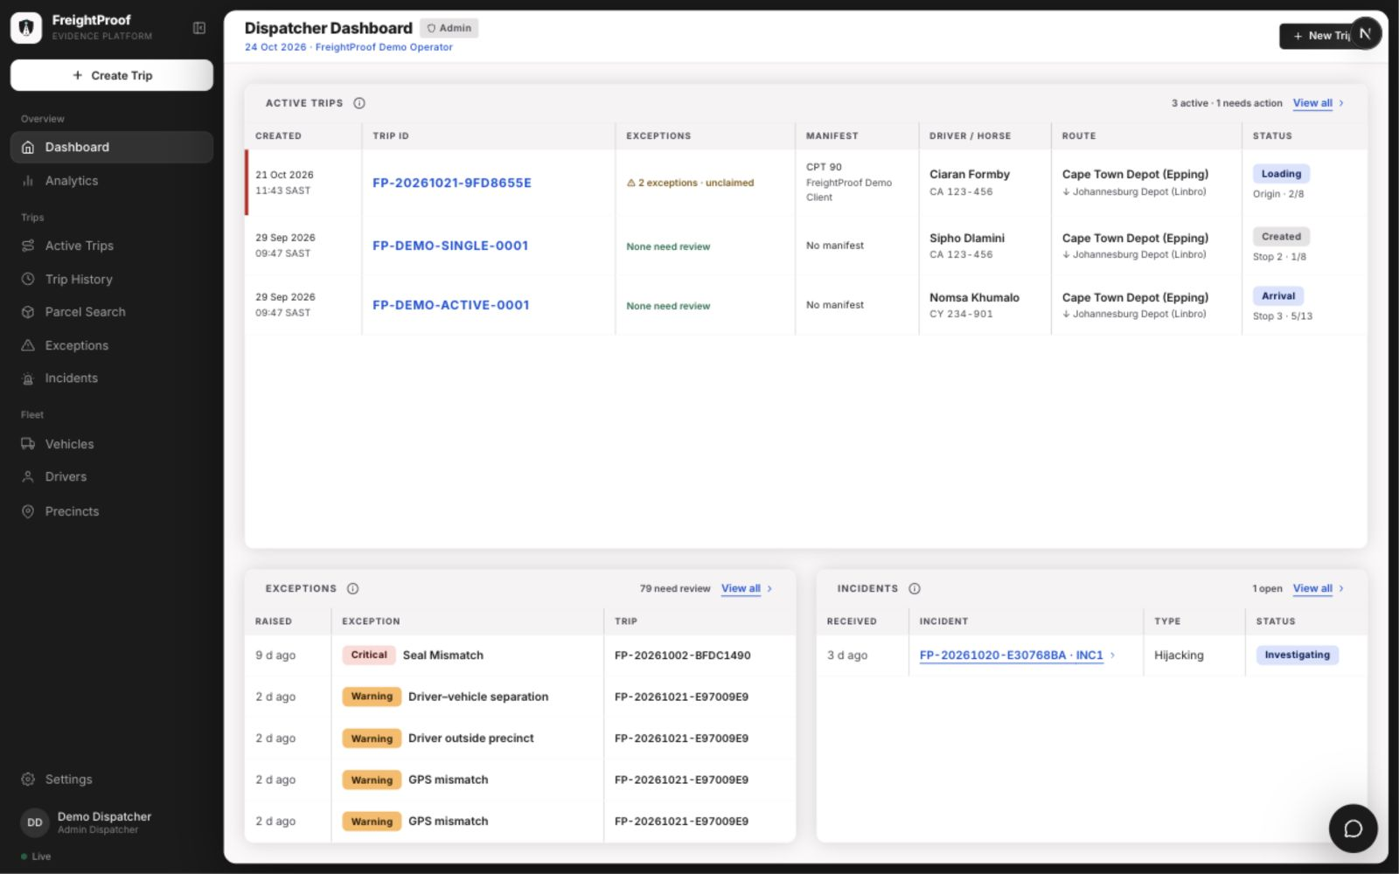
Figure 8: Live trip list: every running trip at a glance (local desktop prototype, 24 October 2026)

8.3 Trip Timeline
The timeline groups evidence and exceptions within the phase where they occurred, so a dispatcher investigates each finding in its custody context. A one-line verdict on each phase card ("Checks passed", "Needs attention" or "In progress") supports scanning, and driver and vehicle details appear once, above the timeline, rather than on every card. Completed, current and future phases look different, which makes progress on a multi-stop route clear. Phases stay in chronological order to preserve the custody sequence, and "Jump to current phase" supports live monitoring. Photographs appear as soon as they are uploaded, not when the phase completes (FP-287, FP-288).
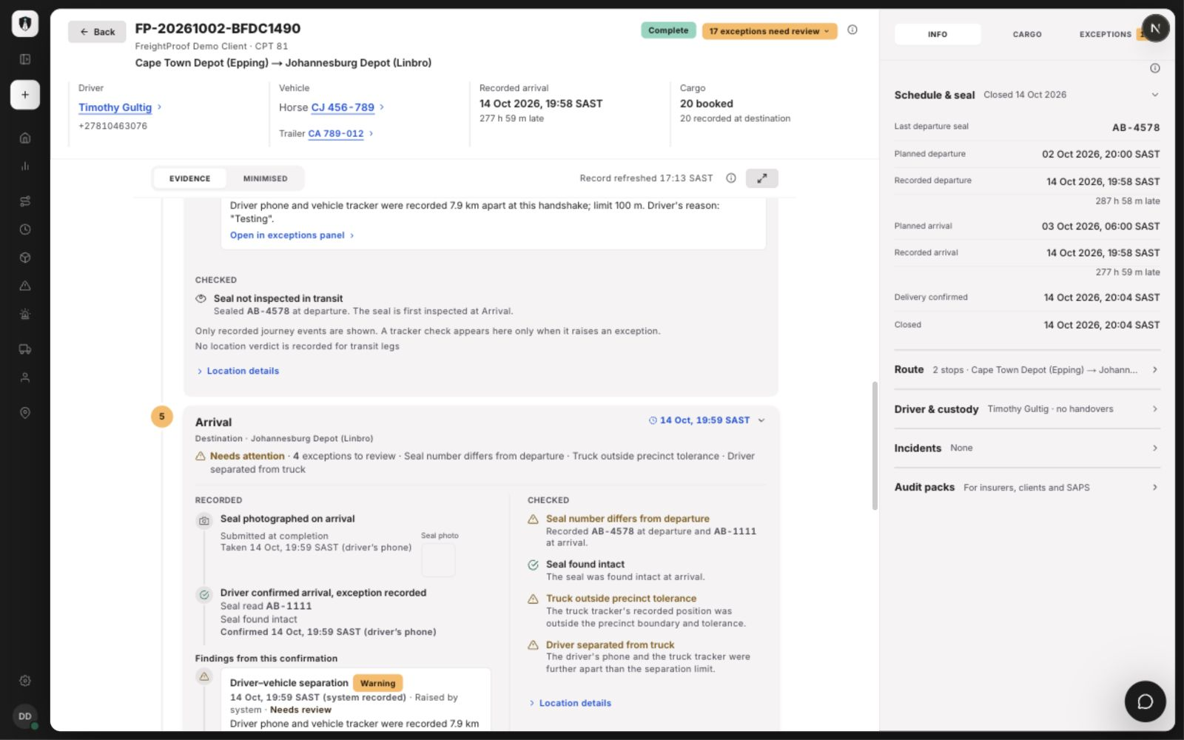
Figure 9: Arrival evidence with critical and warning exceptions (local desktop prototype)
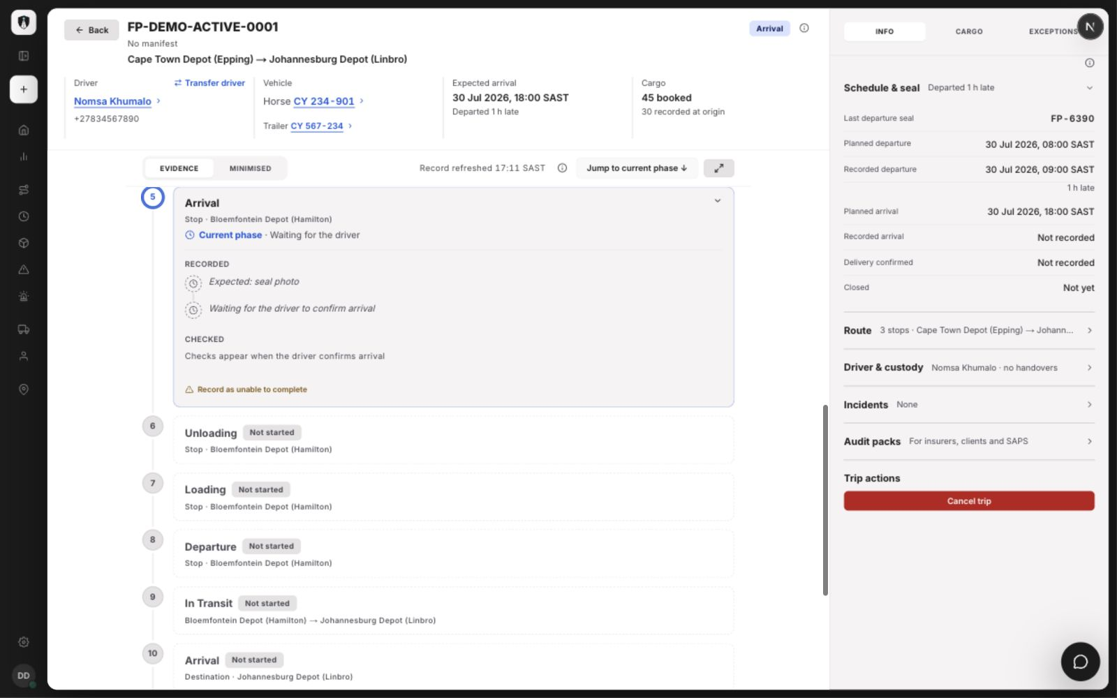
Figure 10: Multi-stop trip at intermediate Arrival (local desktop prototype)

8.4 Exception Inbox and Review
Every exception reaches a shared inbox ordered by severity (FP-280). Claiming an exception shows the other dispatchers, live, who is working on it, so two people do not investigate the same report or phone the same driver. The review records the outcome, contact method and a note, and never changes the original report. Warnings on one trip can be reviewed together, which avoids repetitive work when a trip raises many minor findings; critical exceptions are reviewed one at a time.
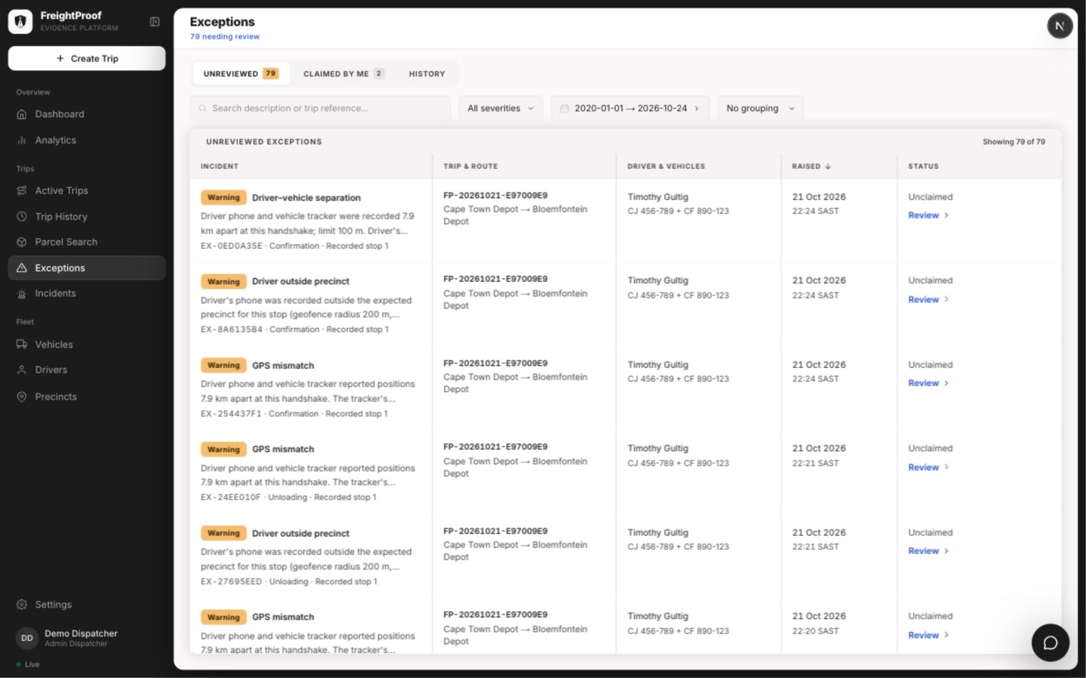
Figure 11: Shared exception inbox (local desktop prototype)
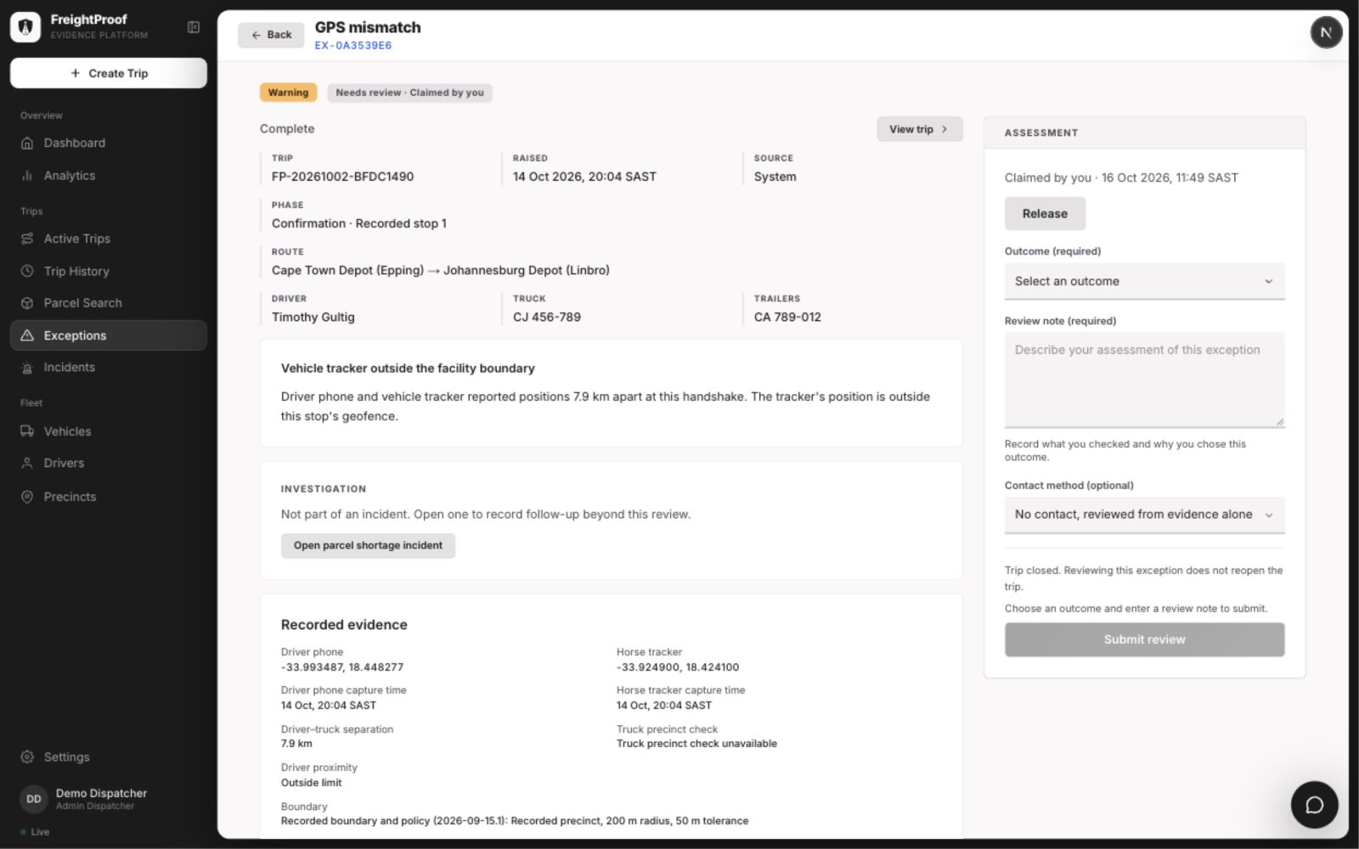
Figure 12: Exception review showing outcome, note and contact method (local desktop prototype)

8.5 Analytics
Today's incidents are on a map for daily use; the other tabs cover a chosen period for weekly or monthly analysis. Each figure is labelled as recorded or estimated and states its source, and small samples are flagged. The new Cost tab estimates value at risk and delay cost from rates an Admin-Dispatcher sets (FP-294, FP-296). The figures shown are demonstration data, not measured business outcomes.
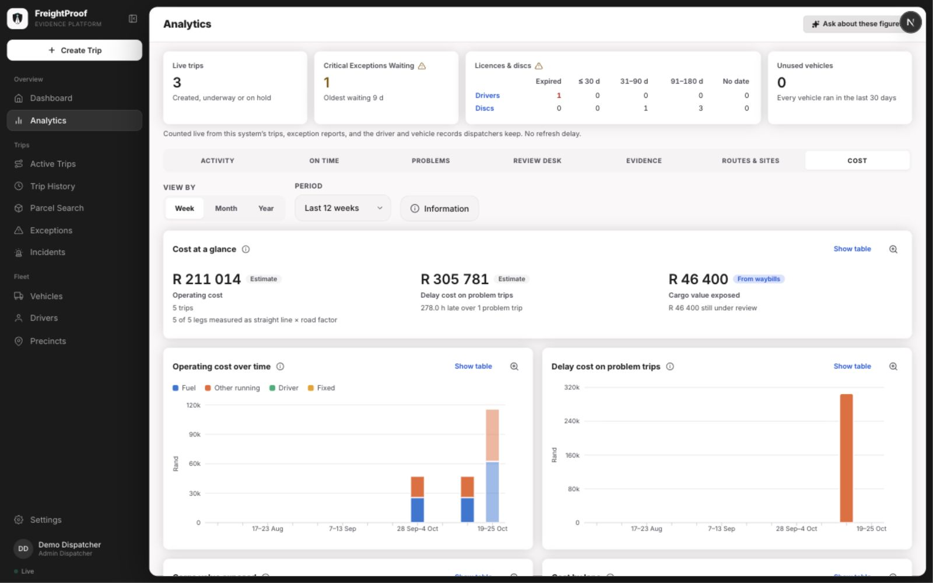
Figure 13: Analytics Cost tab (local desktop prototype, 24 October 2026)

8.6 Driver App: Arrival and Receiver Handover
Each driver screen gives one instruction. At Arrival the seal number is read from the photograph for the driver to confirm or correct (FP-300). At delivery the driver shows a rotating QR code; the receiver scans it, enters their name and identity number on their own phone and swipes to confirm, with an optional identity check. The driver's screen then shows that the receiver's acknowledgement has arrived, and only then can the trip close (FP-273).
Figure 14: Driver app: seal number read from the photograph at Arrival
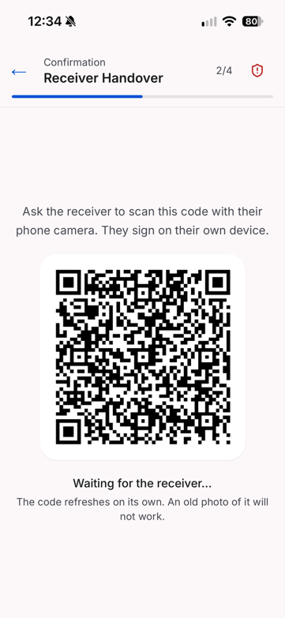  Figure 15: Driver app: QR code for the receiver | 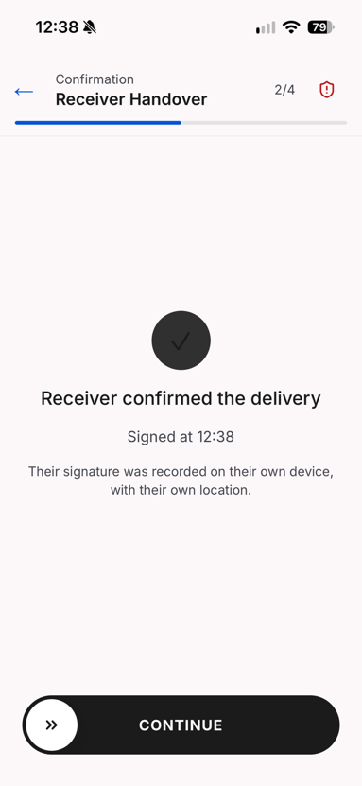  Figure 16: Driver app: receiver confirmation received

8.7 Precinct Set-up
An Admin-Dispatcher places a precinct by searching for its address (FP-309). The form fetches the yard's outline from OpenStreetMap as a starting point, which the Admin-Dispatcher adjusts on the satellite view to match the fence line; a precinct without an outline uses a radius instead (BR-11).
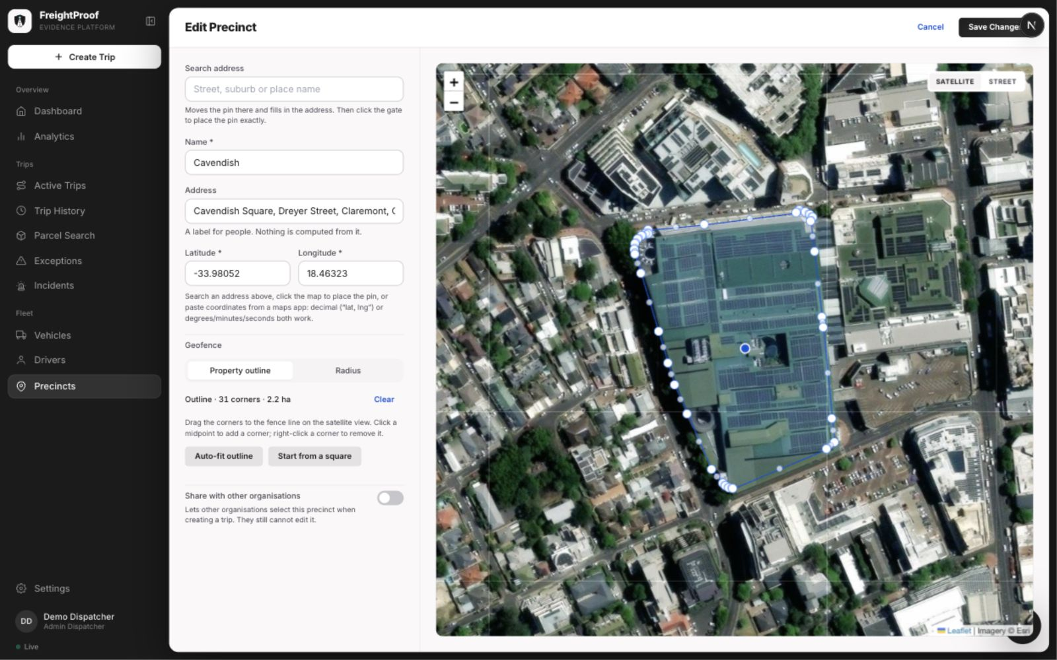
Figure 17: Precinct form with address search and editable property outline (local desktop prototype)

8.8 Audit Pack and Client Portal
An Admin-Dispatcher issues an audit pack from the trip for a stated purpose and recipient (FP-279, FP-291). The pack is a frozen snapshot: its contents are fingerprinted at issue, so later changes to the trip do not alter it. The client portal labels each record by the protection it has and shows evidence gaps rather than hiding them, so a recipient can see what the pack establishes and what it does not.
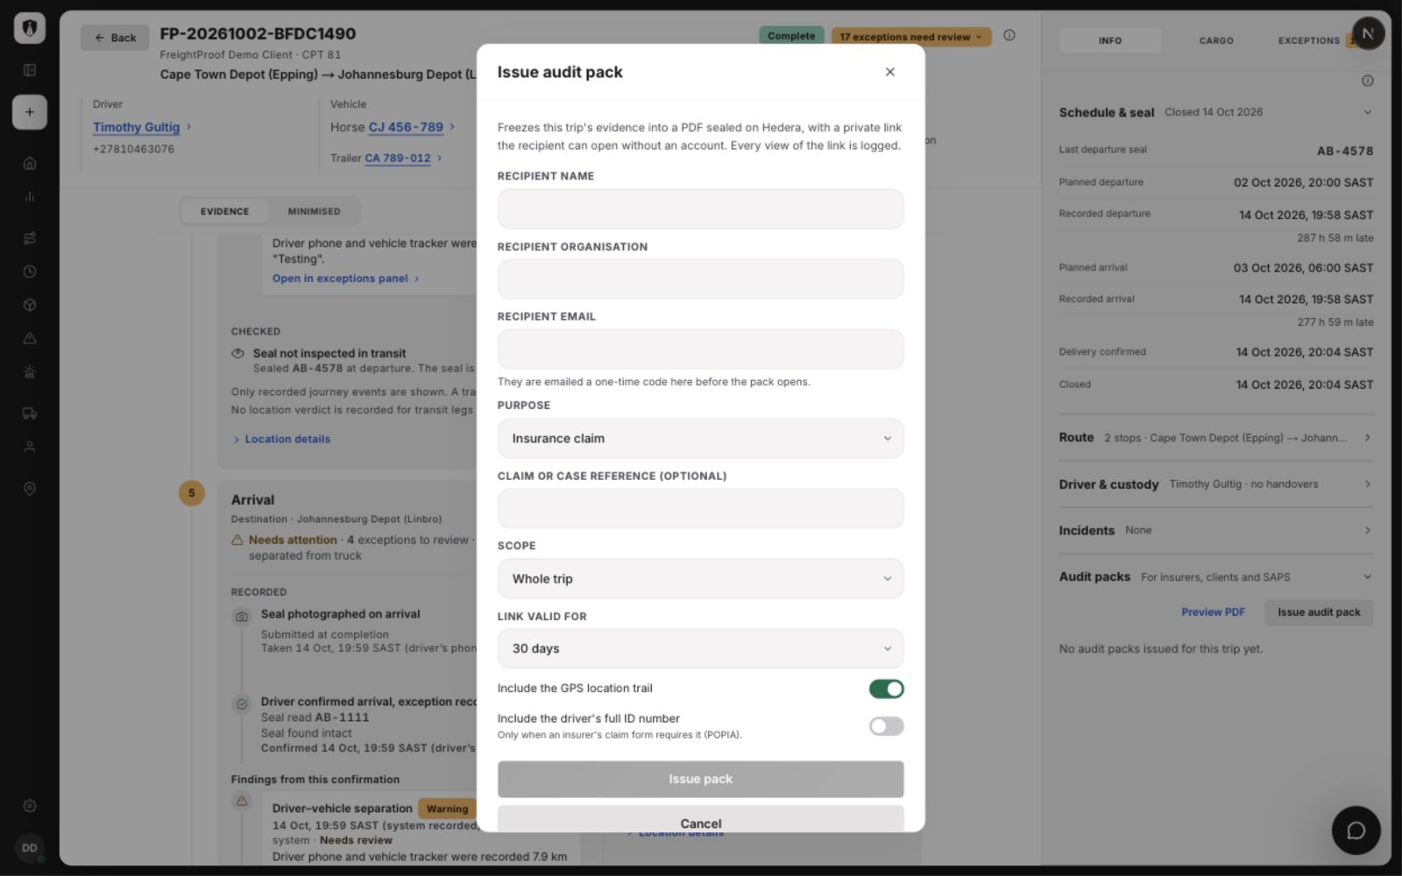
Figure 18: Audit-pack issue form with scope and privacy options (local desktop prototype)
Figure 19: Client portal: verifying an audit pack

9. Testing Approach, Results and Plan
Testing combines backend unit and integration coverage, frontend component tests, synchronised concurrency cases, structural checks and team acceptance walkthroughs. Failure paths cover lost connectivity, retry and provider outages. Database timeouts were load-tested (FP-299); anchoring latency and acceptance on representative devices remain pilot-validation activities.

9.1 Kinds of Tests
Table 28: Test levels used in Iteration 4
Level | Tool and scope | Iteration 4 focus
Backend unit | pytest; one piece of logic, no database or network | Phase-plan generation with Arrival; anchored payloads; corroboration limits; severity; cost calculations
Backend integration | pytest and httpx against a real PostgreSQL database and Redis | Manifest trips; Arrival; exception claims and batch review; anchored exceptions, reviews and cancellations; audit packs; parcel trace; vehicle clashes
Frontend unit and component | Vitest for dispatcher, driver, receiver and client portal; component, hook and client logic tests. | Offline queue and exception store; timeline phase cards; exception inbox; audit-pack panel; portal verification
Concurrency | Barrier-synchronised database connections | Two claims or reviews of one exception; two redemptions of one QR link; two trips for one manifest; simultaneous cancellations
Security | Integration tests per role and organisation | Organisation isolation, identical "not found" responses, locked-down database tables, per-token rate limits
Static and structural | ruff, mypy, import-linter, size limits | New structural violations and growth above the recorded baseline are rejected.
Migration | Alembic against an empty database in CI | Exactly one migration head; the whole chain applies cleanly
Load | Scripted concurrent clients against a disposable local stack with injected database faults (FP-299) | Database timeouts and recovery under concurrent load; anchoring latency not measured
Device and connectivity | Planned manual handset walkthroughs | Device scenarios: connectivity loss, app closure, battery loss, cleared data and unavailable services.
Story acceptance | Team walkthroughs on the deployed system | Each Sprint 8 and 9 story against its acceptance criteria

9.2 Automated Test Evidence
The recorded 19 October development-branch run passed 3,411 backend tests, 1,448 driver-app tests and 2,900 dispatcher tests (Figure 20). The backend output also records four skipped tests and 267 slow tests deselected from that command. This is dated execution evidence rather than a claim about every later revision. CI runs the non-slow backend suite and a separate slow import-cycle step, plus checks for all four front ends.
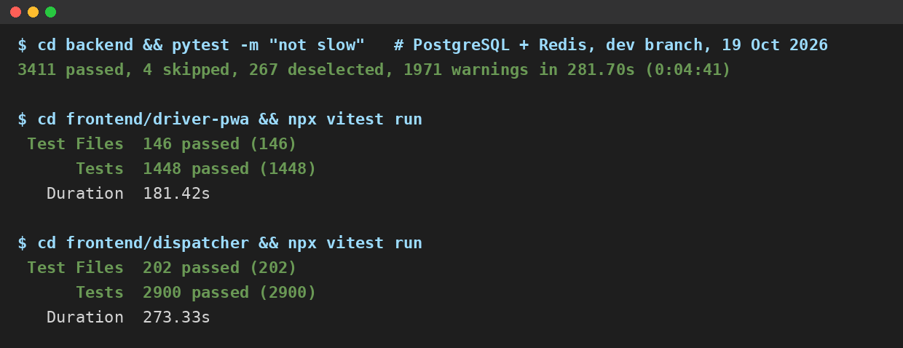
Figure 20: Summary output of the backend, driver-app and dispatcher test suites, 19 October 2026
Table 29: Continuous integration pipeline, run on every pull request
Step | What it checks
Lint (ruff) | Code style and common errors
Structure ratchet | No function or file grows beyond the agreed size limits
Layering (import-linter) | No module skips a layer, for example a request handler calling an integration directly
Type check (mypy) | Type consistency across the backend
Tests (pytest) | Unit and integration tests against isolated PostgreSQL 17 and Redis; slow import-cycle tests run separately.
Import check | Every module imports cleanly in a fresh interpreter, with no import cycles
Migrations | Exactly one migration head; the whole chain applies to an empty database
Frontend | ESLint, TypeScript, Vitest and production builds for dispatcher, driver, receiver and client portal.

9.3 Failure-Scenario and Load Testing
Table 30 defines the expected outcomes used in automated tests and device walkthroughs. Appendix A links representative requirements to concrete automated cases. Device walkthroughs are distinguished from automated execution evidence.
Table 30: Failure scenarios and expected behaviour
Scenario | Expected behaviour
No signal during a phase | The action is queued on the phone and sent when signal returns; the server records it once, using the same identifier on every retry
A queued action is blocked because an earlier phase is incomplete | The item is kept and retried, not discarded (FP-276); if the server refuses it, it stays on the phone and is shown to the driver, who resends it or reports it. The dispatcher is not alerted automatically (§5.4)
App data or cache cleared before sync | Unsent captures are lost on the phone, but nothing false is recorded: the phase stays pending on the server and on the live trip list, and the driver recaptures it
Battery dies, phone lost or stolen | The phase stays pending; a sign-in on another phone ends the old session; overrides only under BR-4 (BR-6)
Tracker silent or position stale | "Could not check" is recorded, never a mismatch; the driver continues
Hedera unavailable | Phases complete and their receipts are marked owed and retried; trip creation is refused
Parcel Perfect unavailable | Trip creation is refused; an active trip keeps its last manifest
Didit unavailable | The receiver's check is recorded as unverified with a reason; delivery continues
API unavailable | The driver app queues actions and retries; the dispatcher application shows the failure rather than stale data
Slow database | Connection and pool-wait timeouts end the request quickly with an error, rather than hanging (FP-275)

Concurrent-load testing (FP-299) ran the real API against a disposable PostgreSQL stack through a fault relay that dropped, stalled or delayed database traffic. In both timeout profiles all 39 fault cycles passed: none of the 1,782 load requests hung, each ended as a success, a logged 503 or a deliberate cancellation within its declared limit, and 12 reads succeeded within 1.64 s of each fault being removed. With the code's default limits a failing request still took up to about 30 s, so values that also fail fast for a user remain a deployment setting. The run led to one production change: asyncpg 0.32 is now required. Anchoring latency under load was not measured; 95% of receipts within 60 s remains a target.

9.4 Risk-to-Test Matrix
Table 31 links each project risk to the tests that cover it. Layer B is backend and F is frontend.
Table 31: Risk-to-test matrix
Risk | What is tested | Layer | Test cases
R-02, R-04 | Separate critical-event commitments and outage/recovery behaviour | B | TC-04, TC-05
R-03 | Server-derived corroboration and stale-fix handling | B | TC-16
R-05 | Offline queue keeps blocked items and replays each item once | F, B | TC-12 (frontend retry key); backend persistence tested separately
R-06 | Anchored payloads contain no positions, names or free text | B | TC-17
R-13 | One redemption per link; a second browser cannot confirm; rotation pauses once the link is opened | B | TC-08, TC-09
R-12 | Receiver may decline the check or have no document; delivery is still confirmed and the outcome recorded | B | TC-10
R-14 | Organisation isolation; locked-down tables; per-token rate limits | B | TC-11
R-16 | Full suite, layering and migrations in CI | B, F | §9.2
SO-3 | Manifest trip creation, duplicates refused, parcel trace | B | TC-01, TC-02, TC-03
SO-5 | Every exception reviewed; claims; concurrent reviews | B | TC-07
SO-6 | Seal mismatch, damage and absence at Arrival | B | TC-06
SO-8 | Audit pack issue, access code, revocation, verification | B, F | TC-13, TC-14, TC-18

9.5 Test Plan and Status
Table 32 updates the Iteration 3 test plan (Team05, 2026b, Table 37, p. 60).
Table 32: Test plan and status at the end of Iteration 4
What | Environment | Status
Load and volume, including anchoring latency | Separate load-test environment | Database timeouts done (FP-299, §9.3); anchoring latency and production-sized volume not measured
Live identity verification and callback | Deployed system with the live provider | Done; the check is offered to every receiver and never blocks delivery
Live Parcel Perfect and Pulsit integration | Partner sandbox | Not possible: credentials not granted (R-22). Simulated feeds tested instead
Override and driver completion of the same phase at the same instant | Backend integration | Done: exactly one write succeeds
Device and connectivity scenarios (Table 30) | Android and iPhone handsets on the deployed system | Representative handset and connectivity acceptance remains a pilot-validation activity.
Acceptance testing with LFG users | Deployed system | Not done within the project; team story acceptance only. Planned as the first step of the pilot (BO-1)

10. Development Approach, Scrum and Progress
This section describes how the team worked, the two Iteration 4 sprints and what the team learnt.

10.1 Development Approach and Standards
Team 05 developed FreightProof iteratively with Scrum (Schwaber & Sutherland, 2020), tracked on the Jira board FP. Roles were unchanged throughout the project: Ciaran Formby was Product Owner, Tim Gultig was Scrum Master, and all four members, with Thomas Davis and Chiko Kasongo, formed the Development Team. Each sprint opened with planning, in which every story was estimated in Fibonacci story points and assigned before work started. The team met in full every Wednesday, coordinated dependent work in the team channels, and closed each sprint with a review against Jira and a retrospective. Each iteration ended with a panel review, whose feedback became the next iteration's backlog.
The team followed these standards:
- Version control. The main and development branches are protected. Every change arrives through a pull request that a second member reviews, and commits reference their Jira key.
- A story is accepted when the agreed criteria are met, checks pass and a second member reviews the merged change. Jira completion and residual acceptance gaps are reported separately where the final release delivers a narrower behaviour.
- Coding standards. The Python backend uses typed code, Pydantic v2 models and async database access, checked by ruff and mypy. The four front ends use TypeScript in strict mode with ESLint. The layering rule is checked by CI (§9.2).
- Database standards. Schema changes go through named, hand-reviewed migrations only. Every new table has row-level security enabled.
- UI standards. A shared design system (colours, type, spacing and status chips) is used by all front ends, and shared types come from one package so that a contract change fails at compile time.

10.2 Sprint 8
Sprint 8, 29 September to 12 October 2026 (13 days). Goal: complete the final features and begin preparing for final submission. Table 33 lists the committed backlog, written as user stories.
Table 33: Sprint 8 committed backlog (19 items, 84 points)
Key | User story | Assignee | Pts | Outcome
FP-281 | As a dispatcher, I want to create a trip from the client's manifest number, so that cargo is imported, not typed | C. Formby | 11 | Done in sprint
FP-280 | As a dispatcher, I want every exception to reach a shared inbox where I can claim it, so that nothing is recorded and forgotten | C. Formby | 8 | Done in sprint
FP-149 | As a dispatcher, I want to find a parcel by barcode and see everywhere it has been | C. Kasongo | 8 | Done in sprint (carried from Sprint 7)
FP-279 | As an insurer, I want an anchored audit pack that I can verify myself, so that I need not trust the operator's copy | T. Gultig | 8 | Done in sprint
FP-270 | As a dispatcher, I want the seal inspected at Arrival and every phase anchored, so that a break in transit is detected when custody arrives | C. Formby | 3 | Done in sprint
FP-272 | As a demonstrator, I want a demo panel that follows the trip, so that partner events can be simulated in order | C. Formby | 2 | Done in sprint
FP-277 | As a developer, I want the identity-provider call inside the service layer, so that request handlers never call an integration directly | T. Gultig | 2 | Done in sprint
FP-271 | As an operator, I want newer tables closed to direct database access, so that evidence cannot be read around the API | C. Formby | 1 | Done in sprint
FP-295 | As an operations manager, I want a plain-language brief of patterns in my analytics, based on de-identified figures | T. Davis | 8 | Carried; done in Sprint 9 as an analytics chat
FP-286 | As the team, we want documentation and evidence captured during the sprint, so that the final document is assembly, not authoring | — | 5 | Carried; done in Sprint 9
FP-294 | As an operations manager, I want to see the cargo value exposed and the estimated cost of delays | T. Davis | 5 | Carried; done in Sprint 9
FP-296 | As an operations manager, I want today's incidents on a map and the source of every figure | T. Davis | 5 | Carried; done in Sprint 9
FP-300 | As a driver, I want the seal number read from my photo, so that I confirm it instead of typing it | T. Gultig | 5 | Carried; done in Sprint 9
FP-273 | As a principal, I want delivery to close only after the receiver confirms, so that a driver cannot sign for the receiver | T. Gultig | 3 | Closed; residual confirmation check in §5.4
FP-276 | As a driver, I want evidence captured offline to be kept until it is accepted, not discarded | T. Gultig | 3 | Carried; done in Sprint 9
FP-274 | As an operator, I want request limits applied per user, so that one user cannot exhaust another's | C. Kasongo | 2 | Carried; done in Sprint 9
FP-275 | As a dispatcher, I want a slow database to fail fast rather than freeze my screen | C. Kasongo | 2 | Carried; done in Sprint 9
FP-297 | As a driver, I want to report a breakdown that affects both the horse and a trailer | C. Formby | 2 | Carried; closed in Jira; not in the release (§5.4)
FP-278 | As a driver, I want real seal numbers accepted, not only an invented format | T. Gultig | 1 | Carried; closed in Jira; not in the release (§5.4)

Sprint 8 completed 43 of 84 points (51%) and carried 41 into Sprint 9. All 41 carried points were closed in Sprint 9; FP-278 and FP-297 (3 points) describe behaviour that is not in the final release (§5.4). The burndown is stepwise because points are credited when stories close, rather than when implementation starts.
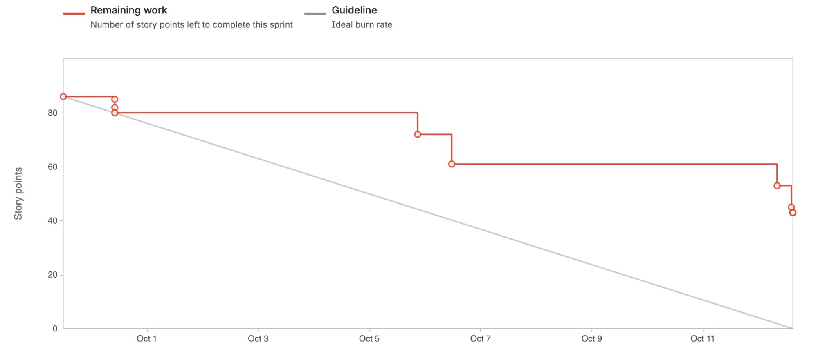
Figure 21: Sprint 8 burndown chart (Jira)
Figure 22: Sprint 8 task board
Table 34: Sprint 8 retrospective
What went well | What should improve | Action taken
Core manifest, exception-inbox and audit-pack features completed. | Only 51% of the sprint commitment completed within the sprint. | Separate carried work from new commitment.
Delivery totals distinguish carry-over. | Work started before the sprint can distort early progress. | Create and estimate tickets before implementation.
Automated checks cover shared-code changes. | Documentation ownership and evidence collection remained late. | Assign documentation and evidence alongside feature work.

10.3 Sprint 9
Sprint 9 is closed. Its planned period was 12–23 October 2026, including the structural freeze from 19 October. The recorded commitment was 118 points: 41 carried from Sprint 8 and 77 new. Jira records all 118 points as completed: 41 carried and 77 new. Three closed tickets (FP-278, FP-297 and FP-293, 5 points) describe behaviour that is not in the final release; §5.4 states those limits. Ticket closure is reported alongside the residual scope boundaries in §5.4.
Table 35: Sprint 9 new backlog (15 items, 77 points)
Key | User story | Assignee | Pts | Outcome
FP-303 | As the team, we want the final document, evidence and code packaged for submission | C. Formby | 13 | Submission preparation
FP-288 | As a dispatcher, I want each phase on the timeline to show its acts live, so that I see what happened inside it | C. Formby | 8 | Done
FP-290 | As an insurer, I want critical exceptions, reviews and cancellations anchored, so that the records a dispute questions are protected | C. Formby | 8 | Done
FP-308 | As an operator, I want upload limits, artefact ownership and session checks enforced | T. Gultig | 8 | Done
FP-287 | As a dispatcher, I want photographs to appear on the timeline as soon as they are uploaded | C. Formby | 5 | Done
FP-289 | As a dispatcher, I want a live trip list showing phase progress and unreviewed exceptions, with further detail available on the trip timeline | C. Formby | 5 | Closed; elapsed-time/location columns excluded
FP-139 | As a dispatcher, I want a horse that is on a live trip to be refused for a second one | T. Davis | 5 | Done
FP-309 | As an Admin-Dispatcher, I want to place a precinct by searching for its address | T. Gultig | 5 | Done
FP-83 | As a dispatcher, I want a driver substitution recorded by both drivers, so that each driver's custody stays on the record | C. Formby | 5 | Done
FP-142 | As a dispatcher, I want to see a vehicle clash before I create a trip | T. Davis | 3 | Done
FP-291 | As an operator, I want audit-pack links to need an e-mailed code before first view | T. Gultig | 3 | Done
FP-316 | As an insurer, I want a "selfie only" verification to exist only when the selfie is stored | T. Gultig | 3 | Done
FP-292 | As an insurer, I want the client portal deployed, so that a share link works outside the team's machines | T. Gultig | 2 | Done
FP-293 | As a receiver, I want an identity check only when the consignment requires it | C. Kasongo | 2 | Closed in Jira; not in the release (§5.4)
FP-299 | As the team, we want a load test that proves the database timeouts hold | C. Kasongo | 2 | Done

Figure 23: Sprint 9 task board
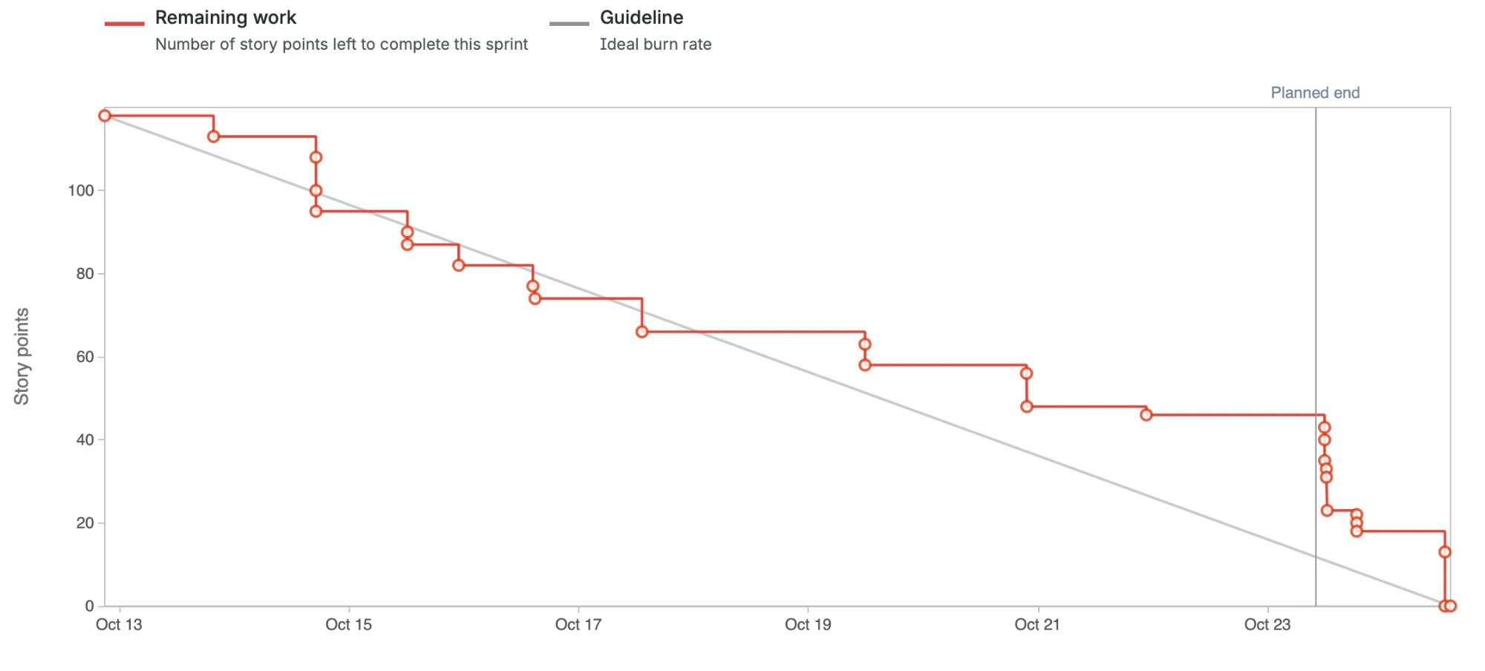
Figure 24: Sprint 9 burndown chart (Jira)
Table 36 records the Sprint 9 retrospective. The burndown (Figure 24) followed the ideal line in the first week and then flattened, with the last 46 points closed at or after the planned end.
Table 36: Sprint 9 retrospective
What went well | What should improve | Lesson
The first week tracked the ideal burn rate (13–17 October), and the work carried from Sprint 8 was finished early. | About 46 points closed on or after the planned end (23 October), so ticket closure lagged the merged work (Figure 24). | Close a ticket when its pull request is merged.
All 118 points were closed, and the freeze from 19 October kept the demonstration build stable. | FP-278, FP-297 and FP-293 were closed without their behaviour reaching the release (§5.4). | Check the acceptance criteria before a ticket is marked Done.
Live operational views, critical-evidence anchors, the client portal and the load test were delivered. | Workload stayed uneven: two members completed 71% of Iteration 4's points (Table 38). | Spread points across members at sprint planning.

10.4 Velocity and Capacity
Figure 25 shows committed and completed points for every sprint. Sprint lengths varied between 10 and 14 days because sprints were fitted around the iteration reviews and the submission date. To compare them, Table 37 also gives points per sprint day. Jira was used sparsely in Sprints 1, 3 and 4 (4, 7 and 4 issues), so their figures understate the work done and are not comparable.
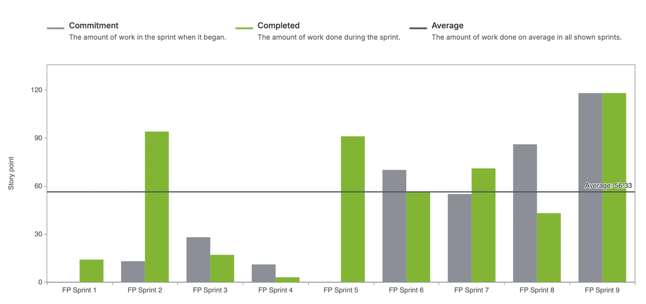
Figure 25: Committed and completed story points, Sprints 1–9 (Jira velocity report)
Table 37: Velocity normalised for sprint length
Sprint | Dates | Days | Committed | Completed | Points per day
2 | 3–17 May | 14 | 94 | 94 | 6.7
5 | 27 Jul – 10 Aug | 14 | 91 | 91 | 6.5
6 | 26 Aug – 7 Sep | 12 | 80 | 56 | 4.7
7 | 7–17 Sep | 10 | 79 | 71 | 7.1
8 | 29 Sep – 12 Oct | 13 | 84 | 43 | 3.3
9 | 12–23 Oct | 11 | 118 | 118 | 10.7

Committed points in Table 37 count every story assigned to the sprint, including stories added after it started. Jira's velocity report (Figure 25) counts only the work in the sprint when it started, so its commitments are lower for Sprints 2, 5, 6 and 7 (13, 0, 70 and 55 points) and 86 for Sprint 8. Completed points are the same in both. The gap is work added after a sprint began, the pattern behind the lesson to ticket work before doing it (§10.5).
Across comparable sprints the team completed about 6.5 points per sprint day. Sprint 8 fell well below this and Sprint 9 well above it, because all 41 carried points were closed in Sprint 9. Taken together, Sprints 8 and 9 delivered 161 points in 24 days, 6.7 points a day, close to the team's earlier rate.
Table 38: Story points completed per member in Iteration 4
Member | Sprint 8 | Sprint 9 | Iteration 4 | Share
Ciaran Formby | 25 | 46 | 71 | 44%
Tim Gultig | 10 | 33 | 43 | 27%
Thomas Davis | 0 | 26 | 26 | 16%
Chiko Kasongo | 8 | 8 | 16 | 10%
Unassigned (documentation) | 0 | 5 | 5 | 3%
Total | 43 | 118 | 161 | 100%

Story points measure feature tickets, not all contributions: documentation, research, meeting minutes, testing and presentation work are largely outside them. Contributions in those areas are described in the portfolio of evidence (Appendix C).

10.5 Reflection on Scrum and Lessons Learnt
Scrum’s review points allowed feedback to change the product incrementally. Iteration 2 feedback led to stronger location corroboration and receiver participation; Iteration 3 feedback shaped the live trip list, exception workflow and audit packs. Backlog estimates exposed capacity pressure, while peer review and CI supported shared development. The delivery record also shows where the process fell short: carry-over, uneven workload and late documentation.
Lessons learnt.
- Keep sprints the same length. Varying lengths made velocity hard to compare and planning harder. A fixed two-week sprint, with reviews placed between sprints, would have been simpler.
- Treat documentation as sprint work. Documentation was under-counted in three iterations and done at the end. It only improved when it became pointed tickets with owners.
- Write smaller stories. Stories of 8 to 13 points closed in one step at the end of a sprint, which hid progress and made the burndown uninformative.
- Balance the workload deliberately. Points were concentrated in two members in every iteration despite being raised in each retrospective. It has to be addressed at sprint planning, when work is assigned, not only noted in the retrospective.
- Ticket work before doing it. Work done between sprints and later credited to a sprint distorted the sprint figures.
- Review AI-assisted code as carefully as your own. Code that works is not the same as code the team understands (§10.6).
- Talk to users early. LFG meetings and the facility visit supplied operational context. The project’s iteration reviews then challenged assumptions about handovers, evidence and day-to-day dispatch work.

10.6 Use of AI Tools
The team used AI tools throughout the project. Claude Code was the main tool, used to understand unfamiliar code, generate and refactor code, write tests, and draft design notes and specifications. Gemini was used to reconcile sprint records against the repository. AI was also used to check documentation against the code and to find merge conflicts across branches.
Repository instructions require planning for non-trivial changes and leave commits and merges to team members. AI-assisted changes are reviewed and checked through the same tests, types and layering controls as other changes. Each member remains responsible for understanding and defending their contribution at the final code review.
In the product, the "Ask about these figures" analytics chat (FP-295) answers questions from de-identified figures only, using Google Gemini, and refuses to state figures it has not looked up. It is off unless AI_CHAT_ENABLED and an API key are set, and the dispatcher assistant has its own switch (ASSISTANT_ENABLED). Severity and other evidence decisions are made by fixed rules, not by an AI model, because evidence must be reproducible.

References
Electronic Communications and Transactions Act 25 of 2002 (South Africa).
Hedera. (n.d.). Consensus service. Hedera documentation. https://docs.hedera.com/guides/docs/hedera-api/consensus-service
National Institute of Standards and Technology. (2015). Secure hash standard (SHS) (FIPS PUB 180-4). https://doi.org/10.6028/NIST.FIPS.180-4
Protection of Personal Information Act 4 of 2013 (South Africa).
Schwaber, K., & Sutherland, J. (2020). The Scrum guide. https://scrumguides.org/scrum-guide.html
South African Police Service. (2025). Annual report 2024/2025. https://www.saps.gov.za/about/stratframework/annual_report/2024_2025/2024-25-SAPS-Annual-Report.pdf
Team05. (2026a). FreightProof SA: Iteration 2 documentation [Unpublished project document]. INF4027W, University of Cape Town.
Team05. (2026b). FreightProof SA: Iteration 3 documentation [Unpublished project document]. INF4027W, University of Cape Town.

Appendix A: Sample Test Cases
The cases below identify implemented automated checks and the behaviour each establishes. Figure 20 supplies dated aggregate execution evidence; the cases are not a substitute for a run tied to the final release. Test names distinguish frontend retry behaviour from backend persistence guarantees.
Table 39: Sample test cases
ID / requirement | Scenario and expected behaviour | Automated evidence
TC-01 / SO-3, TLM 1.2 | Create a trip from a mock manifest; then request an unknown manifest number → Trip saved with its manifest key and verifies against its journey lock; unknown manifest returns 404 | test_trip_from_pp_manifest.py: test_create_persists_a_manifest_trip; test_unknown_manifest_is_404
TC-02 / SO-3, TLM 1.2 alt. 1c | Two dispatchers create a trip from the same manifest at the same instant (barrier) → Exactly one trip is created; the other request is refused cleanly | test_creation_concurrency.py: test_concurrent_creation_from_one_manifest_creates_one_trip
TC-03 / SO-3, TLM 1.13 | Search a barcode belonging to another organisation, and an unknown barcode → Both return the same "not found" response | test_parcel_trace.py: test_foreign_and_unknown_records_are_indistinguishable
TC-04 / SO-1, BR-2 | Raise a critical exception, cancel the trip, then review the exception → Each action has its own anchored event and receipt; earlier receipts unchanged | test_fp290_incident_chain.py: test_each_action_has_its_own_event_and_receipts_stay_separate
TC-05 / SO-1, R-07 | Repeat TC-04 with Hedera unavailable → Events stored with anchor status "failed"; the evidence itself is intact | test_fp290_incident_chain.py: test_hedera_outage_leaves_failed_events_and_the_source_intact
TC-06 / SO-6, CC 1.11 | Arrival with a seal number different from the departure seal → Exactly one critical seal exception is raised | test_arrival_phase.py: test_arrival_seal_number_mismatch_raises_one_critical_exception
TC-07 / SO-5, BR-2 | Dispatcher B claims an exception already claimed by A; then A and B submit reviews simultaneously → Claim refused with 409; exactly one review recorded | test_exception_claims.py: test_claim_over_a_colleague_is_409; test_exception_review_concurrency.py: test_simultaneous_reviews_record_exactly_one_dispatcher
TC-08 / SO-4, R-13 | Two phones redeem the same QR link at the same instant → Exactly one confirmation succeeds | test_handover_token_concurrency.py: test_two_simultaneous_redemptions_of_the_same_token_produce_exactly_one_success
TC-09 / SO-4, R-13 | A second browser opens a link that the receiver's browser holds → The second browser is refused; the receiver's link still works | test_handover_endpoints.py: test_a_refused_binding_does_not_burn_the_real_receivers_token
TC-10 / SO-4, BR-7 | Receiver declines the identity check or has no document → Delivery is still confirmed; outcome recorded as unverified | test_receiver_verification_endpoints.py: test_full_walk_receiver_without_an_id_still_confirms
TC-11 / R-14 | Apply the database lockdown migration and query as the public API roles → Row-level security on; direct access revoked | test_data_api_lockdown.py: test_upgrade_enables_rls_and_revokes_api_roles
TC-12 / R-05 | Retry a queued phase after a simulated timeout. The frontend sends the same idempotency key on both attempts; this case does not assert database writes. | useOfflineQueue.test.ts: "sends the same idempotency_key on a retry as on the first attempt"
TC-13 / SO-8, BR-9 | Open a revoked audit-pack link → 410 response; the attempt is logged | test_audit_pack_public.py: test_open_shared_pack_revoked_is_410_and_logged
TC-14 / SO-8, BR-9 | Open an e-mailed audit pack without entering the code → 401 response; the attempt is logged | test_audit_pack_email_codes.py: test_open_emailed_pack_without_grant_is_401_and_logged
TC-15 / BP-3, TLM 1.2 | Request availability for a horse already on an overlapping trip → The horse is listed as busy, naming the trip; other organisations' trips never appear | test_trip_availability_endpoint.py: test_availability_lists_the_busy_driver_horse_and_trailer
TC-16 / SO-2 | Complete phases using server-derived corroboration and unusable tracker fixes; unusable comparisons are not reported as matches. | test_phase_corroboration.py
TC-17 / R-06 | Canonical phase payloads exclude GPS, artefact identifiers, personal data and completion timestamps. | test_phase_anchor_payload.py: test_no_v2_payload_leaks_gps_artifact_ids_pii_or_completed_at
TC-18 / SO-8 | Verify a matching payload; reject changed payload/ledger hashes; distinguish mirror unavailability. | client-portal/lib/verify.test.ts

Appendix B: Addendum – Changes Since Iteration 3
Table 40 summarises the principal changes delivered since Iteration 3 and where they are documented.
Table 40: Changes since Iteration 3 and the feedback they answer
Area | Iteration 4 development | Section
Purpose and objectives | Venture/customer roles clarified; objectives separated and traced to system outcomes. | 1–3
Risk and plan | Unified risk treatment, project risks, release scope and pilot boundaries. | 4–5
Custody lifecycle | Arrival, manifest-first creation, trailer checks and driver-substitution workflow. | 6
Exceptions | Shared inbox, claims, reviews, incident declarations and append-only updates. | 6.4–6.5; 8.4
Evidence integrity | Every-phase anchoring and separate critical-event, review and cancellation commitments. | 7.2
Evidence sharing | Frozen audit packs, e-mail access codes and independent portal verification. | 6.5; 8.8
Operations interface | Live trip overview, phase timelines, immediate photo display and parcel tracing. | 8
Analytics | Cost view, Today incident map, source labels and optional analytics chat. | 8.5
Receiver flow | Own-device acknowledgement, optional identity check and typed-only fallback. | 6.4–6.5
Testing | CI gates, automated results, failure scenarios and named sample cases. | 9; Appendix A
Scrum | Carry-over separated, sprint-length normalisation and delivery reflections. | 10
Participation | Individual contribution descriptions and separate scoring/sign-off records. | Appendix C

Appendix C: Portfolio of Evidence and User Log
The portfolio summarises each member’s contribution. Coding, documentation, presentation, research, meeting minutes and communication are scored separately; each member’s log is signed by the other three members.
Ciaran Formby (Product Owner). Code: manifest-first trip creation (FP-281), the exception inbox with claims and batch review (FP-280), the Arrival phase with every-phase anchoring and trailer geofences (FP-270), anchored critical exceptions, reviews and cancellations (FP-290), the live trip list and live phase timelines (FP-287, FP-288, FP-289), the database lockdown (FP-271), driver substitution (FP-83) and the demo panel (FP-272). Documentation: design notes for the Arrival phase and the exception workflow; owner of the final submission package (FP-303). Other: team contact for the Pulsit and Parcel Perfect partners; backlog ordering and sprint goals.
Tim Gultig (Scrum Master). Code: audit packs and client portal (FP-279, FP-291, FP-292), delivery-signature controls (FP-273), offline retention (FP-276), seal reading (FP-300), precinct search (FP-309), receiver-flow changes (FP-316), security hardening (FP-308) and layering (FP-277). Documentation: evidence-sharing design and supporting standards research. Process: sprint coordination, Jira reconciliation and sprint records.
Thomas Davis. Code: cost analytics (FP-294), today's incident map and figure sources (FP-296), the analytics chat (FP-295), and the vehicle-clash guard and crew availability in trip creation (FP-139, FP-142). Documentation: analytics specifications for cost and provenance; project context and plan sections. Other: architecture and package diagrams.
Chiko Kasongo. Code: parcel search by barcode (FP-149), per-token rate limits (FP-274) and database timeouts (FP-275). Documentation: UI evidence and state-machine sections. Other: sprint metrics, burndown and velocity reporting.
Table 41: Contribution scores out of 5
Member | Coding | Documentation | Presentation | Research | Meeting minutes | Communication
Ciaran Formby
Tim Gultig
Thomas Davis
Chiko Kasongo

Table 42: Sign-off of the user logs
Member's log | Reviewed and signed by | Reviewed and signed by | Reviewed and signed by
Ciaran Formby | Tim Gultig ________________ | Thomas Davis ________________ | Chiko Kasongo ________________
Tim Gultig | Ciaran Formby ________________ | Thomas Davis ________________ | Chiko Kasongo ________________
Thomas Davis | Ciaran Formby ________________ | Tim Gultig ________________ | Chiko Kasongo ________________
Chiko Kasongo | Ciaran Formby ________________ | Tim Gultig ________________ | Thomas Davis ________________

