
INF4027W
Information Systems Honours Systems Development Project
FreightProof SA
Iteration 3 Documentation
Team 05
[Ciaran / Tim / Chiko / Tom — full names and student numbers]
Submitted: [date] — 17/18 September 2026 presentation slot
Version: [v1.0] | Document: Team05_Iteration3_Documentation

Table of Contents
List of Figures 4
List of Tables 4
Glossary 5
1. Project Context, Problems and Objectives 8
1.1 Background and Operating Context 8
1.1.1 Industry Setting 8
1.1.2 Industry Partner and Project Sponsorship 9
1.1.3 System Overview 9
1.2 Business Problems and Traceability 10
1.3 Business, Project and System Objectives 11
1.3.1 Business Objectives 11
1.3.2 Project Objectives 12
1.3.3 System Objectives 12
2. Iteration 3 Scope and Revised Plan 15
2.1 Current Project Position 15
2.2 User Story Map 15
2.3 Delivery Against Previous Commitments 16
2.4 Revised Milestones 17
3. Updated Analysis and Design Work Products 18
3.1 Package Diagram 18
3.3 Use-Case Model and Index 21
3.3.1 Actors and system boundary 21
3.3.2 Retention and replacement index 24
3.4 Changed and New Use-Case Narratives 25
3.4.1 New and changed narratives written in full 26
3.4.2 Changed narratives with replacement steps 30
3.5 State-Machine Diagram 35
3.6 Relational Schema 37
4. Architecture and Integrations 39
4.1 Architecture 39
4.2 Key Flows 39
4.3 Integrations 40
4.4 Quality Attributes 41
5. Risk Assessment and Treatment Changes 42
5.1 Scoring and Treatment Structure 42
5.2 Risk Register Summary 42
5.3 Treatment: Mitigate, Monitor and Manage 45
6. UI Evidence 48
6.1 Precinct / Geofence Setup 48
6.2 Trip Timeline and Recorded Location Comparison 49
6.3 Exception Capture and Dispatcher Review 50
6.4 Receiver QR / Consent / Verification / Signature 51
6.5 Entity and Fleet Analytics 53
7. Testing Approach, Results and Limitations 55
7.1 Testing approach 55
7.1.1 Concurrency, offline and outages 56
7.1.2 Frontend and backend 57
7.1.3 Story acceptance testing 57
7.2 Risk-to-test matrix 58
7.3 Remaining test plan 59
8. Development Approach, Scrum and Progress 60
8.1 Virtual Team Roles and Mechanisms 60
8.2 Sprint 6 61
8.3 Sprint 7 63
8.4 Velocity and Capacity 65
8.5 Iteration Reflection 66
8.6 Use of AI Tools 67
References 67
Portfolio of Evidence 67
Contribution scores 67

List of Figures
Figure 1: User Story Map 17
Figure 2: Package Diagram 20
Figure 3: Analysis Class Diagram 21
Figure 4: Trip Lifecycle Management Use Case 23
Figure 5: Custody Chain Capture Use Case 24
Figure 6: State Machine Diagram 37
Figure 7: Entity Relationship Diagram 39
Figure 8: Technical Architecture Diagram 40
Figure 9: Precincts page 49
Figure 10: create precinct page 49
Figure 11: Precinct detail page 50
Figure 12: Trip timeline exception flow 50
Figure 13: GPS location comparison 51
Figure 14: Exception in the exception panel on the trip detail page 51
Figure 15: Exception detail page 52
Figure 16: Driver QR code for receiver 52
Figure 17: Driver app confirmation 54
Figure 18: Activityl analytics 55
Figure 19: General analytics 55
Figure 20: Exceptions heat map 56
Figure 21: Specific vehicle analytics 56
Figure 22: Sprint Timeline 62
Figure 23: Sprint 6 Burndown Chart 64
Figure 24: Sprint 7 Burndown Chart 66
Figure 25: Full Velocity Report 67

List of Tables
Table 1: Existing systems and providers 9
Table 2: Business problem traceability 11
Table 3: System objectives, acceptance criteria and status 14
Table 4: Previous Commitment and Iteration 3 outcome 17
Table 5: Use-case retention and replacement index 25
Table 6: Shared business rules 26
Table 7: TLM 1.9 - Review an Exception 27
Table 8: TLM 1.9 - Main success scenario 27
Table 9: TLM 1.9 - Alternative and exception flows 28
Table 10: TLM 1.10 - Inspect Operational Analytics 28
Table 11: TLM 1.10 - Main success scenario 28
Table 12: TLM 1.10 - Alternative and exception flows 29
Table 13: TLM 1.11 - Manage a Precinct 29
Table 14: TLM 1.11 - Main success scenario 29
Table 15: TLM 1.11 - Alternative and exception flows 30
Table 16: CC 1.10 - Receive and Acknowledge Delivery 30
Table 17: CC 1.10 - Main success scenario 30
Table 18: CC 1.10 - Alternative and exception flows 31
Table 19: CC 1.8 - Confirm Delivery and Close Trip 32
Table 20: CC 1.8 - Changed main-flow steps 32
Table 21: CC 1.8 - Alternative and exception flows 32
Table 22: TLM 1.5 - Verify Evidence Against the Blockchain 33
Table 23: TLM 1.5 - Changed main-flow steps 33
Table 24: TLM 1.5 - Alternative and exception flows 33
Table 25: CC 1.4 - Seal and Depart 34
Table 26: CC 1.4 - Changed main-flow steps 34
Table 27: CC 1.4 - Alternative and exception flows 34
Table 28: CC 1.6 - Raise Exception or Panic 35
Table 29: CC 1.6 - Changed main-flow steps 35
Table 30: CC 1.6 - Alternative and exception flows 35
Table 31: Integration status 41
Table 32: Risk register summary 43
Table 33: Risk treatment 46
Table 34: Test levels used in Iteration 3 57
Table 36: Risk-to-test matrix, Iteration 3. Test file and function names for each row are in Appendix A and the evidence register. 59
Table 37: Remaining test plan 60
Table 38: Agreed process adjustments carried from Iteration 2 into this reporting period 62
Table 39: Sprint 6 committed backlog (16 items, 80 points) 62
Table 40: Sprint 6 retrospective 64
Table 41: Sprint 7 committed backlog 65
Table 42: Sprint 7 retrospective 66
Table 43: Story points by person, Sprint 6 and Sprint 7 67

Glossary
Term | Expansion | Meaning in this document
Anchoring | - | Submitting the digital fingerprint of a record to the Hedera ledger so that any later change to the record can be detected. Only the fingerprint is sent, never the record itself.
API | Application Programming Interface | The defined way one system requests data from another, as opposed to reading a document or screen.
CC | Custody Chain Capture | The group of use cases describing the driver's and receiver's handover steps.
CI | Continuous Integration | Automated checks that build and test every code change before it joins the shared codebase.
Consignment | - | A batch of cargo travelling under one waybill.
Corroboration | - | Comparing independent sources, such as the driver's phone, the vehicle tracker and the precinct, to support or question a recorded handover.
"Could not check" | - | The recorded result when a comparison cannot be made, for example because a position is missing. It is never treated as a match or a mismatch.
Didit | - | The identity-verification provider FreightProof uses to check a receiver's identity document and face at delivery.
Dispatcher | - | The operations user who creates trips, monitors progress and reviews exceptions in the dispatcher web application.
Driver app | - | The mobile application drivers use to complete each phase of a trip.
ERD | Entity Relationship Diagram | A diagram of database tables and how they relate.
Exception | - | A recorded problem or disagreement during a trip, raised by the driver (for example a panic alert or cargo damage) or by the system (for example a seal mismatch).
Exception review | - | A dispatcher's recorded assessment of an exception: the outcome, note, reviewer and time. It is added to the report without altering the original.
Fingerprint (hash) | - | A fixed-length value calculated from a record. Any change to the record produces a different fingerprint.
Geofence | - | A virtual circular boundary around a precinct, used to check whether a position is inside it.
Handover | - | The moment responsibility for cargo passes from one party to another, such as from warehouse to driver, or from driver to receiver.
HCS | Hedera Consensus Service | The public ledger service FreightProof uses as an independent timestamp for record fingerprints.
Horse | - | The truck tractor unit that pulls one or more trailers.
IDVS | Identity Document Verification Service | A general term for a service that checks a person's identity document. In Iteration 3 this is Didit, used only for receivers.
Journey lock | - | The fingerprint of a trip's committed details, anchored when the trip is created.
Line haul | - | The long-distance leg between two depots, as opposed to local collection or delivery.
LFG | Load Factor Group | FreightProof's industry partner: a road-freight operator supplying vehicles, drivers and line-haul transport.
Migration | - | A controlled, versioned change to the database structure.
Mock (simulated) | - | A stand-in for an external system, used in tests or demonstrations when live access is not available.
MVP | Minimum Viable Product | The smallest complete system that can run a trip end to end, with its limitations stated.
OTP | One-Time Password | A short code sent to a phone to confirm a sign-in.
Override | - | A dispatcher action that completes a phase the driver cannot complete. A note is mandatory, and the phase is visibly marked as overridden, never as verified.
Parcel Perfect | - | The parcel-management system that holds waybills and parcels. FreightProof reads the expected cargo from it.
Phase | - | One step in a trip's custody sequence: trip creation, activation, loading, departure, in transit, unloading or confirmation.
Phase plan | - | The ordered list of phases generated for a trip from its stops and consignments.
POD | Proof of Delivery | The evidence captured when cargo is handed over at the destination.
POPIA | Protection of Personal Information Act 4 of 2013 | South Africa's data-protection legislation.
Precinct | - | A depot, warehouse or facility where handovers take place, defined in FreightProof with a location and geofence.
Principal | - | The organisation (for example a courier) that owns the consignments and contracts the transporter.
Pulsit | - | The fleet telematics provider whose trackers report the positions of the horse and trailers.
PWA | Progressive Web App | A web application that installs on a phone and keeps working with poor connectivity.
QR code | Quick Response code | A scannable square barcode. The driver's phone shows one that the receiver scans to confirm delivery.
Receipt | - | The stored record that a fingerprint was accepted by the Hedera ledger, used later to verify the record.
Receiver | - | The person at the destination who takes delivery and confirms it on their own phone.
Scan feed | - | The source of warehouse parcel scans, compared with the cargo expected from Parcel Perfect.
Seal | - | A numbered seal fitted to the vehicle doors at departure and checked at the destination.
SHA-256 | Secure Hash Algorithm, 256-bit | The method used to calculate record fingerprints.
Sprint | - | A fixed period of planned work under Scrum. Iteration 3 contained Sprints 6 and 7.
SSE | Server-Sent Events | A one-way live connection that pushes trip updates and alerts to the dispatcher.
Story points | - | The team's relative estimate of the effort in a backlog item, used for sprint planning and velocity.
TLM | Trip Lifecycle Management | The group of use cases describing the dispatcher's trip, fleet and evidence work (§3).
Trailer | - | The unit pulled by the horse that carries the cargo.
Trip | - | A planned movement from origin to final stop, made up of ordered stops and phases.
UAT | User Acceptance Testing | Testing whether users can complete their tasks, not only whether the code runs.
UML | Unified Modeling Language | The standard notation used for the diagrams in §3.
Waybill | - | The document identifying a consignment and its parcels.

1. Project Context, Problems and Objectives

Background and Operating Context

1.1.1 Industry Setting
South African road freight moves goods between depots, warehouses and customers over long corridors such as Johannesburg to Durban. A single movement involves several organisations: the principal (such as a courier) that owns the consignment, the transporter that supplies the truck and driver, the precinct operator that controls the gates, the receiver who takes delivery and, when something goes wrong, the insurer that carries the consequence. Each time cargo passes from one party to another there is a handover, and responsibility for the cargo moves with it.
Cargo theft, short deliveries and disputed deliveries are a recognised operational risk in this sector, SAPS recorded 1,589 truck hijackings in South Africa during 2024/25 – approximately 4.4 per day (SAPS, 2025). When one occurs, the parties must reconstruct events, often weeks or months later, from records each of them keeps separately. Table 1 lists the systems operators already use and the providers FreightProof connects to.
Table 1: Existing systems and providers
System | What it records | Role for FreightProof | Iteration 3 mode
Pulsit (fleet telematics) | Positions of the horse and trailers, from fitted trackers | A location source the driver cannot influence from the app | Simulated; no live access during Iteration 3
Parcel Perfect (parcel management) | Waybills, parcels and barcodes: what should be on the truck | Supplies expected cargo through its waybill application programming interface (API), not by reading paper documents | Interface built; simulated by default
Warehouse scanning | Which parcels were physically scanned at a depot: what moved | The observed cargo, compared with the expected cargo | Not integrated; simulated scan feed
Gate security | Vehicle and licence checks at precinct entry and exit | Controls the places where handovers happen | Not integrated
Didit (identity verification) | Identity document and face checks on a person | Checks the receiver's identity at delivery | Simulated by default
Each system performs its own function well. The gap lies between them at the moment of handover. Each keeps a partial record keyed to its own reference (Parcel Perfect to the waybill, Pulsit to the vehicle, the gate to the entry event), and no shared record ties them to one trip. No single party in the chain owns the whole journey or all of its records, so none is positioned to join them.

1.1.2 Industry Partner and Project Sponsorship
FreightProof is a self-sponsored Honours project developed with an industry partner, Load Factor Group (LFG), a Gauteng-based road-freight operator that supplies vehicles, drivers and line-haul transport to freight principals on depot-to-depot routes. Principals hand LFG cargo that is already packaged and manifested, so LFG is responsible for goods it did not pack and whose records it does not own. LFG uses Pulsit for fleet tracking and Parcel Perfect for waybill management.
LFG's director, Bruce van Wyk, is the project's industry expert. His operational input, including a walkthrough of a tracked Johannesburg–Durban consignment, a live viewing of the RTT facility in Joburg, and Teams meetings, are the main source for the workflows and design decisions in this document. LFG is not a commissioning client: the team sets the scope and is responsible for the design.

1.1.3 System Overview
FreightProof brings trip and handover evidence into a common record for road-freight operations. It does not replace any system already in use; it sits between them and captures what none of them owns, evidence of each handover. It supports investigation of cargo discrepancies and disputed deliveries by connecting operational records with captured evidence and integrity checks. The project draws on engagement with LFG to understand depot-to-depot transport workflows. Its purpose is to improve the availability and traceability of evidence across existing operational systems.
Each trip follows a phase plan generated from its stops and consignments, from trip creation by the dispatcher to confirmation at the final stop. The driver completes the phases in the Driver Progressive Web App (PWA), a mobile web application. During these phases FreightProof records the positions of the driver's phone and the vehicle trackers, compares them with each other and, at a stop, with the precinct, and checks parcels and seals where the phase requires it. Disagreements are recorded, most as exceptions for review, rather than stopping the driver. At the final stop the receiver confirms delivery and signs on their own phone.
Selected records are anchored. FreightProof calculates a digital fingerprint of the record, a Secure Hash Algorithm (SHA-256) hash, and submits only that fingerprint to the Hedera Consensus Service (HCS), a public ledger used as an independent timestamp. A later change to the record no longer matches its anchored fingerprint. Personal data such as identities, positions and photographs stays in FreightProof's own database and file storage, except where an outside provider must handle it to deliver a service. That covers sending sign-in codes to drivers' phones through the authentication service's messaging provider – Twillio, and checking a receiver's identity with their consent. This separation is designed to support compliance with the Protection of Personal Information Act (POPIA).
FreightProof records what happened; it does not respond to incidents, dispatch armed reaction or re-route drivers. A dispute, insurance claim or investigation raised long after a trip can be checked against one consolidated evidence record instead of several disconnected ones.

1.2 Business Problems and Traceability
The six business problems identified with the industry partner in Iteration 2 remain the basis of the project. They are reworded below following Iteration 2 feedback and they summarise partner input as interpreted by the team. Table 2 traces each problem to:
- its business objectives (BO, §1.3.1);
- the system objectives (SO, Table 3) whose capabilities address it;
- the Trip Lifecycle Management (TLM) and Custody Chain Capture (CC) use cases in §3.4 where the evidence is presented.
BP-1 Fragmented evidence at handovers: dispatchers, principals and insurers each hold only part of the record of a handover, so disputes are investigated slowly and on an account that is easy to challenge.
BP-2 Uncertainty about who performed a handover: a driver may be checked at registration, but nothing reliably shows the same person was present at each later handover, and receivers are often identified only by a name on paper. The transporter therefore cannot confidently rebut or pursue a disputed handover.
BP-3 Undetected vehicle, trailer or driver substitution: planned driver changes and trailer swaps occur on long corridors, so without a timestamped record an unplanned substitution looks like a planned one. The transporter carries the resulting loss and dispute.
BP-4 Cargo quantity disputes at delivery: the expected quantity sits in the parcel system and the received quantity on paper, so without a neutral comparison the transporter often absorbs the loss or the cost of the dispute.
BP-5 Reconstructing events long after the trip: insurers, investigators and claims staff may need evidence weeks or months later, when documents may be lost and tracker history no longer detailed enough, so claims are settled on incomplete evidence.
BP-6 Business and insurance exposure: unresolved theft and disputes cost money and weaken the operator's position with principals and insurers. Better insurance terms are a long-term outcome only.
Table 2: Business problem traceability
Problem ID and operational problem | Business objective | Capability (Iteration 3 unless marked) | Evidence location | Remaining limitation
BP-1 Fragmented evidence | BO-4, BO-1 | SO-1, SO-2: photograph and signature fingerprints added to the anchored departure and confirmation records (anchoring from Iteration 2); location comparison at each phase | §3.4 TLM 1.3, TLM 1.5; §6; §7 | Partial: gate-security events not integrated; only trip creation, departure and confirmation phases are anchored
BP-2 Uncertain identity | BO-3, BO-4 | SO-4: receiver QR (Quick Response code) handover with optional identity check | §3.4 CC 1.10; §5; §7 | Partial: driver identity remains based on phone sign-in; receiver identity provider simulated by default; receiver checks do not address driver impersonation
BP-3 Undetected substitution | BO-1 | SO-2: comparison of driver phone, vehicle tracker and precinct, with position and separation exceptions; SO-5 exception review | §3.4 CC 1.2–CC 1.5, TLM 1.9, TLM 1.11; §6; §7 | Partial: tracker positions simulated; location supports an account of events but does not prove identity
BP-4 Quantity disputes | BO-4, BO-3, BO-1 | SO-3 (Iteration 2): expected versus scanned parcel comparison; SO-6 seal comparison (Iteration 2); SO-4, SO-6: receiver confirmation, anchored delivery photograph and signature, anchored seal photograph | §3.4 CC 1.3, CC 1.7, CC 1.8, CC 1.10; §4; §7 | Partial: scans come from a simulated feed; receiver confirmation occurs only at the final stop
BP-5 Late reconstruction | BO-4 | SO-1: anchored records with receipt lookup and verification; trip history (Iteration 2) | §3.4 TLM 1.4–TLM 1.6; §4; §7 | Partial: only selected records are anchored and can be verified against the ledger
BP-6 Business exposure | BO-0, BO-2 | Not addressed directly in Iteration 3. SO-5 review outcomes and SO-7 analytics produce records a future pilot could use as a baseline | §3.4 TLM 1.9, TLM 1.10 | Not addressed: no baseline or pilot data; reductions in loss, dispute cost or premiums are not measured or claimed

Business, Project and System Objectives

1.3.1 Business Objectives
Following Iteration 2 feedback, the business objectives are structured as one parent objective (BO-0) with supporting objectives BO-1 to BO-4. The wording is the team's interpretation of LFG's needs.
BO-0 Parent business objective: support LFG's commercial sustainability and client relationships by reducing the operational and financial exposure associated with disputed freight movements while providing full evidence and detail into trips.
- BO-1 Reduce exposure to theft- and dispute-related losses: lower the direct and indirect cost LFG bears when cargo is stolen, short-delivered or disputed.
- BO-2 Strengthen insurability over time: demonstrate stronger custody controls to insurers as a basis for better terms in the longer term.
- BO-3 Strengthen client trust and competitiveness: give principals evidence of custody that supports LFG in winning and retaining contracts.
- BO-4 Reduce the effort and time of resolving disputes: shorten the investigation needed to establish what happened at a handover.

1.3.2 Project Objectives
Project objectives PO-1 to PO-4 describe what the project sets out to deliver in support of the business objectives.
- PO-1 Capture handover evidence: record, at each phase of a trip, which registered account acted, where, when and with what supporting evidence, and make it available for review and analysis.
- PO-2 Preserve evidence and detect changes: retain handover records so that a later change to an anchored record can be detected by comparison with its anchored fingerprint and ledger timestamp.
- PO-3 Detect discrepancies and substitution indicators: compare independent sources (driver phone, vehicle tracker, precinct, expected and scanned cargo, and seal numbers) and record disagreements. The aim is detection, not prevention.
- PO-4 Deliver a working MVP with stated limitations: build a minimum viable product (MVP), the smallest complete system that can run a trip end to end, and state which parts use simulated integrations. MVP is the only delivery term used in this document.

1.3.3 System Objectives
Table 3 states system objectives SO-1 to SO-7. The 60-second anchoring figure is a target carried forward from Iteration 2. The other numeric values are the current configured settings: initial design values, not measured results, all adjustable. Tested and deployed status is recorded separately from implementation
Table 3: System objectives, acceptance criteria and status
ID | System objective and acceptance criterion | Capability and iteration | Status | Not yet measured
SO-1 | Evidence anchoring. Fingerprints are submitted to Hedera for trip creation, for driver, vehicle and precinct records when created or critically changed, and for every departure and confirmation phase; target receipt within 60 s of phase sign-off. A ledger outage does not stop a driver completing a phase, and failed departure and confirmation submissions are retried; trip creation and fleet-record changes need a successful submission. | Iteration 3: photograph and signature fingerprints bound into departure and confirmation records; precinct records anchored; automatic retry of failed receipts | Implemented.  Tested.  Deployed. | 60 s target
SO-2 | Location corroboration. At each driver phase the phone and vehicle trackers are recorded and the phone is compared with the horse's tracker. At a stop, the phone and truck are each compared with the precinct geofence (default radius 200 m plus 50 m tolerance): a truck outside raises a position exception; a phone outside is recorded without an exception. A phone more than 100 m from the truck, using positions no older than 60 s and taken within 30 s of each other, raises a separation exception. Missing or unusable positions are recorded as "could not check", never as a mismatch. | Iteration 3: tracker corroboration, phone-to-truck separation, dispatcher location comparison, configurable precinct geofences | Implemented with simulated tracker data.  Tested.  Deployed. | Distances against real devices and trackers
SO-3 | Manifest sync. Waybills of active consignments are refreshed from Parcel Perfect on a schedule (default every 60 s). Scanned parcels are compared with expected parcels at loading and unloading, and origin and destination scans are compared at the final stop's confirmation; discrepancies are recorded as exceptions. | Iteration 2, retained | Implemented with simulated Parcel Perfect and scan data.  Tested.  Deployed. | Live polling
SO-4 | Receiver acknowledgement. The driver's phone shows a QR code that refreshes every 20 s until the receiver opens it; each link can be used once and expires after 10 min. The receiver's typed name and ID number are written into their signature image, which is stored and fingerprinted in the anchored confirmation record. An optional, consented identity check is recorded as verified, failed or unverified and never prevents confirmation. | Iteration 3: receiver handover page and identity check | Implemented with a simulated identity provider.  Tested.  Deployed. | Completion and fallback rates
SO-5 | Exception recording and review. Drivers raise exceptions with type, description, position and an optional photograph, and severity follows from the type; the system raises seal, position, separation, parcel-count and receiver-identity exceptions. Critical and separation exceptions enter the dispatcher review queue; others are kept in exception history. A dispatcher records one review (outcome, note, reviewer and time) without altering the original report; a conflicting second review is refused. | Iteration 3: exception photographs, review queue and outcomes. Not delivered: automatic intake of Pulsit route-deviation alerts, an Iteration 2 objective | Implemented.  Tested.  Deployed. | Review turnaround
SO-6 | Seal integrity. The driver records the seal number and a photograph at departure, and the photograph's fingerprint is anchored. The seal number presented at unloading is compared with the departure seal. A mismatch raises a critical exception, and a departure without a recorded seal (for example after a dispatcher override) raises a seal-unverified exception. | Comparison from Iteration 2; Iteration 3 anchors the seal photograph and adds the seal-unverified check | Implemented.  Tested.  Deployed. | Live trip observation
SO-7 | Operational analytics. Driver, vehicle and trailer, lane, facility and fleet figures are calculated from current trip and exception records when viewed and agree with those records. | Iteration 3: entity and fleet analytics | Implemented. Tested.  Deployed. | Business benefit

2. Iteration 3 Scope and Revised Plan

2.1 Current Project Position
Iteration 1 established the technical foundation, while Iteration 2 replaced the original fixed handover sequence with a plan-driven custody lifecycle. Iteration 3, covering Sprint 6 and Sprint 7 from 26 August to 16 September 2026, focused on strengthening the reliability and business usefulness of the evidence captured by that lifecycle.
The principal change arose from the Iteration 2 review. A location reported by the driver's phone was still a single party claim and could not prove that the vehicle had reached the correct facility. Iteration 3 therefore centred on three questions:
- Where did the action occur? Driver-phone positions are compared with independent horse and trailer tracker fixes and the expected precinct geofence.
- Who confirmed delivery? The receiver participates on their own phone through a rotating QR handover, consent, an identity-verification tier and a signature.
- What does the evidence show? Dispatchers can inspect location comparisons, exception evidence, blockchain receipts and operational analytics.
Sprint 7 closed with FP-149, parcel search by barcode, carried into Sprint 8. The remaining work is directed towards pilot readiness rather than another redesign of the core evidence lifecycle.

2.2 User Story Map
The backbone of the Iteration 2 story map is retained: three user activities (prepare and plan, execute custody, assure and prove) broken down into the user tasks a trip passes through. One task column is added, hand over to receiver, because the receiver now participates directly rather than through the driver's device. Figure 2.1 shades the Iteration 3 release slice and labels each story with its Jira key; Iteration 4 items are shown dashed. The most important changes at map level are the receiver's participation at delivery and the expansion of evidence inspection from a document trail into location comparison, exception review, receipt lookup and analytics.
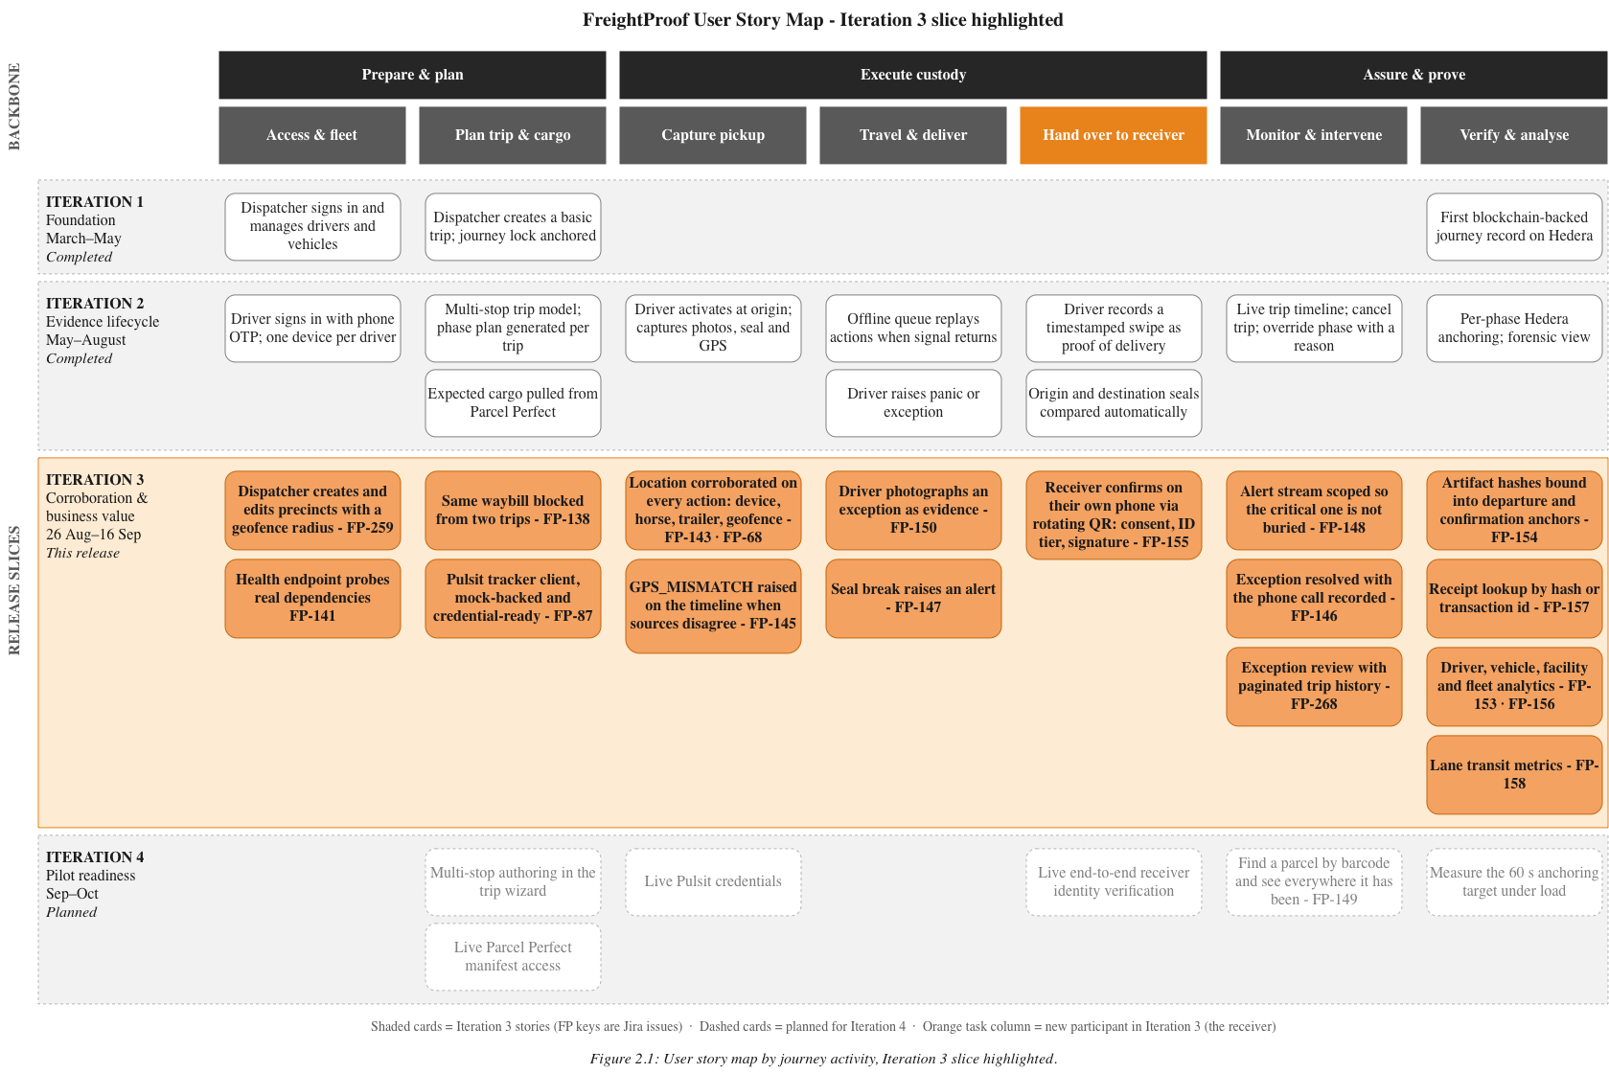
Figure 1: User Story Map

2.3 Delivery Against Previous Commitments
Table 4: Previous Commitment and Iteration 3 outcome
Previous commitment | Iteration 3 outcome | Status and remaining work
Connect Pulsit tracking | Added a mock-backed Pulsit client, geofence evaluation and location corroboration for phase actions. Mismatches can be recorded on the trip timeline. | Partial: implementation and automated coverage exist, but live API documentation and credentials were not available.
Integrate identity verification | Re-scoped identity verification to the receiving party and added provider session creation, decision retrieval and assurance-tier recording. | limited Didit interactions were observed, but a complete live document-check and webhook journey still requires verification.
Complete multi-stop authoring | The database and API continue to support ordered stops, but the dispatcher wizard remains focused on an origin-to-destination journey. | Deferred: dispatcher authoring of intermediate stops moves to Iteration 4 or after.
Full organization analytics | Added visual and statistical graphs and tables to show trends across, trips, drivers, vehicles, and precincts | Implemented: The dispatcher can view all analytics for all trips in there organization. Still need to separate who sees what data.
Strengthen delivery confirmation | Replaced driver-controlled confirmation with receiver participation through a rotating, expiring and single-use QR flow, consent, verification tier and signature. | Implemented: one complete live provider-verification journey remains outstanding.
Improve controls and security | Added session-concurrency handling, idle-session controls, security headers, health probes and additional validation. | Implemented in the repository: the deployed commit and runtime modes must be recorded separately.
Measure anchoring performance and system load | No formal load test or 60-second anchoring benchmark was completed during this iteration. | Deferred: include in Iteration 4 pilot-readiness testing.
Improve sprint readiness and Jira reconciliation | Sprint 6 and Sprint 7 opened with estimated and assigned work, and ticket status was reconciled against the repository at the reporting cutoff. | Process improvement: detailed sprint evidence and limitations are reported in §8.

2.4 Revised Milestones
Iteration 3 changed from the earlier theme of broadly pursuing "integrity and staging" to a more specific focus on corroboration and business value. It delivered the location-corroboration path, receiver-controlled handover, exception evidence and review, precinct management, receipt lookup, analytics and security hardening. FP-149 was the only planned Sprint 7 feature carried into Sprint 8.
Precinct management was added because geofence evidence could not be meaningfully configured or demonstrated without it. Receiver handover was prioritised because the previous delivery swipe could be completed by the driver. Analytics and evidence inspection were brought forward to demonstrate how the accumulated evidence supports operational and assurance decisions, also raised in iteration 2 feedback.
Capacity was created by deferring multi-stop authoring, the client-facing analytics lens and the trip child ledger. The proposed Bluetooth receiver handover was rejected because browser support, particularly on iOS, could not provide a dependable no-install workflow; the rotating QR remained the more practical mechanism.
Iteration 4 therefore concentrates on pilot readiness: live Pulsit and Parcel Perfect access if possible, completion of live receiver-verification testing, more detailed granularity into live trips, parcel search, performance and resilience measurement, POPIA controls and preparation of the Johannesburg–Durban demonstration. The underlying FastAPI and Next.js stack, PostgreSQL and Supabase storage, and Hedera anchoring approach remain unchanged. The revised architecture and new integration boundaries are described in §4.

3. Updated Analysis and Design Work Products

3.1 Package Diagram
This diagram shows FreightProof as a domain view: three user-facing applications, twelve backend packages grouped by responsibility, and the external systems they call, each package listing the modules it actually contains and every relationship drawn as a labelled UML dependency. The dispatcher dashboard, the driver PWA (a Next.js static export wrapped by Capacitor) and the zero-login receiver app each depend on whole groups rather than on individual packages, because each one calls many packages inside a group. Trip Operations owns the trip lifecycle, phase plan and gating, and depends on Custody & Corroboration for independent corroboration of every driver action, on Exception Management for deviations, and on Evidence Integrity & Anchoring for the journey lock hash; Platform Services has its fleet and precinct writes anchored the same way, while Operational Analytics only reads recorded evidence through SQL views. Externally, Parcel Perfect supplies the expected cargo, Pulsit the GPS fixes, IDVS the receiver identity, Supabase Auth the sessions and Supabase Storage the evidence artefacts, with the Scan Feed mocked and Google Geocoding unconfigured. Only SHA-256 hashes reach Hedera, so all personal data stays in af-south-1. Module-to-module calls inside a group, and the technical layering, stay in Figure
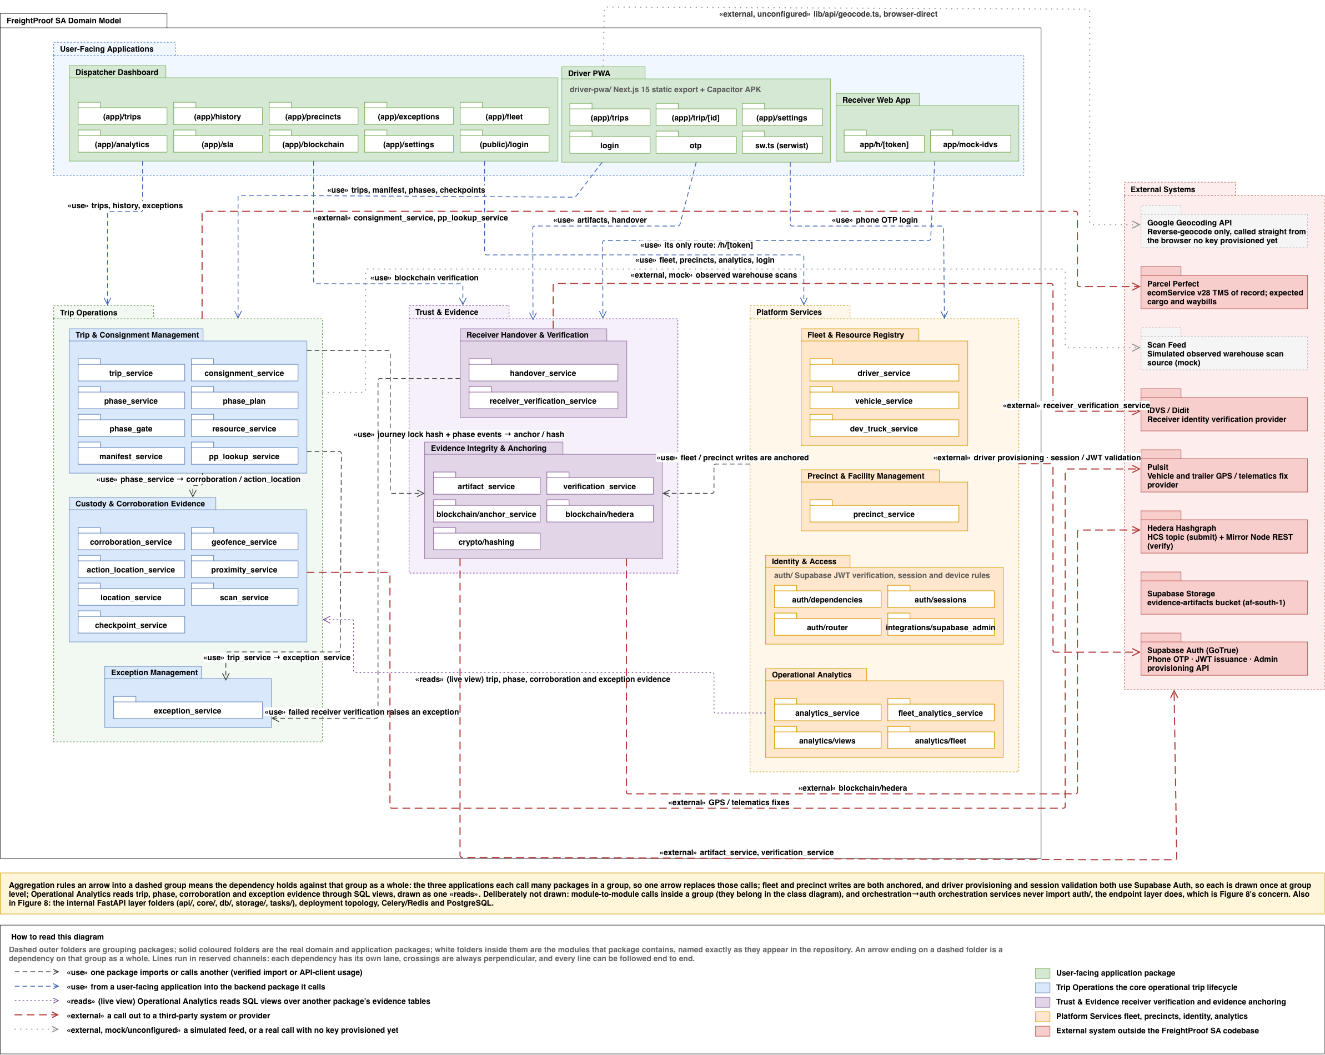
Figure 2: Package Diagram

3.2 Analysis Class Diagram
The Iteration 3 diagram builds on Iteration 2's Trip-centred model, adding two subsystems: an append-only event ledger (VehicleEvent, DriverEvent, PrecinctEvent) recording changes to those entities, and the receiver handover flow (HandoverCapabilityToken, HandoverTokenAttempt, HandoverConfirmation, and optional ReceiverIdentityVerification) replacing the previously undocumented confirmation step. A UserSession class parallels DriverSession for dispatcher idle-timeout tracking. BlockchainReceipt anchoring is now generalised to cover these new event types, and TripException gains direct links to the Consignment, TripStop, Vehicle, PhaseEvent, or Checkpoint it was raised against.
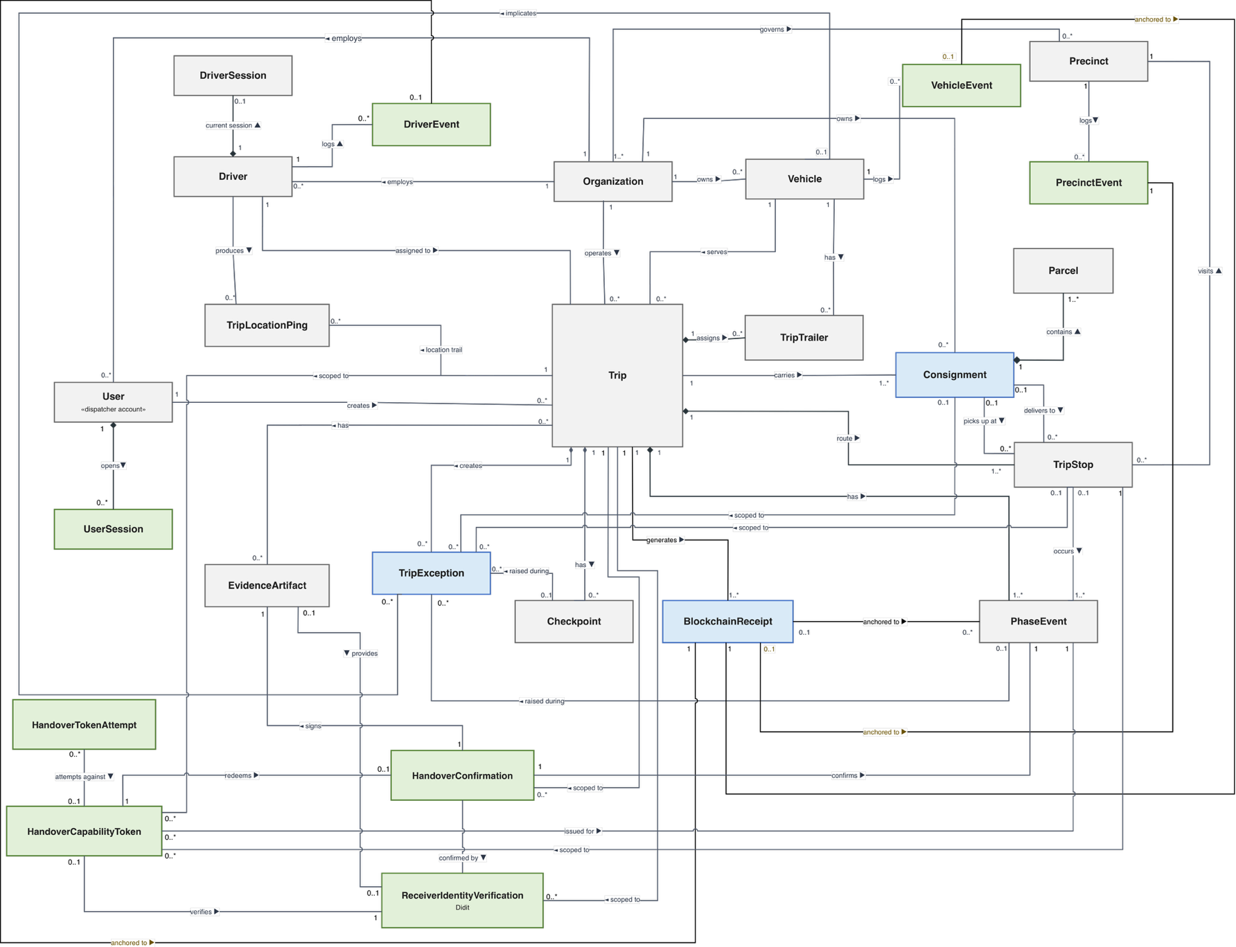
Green classes were introduced in Iteration 3, blue were materially changed, grey were retained. The same schema-only classes excluded in Iteration 2 (TripTemplate, DriverSubstitution, TrailerGpsSnapshot, MerkleBatch, MerkleBatchLeaf, SlaConfig) plus IdvsQuotaLedger remain excluded, as they still have no working end-to-end functionality.
Figure 3: Analysis Class Diagram

3.3 Use-Case Model and Index

3.3.1 Actors and system boundary
The two Iteration 2 diagrams are retained, Trip Lifecycle Management (TLM, dispatcher-side) and Custody Chain Capture (CC, driver-side). They retain the Dispatcher, Admin-Dispatcher and Driver actors and add the Receiver as a hands-on participant.
Primary actors. Dispatcher plans and monitors trips, reviews exceptions and reads analytics. Admin-Dispatcher (inherits Dispatcher) alone registers drivers and vehicles, manages precincts and opens blockchain receipts; Iteration 2 drew registration on the base Dispatcher and noted the gap, and the diagram now matches the code. Driver performs every custody phase in the Driver PWA. Receiver is new as a hands-on actor: in Iteration 2 the receiver swiped on the driver’s device; they now act on their own phone, with no account, through a link that exists only as a QR on the driver’s screen. This is the only unauthenticated end-user path that contributes custody evidence, and it is modelled as its own use case, CC 1.10.
External systems are not drawn as actors. Parcel Perfect (expected cargo), the warehouse scan feed (observed cargo, simulated), the Pulsit vehicle tracker (horse position, simulated), the Didit identity provider (optional receiver check, simulated by default) and the Hedera Consensus Service (fingerprints only, configured for testnet) are shown with their integration modes in the §4 architecture diagram and Table 4.1. Guards and warehouse staff have no accounts; the guard seal re-entry step was removed on 5 August 2026 (§5, R-08).
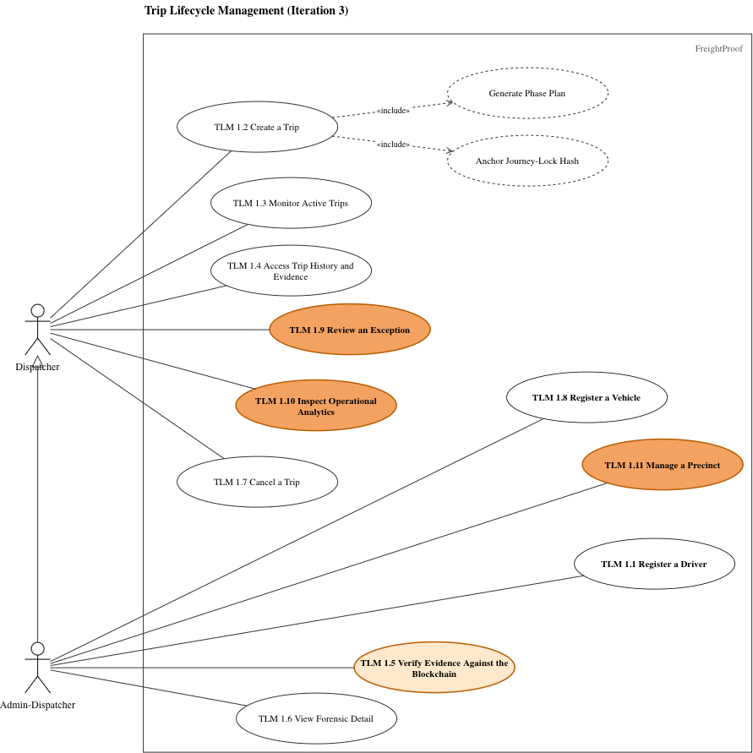
Figure 4: Trip Lifecycle Management Use Case
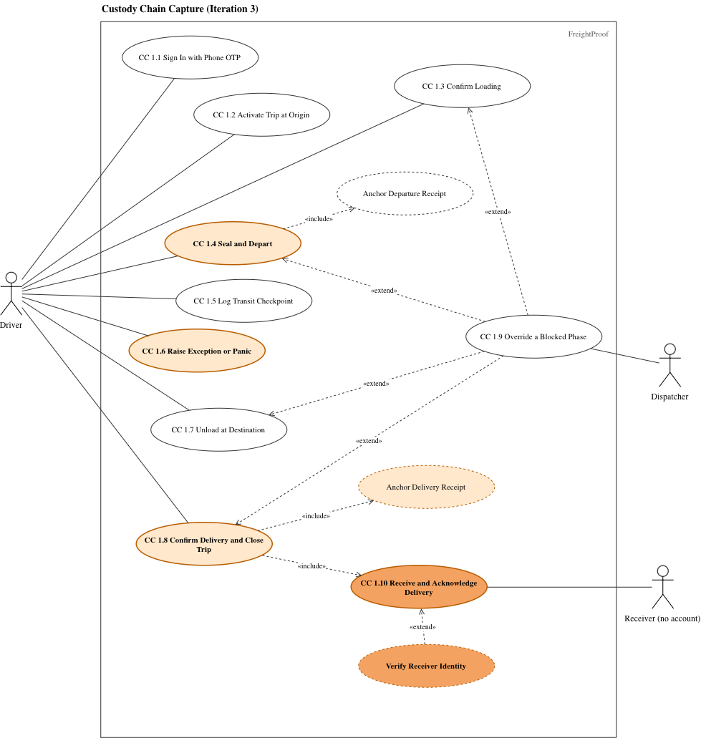
Figure 5: Custody Chain Capture Use Case

3.3.2 Retention and replacement index
Every white numbered use case is referred to is Team05, INF4027W Iteration 2 Documentation (2026), and is not repeated here. For numbered use cases, the shading in Figures 3.3 and 3.4 has three meanings: New (dark orange) has no Iteration 2 equivalent and is written in full; Changed (light orange) existed in Iteration 2 and its flow changed materially, so its replacement steps are written and the rest is referenced; Retained (white) is not reproduced as a narrative. Dashed ovals are supporting behaviour rather than separate actor use cases. The two orange dashed ovals are covered inside their parent narratives rather than given separate IDs: Anchor Delivery Receipt by CC 1.8 and SR-4(below), and Verify Receiver Identity by CC 1.10 and SR-6(below). The white Anchor Departure Receipt remains supporting behaviour and its Iteration 3 payload change is covered by CC 1.4 and SR-4.
Table 5: Use-case retention and replacement index
ID | Title | Treatment
TLM 1.1 | Register a Driver | Retained; refer to Iteration 2
TLM 1.8 | Register a Vehicle | Retained; refer to Iteration 2
TLM 1.2 | Create a Trip | Retained; refer to Iteration 2
TLM 1.3 | Monitor Active Trips | Retained; refer to Iteration 2
TLM 1.4 | Access Trip History and Evidence | Retained; refer to Iteration 2
TLM 1.5 | Verify Evidence Against the Blockchain | Changed
TLM 1.6 | View Forensic Detail | Retained; refer to Iteration 2
TLM 1.7 | Cancel a Trip | Retained; refer to Iteration 2
TLM 1.9 | Review an Exception | New
TLM 1.10 | Inspect Operational Analytics | New
TLM 1.11 | Manage a Precinct | New
CC 1.1 | Sign In with Phone OTP | Retained; refer to Iteration 2
CC 1.2 | Activate Trip at Origin | Retained; refer to Iteration 2
CC 1.3 | Confirm Loading | Retained; refer to Iteration 2
CC 1.4 | Seal and Depart | Changed
CC 1.5 | Log Transit Checkpoint | Retained; refer to Iteration 2
CC 1.6 | Raise Exception or Panic | Changed
CC 1.7 | Unload at Destination | Retained; refer to Iteration 2
CC 1.8 | Confirm Delivery and Close Trip | Changed
CC 1.9 | Override a Blocked Phase | Retained; refer to Iteration 2
CC 1.10 | Receive and Acknowledge Delivery | New

3.4 Changed and New Use-Case Narratives
Only the numbered orange use cases are narrated in full or by replacement steps here. White numbered use cases are not reproduced; their existing narratives remain in the Iteration 2 document. The dashed orange supporting flows are not standalone user goals: Anchor Delivery Receipt is part of CC 1.8/SR-4, while optional Verify Receiver Identity is part of CC 1.10/SR-6. Rules shared by several narratives are stated once in Table 3.6 and cited by ID. “Replaces step n” refers to the Iteration 2 table named in Table 3.5.
Table 6: Shared business rules
ID | Rule
SR-1 | Phase gate. A phase completes only for the assigned driver, in plan order, once; a resend returns the current state and writes nothing. Position is derived from the ledger, never from trip status.
SR-2 | At every phase except in-transit, the system records the phone position and reads the horse tracker itself. The horse is compared with the precinct fence at a stop (outside: GPS_MISMATCH exception), and the phone with the horse (too far apart: DRIVER_VEHICLE_SEPARATION, review queue). A missing or stale position is recorded as "could not check", never as a match or mismatch.
SR-3 | Scan gate. Loading, Unloading and Confirmation wait until the warehouse closes its scan session; the driver app shows the wait state. Expected parcels come from Parcel Perfect, observed parcels from the scan feed (simulated). A shortfall is recorded as a warning exception; the trip continues.
SR-4 | Evidence binding and anchoring. Photographs and signatures are uploaded first, fingerprinted and tied to the trip. Departure and confirmation records anchor a fingerprint that includes the cited photographs and signature. Only fingerprint hashes go on chain. If the ledger is unreachable the phase still completes and the receipt is owed and retried.
SR-5 | Handover token. A single-use, expiring link bound to one stop; the driver’s QR rotates until a receiver opens it, then holds. Confirming needs the link and the browser that opened it. Every failure shows the same “not found”; the reason is logged. The driver can show a fresh code.
SR-6 | Receiver identity. The receiver always types a name and ID number and signs. With consent they may complete a document-and-face check. Outcome recorded as verified, failed (RECEIVER_ID_MISMATCH exception) or unverified with reason (RECEIVER_ID_UNVERIFIED). A check never prevents confirmation.
SR-7 | Severity follows type, except driver-vehicle separation, which is always sent to review regardless of its severity. Critical exceptions and driver-vehicle separation enter the review queue, others go to history. One review per exception, attributed and timestamped by the server. The original report is never altered and a second dispatcher's review is refused.
SR-8 | Organisation scoping. All reads and writes are scoped to the caller’s organisation. Another organisation’s record reads as not found. Precincts are readable if owned or shared, writable only if owned.
SR-9 | Driver session. OTP sign-in: a newer sign-in replaces the older session, idle sessions time out. A session proves possession of the phone and account.

3.4.1 New and changed narratives written in full

Use Case Narrative 1

Table 7: TLM 1.9 - Review an Exception
Field | Detail
ID / Name | TLM 1.9 - Review an Exception
Actor | Dispatcher
Description | Assess an exception and record who reviewed it, when it was reviewed and the conclusion reached without changing the original report.
Pre / Post | Pre: Dispatcher is authenticated. The exception appears in the review queue or is opened from history or a trip timeline (SR-7 and SR-8). Post: One immutable, server-timestamped review is attached to the exception. The original exception report is unchanged.
Trigger | Dispatcher selects an exception that requires review.

Table 8: TLM 1.9 - Main success scenario
Step | Actor action | System response
1 | Opens the review queue or history and selects an exception. | Shows the queue newest first or paginated history, then opens the selected exception.
2 | Examines the exception and related trip evidence. | Shows the type, severity, description, position, photograph if present, phase, stop and trip history.
3 | Selects an outcome, optionally records the contact method, enters a note and submits. | Validates the review details.
4 | No further action. | Stamps the reviewer and time, stores the review without altering the report and removes the exception from the queue.

Table 9: TLM 1.9 - Alternative and exception flows
Step | Alternative / exception
1a | If the exception belongs to another organisation, the system returns not found.
4a | If the same dispatcher resubmits, the system returns the unchanged existing review.
4b | If another dispatcher has already reviewed the exception, the system refuses the second review and shows the existing review.
4c | Reviewing an exception does not change a trip phase; a blocked phase is handled through CC 1.9.

Use Case Narrative 2
Table 10: TLM 1.10 - Inspect Operational Analytics
Field | Detail
ID / Name | TLM 1.10 - Inspect Operational Analytics
Actor | Dispatcher
Description | Inspect operational trends derived from closed trips and exception records across drivers, vehicles, lanes, facilities and the fleet.
Pre / Post | Pre: Dispatcher is authenticated. Figures are calculated at request time from the organisation's closed trips and exceptions; no aggregate is stored (SR-8). Post: No data is changed; the use case is read-only.
Trigger | Dispatcher opens Operational Analytics.

Table 11: TLM 1.10 - Main success scenario
Step | Actor action | System response
1 | Chooses a driver, vehicle, lane, facility or fleet view. | Displays the available measures for that view, including activity, on-time performance, problems, evidence, routes and incidents.
2 | Sets an inclusive month range. | Validates the range.
3 | Requests the figures. | Returns organisation-scoped figures with the contributing sample counts.
4 | Selects a fleet figure or chart. | Opens the related entity view or a full-screen chart.

Table 12: TLM 1.10 - Alternative and exception flows
Step | Alternative / exception
2a | If the date range is invalid, the system shows a validation error.
3a | If fewer than five trips contribute to a figure, the system marks it as a small sample.
3b | If there are no closed trips, the system shows an empty state.
Scope | Figures describe trends within one organisation's records; they are not driver scores.

Use Case Narrative 3
Table 13: TLM 1.11 - Manage a Precinct
Field | Detail
ID / Name | TLM 1.11 - Manage a Precinct
Actor | Admin-Dispatcher
Description | Create or update a depot or warehouse and its circular geofence so the precinct can be used in trip planning and location corroboration.
Pre / Post | Pre: Admin-Dispatcher is authenticated. An existing precinct must be owned by the organisation before it can be edited (SR-8). Post: The precinct is available in trip creation; its fence is available to SR-2; change history and applicable Hedera receipts are stored.
Trigger | Admin-Dispatcher creates a precinct or opens an owned precinct for editing.

Table 14: TLM 1.11 - Main success scenario
Step | Actor action | System response
1 | Enters the name, address, coordinates, circular geofence radius and sharing choice, then saves. | Validates the submitted values.
2 | No further action. | Checks that the name is unique in the organisation, stores the precinct and writes a created event with the geofence snapshot.
3 | No further action. | Anchors the created event and stores the receipt.
4 | Edits and saves an owned precinct when required. | Writes a change event. Changes to coordinates, radius or sharing are anchored again; other changes are not re-anchored.
5 | Opens the precinct detail. | Shows the map, change history and receipts.

Table 15: TLM 1.11 - Alternative and exception flows
Step | Alternative / exception
1a | If an existing precinct is owned by another organisation, the system returns not found.
2a | If the name is already used in the organisation, the system refuses the duplicate.
3a | If Hedera is unavailable, the system refuses the save.
Scope | Polygon geofences are not supported in Iteration 3.

Use Case Narrative 4

Table 16: CC 1.10 - Receive and Acknowledge Delivery
Field | Detail
ID / Name | CC 1.10 - Receive and Acknowledge Delivery
Actor | Receiver (no FreightProof account required)
Description | Confirm receipt on the receiver's own phone so the acknowledgement is produced independently of the driver's device.
Pre / Post | Pre: The driver is at the Confirmation phase and is displaying a live rotating QR code. The receiver has a phone with a camera and browser (SR-5). Post: One confirmation exists for the stop; the handover link is redeemed; the signature is fingerprinted and the identity-verification outcome is recorded.
Trigger | Receiver scans the handover QR code shown by the driver.

Table 17: CC 1.10 - Main success scenario
Step | Actor action | System response
1 | Scans the QR code and opens the link. | Validates the link.
2 | Continues in the same browser. | Holds QR rotation, binds the browser and shows only the trip reference, destination, waybill references and expiry.
3 | Accepts or declines the optional identity check, or indicates that no document is available. | Records the consent choice.
4 | If consent was given, completes the provider's document-and-face check. | Extends the link while the check runs, records the outcome and compares the returned document details with the typed details (SR-6).
5 | Types a name and ID number, draws a signature and swipes to confirm. | Captures location if permitted without delaying confirmation.
6 | No further action. | Checks that the browser matches and redeems the link exactly once.
7 | No further action. | Stores the signature as a fingerprinted trip artifact, records the confirmation and verification outcome, and shows Confirmed.
8 | No further action. | Advances the driver's screen through CC 1.8.

Table 18: CC 1.10 - Alternative and exception flows
Step | Alternative / exception
2a | If the link is unknown, expired, retired or already used, the system shows the same not-found message and logs the actual reason.
3a/4a | If consent is declined, no document is available, or the provider is unavailable or out of quota, the system records unverified and continues.
4b | If the provider declines the check or the details disagree, the system records failed, raises RECEIVER_ID_MISMATCH and continues.
4c | If the receiver abandons the provider check, the system later closes it as unverified.
6a | If the link is opened in a different browser, the system refuses confirmation without spending the link.
6b | If two devices submit together, exactly one confirmation succeeds.
6c | If the browser session is lost, the driver displays a fresh code.
7a | If the browser contains an active FreightProof sign-in, the confirmation records that fact; an account is still not required.

3.4.2 Changed narratives with replacement steps

Changed Use Case Narrative 5
Table 19: CC 1.8 - Confirm Delivery and Close Trip
Field | Detail
ID / Name | CC 1.8 - Confirm Delivery and Close Trip
Actor | Driver
Description | Complete delivery only after the receiver acknowledges the handover on a separate device and the final evidence is bound to the trip.
Pre / Post | Pre: Iteration 2 steps 1-2 are complete and the driver is at the Confirmation phase. The receiver is present (SR-1, SR-3 and SR-5). Post: The destination confirmation is completed once, delivery evidence is stored and fingerprinted, and the trip can close. Iteration 2 step 6 remains applicable.
Trigger | Driver selects Receiver Handover at the destination.

Table 20: CC 1.8 - Changed main-flow steps
Step | Actor action | System response
3 (replace) | Taps Receiver Handover. | Issues a single-use link and displays it as a rotating QR code. The receiver completes CC 1.10 on their own phone.
4 (add) | Keeps the handover screen open while the receiver confirms. | Polls the handover state and advances only after one valid receiver confirmation is stored.
5 (replace) | Checks the displayed evidence count and swipes to confirm delivery. | Applies the scan gate and location corroboration, binds the receiver signature and delivery evidence to the confirmation fingerprint, anchors the record and stores or queues the receipt (SR-2, SR-3 and SR-4).

Table 21: CC 1.8 - Alternative and exception flows
Step | Alternative / exception
3a | If the receiver has no suitable phone, data connection or camera, the driver requests the existing dispatcher override through CC 1.9.
4a | If the link expires or the receiver loses the browser session, the driver displays a fresh QR code.
Retained | Iteration 2 alternative and exception flows not replaced above remain applicable.

Changed Use Case Narrative 6
Table 22: TLM 1.5 - Verify Evidence Against the Blockchain
Field | Detail
ID / Name | TLM 1.5 - Verify Evidence Against the Blockchain
Actor | Admin-Dispatcher
Description | Reconstruct the correct version of an anchored evidence payload and compare its fingerprint with the Hedera receipt.
Pre / Post | Pre: Admin-Dispatcher is authenticated and has selected a receipt, transaction ID or evidence record to verify (SR-8). Post: The interface reports whether the reconstructed database evidence matches the anchored fingerprint; no operational record is changed.
Trigger | Admin-Dispatcher requests verification of an evidence receipt.

Table 23: TLM 1.5 - Changed main-flow steps
Step | Actor action | System response
1 (replace) | Selects a receipt or enters its hash or transaction ID and requests verification. | Reads the receipt's payload version and rebuilds the payload in that version's shape. For records anchored from 15 September 2026, the reconstruction includes the current artifact fingerprints.
2 (clarify) | Reviews the result. | Hashes the reconstructed payload, compares it with the anchored fingerprint and shows match or mismatch together with the receipt details.

Table 24: TLM 1.5 - Alternative and exception flows
Step | Alternative / exception
1a | If an artifact referenced by the receipt no longer matches the database record, the system returns an evidence mismatch identified as db_mismatch.
1b | If the receipt uses a legacy payload shape, the system reconstructs and verifies that legacy version rather than applying the current shape.
Retained | Iteration 2 alternative and exception flows not replaced above remain applicable.

Changed Use Case Narrative 7
Table 25: CC 1.4 - Seal and Depart
Field | Detail
ID / Name | CC 1.4 - Seal and Depart
Actor | Driver
Description | Capture the sealed departure evidence, corroborate location and anchor a fingerprint that binds the seal and waybill photograph to the departure record.
Pre / Post | Pre: Iteration 2 step 1 is complete; the trip is active and the driver is at the Seal and Depart phase (SR-1). Post: The departure phase is complete once, with waybill evidence and location results stored and the departure fingerprint anchored or queued for retry. Iteration 2 steps 3 and 5 remain applicable.
Trigger | Driver begins the Seal and Depart phase.

Table 26: CC 1.4 - Changed main-flow steps
Step | Actor action | System response
2 (replace) | Photographs the waybill and continues. | Uploads the photograph, fingerprints it and binds it to the trip. The previous guard re-entry value is no longer collected.
4 (replace) | Swipes to depart. | Runs location corroboration and anchors a departure fingerprint that includes the waybill photograph fingerprint. The capture time records when evidence was submitted; it is not proof of when the paper document was created (SR-2 and SR-4).

Table 27: CC 1.4 - Alternative and exception flows
Step | Alternative / exception
2a | If the photograph cannot be uploaded, the phase cannot cite it and the system asks the driver to retry.
4a | If location is missing or stale, the system records could not check and does not block departure.
4b | If Hedera is unavailable, the phase completes and the receipt is marked as owed for retry (SR-4).
Retained | Iteration 2 alternative and exception flows not replaced above remain applicable.

Changed Use Case Narrative 8
Table 28: CC 1.6 - Raise Exception or Panic
Field | Detail
ID / Name | CC 1.6 - Raise Exception or Panic
Actor | Driver
Description | Report an operational exception or panic event with optional photographic evidence and route it according to its severity.
Pre / Post | Pre: Driver is authenticated on an assigned trip. Iteration 2 steps 1-2 are retained (SR-8 and SR-9). Post: The immutable exception report is stored with any photograph fingerprint and is placed in review queue or history according to severity (SR-7).
Trigger | Driver reports an exception or activates panic.

Table 29: CC 1.6 - Changed main-flow steps
Step | Actor action | System response
3 (replace) | Optionally takes or selects a photograph and submits the report. | Uploads and fingerprints the photograph, if supplied, and binds it to the trip and exception.
4 (replace) | No further action. | Assigns severity from the exception type. Critical exceptions and driver-vehicle separation enter the review queue; other exceptions enter history. A seal-related alert is recorded when applicable.

Table 30: CC 1.6 - Alternative and exception flows
Step | Alternative / exception
3a | If no photograph is supplied, the system records the exception without one; the photograph is optional.
4a | If the report is critical, it appears in the dispatcher review queue immediately.
Scope | Dispatcher assessment is described by TLM 1.9; the review never alters the driver's original report.
Retained | Iteration 2 alternative and exception flows not replaced above remain applicable.

3.5 State-Machine Diagram
This diagram follows one Trip from creation to closure or cancellation. It starts in Trip Creation (P0), where the dispatcher's submission builds the phase plan from the stops and anchors the journey-lock hash to Hedera before saving; this gate is fail-closed, so if the anchor fails everything rolls back and no trip exists. On success it waits in Created for the driver to request activation, allowed only if the trip isn't started early, the driver isn't already on another trip, and no earlier trip of theirs is due that day. Once activated it enters Active, a composite state whose loop runs once per stop rather than in a fixed order: at each stop it asks whether cargo is collected (Loading, P2), whether this is the final stop (Confirmation, P6) or another drop (Departure, P3, where the seal is applied and the pickup receipt anchored), and on arrival whether cargo is dropped (Unloading, P5), with In Transit (P4) covering the drive until the driver attests arrival. Loading, Unloading and Confirmation are each held until that stop's warehouse closes its scan session. The trip can be Cancelled at any point while Created or Active, leaving the remaining phases pending as an honest record of a plan stopped partway. It reaches Closed only once every phase in the plan is resolved the same check that runs after every phase, not something that happens automatically once Confirmation is done.

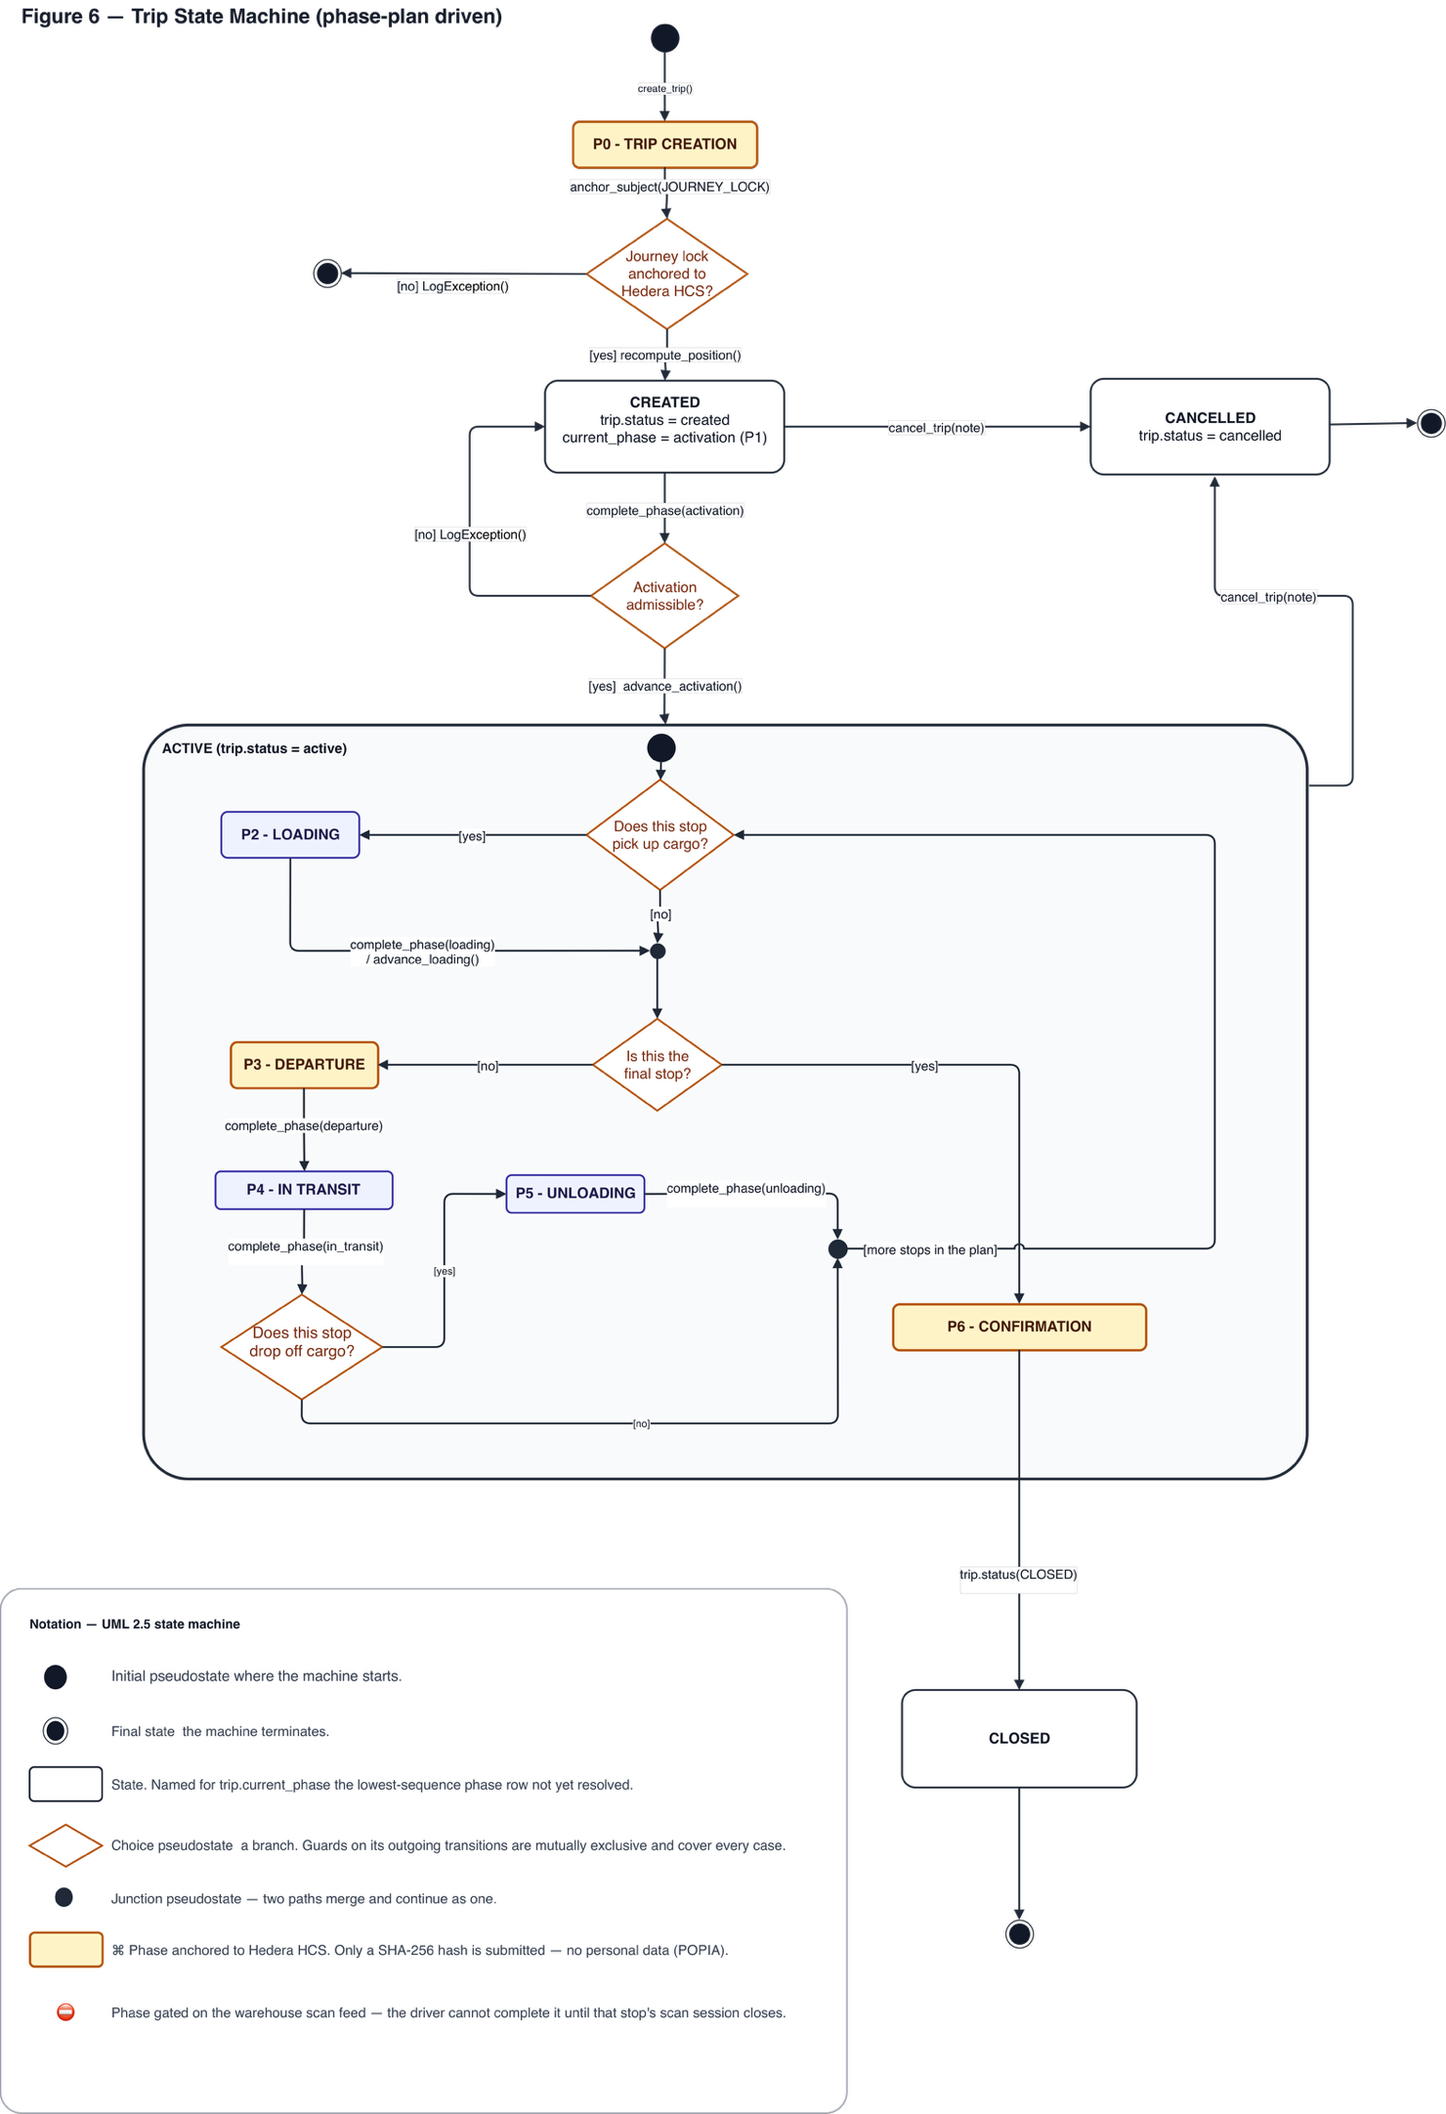
Figure 6: State Machine Diagram

3.6 Relational Schema
The Entity Relationship Diagram (ERD) presents selected relational schema changes documented during Iteration 3. It extends rather than replaces the complete schema in the Iteration 2 document. Existing tables are included only where required to explain foreign-key relationships. Readers should refer to the Iteration 2 document for omitted tables, complete entity definitions, and relationships outside this scope.
The highlighted schema elements cover user sessions, SLA configuration, precinct auditing, checkpoints, Merkle-based evidence grouping, receiver handover, and identity verification. Capability tokens are linked to a specific trip, stop, and phase; token attempts are recorded for auditing; and successful handovers reference confirmation and identity-verification evidence. Personal information remains in PostgreSQL, while only non-personal hashes may be anchored to the blockchain.

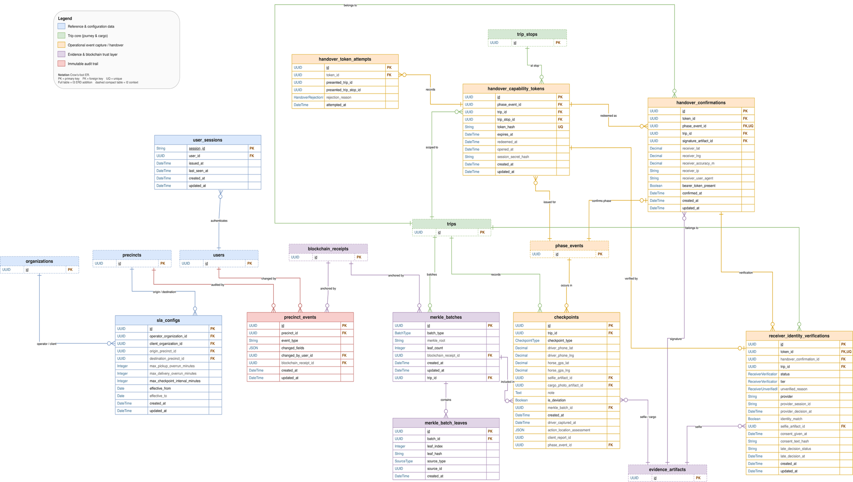
Figure 7: Entity Relationship Diagram

4. Architecture and Integrations
Iteration 3 extends the existing trip workflow with receiver-side acknowledgement and additional evidence checks. Receiver confirmation is linked to a handover token and browser session, while identity-verification outcomes are recorded with their assurance level. Location corroboration contributes additional observations to the evidence record. Missing or unavailable observations remain distinguishable from a confirmed match.

4.1 Architecture
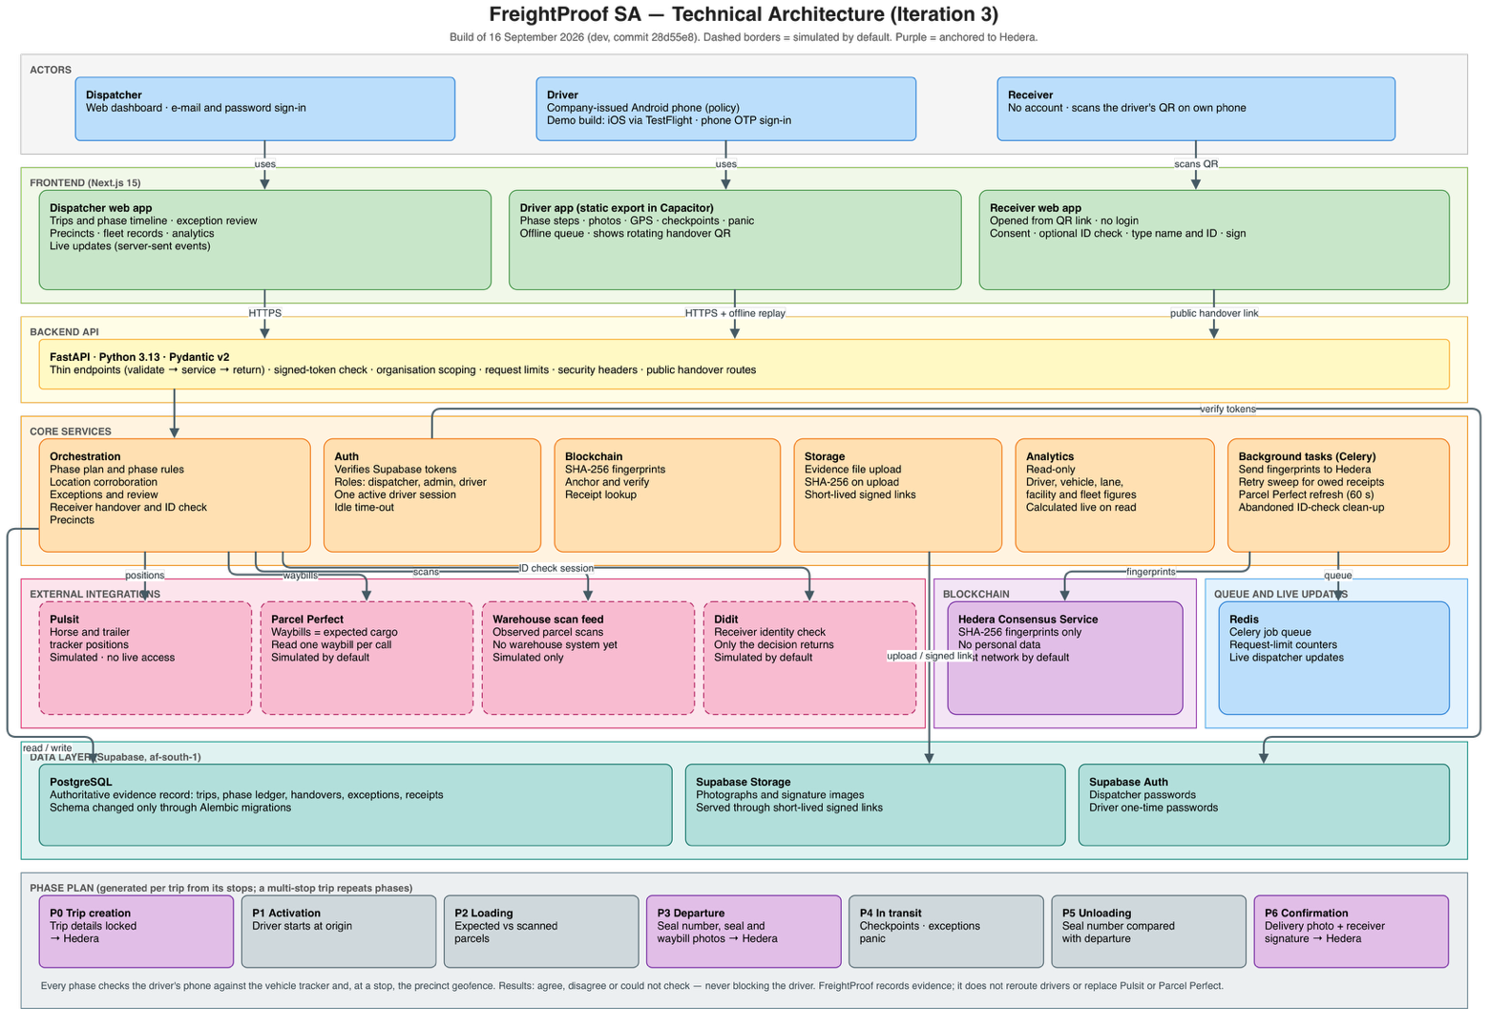
Three Next.js applications serve dispatchers (web), drivers (a static app in a Capacitor mobile shell that queues work offline) and receivers (a public web page with no login). A FastAPI service holds all business rules in layers (request handlers, then services, then integrations and the ledger client, then database models) and is the only component that writes evidence. Supabase provides PostgreSQL and file storage in af-south-1, and authentication (dispatcher passwords; driver one-time passwords). Redis carries the Celery job queue, request limits and live dispatcher updates. Each external system sits behind an interface with simulated and live implementations selected by configuration.
Figure 8: Technical Architecture Diagram

4.2 Key Flows
Location. At each driver phase the API records the phone's position and Pulsit's horse and trailer positions. It compares the phone with the truck and, at a stop, compares both with the precinct geofence. Results are stored as agree, disagree or "could not check", and never stop the driver.
Cargo. Parcel Perfect supplies only the expected cargo. Waybills are read at trip creation, which fails if Parcel Perfect is unavailable, and are then refreshed every 60 seconds. Observed scans come from a separate scan feed, which is simulated in Iteration 3.
Anchoring.
- Departure and confirmation records: each record's SHA-256 fingerprint is saved with the record. The background worker then submits it to Hedera, backed by a back-up sender, retries and a five-minute recovery sweep, so drivers are not kept waiting for the four-to-six-second submission.
- What is fingerprinted: the departure record covers the seal number and the seal and waybill photographs. The confirmation record covers the parcel counts, the delivery photograph and the receiver signature image.
- Immediate anchoring: trip creation, and the creation and critical changes of drivers, vehicles and precincts, are anchored straight away and refused during a ledger outage.
- Off-chain: positions, identities and the other phases stay off-chain.
- Verification: re-reads the stored files and compares them with the ledger through Hedera's mirror service.
Receiver handover. The driver app shows a single-use QR code. It refreshes every 20 seconds until opened and is valid for 10 minutes, extended once if an identity check starts. The receiver's own browser is bound to the link. The receiver types their name and ID number and signs, and these details, the time and the position are drawn into the signature image. The trust boundary is the receiver's browser, so the handover is evidence, not proof of identity. With consent, a Didit check sends document and face images from the browser directly to Didit. Only the decision comes back, and it never blocks delivery.
Live updates and analytics. Committed changes are published through Redis to each dispatcher's live connection, limited to their organisation. Analytics are read-only and are calculated from current records each time they are read.

4.3 Integrations
Table 31: Integration status
Component/provider | Purpose and exchanged data | Implemented capability | Mock/live mode evidenced | Failure behaviour | Evidence and limitation
Supabase | Sign-in, records, files | Token-verified roles, organisation scoping, file fingerprints | Live; shared by development and hosting | Requests refused; nothing written | Table-level protection gaps
Redis and Celery | Jobs, limits, live events | Anchoring, recovery, Parcel Perfect refresh | Local; hosted | Back-up sender; limits fail open | No recovery without scheduler
Hedera | Fingerprints out; receipts in | Background anchoring, verification | Test network by default | Phases pending; trip creation refused | Pending receipts not flagged
Parcel Perfect | Waybill number out; parcels in | Single-waybill read and refresh | Simulated by default | Trip creation refused | No scan events available
Warehouse scan feed | Parcel scans in | Scan gating and comparison | Simulated only | Phase waits; dispatcher override | No warehouse system integrated
Pulsit | Horse and trailer positions in | Geofence and separation checks | Simulated; no live access | "Could not check"; driver continues | Interface shape unconfirmed
Didit | Session out; decision in | Consented receiver identity check, 500 per month | Simulated by default; live in hosting guide | Recorded unverified; delivery continues | Consent and selfie defects

4.4 Quality Attributes
Security. Requests need a signed token, except for the health check, the receiver pages, the provider callback, and developer routes that are enabled only by a setting. Data is scoped to each organisation, fleet changes need an admin dispatcher, and production refuses to start with unsafe settings.
Maintainability. Layering, swappable provider interfaces, versioned anchored records and versioned migrations keep changes contained. Backend tests passed locally, although the backend's continuous-integration checks currently stop at a style check.
Scalability and performance. No load tests were run. What is known:
- On 15 closed trips, the analytics views took 2.7 ms of database time against about 166 ms of network time, but they recalculate across all closed trips on every read.
- Identity checks are capped at 500 a month.
- The back-up anchor sender is lost if the API restarts.
Deployment. The API (Railway) and dispatcher (Vercel) were reachable on 16 September 2026. The receiver app was not yet hosted, and the driver app is distributed through TestFlight. End-to-end operation of the hosted system is not yet evidenced.

5. Risk Assessment and Treatment Changes
This section is the complete Iteration 3 risk register. The Iteration 2 document contained no full register. All ten Iteration 2 risks (§5.4, Table 55) were reassessed against the development build of 16 September 2026: eight are changed, R-01 is restated and R-08 is closed. R-11 to R-18 are new, from Iteration 3 work, Iteration 2 feedback. The risk matrix table and the risk category table are visible in Iteration 2.

5.1 Scoring and Treatment Structure
Scoring follows Iteration 2:
- Likelihood and impact each run from 1 (rare; insignificant) to 5 (almost certain; catastrophic).
- Score = likelihood × impact: Critical 15–25, High 8–14, Medium 4–7, Low 1–3.
Following Iteration 2 feedback, each risk is treated as Mitigate (controls that reduce likelihood or impact), Monitor (the signal, who sees it and the trigger level) and Manage (the action when triggered).

5.2 Risk Register Summary
Table 32: Risk register summary
ID | Risk (cause / event / consequence) | Category | Score (L × I) | Status | Owner
R-01 | No independent warehouse scan source / counts rely on a simulated feed or dispatcher override / no independent evidence of what was loaded | Integration / External Dependency | 4×4 = 16 Critical | Restated | Tim Gultig
R-02 | Background service sending fingerprints to the ledger not running / receipts stay pending unnoticed / evidence lacks an independent timestamp | Technical | 4×4 = 16 Critical | Changed | Thomas Davis
R-03 | Phone or tracker positions inaccurate, missing or simulated / wrong or impossible location checks / false alarms or missed substitution | Technical / Operational | 4×3 = 12 High | Changed | Thomas Davis
R-04 | Evidence altered before fingerprinting, or in a phase never anchored / change undetectable / weaker dispute evidence | Security | 2×4 = 8 High | Changed | Chiko Kasongo
R-05 | Driver's offline queue discards or cannot store evidence / evidence lost unnoticed / incomplete trip record | Technical | 4×4 = 16 Critical | Changed | Ciaran Formby
R-06 | A code change adds a personal field to a fingerprinted record / personal data on the public ledger / irreversible POPIA breach | Legal / Compliance | 1×5 = 5 Medium | Changed | Ciaran Formby
R-07 | Hedera ledger outage / anchoring delayed and new trips cannot be created / operational delay | External Dependency | 2×4 = 8 High | Changed | Tim Gultig
R-08 | Guard resistance disrupts gate capture | Operational | — | Closed | —
R-09 | Driver data processed beyond lawful scope / POPIA breach | Legal / Compliance | 3×4 = 12 High | Changed | Chiko Kasongo
R-10 | Driver app fails on untested Android devices / silent evidence gaps | Operational / Technical | 3×3 = 9 High | Changed | Chiko Kasongo
R-11 | Delivery closed without a receiver confirmation / signature the receiver never gave / false proof of delivery | Security | 2×5 = 10 High | New | Thomas Davis
R-12 | Receiver identity check recorded inaccurately, handled unlawfully or impossible / misleading evidence or POPIA complaint | Legal / Compliance; Security | 3×4 = 12 High | New | Ciaran Formby
R-13 | QR link forwarded or opened first by someone else / remote handover / receiver participation unproven | Security | 3×4 = 12 High | New | Ciaran Formby
R-14 | Open platform security weaknesses exploited / data exposed or records altered outside the application | Security | 3×5 = 15 Critical | New | Ciaran Formby
R-15 | Analytics misread or slow as data grows / wrong operational conclusions | Operational / Technical | 3×3 = 9 High | New | Chiko Kasongo
R-16 | Build not release-ready / failed demonstration or unverifiable submission | Team | 4×4 = 16 Critical | New | Thomas Davis
R-17 | Late or stalled trips not detected in progress / delayed awareness of an incident | Operational | 4×3 = 12 High | New | Tim Gultig
R-18 | Driver's account used by someone else (shared phone, SIM swap) / evidence attributed to the wrong driver | Security | 3×4 = 12 High | New | Tim Gultig
R-08 closed. Guard seal re-entry was dropped from the driver app on 5 August 2026, and guards have no accounts. The anchored departure seal, seal comparison at unloading and receiver confirmation replace gate evidence.
R-01 restated. Feedback asked why R-01 ranked highest. The team established that Parcel Perfect's web-service interface exposes no scan events for any account, so the remaining risk is obtaining any independent scan source. It stays Critical because scanned counts are the only evidence of what was loaded that does not come from the driver.

5.3 Treatment: Mitigate, Monitor and Manage
Table 33: Risk treatment
ID | Mitigate | Monitor (signal → who; trigger) | Manage | Remaining gaps
R-01 | Replaceable scan-source interface; client warehouse route pursued; anchored seal and receiver confirmation as independent evidence | Phase blocked awaiting scans, or overridden ("A dispatcher bypassed this phase's checks") → driver, dispatcher; any occurrence | Dispatcher overrides with a mandatory note, logged as an exception | Only the simulated feed satisfies scan checks; a Parcel Perfect outage also stops trip creation
R-02 | Fingerprint sent after saving; back-up sender if the queue is unreachable; three retries; automatic re-send every minute for receipts owed over 5 minutes, only if evidence still matches | "Anchor failed: receipt still owed" on the timeline → dispatcher; minutes decided | Restart the background service; re-send then clears owed receipts | Stuck pending receipts show no warning; hosted background service not documented
R-03 | Independent tracker position at every phase; limits in Table 3 (SO-2); missing data recorded as "could not check", never as a match or mismatch | Position exception in exception history; separation exception in the review queue → dispatcher; any occurrence | Review, phone the driver, record the outcome; override an unworkable phase with a note | Tracker data is simulated, and stored results do not show whether a position was simulated
R-04 | Departure and confirmation records fingerprint the seal, waybill and delivery photographs and receiver signature; files fingerprinted on arrival and tied to the trip | Check result other than "verified" → admin dispatcher (forensic mode); any occurrence | Preserve record and receipt; investigate as suspected tampering | Unanchored phases and capture-to-upload are not protected
R-05 | Resent items carry the same identifier and are not recorded twice; later phases wait behind a stalled one; server refuses out-of-order phases | Driver banner "N items could not be synced and were removed. Contact your dispatcher." → driver; any dropped item | Driver contacts dispatcher, who records it in an exception review or overrides the phase. Planned fix | Refused items are discarded silently; an expired sign-in discards queued evidence; a resend to an overridden phase stores nothing; queue not separated by account
R-06 | Ledger accepts only a 64-character fingerprint; fingerprinted records exclude positions and identities; licence numbers hashed | Automated tests fail on a forbidden field → developers; any failure | Block release; correct what is fingerprinted, keeping earlier records checkable | Tests not running in continuous integration.
R-07 | Phases complete during an outage and are re-sent later (R-02); ledger calls time out after 15 s | "Trip was not created" error; failed anchor on timeline → dispatcher; any occurrence | Retry after the outage; the original fingerprint is re-sent | Creation of trips and fleet records blocked during an outage; default network is Hedera's test network
R-09 | Location captured only during open trips while the app is in use; analytics show driver trends, not scores; company-issued Android policy | Manual review | Complete erasure and consent controls before real driver data | Erasure not implemented; no recorded driver consent; demonstration build runs on iPhone (TestFlight)
R-10 | Company-issued Android devices; dropped-item banner and "could not check" results expose failures | Dropped items or incomplete phases → driver, dispatcher; | Replace device; override incomplete phases with a note | Android never run against the hosted system; no supported-device list
R-11 | Driver app requires receiver confirmation; receiver signature fingerprint anchored | No report of trips closed without a receiver confirmation → gap in evidence | Treat as disputed delivery. Planned fix: server requires the confirmation | Server does not check the confirmation exists; score assumes open; intermediate drop-offs have no receiver confirmation
R-12 | Consent before a check; checks never block delivery; outcomes stored with a reason; provider results authenticated; 500 checks per month | Identity mismatch or unverified exceptions in exception history → dispatcher | Follow up with the receiving party; if the receiver has no phone or data, dispatcher overrides with a note. Planned fixes | Skip recorded as consent; ID number in the web address; selfie not stored; approval with no extracted data recorded as verified; data processed by Didit abroad
R-13 | Single-use rotating link, extended once for a check; first browser bound; receiver address, browser, position and FreightProof sign-in presence recorded | Fleet count of confirmations sent with a FreightProof sign-in → dispatcher; any occurence | Use stored handover details in disputes; escalate repeats | A second phone or forwarded link can complete a handover; receiver position not compared with the stop
R-14 | Company data separation; request limits; production start-up refuses unsafe settings; checkpoint evidence tied to its trip | Security review; report-only dependency checks → developers | Fix in order: table protection, upload limits and dependencies, request limits and sessions. Planned fixes | Newer tables lack database-level protection; uploads read before sender checked; request limits exhaustible by forged sign-ins
R-15 | Charts flag figures from fewer than 5 trips; driver trends, not rankings | Page load time → developers | Prepare figures in advance if slow, accepting delay | Analytics views measured on 15 closed trips; database shared with demonstration trips
R-16 | Deployment guide; production start-up checks; receiver app added to automated checks; full backend suite passes locally | Automated check status; server build version → team; any red check on the release build | Freeze feature; fix checks; deploy a labelled release; local demonstration as fallback | Backend checks fail at a style check, so tests do not run automatically
R-17 | Planned times can be recorded; exceptions and panic alerts reach dispatchers live | None automated; interim manual check | Phone the driver from the trip screen. Planned lateness alert | Lateness limits defined but not implemented; calls without an exception not recorded
R-18 | One-time password sign-in; newer sign-in normally replaces older sessions; idle time-out; location corroboration | Reports of account misuse → dispatcher; any occurrence | Deactivate account; treat affected evidence as disputed | No independent driver identity check; SIM-swap protection deferred to Iteration 4

6. UI Evidence

6.1 Precinct / Geofence Setup
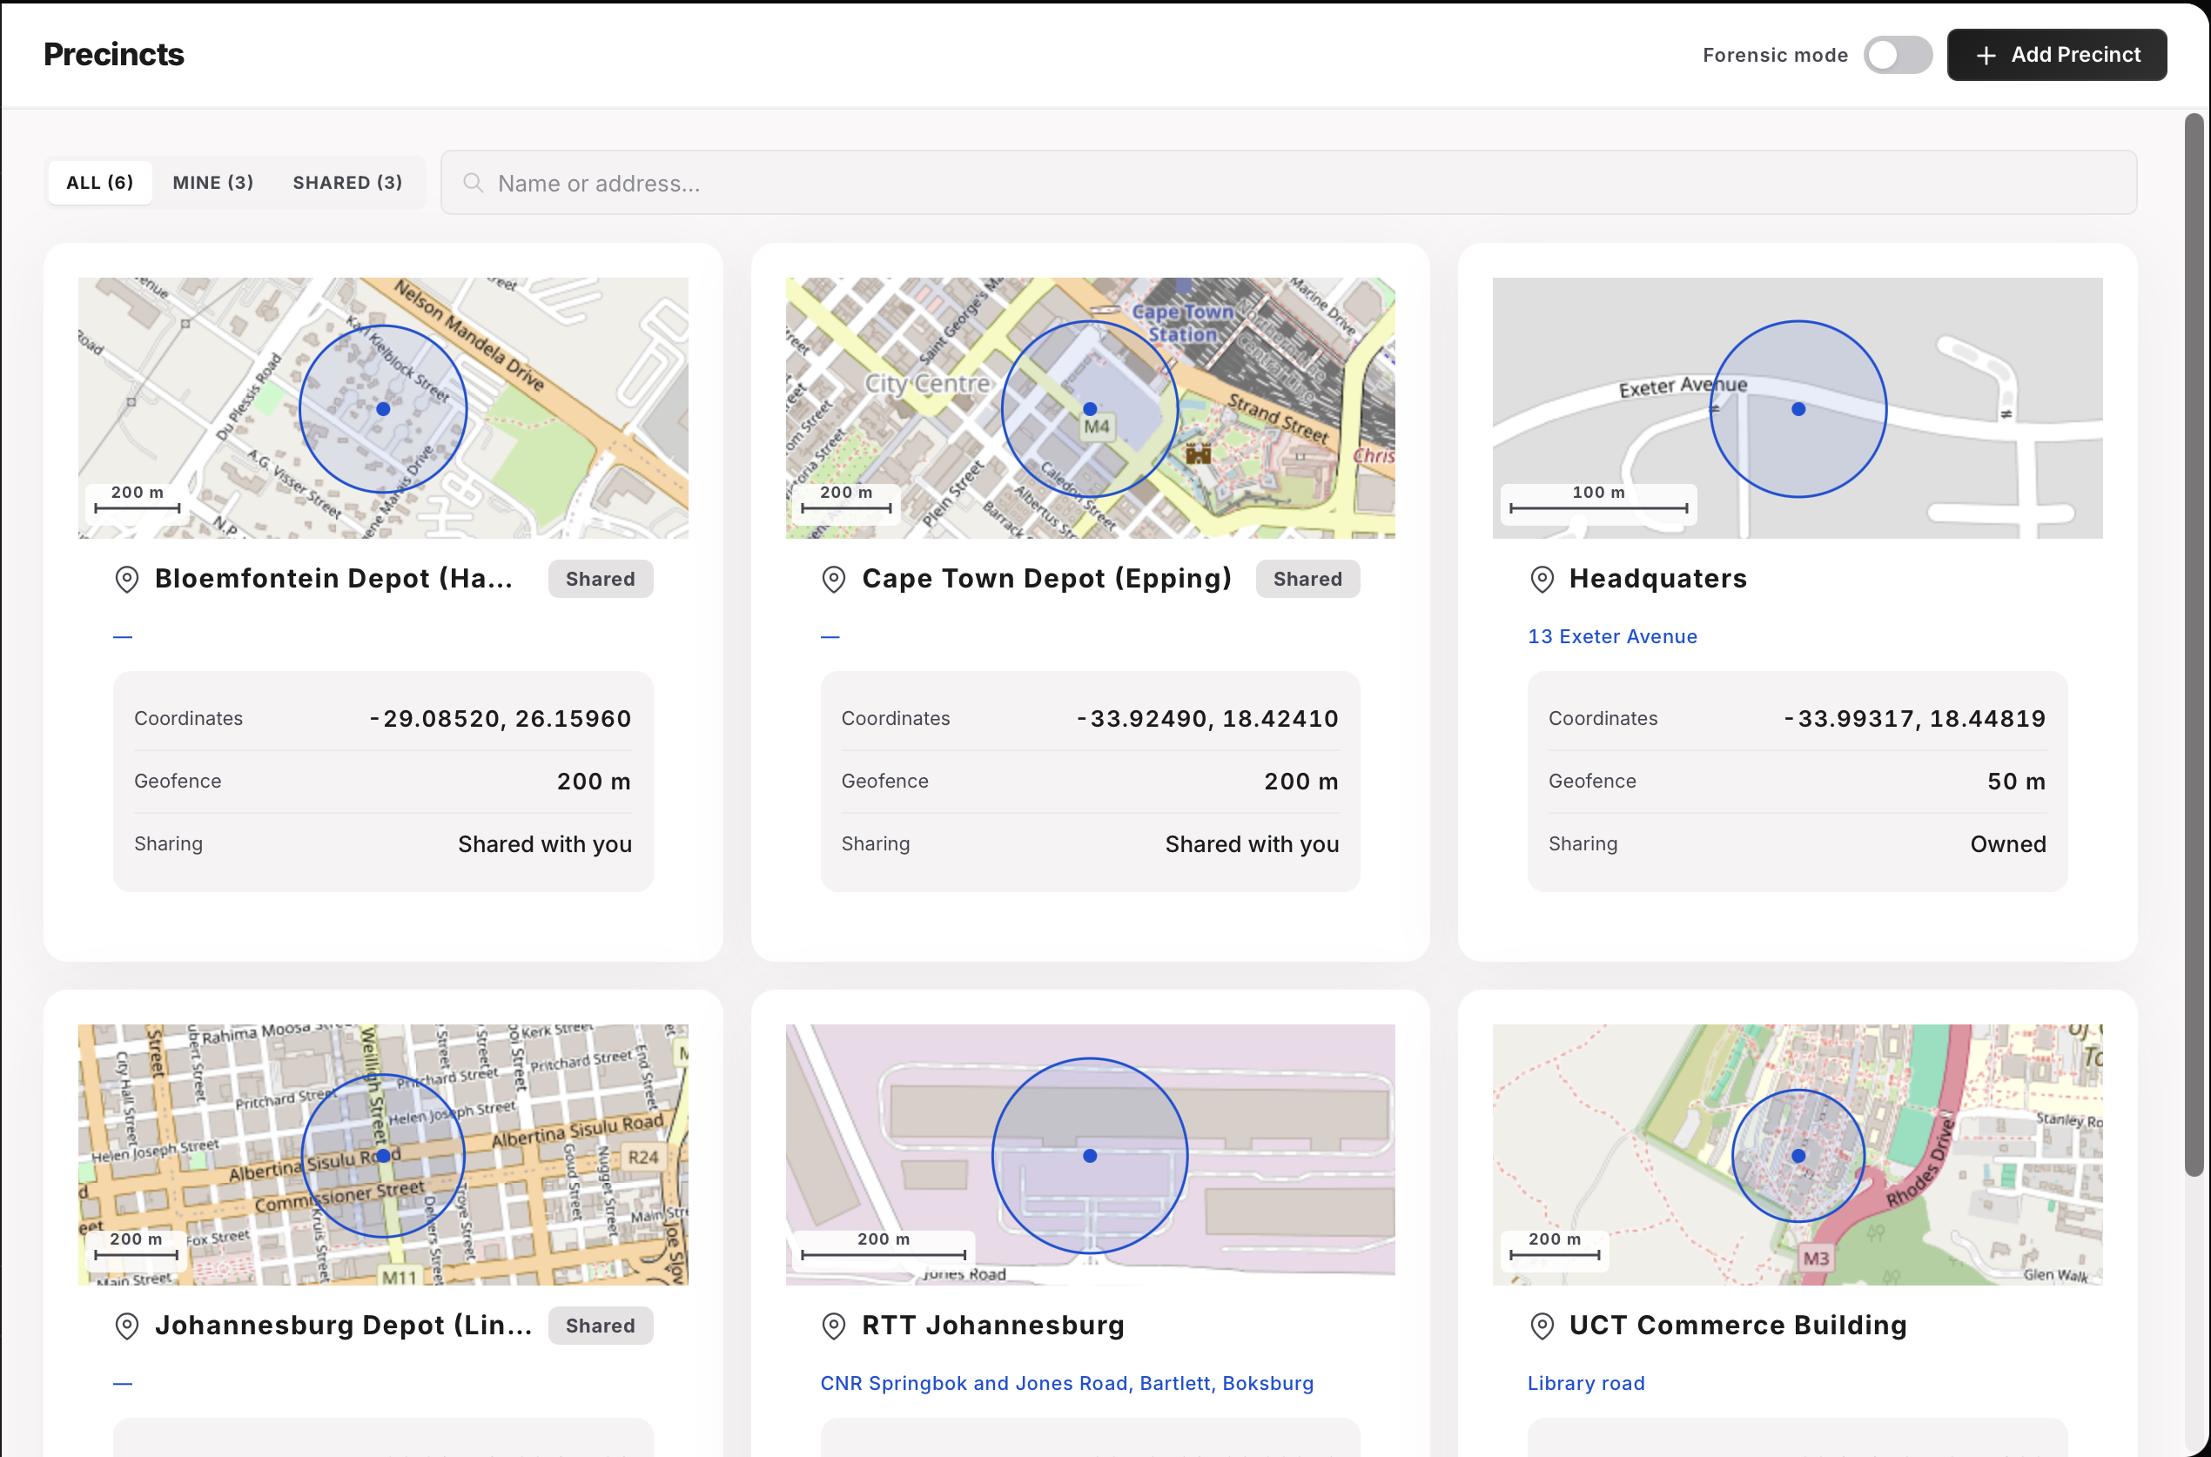
Figure 9: Precincts page
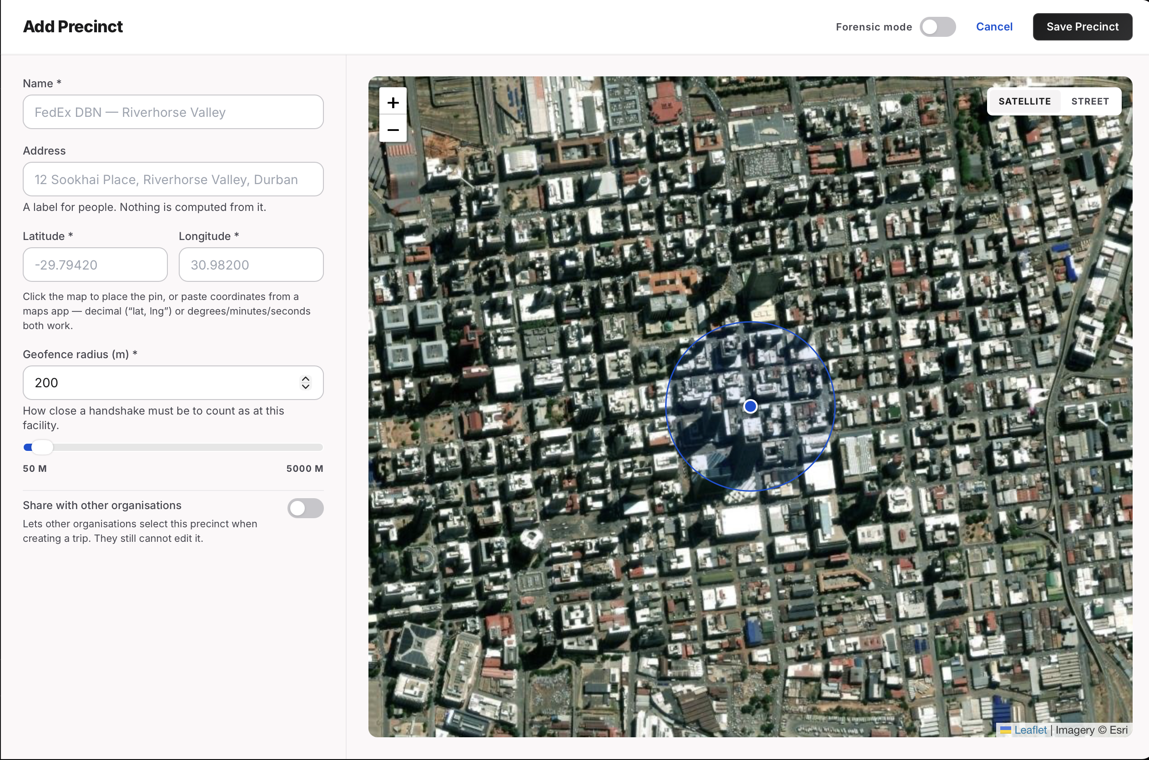
Figure 10: create precinct page
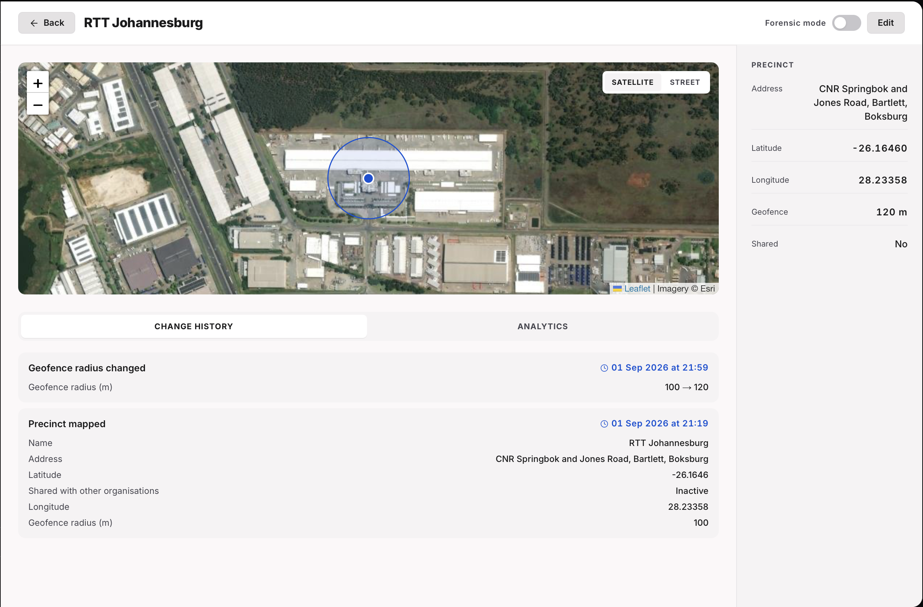
Figure 11: Precinct detail page

6.2 Trip Timeline and Recorded Location Comparison
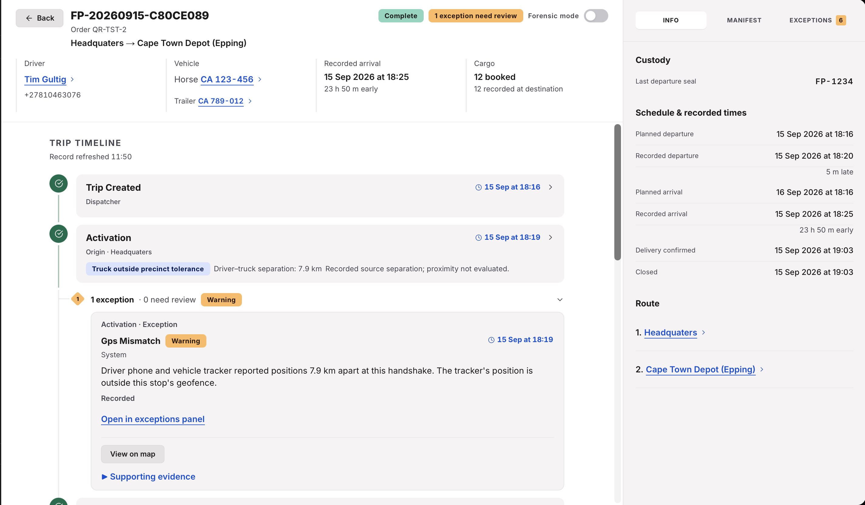
Figure 12: Trip timeline exception flow
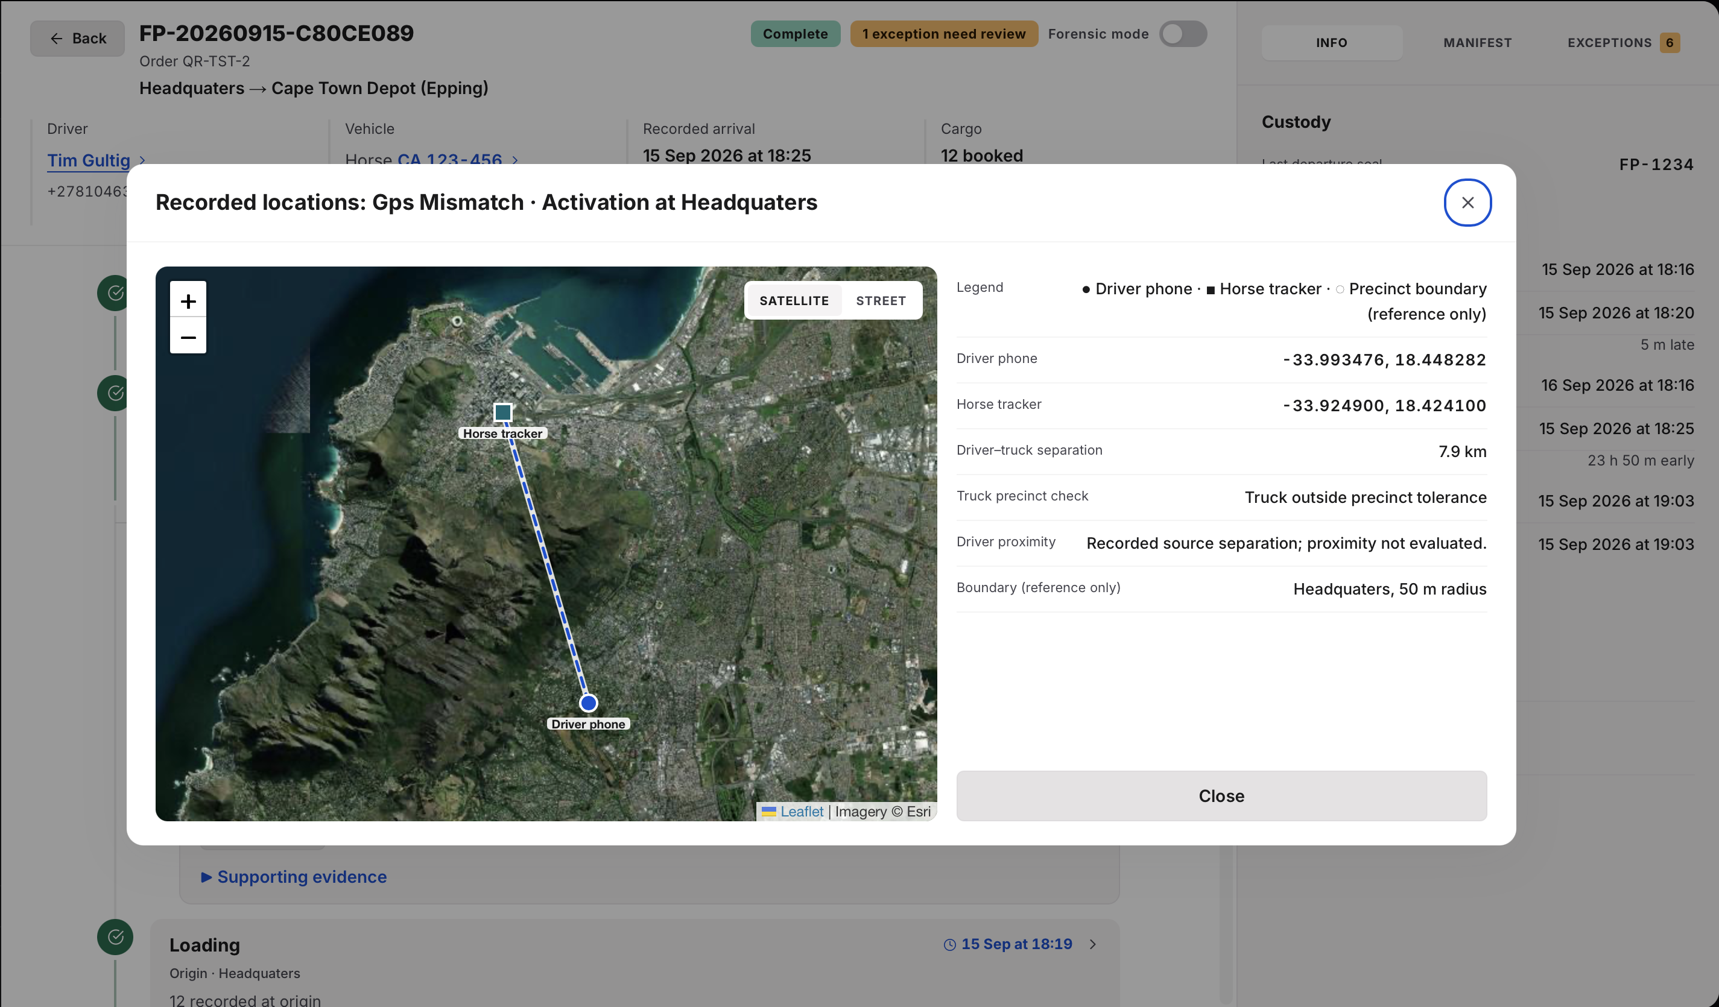
Figure 13: GPS location comparison

6.3 Exception Capture and Dispatcher Review
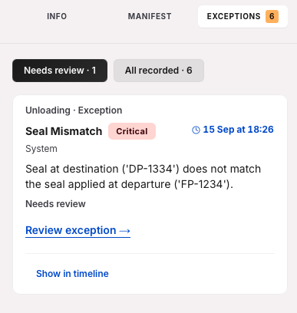
Figure 14: Exception in the exception panel on the trip detail page
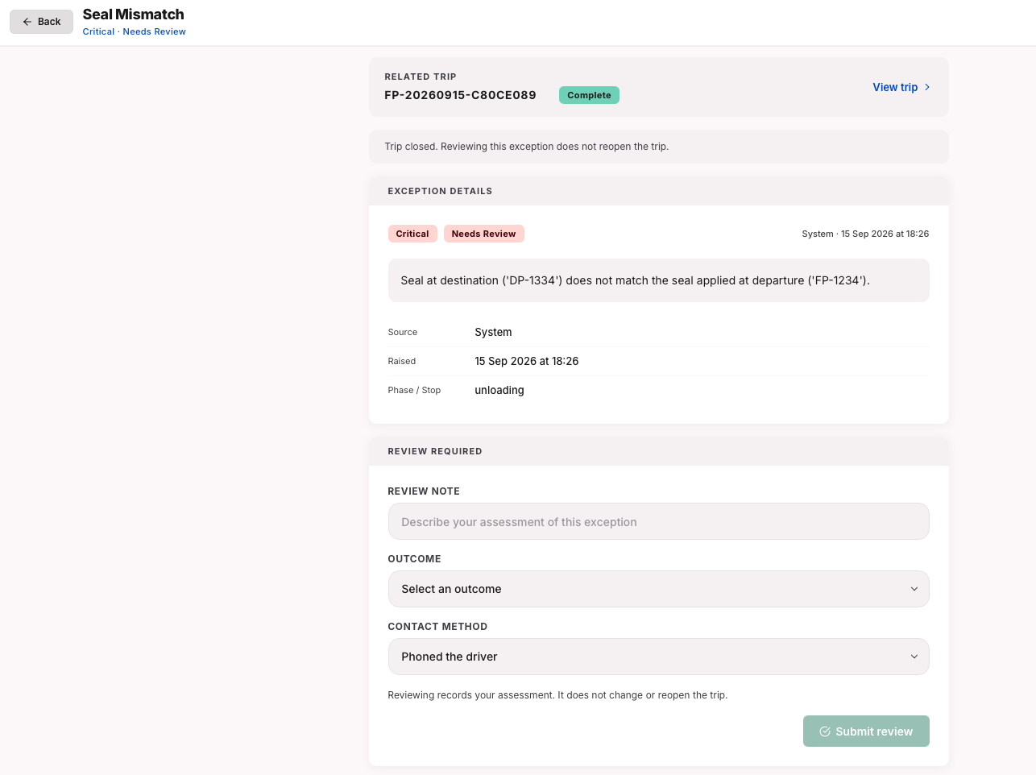
Figure 15: Exception detail page

6.4 Receiver QR / Consent / Verification / Signature
Starting with a QR code on the Driver app:
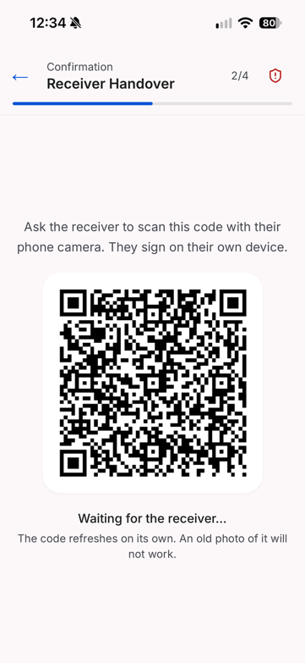
Figure 16: Driver QR code for receiver
Then moving onto the Receiver’s web browser page (from left to right):
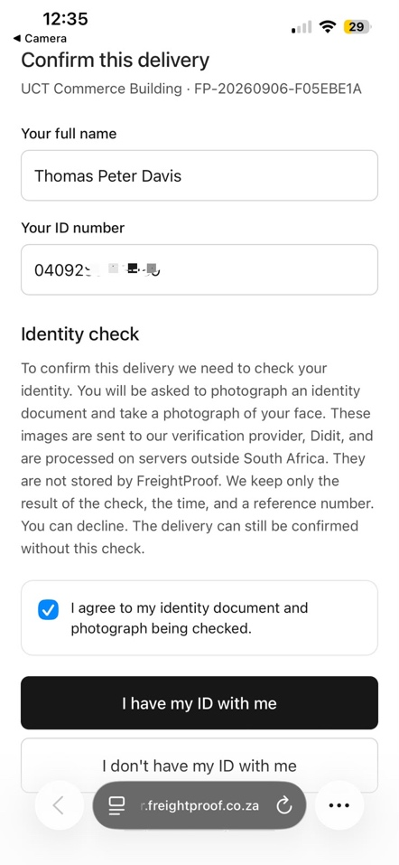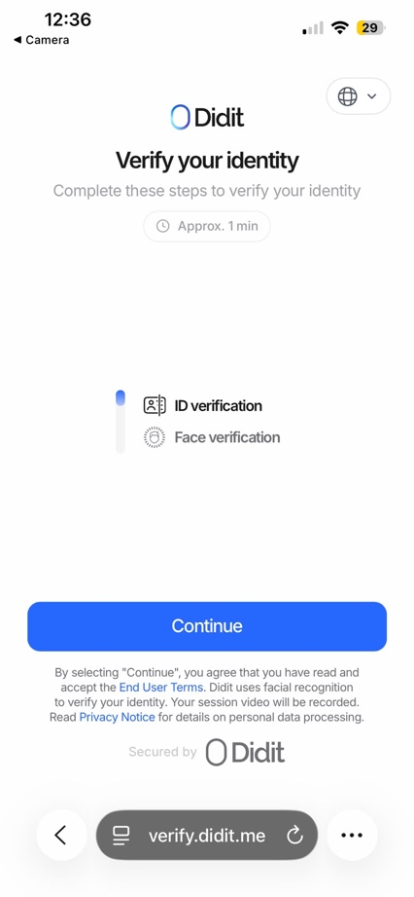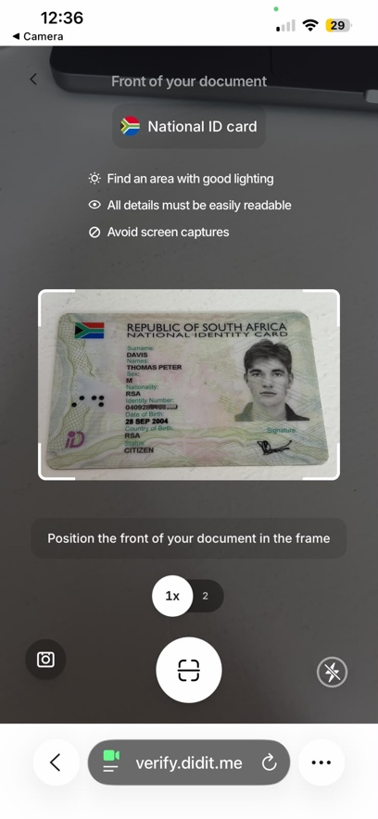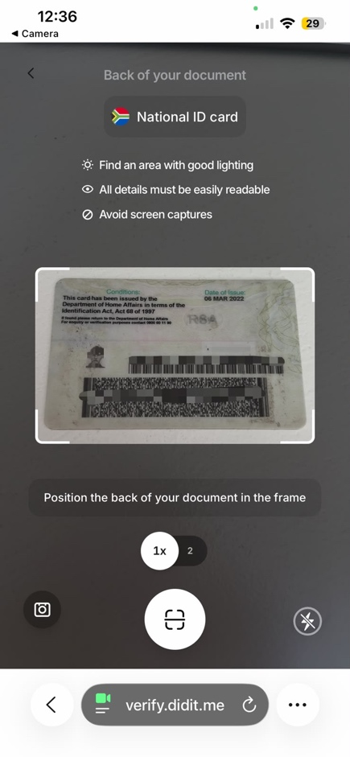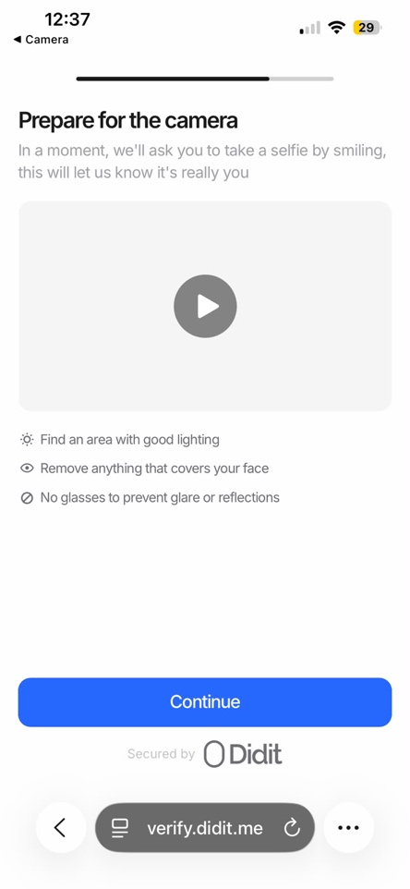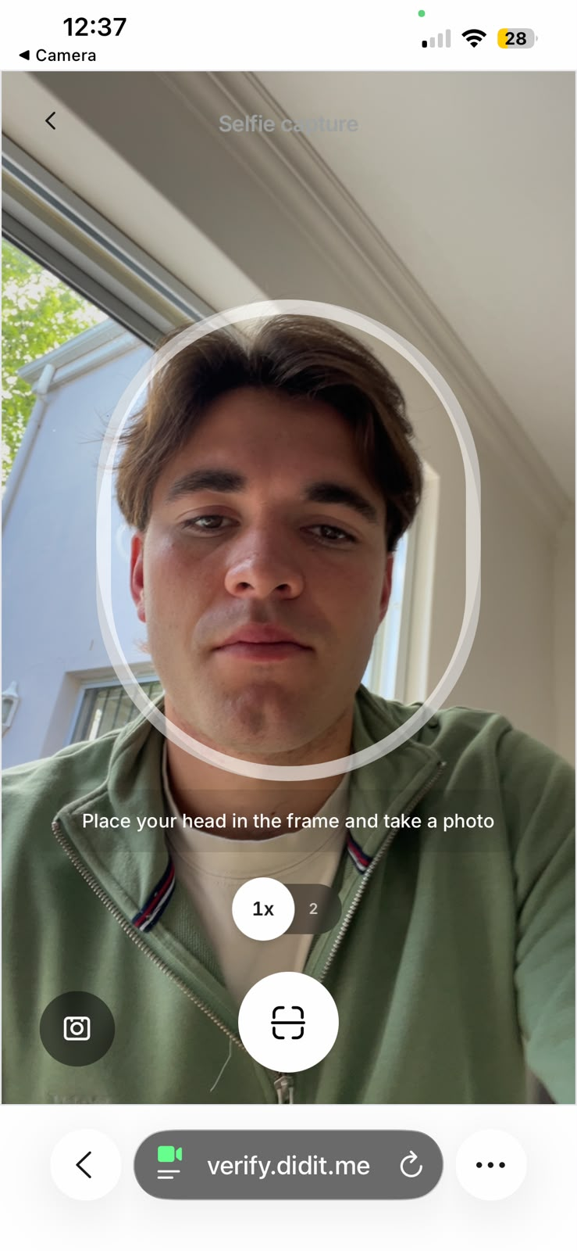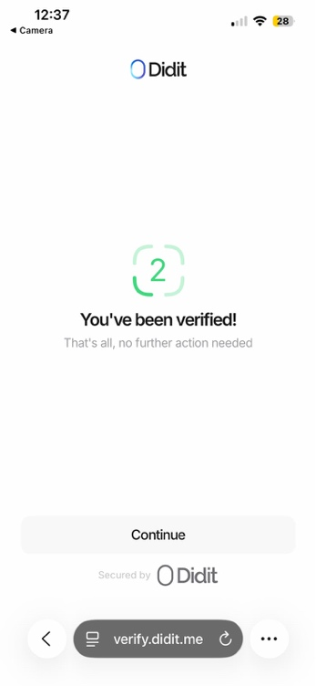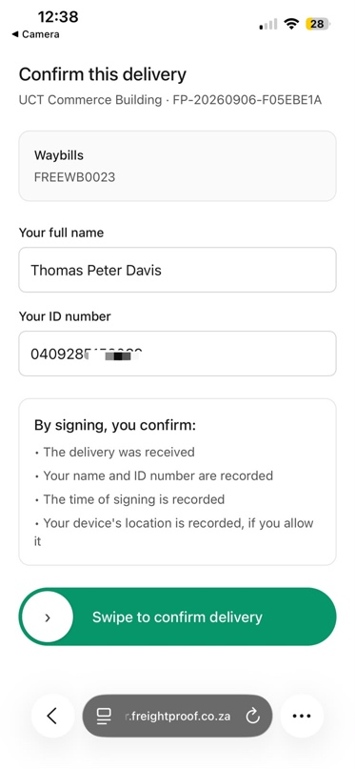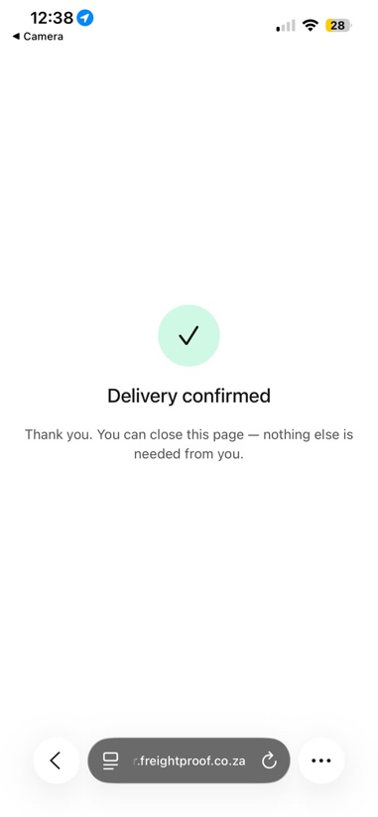
Back to the Driver app:
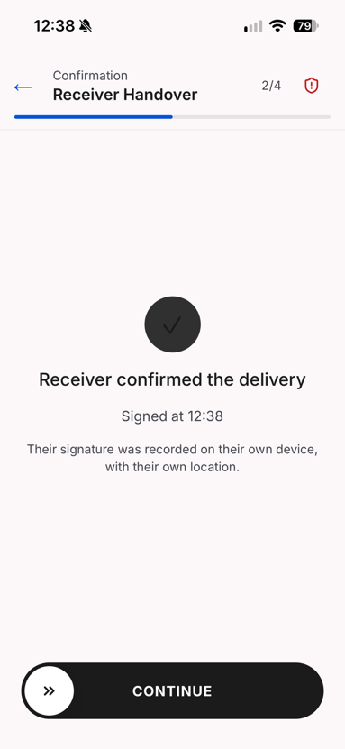
Figure 17: Driver app confirmation

6.5 Entity and Fleet Analytics
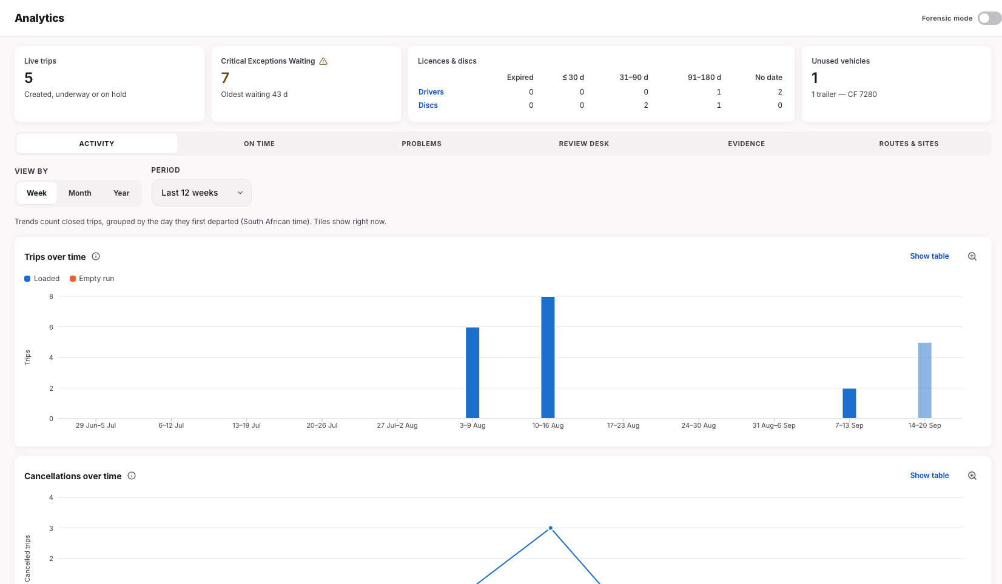
Figure 18: Activityl analytics
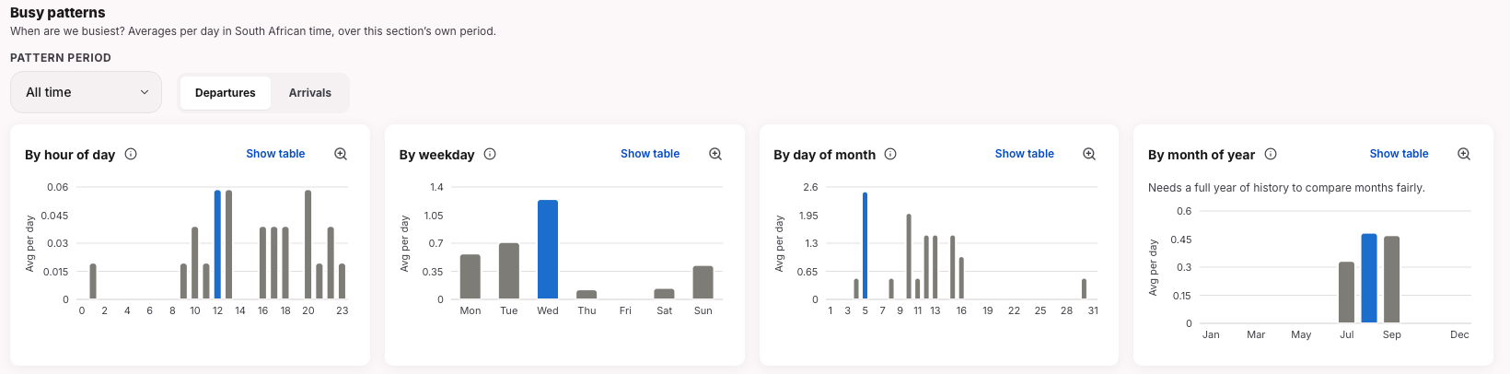
Figure 19: General analytics
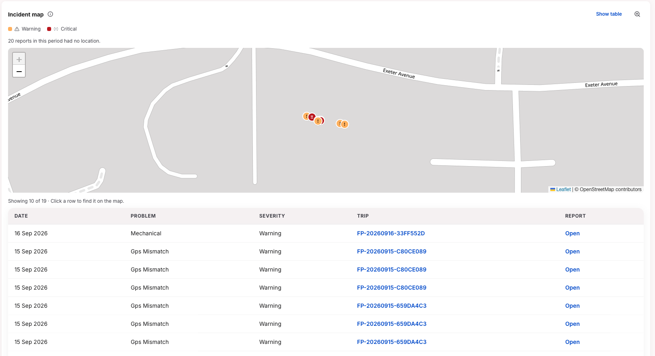
Figure 20: Exceptions heat map
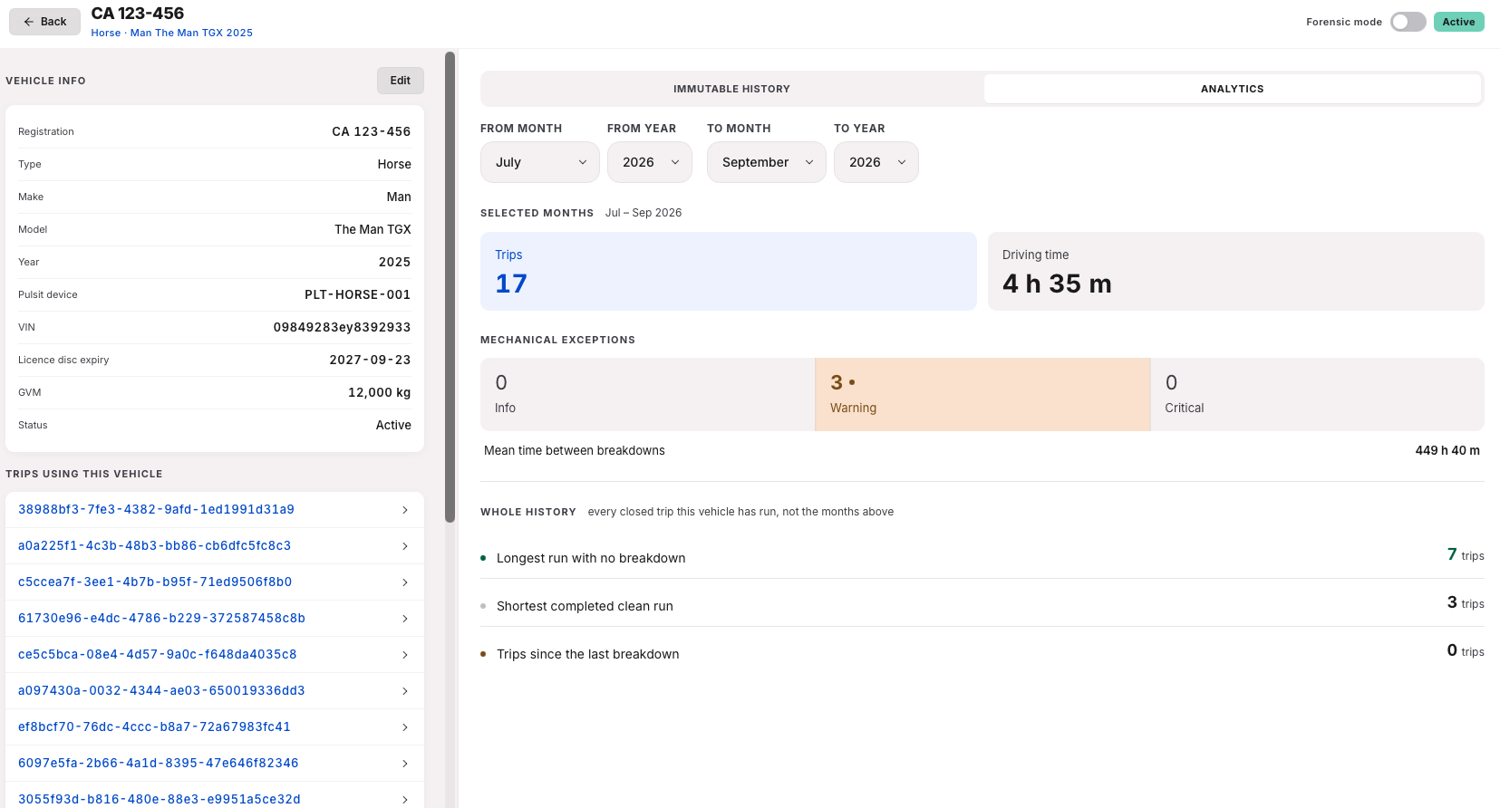
Figure 21: Specific vehicle analytics

7. Testing Approach, Results and Limitations
This section describes how Iteration 3 was tested, the results on the current build, and what remains to be tested before the pilot. The approach is the one used in Iteration 2: unit, integration and acceptance testing organised around the project risks. Things that can happen at the same time are now tested as genuine races rather than one after the other, offline and outage behaviour is stated and tested explicitly, and every test says whether it lives on the phone, the dashboard or the server.
The Iteration 3 features that needed new testing were the receiver-side QR handover and receiver identity verification (including the fallback when the provider is unavailable); photo and signature hashes inside the departure and delivery anchors, so a swapped photo is detectable; corroboration of the driver's phone position against the horse and trailer trackers; exception photos, severity and dispatcher review; driver, vehicle, lane and fleet analytics; precinct geofences; stricter validation and concurrency protection on trips and fleet records; and the single-device and idle-timeout session rules.

7.1 Testing approach
Table 34: Test levels used in Iteration 3
Level | Purpose | Iteration 3 focus
Backend unit (pytest) | One piece of logic, no database or network | Anchor payloads (v1 byte-compatible, v2 with artifact hashes) and tamper verification; corroboration maths incl. missing, unknown and stale fixes; analytics and exception rules; session idle timer
Frontend unit and component (Vitest) | Screens, hooks and client logic behave as designed | Driver PWA: double-submit guard, offline queue, replay of resolved phases, OTP page, idle sign-out. Dispatcher: timeline, exception review, cancel and override actions, analytics, live updates
Backend integration (pytest + httpx) | Real API against a real database; state read back after every write | Handover and verification flows and every refusal; anchoring and end-to-end tamper detection; location corroboration; exception review; analytics and fleet tiles; precincts; trip and fleet validation; sessions, health, headers, live stream
Concurrency, offline and outage | Two actions at once, offline-then-online, partner or server down | See §7.1.1
Security | Isolation, roles, information leaks, sessions | Organisation isolation for every subject type; token and role refusals; identical 404s for foreign or bad tokens; one device per driver under a race; security headers
Story acceptance (internal) | Can the user complete the story as written | Team walkthroughs of the Iteration 3 stories on the shared development deployment

7.1.1 Concurrency, offline and outages
Two independent database connections are held at a barrier so they genuinely arrive together, then released; the test asserts that exactly one wins and the other gets a clean refusal, never a database error. This covers two redemptions of the same QR code, two dispatchers reviewing the same exception, two trips created with the same order number, two claims on the same waybill, two handsets logging in to one driver account, and two replays of the same exception report or checkpoint. On the phase ledger, a driver completing a phase and a dispatcher overriding it both load the phase row through one shared function that takes a row lock, so only one write happens; the second caller re-reads the row as resolved and gets either the idempotent “already done” response or a 409.
Offline, then online. A queued action carries the same idempotency key on every send, so a lost response plus a retry cannot create a second record. If the phase was resolved another way while the driver was offline, for example an override, the replay returns a 409. The PWA re-fetches the trip, sees the phase is resolved and treats it as an earlier success and dequeues it once. Only a 409 on a phase that is still pending is shown to the driver as a real conflict. A replayed capture time hours old is “could not compare”, never a location mismatch.
Server or partner down. On a 5xx or no network connection the PWA keeps the action queued and retries when the app is next visible. Only a 4xx client-side issue fails forever and is dropped and shown to the driver. A Hedera failure on a non-critical phase saves the phase with its anchor state recorded, and a recovery job retries later without changing the original hash. If the identity provider is down, the delivery still confirms with the reason recorded. Storage down during verification: “error”. Pulsit down: no location finding is raised.

7.1.2 Frontend and backend
The frontend stops the user getting there: a driver never sees another driver's trip, a Submit button is disabled once pressed, a second submission for the same phase is refused while the first is in flight. The backend is the actual gate, because the API can be called without the app: another driver's trip is a 404 (not a 403, so its existence is not revealed), a replayed completion is idempotent, a second QR redemption is refused.

7.1.3 Story acceptance testing
The four team members walked the Iteration 3 stories against their acceptance criteria on the shared development deployment, one as driver and one as receiver on phones and one as dispatcher on a laptop, with Parcel Perfect, the tracker feed and the identity provider in mock mode. The scenarios covered the QR handover with and without identity verification and with the provider switched off. A second phone refused on a used code, a swapped seal photo reported as a mismatch, two dispatchers reviewing one exception, a step completed in flight mode appearing once after reconnecting, and precinct geofence edits reflected in corroboration and analytics. No external users took part, so this is story acceptance by the team, not client acceptance.
Table 35: Story Acceptance Testing
Scenario walked | Expected | Outcome
Driver shows the rotating QR; receiver scans, consents, verifies, signs | Trip closes; dispatcher sees the receiver's verification tier | As expected
Receiver skips identity verification | Delivery still confirms, tier shown as selfie-only / unverified | As expected
Identity provider switched off (mock quota 0) | Receiver still confirms; dispatcher sees “unverified: provider unavailable” | As expected
Second phone tries the same QR code | Refused; first receiver's confirmation unaffected | As expected
Seal photo swapped in storage after departure, then Verify on the dashboard | Reported as a mismatch, not verified | As expected
Driver reports an exception with photo; two dispatchers review at once | One review recorded; the other told it was already reviewed | As expected
Driver completes a step in flight mode, then reconnects | Step appears once on the dashboard; queue empties | As expected
Driver's phone far from the truck at activation (mock tracker) | One GPS-mismatch exception with both positions; no exception when the fix is stale | As expected
Dispatcher edits a precinct geofence, then phases inside and outside it | Corroboration result follows the new fence; analytics reflect the trips just run | As expected

7.2 Risk-to-test matrix
Layer: B = backend, F = frontend. All rows passed on the build in Table 7.2. Case IDs refer to Appendix A; other rows are covered by the suites without a full narrative.
Table 36: Risk-to-test matrix, Iteration 3. Test file and function names for each row are in Appendix A and the evidence register.
Requirement / risk | Layer | Result
Receiver QR handover: single use, expiry, rotation, binding cookie. forwarded or replayed QR | B | Pass
Receiver identity verification, consent tiers, provider unavailable. external dependency | B | Pass
Evidence anchoring with artifact hashes; tamper detection; legacy receipts still verify | B | Pass
Location corroboration; stale or missing GPS never manufactures a mismatch; tracker outage | B | Pass
Exception reporting with photo and severity; concurrent dispatcher review | B / F | Pass
Organisation isolation and roles across trips, receipts, exceptions, analytics. POPIA | B | Pass
Offline queue, idempotent replay, double-submit guard. duplicated or lost evidence | F / B | Pass
Trip and fleet validation under concurrency. one order, one trip, one journey lock | B | Pass
Analytics and fleet tiles correct after trip completion; nothing from another operator | B / F | Pass
Single device per driver under a race; idle timeout matches server | B / F | Pass
Phase order, idempotent completion, override and cancel (Iteration 2 cases re-run) | B / F | Pass
Precinct geofence create, edit and audit | B / F | Pass
Health probes, security headers, live dispatcher stream | B | Pass

7.3 Remaining test plan
No failing tests are outstanding. The items below are what has not yet been tested, or has only been tested in mock mode, and when we intend to close each.
Table 37: Remaining test plan
What | When | Environment | Success criterion
Load and volume: concurrent drivers completing phases, GPS ping batches, dashboard reads; anchoring latency | Iteration 4, sprint 1 | Staging with seeded fleet; Hedera testnet | No server errors or duplicate records under sustained load; 95% of anchors within 60 s
Live identity verification and webhook journey | Iteration 4, sprint 1 | Staging against the live provider (limited credits) | One recorded end-to-end verified confirmation and one recorded provider-unavailable fallback, with webhook receipt
Live Parcel Perfect and Pulsit integration | Iteration 4, once partner access is granted | Staging with partner sandbox credentials | Waybills and tracker fixes arrive from the live systems; corroboration gives the same verdicts as the mocked tests
Dispatcher override vs driver completion of the same phase at the same instant | Iteration 4, sprint 1 | Backend integration, parallel connections | Exactly one write; the loser receives an idempotent 200 or a 409, never a database error
Seal-number uniqueness across live trips | Iteration 4, sprint 1 | Backend integration | A repeated seal number on a live trip is refused or flagged for review
Acceptance testing with LFG dispatchers and a receiver | Iteration 4, pilot preparation | Staging, Johannesburg to Durban demonstration trip | Each story accepted or rejected in writing by an LFG user, with defects logged

8. Development Approach, Scrum and Progress

8.1 Virtual Team Roles and Mechanisms
Team05 applies Scrum through a Jira backlog (board FP), fixed-length sprints, Fibonacci story-point estimation and shared implementation ownership. Roles are unchanged from Iteration 2: Ciaran Formby (Product Owner), Tim Gultig (Scrum Master), and all four (Formby, Gultig, Thomas Davis, Chiko Kasongo) as the Development Team. Weekly online check-ins continue, with ad hoc coordination through the team channels when dependent work must be aligned.
Standards adopted. Branch protection is enabled on main and dev; direct pushes are not permitted and changes land through reviewed pull requests.
Table 38: Agreed process adjustments carried from Iteration 2 into this reporting period
Adjustment (agreed at Iteration 2 close) | Applied in Sprints 6–7
Ready-before-start rule: a story needs acceptance criteria, an estimate and an assignee before sprint commitment | Sprint 6 opened with all 16 committed items already estimated and assigned. Sprint 7 was the same, including the five documentation tasks FP-162–FP-166.
Jira review and retrospective record | Reconciliation was performed against actual delivered work after the end of every sprint
Evidence-linked completion: reference the Jira key in the PR/commit before moving an issue to Done | Almost every feature commit had the Jira reference linked to it

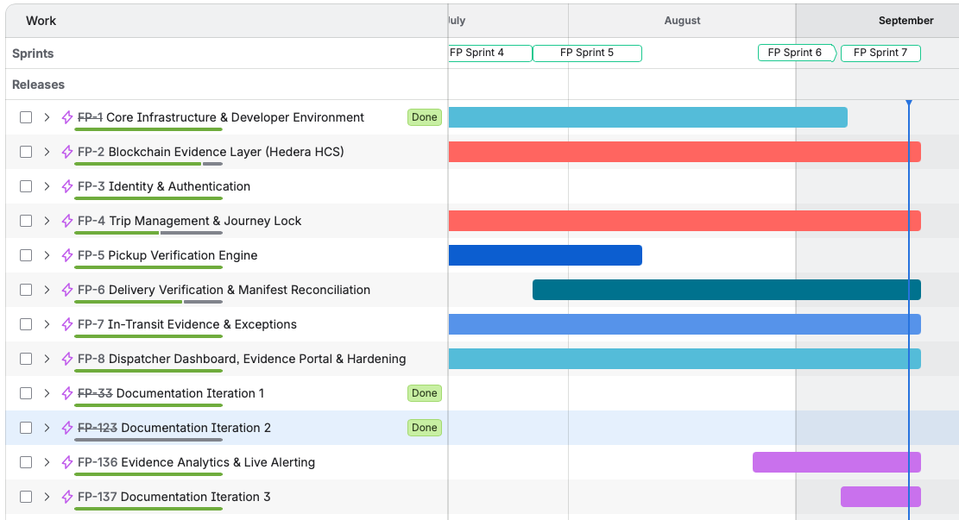
Figure 22: Sprint Timeline

8.2 Sprint 6
Sprint: FP Sprint 6, board FP. Dates: 2026-08-26 to 2026-09-07
Goal: close the location-corroboration and exception-handling gaps carried out of Iteration 2, add precinct management, and lay the analytics read-model foundation, while completing the Pulsit client and geofence service.
Table 39: Sprint 6 committed backlog (16 items, 80 points)
Key | User story / task | Assignee | Pts | Type | Outcome
FP-259 | As an admin dispatcher, I want to create and edit a precinct. | Ciaran Formby | 5 | Story | Done in sprint
FP-148 | As a dispatcher, I want the alert stream scoped so the critical one isn’t buried. | Ciaran Formby | 5 | Story | Done in sprint
FP-147 | As a dispatcher, I want to be pinged when a seal breaks. | Ciaran Formby | 5 | Story | Done in sprint
FP-146 | As a dispatcher, I want to resolve exceptions with the phone call recorded. | Ciaran Formby | 8 | Story | Done in sprint
FP-144 | A seal typed with a trailing space raised a false CRITICAL tamper alert. | Ciaran Formby | 2 | Bug | Done in sprint
FP-141 | As an operator, I want a health endpoint that actually probes dependencies. | Ciaran Formby | 3 | Story | Done in sprint
FP-138 | As a dispatcher, I want the same waybill blocked from landing on two trips. | Ciaran Formby | 5 | Story | Done in sprint
FP-154 | As a dispatcher, I want evidence artifact hashes anchored so tampering is detectable. | Chiko Kasongo | 8 | Story | Carried, closed in Sprint 7
FP-156 | As a dispatcher, I want an analytics screen to see operational trends. | Thomas Davis | 8 | Story | Carried, closed in Sprint 7
FP-153 | As a dispatcher, I want analytics read models over the ledger so dashboards use current data. | Thomas Davis | 8 | Story | Carried, closed in Sprint 7
FP-150 | As a driver, I want to photograph an exception so it’s captured as evidence. | Tim Gultig | 5 | Story | Done in sprint
FP-145 | As a dispatcher, I want a position disagreement to raise GPS_MISMATCH on the timeline. | Tim Gultig | 3 | Story | Done in sprint
FP-143 | As a dispatcher, I want the four corroboration columns filled so location evidence is trustworthy. | Tim Gultig | 5 | Story | Done in sprint
FP-116 | As a demonstrator, I want to move the truck from the UI to drive the demo. | Tim Gultig | 2 | Story | Done in sprint
FP-87 | As a developer, I want a mock-backed, credential-ready Pulsit client to swap for the live one later. | Tim Gultig | 5 | Story | Done in sprint
FP-68 | As a dispatcher, I want to know the truck is actually at the facility before trusting a phase transition. | Tim Gultig | 3 | Story | Done in sprint
Completed within the Sprint 6 window: 13 items, 56 points (Ciaran Formby 33, Tim Gultig 23). Carried past the formal close and completed in the opening hours of Sprint 7: 3 items, 24 points (Chiko Kasongo 8, Thomas Davis 16). All 16 committed items were eventually delivered, no scope was dropped, but three closed after.
Burndown.
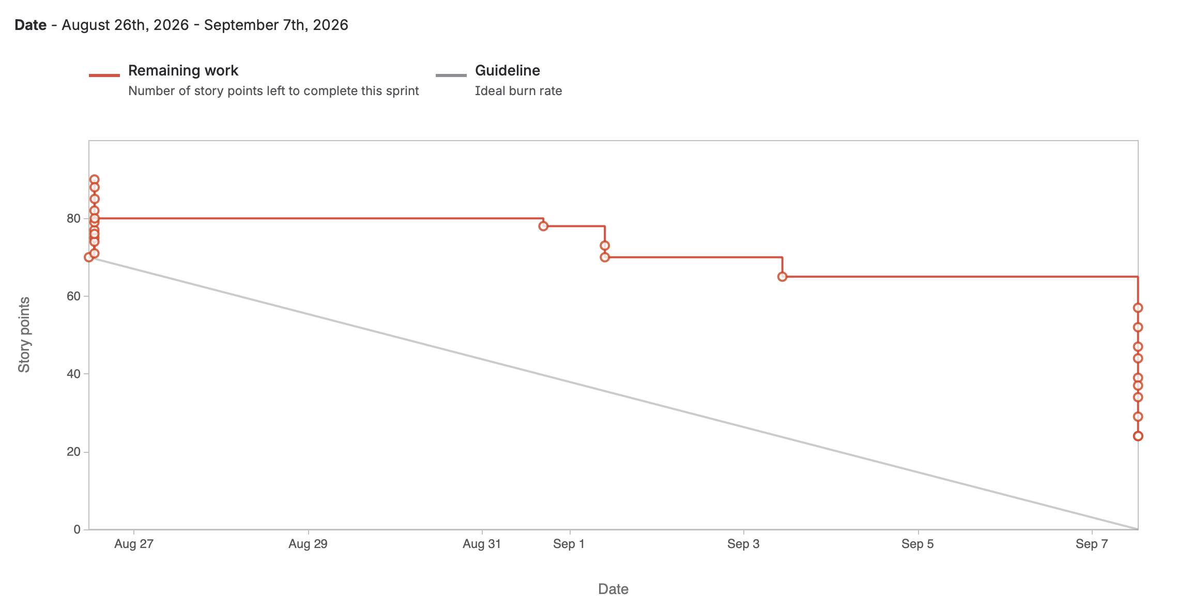
Figure 23: Sprint 6 Burndown Chart

Retrospective.
Table 40: Sprint 6 retrospective
What went well | What should improve | Action taken
All 16 items had points and an owner before the sprint even started. | 3 items (24 points) finished just after the sprint closed, not before. | Tracked those 3 items through to done inside Sprint 7 instead of calling them late.
Every committed item got done in the end. 80 points committed and delivered. | No screenshot or burndown chart was saved at the time. | Started writing down what happened each sprint (see Sprint 7 below), so that it is easier to check going forward.
Good wins shipped: precinct management, exception review, geofence service, the Pulsit client. | Points were not spread evenly. Ciaran and Tim carried most of the sprint. | No fix agreed yet. Flagged for Sprint 8 planning.

8.3 Sprint 7
Sprint: FP Sprint 7, board FP. Dates: 2026-09-07 to 2026-09-17.
Goal: complete receiver-side handover and evidence-verification lookups, extend Pulsit and analytics integration, refactor the state machine, and produce the Iteration 3 documentation draft.
Table 41: Sprint 7 committed backlog
Key | User story / task | Assignee | Pts | Type | Outcome
FP-157 | As a dispatcher, I want to look up a blockchain receipt by hash or transaction id. | Chiko Kasongo | 5 | Story | Done
FP-152 | Rebuild the state machine as states, not a process. | Chiko Kasongo | 3 | Task | Done
FP-164 | Draft Report §8, Development approach and Scrum. | Ciaran Formby | 2 | Task | Done
FP-167 | Split phase_service.py (post-merge window only). | Ciaran Formby | 2 | Task | Done
FP-166 | Draft Report §6, UI evidence. | Chiko Kasongo | 2 | Task | Done
FP-149 | As a dispatcher, I want to find a parcel by barcode and see everywhere it has been. | Ciaran Formby | 8 | Story | Not completed, carried to Sprint 8
FP-163 | Draft Report §2, Updated project and iteration plan. | Thomas Davis | 3 | Task | Done
FP-162 | Draft Report §1, Project context and objectives. | Thomas Davis | 5 | Task | Done
FP-161 | As an insurer, I want an evidence packet export with what I’d actually need to assess a claim. | Thomas Davis | 8 | Story | Done
FP-151 | Solution architecture slide and readable package/DB diagrams. | Thomas Davis | 3 | Task | Done
FP-165 | Draft Report §4, Architecture and integrations. | Tim Gultig | 3 | Task | Done
FP-158 | As a dispatcher, I want Pulsit route reports to feed lane transit metrics with real, not mock, data. | Tim Gultig | 5 | Story | Done
FP-155 | As a receiver, I want to confirm delivery on my own phone via a rotating QR. | Tim Gultig | 8 | Story | Done
Final result: everything closed except FP-149 (8 points), which stayed genuinely “To Do” all sprint and moved to Sprint 8 rather than being rushed or reworded to look finished. Combined with the 3 carried-in items, Sprint 7 delivered 71 of 79 committed points (90%).
Burndown 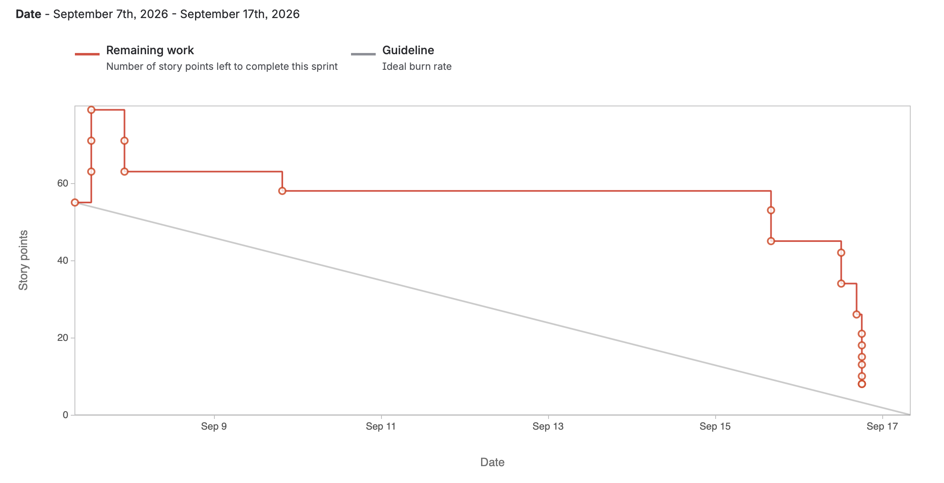.
Figure 24: Sprint 7 Burndown Chart

Retrospective.
Table 42: Sprint 7 retrospective
What went well | What should improve | Action taken
Ready-before-start worked again. Every item had an assigned owner, and the user stories were estimated before work began. The five report tasks were also allocated at sprint planning. | Sprint 7 included both new work and 24 points carried from Sprint 6. Reporting these together made the total commitment harder to interpret and placed pressure on the sprint’s available capacity. | Carry-over and new work will be reported separately when planning capacity. The Product Owner will use completed points and known carry-over, rather than the headline commitment alone, when setting Sprint 8 priorities.
FP-149 (8 points) genuinely did not get done, and was not rushed or relabelled to hide it. There was more important things to do | FP-149 could not be completed within the available capacity after higher-priority receiver handover, evidence verification and reporting work. | FP-149 was carried into Sprint 8 with its scope and estimate unchanged and will be prioritised before optional new work.

8.4 Velocity and Capacity
Sprint 6 and Sprint 7 both opened with a fully estimated, assigned backlog. Sprint 6 committed 80 points and delivered all of them, 56 within the sprint window and 24 in the opening hours of Sprint 7.
Distribution across the team is shown explicitly below. Each item is counted once, credited to the sprint in which it was first committed. The three items carried from Sprint 6 into Sprint 7 are credited to Sprint 6, not double-counted.
Table 43: Story points by person, Sprint 6 and Sprint 7
Person | Sprint 6 (origin) | Sprint 7 (new items only) | Combined | Share
Ciaran Formby | 33 (7 items) | 10 (3 items, 1 unpointed) | 43 | 31.9%
Tim Gultig | 23 (6 items) | 16 (3 items) | 39 | 28.9%
Thomas Davis | 16 (2 items) | 19 (4 items) | 35 | 25.9%
Chiko Kasongo | 8 (1 item) | 10 (3 items) | 18 | 13.3%
Total | 80 (16 items) | 55 (13 items) | 135 (29 items) | 100%
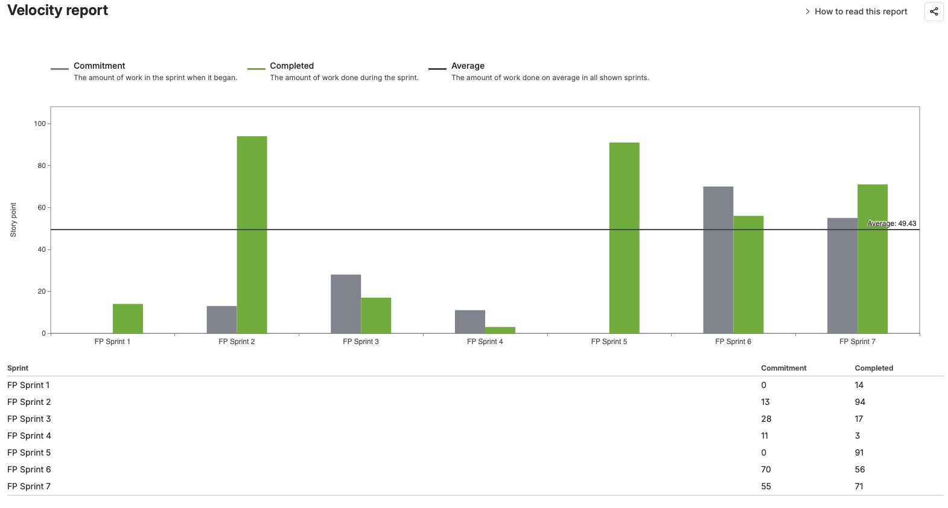
Figure 25: Full Velocity Report

8.5 Iteration Reflection
The team became more organised during these sprints by agreeing on the planned work, estimating its size and assigning responsibilities before each sprint began. Regular check-ins also helped the team coordinate work that depended on other members.
Sprint 6 delivered precinct management, improved exception handling, location and geofence checks, Pulsit integration and the foundation for analytics. Three tasks were completed shortly after the sprint ended, showing that the original plan was slightly too ambitious. Sprint 7 delivered receiver QR confirmation, evidence exports, blockchain receipt lookups, live route reporting and improvements to the trip state logic. One unfinished feature was moved to the next sprint rather than being rushed.
Overall, the team shipped meaningful improvements across the evidence journey. Planning became more reliable, although responsibilities were not always evenly distributed and some sprint records were completed afterwards. Future sprints should focus on balancing the workload and recording progress and lessons as they happen.

8.6 Use of AI Tools
AI tools, mainly Claude Code, were used extensively throughout the project. They helped the team understand unfamiliar code, generate and improve code, troubleshoot and debug errors, and write tests. AI also helped compare the completed work with the sprint records as well as branch comparisons and merge conflict discovery. This support allowed the team to develop a broader system within the available time than would otherwise have been possible.
A recent code demonstration showed that getting a feature to work is not the same as fully understanding how it works. Since then, the team has placed greater emphasis on reading AI-assisted code, tracing how data moves through the system and testing important behaviour.
The work remains reviewable through the source-code history, pull requests, tests, sprint records and the working system. The team remains responsible for reviewing, explaining and accepting all AI-assisted work included in the project.

References
South African Police Service. (2025). Annual report 2024/2025. https://www.saps.gov.za/about/stratframework/annual_report/2024_2025/2024-25-SAPS-Annual-Report.pdf

Portfolio of Evidence
This just includes a snippet of the portfolio of evidence. The rest is in a supporting document.

Contribution scores
Member | Coding | Documentation | Presentation | Research | Meeting minutes | Communication
Ciaran Formby | 5 | 5 | 4 | 5 | 4 | 5
Tim Gultig | 5 | 5 | 5 | 4 | 4 | 5
Thomas Davis | 5 | 5 | 4 | 4 | 4 | 5
Chiko Kasongo | 4 | 5 | 4 | 4 | 5 | 5

