University of Cape Town · Department of Information Systems
INF4027W Information Systems Honours: Systems Development Project 2026

FreightProof SA
Verified chain of custody for South African road freight
Iteration 4 Documentation
Team 05
Ciaran Formby (Product Owner)
Tim Gultig (Scrum Master)
Thomas Davis (Developer)
Chiko Kasongo (Developer)
Industry partner: Bruce van Wyk, Load Factor Group
Supervisors: Elsje Scott, Ammar Canani, Maureen Tanner, Ridewaan Hanslo
Iteration 4 final release · October 2026

Table of Contents
Glossary 6
1. Project Background 8
1.1 Industry Setting 8
1.2 Industry Partner and Sponsorship 8
1.3 System Overview 9
2. Business Problems 10
3. Business, Project and System Objectives 11
3.1 Business Objectives 11
3.2 Project Objectives 11
3.3 System Objectives 12
3.4 Traceability from Problems to Objectives 13
4. Risk Assessment 15
5. Updated Project Plan and Revisions 18
5.1 Project Timeline 18
5.2 Delivery Against Iteration 3 Commitments 18
5.3 Iteration 4 Release Slice 19
5.4 Prototype Boundaries and Pilot Preparation 19
6. Analysis and Design Work Products 21
6.1 Package Diagram 21
6.2 Analysis Class Diagram 23
6.3 Use-Case Model and System Boundary 25
6.4 Business Rules 27
6.5 New and Changed Use-Case Narratives 30
6.6 State-Machine Diagram 35
6.7 Database Schema Changes 37
7. Architecture 39
7.1 Deployment Architecture 39
7.2 Integrity Model and Terminology 40
7.3 Configured Values and Their Rationale 41
7.4 Legal Standing of the Receiver's Signature 42
7.5 Integration Status 43
7.6 Quality Attributes 44
8. User Interface (UI) Mock-ups and Design Rationale 45
8.1 Design Approach 45
8.2 Live Trip List: the Summary of the Summary 45
8.3 Trip Timeline 46
8.4 Exception Inbox and Review 47
8.5 Analytics 49
8.6 Driver App: Arrival and Receiver Handover 51
8.7 Precinct Set-up 52
8.8 Audit Pack and Client Portal 53
9. Testing Approach, Results and Plan 55
9.1 Kinds of Tests 55
9.2 Automated Test Evidence 56
9.3 Failure-Scenario and Load Testing 56
9.4 Risk-to-Test Matrix 57
9.5 Test Plan and Status 58
10. Development Approach, Scrum and Progress 60
10.1 Development Approach and Standards 60
10.2 Sprint 8 60
10.3 Sprint 9 62
10.4 Velocity and Capacity 64
10.5 Reflection on Scrum and Lessons Learnt 65
10.6 Use of AI Tools 66
References 67
Appendix A: Sample Test Cases 68
Appendix B: Addendum – Changes Since Iteration 3 70
Appendix C: Portfolio of Evidence and User Log 71
List of Figures
Figure 1: Package diagram 22
Figure 2: Analysis class diagram 24
Figure 2b: Iteration 4 additions to the analysis class diagram 24
Figure 3: Trip Lifecycle Management use-case diagram 25
Figure 4: Custody Chain Capture use-case diagram 26
Figure 5: Trip state-machine diagram 36
Figure 6: Entity relationship diagram 38
Figure 7: Deployment architecture diagram 39
Figure 8: Live trip list: every running trip at a glance (local desktop prototype, 24 October 2026) 46
Figure 9: Arrival evidence with critical and warning exceptions (local desktop prototype) 47
Figure 10: Multi-stop trip at intermediate Arrival (local desktop prototype) 47
Figure 11: Shared exception inbox (local desktop prototype) 48
Figure 11a: Exception review showing outcome, note and contact method (local desktop prototype) 49
Figure 12: Daily incident-map view with no reports recorded today (local desktop prototype) 50
Figure 13: Analytics Cost tab (local desktop prototype, 24 October 2026) 50
Figure 14: Analytics headline tiles (local desktop prototype, 24 October 2026) 51
Figure 15: Driver app: seal number read from the photograph at Arrival 51
Figure 16: Driver app: QR code for the receiver 52
Figure 17: Driver app: receiver confirmation received 52
Figure 18: Precinct list with geofences (local desktop prototype, 24 October 2026) 53
Figure 19: Precinct form with address search and editable property outline (local desktop prototype) 53
Figure 20: Audit-pack issue form with scope and privacy options (local desktop prototype) 54
Figure 21: Client portal: verifying an audit pack 54
Figure 22: Summary output of the backend, driver-app and dispatcher test suites, 19 October 2026 56
Figure 23: Sprint 8 burndown chart 62
Figure 24: Sprint 8 task board 62
Figure 25: Sprint 9 task board 63
Figure 26: Sprint 9 burndown chart 63
Figure 27: Committed and completed story points, Sprints 1–9 64
List of Tables
Table 1: Glossary of terms and acronyms 6
Table 2: Existing systems and providers, and their final integration mode 8
Table 3: Business problems in summary 10
Table 4: Business objectives and how each will be measured 11
Table 5: Project objectives and final status 11
Table 6: System objectives, acceptance criteria and status 12
Table 7: Traceability from business problems to objectives and use cases 14
Table 8: Risk status legend 15
Table 9: Risk register, Iteration 4 (Δ = change in score since Iteration 3) 16
Table 10: Project timeline by iteration and sprint 18
Table 11: Iteration 3 commitments and their outcome 18
Table 12: Iteration 4 release slice by story-map activity 19
Table 13: Use-case retention and change index 26
Table 14: Business rules added in Iteration 4 28
Table 15: TLM 1.2 – Create a Trip from a Manifest (changed) 30
Table 16: TLM 1.9 – Review an Exception (changed) 31
Table 17: TLM 1.12 – Issue an Audit Pack (new) 32
Table 18: TLM 1.13 – Trace a Parcel (new) 33
Table 19: CC 1.11 – Record Arrival (new) 33
Table 20: Changed narratives: replacement steps for CC 1.8 and CC 1.10 34
Table 21: Schema changes in Iteration 4 37
Table 22: Deployment nodes and connections 39
Table 23: Configured values and their rationale 41
Table 24: Integration status at the end of Iteration 4 43
Table 25: Screen design rationale 45
Table 26: Test levels used in Iteration 4 55
Table 27: Continuous integration pipeline, run on every pull request 56
Table 28: Failure scenarios and expected behaviour 57
Table 29: Risk-to-test matrix 57
Table 30: Test plan and status at the end of Iteration 4 59
Table 31: Sprint 8 committed backlog (19 items, 84 points) 60
Table 32: Sprint 8 delivery reflection 62
Table 33: Sprint 9 new backlog (15 items, 77 points) 62
Table 34: Velocity normalised for sprint length 64
Table 35: Story points completed per member in Iteration 4 65
Table 36: Sample test cases 68
Table 37: Changes since Iteration 3 and the feedback they answer 70
Table 38: Contribution scores out of 5 71
Table 39: Sign-off of the user logs 72

Glossary
Acronyms are also written out in full the first time they appear in the text.
Table 1: Glossary of terms and acronyms
Term | Meaning in this document
Anchoring | Publishing the SHA-256 fingerprint of a record to the Hedera Consensus Service so that any later change to the record can be detected. Only the fingerprint leaves FreightProof, never the record.
API (Application Programming Interface) | The defined way one system requests data from another.
Arrival | The phase, new in Iteration 4, in which the driver records the seal as found at a stop before anything is opened.
Audit pack | A frozen, anchored evidence bundle for one trip or consignment, issued to an insurer or principal as a PDF and a verifiable web page.
BO, PO, SO | Business objective, project objective and system objective (§3).
BP | Business problem (§2).
CC | Custody Chain Capture: the driver- and receiver-side use cases.
CI (Continuous Integration) | Automated checks that build and test every change before it joins the shared code.
Client portal | The public web application where an audit-pack recipient views and independently verifies a pack.
Consignment | One waybill on a trip and the parcels it lists.
Corroboration | Comparing independent position sources (driver phone, horse tracker, trailer trackers, precinct) to support or question a recorded action.
"Could not check" | The recorded result when a comparison cannot be made, for example because a position is missing or stale. It is never treated as a match or a mismatch.
Dispatcher / Admin-Dispatcher | The operations users who create and monitor trips and review exceptions. Only an Admin-Dispatcher may change fleet and precinct records.
ECTA | Electronic Communications and Transactions Act 25 of 2002.
Exception | A recorded problem raised by a driver, a dispatcher or the system, with a severity of info, warning or critical.
Fingerprint | A SHA-256 (Secure Hash Algorithm, 256-bit) hash of a record. It is not a digital signature (§7.2).
FP-nnn (Jira issue key) | The key of one story or task on the team's Jira board (project FP), for example FP-281 (§10.1).
Geofence | The boundary around a precinct used to check whether a position is inside it: the outline of the yard when one is set, otherwise a circle of the precinct's radius.
HCS | Hedera Consensus Service, the public ledger service that timestamps fingerprints.
Horse | The truck tractor unit that pulls one or more trailers.
IDV (Identity Verification) | A document-and-face check of a person, provided by Didit and offered to every receiver, who may decline it.
LFG | Load Factor Group, FreightProof's industry partner.
Manifest | The client's Parcel Perfect list of waybills for one departure. FreightProof creates a loaded trip from it.
MVP (Minimum Viable Product) | The smallest complete system that runs a trip end to end, with its limitations stated.
Organisation | One tenant of FreightProof: an operator, a principal or both. Users and data are isolated per organisation (§1.3).
OTP (One-Time Password) | A short code sent to a phone or e-mail address to confirm a sign-in or an access request.
Override | A dispatcher action that closes a phase the driver cannot complete. A reason is mandatory and the phase is shown as overridden, never as verified.
Phase | One step in a trip's custody sequence: trip creation, activation, loading, departure, in transit, arrival, unloading or confirmation.
POD (Proof of Delivery) | The evidence captured when cargo is handed over at the destination.
POPIA | Protection of Personal Information Act 4 of 2013.
Precinct | A depot, warehouse or client site where handovers take place, with a location and geofence.
Principal | The organisation, for example a courier, that owns the consignments and contracts the transporter.
PWA (Progressive Web App) | A web application that installs on a phone and keeps working with poor connectivity.
QR code (Quick Response code) | A scannable square barcode. The driver's phone shows one that the receiver scans to confirm delivery.
Receiver | The person at the destination who confirms delivery on their own phone.
TLM | Trip Lifecycle Management: the dispatcher-side use cases.
Waybill | The document identifying a consignment and its parcels.

1. Project Background

1.1 Industry Setting
South African road freight moves goods between depots, warehouses and customers over long corridors such as Johannesburg to Durban. A single movement involves several organisations. The principal, such as a courier, owns the consignment. The transporter supplies the truck and driver. The precinct operator controls the gates, and the receiver takes delivery. When something goes wrong, the insurer carries the consequence. Each time cargo passes from one party to another there is a handover, and responsibility for the cargo moves with it.
Cargo theft, short deliveries and disputed deliveries are a recognised operational risk. The South African Police Service (SAPS) recorded 1,589 truck hijackings during 2024/25, about 4.4 a day (South African Police Service [SAPS], 2025). When an incident occurs, the parties must reconstruct events, often weeks or months later, from records each of them keeps separately. Table 2 lists the systems operators already use and how FreightProof connects to each one at the end of Iteration 4.
Table 2: Existing systems and providers, and their final integration mode
System | What it records | Role for FreightProof | Iteration 4 mode
Pulsit (fleet telematics) | Positions of the horse and trailers from fitted trackers | A position source the driver cannot influence | Integration code complete; simulated feed, no partner credentials
Parcel Perfect (parcel management) | Manifests, waybills and parcel barcodes: what should be on the truck | Supplies the expected cargo when a trip is created from a manifest | Waybill interface built; manifest feed simulated
Warehouse scanning | Which parcels were physically scanned at a depot | The observed cargo, compared with the expected cargo | Simulated scan feed
Didit (identity verification) | Identity document and face checks | Optional receiver check, offered to every receiver | Live in the deployed system; off by default
Hedera Consensus Service | Ordered, timestamped messages on a public ledger | Independent timestamp for record fingerprints | Live on the Hedera test network

Each system performs its own function well. The gap lies between them at the moment of handover. Each keeps a partial record keyed to its own reference: Parcel Perfect to the waybill, Pulsit to the vehicle and the gate to the entry event. No shared record ties them to one trip, and no single party owns the whole journey or all of its records.

1.2 Industry Partner and Sponsorship
FreightProof is a self-sponsored Honours project. It is designed as a product venture: an evidence service that road-freight operators would subscribe to. Its industry partner is Load Factor Group (LFG), a Gauteng-based operator that supplies vehicles, drivers and line-haul transport to principals on depot-to-depot routes. LFG uses Pulsit for fleet tracking and Parcel Perfect for waybills, and carries cargo that principals have already packed and manifested.
LFG’s director, Bruce van Wyk, is the project’s domain expert and LFG is the intended first customer. LFG does not commission, fund or own the system; the team sets the scope and is responsible for the design. Partner meetings, the distribution-facility visit and the iteration reviews informed the custody workflow, evidence requirements and final release priorities.

1.3 System Overview
FreightProof is delivered as a working prototype for recording and reviewing road-freight custody evidence. The dispatcher dashboard, driver application, receiver confirmation page and client portal support one connected workflow, from manifest-based trip creation to a verifiable audit pack. The final release extends the existing lifecycle with Arrival, live operational views, broader anchoring and evidence sharing.
Trip and phases. A dispatcher creates a loaded trip by entering the client's Parcel Perfect manifest number and choosing the driver, horse and trailers. FreightProof imports every waybill and parcel on that manifest and generates a phase plan from the trip's stops. The driver completes each phase in the Driver Progressive Web App (PWA): activation, loading, departure, in transit, arrival, unloading and confirmation. At each stop phase FreightProof records the driver's phone position and the horse and trailer tracker positions, and compares them with each other and with the precinct. It also checks parcels and seals where the phase requires it. Disagreements become exceptions for review; they never stop the driver.
Delivery. At the final stop the receiver scans a rotating QR (Quick Response) code shown on the driver's phone and confirms delivery on their own phone: they type their name and identity number and swipe to confirm, and the app records the time and their position. Every receiver is offered a document-and-face check, which they may decline; it never blocks delivery.
Integrity. Each completed phase and each supported evidence event has a canonical set of committed fields. FreightProof hashes those fields and publishes the fingerprint to Hedera Consensus Service (HCS). Verification detects changes to committed values; it does not prove that the original observation was true. Personal records and files remain in managed database and storage services; external processing and prototype privacy boundaries are described in §7.
Sharing evidence. An Admin-Dispatcher issues a frozen audit pack to a named recipient. A share link and e-mailed one-time code control access. The recipient’s browser checks committed evidence against Hedera, independently of the API’s verification response.
Organisations. FreightProof is multi-tenant. An organisation is one company using the system: an operator (such as LFG), a principal (such as a courier client) or both. Every user belongs to one organisation, and every read and write is limited to that organisation's records; another organisation's record reads as "not found". The one deliberate exception is precincts. A precinct, such as a principal's depot, can be marked as shared; a shared precinct is visible to every organisation, which may read it but not change it. Receivers and audit-pack recipients are not members of any organisation: they act through single-use links and never see other records.

2. Business Problems
Six business problems (BP) were identified with LFG in Iteration 2 and refined after each review. Table 3 summarises them; the paragraphs that follow give the detail. How each problem is addressed is traced in §3.4, after the objectives are defined.
Table 3: Business problems in summary
ID | Problem in one line | Who bears the loss
BP-1 | Evidence of each handover is split across parties and systems | Transporter and insurer, through slow and contestable investigations
BP-2 | Nobody can show reliably who performed or accepted a handover | Transporter, who cannot rebut a disputed delivery
BP-3 | Unplanned driver, vehicle or trailer substitution looks like a planned one | Transporter, who carries the theft or dispute
BP-4 | Expected and received quantities are compared on paper, if at all | Transporter, who usually absorbs short deliveries
BP-5 | Events must be reconstructed weeks or months later from incomplete records | Insurer and transporter, through claims settled on partial evidence
BP-6 | Unresolved theft and disputes raise costs and weaken commercial terms | Transporter, through higher premiums and lost contracts

BP-1 Fragmented evidence at handovers. Dispatchers, principals and insurers each hold part of the record of a handover. An investigator must find and connect records from transport systems, warehouse systems, trackers, cameras and documents. Assembling these separate records makes investigations slow and difficult to reproduce.
BP-2 Uncertain identity at handovers. A driver is checked at registration, but nothing reliably shows that the same person was present at each later handover. Receivers are often identified only by a name on paper. The transporter therefore cannot confidently rebut or pursue a disputed handover.
BP-3 Undetected substitution. Planned driver changes and trailer swaps occur on long corridors, for example at the Harrismith exchange point on the Johannesburg–Durban route. Without a timestamped record, an unplanned substitution looks like a planned one.
BP-4 Quantity disputes at delivery. The expected quantity sits in Parcel Perfect and the received quantity on a paper proof of delivery. Without a neutral comparison, the transporter often absorbs the loss or the cost of the dispute.
BP-5 Late reconstruction. Insurers and investigators may ask for evidence long after a trip, when documents are lost, camera footage has expired and tracker history is no longer detailed enough.
BP-6 Business and insurance exposure. Unresolved theft and disputes cost money directly and weaken the operator's position with principals and insurers. Better insurance terms are a long-term outcome only, and FreightProof does not claim to deliver them.

3. Business, Project and System Objectives

3.1 Business Objectives
The business objectives (BO) describe FreightProof as an evidence-service venture. Customer outcomes provide the measures of business value. The project delivers the prototype through which these outcomes can be evaluated; commercial adoption, loss reduction and third-party acceptance remain pilot outcomes.
BO-0 (parent): establish FreightProof as a sustainable evidence service for South African road-freight operators, with LFG as the reference customer.
Table 4: Business objectives and how each will be measured
ID | Business objective | Measure and baseline
BO-1 | Secure a reference customer by completing a pilot with LFG on the Johannesburg–Durban lane | A completed pilot with LFG's written acceptance of the evidence it produced. The project ends before a pilot can run, so this is the first post-project milestone.
BO-2 | Reduce the time customers spend assembling evidence for a dispute or claim | Hours from request to complete evidence pack. LFG's current figure will be measured at the start of the pilot; no figure is assumed.
BO-3 | Reduce the losses customers absorb from short deliveries, substitution and disputed handovers | Share of disputes resolved with FreightProof evidence, and value written off per quarter, compared with the operator's records for the previous year
BO-4 | Make customers' evidence acceptable to third parties | Audit packs accepted by an insurer or principal without further evidence requests; recipients able to verify a pack without FreightProof's help
BO-5 | Run the service at a cost per trip that an operator will pay | Hosting, ledger and identity-check cost per trip, from provider invoices, against a price agreed with the pilot customer

3.2 Project Objectives
The project objectives (PO) describe what this Honours project set out to deliver in support of the business objectives. Table 5 gives their status at the end of Iteration 4.
Table 5: Project objectives and final status
ID | Project objective | Status | Evidence
PO-1 | Capture handover evidence: record, at each phase, which registered account acted, where, when and with what supporting evidence | Achieved | Phase ledger, location corroboration and photo evidence (§6.5, §8)
PO-2 | Preserve evidence and detect changes, so that a later change to an anchored record can be detected | Achieved | Every phase, critical exception, review, cancellation and audit pack anchored (§7.2)
PO-3 | Detect discrepancies and substitution indicators by comparing independent sources. The aim is detection, not prevention | Achieved, with simulated feeds | Tracker, precinct, parcel and seal comparisons (§6.5); Pulsit and scan feeds simulated
PO-4 | Deliver a working minimum viable product (MVP) with stated limitations | Working prototype delivered | Deployed system (§7.1) and known limitations (§5.4)

3.3 System Objectives
Table 6 states the system objectives (SO), their acceptance criteria and their status at the end of Iteration 4. The configured values, such as distances and time limits, are explained in §7.3. Codes such as FP-270 are Jira issue keys: each identifies one story on the team's Jira board (project FP).
Table 6: System objectives, acceptance criteria and status
ID | System objective and acceptance criterion | Iteration 4 change | Status
SO-1 | Evidence anchoring. Every completed phase, critical exception, exception review, trip cancellation, phase override, audit pack and fleet or precinct change is fingerprinted and anchored, with a receipt targeted within 60 s. A ledger outage never stops a driver; failed submissions are retried. | Every phase anchored (FP-270); exceptions, reviews and cancellations anchored (FP-290) | Implemented; 60 s receipt target not benchmarked under load
SO-2 | Location corroboration. At each stop phase the phone, horse tracker and every trailer tracker are compared with the precinct geofence, and the phone with the horse. A missing or stale position is recorded as "could not check", never as a mismatch. | Trailer trackers and on-road tracker check added (FP-270, FP-272) | Delivered with a simulated Pulsit feed
SO-3 | Manifest and parcel traceability. A loaded trip is created from a Parcel Perfect manifest; expected and scanned parcels are compared at loading and unloading; any parcel can be traced by barcode. | Manifest-first creation (FP-281); parcel search (FP-149) | Delivered with simulated Parcel Perfect and scan feeds
SO-4 | Receiver acknowledgement. Delivery is confirmed on the receiver's own phone through a single-use, rotating QR link, with a typed name and identity number, a swipe to confirm, the time and the position. An identity check is offered to every receiver, may be declined, and never prevents confirmation. The server refuses a delivery signature uploaded by the driver; it does not yet check that a receiver confirmation exists for the stop. | Driver-made signatures refused (FP-273); receiver selfie removed, so no document gives a typed-only result (FP-316); per-consignment check (FP-293) not built | Implemented; server-side confirmation-presence check remains a pilot hardening item
SO-5 | Exception recording and review. Every exception, of every severity, is reviewed by a dispatcher, who claims it, records an outcome and contact method, and cannot alter the original report. | All exceptions reviewed; claim, release and batch review (FP-280) | Delivered
SO-6 | Seal integrity. The seal number and photograph are recorded at departure and inspected at arrival, before the doors open. A mismatch, damaged seal or missing seal raises a critical exception. | Arrival phase (FP-270); seal number read from the photo (FP-300) | Delivered
SO-7 | Operational analytics. Activity, timeliness, problems, evidence, routes, sites and cost are calculated from current records, and every figure states its source. | Cost analytics (FP-294); today's incident map and sources (FP-296); "Ask about these figures" artificial intelligence (AI) chat, off by default (FP-295) | Delivered
SO-8 | Evidence sharing. A dispatcher issues an audit pack that a named recipient can open with a share link and e-mailed code, and verify independently against the ledger. Access is logged and revocable. | New (FP-279, FP-291, FP-292) | Delivered

3.4 Traceability from Problems to Objectives
Table 7 traces each business problem to the business objectives it threatens, the system objectives that address it and the use cases in §6.5 where the evidence is captured.
Table 7: Traceability from business problems to objectives and use cases
Problem | BO | SO | Use cases | Remaining limitation
BP-1 Fragmented evidence | BO-2, BO-4 | SO-1, SO-2, SO-8 | TLM 1.12, TLM 1.5, CC 1.4 | Gate-security and camera records are not integrated
BP-2 Uncertain identity | BO-3, BO-4 | SO-4 | CC 1.10, CC 1.8 | Driver identity rests on phone sign-in; the receiver check is optional by design
BP-3 Undetected substitution | BO-3 | SO-2, SO-5 | CC 1.11, TLM 1.9, TLM 1.14 | Tracker positions are simulated; location supports an account but does not prove identity
BP-4 Quantity disputes | BO-2, BO-3 | SO-3, SO-6 | TLM 1.2, TLM 1.13, CC 1.11 | Scans come from a simulated feed; pallet-level counts are not modelled
BP-5 Late reconstruction | BO-2, BO-4 | SO-1, SO-8 | TLM 1.12, TLM 1.5 | Evidence held outside FreightProof, such as camera footage, is referenced but not preserved
BP-6 Business exposure | BO-1, BO-5 | SO-7 | TLM 1.10 | No pilot data; reductions in loss or premiums are not measured or claimed

4. Risk Assessment
Risks use likelihood (L) and impact (I) scores from 1 to 5; score = L × I. Critical is 15–25, High 8–14, Medium 4–7 and Low 1–3 (Team05, 2026b, §5.1). Each risk identifies an owner, mitigation, monitoring signal and response.
The register combines product, integration and project-delivery risks. Score movements are marked in the Δ column. Prototype scope boundaries are stated separately in §5.4.
Table 8: Risk status legend
Status | Meaning
New | First recorded in Iteration 4
Open | Unchanged since Iteration 3: same wording and score
Changed | The score has changed since Iteration 3; the arrow in the Δ column shows the direction
Realised | The risk has happened; the treatment describes how it is being handled
Closed | No longer applies; the reason is given below the register

R-08 remains closed because guards have no accounts. R-11 remains open as a residual risk: rejecting driver-uploaded delivery signatures does not independently establish that receiver confirmation exists for the stop. R-17 is represented as a prototype boundary: the live list shows phase progress and exceptions, while elapsed-time and automatic lateness alerts remain outside the final release.

Table 9: Risk register, Iteration 4 (Δ = change in score since Iteration 3)
ID | Risk (cause → event → consequence) | Category | L×I | Δ | Status | Treatment: mitigate · monitor · manage | Owner
R-01 | No independent scan source → counts rely on a simulated feed → loading unproven | Integration | 4×4=16 | = | Open | Replaceable scan interface; seal and receiver evidence · phase waits for scans · override with reason | Tim Gultig
R-02 | Anchoring worker stops → receipts stay pending → no independent timestamp | Technical | 3×4=12 | ↓ | Changed | Retries and a recovery sweep every 60 s for receipts owed over 5 min · "receipt still owed" shown to all users · restart worker | Thomas Davis
R-03 | Positions inaccurate, stale or simulated → wrong verdicts → false alarms or missed substitution | Technical | 4×3=12 | = | Open | Phone, horse and trailer compared; age limits; "could not check" · review inbox · phone driver, record outcome | Thomas Davis
R-04 | Evidence altered before fingerprinting or while unanchored → change undetectable | Security | 1×4=4 | ↓ | Changed | Every phase, critical exception, review and pack anchored · failed verification · investigate as tampering | Chiko Kasongo
R-05 | Offline queue loses evidence (blocked item, app data cleared) → incomplete record | Technical | 3×4=12 | ↓ | Changed | Blocked items kept (FP-276) · refused items shown to the driver on the phone, not to the dispatcher · recapture, resend or override | Ciaran Formby
R-06 | Personal field added to an anchored payload → personal data on a public ledger | Legal | 1×5=5 | = | Open | Typed payload records; tests forbid personal fields in continuous integration (CI) · failing test · block release | Ciaran Formby
R-07 | Hedera outage → new trips and fleet changes refused → delay | External | 2×4=8 | = | Open | Phases complete and anchor later · "trip not created" error · retry after outage | Tim Gultig
R-09 | Driver data processed beyond lawful scope → POPIA complaint | Legal | 3×4=12 | = | Open | Location only during trips; no driver scores · manual review · erasure and consent before real data | Chiko Kasongo
R-10 | Driver app fails on untested Android devices → silent evidence gaps | Operational | 3×3=9 | = | Open | Company-issued devices; failures visible · incomplete phases on live list · replace device; override | Chiko Kasongo
R-12 | Receiver identity check inaccurate or disproportionate → misleading evidence or POPIA complaint | Legal | 1×4=4 | ↓ | Changed | Check offered to every receiver, optional and never blocking; consent recorded · mismatch exceptions · follow up with receiver's company | Ciaran Formby
R-13 | QR link forwarded or opened by someone else → remote handover | Security | 3×4=12 | = | Open | Single-use link, 20 s rotation, browser bound, position recorded · distant confirmations · treat as disputed | Ciaran Formby
R-14 | Platform security weakness exploited → data exposed or altered | Security | 2×5=10 | ↓ | Changed | Database lockdown, per-token rate limits, upload limits (FP-271, 274, 308) · security review · fix before release | Ciaran Formby
R-15 | Analytics misread or slow as data grows → wrong conclusions | Operational | 2×3=6 | ↓ | Changed | Source stated on every figure (FP-296); small samples flagged · load time · pre-compute if slow | Thomas Davis
R-16 | Build or demonstration environment fails at the final presentation | Team | 3×4=12 | ↓ | Changed | Full suite in CI; deployment runbook; freeze from 19 Oct · red CI or failed health probe · local fallback | Thomas Davis
R-18 | Driver account used by someone else (shared phone, subscriber identity module (SIM) swap) → evidence misattributed | Security | 3×4=12 | = | Open | One-time password (OTP) sign-in; one session per driver; idle time-out · reported misuse · deactivate; treat as disputed | Tim Gultig
R-19 | Work concentrated in two members → key-person dependency | Team | 3×4=12 | – | New | Per-person point limits; paired reviews · points per person · rebalance at planning | Tim Gultig
R-20 | Carry-over and new scope crowd out hardening and documentation | Schedule | 4×3=12 | – | New | Carry-over reported separately; pointed documentation tickets; freeze · completion below 70% · cut lowest priority | Ciaran Formby
R-21 | Members cannot explain AI-assisted code at code review → marks lost, defects missed | Team | 3×4=12 | – | New | Reviewed pull requests; author tests; module walk-throughs · unanswered review questions · pair on module | Tim Gultig
R-22 | Partner credentials never arrive → integrations simulated at the final demonstration | External | 5×3=15 | – | Realised | Realistic mock feeds; one switch per integration · partner status · state the limitation; show the switch | Ciaran Formby
R-23 | Large late merges break shared code → regressions near the deadline | Technical | 3×3=9 | – | New | CI checks migration head, layering and full suite · failed CI on dev · revert or fix before further merges | Ciaran Formby
R-11 | Missing server confirmation-presence check → delivery may close without a corresponding receiver record | Security | 2×5=10 | = | Open | Reject driver-made signatures; inspect confirmation evidence; treat unsupported delivery as disputed | Thomas Davis

5. Updated Project Plan and Revisions
This section is kept short, as the guidelines ask. Revisions made in Iteration 4 are marked Revised in the tables. The architecture revisions are described in §7 and the revised risks in §4.

5.1 Project Timeline
Table 10 shows every sprint in the project, taken from the Jira board. The gaps between sprints are the iteration reviews and the work that followed them: feedback analysis, research and backlog refinement.
Table 10: Project timeline by iteration and sprint
Iteration | Sprint | Dates (2026) | Focus
1 | 1–2 | 19 Apr – 17 May | Technical foundation: data model, ledger anchoring, sign-in, first trip flow
2 | 3–5 | 22 Jun – 10 Aug | Plan-driven phase lifecycle, Parcel Perfect interface, seal comparison, scan-driven loading
3 | 6–7 | 26 Aug – 17 Sep | Location corroboration, receiver handover, exception review, precincts, analytics
4 | 8 (Revised start) | 29 Sep – 12 Oct | Hardening after the Iteration 3 review, Arrival phase, manifest-first trips, exception inbox, audit packs
4 | 9 | 12 Oct – 23 Oct | Live operations view, critical-evidence anchors, cost analytics, receiver model, final submission
— | Review | 23 Oct; 26–28 Oct | Documentation submitted 23 Oct; presentation 26–27 Oct; code review 28 Oct

Sprint 8 started on 29 September after review feedback was analysed and the backlog refined. Sprint 9 completed the final release and is closed. Sprint lengths varied around review and submission dates, so §10.4 reports throughput per sprint day as well as raw story points.

5.2 Delivery Against Iteration 3 Commitments
Iteration 3 set out what Iteration 4 would deliver (Team05, 2026b, §2.4, p. 18). Table 11 reports each commitment.
Table 11: Iteration 3 commitments and their outcome
Commitment | Outcome | Evidence and remaining work
Live Pulsit and Parcel Perfect access, if possible | Not achieved | Partner introductions did not produce credentials in time. Both integrations remain simulated behind a configuration switch (R-22).
Live receiver identity-verification testing | Delivered | Live provider workflow implemented; verification is optional for every receiver. Per-consignment eligibility (FP-293) remains outside the final release.
More detail on live trips | Delivered | Live trip list (FP-289), per-phase live timelines (FP-288) and photos appearing mid-phase (FP-287)
Parcel search by barcode (FP-149) | Delivered | Carried from Sprint 7 and completed in Sprint 8
Performance and resilience measurement | Partly delivered | Database timeouts (FP-275). The load test (FP-299) was not done; §9.3 states what it would measure
POPIA controls | Partly delivered | Receiver biometrics off by default; database access locked down (FP-271). Driver data erasure is still a known limitation.
Johannesburg–Durban demonstration | Prepared for the final presentation | Johannesburg–Durban scenario and trip-following demo panel (FP-272).

5.3 Iteration 4 Release Slice
The story-map backbone is unchanged: three user activities, prepare and plan, execute custody and assure and prove, with a hand over to receiver task column (Team05, 2026b, §2.2, Fig. 1, p. 17). Table 12 lists the Iteration 4 slice under each activity.
Table 12: Iteration 4 release slice by story-map activity
Activity | Iteration 4 stories
Prepare and plan | Create a trip from a manifest (FP-281); see vehicle and driver clashes before creating a trip (FP-139, FP-142); find precincts by address (FP-309)
Execute custody | Arrival phase and trailer geofence (FP-270); seal number read from the photo (FP-300); driver substitution (FP-83); offline evidence retained (FP-276). Not done: real seal formats (FP-278) and a breakdown naming several vehicles (FP-297)
Hand over to receiver | Driver-made delivery signatures refused (FP-273); receiver selfie removed (FP-316). Not done: identity check opt-in per consignment (FP-293)
Assure and prove | Every exception reviewed (FP-280); anchored exceptions, reviews and cancellations (FP-290); live trip list and timelines (FP-287, FP-288, FP-289); audit packs and client portal (FP-279, FP-291, FP-292); parcel search (FP-149); cost analytics, today's incident map and analytics chat (FP-294, FP-296, FP-295)

5.4 Prototype Boundaries and Pilot Preparation
The final prototype supports the complete custody-evidence workflow using the integration modes below. Operational deployment at LFG requires validation with partner feeds, representative devices and agreed business procedures.
- Pulsit tracker positions, Parcel Perfect manifests and warehouse scans use simulated feeds. Their interfaces isolate the source from the custody workflow; live partner compatibility has not been established with operational credentials.

- There is no automatic lateness alert, and the live trip list does not show the time since a trip's last update or its latest location check. Dispatchers open the trip's timeline (§8.3) to see when it last reported and what its location checks found.
- Alerts reach dispatchers inside the application only. E-mail is used for audit-pack access codes, not for operational alerts.
- Before a live pilot, driver consent recording, erasure and retention procedures require completion and operational approval.
- A separate evidence sign-off step was designed but not built. Reviews record the outcome and the method of contact, and information found later is added to an incident as an incident update (§8.4).
- Pallet or handling-unit counts are not modelled. Counts are at parcel and consignment level.
- Camera footage and gate-security records are not integrated.
- Receiver identity verification is optional and offered to every receiver. Consignment-specific eligibility (FP-293) is not part of the final release.
- A capture that the server refuses when the phone sends its offline queue is kept on the phone and shown to the driver, who resends it or reports it. The dispatcher is not alerted automatically.
- When the confirmation phase completes, the server refuses a delivery signature uploaded by the driver, but it does not separately check that a receiver confirmation exists for that stop.
- An exception names at most one vehicle. A breakdown affecting both the horse and a trailer (FP-297) is recorded against one of them, and the other can only be named in the description.
- Seal numbers must still have two letters, a hyphen and four digits, for example AB-1234; accepting real seal formats (FP-278) was not built. Seal input is trimmed and upper-cased before it is checked.
- Concurrent-load capacity and anchoring-latency percentiles have not been measured. The 60 s anchoring criterion is a target, not a demonstrated service-level guarantee.

6. Analysis and Design Work Products
The work products describe the final release’s structure, actors, custody rules, phase lifecycle and relational data. Table 13 identifies retained, changed and new use cases; Table 21 summarises the schema changes.

6.1 Package Diagram
Figure 1 shows FreightProof's packages. Iteration 4 changed the structure in three ways. First, the backend's orchestration layer was split into one package per responsibility: trips, phases, consignments, parcel trace, substitutions, evidence, evidence anchors, exceptions, incidents, handover, audit packs, analytics, analytics chat, assistant, fleet, notifications and verification. The assistant package serves the dispatcher assistant, a help panel in the dispatcher application that is off unless ASSISTANT_ENABLED and a provider key are set. The phase service, 1,962 lines at the Iteration 3 review, is now a package of small modules. Second, a fourth front end was added: the client portal, where an audit-pack recipient views and verifies a pack. Third, the layering rule (request handlers → orchestration → integrations and ledger client → database) is now enforced automatically: an import-linter check in CI fails any change that skips a layer.

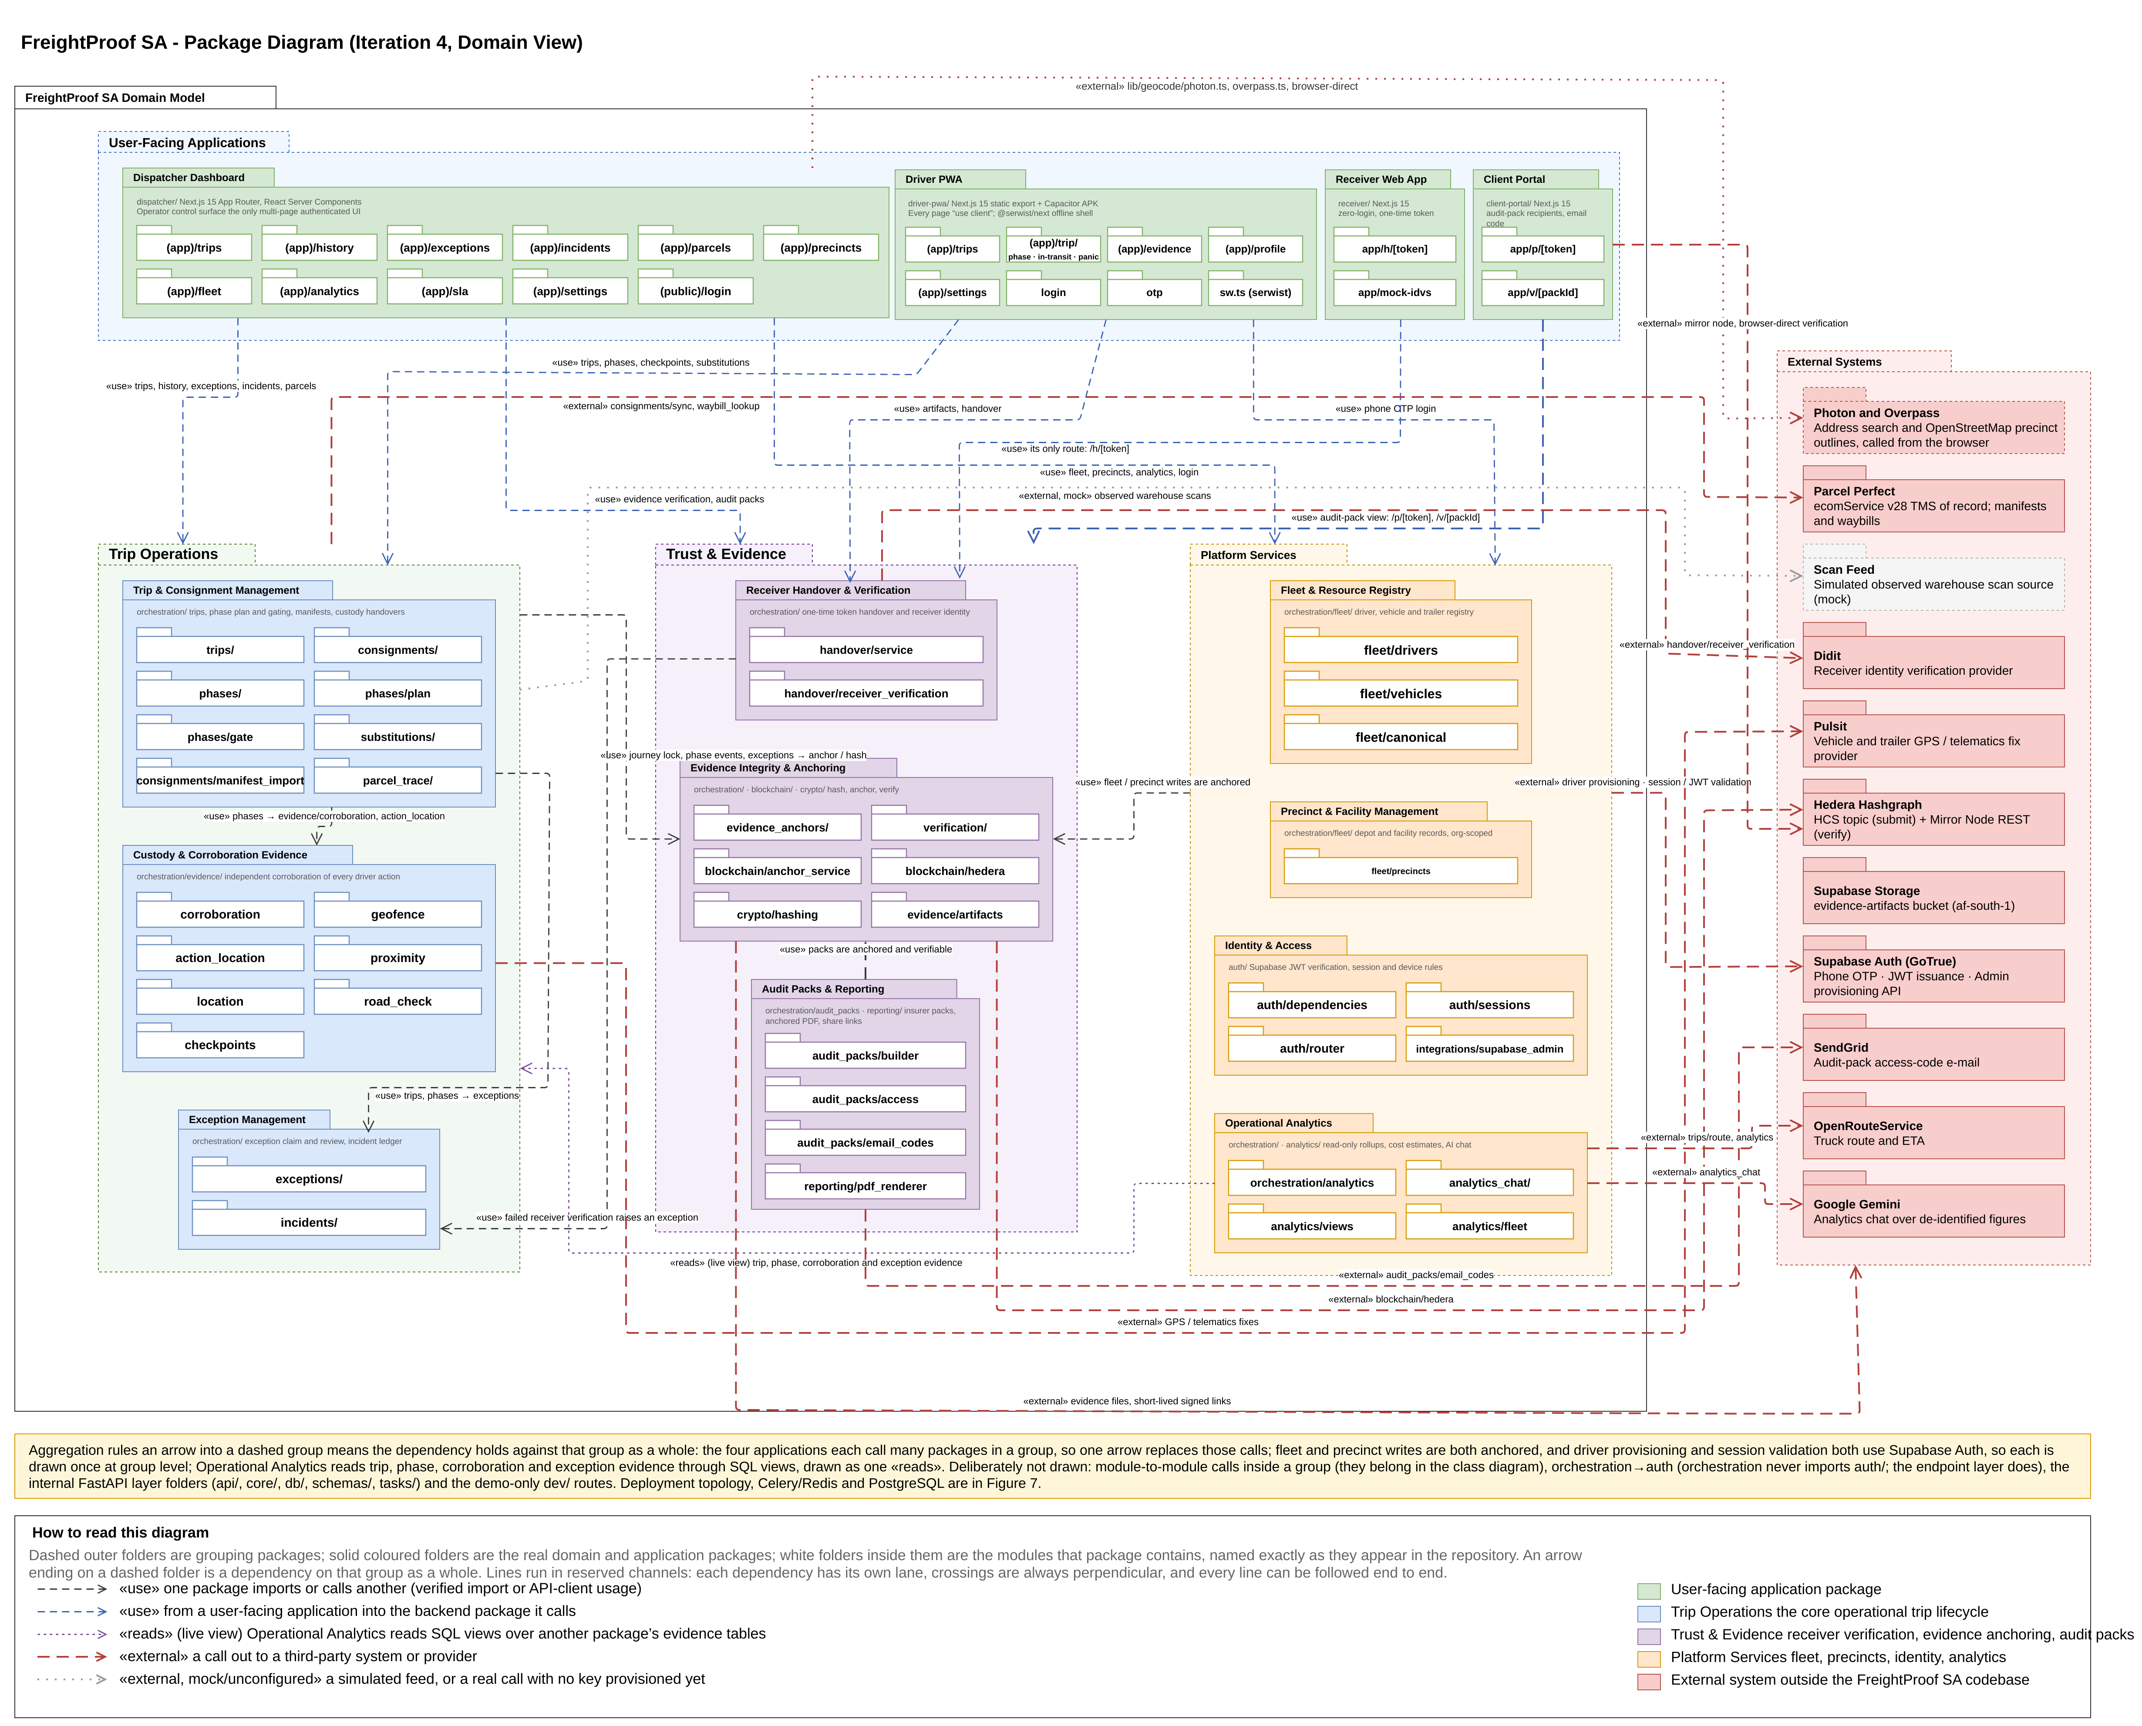
Figure 1: Package diagram

The dispatcher application, Driver PWA, receiver application and client portal depend on groups of packages rather than individual ones. The receiver application and the client portal each have only two routes, which is why they are drawn small. External systems remain behind interfaces with simulated and live implementations: Parcel Perfect supplies manifests and waybills, Pulsit supplies tracker positions, Didit performs optional receiver checks, SendGrid sends audit-pack access codes, OpenRouteService supplies planned routes, and Hedera receives fingerprints only. Figure 1 also shows three services used directly: Google Gemini answers analytics questions from de-identified figures, and, from the dispatcher's browser, Photon geocodes precinct addresses and Overpass supplies OpenStreetMap outlines of precinct properties.

6.2 Analysis Class Diagram
Figure 2 shows the analysis class model. It remains centred on Trip, with its ordered TripStops, its PhaseEvent ledger and its Consignments. Iteration 4 made five changes, which answer the Iteration 3 comment that parcel detail was modelled at too high a level:
- Cargo hierarchy. A loaded Trip now carries the key of the client's Parcel Perfect manifest. The hierarchy is manifest → waybill (Consignment) → Parcel. Each Consignment names its pickup stop and delivery stop, so a multi-stop trip can drop off and collect different waybills at each intermediate stop. The manifest snapshot taken at creation is stored on the trip-creation phase and covered by the journey lock.
- Arrival. PhaseEvent gains the seal condition found at arrival (intact, damaged or missing) and how the seal number was entered (read from the photo and confirmed, read and corrected, or typed).
- Exception review. TripException gains the claiming dispatcher and claim time, alongside the existing reviewer, outcome, contact method and note.
- Evidence sharing. AuditPack, AuditPackAccessEvent, AuditPackEmailCode and IncidentDeclaration are new. Incident groups related exceptions and affected parcels for a trip, with an append-only IncidentUpdate ledger. EvidenceAnchorEvent records each anchored exception, review and cancellation with its own receipt.
- Operations. CostProfile holds an organisation's cost rates for cost analytics, and DriverSubstitution, present but unused in Iteration 3, now records driver handovers, each fulfilling a dispatcher-arranged DriverSubstitutionRequest.
Figure 2b shows the classes new in Iteration 4 and the existing classes they attach to; Figure 2 shows the full model.

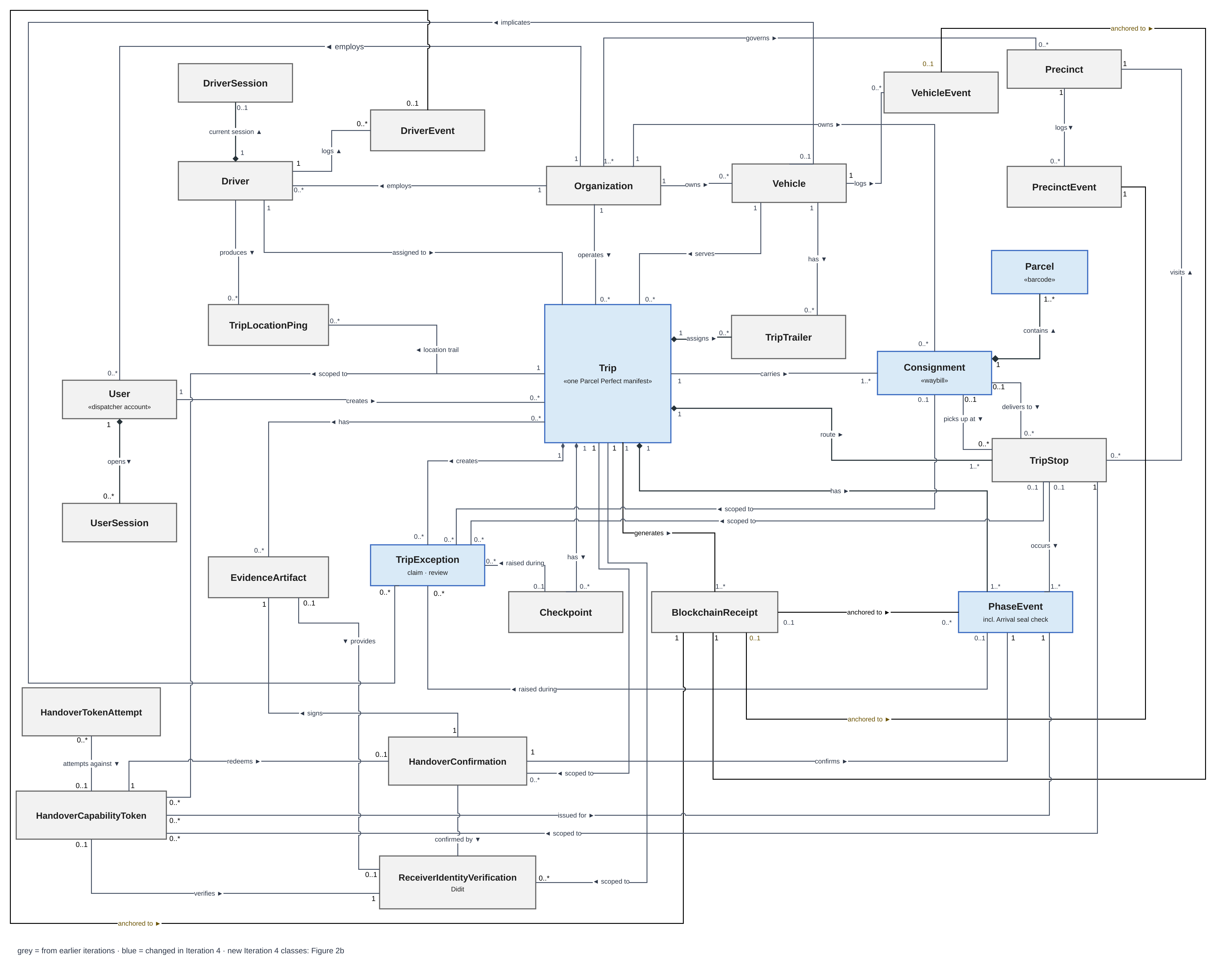
Figure 2: Analysis class diagram
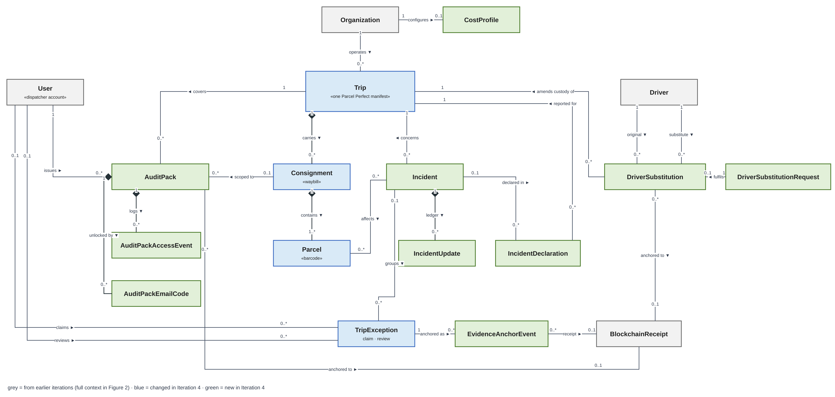
Figure 2b: Iteration 4 additions to the analysis class diagram
Damage in transit is recorded as an exception against the trip, the affected consignment and the affected vehicle, with photographs; an exception names at most one vehicle (§5.4). Pallet or handling-unit counts are not modelled: the partner could not confirm whether a handling unit sits between waybill and parcel, so counts stay at parcel level (§5.4).

6.3 Use-Case Model and System Boundary
The use-case model separates Trip Lifecycle Management (TLM) from Custody Chain Capture (CC). Iteration 4 adds audit-pack issuance and recipient verification, parcel tracing, arranged driver substitution and Arrival. Their actors and outcomes are indexed in Table 13 and described in §6.5.
System boundary. FreightProof is the system under consideration. Organisation scoping is an access-control boundary within that system. Dispatchers, Admin-Dispatchers and drivers act on their organisation’s records. Receivers and audit-pack recipients participate through limited links without platform accounts. External providers support identity checks, notifications, ledger publication and operational data exchange.
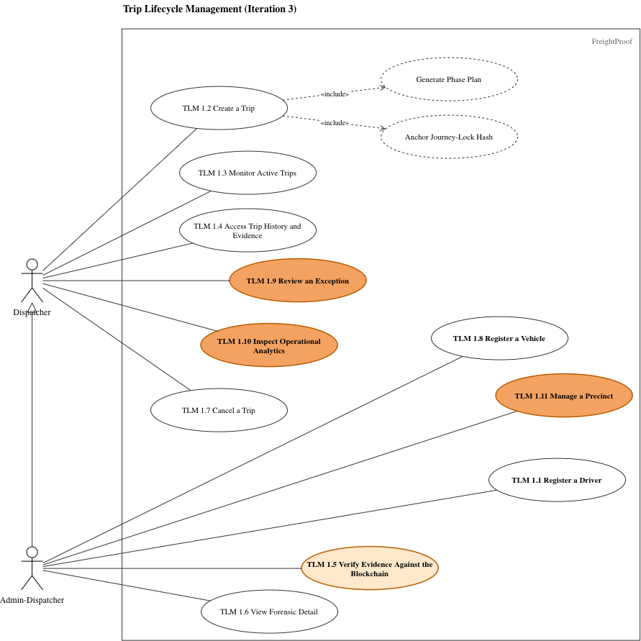
Figure 3: Trip Lifecycle Management use-case diagram
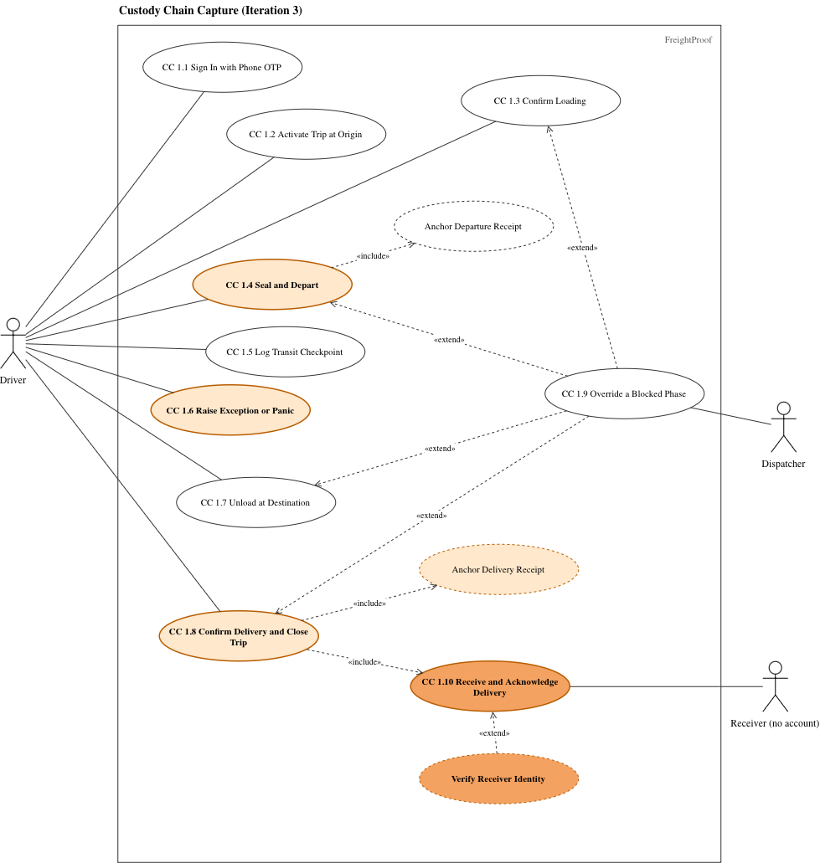
Figure 4: Custody Chain Capture use-case diagram
Table 13 shows how each use case is treated in this document. Retained narratives are in the Iteration 2 document (Team05, 2026a) or the Iteration 3 document (Team05, 2026b, §3.4, pp. 27–35).
Table 13: Use-case retention and change index
ID | Use case | Treatment in Iteration 4
TLM 1.1, 1.8 | Register a Driver; Register a Vehicle | Retained (Iteration 2)
TLM 1.2 | Create a Trip from a Manifest | Changed: written in full (FP-281, FP-139, FP-142)
TLM 1.3 | Monitor Active Trips | Changed: live trip list shows each trip's status, current phase, plan position and unreviewed exceptions (FP-289); covered in §8.2
TLM 1.4, 1.6 | Access Trip History; View Forensic Detail | Retained (Iteration 2)
TLM 1.5 | Verify Evidence Against the Blockchain | Retained (Iteration 3, pp. 33–34); now also verifies exceptions, reviews and cancellations
TLM 1.7 | Cancel a Trip | Changed: cancellation is anchored (BR-8); otherwise retained
TLM 1.9 | Review an Exception | Changed: written in full (FP-280, FP-290)
TLM 1.10 | Inspect Operational Analytics | Changed: cost view, today's incident map and figure sources (FP-294, FP-296); covered in §8.5
TLM 1.11 | Manage a Precinct | Changed: address search replaces typed coordinates (FP-309), and a precinct can follow its yard's outline; otherwise retained (Iteration 3, pp. 29–30)
TLM 1.12 | Issue an Audit Pack | New: written in full (FP-279, FP-291)
TLM 1.13 | Trace a Parcel | New: written in full (FP-149)
TLM 1.14 | Arrange a Driver Substitution | New: governed by BR-10 (FP-83)
CC 1.1–1.3, 1.5 | Sign In; Activate Trip; Confirm Loading; Log Transit Checkpoint | Retained (Iteration 2)
CC 1.4 | Seal and Depart | Changed: seal number read from the photo and confirmed by the driver (FP-300)
CC 1.6 | Raise Exception or Panic | Changed: severity per BR-1. A breakdown naming several vehicles (FP-297) was not built; an exception names one vehicle
CC 1.7 | Unload at Destination | Changed: the seal inspection moved to Arrival (CC 1.11)
CC 1.8 | Confirm Delivery and Close Trip | Changed: replacement steps below (FP-273)
CC 1.9 | Override a Blocked Phase | Changed: governed by BR-4
CC 1.10 | Receive and Acknowledge Delivery | Changed: replacement steps below (FP-316)
CC 1.11 | Record Arrival | New: written in full (FP-270)

6.4 Business Rules
Shared rules SR-1 to SR-9 remain in force where not replaced below (Team05, 2026b, Table 6). Table 14 defines the final release’s exception, override and evidence-sharing rules. “System” identifies automated enforcement; “procedure” identifies an operator responsibility.
Table 14: Business rules added in Iteration 4
ID | Rule | Enforced by
BR-1 | Severity. An exception is critical if a person may be at risk, cargo may be lost or reached by someone outside the custody chain, goods went to the wrong party, or the trip cannot finish as planned. The system raises panic, a seal broken in transit, a seal mismatch, a damaged or missing seal at arrival, a trailer separated from its horse, a vehicle moved before departure, a missing departure seal (unless that departure was overridden) and seal findings at a driver handover as critical; other exceptions start as warnings. When a reviewing dispatcher finds that a warning meets one of the criteria, for example cargo damage or a refused delivery, they handle it as critical under BR-3. Nobody may lower a severity. | System (severity by type); procedure (escalation)
BR-2 | Every exception is reviewed. Every exception starts unreviewed, except the notes a dispatcher writes when overriding a phase or cancelling a trip, which are created already reviewed by their author. A dispatcher claims it, which records who and when, and may release it. The review records an outcome, the contact method and a note; the first review is final, and the original report is never changed. Critical exceptions are reviewed one at a time; warnings on one trip may be reviewed together. Critical exceptions and every review are anchored. | System (FP-280, FP-290)
BR-3 | A critical report appears in the organisation’s live inbox when it reaches the server. The reviewing dispatcher promptly informs the operations manager of theft, hijacking, collision or injury. The manager notifies the principal and insurer under the applicable contract and policy and opens a SAPS case where appropriate. Incident declarations record notification times and reference numbers. These notification duties are operator procedures; the application records their completion. | System (live inbox, incident declarations); procedure (notifications)
BR-4 | A dispatcher may override a blocked phase with a mandatory reason; the override is anchored and labelled as overridden. For departure, arrival and confirmation, the operating procedure requires Admin-Dispatcher approval and available supporting evidence. The second approval is recorded in the reason rather than enforced as a separate approval transaction. Incident attachments require INCIDENT_DOCUMENTS_ENABLED. | System (reason, marking, anchoring); procedure (second approval, documents)
BR-5 | Disputed delivery. If the scanned count differs from the manifest, a parcel-count exception is raised as a warning; the reviewing dispatcher escalates a shortfall and handles it as critical under BR-1 and BR-3. If the receiver refuses to sign or disputes the goods, the driver records a delivery refused exception with a reason and photographs. The reviewing dispatcher then decides whether the delivery is completed, overridden under BR-4 or cancelled under BR-8, and the principal is notified under BR-3. The refusal stays on the record, and a later inspection result is added to the incident as an incident update, a new, attributed record, never by editing the original. | System (exceptions, receiver confirmation); procedure (decision, notification)
BR-6 | Lost, forgotten, stolen or dead phone. The driver reports it to the dispatcher by any available means. Signing in on a replacement phone ends the old session automatically, and the dispatcher deactivates the account if the phone was stolen. Phases that cannot be completed are overridden under BR-4. Evidence captured between the loss and the deactivation is treated as disputed, and a theft is reported to SAPS. | System (single session); procedure (reporting)
BR-7 | A receiver types their name and identity number and swipes to confirm through a single-use link. An optional document-and-face check never blocks delivery. Verification supports the recorded identity; it does not establish the person’s authority to receive for a company. Nominated authorised receivers are a pilot option. | System (handover link, optional check)
BR-8 | Cancellation. A reason is mandatory. The cancellation is anchored, the phases not reached stay pending as an honest record, and the manifest becomes available for a new trip. | System (FP-290)
BR-9 | Only an Admin-Dispatcher may issue an audit pack, for a stated purpose and named recipient. Contents are frozen and fingerprinted at issue. Access requires the share link and an e-mailed code; views are logged and access may be revoked. | System (FP-279, FP-291)
BR-10 | Driver substitution. A substitution is a normal custody event, not an exception. A dispatcher arranges it; the outgoing and incoming drivers each record the handover, including the seal, on their own phones. The original driver's record is kept. A seal mismatch at the exchange is critical. The exchange point is recorded as free text and is not compared with positions; each driver's phone position is compared with the truck's tracker. Substitutions are switched off by default (DRIVER_SUBSTITUTIONS_ENABLED). | System (FP-83)
BR-11 | Geofence size. A precinct's geofence can follow the yard's own outline, taken from OpenStreetMap and adjusted on the satellite map by an Admin-Dispatcher; when an outline is set, it is the fence and the radius is not used. Otherwise the Admin-Dispatcher sets the radius to cover the yard where trucks stand and handovers happen. The 200 m radius is only the default for a precinct without an outline, and the 50 m tolerance absorbs normal position error. | System (outline or radius per precinct); procedure (choosing it)

6.5 New and Changed Use-Case Narratives
The narratives state actors, preconditions, outcomes, success steps and alternatives. Failure paths distinguish automatic system behaviour from dispatcher and operator procedures.
Table 15: TLM 1.2 – Create a Trip from a Manifest (changed)
Actor | Dispatcher
Description | Create an evidence-bearing trip for one departure from the client's Parcel Perfect manifest, so that the cargo is imported rather than typed.
Pre / Post | Pre: dispatcher signed in; the manifest exists in Parcel Perfect. Post: one trip with its stops, consignments, parcels and phase plan; the manifest snapshot and journey lock anchored.
Main success scenario
Step | Actor action | System response
1 | Enters the manifest number. | Fetches the manifest and shows the client, route, planned times, waybills and parcel totals.
2 | Chooses the driver, horse and trailers. | Shows, beside each driver and vehicle option, whether it is already on a trip in the chosen window and when it is free ("On TRIP-x, free after …"), and names any trip that already holds a chosen driver or vehicle (FP-142).
3 | Reviews and confirms. | Checks again for clashes, creates the trip and phase plan, stores the manifest snapshot, and anchors the journey lock before saving.
Alternative and exception flows
1a | Manifest not found, or its waybills belong to different clients: the system refuses and names the reason.
1b | Parcel Perfect unavailable: the system refuses creation; no partial trip is saved.
1c | A non-cancelled trip already exists for this manifest: the system refuses a second trip and names the existing one.
2a | A precinct for the manifest's hub is not set up: the dispatcher chooses the precinct manually.
3a | A clash appears between steps 2 and 3, for example another dispatcher assigned the horse: creation is refused with the clashing trip named (FP-139).
3b | Hedera unavailable: creation is refused and nothing is saved (fail-closed), because the journey lock must be anchored.

Table 16: TLM 1.9 – Review an Exception (changed)
Actor | Dispatcher
Description | Assess every exception, record the conclusion and the contact made, and leave the original report unchanged.
Pre / Post | Pre: dispatcher signed in; the exception belongs to the organisation. Post: one immutable review with reviewer, time, outcome and contact method; critical exceptions and the review anchored (BR-2).
Main success scenario
Step | Actor action | System response
1 | Opens the unreviewed inbox, ordered by severity, or an exception from a trip timeline. | Shows type, severity, description, photographs, position, phase and stop.
2 | Claims the exception. | Records who claimed it and when, and shows the claim to other dispatchers live.
3 | Contacts the driver or site, then selects the outcome and contact method and writes a note. | Validates the review.
4 | Submits. | Stores the review without changing the report, anchors it, and removes the exception from the inbox.
Alternative and exception flows
2a | Another dispatcher has claimed it: the system shows who; this dispatcher may wait or ask them to release it.
2b | The dispatcher cannot finish: they release the claim and the exception returns to the inbox.
3a | Several warnings on one trip: the dispatcher reviews them together with one outcome and note; a review is stored for each. Critical exceptions cannot be batch-reviewed.
4a | Another dispatcher submitted first: the system refuses the second review and shows the first.
4b | Hedera unavailable: the review is saved, the receipt is marked owed and retried.
4c | The incident requires notification: the dispatcher follows BR-3 and records an incident declaration.

Table 17: TLM 1.12 – Issue an Audit Pack (new)
Actor | Admin-Dispatcher; audit-pack recipient (insurer or principal, no account)
Description | Give an outside party a frozen, verifiable evidence record of a trip or consignment without giving them access to FreightProof.
Pre / Post | Pre: Admin-Dispatcher signed in; trip belongs to the organisation. Post: frozen evidence pack and share link for a named recipient; access logged and pack integrity checkable against Hedera.
Main success scenario
Step | Actor action | System response
1 | Previews the trip's audit trail and chooses scope, purpose, recipient and whether to include the location trail. | Builds the pack from current records, marking each item as anchored or recorded only, and lists missing evidence.
2 | Issues the pack. | Freezes the contents, renders the PDF, anchors the pack's fingerprint and shows the share link once.
3 | Sends the link to the recipient. | No further action.
4 | Recipient opens the link and enters the code sent to their e-mail address. | Logs the view and shows the evidence page: timeline, route map, photographs, exceptions and parties.
5 | Recipient selects Verify. | The recipient's browser recomputes the fingerprints and checks them against the Hedera mirror service, then reports a match or a mismatch for each item.
Alternative and exception flows
4a | Wrong code entered repeatedly: access is locked and the attempt logged.
4b | Link revoked or expired: the page states this and shows no evidence.
5a | Hedera mirror unavailable: verification reports “could not check”, never a successful integrity check.
5b | The frozen pack is checked against its committed fingerprint. An altered payload produces a mismatch. Changes in the current trip after issue do not rewrite the issued snapshot.

Table 18: TLM 1.13 – Trace a Parcel (new)
Actor | Dispatcher
Description | Find a parcel by its barcode and see where it has been, derived from the phase ledger.
Pre / Post | Pre: dispatcher signed in. Post: none; the use case is read-only.
Main success scenario
Step | Actor action | System response
1 | Enters or scans a parcel barcode. | Finds the parcel among the organisation's consignments.
2 | Opens the result. | Shows the parcel's waybill, current state and a timeline of every phase and scan that involved it, with exceptions and evidence.
Alternative and exception flows
1a | Barcode not found in this organisation: the system shows "not found" and does not reveal other organisations' parcels.
2a | Parcel never scanned at a stop: the timeline shows the gap rather than inferring a location.

Table 19: CC 1.11 – Record Arrival (new)
Actor | Driver
Description | Record the seal as found at a stop before anything is opened, so that a break in transit is detected at the moment custody arrives.
Pre / Post | Pre: the preceding in-transit phase is complete; the driver is at the Arrival phase. Post: Arrival completed once, with seal number, condition, photograph and positions stored and anchored.
Main success scenario
Step | Actor action | System response
1 | Confirms arrival at the stop. | Records the phone, horse and trailer positions and compares each with the precinct geofence.
2 | Photographs the seal. | Reads the seal number from the photograph and asks the driver to confirm or correct it (FP-300).
3 | Confirms the number and records the seal as intact, damaged or missing. | Compares the number with the seal applied at departure.
4 | Swipes to complete. | Stores the evidence, anchors the phase and opens the next phase (unloading, loading or confirmation).
Alternative and exception flows
1a | Truck or a trailer outside the precinct: a location exception is raised for review; the driver continues.
1b | No usable position, or no signal: recorded as "could not check"; the action is queued on the phone and sent when signal returns.
3a | A seal mismatch, damage or absence raises a critical exception. The dispatcher receives it when the capture reaches the server; offline reporting is delayed until synchronisation.
4a | Phone lost or dead before completion: handled under BR-6; the phase is overridden only under BR-4.
4b | App data cleared before the queued action was sent: the capture is lost on the phone, but nothing false is recorded. The phase stays pending on the server and on the live trip list, and the driver recaptures it.

Table 20: Changed narratives: replacement steps for CC 1.8 and CC 1.10
CC 1.8 – Confirm Delivery and Close Trip (Driver)
Replaces step 5 | The driver completes the confirmation phase with the delivery photograph and the receiver's signature attestation from CC 1.10. The server refuses a signature uploaded by the driver (FP-273); it does not yet check separately that a receiver confirmation exists for the stop (§5.4).
Replaces alt. 3a | If the receiver lacks a suitable phone or connection, the driver requests a dispatcher override. BR-4 requires a recorded reason, manual Admin-Dispatcher approval and available supporting evidence. A photographed paper delivery note can be attached when incident attachments are enabled.
New alt. 5a | If the receiver refuses to sign, the driver raises delivery refused under BR-5.
CC 1.10 – Receive and Acknowledge Delivery (Receiver)
Step 3 (clarified) | Every receiver is offered the identity check and may accept it, decline it or say that no document is available (BR-7). Declining never blocks confirmation.
Replaces step 4 | If the receiver consents and has a document, they complete Didit's document-and-face check, and the server compares the name and identity number the receiver typed with those read from the document (SR-6). With no document the result is recorded as typed only; the receiver selfie was removed (FP-316).
Replaces step 5 | The receiver types their name and identity number and swipes to confirm; no signature is drawn. The app records the time and, if permitted, the position, and generates an attestation image from the name, identity number, time and position, which is stored as the signature (Swipe.tsx, render-attestation.ts).
Unchanged | Steps 1–2 and 6–8 and the alternative flows remain as in Iteration 3 (Team05, 2026b, pp. 30–31).

TLM 1.14 Arrange a Driver Substitution
Actor: Dispatcher, outgoing driver and incoming driver. Precondition: the trip belongs to the organisation and substitutions are enabled. The dispatcher arranges the handover; each driver records their own confirmation, seal evidence and position. The system retains the original custody record and records the new custody period. A clean handover is a normal event. Seal discrepancies or missing verification produce findings for review; the exchange description is not itself a geofenced location (BR-10).

6.6 State-Machine Diagram
Figure 5 shows the life of one trip. Iteration 4 made the following changes, answering the Iteration 3 comments that a refused activation had no drawn path, that the "more stops planned?" decision had no false branch, and that the current stop could not load.
- Created → Created on a refused activation. When the driver asks to activate, the guards are checked: the trip is not being started early, the driver and the vehicles are not on another live trip, and no earlier trip of the driver's is due. If any guard fails, the trip stays in Created and the driver is shown the reason. This is drawn as the [no] branch of the "Activation admissible?" choice, which returns the trip to Created.
- One loop per stop, in a fixed order. At each stop the order is: Arrival (every stop after the first), then Unloading [anything delivered here, or the final stop], then Loading [anything collected here]. A decision node then tests [more stops planned]: the [yes] branch goes to Departure and In Transit, and the [no] branch goes to Confirmation. The current stop therefore always loads before the vehicle departs.
- Arrival is a new state after every In Transit, where the seal is inspected (CC 1.11).
- Cancelled remains reachable from Created and Active, either directly or when a dispatcher reports an incident that stops the trip; a reason is mandatory and the cancellation is now anchored (BR-8). Closed is reached only when every phase in the plan is resolved: completed, ended with a recorded exception, or overridden.

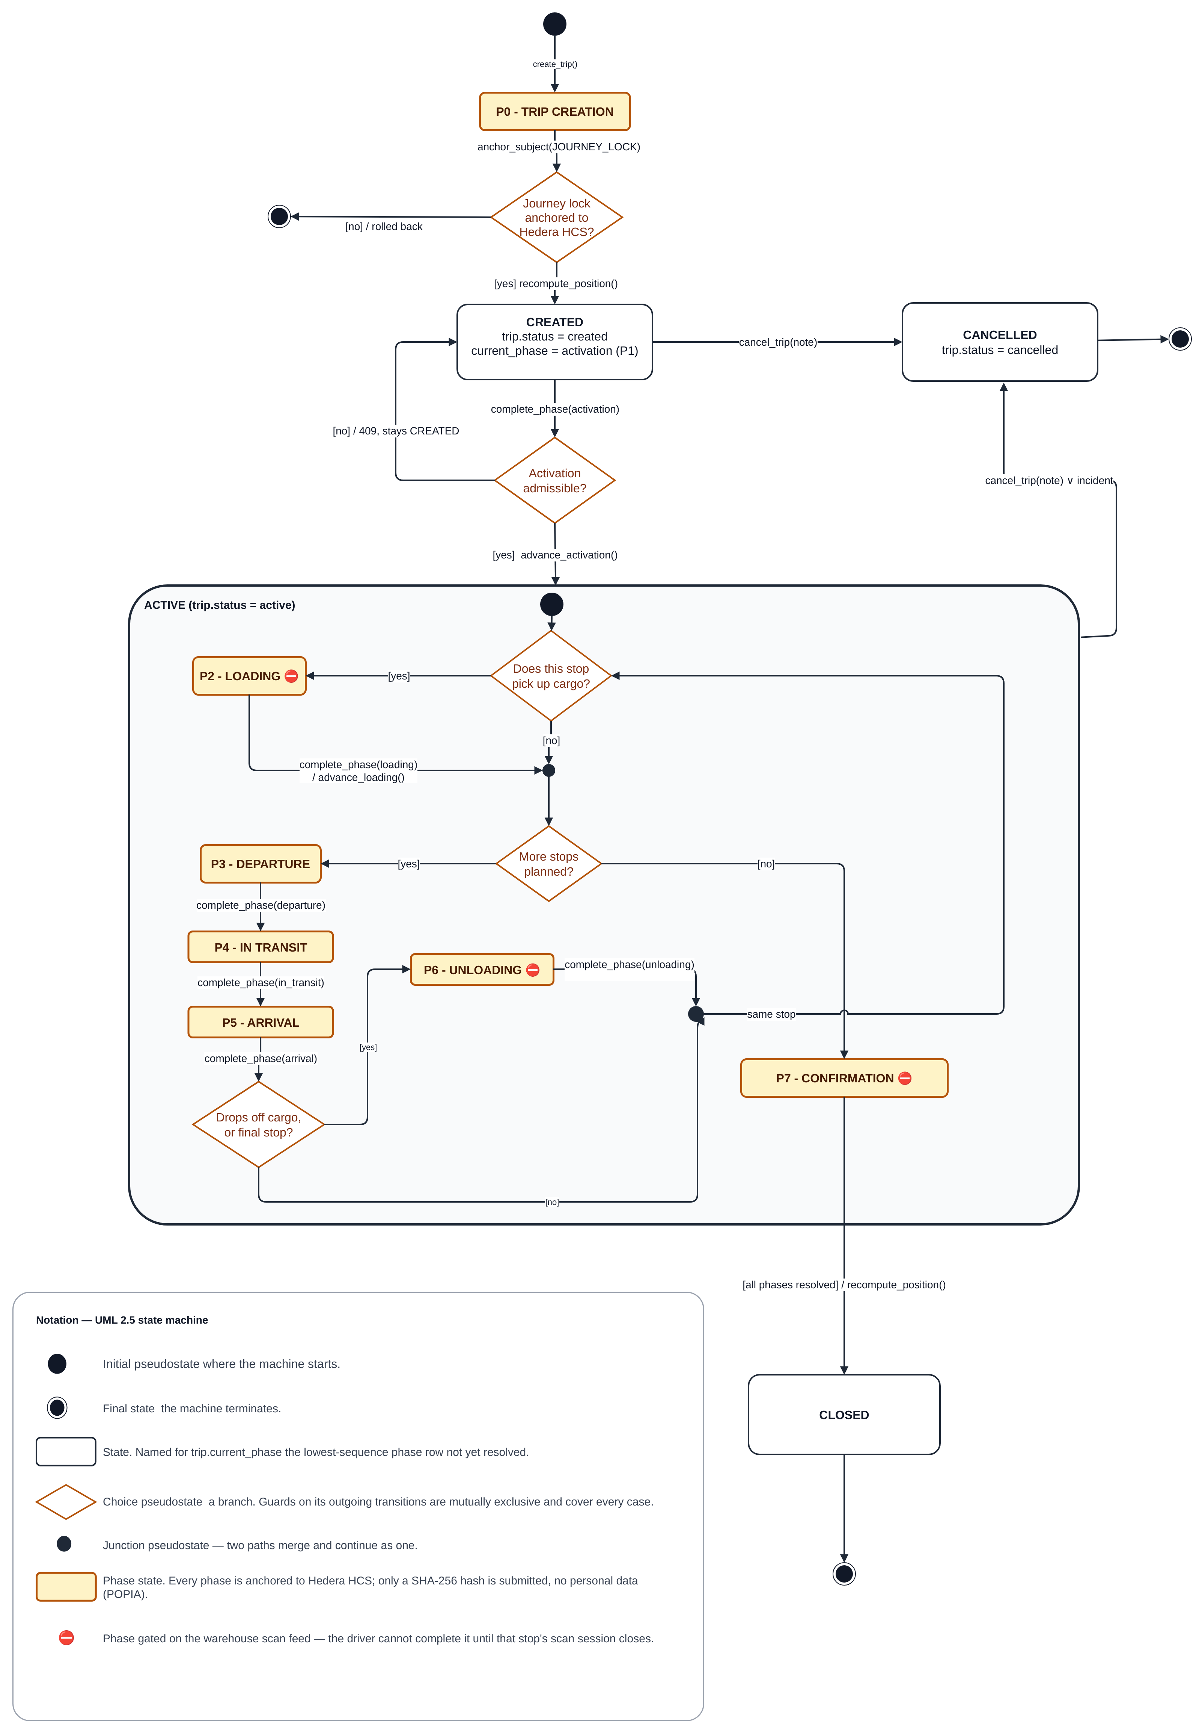
Figure 5: Trip state-machine diagram
Each exception also has a simple life cycle, enforced by BR-2: Unreviewed → Claimed (claim) → Reviewed (review). A claimed exception returns to Unreviewed when released, and a reviewed exception never changes state again.

6.7 Database Schema Changes
Schema changes are versioned through Alembic migrations. CI checks for a single migration head and applies the chain to a fresh test database. Table 21 identifies the final release’s new tables and changed columns; the relational model uses explicit keys and organisation scoping.
Table 21: Schema changes in Iteration 4
Table | Change | Story
trips | Manifest key (issuer account, origin hub, manifest number), unique among non-cancelled trips; order number made optional | FP-281
precincts | Parcel Perfect hub code, so a manifest's hubs resolve to precincts | FP-281
precincts | Geofence outline (geofence_polygon): the corners of the yard's outline; when set, it is the fence and the radius is not used | —
phase_events | Seal condition at arrival; seal-number entry method (seal_number_source); manifest snapshot on the trip-creation row; arrival phase type | FP-270, FP-300
exceptions | Claiming dispatcher and claim time; review status for every severity | FP-280
evidence_anchor_events (new) | One row per anchored exception raise, review or cancellation, with its frozen payload and receipt | FP-290
audit_packs, audit_pack_access_events, audit_pack_email_codes (new) | Issued packs with their fingerprints, share-link hashes, access log and one-time codes | FP-279, FP-291
incident_declarations (new) | Notifications and declared facts for an incident (BR-3) | FP-279
incidents, incident_updates, incident_exceptions, incident_parcels (new) | An incident groups related exceptions and affected parcels on a trip; incident_updates is its append-only log of later information | —
cost_profiles (new) | Per-organisation cost rates for cost analytics | FP-294
driver_substitutions | Now written by the substitution workflow | FP-83
driver_substitution_requests (new), with driver_substitution_confirmations, driver_substitution_confirmation_artifacts, driver_substitution_notices, driver_substitution_corrections, driver_substitution_operations, late_driver_evidence and late_driver_evidence_artifacts | Dispatcher-arranged substitution requests, each driver's confirmation and uploads, and evidence sent late | FP-83
receiver_identity_verifications | Receiver selfie no longer stored, so its column is unused (FP-316); resolved_at records when the receiver's own check recorded its final verdict | FP-316

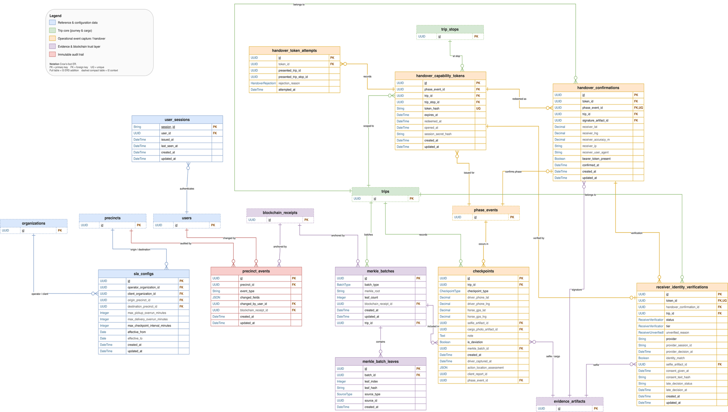
Figure 6: Entity relationship diagram
New evidence tables use row-level security and restricted direct access. Personal records remain in the managed database and file storage. Only the selected cryptographic commitments are published to Hedera; §7.2 distinguishes captured evidence from committed evidence.

7. Architecture

7.1 Deployment Architecture
The deployment view separates user devices, web hosting, the API, background processing, managed data services and external providers. The current container configuration targets Fly.io for the API, worker and scheduler. Application structure is shown separately in Figure 1.
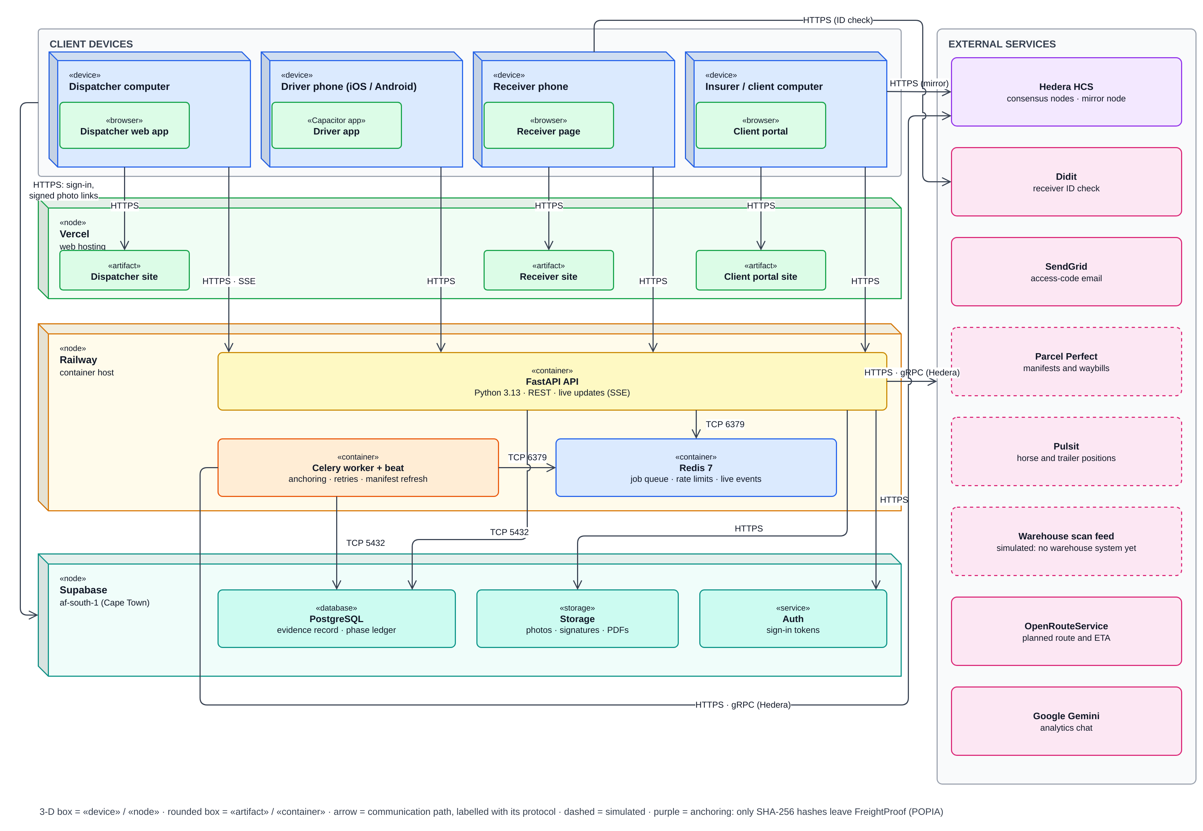
Figure 7: Deployment architecture diagram
Table 22: Deployment nodes and connections
Node | Runs on | Connections and purpose
Dispatcher application | Vercel (www.freightproof.co.za) | HTTPS/REST to the application programming interface (API); Server-Sent Events (SSE) for live trip and exception updates
Driver app | Driver's phone: iOS (TestFlight) and Android, in a Capacitor shell | HTTPS/REST to the API; actions queued on the phone when offline and sent when signal returns
Receiver application | Receiver's phone browser; Vercel (receiver.freightproof.co.za) | HTTPS to the API through a single-use link and a browser-binding cookie; Didit only when the receiver accepts a check
Client portal | Recipient's browser; Vercel (portal.freightproof.co.za) | HTTPS to the API's public audit-pack endpoints; direct HTTPS to the Hedera mirror service for independent verification
API | Fly.io container configuration (api.freightproof.co.za) | The only component that writes evidence; holds all business rules
Background worker and Redis | Fly.io process groups and configured Redis service | Anchoring jobs and retries; a recovery sweep every 60 s for receipts owed over 5 min; manifest refresh; rate limits; live-event fan-out
Supabase managed services | Managed PostgreSQL, file storage and authentication | Managed records, photographs, attestations and PDFs; authentication and short-lived file links. Database, authentication and storage residency follow the selected project region and provider processing arrangements.
External services | Hedera, Parcel Perfect, Pulsit, scan feed (simulated: no warehouse system yet), Didit, SendGrid, OpenRouteService, Google Gemini (analytics chat) | Fingerprints out and receipts in; manifests and waybills; tracker positions; parcel scans; receiver checks; access-code e-mail; planned routes; answers to analytics questions

Trust boundaries. Three boundaries matter. The receiver's browser and the recipient's browser are outside FreightProof's control, so what they submit is evidence, not proof. The API is the only writer of evidence. Hedera is outside FreightProof's control, which is exactly why it is used: an operator cannot rewrite a fingerprint after it has been published.

7.2 Integrity Model and Terminology
The Iteration 3 document used "fingerprinted" in a way that could be read as "digitally signed". The terms are now used precisely:
- A fingerprint is a SHA-256 hash of a record's committed values (National Institute of Standards and Technology [NIST], 2015). Any change to those values produces a different fingerprint. A fingerprint is not a digital signature: it shows that a record changed, not who created it.
- Anchoring publishes the fingerprint to a Hedera Consensus Service topic. Each submission is signed with FreightProof's Hedera account key, and Hedera's consensus assigns it an order and a timestamp (Hedera, n.d.). The receipt therefore proves that this exact set of values existed no later than the consensus time. It does not prove that the values were true.
- Verification rebuilds the record's committed values from the database, recalculates the fingerprint and compares it with the anchored one. The result is "matches", "does not match" or "could not check".

Anchoring covers selected canonical fields, not every column on an evidence row. Critical exception reports, reviews and cancellations have separate event commitments, so a review does not rewrite an earlier receipt. Free text is committed as a hash. Phase location observations remain outside the phase payloads; a frozen audit pack protects its included snapshot from its issue time.
Evidence | Phase or event commitment | Audit-pack snapshot
Seal and delivery artefacts | Role-labelled file hashes for supported phases. | Included evidence is represented in the frozen manifest.
Activation, transit and unloading | Phase identity; driver/custody envelope where applicable. | Included records are frozen at issue.
Location observations | Outside the phase canonical payload. | Included location trail is protected from pack issue time.
Critical exception, review, cancellation | Separate canonical event commitments. | Available events and protection states are included.
The frozen audit-pack manifest protects included evidence from issue time. A successful check establishes agreement with the ledger commitment; it does not prove the truth or completeness of the original observations.

7.3 Configured Values and Their Rationale
Iteration 3 stated several numbers without explaining them. Table 23 gives the reason for each. Most are configuration settings rather than constants in the code and can be tuned in the pilot. The exceptions are the 200 m radius, a default in the database schema that is changed per precinct, and the 60 s anchoring time, which is a target rather than a setting.
Table 23: Configured values and their rationale
Setting | Value | Why this value
QR code rotation | 20 s | A photograph or screenshot of the code stops working within 20 s, which limits a forwarded or remote handover. Scanning a code that is on screen takes a few seconds, so honest use is not affected. The code stops rotating once the receiver opens it, and the driver can always show a fresh one.
Handover link lifetime | 10 min | Long enough to complete the confirmation; extended once when an identity check starts, because a check can take several minutes.
Precinct geofence | Yard outline, or 200 m radius (default); 50 m tolerance | A precinct can follow its yard's own outline, traced from OpenStreetMap and adjusted on the map; the outline is then the fence and no radius is used. The 200 m radius is only the default for a precinct without an outline, set per precinct (BR-11); 200 m was a sample in the Iteration 3 screenshots. The 50 m tolerance absorbs normal phone and tracker inaccuracy.
Driver-to-truck separation | 100 m | A driver performing a handover stands at the truck. 100 m allows for a large yard and Global Positioning System (GPS) error while still detecting a phone that is somewhere else.
Position freshness | Phone vs truck: 60 s age, 30 s apart. Horse and trailer fixes: up to 300 s from the action | Comparing positions taken at different times would produce false mismatches. Older positions are "could not check". Trackers report less often than phones, so a horse or trailer fix may be up to 300 s from the action; a larger gap also rejects a replayed offline action.
Trailer-to-horse separation | 500 m | A coupled trailer parked at the edge of a fence must not raise a critical alarm; a decoupled trailer on the road should.
Anchoring receipt time | 60 s (target, not a setting) | Submissions take four to six seconds; 60 s leaves room for retries without delaying the driver.
Manifest refresh | 60 s | Keeps expected cargo current while a trip is active, within Parcel Perfect's request limits.
Idle sign-out | 60 min | Long enough that a dispatcher working a shift is not signed out between interactions, while still ending an unattended session or phone. Raised from 10 min in Sprint 9.

7.4 Legal Standing of the Receiver's Signature
The receiver’s confirmation is the deliberate action associated with the delivery record: a typed identity and swipe through a single-use link. The stored attestation image represents that action; the image alone is not evidence that a particular person performed it. ECTA recognises electronic signatures and sets reliability conditions where the parties require a signature without agreeing its type (Electronic Communications and Transactions Act, 2002, s. 13). FreightProof is designed to preserve the action and supporting context; legal sufficiency depends on the transaction and the reliability of the method.
ECTA section 15 is also relevant: evidential weight considers how a data message was generated, stored and communicated, how integrity was maintained and how the originator was identified. FreightProof supplies records for that assessment. A matching fingerprint establishes integrity of committed values, not truth, authority to receive or automatic acceptance by an insurer. Operational use requires agreed receiving and evidence procedures.

7.5 Integration Status
Table 24 gives the final state of each integration.
Table 24: Integration status at the end of Iteration 4
Component | Implemented capability | Mode | Failure behaviour
Supabase | Records, files, authentication, organisation scoping, row-level security | Implemented managed services | Requests refused; nothing written
Redis and worker | Anchoring, retries, recovery sweep, manifest refresh, live events | Configured worker and scheduler | Receipts owed and retried
Hedera | Fingerprints out, receipts in, mirror verification | Hedera test network | Phases complete and anchor later; trip creation refused
Parcel Perfect | Manifest import, waybill lookup and refresh | Simulated manifest feed | Trip creation refused
Scan feed | Scan gating and parcel comparison | Simulated | Phase waits; override under BR-4
Pulsit | Horse and trailer positions; on-road tracker check | Simulated | "Could not check"; driver continues
Didit | Optional receiver identity check, offered to every receiver | Live provider integration; optional and off by default | Recorded as unverified; delivery continues
SendGrid | Audit-pack access codes | Access-code integration | Code not sent; dispatcher re-issues
OpenRouteService | Planned truck route and expected arrival | Live | Falls back to the planned arrival time
Google Gemini | "Ask about these figures" analytics chat, answering from de-identified figures (FP-295) | Built; off unless AI_CHAT_ENABLED and an API key are set | The chat is unavailable; the figures are unaffected
Dispatcher assistant | Help panel in the dispatcher application that looks up the organisation's records and answers questions, using the same provider and key; record details, including driver names, are sent to the provider | Built; off unless ASSISTANT_ENABLED and the provider key are set | The assistant is unavailable; nothing else is affected

7.6 Quality Attributes
Requests use signed tokens except explicitly public capability endpoints and the health check. The API scopes data by organisation and restricts fleet changes and audit-pack issuance to Admin-Dispatchers. Rate limits, upload limits and database access restrictions reduce misuse. Identity verification, e-mail delivery and the optional assistant involve external processing; these flows require appropriate operational privacy arrangements before a live pilot.
CI checks style, typing, structural limits, layering, imports, tests, migrations and all four frontend builds. Structural checks prevent new violations and growth beyond the recorded baseline; they do not imply that every existing function is below a universal size limit.
Scalability and performance. Database connection and pool-wait timeouts make a slow database fail fast instead of hanging requests (FP-275). A load test against a separate environment was planned to measure these limits and anchoring latency (FP-299; §9.3), but it has not been built or run. Analytics are calculated from read-only views each time they are read.

8. User Interface (UI) Mock-ups and Design Rationale

8.1 Design Approach
Screens are organised around the user’s task, frequency of use and decision. The dispatcher’s desktop interface provides an overview of active trips, exceptions and incidents, with a trip timeline for investigation. Driver and receiver screens focus on the next custody action. The dispatcher screenshots in this section show the local prototype at a 1,600 × 1,000 desktop viewport.
Table 25: Screen design rationale
Screen | User | Used | Must be visible at first glance
Live trip list (§8.2) | Dispatcher, operations room | Continuously | Which trips need attention now: status and current phase, plan position, unreviewed exceptions
Trip timeline (§8.3) | Dispatcher | When a trip needs attention | What happened in each phase, in order, and what is wrong; exceptions inside the phase where they occurred
Exception inbox and review (§8.4) | Dispatcher | Several times a day | Severity, what happened, who has claimed it, what must be decided
Analytics (§8.5) | Operations manager | Daily for today's incidents; weekly or monthly for the rest | Today's incidents on a map (Routes & sites tab); where problems and cost concentrate, with the source of every figure
Receiver handover (§8.6) | Driver and receiver | At every delivery | One clear instruction per screen; nothing that slows a delivery
Precinct set-up (§8.7) | Admin-Dispatcher | Rarely | The geofence on a map, placed by address and following the yard's outline
Audit pack and portal (§8.8) | Dispatcher; insurer or principal | Per incident or claim | What the pack contains, what is anchored, and whether it verifies

8.2 Live Trip List: the Summary of the Summary
The dashboard opens with active trips, unreviewed exceptions and open incidents. Each trip row identifies the manifest, driver and horse, route, exception workload, current phase and plan progress. Live updates keep the view current and selectable rows open the trip timeline. Time since last update and the latest location comparison remain available through drill-down rather than as dedicated list columns.
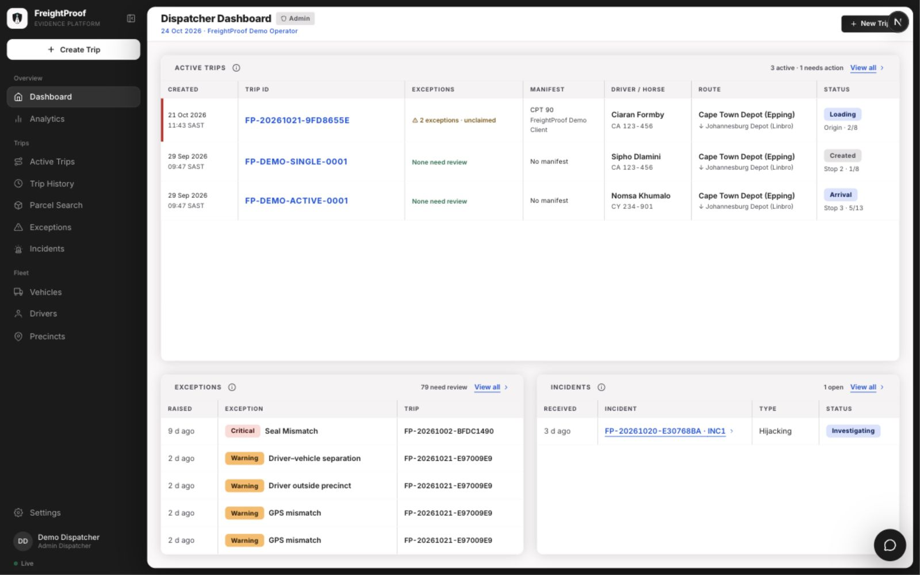
Figure 8: Live trip list: every running trip at a glance (local desktop prototype, 24 October 2026)

8.3 Trip Timeline
Each phase on the trip page is a card with a one-line verdict ("Checks passed", "Needs attention" or "In progress"), followed by the acts inside the phase as a live mini-timeline: what was recorded, then what was checked (FP-288). Photographs appear as soon as they are uploaded, not when the phase completes (FP-287). The design answers each of the Iteration 3 comments:
- Exceptions are inside the phase where they happened, not in a corner panel. A phase with an unreviewed exception turns amber and shows its count in the verdict line (Figure 9). Each exception opens the review panel directly.
- Driver and vehicle details appear once, in the trip summary above the timeline, with a call link to the driver. They are not repeated on each phase card, so the most visible space carries the verdict lines.
- The current position on a multi-stop route is explicit: completed phases show a tick, the current phase pulses and names its stop, and future phases are dashed and labelled "Not started" (Figure 10).
- Order. Phases run oldest to newest, because a trip is read as a sequence of custody events and later phases depend on earlier ones. The "Jump to current phase" button and the live list (§8.2) give the newest state immediately, so the dispatcher never scrolls to find it.

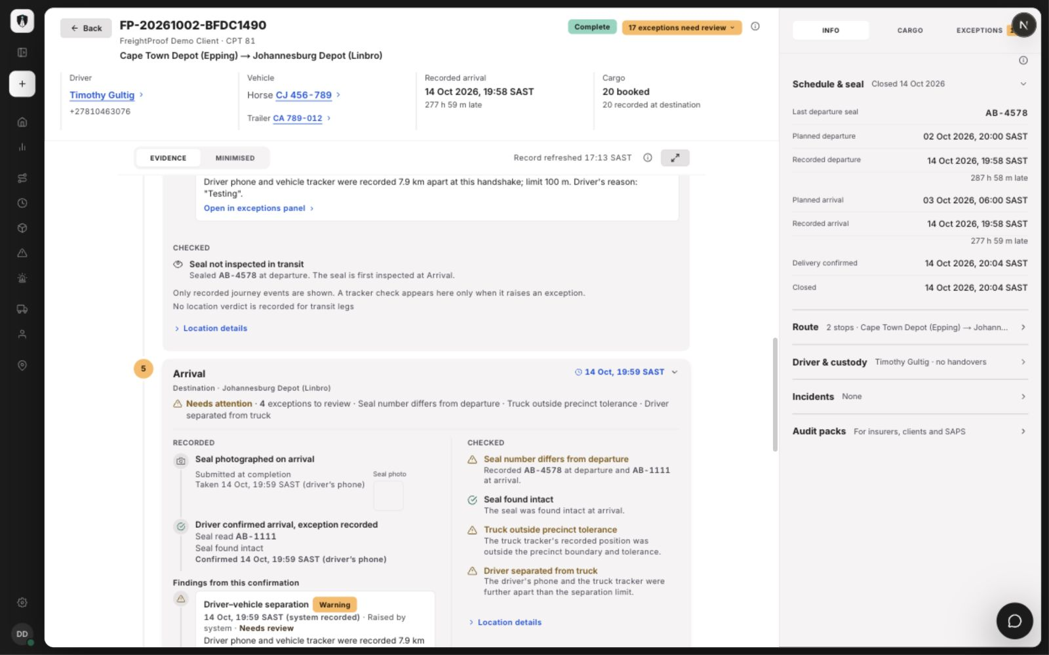
Figure 9: Arrival evidence with critical and warning exceptions (local desktop prototype)
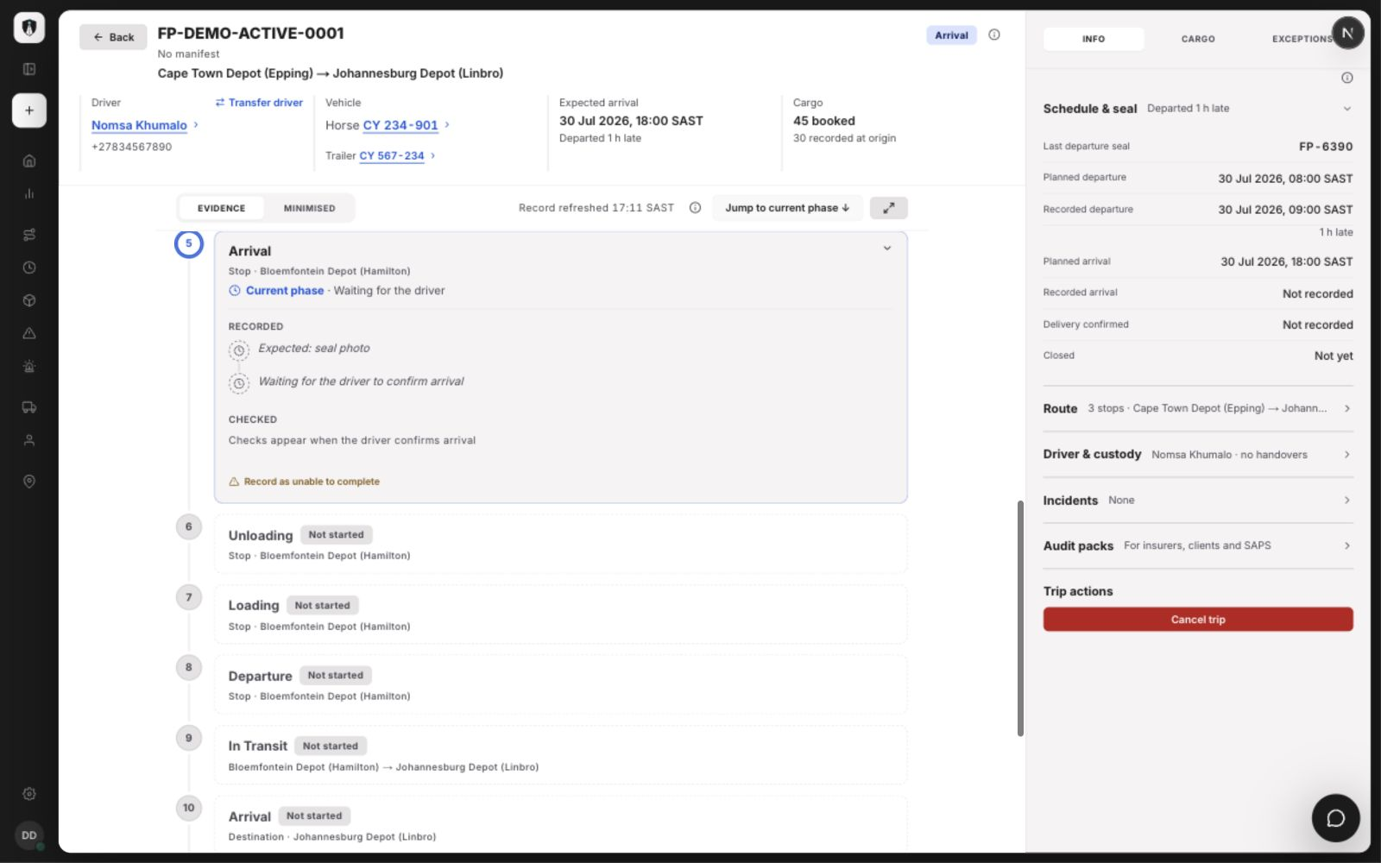
Figure 10: Multi-stop trip at intermediate Arrival (local desktop prototype)

8.4 Exception Inbox and Review
Every exception now reaches the dispatchers' shared inbox (FP-280), ordered by severity, with tabs for Unreviewed, Claimed by me and History. A dispatcher claims an exception before working on it, so two people do not phone the same driver, and the claim is visible to everyone live. The review form records the outcome, the contact method (phone, WhatsApp or in person) and a note. Several warnings on one trip can be reviewed together, which keeps a demonstration trip with 15 minor findings from flooding the inbox. Reviewing never alters the original report; the review is anchored (FP-290).
The surrounding process is defined by BR-3 to BR-5. An incident groups related exceptions and affected parcels; declarations record notification times and reference numbers. Later findings are appended as attributed incident updates. Manual approval and document requirements remain operating procedures, and document attachment depends on its feature setting.
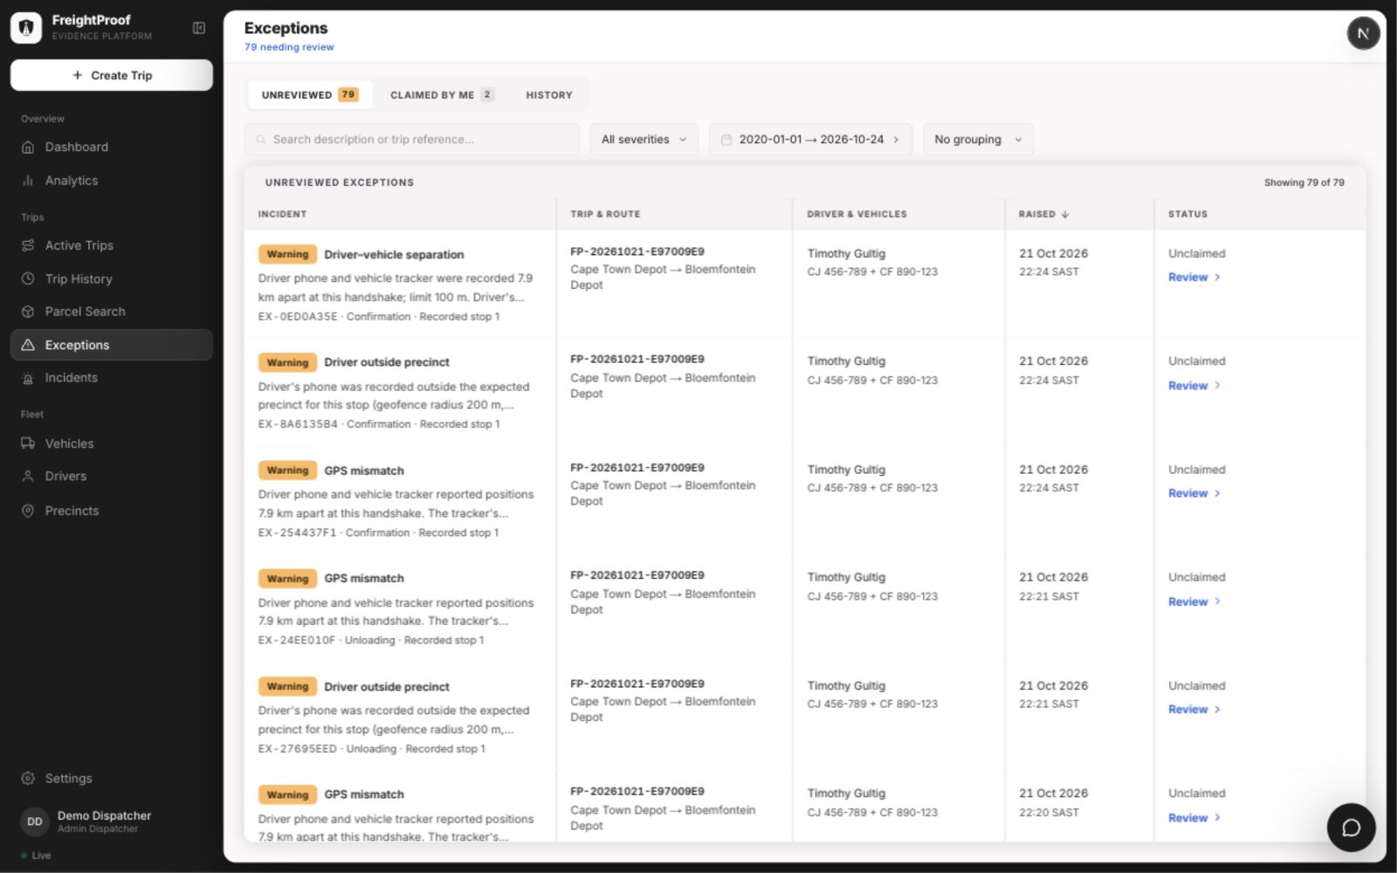
Figure 11: Shared exception inbox (local desktop prototype)
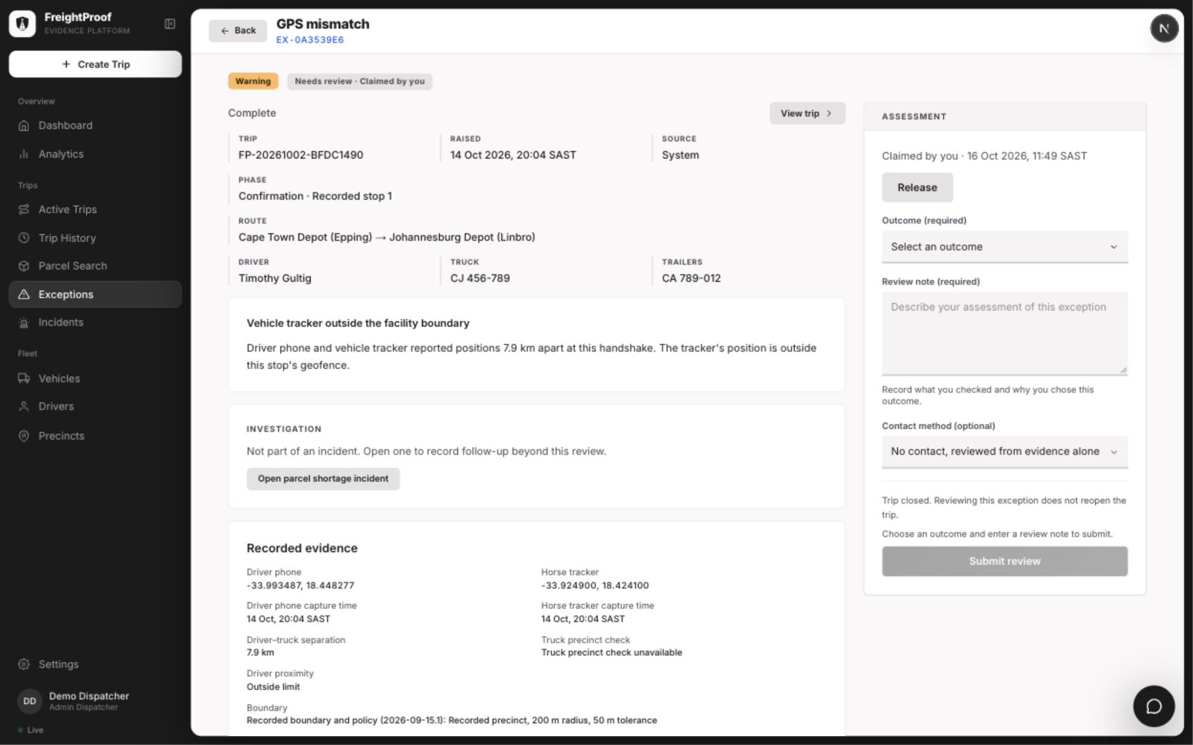
Figure 11a: Exception review showing outcome, note and contact method (local desktop prototype)

8.5 Analytics
The analytics page has seven tabs: Activity, On time, Problems, Review desk, Evidence, Routes & sites, and a new Cost tab (FP-294). Each covers a chosen period, for weekly or monthly analysis. For daily use, the incident map in the Routes & sites tab can be switched from the period to Today: it then shows today's incidents, updates by itself when a report is raised, and can be opened directly from a link (FP-296). The Cost tab shows the declared value of cargo on trips that had a theft signal, and estimated operating and delay costs from rates an Admin-Dispatcher can edit.
Analytics distinguish recorded values from estimates and identify the basis of each figure. Small samples are flagged. The optional analytics chat answers from de-identified figures and is disabled unless configured. Figures 12–14 show the daily view, cost estimates and activity charts; these are demonstration data, not measured business outcomes.
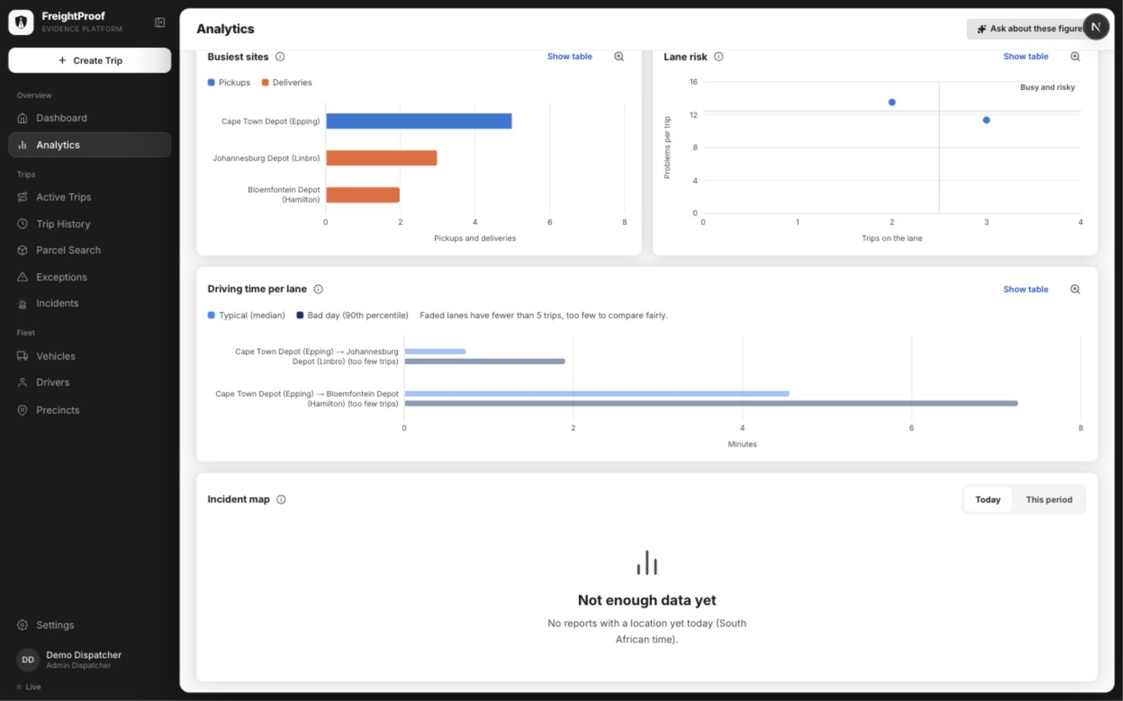
Figure 12: Daily incident-map view with no reports recorded today (local desktop prototype)
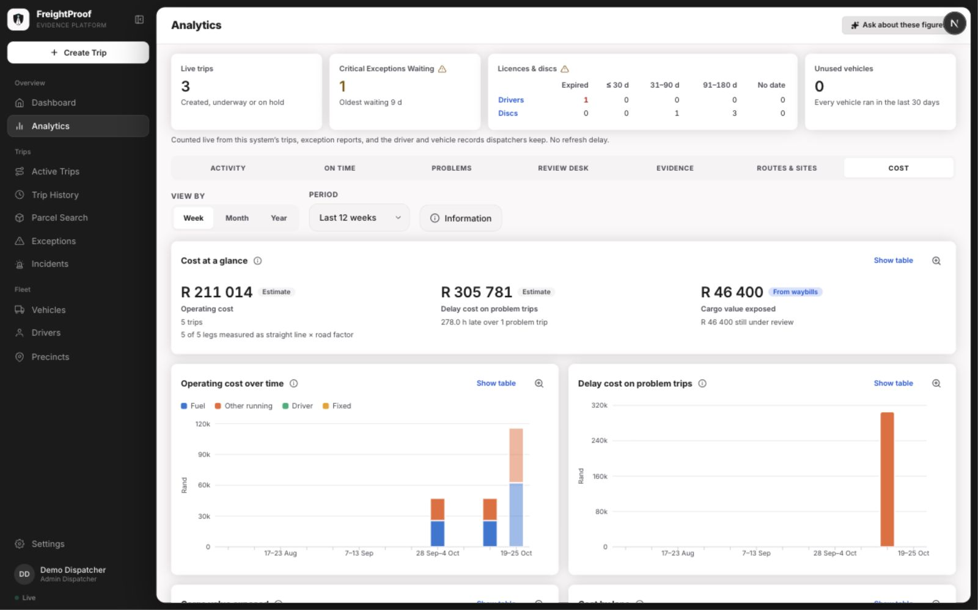
Figure 13: Analytics Cost tab (local desktop prototype, 24 October 2026)
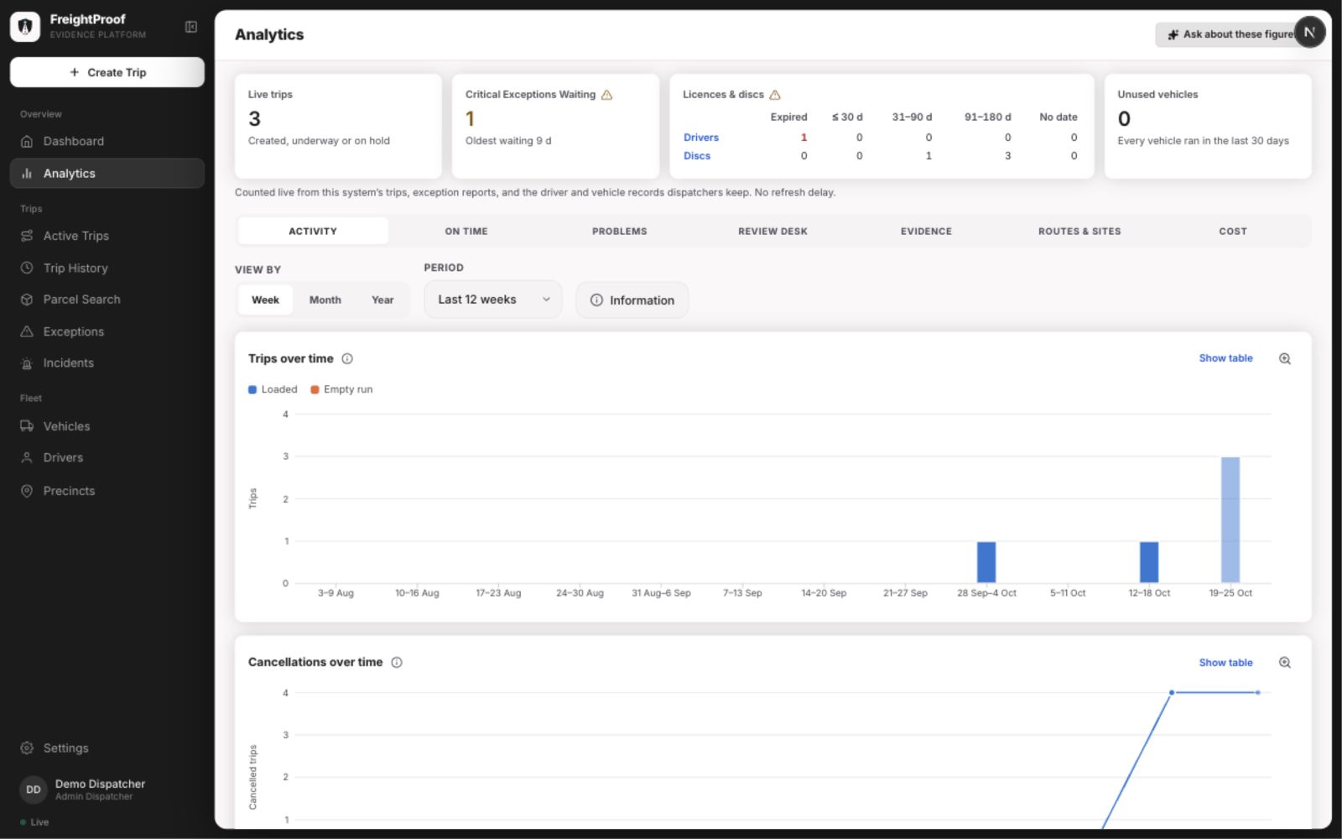
Figure 14: Analytics headline tiles (local desktop prototype, 24 October 2026)

8.6 Driver App: Arrival and Receiver Handover
At Arrival the driver photographs the seal; the app reads the seal number from the photograph and asks the driver to confirm or correct it, instead of typing it (FP-300). The seal's condition is recorded as intact, damaged or missing (Figure 15).
Figure 15: Driver app: seal number read from the photograph at Arrival
The driver shows a rotating QR code. The receiver opens the link on their own phone, enters their identity and swipes to confirm, with an optional identity check. The driver then sees the acknowledgement status. Example screens use demonstration records; identity-document images are excluded.
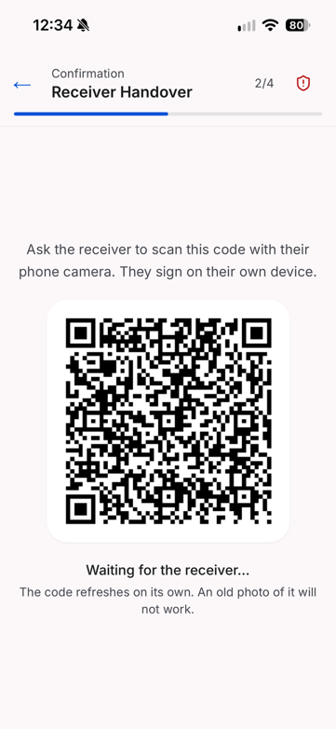  Figure 16: Driver app: QR code for the receiver | 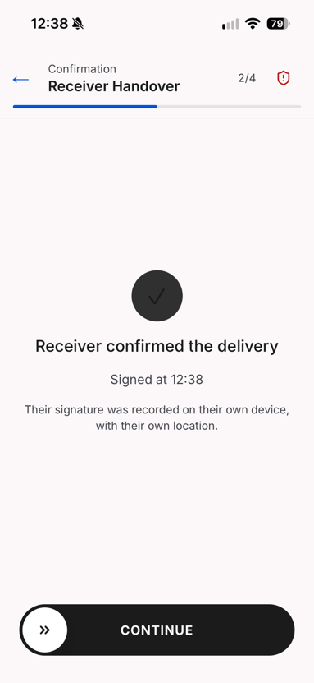  Figure 17: Driver app: receiver confirmation received

8.7 Precinct Set-up
An Admin-Dispatcher now finds a precinct by searching for its address, which places the pin on the map and fills in the coordinates (FP-309); a click on the map moves the pin and sets its coordinates. The geofence can then follow the yard's own outline: the form fetches the property's outline from OpenStreetMap through the Overpass service, and the Admin-Dispatcher drags its corners to the fence line on the satellite view. A precinct without an outline uses a radius, drawn on the map and set per precinct (BR-11). Figure 18 shows the precinct list with each geofence and whether the precinct is owned or shared, and Figure 19 the address search.
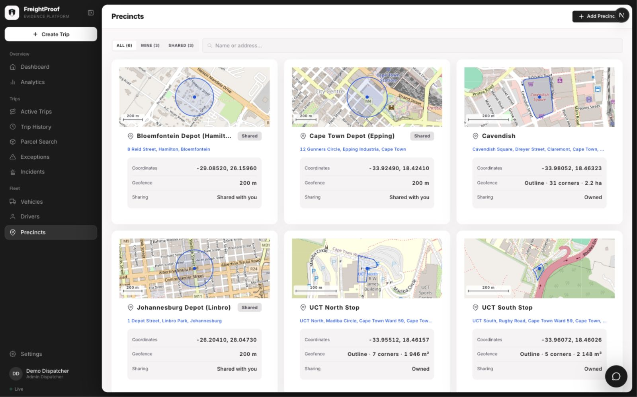
Figure 18: Precinct list with geofences (local desktop prototype, 24 October 2026)
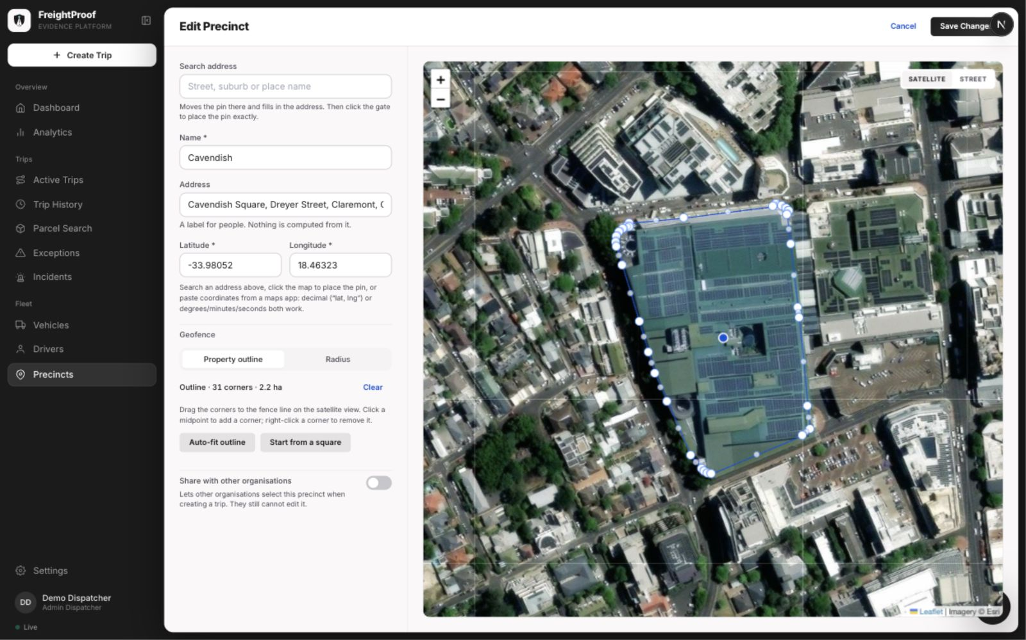
Figure 19: Precinct form with address search and editable property outline (local desktop prototype)

8.8 Audit Pack and Client Portal
An Admin-Dispatcher opens Audit packs from the trip’s Info tab to preview evidence, issue a pack, inspect access records or revoke sharing. The client portal presents the frozen evidence and integrity checks. Records are labelled by the protection available, and evidence gaps remain visible to the recipient.
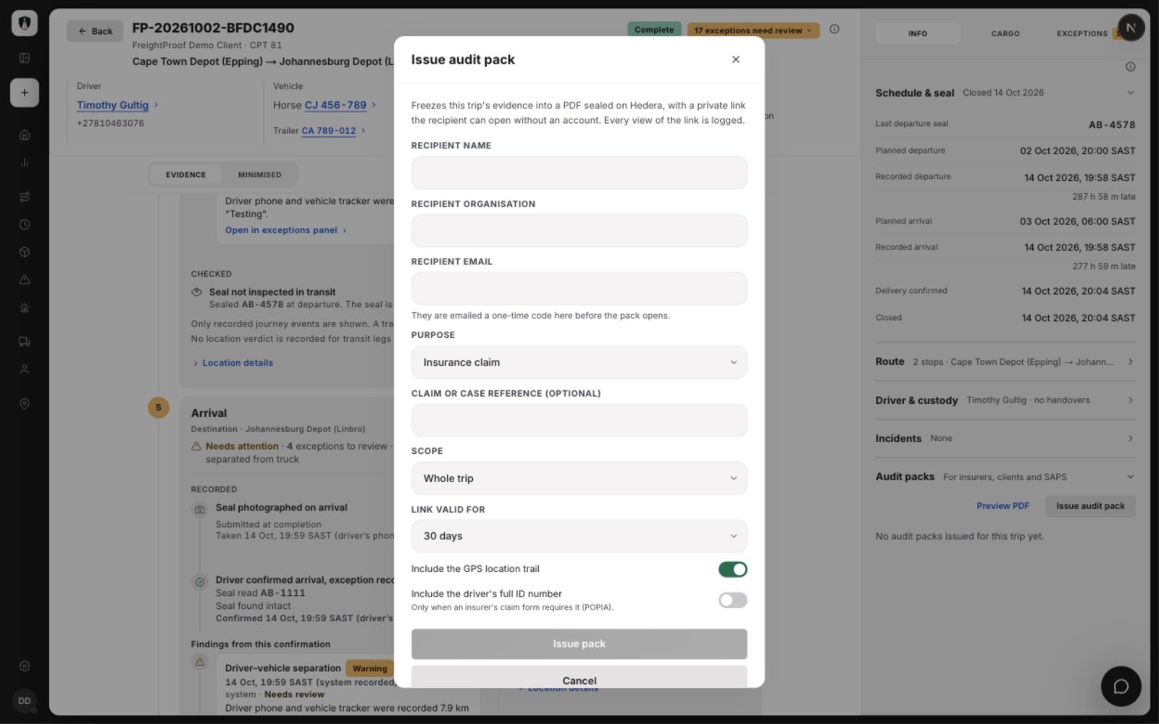
Figure 20: Audit-pack issue form with scope and privacy options (local desktop prototype)
Figure 21: Client portal: verifying an audit pack

9. Testing Approach, Results and Plan
Testing combines backend unit and integration coverage, frontend component tests, synchronised concurrency cases, structural checks and team acceptance walkthroughs. Failure paths cover lost connectivity, retry and provider outages. Load benchmarking and representative device acceptance remain separate pilot-validation activities.

9.1 Kinds of Tests
Table 26: Test levels used in Iteration 4
Level | Tool and scope | Iteration 4 focus
Backend unit | pytest; one piece of logic, no database or network | Phase-plan generation with Arrival; anchored payloads; corroboration limits; severity; cost calculations
Backend integration | pytest and httpx against a real PostgreSQL database and Redis | Manifest trips; Arrival; exception claims and batch review; anchored exceptions, reviews and cancellations; audit packs; parcel trace; vehicle clashes
Frontend unit and component | Vitest for dispatcher, driver, receiver and client portal; component, hook and client logic tests. | Offline queue and exception store; timeline phase cards; exception inbox; audit-pack panel; portal verification
Concurrency | Barrier-synchronised database connections | Two claims or reviews of one exception; two redemptions of one QR link; two trips for one manifest; simultaneous cancellations
Security | Integration tests per role and organisation | Organisation isolation, identical "not found" responses, locked-down database tables, per-token rate limits
Static and structural | ruff, mypy, import-linter, size limits | New structural violations and growth above the recorded baseline are rejected.
Migration | Alembic against an empty database in CI | Exactly one migration head; the whole chain applies cleanly
Load | Planned, not done: scripted concurrent clients against a separate environment (FP-299) | Concurrent phase completions and dashboard reads; database timeouts; anchoring latency
Device and connectivity | Planned manual handset walkthroughs | Device scenarios: connectivity loss, app closure, battery loss, cleared data and unavailable services.
Story acceptance | Team walkthroughs on the deployed system | Each Sprint 8 and 9 story against its acceptance criteria

9.2 Automated Test Evidence
The recorded 19 October development-branch run passed 3,411 backend tests, 1,448 driver-app tests and 2,900 dispatcher tests (Figure 22). The backend output also records four skipped tests and 267 slow tests deselected from that command. This is dated execution evidence rather than a claim about every later revision. CI runs the non-slow backend suite and a separate slow import-cycle step, plus checks for all four front ends.
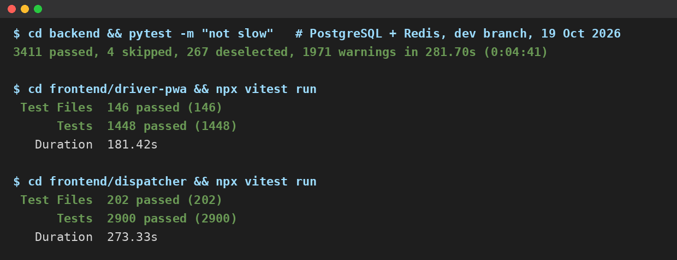
Figure 22: Summary output of the backend, driver-app and dispatcher test suites, 19 October 2026
Table 27: Continuous integration pipeline, run on every pull request
Step | What it checks
Lint (ruff) | Code style and common errors
Structure ratchet | No function or file grows beyond the agreed size limits
Layering (import-linter) | No module skips a layer, for example a request handler calling an integration directly
Type check (mypy) | Type consistency across the backend
Tests (pytest) | Unit and integration tests against isolated PostgreSQL 17 and Redis; slow import-cycle tests run separately.
Import check | Every module imports cleanly in a fresh interpreter, with no import cycles
Migrations | Exactly one migration head; the whole chain applies to an empty database
Frontend | ESLint, TypeScript, Vitest and production builds for dispatcher, driver, receiver and client portal.

9.3 Failure-Scenario and Load Testing
Table 28 defines the expected outcomes used in automated tests and device walkthroughs. Appendix A links representative requirements to concrete automated cases. Device walkthroughs are distinguished from automated execution evidence.
Table 28: Failure scenarios and expected behaviour
Scenario | Expected behaviour
No signal during a phase | The action is queued on the phone and sent when signal returns; the server records it once, using the same identifier on every retry
A queued action is blocked because an earlier phase is incomplete | The item is kept and retried, not discarded (FP-276); if the server refuses it, it stays on the phone and is shown to the driver, who resends it or reports it. The dispatcher is not alerted automatically (§5.4)
App data or cache cleared before sync | Unsent captures are lost on the phone, but nothing false is recorded: the phase stays pending on the server and on the live trip list, and the driver recaptures it
Battery dies, phone lost or stolen | The phase stays pending; a sign-in on another phone ends the old session; overrides only under BR-4 (BR-6)
Tracker silent or position stale | "Could not check" is recorded, never a mismatch; the driver continues
Hedera unavailable | Phases complete and their receipts are marked owed and retried; trip creation is refused
Parcel Perfect unavailable | Trip creation is refused; an active trip keeps its last manifest
Didit unavailable | The receiver's check is recorded as unverified with a reason; delivery continues
API unavailable | The driver app queues actions and retries; the dispatcher application shows the failure rather than stale data
Slow database | Connection and pool-wait timeouts end the request quickly with an error, rather than hanging (FP-275)

Concurrent-load benchmarking (FP-299) was not completed in this release. The planned isolated-environment workload combines driver phase completions, location updates and dashboard reads. Measures are request errors, duplicate records, database response times and anchor-receipt latency; 95% of receipts within 60 s remains a proposed target.

9.4 Risk-to-Test Matrix
Table 29 links each project risk to the tests that cover it. Layer B is backend and F is frontend.
Table 29: Risk-to-test matrix
Risk | What is tested | Layer | Test cases
R-02, R-04 | Separate critical-event commitments and outage/recovery behaviour | B | TC-04, TC-05
R-03 | Server-derived corroboration and stale-fix handling | B | TC-16
R-05 | Offline queue keeps blocked items and replays each item once | F, B | TC-12 (frontend retry key); backend persistence tested separately
R-06 | Anchored payloads contain no positions, names or free text | B | TC-17
R-13 | One redemption per link; a second browser cannot confirm; rotation pauses once the link is opened | B | TC-08, TC-09
R-12 | Receiver may decline the check or have no document; delivery is still confirmed and the outcome recorded | B | TC-10
R-14 | Organisation isolation; locked-down tables; per-token rate limits | B | TC-11
R-16 | Full suite, layering and migrations in CI | B, F | §9.2
SO-3 | Manifest trip creation, duplicates refused, parcel trace | B | TC-01, TC-02, TC-03
SO-5 | Every exception reviewed; claims; concurrent reviews | B | TC-07
SO-6 | Seal mismatch, damage and absence at Arrival | B | TC-06
SO-8 | Audit pack issue, access code, revocation, verification | B, F | TC-13, TC-14, TC-18

9.5 Test Plan and Status
Table 30 updates the Iteration 3 test plan (Team05, 2026b, Table 37, p. 60).
Table 30: Test plan and status at the end of Iteration 4
What | Environment | Status
Load and volume, including anchoring latency | Separate load-test environment | Not done: no load-test script exists (FP-299); see §9.3
Live identity verification and callback | Deployed system with the live provider | Done; the check is offered to every receiver and never blocks delivery
Live Parcel Perfect and Pulsit integration | Partner sandbox | Not possible: credentials not granted (R-22). Simulated feeds tested instead
Override and driver completion of the same phase at the same instant | Backend integration | Done: exactly one write succeeds
Device and connectivity scenarios (Table 28) | Android and iPhone handsets on the deployed system | Representative handset and connectivity acceptance remains a pilot-validation activity.
Acceptance testing with LFG users | Deployed system | Not done within the project; team story acceptance only. Planned as the first step of the pilot (BO-1)

10. Development Approach, Scrum and Progress

10.1 Development Approach and Standards
Team 05 developed FreightProof iteratively with Scrum (Schwaber & Sutherland, 2020), tracked on the Jira board FP. Roles were unchanged throughout the project: Ciaran Formby was Product Owner, Tim Gultig was Scrum Master, and all four members, with Thomas Davis and Chiko Kasongo, formed the Development Team. Each sprint opened with planning, in which every story was estimated in Fibonacci story points and assigned before work started. The team met in full every Wednesday, coordinated dependent work in the team channels, and closed each sprint with a review against Jira and a retrospective. Each iteration ended with a panel review, whose feedback became the next iteration's backlog.
The team followed these standards:
- Version control. The main and development branches are protected. Every change arrives through a pull request that a second member reviews, and commits reference their Jira key.
- A story is accepted when the agreed criteria are met, checks pass and a second member reviews the merged change. Jira completion and residual acceptance gaps are reported separately where the final release delivers a narrower behaviour.
- Coding standards. The Python backend uses typed code, Pydantic v2 models and async database access, checked by ruff and mypy. The four front ends use TypeScript in strict mode with ESLint. The layering rule is checked by CI (§9.2).
- Database standards. Schema changes go through named, hand-reviewed migrations only. Every new table has row-level security enabled.
- UI standards. A shared design system (colours, type, spacing and status chips) is used by all front ends, and shared types come from one package so that a contract change fails at compile time.

10.2 Sprint 8
Sprint 8, 29 September to 12 October 2026 (13 days). Goal: complete the final features and begin preparing for final submission. Table 31 lists the committed backlog, written as user stories.
Table 31: Sprint 8 committed backlog (19 items, 84 points)
Key | User story | Assignee | Pts | Outcome
FP-281 | As a dispatcher, I want to create a trip from the client's manifest number, so that cargo is imported, not typed | C. Formby | 11 | Done in sprint
FP-280 | As a dispatcher, I want every exception to reach a shared inbox where I can claim it, so that nothing is recorded and forgotten | C. Formby | 8 | Done in sprint
FP-149 | As a dispatcher, I want to find a parcel by barcode and see everywhere it has been | C. Kasongo | 8 | Done in sprint (carried from Sprint 7)
FP-279 | As an insurer, I want an anchored audit pack that I can verify myself, so that I need not trust the operator's copy | T. Gultig | 8 | Done in sprint
FP-270 | As a dispatcher, I want the seal inspected at Arrival and every phase anchored, so that a break in transit is detected when custody arrives | C. Formby | 3 | Done in sprint
FP-272 | As a demonstrator, I want a demo panel that follows the trip, so that partner events can be simulated in order | C. Formby | 2 | Done in sprint
FP-277 | As a developer, I want the identity-provider call inside the service layer, so that request handlers never call an integration directly | T. Gultig | 2 | Done in sprint
FP-271 | As an operator, I want newer tables closed to direct database access, so that evidence cannot be read around the API | C. Formby | 1 | Done in sprint
FP-295 | As an operations manager, I want a plain-language brief of patterns in my analytics, based on de-identified figures | T. Davis | 8 | Carried; done in Sprint 9 as an analytics chat
FP-286 | As the team, we want documentation and evidence captured during the sprint, so that the final document is assembly, not authoring | — | 5 | Carried; done in Sprint 9
FP-294 | As an operations manager, I want to see the cargo value exposed and the estimated cost of delays | T. Davis | 5 | Carried; done in Sprint 9
FP-296 | As an operations manager, I want today's incidents on a map and the source of every figure | T. Davis | 5 | Carried; done in Sprint 9
FP-300 | As a driver, I want the seal number read from my photo, so that I confirm it instead of typing it | T. Gultig | 5 | Carried; done in Sprint 9
FP-273 | As a principal, I want delivery to close only after the receiver confirms, so that a driver cannot sign for the receiver | T. Gultig | 3 | Closed; residual confirmation check in §5.4
FP-276 | As a driver, I want evidence captured offline to be kept until it is accepted, not discarded | T. Gultig | 3 | Carried; done in Sprint 9
FP-274 | As an operator, I want request limits applied per user, so that one user cannot exhaust another's | C. Kasongo | 2 | Carried; done in Sprint 9
FP-275 | As a dispatcher, I want a slow database to fail fast rather than freeze my screen | C. Kasongo | 2 | Carried; done in Sprint 9
FP-297 | As a driver, I want to report a breakdown that affects both the horse and a trailer | C. Formby | 2 | Carried; not done
FP-278 | As a driver, I want real seal numbers accepted, not only an invented format | T. Gultig | 1 | Carried; not done

Sprint 8 completed 43 of 84 points (51%) and carried 41 into Sprint 9. Of the carried work, 38 points completed in Sprint 9 and three remained outside the final release. The burndown is stepwise because points are credited when stories close, rather than when implementation starts.
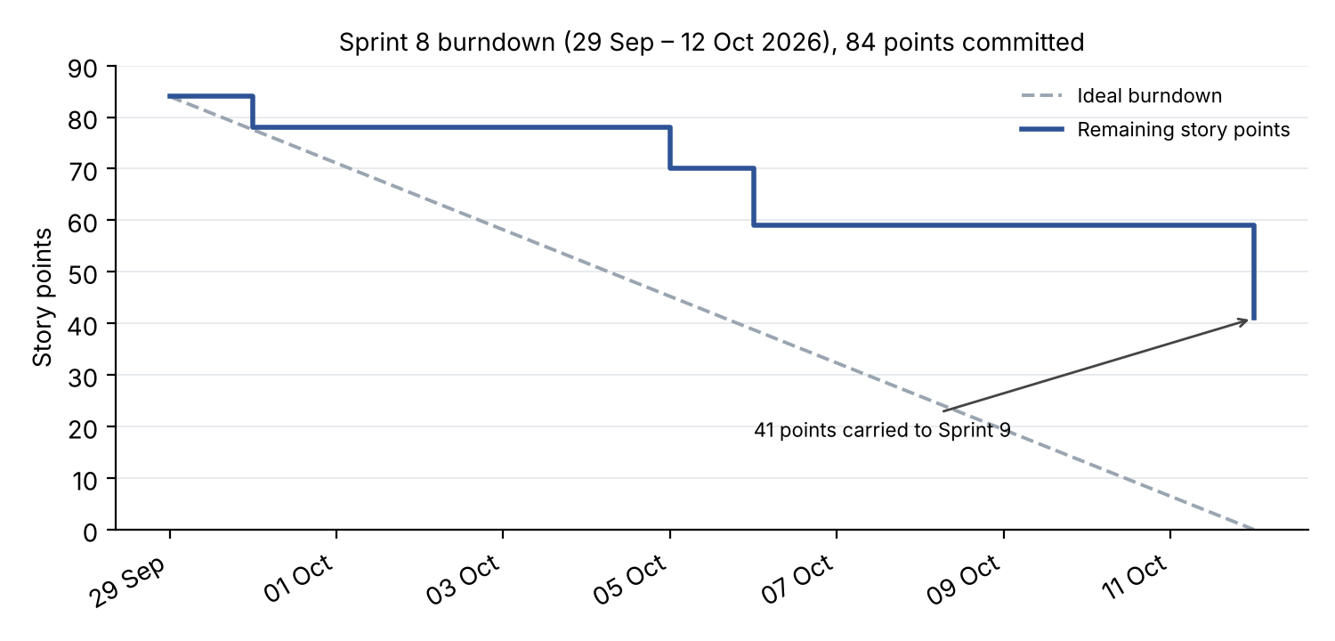
Figure 23: Sprint 8 burndown chart
Figure 24: Sprint 8 task board
Table 32: Sprint 8 delivery reflection
What went well | What should improve | Action taken
Core manifest, exception-inbox and audit-pack features completed. | Only 51% of the sprint commitment completed within the sprint. | Separate carried work from new commitment.
Delivery totals distinguish carry-over. | Work started before the sprint can distort early progress. | Create and estimate tickets before implementation.
Automated checks cover shared-code changes. | Documentation ownership and evidence collection remained late. | Assign documentation and evidence alongside feature work.

10.3 Sprint 9
Sprint 9 is closed. Its planned period was 12–23 October 2026, including the structural freeze from 19 October. The recorded commitment was 118 points: 41 carried from Sprint 8 and 77 new. Recorded completion was 111 points: 38 carried and 73 new. Seven points remained unfinished across both groups. Ticket closure is reported alongside the residual scope boundaries in §5.4.
Table 33: Sprint 9 new backlog (15 items, 77 points)
Key | User story | Assignee | Pts | Outcome
FP-303 | As the team, we want the final document, evidence and code packaged for submission | C. Formby | 13 | Submission preparation
FP-288 | As a dispatcher, I want each phase on the timeline to show its acts live, so that I see what happened inside it | C. Formby | 8 | Done
FP-290 | As an insurer, I want critical exceptions, reviews and cancellations anchored, so that the records a dispute questions are protected | C. Formby | 8 | Done
FP-308 | As an operator, I want upload limits, artefact ownership and session checks enforced | T. Gultig | 8 | Done
FP-287 | As a dispatcher, I want photographs to appear on the timeline as soon as they are uploaded | C. Formby | 5 | Done
FP-289 | As a dispatcher, I want a live trip list showing phase progress and unreviewed exceptions, with further detail available on the trip timeline | C. Formby | 5 | Closed; elapsed-time/location columns excluded
FP-139 | As a dispatcher, I want a horse that is on a live trip to be refused for a second one | T. Davis | 5 | Done
FP-309 | As an Admin-Dispatcher, I want to place a precinct by searching for its address | T. Gultig | 5 | Done
FP-83 | As a dispatcher, I want a driver substitution recorded by both drivers, so that each driver's custody stays on the record | C. Formby | 5 | Done
FP-142 | As a dispatcher, I want to see a vehicle clash before I create a trip | T. Davis | 3 | Done
FP-291 | As an operator, I want audit-pack links to need an e-mailed code before first view | T. Gultig | 3 | Done
FP-316 | As an insurer, I want a "selfie only" verification to exist only when the selfie is stored | T. Gultig | 3 | Done
FP-292 | As an insurer, I want the client portal deployed, so that a share link works outside the team's machines | T. Gultig | 2 | Done
FP-293 | As a receiver, I want an identity check only when the consignment requires it | C. Kasongo | 2 | Not done
FP-299 | As the team, we want a load test that proves the database timeouts hold | C. Kasongo | 2 | Not done

Figure 25: Sprint 9 task board
Figure 26: Sprint 9 burndown chart
Sprint 9 delivery reflection. The release added live operational views and broader incident evidence. Its high completion total includes carried work already partly implemented in Sprint 8. Workload remained uneven (Table 35), and final acceptance must distinguish ticket closure from unmet parts of a story’s original wording.

10.4 Velocity and Capacity
Figure 27 shows committed and completed points for every sprint. Sprint lengths varied between 10 and 14 days because sprints were fitted around the iteration reviews and the submission date. To compare them, Table 34 also gives points per sprint day. Jira was used sparsely in Sprints 1, 3 and 4 (4, 7 and 4 issues), so their figures understate the work done and are not comparable.
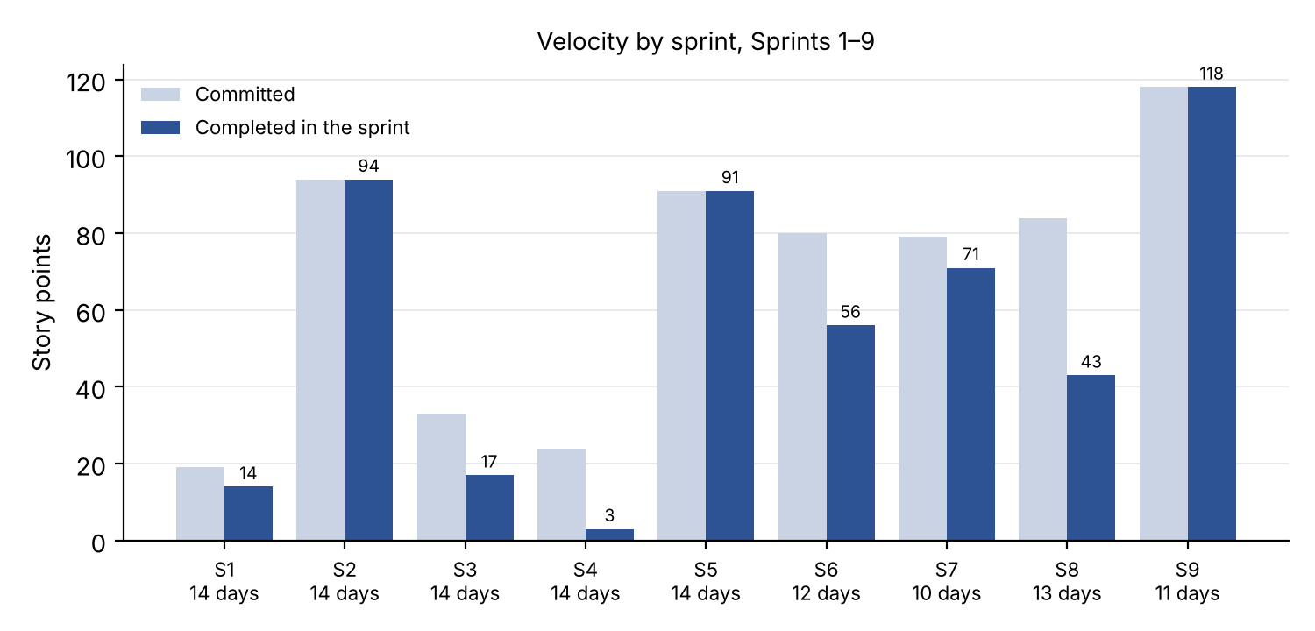
Figure 27: Committed and completed story points, Sprints 1–9
Table 34: Velocity normalised for sprint length
Sprint | Dates | Days | Committed | Completed | Points per day
2 | 3–17 May | 14 | 94 | 94 | 6.7
5 | 27 Jul – 10 Aug | 14 | 91 | 91 | 6.5
6 | 26 Aug – 7 Sep | 12 | 80 | 56 | 4.7
7 | 7–17 Sep | 10 | 79 | 71 | 7.1
8 | 29 Sep – 12 Oct | 13 | 84 | 43 | 3.3
9 | 12–23 Oct | 11 | 118 | 111 | 10.1

Across comparable sprints the team completed about 6.5 points per sprint day. Sprint 8 fell well below this and Sprint 9 well above it, because 38 of the 41 carried points were finished early in Sprint 9. Taken together, Sprints 8 and 9 delivered 154 points in 24 days, 6.4 points a day, close to the team's earlier rate.
Table 35: Story points completed per member in Iteration 4
Member | Sprint 8 | Sprint 9 | Iteration 4 | Share
Ciaran Formby | 25 | 44 | 69 | 45%
Tim Gultig | 10 | 32 | 42 | 27%
Thomas Davis | 0 | 26 | 26 | 17%
Chiko Kasongo | 8 | 4 | 12 | 8%
Unassigned (documentation) | 0 | 5 | 5 | 3%
Total | 43 | 111 | 154 | 100%

Story points measure feature tickets, not all contributions: documentation, research, meeting minutes, testing and presentation work are largely outside them. Contributions in those areas are described in the portfolio of evidence (Appendix C).

10.5 Reflection on Scrum and Lessons Learnt
Scrum’s review points allowed feedback to change the product incrementally. Iteration 2 feedback led to stronger location corroboration and receiver participation; Iteration 3 feedback shaped the live trip list, exception workflow and audit packs. Backlog estimates exposed capacity pressure, while peer review and CI supported shared development. The delivery record also shows where the process fell short: carry-over, uneven workload and late documentation.
Lessons learnt.
- Keep sprints the same length. Varying lengths made velocity hard to compare and planning harder. A fixed two-week sprint, with reviews placed between sprints, would have been simpler.
- Treat documentation as sprint work. Documentation was under-counted in three iterations and done at the end. It only improved when it became pointed tickets with owners.
- Write smaller stories. Stories of 8 to 13 points closed in one step at the end of a sprint, which hid progress and made the burndown uninformative.
- Balance the workload deliberately. Points were concentrated in two members in every iteration despite being raised in each retrospective. It has to be addressed at sprint planning, when work is assigned, not only noted in the retrospective.
- Ticket work before doing it. Work done between sprints and later credited to a sprint distorted the sprint figures.
- Review AI-assisted code as carefully as your own. Code that works is not the same as code the team understands (§10.6).
- Talk to users early. LFG meetings and the facility visit supplied operational context. The project’s iteration reviews then challenged assumptions about handovers, evidence and day-to-day dispatch work.

10.6 Use of AI Tools
The team used AI tools throughout the project. Claude Code was the main tool, used to understand unfamiliar code, generate and refactor code, write tests, and draft design notes and specifications. Gemini was used to reconcile sprint records against the repository. AI was also used to check documentation against the code and to find merge conflicts across branches.
Repository instructions require planning for non-trivial changes and leave commits and merges to team members. AI-assisted changes are reviewed and checked through the same tests, types and layering controls as other changes. Each member remains responsible for understanding and defending their contribution at the final code review.
In the product, the "Ask about these figures" analytics chat (FP-295) answers questions from de-identified figures only, using Google Gemini, and refuses to state figures it has not looked up. It is off unless AI_CHAT_ENABLED and an API key are set, and the dispatcher assistant has its own switch (ASSISTANT_ENABLED). Severity and other evidence decisions are made by fixed rules, not by an AI model, because evidence must be reproducible.

References
Electronic Communications and Transactions Act 25 of 2002 (South Africa).
Hedera. (n.d.). Consensus service. Hedera documentation. https://docs.hedera.com/guides/docs/hedera-api/consensus-service
National Institute of Standards and Technology. (2015). Secure hash standard (SHS) (FIPS PUB 180-4). https://doi.org/10.6028/NIST.FIPS.180-4
Protection of Personal Information Act 4 of 2013 (South Africa).
Schwaber, K., & Sutherland, J. (2020). The Scrum guide. https://scrumguides.org/scrum-guide.html
South African Police Service. (2025). Annual report 2024/2025. https://www.saps.gov.za/about/stratframework/annual_report/2024_2025/2024-25-SAPS-Annual-Report.pdf
Team05. (2026a). FreightProof SA: Iteration 2 documentation [Unpublished project document]. INF4027W, University of Cape Town.
Team05. (2026b). FreightProof SA: Iteration 3 documentation [Unpublished project document]. INF4027W, University of Cape Town.

Appendix A: Sample Test Cases
The cases below identify implemented automated checks and the behaviour each establishes. Figure 22 supplies dated aggregate execution evidence; the cases are not a substitute for a run tied to the final release. Test names distinguish frontend retry behaviour from backend persistence guarantees.
Table 36: Sample test cases
ID / requirement | Scenario and expected behaviour | Automated evidence
TC-01 / SO-3, TLM 1.2 | Create a trip from a mock manifest; then request an unknown manifest number → Trip saved with its manifest key and verifies against its journey lock; unknown manifest returns 404 | test_trip_from_pp_manifest.py:  test_create_persists_a_manifest_trip;  test_unknown_manifest_is_404
TC-02 / SO-3, TLM 1.2 alt. 1c | Two dispatchers create a trip from the same manifest at the same instant (barrier) → Exactly one trip is created; the other request is refused cleanly | test_creation_concurrency.py:  test_concurrent_creation_from_one_manifest_creates_one_trip
TC-03 / SO-3, TLM 1.13 | Search a barcode belonging to another organisation, and an unknown barcode → Both return the same "not found" response | test_parcel_trace.py:  test_foreign_and_unknown_records_are_indistinguishable
TC-04 / SO-1, BR-2 | Raise a critical exception, cancel the trip, then review the exception → Each action has its own anchored event and receipt; earlier receipts unchanged | test_fp290_incident_chain.py:  test_each_action_has_its_own_event_and_receipts_stay_separate
TC-05 / SO-1, R-07 | Repeat TC-04 with Hedera unavailable → Events stored with anchor status "failed"; the evidence itself is intact | test_fp290_incident_chain.py:  test_hedera_outage_leaves_failed_events_and_the_source_intact
TC-06 / SO-6, CC 1.11 | Arrival with a seal number different from the departure seal → Exactly one critical seal exception is raised | test_arrival_phase.py:  test_arrival_seal_number_mismatch_raises_one_critical_exception
TC-07 / SO-5, BR-2 | Dispatcher B claims an exception already claimed by A; then A and B submit reviews simultaneously → Claim refused with 409; exactly one review recorded | test_exception_claims.py:  test_claim_over_a_colleague_is_409;  test_exception_review_concurrency.py:  test_simultaneous_reviews_record_exactly_one_dispatcher
TC-08 / SO-4, R-13 | Two phones redeem the same QR link at the same instant → Exactly one confirmation succeeds | test_handover_token_concurrency.py:  test_two_simultaneous_redemptions_of_the_same_token_produce_exactly_one_success
TC-09 / SO-4, R-13 | A second browser opens a link that the receiver's browser holds → The second browser is refused; the receiver's link still works | test_handover_endpoints.py:  test_a_refused_binding_does_not_burn_the_real_receivers_token
TC-10 / SO-4, BR-7 | Receiver declines the identity check or has no document → Delivery is still confirmed; outcome recorded as unverified | test_receiver_verification_endpoints.py:  test_full_walk_receiver_without_an_id_still_confirms
TC-11 / R-14 | Apply the database lockdown migration and query as the public API roles → Row-level security on; direct access revoked | test_data_api_lockdown.py:  test_upgrade_enables_rls_and_revokes_api_roles
TC-12 / R-05 | Retry a queued phase after a simulated timeout. The frontend sends the same idempotency key on both attempts; this case does not assert database writes. | useOfflineQueue.test.ts: "sends the same idempotency_key on a retry as on the first attempt"
TC-13 / SO-8, BR-9 | Open a revoked audit-pack link → 410 response; the attempt is logged | test_audit_pack_public.py:  test_open_shared_pack_revoked_is_410_and_logged
TC-14 / SO-8, BR-9 | Open an e-mailed audit pack without entering the code → 401 response; the attempt is logged | test_audit_pack_email_codes.py:  test_open_emailed_pack_without_grant_is_401_and_logged
TC-15 / BP-3, TLM 1.2 | Request availability for a horse already on an overlapping trip → The horse is listed as busy, naming the trip; other organisations' trips never appear | test_trip_availability_endpoint.py:  test_availability_lists_the_busy_driver_horse_and_trailer
TC-16 / SO-2 | Complete phases using server-derived corroboration and unusable tracker fixes; unusable comparisons are not reported as matches. | test_phase_corroboration.py
TC-17 / R-06 | Canonical phase payloads exclude GPS, artefact identifiers, personal data and completion timestamps. | test_phase_anchor_payload.py: test_no_v2_payload_leaks_gps_artifact_ids_pii_or_completed_at
TC-18 / SO-8 | Verify a matching payload; reject changed payload/ledger hashes; distinguish mirror unavailability. | client-portal/lib/verify.test.ts

Appendix B: Addendum – Changes Since Iteration 3
Table 37 summarises the principal changes delivered since Iteration 3 and where they are documented.
Table 37: Changes since Iteration 3 and the feedback they answer
Area | Iteration 4 development | Section
Purpose and objectives | Venture/customer roles clarified; objectives separated and traced to system outcomes. | 1–3
Risk and plan | Unified risk treatment, project risks, release scope and pilot boundaries. | 4–5
Custody lifecycle | Arrival, manifest-first creation, trailer checks and driver-substitution workflow. | 6
Exceptions | Shared inbox, claims, reviews, incident declarations and append-only updates. | 6.4–6.5; 8.4
Evidence integrity | Every-phase anchoring and separate critical-event, review and cancellation commitments. | 7.2
Evidence sharing | Frozen audit packs, e-mail access codes and independent portal verification. | 6.5; 8.8
Operations interface | Live trip overview, phase timelines, immediate photo display and parcel tracing. | 8
Analytics | Cost view, Today incident map, source labels and optional analytics chat. | 8.5
Receiver flow | Own-device acknowledgement, optional identity check and typed-only fallback. | 6.4–6.5
Testing | CI gates, automated results, failure scenarios and named sample cases. | 9; Appendix A
Scrum | Carry-over separated, sprint-length normalisation and delivery reflections. | 10
Participation | Individual contribution descriptions and separate scoring/sign-off records. | Appendix C

Appendix C: Portfolio of Evidence and User Log
The portfolio summarises each member’s contribution. Coding, documentation, presentation, research, meeting minutes and communication are scored separately; each member’s log is signed by the other three members.
Ciaran Formby (Product Owner). Code: manifest-first trip creation (FP-281), the exception inbox with claims and batch review (FP-280), the Arrival phase with every-phase anchoring and trailer geofences (FP-270), anchored critical exceptions, reviews and cancellations (FP-290), the live trip list and live phase timelines (FP-287, FP-288, FP-289), the database lockdown (FP-271), driver substitution (FP-83) and the demo panel (FP-272). Documentation: design notes for the Arrival phase and the exception workflow; owner of the final submission package (FP-303). Other: team contact for the Pulsit and Parcel Perfect partners; backlog ordering and sprint goals.
Tim Gultig (Scrum Master). Code: audit packs and client portal (FP-279, FP-291, FP-292), delivery-signature controls (FP-273), offline retention (FP-276), seal reading (FP-300), precinct search (FP-309), receiver-flow changes (FP-316), security hardening (FP-308) and layering (FP-277). Documentation: evidence-sharing design and supporting standards research. Process: sprint coordination, Jira reconciliation and sprint records.
Thomas Davis. Code: cost analytics (FP-294), today's incident map and figure sources (FP-296), the analytics chat (FP-295), and the vehicle-clash guard and crew availability in trip creation (FP-139, FP-142). Documentation: analytics specifications for cost and provenance; project context and plan sections. Other: architecture and package diagrams.
Chiko Kasongo. Code: parcel search by barcode (FP-149), per-token rate limits (FP-274) and database timeouts (FP-275). Documentation: UI evidence and state-machine sections. Other: sprint metrics, burndown and velocity reporting.
Table 38: Contribution scores out of 5
Member | Coding | Documentation | Presentation | Research | Meeting minutes | Communication
Ciaran Formby
Tim Gultig
Thomas Davis
Chiko Kasongo

Table 39: Sign-off of the user logs
Member's log | Reviewed and signed by | Reviewed and signed by | Reviewed and signed by
Ciaran Formby | Tim Gultig ________________ | Thomas Davis ________________ | Chiko Kasongo ________________
Tim Gultig | Ciaran Formby ________________ | Thomas Davis ________________ | Chiko Kasongo ________________
Thomas Davis | Ciaran Formby ________________ | Tim Gultig ________________ | Chiko Kasongo ________________
Chiko Kasongo | Ciaran Formby ________________ | Tim Gultig ________________ | Thomas Davis ________________

