Park Me

#### CSC 4350 Fall 2023

Group 7

* Seth Quiros
* Hieu Vu
* Jay Patel
* Wajeeha Mehr
* Christopher Reed (Coordinator)

## Planning / Scheduling

|  |  |  |  |  |  |  |
| --- | --- | --- | --- | --- | --- | --- |
| Assignee Name | Email | Task | Duration | Dependency | Due Date | Evaluation |
| Jay Patel | jpatel182@student.gsu.edu | Task 4 (Use case 3) | 4 hours | none | 10/20/2023 | Hieu-100%  Wajeeha-100%  Chris – 100%  Seth – 100% |
| Seth Quiros | Squiros1@student.gsu.edu | Task 4 (Use case 3) | 4 hours | none | 10/20/2023 | Hieu-100%  Wajeeha-100%  Chris – 100%  Jay – 100% |
| Hieu Vu | hvu13@student.gsu.edu | Task 4 (use case 1,2) | 4 hours | None | 10/20/2023 | Wajeeha-100%  Chris – 100%  Jay – 100%  Seth – 100% |
| Wajeeha Mehr | wmehr1@student.gsu.edu | Task 3 | 2 hours | None | 10/20/2023 | Hieu-100%  Chris – 100%  Jay – 100%  Seth – 100% |
| Christopher Reed (coordinator) | creed27@student.gsu.edu | Task 5, 6 | 2 hours | None | 10/20/2023 | Hieu-100%  Wajeeha-100%  Jay – 100%  Seth – 100% |

## Todo=Seth and jay

Use case 3 front end due by 10/227

Picture on git hub by Friday 10/20

Task 4 present Monday

## Problem Statement

1. Product: The ParkMe University Web Page is a user-centric platform designed to provide real-time parking information and registration, permit purchasing, and transportation options for the university community.

2. Target Audience: Students, faculty, staff, and visitors of the university.

3. Problem: Campus parking is often challenging due to limited space and lack of accessible information about parking availability, regulations, and alternatives. So, our users can use the website to register their space in advance while paying a little amount of money for registering in advance. (That means they are paying a little extra than parking fee.)

4. Solution: The ParkMe web page aims to address this issue by offering real-time parking availability updates, permit purchasing, comprehensive parking guidelines, and information on alternative transportation.

For our customers, we would also like to develop a payment system that would allow them to reserve a spot in advance for a certain parking lot. For instance, if a student wishes to leave and return or if they desire a spot for the entire month.

5. Alternatives: Currently, users rely on physical signage, word-of-mouth, and generic maps for parking information. Some universities have basic online parking systems, but they often lack real-time data and user-friendly interfaces.

6. Describe the top-level objectives, differentiators, target customers, and scope of your product:

Objectives: The primary goal is to provide a user-friendly platform that enhances the parking experience on campus.

Differentiators: Real-time parking availability, online permit management, interactive campus map, alternative transportation options, and user feedback mechanism.

Target Customers: Students, faculty, staff, and visitors who commute to the university.

Scope: The web page will display real-time parking availability, offer permit purchasing and management, provide parking guidelines, highlight alternative transportation options, and allow user feedback.

7. Competitors and Novel Approach: Existing solutions lack real-time updates and comprehensive information. Our novel approach includes integrating dynamic parking availability data and offering a seamless user experience.

8. Technical Perspective: The ParkMe web page can be developed effectively utilizing available resources and technology. It will be designed using modern web technologies to ensure responsiveness across devices.

9. Client Login and Admin Login: The system will have both client and admin logins. Clients (users) will access features like real-time parking availability, permit purchasing, and alternative transportation information. Admins will manage parking data, permits, and user feedback.

## Requirements

Requirement: 1

Use Case: 1

Name: User Registration and Account Management

Introduction: System provides a page for users to create an account and a page to allow them to make changes to their information that is necessary to use said account.

Rationale: This allows users to store their information for repeat access to the parking lots of the school.

Input: User enters the page, inputs valid information into the text box. Users can click on a button to change personal information.

Requirement Description: The system should display text input boxes for required information from the user to make and use an account. In the account management page, the system should display the previously inputted information and an option to change said information.

Output: The system stores the user information into a user database for look up. The system displays user information on a page for the user to edit.

Test Cases: TBD

Requirement: 2

Use Case: 2

Name: User Authentication & Login

Introduction: System provides a page for users to enter valid log-in information to allow them to access their accounts and use the service; Database verifies input log-in information matches user profile stored.

Rationale: This allows the users to have their account safeguarded from people attempting to use their personal information.

Input: User clicks prompt to access log-in page, where they will enter their account log-in credentials.

Requirement Description: The system provides a page with the necessary number of input boxes for the user to input their account information and a button to send the information to be verified by the database as accurate or inaccurate.

Output: Upon inputting correct information, the user will have access to their account and the ability to reserve parking.

Test Cases: TBD

Requirement: 3

Use Case: 3

Name: Real-time Parking Availability Check

Introduction: System provides a page that displays whether a parking spot is available or not.

Rationale: To allow what parking spot is available and where it is located.

Input: The user enters a page, and the database populates the page with information stored.

Requirement Description: The database provides a description of all the parking spaces stored and shows whether they are occupied or not.

Output: User will be able to select from available spaces to reserve.

Test Cases: TBD

Requirement: 4

Use Case: 4

Name: Secure Payment Processing

Introduction: Ensure secure payment processing for parking permit purchases.

Rationale: To safeguard user financial information and provide a seamless payment experience.

Input: User selects permit type and provides payment details.

Requirement Description: Implement secure payment processing with encryption, payment gateway integration, clear error handling, and email receipts.

Output: Secure payment transactions, payment confirmation, email receipts, and transaction logs.

Test Cases: TBD

Requirement: 5

Use Case: 5

Name: Real-time Data Updates

Introduction: Ensure real-time data updates on the interactive campus map.

Rationale: To provide users with accurate and up-to-date information for effective navigation.

Input: User interacts with the map, selects filters, or searches for locations.

Requirement Description: Implement a system that regularly updates map data, including parking availability, shuttle locations, and events. Updates should occur at least every minute to ensure real-time accuracy.

Output: Users see the most current information on the map, such as parking availability and shuttle locations.

Test Cases: TBD

Requirement: 6

Use Case: 6

Name: Reservation Confirmation

Introduction: Provide users with reservation confirmations.

Rationale: To assure users that their parking reservations are successfully made.

Input: User selects reservation parameters and makes a payment.

Requirement Description: After a successful reservation, the system must generate a confirmation message with the reservation details, including date, time, parking lot, and a unique reservation ID.

Output: Users receive a reservation confirmation message on the screen, indicating a successful reservation with all relevant details.

Test Cases: TBD

Requirement: 7

Use Case: 7: Alternative Transportation Information

Name: Alternative Transportation Information

Introduction: The system shall provide users with information about alternative transportation options to and from the parking location.

Rationale: To enhance user convenience and encourage the use of alternative transportation methods, such as public transit or carpooling.

Inputs: User's request for alternative transportation information.

Requirements Description: The system shall access and display information regarding public transportation routes, schedules, nearby carpooling options, and any special discounts or promotions related to alternative transportation.

Outputs: The system shall present alternative transportation information to the user, including details about public transportation routes, nearby carpooling options, and any available discounts or promotions.

Test Cases: TBD

Requirement: 8

Use Case: 8: User Feedback and Support

Name: User Feedback and Support

Introduction: The system shall provide a user feedback mechanism and offer customer support options to address user inquiries and issues.

Rationale: To ensure a positive user experience and resolve any problems or questions users may have.

Inputs: User-initiated requests for assistance or feedback submission.

Requirements Description: The system shall include a user-friendly feedback form where users can submit comments, questions, or issues. The system shall provide access to a customer support portal or chatbot for real-time assistance. The system shall log and categorize user feedback and inquiries for analysis and response.

Outputs: Users shall have the ability to submit feedback or inquiries. Users shall have access to customer support options, including a chatbot or support portal.

Test Cases: TBD

Requirement: 9

Use Case: 9

Name: Admin Parking Management

Introduction: Allows an authorized admin user to make changes to the parking system. The primary purpose is to provide administrators with the necessary tools to modify existing parking configurations or create new ones.

Rationale: The parking system remains flexible and responsive to changes. Admins need the capabilities to manage parking resources effectively.

Inputs: Admin user selects action to either modify existing parking or create new parking. Admin inputs mandatory data, which includes location detail, parking lot information (e.g., name, size, type), available parking spots, and any other relevant information.

Requirements Description: The system provides admin users the option to modify/ create parking configurations. When modifying, it allows admin to update relevant information. When creating, it allows admin to successfully input and create a parking system.

Outputs: Modified/new parking and notification to student users regarding changes made via emails they provided and within the application.

Test Cases: TBD

Requirement: 10

Use Case: 10

Name: Admin Permit Management

Introduction: Allows an authorized admin user to make changes to permits within the parking system.

Rationale: The permit system remains flexible and responsive to changes. Admins need the capabilities to manage permit resources effectively.

Inputs: Admin user selects action to either modify existing permit or create new permit. Admin inputs mandatory data, which includes location detail, parking lot information (e.g., name, size, type), available parking spots, dates/times of availability, length of permit, and any other relevant information.

Requirements Description: The system provides admin users the option to modify/ create permit configurations. When modifying, it allows admin to update relevant information. When creating, it allows admin to successfully input and create a permit selection.

Outputs: Modified/new permits and notification to student users regarding changes made via emails they provided and within the application.

Test Cases: TBD

Requirement: 11

Use Case: 11

Name: Admin User Feedback Analysis

Introduction: User feedback on issues with the site and recommendations to update site.

Rationale: To provide user feedback to ensure the website meets everyone's needs

Inputs: User error, page cannot load, Improvements to make the site better

Requirement Description: Requires users to submit feedback so admin can address all issues within the website. Admins can respond with a solution or officially announce a new update.

Output: Will be admin response to the error or admins public announcements on updates that have been done.

Test Cases: TBD

Requirement: 12

Use Case: 12

Name: Security and Privacy Management

Introduction: Security and privacy of all accounts on the website. The protection from sensitive information being leaked out to the public.

Rationale: The security allows the user to determine how secure their account is with warnings of not having security measure what information can be breached.

Inputs: User first name, Last name, Panther id, emails, passwords, birthdates, card information

Requirement Description: When security measures are in place user will have two factor authentication with notifications of who is on your account. Requires user to choose this option or opt out of it by giving little information but just enough to use the website features.

Output: Safe and secure account, worry free from sensitive information leaked.

Test Cases: TBD

## System Modeling

Class Diagram

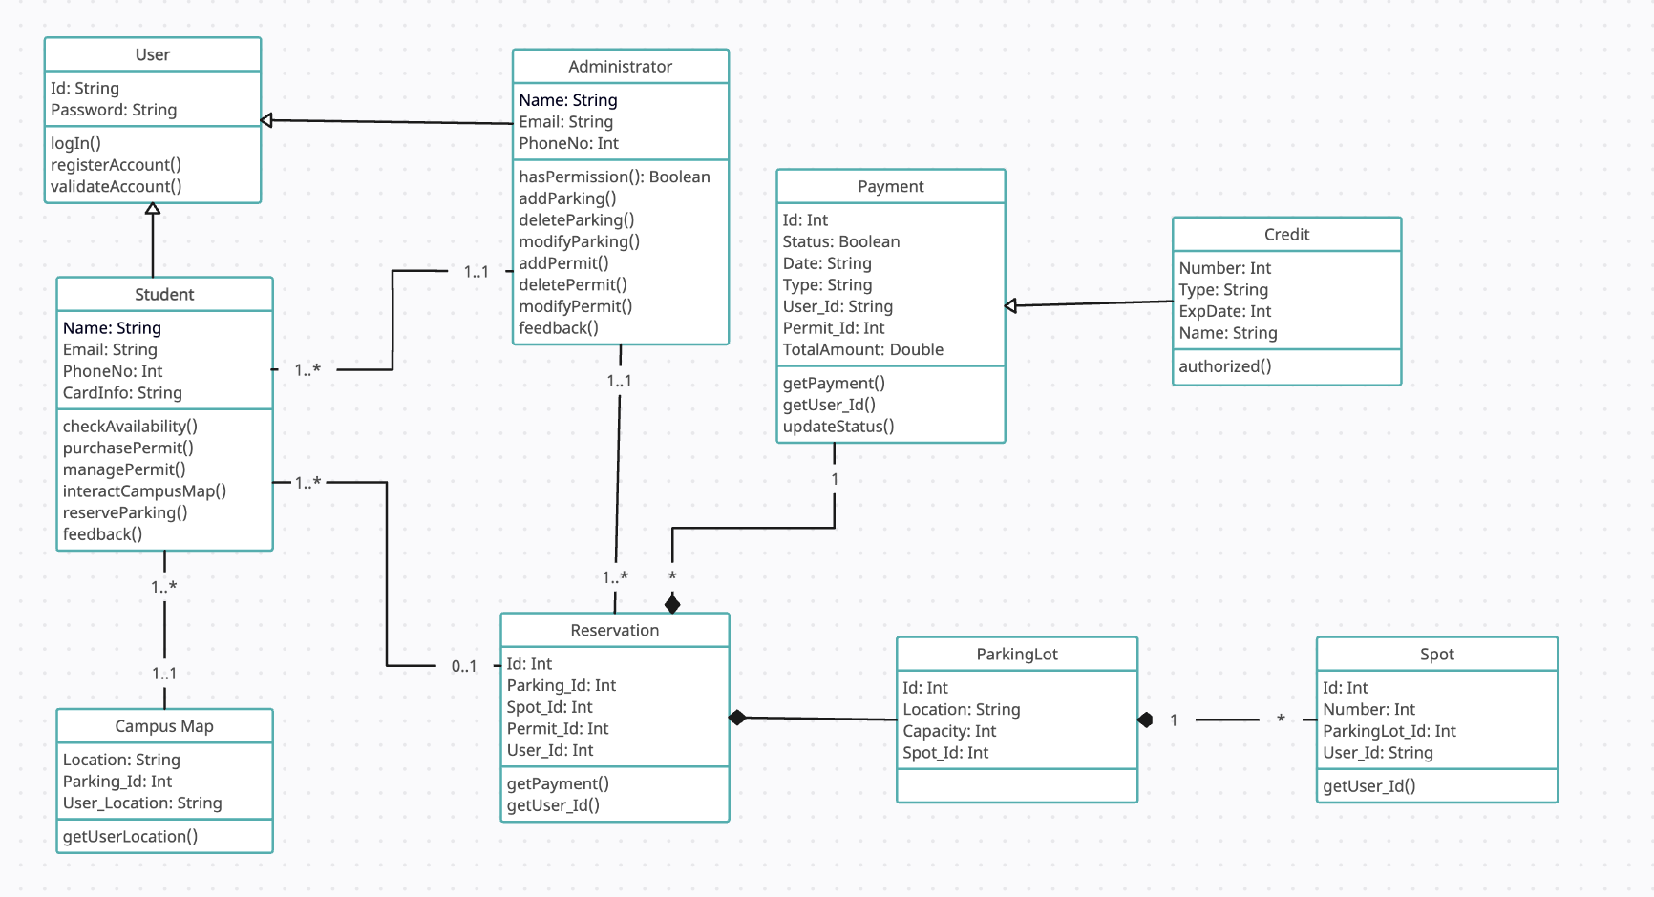

Database Specifications

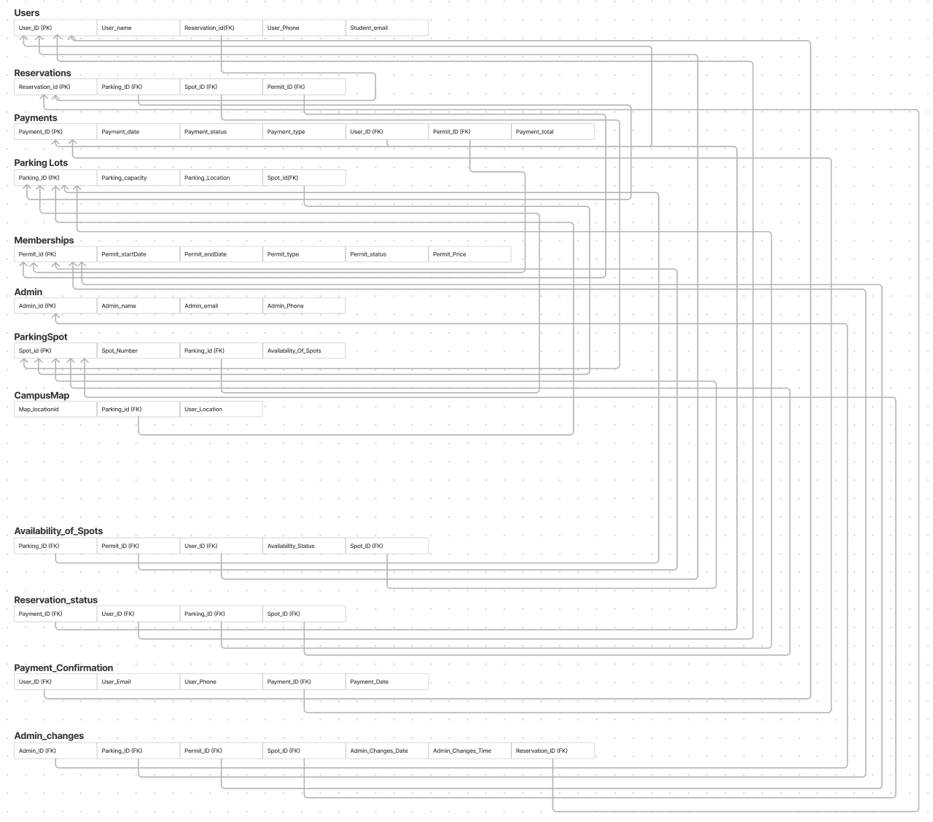

Behavioral Modeling: Sequence Diagrams

Use Case 1 and 2: User Registration and Log-in

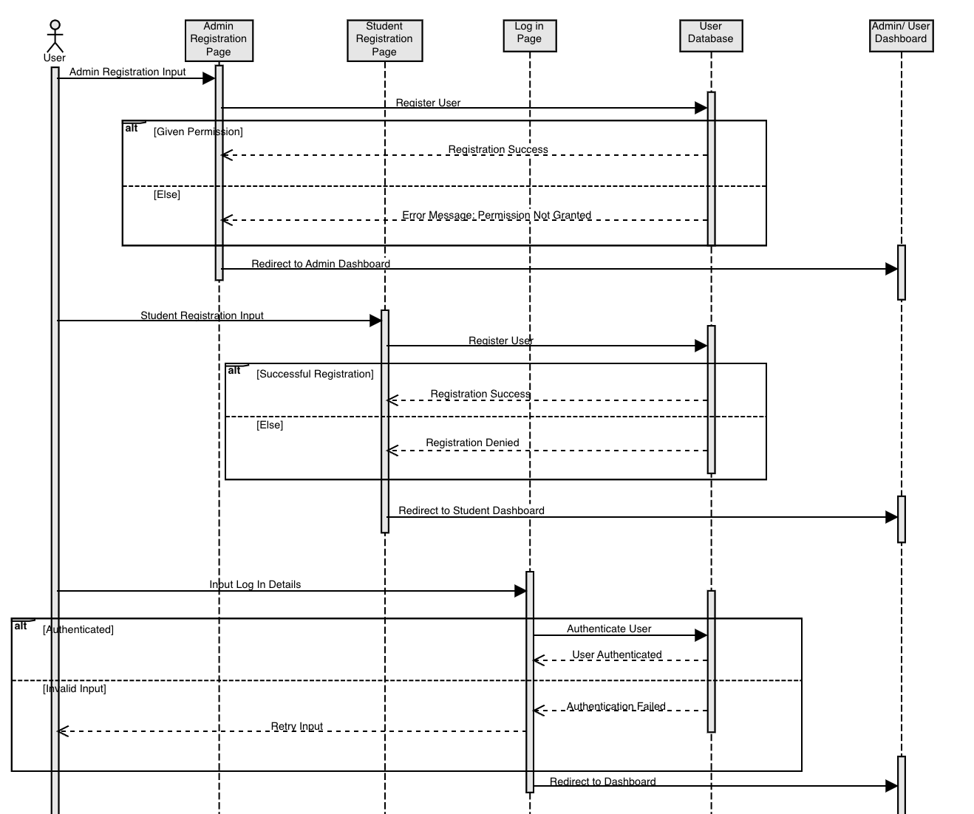

Use Case 3: Real-time Parking Availability Check

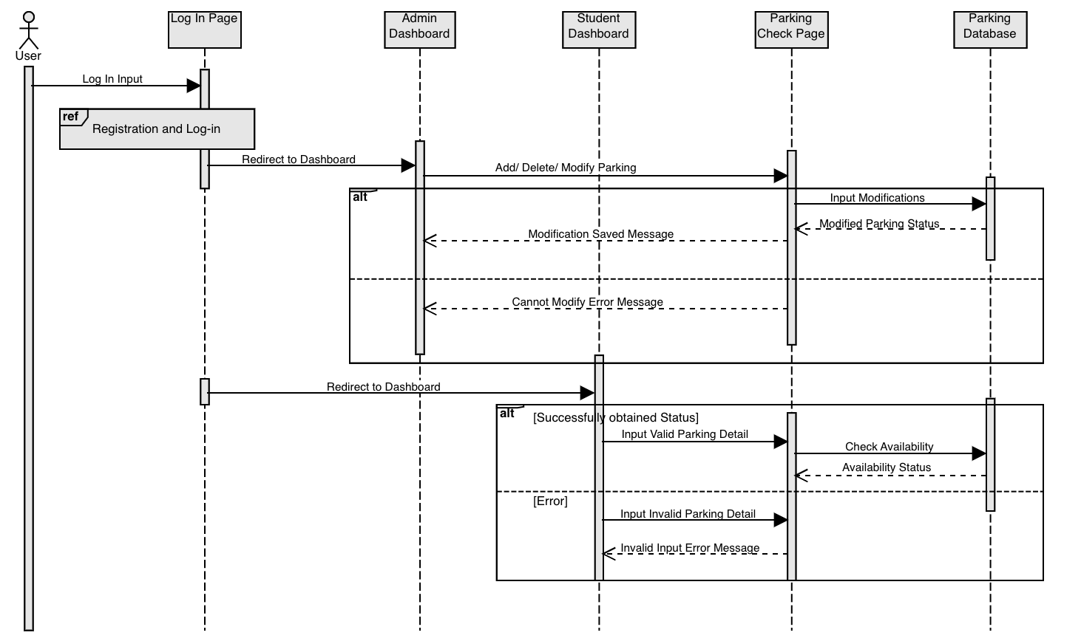

## Implementation

Front End

Log-in

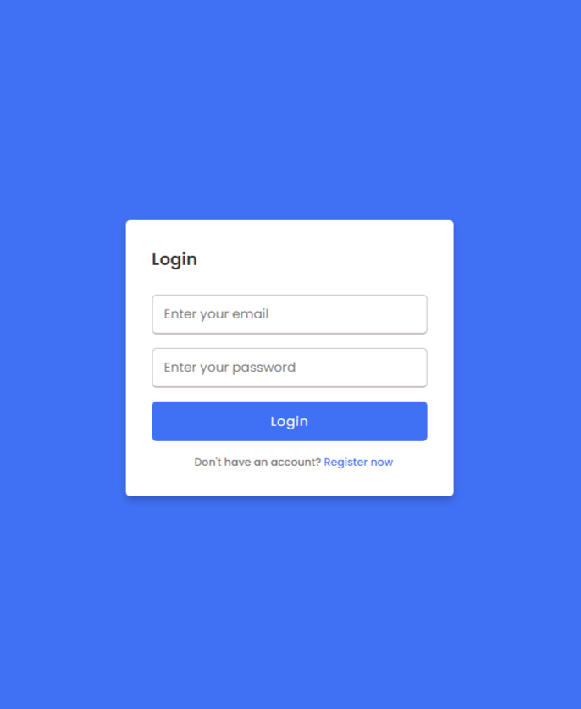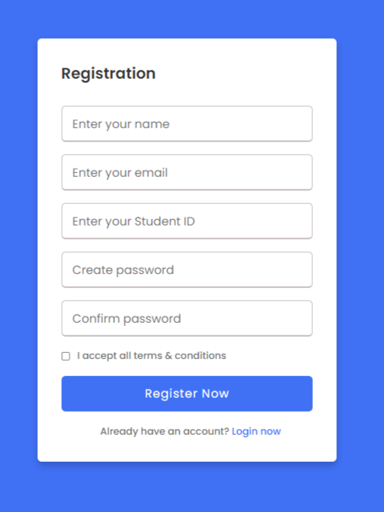

How to Compile

* <https://loginpage.hvu13.repl.co/>

Map Page

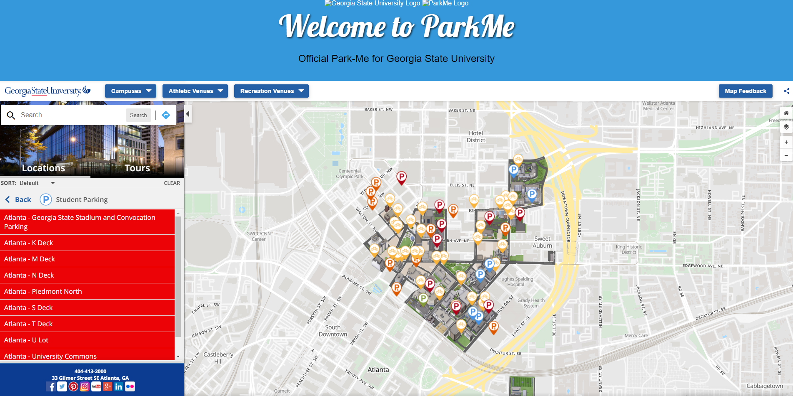

How to compile

* <https://aquamarine-beverlie-92.tiiny.site>

## Testing

Use Case 2

* Description: User inputs information to log into the service. Valid username should be between 1 and 16 characters and valid password should be between 8 and 12 characters.
* Features:
  + check (str username, str password, list User)
* Inputs:
  + ctr username is a string with a length up to 16 characters
  + ctr password is string with a length between 8 and 12 characters
* Test Specifications:
  + check (1 - 16 characters, 8 - 12 characters, list User)
  + check (< 1 character, < 8 characters, list User)
  + check (>16 characters, >12 characters, list User)
  + check (< 1 character, 8 - 12 characters, list User)
  + check (1 - 16 character, < 8 characters, list User)
* Test Case:
  + check (ABCDEFG, ABCD1234, list User)
  + check ( , ABC123, list User)
  + check (ABCDEFGHIJKLMNOPQ, ABCDEFG123456, list User)
  + check ( , ABCD1234, list User)
  + check (ABCDEFG, ABC123, list User)

Use Case 4

* Description: User with a reservation ID number inputs payment information. Information is sent through secure gateway to be verified. Valid information should be a name string with more than 0 characters, a creditCardNum string with more than 0 numeric characters, and a ccSecurityNum string with more than 0 numeric characters.
* Features:
  + paymentCheck(str name, str creditCardNum, str ccSecurityNum)
* Inputs:
  + str name is a string with more than 0 characters
  + str creditCardNum is a string with more than 0 numeric characters and no letters
  + str ccSecurityNum is a string with more than 0 numeric characters and no letters
* Test Specifications:
  + paymentCheck (>0 characters, >0 characters, >0 characters)
  + paymentCheck (0 characters, 0 characters, 0 characters)
  + paymentCheck (0 characters, >0 characters, >0 characters)
  + paymentCheck (>0 characters, 0 characters, >0 characters)
  + paymentCheck (>0 characters, >0 characters, 0 characters)
  + paymentCheck (>0 characters, 0 characters, 0 characters)
  + paymentCheck (0 characters, >0 characters, 0 characters)
  + paymentCheck (0 characters, 0 characters, >0 characters)
* Test Case:
  + paymentCheck (ABC, 123456, 1234)
  + paymentCheck ( , , )
  + paymentCheck ( ,123456, 1234)
  + paymentCheck (ABC, , 1234)
  + paymentCheck (ABC, 123456, )
  + paymentCheck (ABC, , )
  + paymentCheck ( , 123456, )
  + paymentCheck ( , , 1234)

Use Case 6

* Description: User with a successful reservation will receive confirmation with details, including the date, time, parking lot, and a unique reservation ID
* Features:
  + printReservation(str time, str date, list lot, int reservationID)
* Inputs:
  + str time is a string depicting the time
  + str date is a string depicting the date
  + list lot is a list of length x depicting the parking lot
  + int reservationID is an int between 4 and 6 digits
* Test Specifications:
  + printReservation(time, date, list[1-x], 0000 – 999999)
  + printReservation(empty time, empty date, empty list, <0000)
  + printReservation(time, date, list[>x] >999999)
* Test Case:
  + printReservation(“xx : xx”, “xx-xx-xxxx", list[3], 0000 – 999999)
  + printReservation ( , , list[], <0000)
  + printReservation (“xx : xx”, “xx-xx-xxx", list[x+1] >999999)

Use Case 8

* Description: User can text for the user feedback system. A valid submission contains text that features between 1 and 240 characters.
* Features:
  + feedback (str text)
* Inputs:
  + str text is a string of length 1 - 240
* Test Specifications:
  + feedback (str 1-240)
  + feedback (str 0)
  + feedback (str >240)
* Test Case:
  + feedback (“xxx”)
  + feedback (“ ”)
  + feedback(“x...”+240)

Use Case 9

* Description: Administrators can modify parking lot entries.
* Features:
  + change (str lotName, int spotNumber, bool occupancy)
  + add (str lotName, int newSpotNum)
* Inputs:
  + str lotName is a string of length 1-12
  + int spotNumber is an integer between 0-127
  + bool occupancy is a boolean of values 0 and 1
  + int newSpotNum is an integer between 1-128
* Test Specifications:
  + change (1-12, 0-127, 0-1)
  + change (<1, <0, <0)
  + change (>12, >127, >1)
  + add (1-12, 1-128)
  + add (<1, <1)
  + add (>12, >128)
* Test Case:
  + change (ABCDEFG, 48, 1)
  + change (0, -1, -1)
  + change (ABCDEFGHIJKLM, 128, 2)
  + add (ABCDEFG, 24)
  + add (0, 0)
  + add (ABCDEFGHIJKLM, 129)

## Appendix