Software Requirements Specification (SRS)
Project: Online Quiz System — console-based multiple-choice quiz game with scoring (C / C++)
Version: 1.0
Authors: << Student name / SRN >>
Date: 06-09-2026
Status: Draft for review

Revision history
Version | Date | Author | Change summary | Approval
0.1 | 06-09-2026 | << Student >> | Initial draft: scope, FRs, NFRs, security section | —
1.0 | 06-09-2026 | << Student >> | Complete SRS with use-case diagrams and RTM | Pending

Approvals
Role | Name | Signature / Email | Date
Course Coordinator
Student (Author)

Table of Contents
1. Introduction
2. Overall description
3. External interface requirements
4. System features (detailed)
5. Non-functional requirements (detailed)
6. Quality attributes & Acceptance tests
7. System models and diagrams (UML use-case)
8. Requirements Traceability Matrix (RTM)

1. Introduction

1.1 Purpose
This document is a Software Requirements Specification (SRS) for the Online Quiz System, a single-user, console-based multiple-choice quiz application implemented in C / C++. It defines the functional and non-functional requirements, the external interfaces, the security objectives and requirements, and the verification criteria against which the delivered program will be assessed. The intended readers are the developer, the reviewing instructor, and any evaluator running the acceptance tests.

1.2 Scope
The system presents multiple-choice questions to a player through a text terminal, accepts a keyed answer per question, scores the attempt, and persists results to a local file so that a leaderboard can be shown. An authenticated administrator mode allows the question bank to be listed, added to, edited, and deleted. All state is held in plain local files; there is no database, no network component, and no concurrent multi-user access.
Explicitly out of scope: graphical or web user interfaces, networked or client–server play, user account registration with per-user credentials beyond the single administrator passphrase, question types other than single-correct-answer multiple choice, and any form of adaptive or randomised question generation beyond shuffling an existing bank.

1.3 Audience
Developer, code reviewer, QA / test author, course instructor, and assessment evaluator

1.4 Definitions and Acronyms
Term | Meaning
MCQ | Multiple-Choice Question
CLI | Command-Line Interface
SRS | Software Requirements Specification
FR | Functional Requirement
NFR | Non-Functional Requirement
RTM | Requirements Traceability Matrix
Question Bank | The local collection of quiz questions, answer options, and correct answers
Attempt | One complete run of the quiz by a player

2. Overall description

2.1 Product perspective
The Online Quiz System is a self-contained console executable. It is not a component of a larger system and exposes no API. It reads two data files at start-up — the question bank and the results file — and writes the results file and an administrator audit log. The program is single-process and single-threaded; the only concurrency consideration is that two copies of the program started against the same data directory must not corrupt each other's writes, which is handled by atomic replacement rather than by locking.

2.2 Major product functions
- Player identification and session start
- Category and question-count selection
- Randomised presentation of MCQs with option shuffling
- Bounded, validated answer input with an optional per-question time limit
- Scoring (flat or difficulty-weighted) and end-of-session score report
- Per-question answer review after submission
- Result persistence and top-N leaderboard display
- Administrator-authenticated question-bank management (list, add, edit, delete)
- Question-bank integrity verification and administrator audit logging

2.3 User roles and characteristics
- Player — any user with basic terminal familiarity. Expects unambiguous prompts, tolerance of mistyped input, and a clear final score. No prior knowledge of the file formats is assumed.
- Administrator — the instructor or question author. Knows the question format, needs to edit the bank quickly, and is trusted with the administrator passphrase.
- Evaluator — runs the acceptance test suite and inspects data files directly; needs the on-disk formats to be human-readable and documented.

2.4 Operating environment
- Any POSIX-compliant system (Linux, macOS) or Windows 10+ with a terminal of at least 80 columns × 24 rows.
- Toolchain: GCC 9+ / Clang 12+ / MSVC 2019+; C11 or C++17.
- Storage: local filesystem, read-write access to the program's data directory. Total data footprint under 1 MB for a 1000-question bank.
- No network connectivity is required or used at any point.

2.5 Constraints and assumptions
- Standard library only, plus platform headers where a portable equivalent does not exist (for example, non-blocking input for the question timer). Third-party libraries are not permitted.
- Data files are plain text so that they can be inspected and diffed by the evaluator.
- Exactly one correct option per question; partial credit is not supported.
- The per-question timer requires non-blocking console input, which has no ISO C equivalent; the implementation is expected to isolate this behind a small platform-abstraction module (poll/select on POSIX, kbhit on Windows).
- The administrator passphrase protects against casual tampering by another user of the same machine. It is not a defence against a user who can already write to the data files directly; that limitation is stated explicitly in section 5.1.1.

3. External interface requirements

3.1 User interfaces
A single text-mode interface. The main menu offers numbered choices (Take Quiz, View Leaderboard, Administrator Mode, Help, Exit) selected by typing a digit and pressing Enter. Question screens display the stem, four labelled options (A–D), the question index ("Question 4 of 10"), and the remaining time when the timer is enabled. Every prompt states the accepted input set. Invalid input produces a one-line diagnostic and re-prompts without consuming an attempt. All output fits within 80 columns; long question stems are word-wrapped, not truncated.

3.2 Hardware Interfaces
- Keyboard for text/numeric input
- Monitor or terminal display for textual output
- Standard local storage when a file-based question bank is used

3.3 Software Interfaces
- Operating system console/terminal
- Standard C/C++ runtime libraries
- Optional local text/CSV-style question file if the implementation does not embed questions directly in source code

3.4 Communications Interfaces
No network or inter-process communication interface is required for the base version of the Online Quiz System.

4. System features
Each requirement below carries acceptance criteria and a reference test case. Functional requirement IDs follow the pattern QUIZ-F.

4.1 Session start and identification
Description: establish who is playing and which privilege level the session runs at.
Req ID | Requirement (shall…) | Type | Prio. | Source / Stakeholder | Acceptance criteria / Test ref | Dependencies
QUIZ-F-001 | The system shall prompt for a player name of 1–30 characters and accept only letters, digits, spaces, underscores and hyphens. | Functional | High | Evaluator | AC-001: A 30-character valid name is accepted; a 31-character or empty name is rejected with a re-prompt. Test: TC-SES-01 | Feeds the results record
QUIZ-F-002 | The system shall require an administrator passphrase before entering administrator mode and shall verify it against a stored salted hash. | Functional | High | Security | AC-002: Correct passphrase grants admin menu; incorrect passphrase is refused and the menu is not shown. Test: TC-SES-02 | Depends on QUIZ-SR-002
QUIZ-F-003 | The system shall disable administrator mode for the remainder of the process after 3 consecutive failed passphrase attempts and shall record the event in the audit log. | Functional | High | Security | AC-003: After 3 failures the admin option is rejected without prompting; one lockout line appears in admin.log. Test: TC-SES-03 | Per-process only; a restart resets it

4.2 Question Presentation and Answer Input
Description: Present MCQs and safely collect one answer per question.
Req ID | Requirement (shall...) | Type | Priority | Acceptance Criteria / Test Case | Dependencies / Comments
OQS-F-006 | The system shall present one question at a time with a visible question number. | Functional | High | AC: Only the active question is requested for input. Test: TC-QUIZ-01 | Question bank loaded
OQS-F-007 | The system shall display all answer options associated with the current question using consistent option labels. | Functional | High | AC: Every configured option for the current question is printed. Test: TC-QUIZ-02 | Console output
OQS-F-008 | The system shall accept an answer using the documented option format, such as A-D or 1-4. | Functional | High | AC: Valid option input is accepted and recorded. Test: TC-ANS-01 | Keyboard input
OQS-F-009 | The system shall reject input that does not correspond to a displayed option and shall prompt the player again without advancing the question. | Functional | High | AC: Invalid input does not change score or question index. Test: TC-ANS-02 | Robust input handling
OQS-F-010 | The system shall record exactly one accepted answer for each question in the current attempt. | Functional | High | AC: Each completed question has one stored response. Test: TC-ANS-03 | Attempt state

4.3 Answer Evaluation and Scoring
Description: Evaluate responses and maintain a correct score.
Req ID | Requirement (shall...) | Type | Priority | Acceptance Criteria / Test Case | Dependencies / Comments
OQS-F-011 | The system shall compare each accepted answer with the stored correct answer for that question. | Functional | High | AC: Evaluation result matches the configured answer key. Test: TC-SCORE-01 | Answer key
OQS-F-012 | The system shall increment the score by one point for each correct answer and shall not increment it for an incorrect answer. | Functional | High | AC: Score changes only after a correct response. Test: TC-SCORE-02 | OQS-F-011
OQS-F-013 | The system shall display whether the submitted answer was correct or incorrect after evaluation. | Functional | Medium | AC: Feedback appears after every accepted answer. Test: TC-SCORE-03 | OQS-F-011
OQS-F-014 | The system shall show quiz progress using the current question number and total question count. | Functional | Medium | AC: Progress values are accurate for every displayed question. Test: TC-QUIZ-03 | Question count
OQS-F-015 | The system shall continue to the next question after the current answer has been evaluated, until no questions remain. | Functional | High | AC: All questions are asked exactly once in the base sequential mode. Test: TC-QUIZ-04 | Session loop

4.4 Results and Session Control
Description: Complete the attempt and let the player replay or exit.
Req ID | Requirement (shall...) | Type | Priority | Acceptance Criteria / Test Case | Dependencies / Comments
OQS-F-016 | The system shall calculate the final score after the last question has been evaluated. | Functional | High | AC: Final score equals the number of correct answers. Test: TC-RES-01 | OQS-F-012
OQS-F-017 | The system shall calculate the final percentage as (score / total questions) x 100. | Functional | High | AC: Percentage is mathematically correct; division by zero is prevented. Test: TC-RES-02 | Total questions > 0
OQS-F-018 | The system shall display a final result summary containing the player name, score, total questions, and percentage. | Functional | High | AC: All required result fields are displayed. Test: TC-RES-03 | OQS-F-002, OQS-F-016, OQS-F-017
OQS-F-019 | The system shall offer the player an option to replay the quiz after the result summary is displayed. | Functional | Medium | AC: Choosing replay starts a fresh attempt. Test: TC-CTRL-01 | Result completed
OQS-F-020 | The system shall terminate cleanly when the player chooses to exit. | Functional | High | AC: Program exits without crash or unfinished prompt. Test: TC-CTRL-02 | Console process

4.5 Persistence and leaderboard
Description: keep results across runs and rank them.
Req ID | Requirement (shall…) | Type | Prio. | Source / Stakeholder | Acceptance criteria / Test ref | Dependencies
QUIZ-F-040 | The system shall append one result record per completed or aborted session containing the ISO 8601 timestamp, player name, category, questions attempted, correct count, score and maximum score. | Functional | High | Evaluator | AC-040: results.csv grows by exactly one well-formed line per session. Test: TC-PER-01 | Append mode; no rewrite of history
QUIZ-F-041 | The system shall display a leaderboard of the top 10 results sorted by percentage descending, then by timestamp ascending for ties. | Functional | Medium | Player | AC-041: Two equal percentages appear with the earlier timestamp first. Test: TC-PER-02 | Reads results.csv only
QUIZ-F-042 | The system shall treat a missing results file as an empty result set, create it on first write, and continue after reporting an unreadable file rather than terminating. | Functional | Medium | Developer | AC-042: Deleting results.csv then running a session recreates it; a chmod 000 file produces a warning and a still-usable program. Test: TC-PER-03 | Graceful-degradation case
5. Non-functional requirements (detailed)
NFRs are measurable quality constraints and are tied to verification activities
Req ID | Requirement | Category | Priority | Acceptance Criteria / Measurement
OQS-NF-001 | For a local question bank of up to 1,000 questions, the application shall launch and present the first question within 2 seconds on a typical lab computer. | Performance | High | Measure elapsed startup time in 10 runs; each run must be <= 2 s. Test: TC-NF-PERF-01
OQS-NF-002 | After a valid answer is entered, the application shall display evaluation feedback and the next prompt within 1 second under normal local execution. | Performance | Medium | Observed response time <= 1 s for 20 consecutive answers. Test: TC-NF-PERF-02
OQS-NF-003 | The application shall not crash, terminate unexpectedly, or corrupt the score when given invalid menu/answer input during a 100-input robustness test. | Reliability | High | 100 invalid/valid mixed inputs complete without abnormal termination. Test: TC-NF-REL-01
OQS-NF-004 | All interactive prompts shall use consistent wording and clearly state the expected input format. | Usability | Medium | Usability checklist confirms start, answer, replay, and exit prompts are unambiguous. Test: TC-NF-UX-01
OQS-NF-005 | The source code shall compile successfully using at least one standards-compliant C11 compiler or C++17 compiler on the target lab environment without source modification beyond build configuration. | Portability / Maintainability | Medium | Clean build succeeds with documented compiler command. Test: TC-NF-PORT-01

5.1 Security

5.1.1 Security objectives
This system holds no personal data and runs entirely on the local machine, so the realistic threat is not a remote attacker but a local user — typically a player — who wants to see the answers, alter their score, or crash the program with hostile input. The objectives below are scoped to that threat model.
- SO-1 (Integrity of assessment data): the question bank, the results file and the audit log shall be modifiable through the program only by an authenticated administrator, and unauthorised modification made outside the program shall be detectable.
- SO-2 (Memory safety against untrusted input): all data reaching the program — keyboard input and file contents alike — shall be treated as untrusted, so that no input can cause a buffer overflow, an out-of-bounds access or other undefined behaviour.
- SO-3 (Confidentiality of the administrator credential): the administrator passphrase shall not be recoverable from any file the program writes, from its output, or from its source.
Stated limitation: a local user with write access to the data directory can replace both the bank and its digest file, and a user who can read process memory can recover the passphrase while it is being verified. Defeating either would require OS-level access control or a trusted store, both outside the scope of a console coursework application. SO-1 therefore targets detection, not prevention.

5.1.2 Security requirements
Req ID | Requirement (shall…) | Type | Priority | Acceptance criteria / Test case ref
QUIZ-SR-001 | All console and file input shall be read with length-bounded calls (fgets or std::getline into a std::string); gets, scanf("%s") and strcpy into fixed buffers shall not appear in the source. | Security | High | Source grep finds no banned call; a 1 MB input line at every prompt is truncated or rejected with no overflow under ASan. Test: TC-SEC-01
QUIZ-SR-002 | The administrator passphrase shall be stored only as a salted hash with a per-installation random salt of at least 16 bytes, and shall never be echoed to the terminal or written to any log. | Security | High | No plaintext passphrase in any file or log; terminal echo disabled during entry. Test: TC-SEC-02
QUIZ-SR-003 | Every field parsed from the question bank shall be validated against a documented maximum length (stem ≤ 512, option ≤ 256, category ≤ 64 characters) and records exceeding it shall be rejected, not truncated into a fixed buffer. | Security | High | A crafted bank with a 100 KB stem is rejected with a line-numbered diagnostic and no memory error. Test: TC-SEC-03
QUIZ-SR-004 | No string originating from user input or from a data file shall be passed as the format argument of a printf-family function. | Security | High | Source review and -Wformat-security clean; a question stem containing %n and %s renders literally. Test: TC-SEC-04
QUIZ-SR-005 | The system shall verify the SHA-256 digest of the question bank before use and shall refuse all write operations while the digest does not match. | Security | Medium | Tampered bank triggers read-only mode; admin add/edit/delete are unavailable. Test: TC-SEC-05
QUIZ-SR-006 | Data files created by the system shall be given owner-only permissions (0600 on POSIX) and the program shall refuse to write through a symbolic link. | Security | Medium | Newly created files show mode 0600; replacing results.csv with a symlink causes a refusal, not a write through it. Test: TC-SEC-06

6. Quality attributes & acceptance tests
Exit criteria for acceptance:
- Every high-priority functional requirement is implemented and its acceptance criteria verified.
- No non-functional requirement fails: in particular, a clean sanitizer run (QUIZ-NF-002) and a warning-free build (QUIZ-NF-003) are blocking.
- All six security requirements pass; QUIZ-SR-001 to QUIZ-SR-004 are blocking, QUIZ-SR-005 and QUIZ-SR-006 may be waived with a written justification.
- The RTM in section 8 shows every requirement mapped to at least one executed test case with status A (accepted).
Acceptance test suites: TC-SES (session and authentication), TC-BNK (bank management), TC-QZ (quiz flow), TC-SCR (scoring), TC-PER (persistence and leaderboard), TC-INT (integrity and audit), TC-PERF, TC-REL, TC-PORT, TC-UX, TC-MNT (non-functional), TC-SEC (security).
Verification methods used: automated tests driving stdin with recorded transcripts compared against expected stdout; sanitizer and Valgrind runs; static analysis for complexity; manual inspection for the source-level security requirements.

7. System models and diagrams

7.1 Use-case diagram — player quiz session
The player-facing boundary. The player starts a session, answers questions, may abort, and views the score report and leaderboard. Option-input validation is included in every answer; the timeout handler extends validation because it only occurs when the configured limit expires (QUIZ-F-024). The question bank and results files act as a supporting actor at the read/append points.
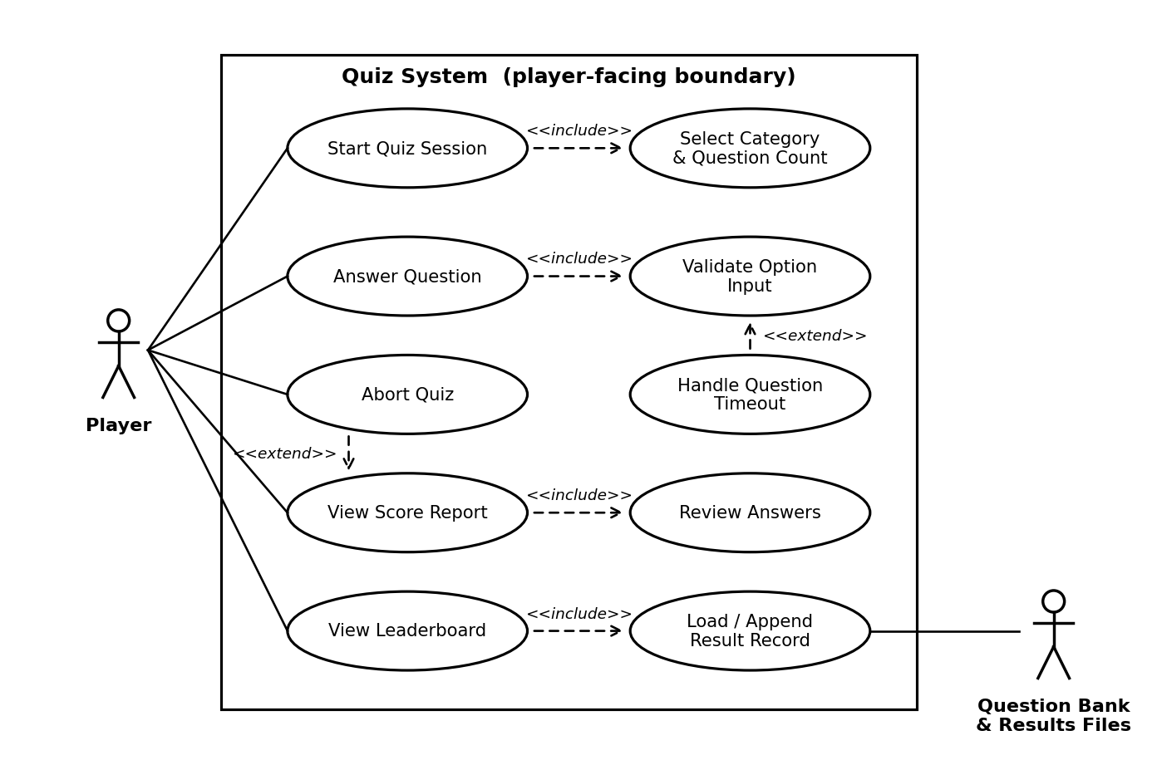
Figure 7.1 — Use-case diagram: player quiz session

7.2 Use-case diagram — question-bank administration
The administration boundary. Authentication (QUIZ-F-002) is a precondition of every bank-modifying use case; the lockout after three failures extends it (QUIZ-F-003). Add, edit and delete each include the atomic persist step, which in turn includes writing an audit record. Checksum verification runs against the same local file store.
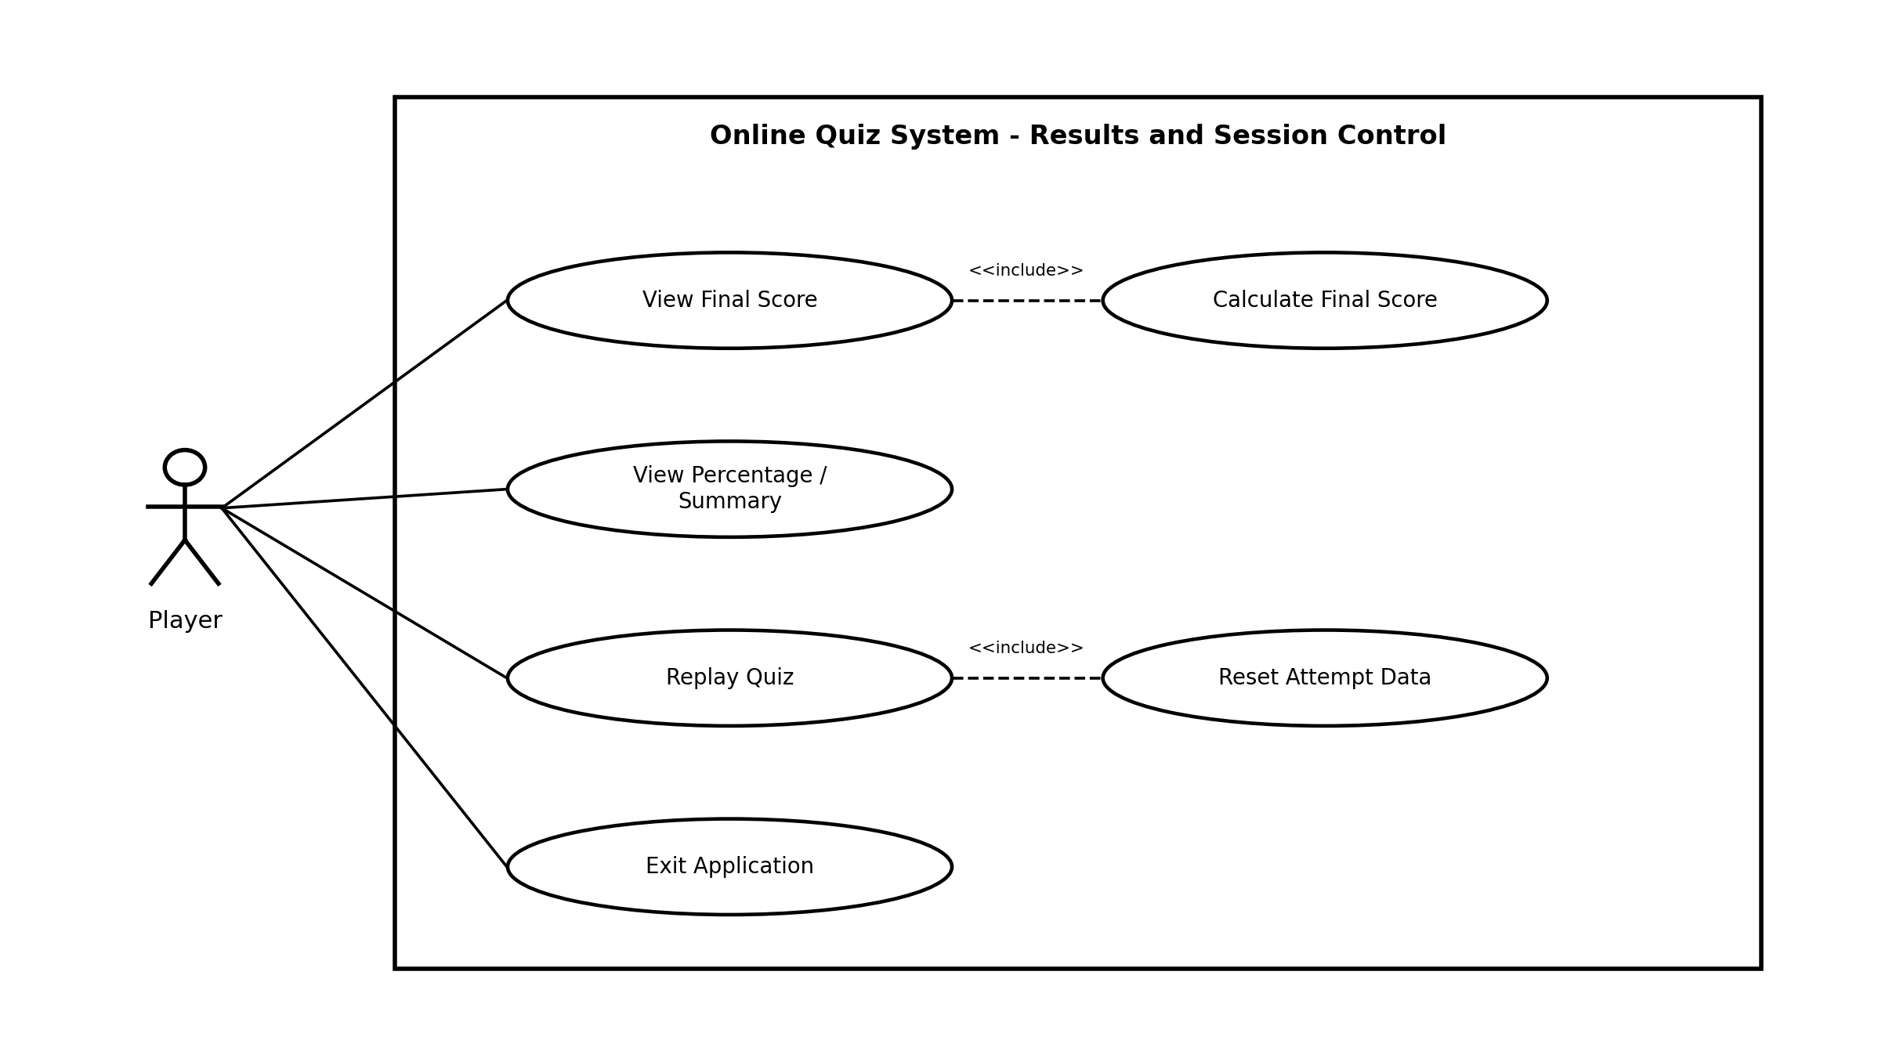
Figure 7.2 — Use-case diagram: question-bank administration

8. Requirements Traceability Matrix (RTM)
Req ID | Requirement Short Name | Section Ref | Module | Test Case(s) | Status (N/P/A) | Comments
OQS-F-001 | Welcome / start | 4.1 | Main / UI | TC-INIT-01 | N
OQS-F-002 | Capture player name | 4.1 | Input Module | TC-INIT-02 | N
OQS-F-003 | Initialize attempt | 4.1 | Session Module | TC-INIT-03 | N
OQS-F-004 | Load question bank | 4.1 | Question Bank | TC-QB-01 | N
OQS-F-005 | Validate question records | 4.1 | Question Bank | TC-QB-02 | N
OQS-F-006 | Present one question | 4.2 | Quiz Engine | TC-QUIZ-01 | N
OQS-F-007 | Display options | 4.2 | Quiz Engine / UI | TC-QUIZ-02 | N
OQS-F-008 | Accept answer | 4.2 | Input Module | TC-ANS-01 | N
OQS-F-009 | Reject invalid answer | 4.2 | Input Validation | TC-ANS-02 | N
OQS-F-010 | Record response | 4.2 | Session Module | TC-ANS-03 | N
OQS-F-011 | Compare answer key | 4.3 | Scoring Module | TC-SCORE-01 | N
OQS-F-012 | Update score | 4.3 | Scoring Module | TC-SCORE-02 | N
OQS-F-013 | Answer feedback | 4.3 | UI / Scoring | TC-SCORE-03 | N
OQS-F-014 | Show progress | 4.3 | Quiz Engine / UI | TC-QUIZ-03 | N
OQS-F-015 | Advance questions | 4.3 | Quiz Engine | TC-QUIZ-04 | N
OQS-F-016 | Final score | 4.4 | Results Module | TC-RES-01 | N
OQS-F-017 | Percentage | 4.4 | Results Module | TC-RES-02 | N
OQS-F-018 | Result summary | 4.4 | Results / UI | TC-RES-03 | N
OQS-F-019 | Replay | 4.4 | Session Control | TC-CTRL-01 | N
OQS-F-020 | Exit | 4.4 | Session Control | TC-CTRL-02 | N
OQS-NF-001 | Performance target | 5 | Application / Build | TC-NF-PERF-01 | N
OQS-NF-002 | Performance target | 5 | Application / Build | TC-NF-PERF-02 | N
OQS-NF-003 | Reliability target | 5 | Application / Build | TC-NF-REL-01 | N
OQS-NF-004 | Usability target | 5 | Application / Build | TC-NF-UX-01 | N
OQS-NF-005 | Portability / Maintainability target | 5 | Application / Build | TC-NF-PORT-01 | N
OQS-SR-001 | Security control | 5.1 | Input / Quiz / Scoring | TC-SEC-01 | N
OQS-SR-002 | Security control | 5.1 | Input / Quiz / Scoring | TC-SEC-02 | N
OQS-SR-003 | Security / Integrity control | 5.1 | Input / Quiz / Scoring | TC-SEC-03 | N
OQS-SR-004 | Security control | 5.1 | Input / Quiz / Scoring | TC-SEC-04 | N
OQS-SR-005 | Security / Integrity control | 5.1 | Input / Quiz / Scoring | TC-SEC-05 | N

Status legend: N = Not Run, P = Pass, A = Accepted / Approved.

