The University of Kansas

Team A’

December 2017

**A’ Video Chat**

User’s Manual

Table of Contents

A. General Information 3

1.1 License 3

1.2 System Requirements 4

B. Getting Started 6

2.1 Creating a room 6

2.2 Joining an existing room 6

2.3 Text Commands 7

2.4 Text Chat 7

2.5 Other Features 8

**1.0 GENERAL INFORMATION**

General Information

# **A. General Information**

General Information

## **1.1 License**

This is free and unencumbered software released into the public domain.

Anyone is free to copy, modify, publish, use, compile, sell, or distribute this software, either in source code form or as a compiled binary, for any purpose, commercial or non-commercial, and by any means.

In jurisdictions that recognize copyright laws, the author or authors of this software dedicate any and all copyright interest in the software to the public domain. We make this dedication for the benefit of the public at large and to the detriment of our heirs and successors. We intend this dedication to be an overt act of relinquishment in perpetuity of all present and future rights to this software under copyright law.

THE SOFTWARE IS PROVIDED "AS IS", WITHOUT WARRANTY OF ANY KIND, EXPRESS OR IMPLIED, INCLUDING BUT NOT LIMITED TO THE WARRANTIES OF MERCHANTABILITY, FITNESS FOR A PARTICULAR PURPOSE AND NONINFRINGEMENT. IN NO EVENT SHALL THE AUTHORS BE LIABLE FOR ANY CLAIM, DAMAGES OR OTHER LIABILITY, WHETHER IN AN ACTION OF CONTRACT, TORT OR OTHERWISE, ARISING FROM, OUT OF OR IN CONNECTION WITH THE SOFTWARE OR THE USE OR OTHER DEALINGS IN THE SOFTWARE.

For more information, please refer to <https://unlicense.org>

## **1.2 System Requirements**

General Information

Web Browser (Desktop):

* Google Chrome v54.0
* Firefox v44.0
* Edge v15.0

Internet Explorer and Safari* are not supported

Web Browser (Mobile):

* Google Chrome v62.0
* Firefox v57.0

Safari* on IOS is not supported

Recommended Internet Speed:

* 5 Mbps Upload
* 5 Mbps Download

*Future versions of Safari may gain support without any updates to this software

Getting Started

**2.0 GETTING STARTED**

# **B. Getting Started**

Getting Started

## **2.1 Creating a room**

Step 1: Go to the applications website

From the application’s website, there are two options:

1. Type a custom room name in the box, then click the “Join” button. (See Figure 1 below)

2. Click the “Join” button. (A random 3-word phrase will be selected as your room name)

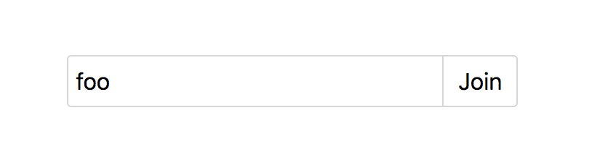

Figure 1: Creating a custom room named "foo".

## **2.2 Joining an existing room**

To join an existing room, type the room name in the text box on the application’s homepage, and click join. (See Figure 1 above)

## **2.3 Text Commands**

Getting Started

|  |  |  |
| --- | --- | --- |
| Command | Example | Result |
| /name | /name Jon Smith | The user’s name is set to “Jon Smith” (See Figures 2 and 3 below) |

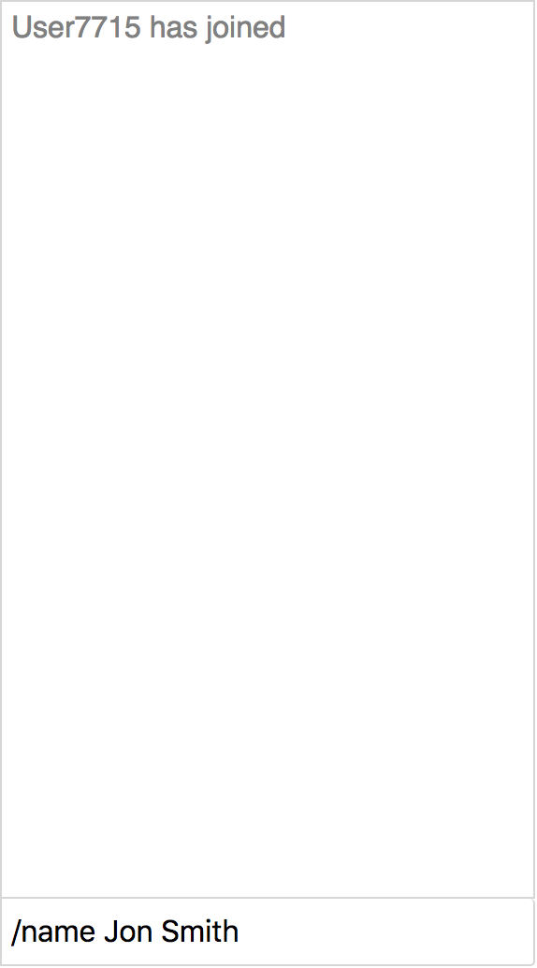

Figure 2: Changing username (1)

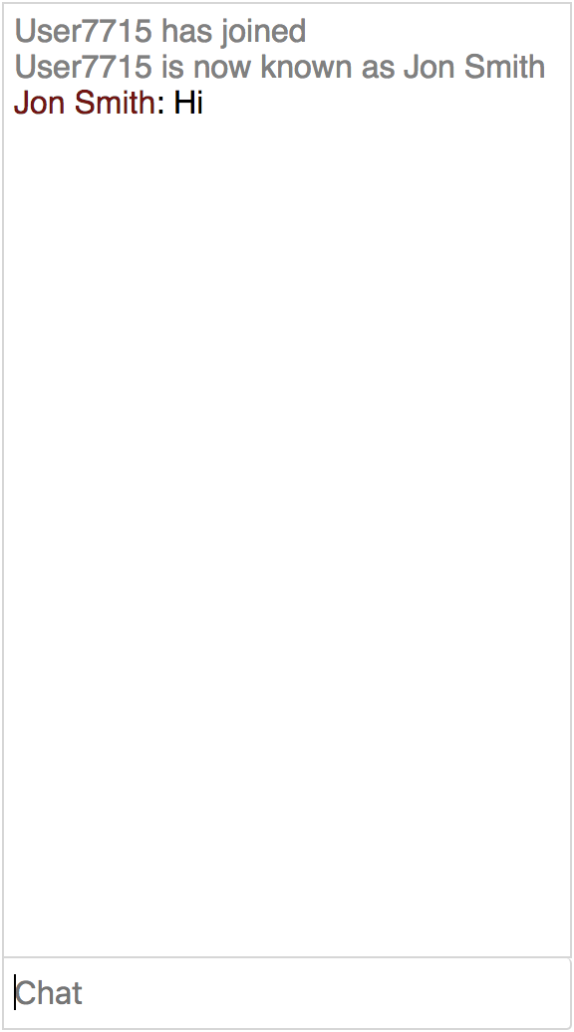

Figure 3: Changing username (2)

## **2.4 Text Chat**

Text chat is a simple feature to use. Type what you want to say in the Chat box and press the enter key on your keyboard. (See Figure 3 above)

## **2.5 Other Features**

Getting Started

**Mirror Video Box:** The box with the image of the current user in it is located in the bottom right of the screen (default), below the text chat. It can be moved to each corner of the screen, counter-clockwise, by clicking on the video. The text chat and mute button (see below), move along with the video box. (See Figures 4 and 5 below)

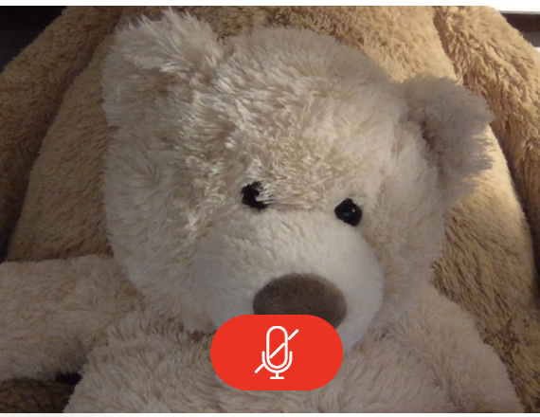

Figure 5: Mute button toggled on

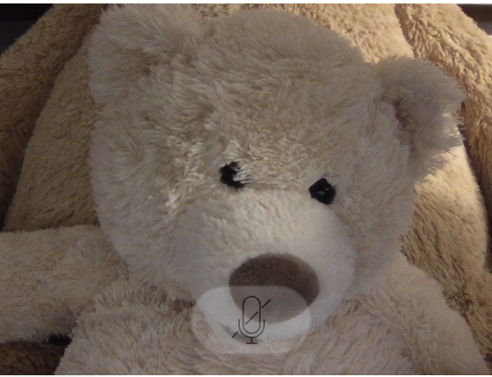

Figure 4: Mute button toggled off

**Mute Button**: The mute button is located in the mirror video box (the one of the current user), located in the bottom right (default). When the mute button is toggled on (See Figure 5 above), signaled by the button becoming red, all out outgoing audio is muted. This means anyone in the chat with the current user will not hear any sound from that user until the that user toggles the mute button off (See Figure 4 above).