**Deployment Plan**

**Team A’**

Team A’ is poised to capture the online video chat market by storm, introducing an application with shockingly low-latency and daring levels of minimality in design. The tech world is perhaps not yet ready for an application with this level of technological sophistication and utility, so it is the job of this document (the deployment plan) to describe a strategy that can take full advantage of the rock-solid tech being developed under our roof.

Our team will take a three-pronged strategy to reach full market penetration:

* Attendance and presentations at core tech conferences and conventions
* Aggressive advertising in mobile apps, websites, and newspapers.
* Local outreach at schools and businesses demonstrating how to transition their workflow from traditional video chat to A’-chat.

Our application, fortunately, does not require many of the startup costs associated with many software companies. For example, we do not require publishing anything to an app store, or distributing our tech via a physical medium like a disk or USB drive. Simply buying a domain is sufficient, which as shown in the maintenance plan, will like be on the order of $60-70 per year for a *.io domain.

First, conference and convention attendance. Through critical connections made in EECS 448, Team A’ has secured presentation slots at TechCrunch Disrupt, Dreamforce, Web Summit, and WSJ Digital Live.

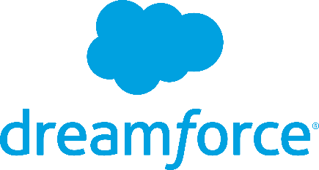



Figure 1. A collection of conferences and conventions Team A’ plans to attend.

These conferences will provide our team with a massive opportunity to impress venture capital and consumers to adopt and fund our product. Our internal testing shows latency levels significantly lower than market competition, and these conferences will give the team an opportunity to demonstrate that technological edge.

**[Insert a paragraph about the cost of attending these conferences, including registration + hotel rooms + flights. These can probably just be rough estimates/guesses]**

Second, an aggressive advertising campaign through multiple mediums. Initially, the ad rollout will occur through the Google AdWords program. This infrastructure is simple to approach, and is capable of mass consumer outreach. This program also only requires paying when a consumer interacts with the advertisement, so starting with this program will yield considerable cost-savings over alternative advertising schemes.

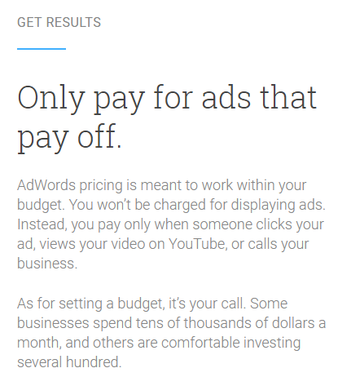

Once AdWords has started generating a steady flow of users for the website, our team will expand the ad campaign to further mediums, such as mobile apps and newspapers. These will reach audiences that the Google ads couldn’t, expanding our market impact significantly. A 2 column wide, 2 inch tall newspaper ad will run the firm approximately $40, which is very cost efficient at reaching consumers who read newspapers (this data is taken from https://bizfluent.com/info-7765342-average-cost-local-advertising.html).

Figure 2. How Google Adwords is priced, taken from adwords.google.com