**Maintenance Plan**

**Team A’**

As the development team of a next-generation, peer-to-peer video chat application, it is imperative to research the cost of maintenance for the application, and develop solutions that minimize our effective-to-cost ratio. Being a web-application, the following raw materials are needed just to operate our business:

* Web servers; either dedicated hardware or production-ready VPSs.
  + STUN servers for getting external network addresses
  + TURN servers to centralize video traffic if peer-to-peer fails
  + Signaling server to manage connections between clients
  + A machine to serve the actual website
  + A machine to manage storage of recorded video chats (once this feature is implemented down the line)
* An auto-renewing domain name
* A team of highly-dedicated web engineers with experience with low-latency communication and WebRTC
* Office space in downtown Kansas City

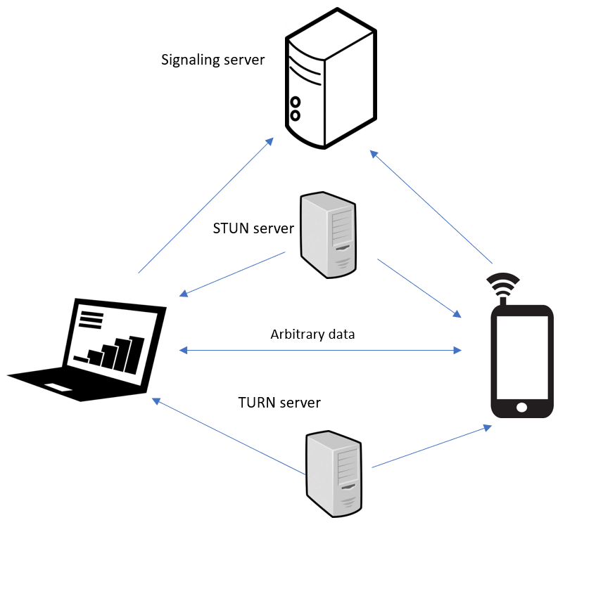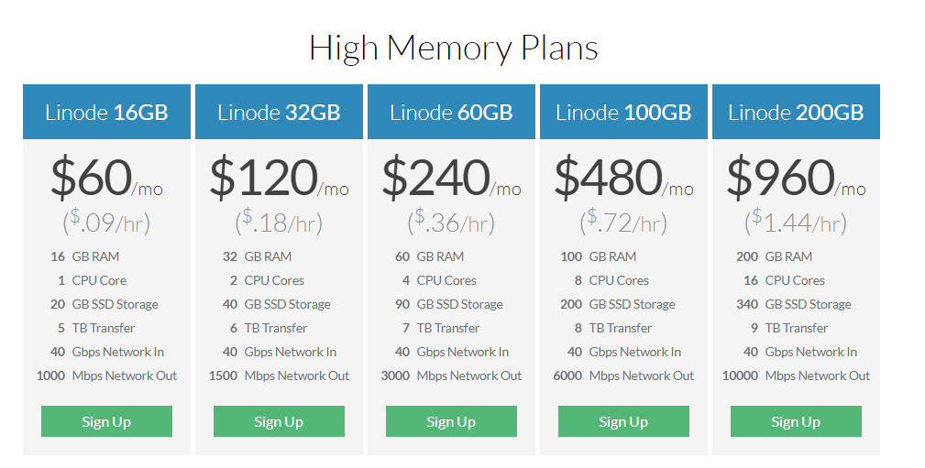

Figure 1. A depiction of some of the required servers for our application

To break down the cost of these requirements further, the cost of a high-memory (required for low-latency video chat applications) VPS is $480 a month, and includes 100 gigabytes of memory, 8 CPU cores, 200 gigabytes of SSD storage, and 40Gbps in 6000 Mbps out internet connections. These virtual servers will work for our application, and our team initially requires four of them (the fifth will be purchased once video storage is enabled in production). That means our monthly total for servers is **$1920**, which sounds like a steep price until this application becomes the clear market leader in the low-latency, online video chat market.

Figure 2. Our VPS options from linode.com/pricing

Next, we will look at the cost of the domain name for this application. In order to attract the hip, young userbase that an app like this requires, we need a pricey .io TLD to prove our startup-credibility. Using data from namecheap, this will cost around **$70** a year.

This application also requires a team of highly-skilled, WebRTC-proficient programmers to maintain the 24/7 uptime requirement of the low-latency video chat features. Using salary results from Glassdoor, our firm will have to pay around **$90,000** a year (to be 10% higher than Kansas City’s average software engineering salary of $80,000).

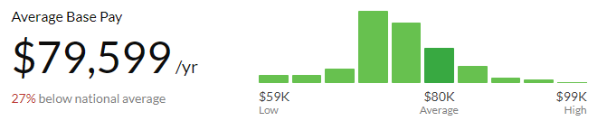

Figure 3. Salary information from glassdoor.com

These employees will also likely be compensated with shares in the firm when it goes public (plans for this are still in draft phase), which will add an estimated $10,000 in net-compensation due to the rapid expected-expansion of the application. For a modest team of 8 developers, this will lead to a **$960,000** yearly cost for salaries ($1,080,000 if one includes the cost of share compensation in this figure).

To accommodate the team of highly-skilled individuals, it is imperative to have an office space that maximizes their productivity. Our team has chosen an office in downtown Kansas City for development headquarters, which has plenty of room to expand once the application hits critical mass in the market.

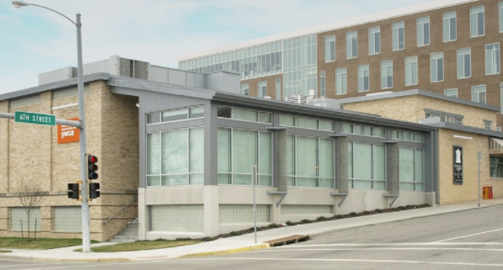

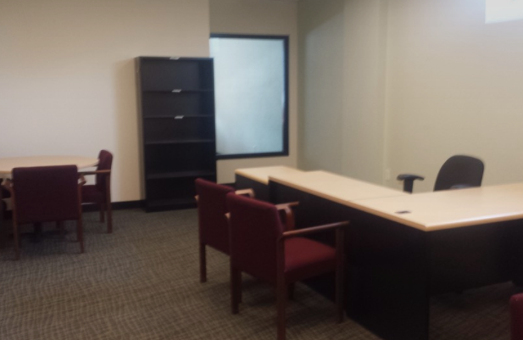

Figures 3 and 4. Photos of the company’s future headquarters in Kansas City

Taken from cityfeet.com

This space is unique, as it incorporates a combination of open space for programmers who prefer that setting, and closed offices for those who prefer privacy. At Team A’, we strongly believe in fitting our office space to the needs of the top-talent we hire. However, this does come with a cost. The space we are renting is **$10,805** a month (however, the productivity gains for our engineers due to the innovative space will far outpace the cost of renting it). This cost also includes the full kitchen and dining space in the office, so engineers behind on the sprints can spend whole days (even weeks) in the office without needing to leave, maximizing the productivity of our scrum methodology.

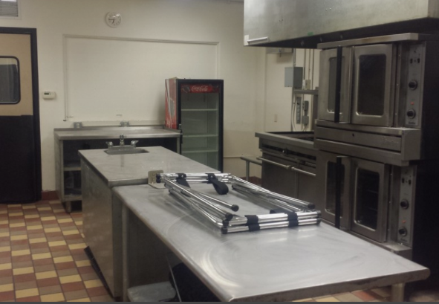

Figure 5. The office kitchen, which adds a new workflow item to the sprint (dinner), a new scrum role (in-house chef), and a new artifact (leftovers).

Taken from cityfeet.com

Overall, our budget comes out to spending **$92,730** a month for the core-necessities of the web-based video chat application. This might seem expensive for a management team of 3 KU students, but once the A’ video chat application pushes all competitors out of the marketplace, these costs will be almost nothing compared to the profits our team will experience.



Figure 6. Projected revenue growth for Team A’

Taken from pixabay.com