# Introduction

## **TRACK YOUR ENERGY**



**Last Updated:** 2024-01-26

## **What is Track Your Energy (TYE)?**

AMOS Corporation is excited to announce the launch of our Track your Energy Application, a cutting-edge solution designed to optimize the integration of renewable energy sources into the grid. As the world moves towards sustainable energy practices, AMOS is proud to lead the charge in maximizing the efficiency and effectiveness of renewable energy utilization.

### **Key Features:**

Key features of the TYE application include:

* **Real-time Monitoring and Analysis:**
  + TYE provides real-time monitoring and analysis of renewable energy production levels from various sources such as solar and wind farms.
  + Through continuous data collection and analysis, the system offers insights into the current status of renewable energy generation, allowing grid operators to make informed decisions promptly.
* **Dynamic Optimization Algorithms:**
  + The platform employs advanced machine learning algorithms to dynamically optimize the integration of renewable energy into the grid.
  + These algorithms adapt in real time to changing weather conditions, energy demand patterns, and grid stability metrics.
  + By dynamically adjusting energy integration strategies, TYE maximizes the utilization of renewable energy while ensuring grid reliability and stability.
* **Seamless Integration with Existing Grid Infrastructure:**
  + TYE seamlessly integrates with the existing grid infrastructure, leveraging standard protocols and interfaces.
  + Compatibility with diverse grid systems allows for easy deployment and adoption by utility companies and grid operators.
  + The integration process is streamlined to minimize disruption and facilitate the transition towards renewable energy-centric grids.
* **User-friendly Interface for Decision Support:**
  + The platform features an intuitive user interface designed to empower grid operators and energy stakeholders.
  + Key insights and recommendations regarding renewable energy integration are presented in a clear and actionable manner.
  + Decision support tools enable users to visualize data trends, explore scenarios, and implement optimized strategies to enhance grid performance.
* **Performance Monitoring and Reporting:**
  + The platform includes built-in performance monitoring and reporting functionalities.
  + Grid operators can track the effectiveness of renewable energy integration efforts over time and identify areas for improvement.
  + Comprehensive reports and analytics dashboards provide stakeholders with actionable insights into system performance and efficiency metrics.

By combining these key features, TYE offers a comprehensive solution for optimizing the integration of renewable energy sources into the grid. From real-time monitoring to predictive analytics and decision support, the platform equips energy stakeholders with the tools they need to embrace sustainable energy practices and build a more resilient energy infrastructure for the future.

### 

# External FAQs

What aspects of the use case should end-users know about?

**Q1**: What is the TYE Application?

**A**: The TYE Application is a cutting-edge solution designed to optimize the integration of renewable energy sources into the grid. It utilizes advanced data analytics and ML algorithms to analyze real-time data on renewable energy production levels, considering factors such as weather conditions and peak demand periods.

**Q2**: How does the TYE Application work?

**A**: TYE works by continuously monitoring renewable energy production levels and dynamically optimizing their integration into existing grid infrastructure. By leveraging real-time data and sophisticated algorithms, the TYE Application ensures the efficient and effective utilization of renewable energy sources.

**Q3**: What are the benefits of using the TYE Application?

**A**: By using the TYE Application, grid operators and energy stakeholders can:

* Maximize the utilization of renewable energy sources.
* Improve grid reliability and stability.
* Reduce reliance on fossil fuels and decrease carbon emissions.
* Make informed decisions in real time based on accurate data and analytics.

**Q4**: What kind of support and maintenance does the TYE Application offer post-implementation?

**A**: We provide comprehensive support and maintenance services to ensure the continued performance and reliability of the TYE application. Our dedicated team offers timely assistance, software updates, and ongoing optimization to address evolving user needs and industry trends.

### 

# Internal FAQs

What will your extended team within your enterprise need to know to build this use case? Be specific with the choice of architectural components, data, and models you plan to use.

**Q1**: What architectural components are utilized in the Application?

**A**: TYE Application is built upon a scalable and modular architecture, incorporating components such as:

* Data ingestion and storage systems for collecting and storing real-time data on renewable energy production levels.
* Advanced analytics and machine learning models for processing and analyzing data.
* Integration interfaces for seamless interaction with existing grid infrastructure.
* User interface components for presenting insights and facilitating decision-making.

**Q2**: What data sources are utilized in the Application?

**A**: TYE Application relies on diverse data sources including:

* Real-time data feeds from renewable energy sources such as solar and wind farms.
* Weather data including forecasts and historical patterns.
* Grid operational data including demand levels and grid stability metrics.

**Q3**: What machine learning models are employed in TYE applications?

**A**: TYE Application leverages a combination of machine learning models including:

* Time series analysis for forecasting renewable energy production levels.
* Predictive modeling to anticipate grid demand and stability.
* Optimization algorithms for dynamically adjusting energy integration strategies based on changing conditions.

**Q4**: How does the TYE Application ensure reliability and scalability?

**A**: TYE Application is designed with reliability and scalability in mind, utilizing:

* Redundant and fault-tolerant architecture to mitigate single points of failure.
* A scalable infrastructure capable of handling increasing volumes of data and user interactions.
* Continuous monitoring and performance optimization to ensure optimal system operation.

By equipping our extended team with a comprehensive understanding of the architectural components, data sources, and models utilized in the TYE application, we are poised to deliver a robust and innovative solution for optimizing renewable energy integration.

### 

# Architectural Diagram

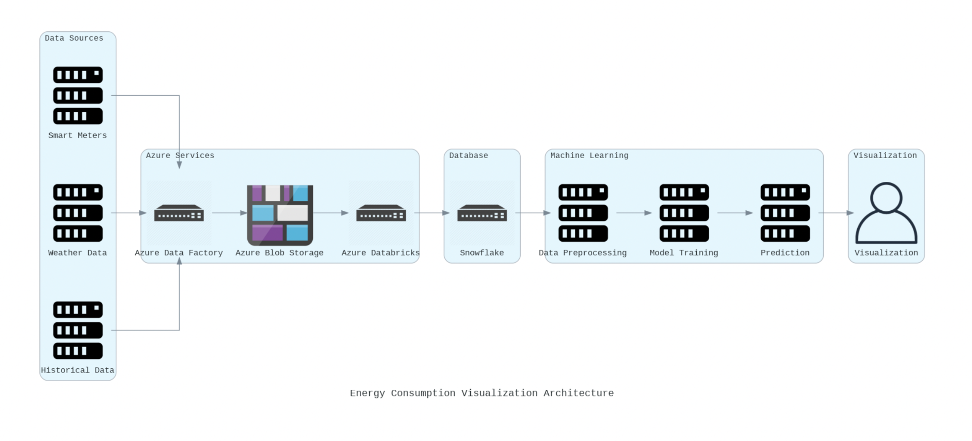

Code:

### 

|  |
| --- |
| // CODELAB: from diagrams import Diagram, Cluster  from diagrams.generic.network import Switch  from diagrams.azure.storage import BlobStorage  from diagrams.onprem.client import User as UserClient  from diagrams.onprem.compute import Server  with Diagram("Energy Consumption Visualization Architecture", show=False) as energy_diagram:  with Cluster("Data Sources"):  smart_meters = Server("Smart Meters")  weather_data = Server("Weather Data")  historical_data = Server("Historical Data")  with Cluster("Azure Services"):  data_factory = Switch("Azure Data Factory")  databricks = Switch("Azure Databricks")  blob_storage = BlobStorage("Azure Blob Storage")    with Cluster("Database"):  data_storage=Switch("Snowflake")  with Cluster("Machine Learning"):  data_preprocessing = Server("Data Preprocessing")  model_training = Server("Model Training")  prediction = Server("Prediction")  with Cluster("Visualization"):  visualization = UserClient("Visualization")    smart_meters >> data_factory  weather_data >> data_factory  historical_data >> data_factory  data_factory >> blob_storage  blob_storage >> databricks  databricks >> data_storage  data_storage >> data_preprocessing  data_preprocessing >> model_training  model_training >> prediction  prediction >> visualization  energy_diagram |

### 

# Research and Understanding

**Research on the data pipeline designs:**

* **Batch Pipeline**: In a batch pipeline, data is processed in large batches at scheduled intervals. This design pattern is suitable for scenarios where real-time processing is not required.
* **Lambda Architecture:** The Lambda Architecture combines batch and real-time processing to handle both historical and incoming data streams. The system is composed of three layers: batch layer, serving layer, and speed layer.
* **Extract, Load, Transform(ELT) Pipeline:** In an ELT pipeline, data is first loaded into a storage system (e.g., data lake, data warehouse) and then transformed as needed. This pattern is useful for scenarios where data needs to be analyzed in its raw form before transformation.
* **CDC (Change Data Capture) pipeline:** It is a data integration approach used to capture and propagate changes made to a source database in real time. It enables the continuous streaming of data changes, such as inserts, updates, and deletes, from the source database to downstream systems, allowing for near real-time synchronization and processing of data across different systems or databases.

**Selected Data pipeline design: Batch Pipeline**

As the solution system will provide suggestions to optimize energy consumption by considering the weekly or monthly usage of customers, the Batch pipeline design will be the optimal and simple solution for this system.

In a Batch Pipeline, data is processed in large batches at scheduled intervals. This approach is well-suited for scenarios where near real-time insights are not critical, and periodic analysis of historical data is sufficient.

Reasons:

* Batch pipelines are simpler to design and implement compared to real-time systems, as they do not require handling of continuous data streams.
* Batch processing can be more cost-effective, as it allows for the optimization of resources during scheduled processing intervals without the need for continuous infrastructure support.
* Batch pipelines are less complex than real-time systems, making them easier to maintain and manage, especially for use cases where real-time insights are not essential.
* Batch processing can be easily scaled by adjusting processing resources and batch sizes, enabling efficient handling of large volumes of data.

### 

# Design Development

**Pipeline Design:**

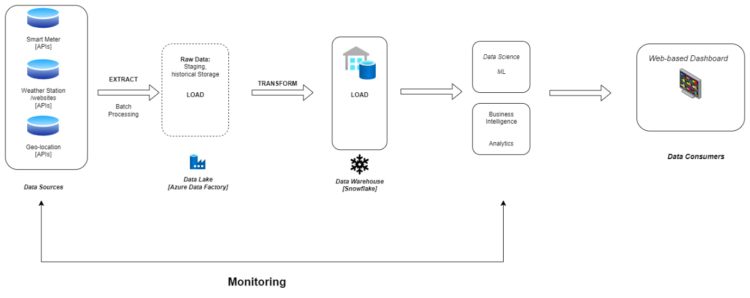

# Assumptions and Use Cases

**Assumptions**:

* Data Availability: Assumption that relevant data sources such as smart meters, IoT devices, weather data, historical energy consumption records, building automation systems, and other relevant sources are accessible for integration and analysis.
* Scalability: Assumption that the solution needs to be scalable to accommodate increasing volumes of data as the system expands to cover more buildings, facilities, or energy-consuming assets.
* Data Quality: Assumption that the incoming data is of reasonable quality and consistency, though data cleansing and preprocessing may be necessary to handle outliers, missing values, and discrepancies.
* Regulatory Compliance: Assumption that the solution will adhere to relevant data privacy regulations and industry standards, especially when dealing with sensitive energy consumption data.
* Actionable Insights: Assumption that the primary goal of the solution is to derive actionable insights that can lead to tangible improvements in energy efficiency and consumption patterns.

**Use Cases:**

1. **Smart Building Energy Optimization:**
   * Use case where the data engineering solution integrates data from smart building systems including HVAC (Heating, Ventilation, and Air Conditioning), lighting, occupancy sensors, and energy meters.
   * Analyzes patterns of energy consumption based on occupancy, weather conditions, and operational schedules.
   * Provides recommendations for optimizing HVAC settings, adjusting lighting levels, and managing energy usage during peak hours to minimize costs and environmental impact.
2. **Industrial Process Optimization:**
   * Use case where the solution integrates data from industrial machinery, production processes, and energy monitoring systems.
   * Analyzes energy consumption patterns across different stages of production, identifying inefficiencies and areas for optimization.
   * Provides real-time alerts and predictive insights to optimize machine usage, reduce idle time, and schedule maintenance activities to minimize energy wastage and improve productivity.
3. **Demand Response and Load Management:**
   * Use case where the solution integrates data from utility providers, smart grids, and consumer energy usage patterns.
   * Analyzes historical energy consumption trends and predicts future demand patterns.
   * Enables demand response strategies such as peak shaving, load shifting, and incentive-based programs to reduce energy costs and alleviate strain on the grid during peak periods.
4. **Renewable Energy Integration and Forecasting:**
   * Use case where the solution integrates data from renewable energy sources such as solar panels, wind turbines, and battery storage systems.
   * Analyzes weather forecasts, historical energy production data, and grid demand patterns to optimize the integration of renewable energy into the grid.
   * Provides real-time insights for managing fluctuations in renewable energy output and coordinating energy storage and distribution to maximize renewable energy utilization.
5. **Energy Consumption Benchmarking and Reporting:**
   * Use case where the solution enables benchmarking of energy consumption across buildings, facilities, or geographical regions.
   * Compares energy usage metrics against industry standards and best practices.
   * Generates comprehensive reports and visualizations to track energy performance, identify outliers, and prioritize areas for energy efficiency improvements.

### 

# Discussion and Justification

Open Questions or Challenges:

* **Handling Anomalous Energy Consumption Patterns**: Designing a system to handle sudden spikes or anomalies in energy consumption is challenging. Real-time anomaly detection algorithms, rapid response mechanisms, and continuous refinement of models are important considerations.
* **Scalability and Performance:** As the number of monitored devices and data volume increase, ensuring scalability and maintaining optimal performance becomes critical. Solutions involve implementing scalable data processing frameworks, efficient resource allocation, and proactive monitoring to identify and mitigate performance bottlenecks.
* **Data Quality and Accuracy**: It's extremely important to make sure that the data used for analysis and optimization is of high quality and accuracy. However, certain challenges need to be dealt with such as data inconsistencies, inaccuracies, and missing values. Therefore, it's essential to have reliable and robust data validation, cleansing, and enrichment processes in place to enhance data quality and make it more reliable.
* **Interoperability with Legacy Systems**: Integrating legacy energy management systems and heterogeneous data sources can pose interoperability issues. Solutions include developing standardized data interfaces, protocol converters, and middleware layers to facilitate seamless data exchange.
* **Privacy and Security Concerns**: It is crucial to protect sensitive energy consumption data and ensure compliance with privacy regulations. This requires implementing robust solutions such as encryption, access controls, and audit trails to effectively safeguard the integrity and confidentiality of the data.
* **User Adoption and Training**: Encouraging user adoption of the energy optimization platform and providing adequate training on interpreting analytics and insights may be challenging. A user-friendly interface, intuitive dashboards, and comprehensive training materials are essential for promoting user engagement and understanding.

**Justification for Proposed Architecture:**

* **Absence of Real-Time Processing Requirements:** The use case for optimizing energy consumption does not require real-time processing capabilities, as immediate responses to data changes are not critical. Batch processing allows for periodic analysis of historical data at scheduled intervals, making it suitable for the requirements of the use case.
* **Suitability for Periodic Analysis:** Batch pipelines excel in scenarios where data analysis can be performed periodically rather than continuously. By processing data in large batches at scheduled intervals, batch pipelines facilitate a comprehensive analysis of historical data to identify trends, patterns, and optimization opportunities.
* **Alignment with Project Goals:** The Batch Pipeline design aligns with the goals and priorities of the energy consumption optimization project by providing a cost-effective, scalable, and efficient solution for processing historical data and deriving actionable insights and optimization recommendations.

### 

# References

* <https://learn.microsoft.com/en-us/azure/architecture/patterns/>
* <https://www.eckerson.com/articles/data-pipeline-design-patterns>
* <https://neptune.ai/blog/ml-pipeline-architecture-design-patterns>
* <https://www.oreilly.com/library/view/data-pipelines-pocket/9781492087823/ch03.html#idm45343337217912>
* <https://docs.google.com/document/d/1E6XMcdTexh5O8JwGy42SY3Ehzi8gOfUGiqTiUX6N04o/edit>