ReleaseShield AI
Successful Test Run Report
Testing Engineer Documentation | Version v0.1 | 29 October 2026
Purpose: Record the successful execution of the ReleaseShield AI CLI scan shown in the attached console screenshot. This report documents tool execution and result aggregation; it does not claim that the scanned repository is free of security issues.

1. Test Run Overview
ReleaseShield AI v0.1 runs Trivy, Semgrep, and Gitleaks and combines their findings into one summary. In the screenshot provided, all three tools show the status “done,” and the application saves a combined SARIF result file.

2. Environment and Evidence
- Application: ReleaseShield AI v0.1
- Repository shown in debug output: C:\ReleaseSheild_EPAM-Project\cli_frontend
- Scanners: Trivy, Semgrep, Gitleaks
- Evidence: Console screenshot supplied by the project team
- Reported output path: ./results/result.sarif

3. Execution Results
Tool | Execution Status | Findings in Screenshot | Test Result
Trivy | Done — 0.7 s | 0 total (0 high, 0 medium, 0 low) | PASS — executed and result displayed
Semgrep | Done — 14.8 s | 3 total (2 high, 0 medium, 1 low) | PASS — executed and findings displayed
Gitleaks | Done — 3.8 s | 4 total (0 high, 4 medium, 0 low) | PASS — executed and findings displayed
Combined summary | Completed — about 15 s total | 7 total (2 high, 4 medium, 1 low) | PASS — results aggregated
Result interpretation: All scanner execution checks passed in this run. The scan reported seven findings overall, including two high-severity Semgrep findings and four medium-severity Gitleaks findings. These findings must be reviewed and triaged; a successful test run does not mean the repository is vulnerability-free.

4. Test Cases and Status
Test ID | Test Area | Test Procedure | Observed Evidence | Status
TC-01 | CLI startup | Start the ReleaseShield AI CLI. | Application banner and scan summary displayed. | PASS
TC-02 | Trivy integration | Verify Trivy starts and returns a result. | Trivy status Done; zero findings shown. | PASS
TC-03 | Semgrep integration | Verify Semgrep starts and returns a result. | Semgrep status Done; three findings shown. | PASS
TC-04 | Gitleaks integration | Verify Gitleaks starts and returns a result. | Gitleaks status Done; four findings shown. | PASS
TC-05 | Finding aggregation | Check combined severity totals. | Total 2 high, 4 medium, 1 low; 7 overall. | PASS
TC-06 | SARIF save message | Check whether the application reports saving output. | Console says Saved: ./results/result.sarif. | PASS — save message observed

5. Screenshot Evidence
The screenshot below is the evidence supplied for this report. It shows Trivy, Semgrep, and Gitleaks as done, the combined severity table, and the SARIF save message.
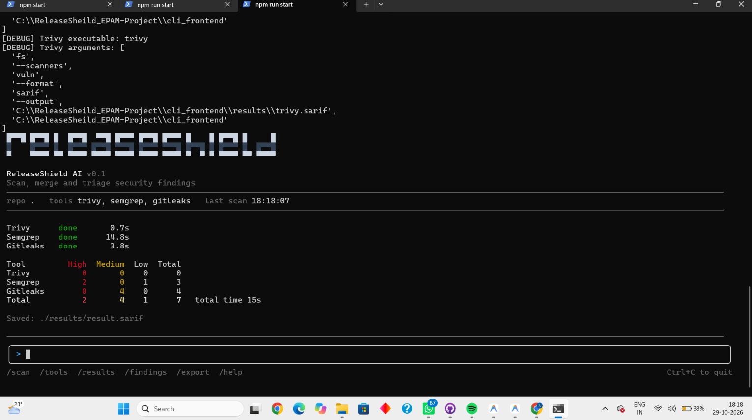
Figure 1. ReleaseShield AI successful scan run (screenshot supplied by the user).

6. Findings Requiring Follow-up
The test execution passed, but the scan found issues that require security triage:
- Semgrep: review the two high-severity and one low-severity findings.
- Gitleaks: review the four medium-severity findings to determine whether they are real secrets or false positives.
- Trivy: zero findings were reported in this run; this is not proof that all dependencies or configurations are secure.
- SARIF: the CLI reported that the file was saved. To confirm full output correctness, inspect the file and validate its structure against the project's expected SARIF version (for example, SARIF 2.1.0 if that is the project requirement).

7. Retest / Validation Checklist
☐ All three scanners start successfully from the project CLI.
☐ Each scanner's status and duration are displayed.
☐ The combined total equals the sum of the tool-level findings: 0 + 3 + 4 = 7.
☐ Severity totals are consistent: 2 high + 4 medium + 1 low = 7.
☐ The results/result.sarif file exists and contains the expected scanner results.
☐ Finding details are reviewed and assigned for triage.

8. Testing Engineer Meeting Update
“I completed a successful integration test of the ReleaseShield AI CLI. Trivy, Semgrep, and Gitleaks all executed successfully. The combined report showed seven findings: two high, four medium, and one low. The application also displayed the SARIF output save message. My next step is to validate the SARIF content and review the reported findings with the team for triage.”

9. Scope and Limitations
This report is based on the screenshot supplied for the 18:18 run. It confirms the visible CLI statuses, displayed counts, and save message. It does not independently verify the SARIF file contents or establish whether each finding is a true positive.

