FIRELINE
Data Exploration & Findings Report
NASA FIRMS • Pontianak Weather • Forest Fire

1. Executive Summary

NASA FIRMS
- 61,583 hotspot detections from 1 Aug 2024 to 31 May 2026.
- 0 missing values, 0 exact duplicates, and 0 spatial-temporal duplicates under (latitude, longitude, date, time).
- July–September contributes 71.9% of hotspots and 78.7% of total FRP.
- FRP is highly right-skewed: median 6.14 MW, 99th percentile 70.20 MW, maximum 954.79 MW.
- Confidence is 93.1% nominal, 3.8% high, 3.2% low; reliability must remain separate from severity.

Pontianak Weather
- 1,734 raw rows become 1,460 unique dates after duplicate-date cleanup.
- Rainfall RR is missing in 26.2% of dates; TAVG and RH_AVG are nearly complete.
- Temperature and humidity have a strong inverse relationship (Pearson about -0.816).
- Single-station coverage means this is not automatically representative of all Kalimantan.

Forest Fire Dataset
- 517 rows, no missing values, 4 exact duplicates.
- Dataset is Montesinho Natural Park, Portugal, 2000–2003.
- Use as methodological/feature reference, not as Kalimantan historical evidence.

2. NASA FIRMS Variable Reference
Variable | Meaning | Unit/code | FIRELINE role | Caution
latitude | Hotspot latitude | degrees | Spatial join / map | Needs admin boundary join
longitude | Hotspot longitude | degrees | Spatial join / map | Same
acq_date | Satellite acquisition date | date | Temporal joins | Not necessarily ignition time
acq_time | Acquisition time | HHMM UTC | Sub-daily patterns | Keep UTC consistent
brightness | Fire-pixel brightness temperature | K | Thermal feature | Nonlinear/saturation effects
bright_t31 | Thermal/background reference field | K | Thermal context | Verify exact field semantics for product export
frp | Fire Radiative Power | MW | Intensity / urgency | Proxy, not full risk
confidence | Detection confidence | l/n/h | Reliability / verification | Not severity
daynight | Day/night flag | D/N | Observation context | Not universal accuracy rank
scan | Across-scan geometry metric | product-specific | QC/geometry | Can affect comparisons
track | Along-track geometry metric | product-specific | QC/geometry | Same
type | Detection type | code | Product context | Constant 0 here
version | Product version | version | Reproducibility | Not risk predictor

3. NASA FIRMS Findings

Finding 1 — Strong temporal concentration
Evidence: July–September represents 71.9% of hotspots and 78.7% of total FRP. The 2024/2026 periods are partial, so cross-year comparisons need coverage normalization.
Action: Build seasonal baselines, daily load indicators, and rolling windows; avoid fixed month-only rules.

Finding 2 — FRP is useful but heavy-tailed
Evidence: Median 6.14 MW, P90 22.11 MW, P99 70.20 MW, max 954.79 MW.
Action: Use percentile/log transforms and combine intensity with exposure/environment.

Finding 3 — Confidence ≠ severity
Evidence: High/nominal/low are reliability classes. Low-confidence high-FRP cases exist in the supplied extract.
Action: Keep confidence separate; use it for evidence strength/verification rather than deleting detections.

Finding 4 — Spatial clustering is real but admin context is missing
Evidence: Coordinate grid cells show concentrated hotspot zones, but province/district names require an explicit spatial join.
Action: Join administrative boundaries, land, settlements and facilities before assigning operational labels.

Finding 5 — Thermal anomalies need QC flags
Evidence: 57 rows have brightness 207.93 K; 166 rows have negative brightness−bright_t31, including high-FRP cases.
Action: Preserve raw records, flag for review, and verify product semantics before filtering.
NASA daily hotspots and 7-day rolling mean
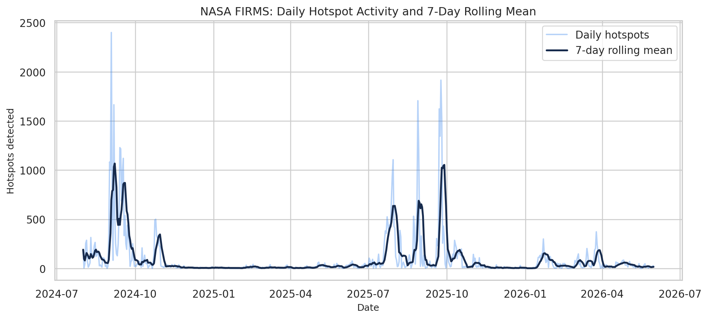
NASA FRP by confidence
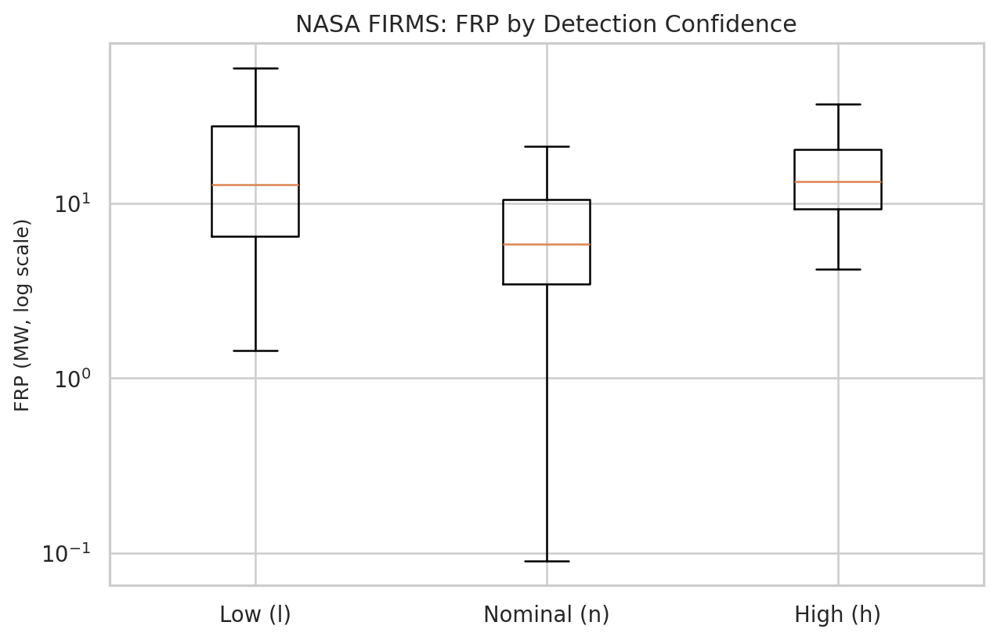
NASA monthly hotspot pattern by year
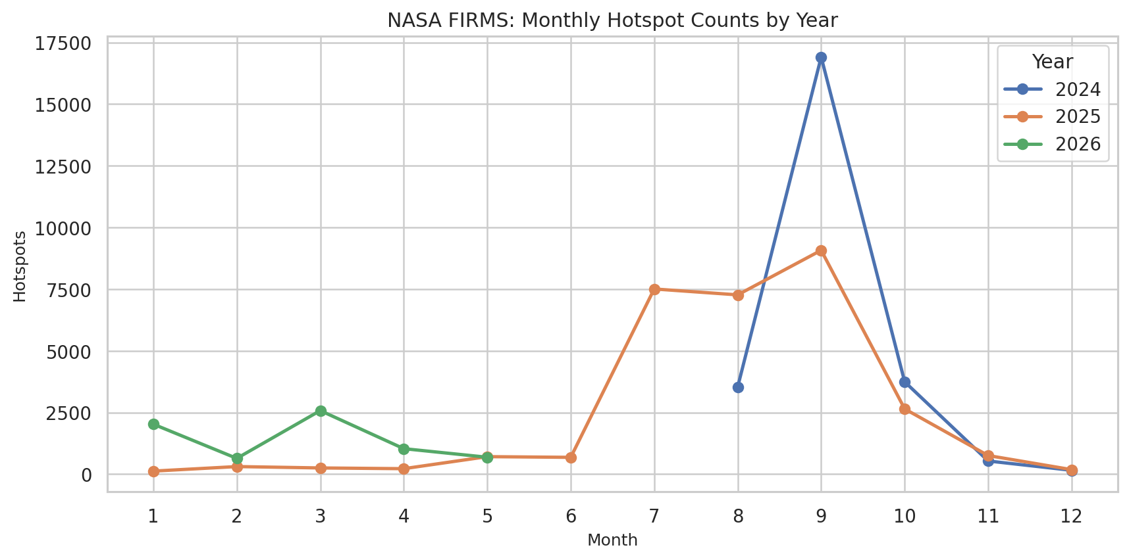
NASA spatial FRP pattern
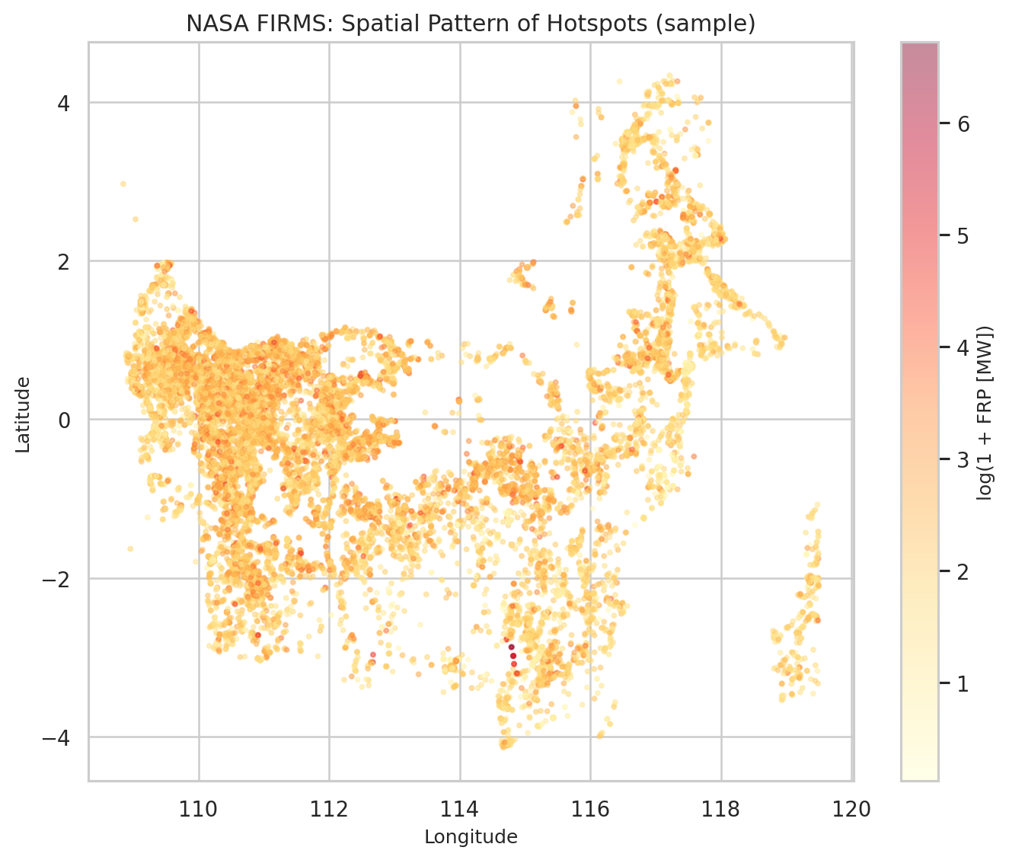

4. Pontianak Weather Findings
Variable | Observed summary | Potential relevance | Limitation
TAVG | Mean 27.68°C; 24–31°C | Hot/dry context; candidate feature | Station-specific
RH_AVG | Mean 82.64%; 65–96% | Lower humidity may indicate drier conditions | Station-specific
RR | Median 5.5 mm; 26.2% missing | Rainfall/moisture context | High missingness
date | 2021–2024 daily | Temporal alignment | Overlap with NASA is limited
Key action: do not blindly impute all rainfall. Consider missingness flags and use broader station/grid weather for production Kalimantan coverage.

5. Forest Fire Dataset Findings
This dataset is from Montesinho Natural Park, Portugal, 2000–2003. It should not be merged as empirical Kalimantan history. Its value for FIRELINE is methodological: it exposes a useful vocabulary of fire-weather variables and FWI components.
Variable | Meaning | FIRELINE use
X, Y | Local 9×9 spatial grid | Demonstrates spatial fire context; not reusable as Kalimantan coordinates
month, day | Calendar context | Temporal feature ideas
FFMC | Fine Fuel Moisture Code | Fine-fuel dryness concept
DMC | Duff Moisture Code | Surface organic-layer dryness concept
DC | Drought Code | Longer-term drought/drying concept
ISI | Initial Spread Index | Spread-potential concept
temp | Temperature | Environmental context
RH | Relative humidity | Environmental context
wind | Wind speed | Potential spread context
rain | Rainfall | Moisture context
area | Burned area (ha) | Historical outcome in Portugal only

6. Integration Blueprint
Use NASA FIRMS as the current event/hotspot backbone. Enrich it using spatial-temporal joins to weather, population/schools, land cover, historical recurrence, and later operational access.
Dataset | Spatial compatibility | Temporal compatibility | Recommendation
NASA FIRMS | Native point coordinates | Current event period | Core event table
Pontianak Weather | Single station | 144 dates overlap with NASA extract | Prototype local weather context; not all-Kalimantan
Forest Fire | Portugal 9×9 grid | 2000–2003 | Method reference only; find Kalimantan history for production
Population/School | Needs spatial join | Annual/static | Exposure layer
Peatland/Land cover | Needs spatial join | Static/periodic | Hazard/vulnerability context

7. Feature Engineering Recommendations
- FRP percentile / log(FRP)
- Daily hotspot count
- Daily total FRP
- 7-day rolling hotspot count and total FRP
- Historical hotspot frequency by spatial cell
- Confidence reliability feature
- Population exposure within a buffer
- Distance/count of schools and critical facilities
- Rainfall accumulation / dry-day sequence once appropriate weather coverage is available
Do not yet create a universal “critical FRP = critical risk” rule, infer province names from longitude, or train a production FIRELINE model on the Portugal Forest Fire dataset.

8. Immediate DS Next Steps
- Standardize NASA event fields and create QC flags.
- Build a date + spatial weather join prototype using Pontianak as a local case, not a Kalimantan-wide assumption.
- Find geographically relevant historical fire data to replace Portugal data for empirical modeling.
- Add population and school exposure through spatial joins.
- Test an interpretable baseline scoring/index before a more complex ML model.

9. Final Finding for FIRELINE
FIRELINE should not be framed as a hotspot detector. NASA FIRMS already provides the current fire-signal backbone. The differentiator is context enrichment: environmental conditions, historical recurrence, human exposure, critical facilities, and eventually operational accessibility. This turns fragmented data into a decision-support queue for the Command Center.
References: NASA Earthdata, Collection 2 VIIRS 375 m Active Fire User Guide; NASA Earthdata FIRMS FAQ / Forum; UCI Machine Learning Repository, Forest Fires dataset (Montesinho Natural Park, Portugal, 2000–2003).

