|  |
| --- |
|  |
| The Documentation |
|  |
|  |
| **[Team “apple Juice”]** |
| **12/22/2016** |

Венелин Петков (VenelinGP)

Ивайло Паскалев (IvayloPaskalev)

Росица Бъндева (rossi.bundeva)

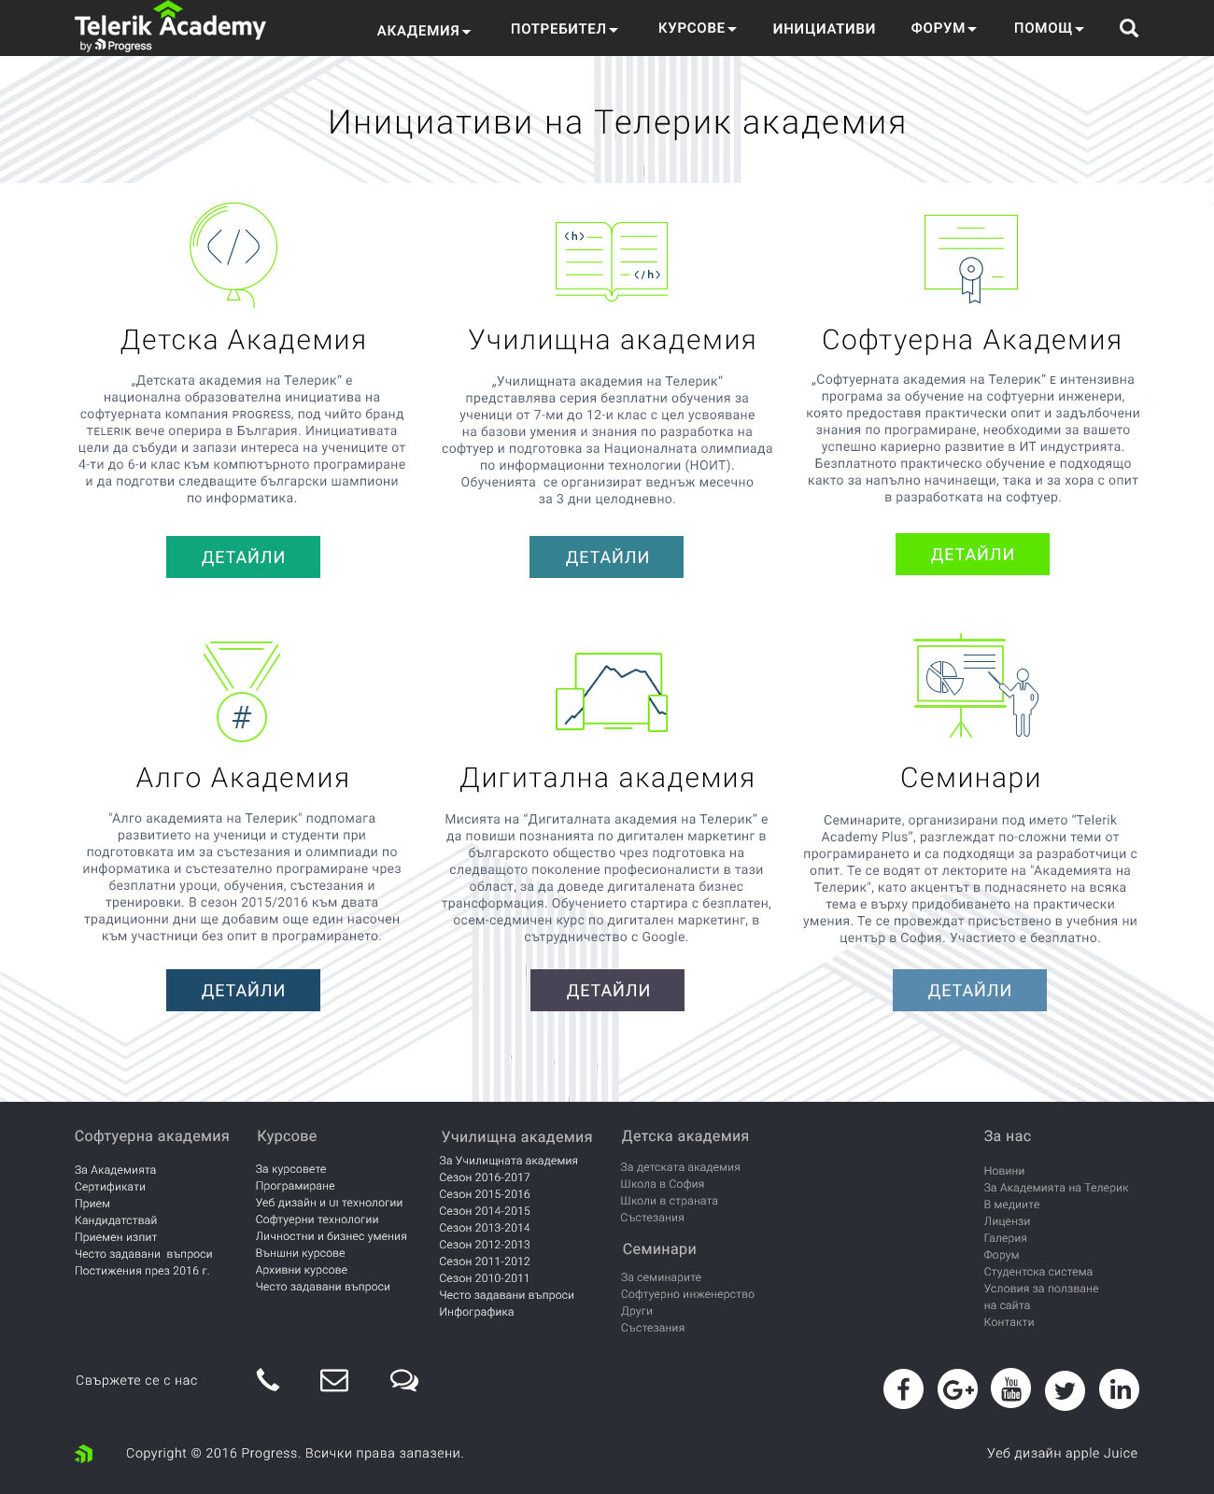

1. Pages
   1. Page Tree

Home

Initiativities page

Algo academy page

School academy page

Menu Object

