DOCUMENTATION

**TEAM NAME**:ARKHITECTON

**TEAM MEMBERS**:

H.ARUNA

V.JANANI

P.MUTHUMARI

E.POONGUZHALI

D.YHAALINI SHRI

**SKILLS** :DIGITAL MARKETING

**COLLEGE NAME** :VELAMMAL COLLEGE OF ENGINEERING AND TECHNOLOGY

Blog Name: Arkhitecton Category: 3D Designing

E-mail: [arkhitectonn@gmail.com](mailto:arkhitectonn@gmail.com) Password: seven3d+

Wordpress blog url: [http://arkhitectonn5.wordpress.com](http://arkhitectonn5.wordpress.com/)

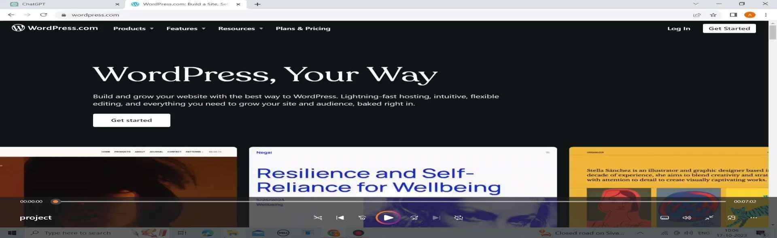step:1 open the wordpress.com

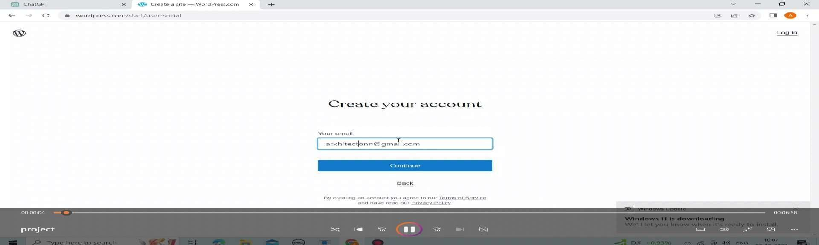step 2: login with your mail id

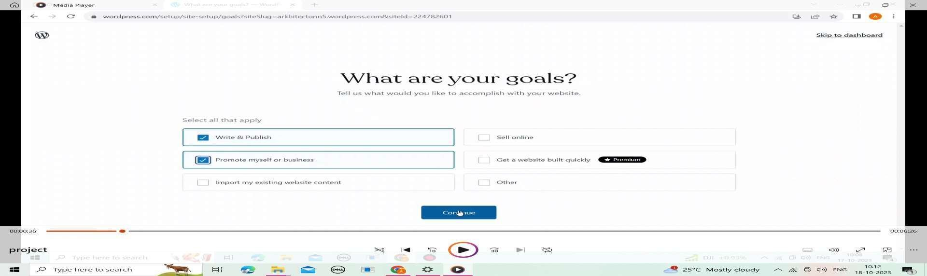step 3: choose your goals

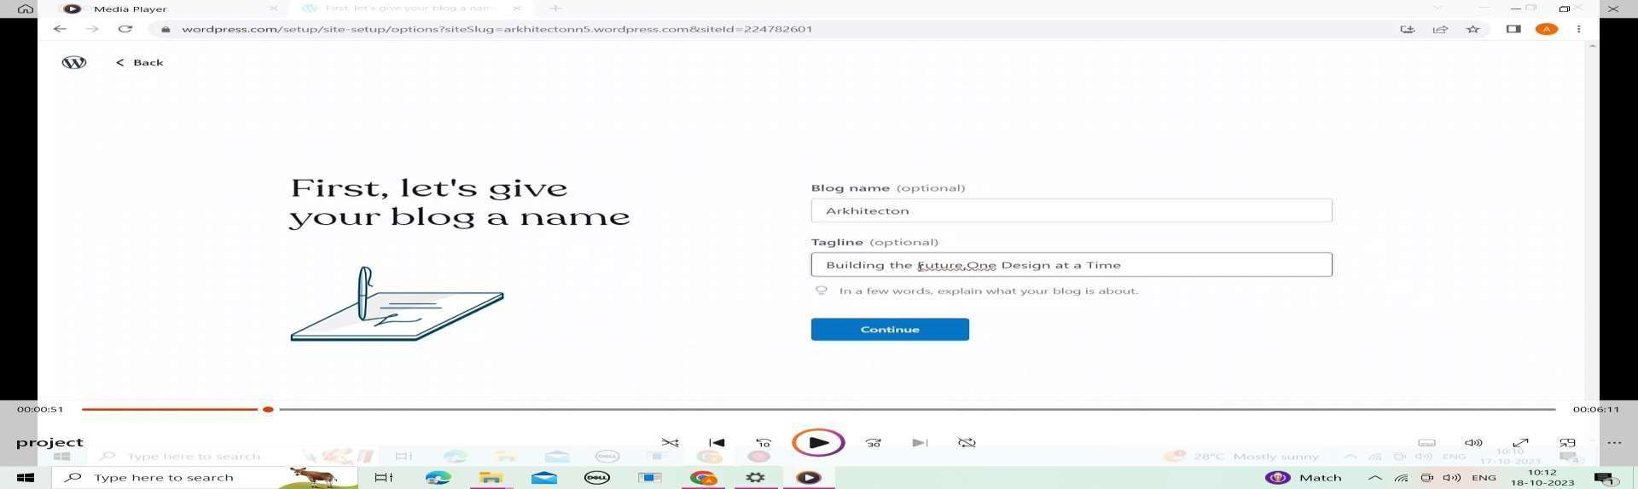step 4: choosing blog name

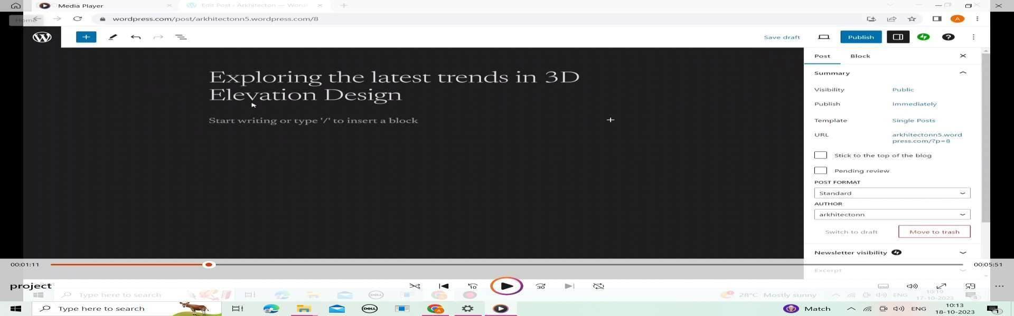step 5: import your ideas in word-press

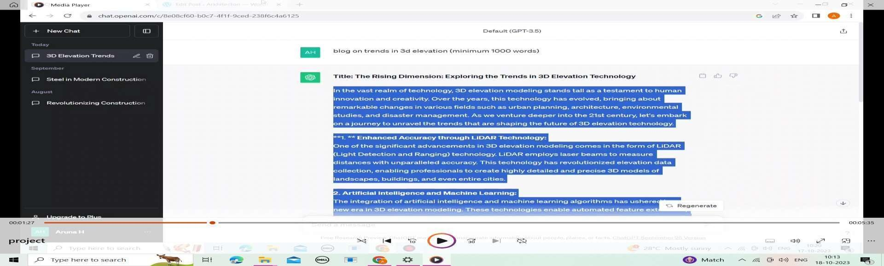step 6: searching for detailed explanation

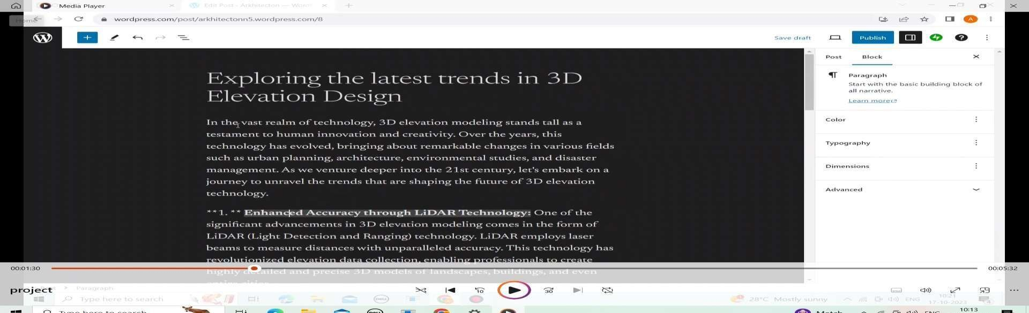step 7: Insert the information in the word-press

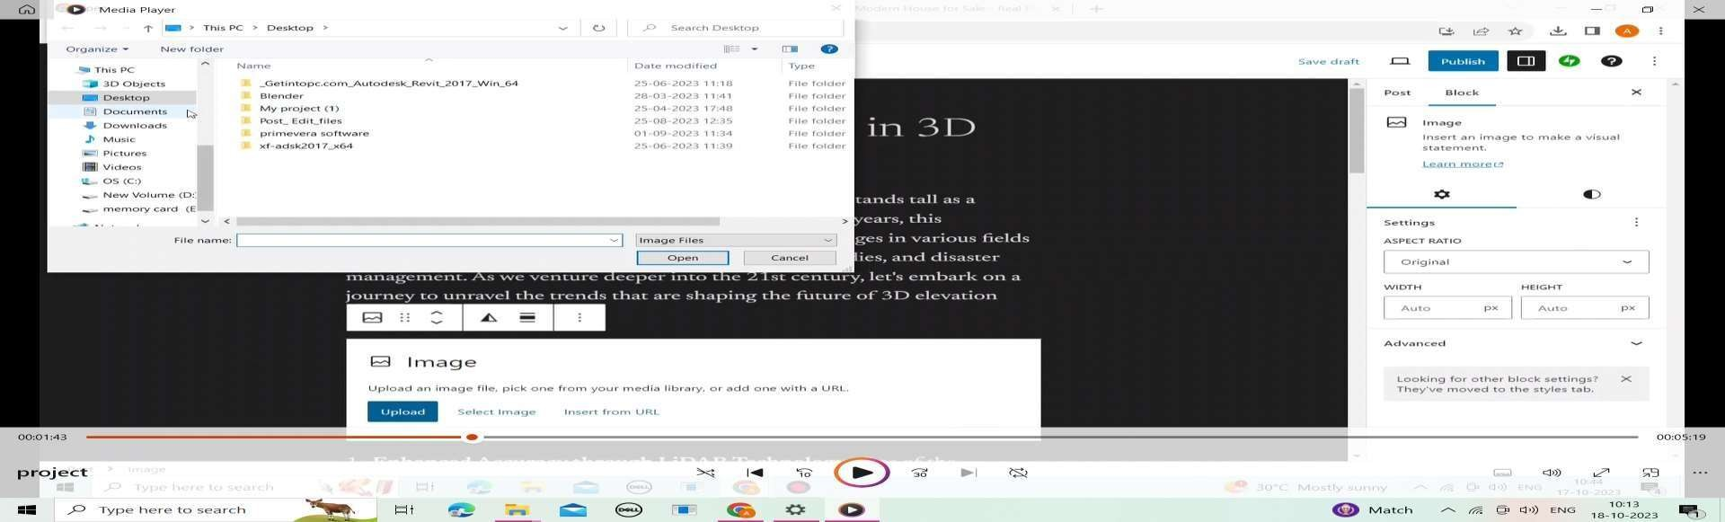step 8: Insert the created poster

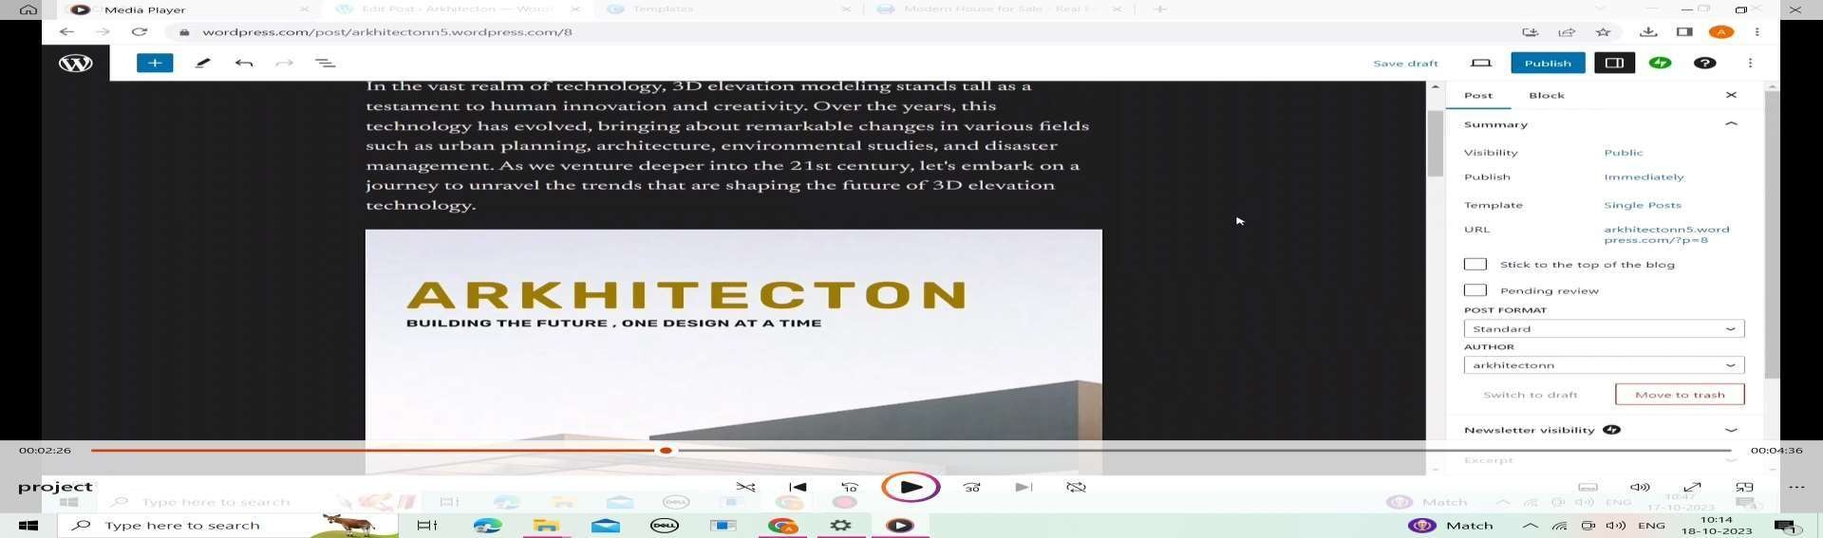step 9: poster implementation

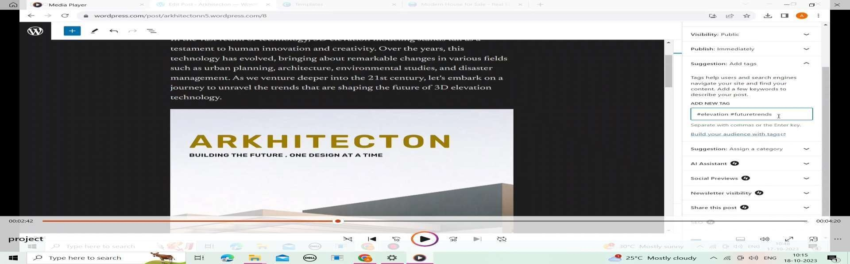step 10: creating tagline

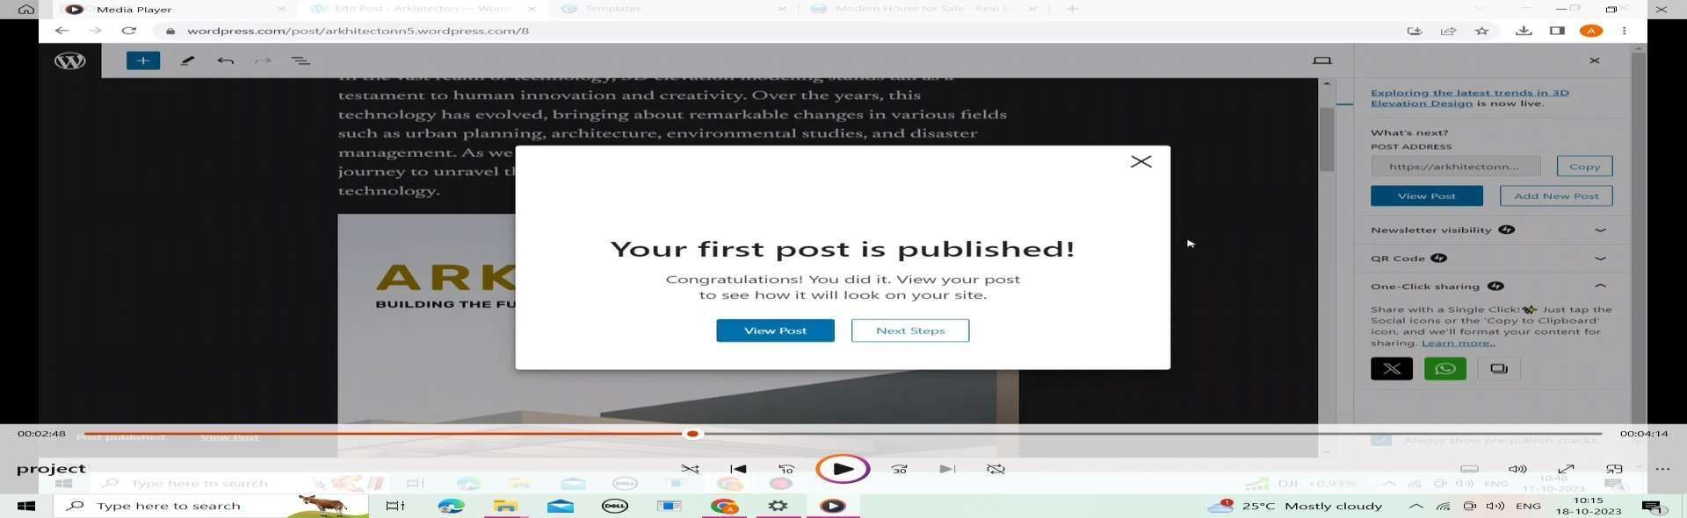step 11:publish your post

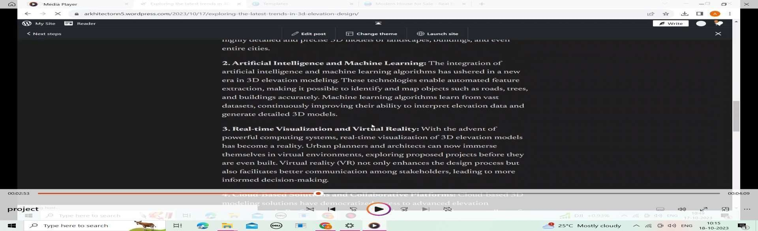step 12:review your post

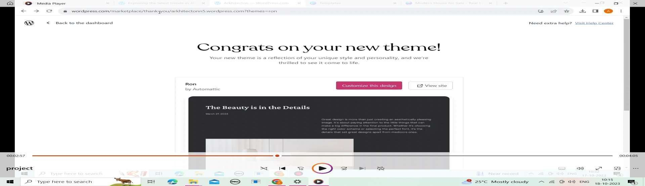step 13:setting up of theme

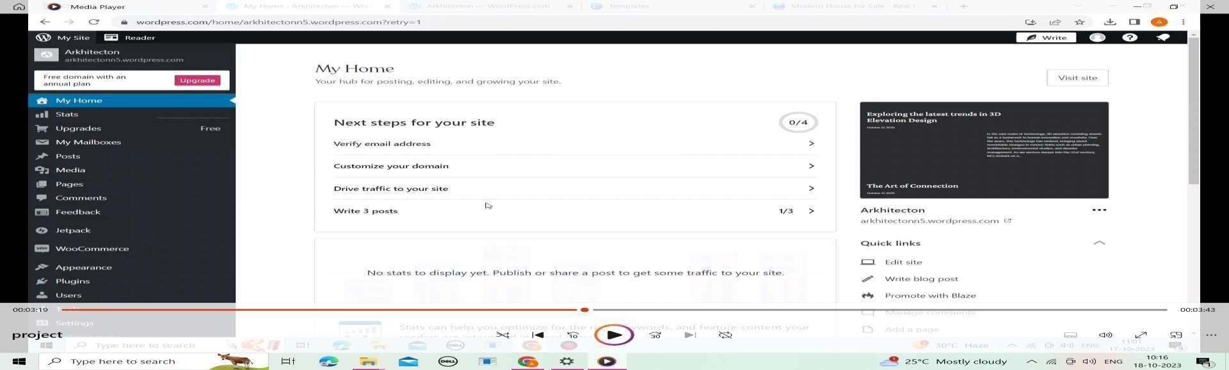step 14:view your home page

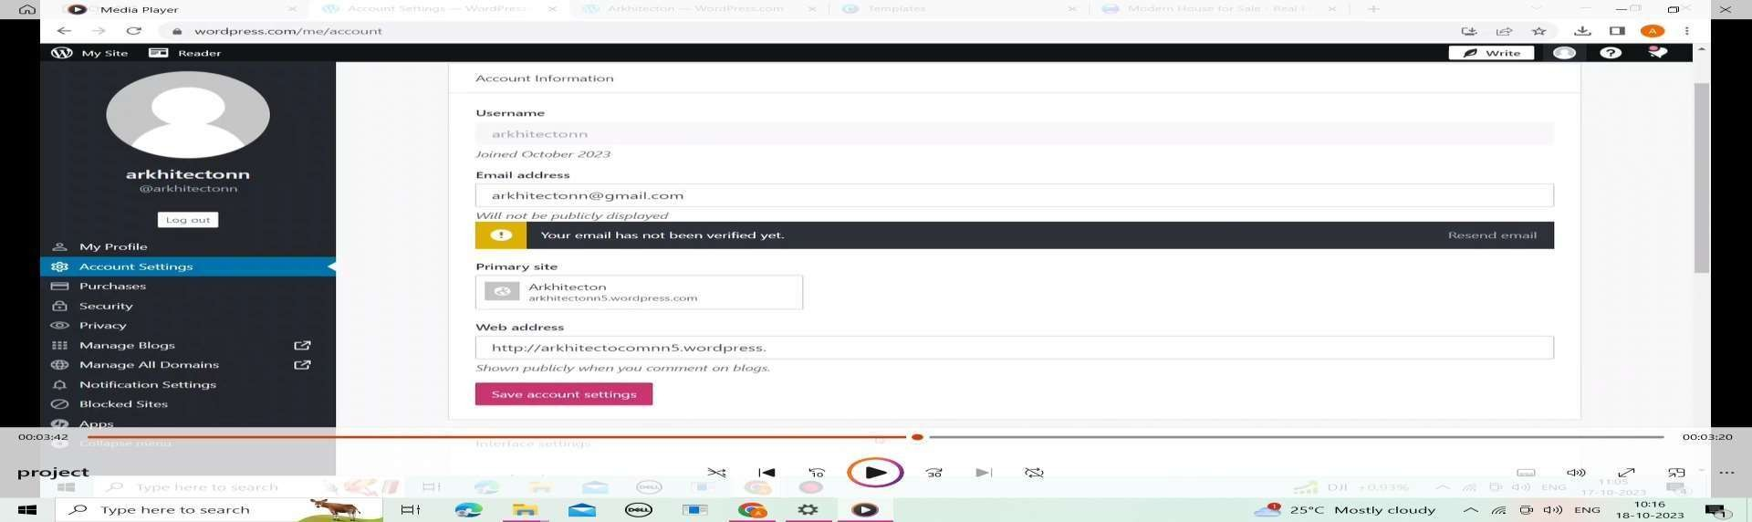step 15:verification of e-mail

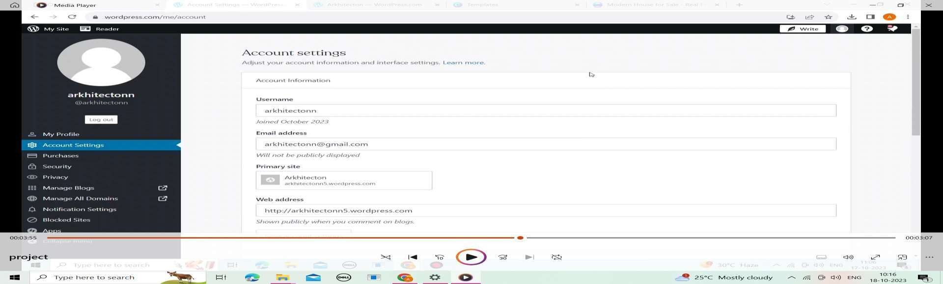step 16:account settings

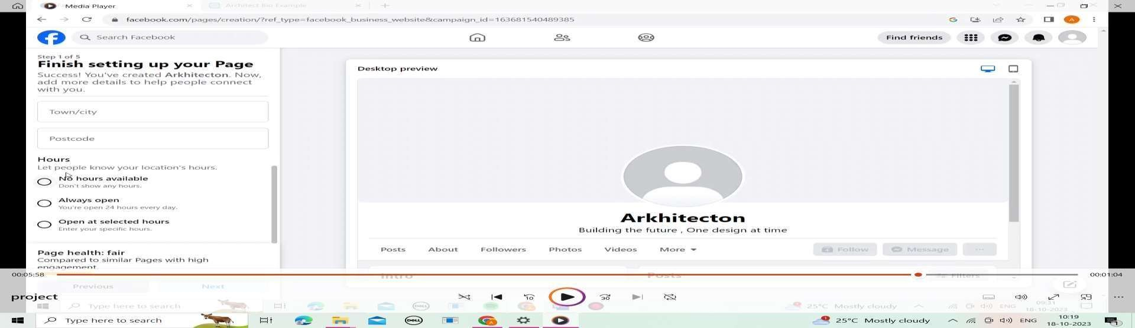

step 17:finish setting up your page

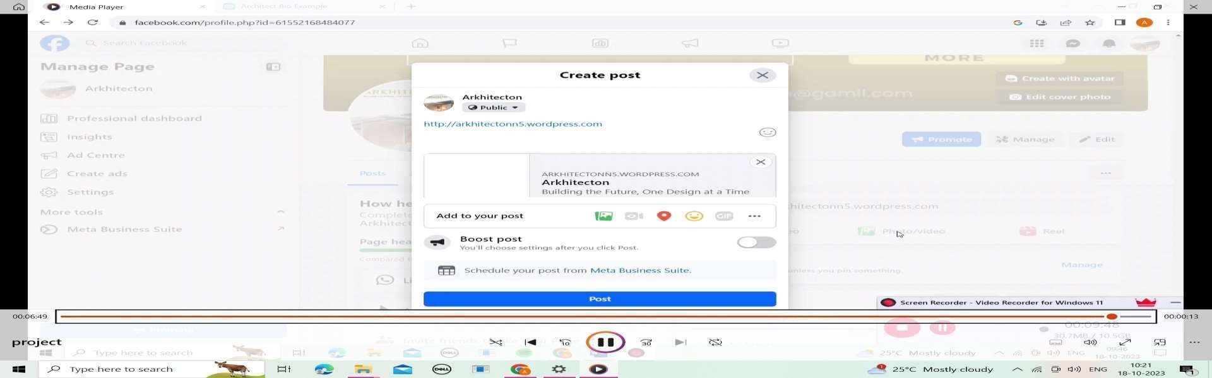step 18:post your article