*Align*, ‘A website planner that gives students the chance to sync their tasks with their goals.’

Team Atomic Thunder:

Liv Anderson, Zo Carroll, Siaka Diarra, Meghann Manson, Kursten Massey

Problem:

At the University of Maine, students take a range of class credits from large to small. For example, a typical undergraduate student taking 4-5 courses must track 10-20 major due dates per class every semester. Regardless of the amount of credits a student takes, it is important for students to be able to keep track of due dates, exam dates, and/or assignments. Time management can be a large obstacle for college students in any field in addition to life outside of class. It can be easy for students to forget due dates, miss syllabus updates, and fall behind in classes. One missed or late assignment can easily compound into a much larger problem. Properly tracking assignments, important dates, and course progress can alleviate a huge amount of stress and academic anxiety.

As a team, we hope to offer a way to make tracking easier and more accessible for students. Prior solutions to tracking assignments are varied, from physical paper planners, to excel spreadsheets, to the notes app in our phones which are very helpful but still lack a wide range of tools. To add on, manually transferring these dates from multiple PDF syllabi into personal calendars is time-consuming and error-prone, leading to missed deadlines and increased academic stress. However, all of these solutions require the commitment of constantly updating and maintaining them as new assignments get released, due dates change, and courses progress. How can we create a centralized way for students to track important dates and course progress while incentivizing starting assignments early and turning work in on time? How can we create a tool that automatically extracts and organizes important academic dates from course syllabi into a unified calendar system, while accounting for the varying formats and structures of different professors' syllabi?

Prior Solutions:

**Solution 1**

A lot of students still use physical planners or notebooks to keep track of their assignments and deadlines. Writing things down by hand can be helpful for memory and organization, but there are some big downsides. If you forget to update it, lose the notebook, or miswrite a deadline, you’re out of luck. Plus, it takes time to constantly transfer dates from your syllabus.

How Align is Different? Align automates this entire process. Instead of manually writing down deadlines, students can just upload their syllabus and Align will pull out important dates and add them to their calendar. No more flipping through pages or forgetting to check your planner!

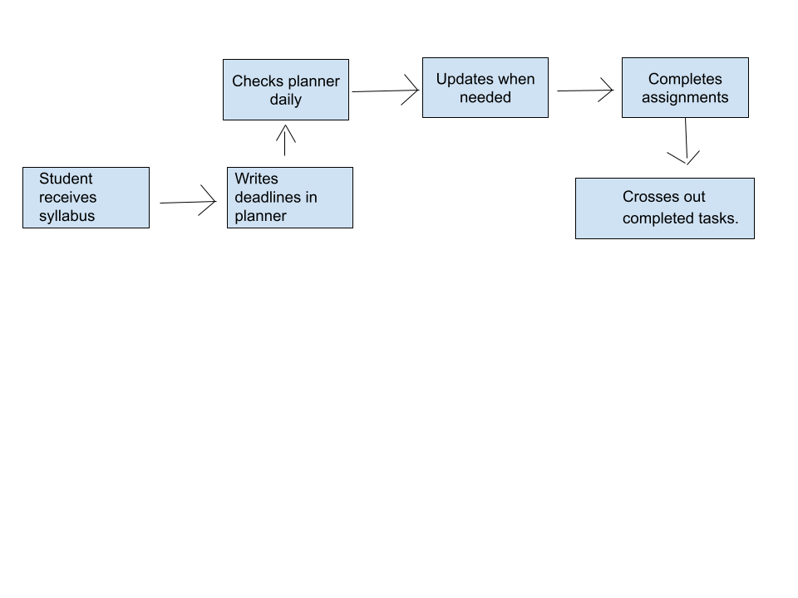

**Solution 2**

Some students prefer a more digital approach and use Google Keep, Notion, or Excel spreadsheets to track their assignments. These tools are definitely more organized than paper planners, and you can access them from anywhere. However, they still have one major issue: everything has to be added manually. That means students are constantly copying and pasting dates, setting reminders, and making sure they don’t miss anything.

How Align is Different? Align automates this step by scanning your syllabus and instantly creating a schedule for you. Instead of spending hours updating a spreadsheet, Align does the work in seconds, so you can focus on actually getting things done.

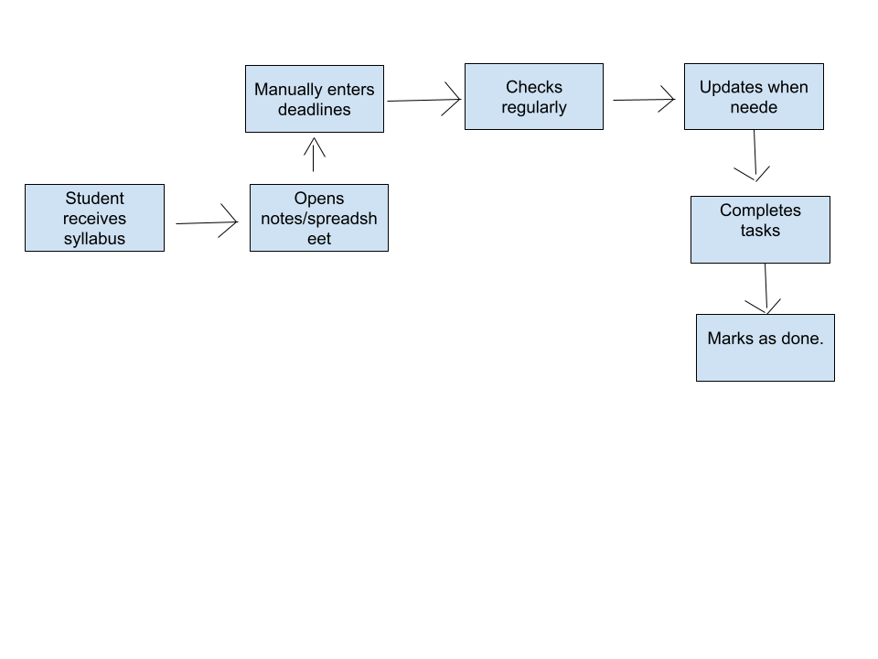

**Solution 3**

Most schools use Blackboard, Canvas, or other Learning Management Systems (LMS) to post assignments and deadlines. While these platforms are helpful, they aren’t always reliable—some professors don’t update due dates, and students have to constantly check multiple locations for different classes. On top of that, these platforms don’t integrate well with personal calendars, so deadlines can get buried.

How Align is Different? Align gathers all your due dates in one place so you don’t have to constantly check multiple platforms. Even if a professor forgets to update Blackboard, you’re covered because Align scans your syllabus and organizes everything into a clear, easy-to-follow schedule.

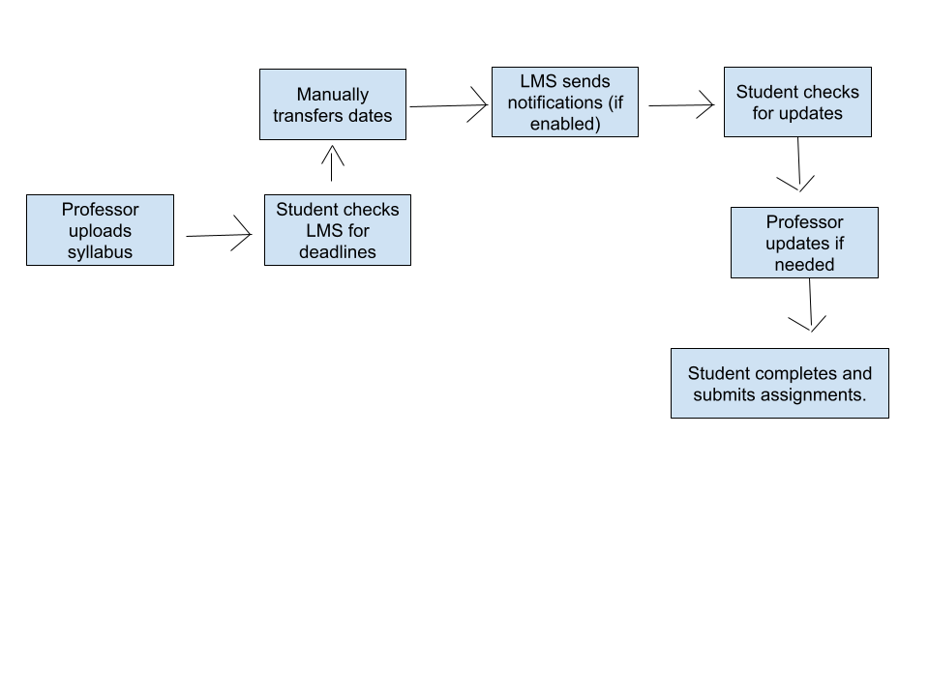

YourApp

**Summary**

Align streamlines academic planning by automatically extracting important dates and deadlines from syllabi and integrating them directly into students’ digital calendars. The application uses natural language processing to identify and parse date-related information, creates calendar events with appropriate details and context, and allows users to review and modify events before finalizing them. This automation significantly reduces the manual effort required for students to maintain their academic schedules while minimizing the risk of missing important deadlines.

[**Task Flow Diagram**](https://lucid.app/lucidchart/1c3ea7aa-6dbf-40a8-9966-3931aeea7e27/edit?invitationId=inv_6bd6a38a-f5cf-419b-8c30-2e85744b7195)

[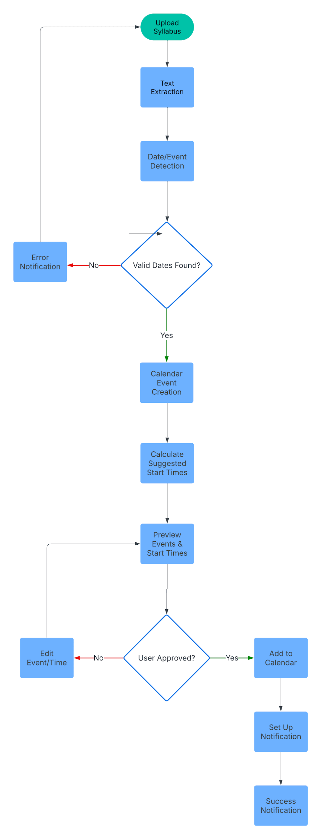](https://lucid.app/lucidchart/1c3ea7aa-6dbf-40a8-9966-3931aeea7e27/edit?page=0&v=731&s=304)

**Detailed Description**

The core functionality of Align centers around document processing and calendar integration. Users begin by uploading their course syllabi. The application then processes these documents using advanced text extraction algorithms to identify dates, deadlines, and associated events. The system is particularly adept at recognizing common academic events such as assignment due dates, exam schedules, project deadlines and reading assignments.

Once dates are extracted, the application creates structured calendar events that include not just the date and time, but also relevant context such as course information, assignment details and any specific instructions mentioned in the syllabus. Users can review these events through an interface, make any necessary adjustments and approve them for addition to their preferred calendar platform.

Over time the application learns the student’s work patterns and preferences. Align analyzes multiple factors including assignment complexity, previous completion times and current workload to create personalized notification schedules. Additionally the application creates start time recommendations that help students better manage their workload. For example, if the AI observes that a student typically needs three days to complete homework assignments but five days to complete a larger project, it automatically adjusts reminder timing accordingly.

**Solutions**

1. Date Recognition: Align employs natural language processing to understand context around dates. It can distinguish between different types of academic events (assignments, exams, readings) and appropriately categorize them. It handles various date formats and relative date references (ex - “due date next Tuesday” or “Week 3 submission”)
2. Academic Context Retention: Align maintains the full academic context of each date. Events are automatically tagged with course codes, assignment types, and relevant details extracted from the syllabus. This means students can easily filter and search their calendar by course or assignment type.
3. Notification System: Align implements an intelligent notification system that adapts to user behavior and assignment types. The system considers factors like assignment complexity, past completion patterns, and course workload to determine optimal notification timing. For instance, major projects might trigger a series of reminders starting weeks in advance, while smaller assignments might have shorter notification windows. The system learns from user interaction patterns to improve notification timing.
4. Suggested Start Times: The application addresses the well known issues of last minute assignment completion and exam crunching through its intelligent start time recommendation system. By analyzing assignment types, course difficulty levels, and current calendar load, the system suggests the best dates to begin each task.