PES UNIVERSITY, BANGALORE
Department of Computer Science and Engineering
Jackfruit Phase-1
Software Architecture & Design Specification
for
ChatSphere – Real-Time Direct & Group Messaging Platform
Version 1.0
Prepared by Team 16 – Satvik L, Prithvi Aithal, Sourish Ganesh
PES University, Bangalore – Dept. of CSE, Section G
September 2026

Revision History
Name | Date | Reason For Changes | Version
Team 16 | Sep 2026 | Initial Architecture & Design Specification baseline | 1.0

Table of Contents

1. Introduction

1.1 Purpose
This document specifies the software architecture and detailed design of ChatSphere Version 1.0, building on the requirements baselined in the Software Requirements Specification (SRS-CHATSPHERE-16-1.1). It is the Level 3 Software Engineering mini-project (UE24CS341A) Deliverable 3 (Architecture & Design) for Team 16, and is the contract against which implementation (Deliverable 4) and design-level code review are performed.

1.2 Scope
This document covers: the system's architectural style and components (Section 2); the detailed design of representative interaction flows, the API contract and error-handling strategy (Section 3); and the traceability of both architecture and design elements back to SRS requirements (Section 4).

1.3 References
- ChatSphere Software Requirements Specification, Version 1.1 (SRS-CHATSPHERE-16-1.1).
- ChatSphere Test Plan, Version 1.0 (TP-CHATSPHERE-16-1.0).
- ChatSphere Synopsis / Project Proposal, Version 1.0.

2. Architecture

2.1 Architectural Pattern
ChatSphere follows a three-tier, event-driven layered architecture. The client tier (React SPA) communicates with the application tier over two channels: a stateless REST API (Express.js, used for registration, login and history retrieval) and a stateful WebSocket gateway (Socket.IO, used for every real-time event). The application tier is itself organised using a Service Layer pattern: each system feature from SRS Section 5 is implemented as an independent service (Auth & Presence, Messaging, Room) sitting behind a common JWT authentication middleware, which keeps business logic testable in isolation (per SRS quality attribute “Testability”) and lets each service be owned end-to-end by one team member (Synopsis Section 9). The persistence tier separates durable state (MongoDB, via Mongoose) from ephemeral/pub-sub state (Redis), reflecting the very different consistency and latency needs of chat history versus live presence.
This pattern was chosen over a monolithic single-file server because it lets each of the three team members build, unit-test and demo their owned feature independently within a sprint, and over a full microservices split (separate deployable processes per service) because the single-server deployment target for this phase (SRS Section 2.6) does not need independent scaling or deployment of each service yet — that migration path is kept open by the existing service-layer boundaries.

2.2 Component Diagram and Description
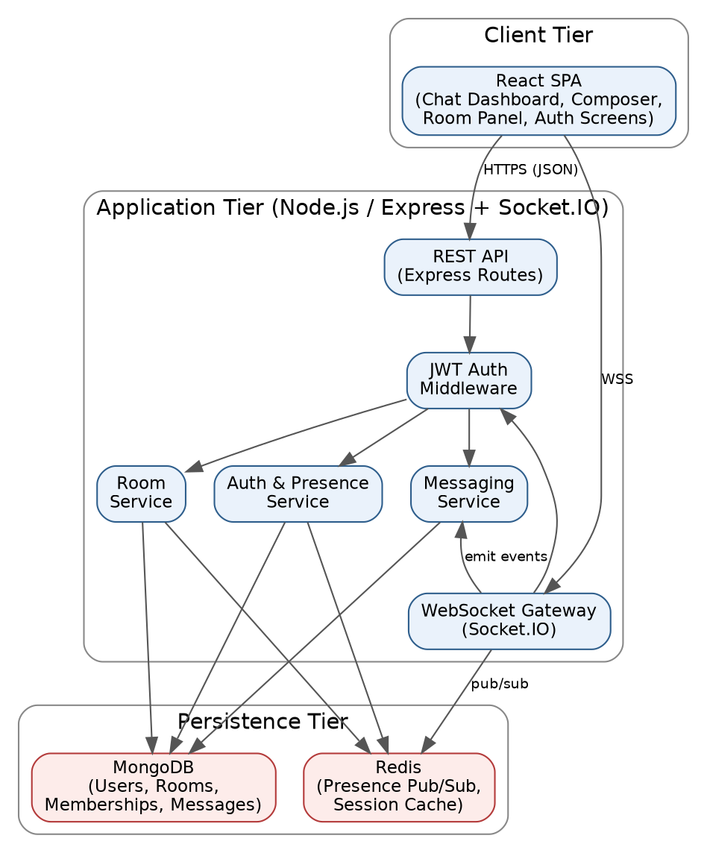
Figure 1 – Component Diagram for ChatSphere
Component responsibilities:
- React SPA — renders the Registration/Login screen, Chat Dashboard, Message Composer, Room Panel and Search (SRS Section 3.1); holds no business logic beyond client-side validation and UI state.
- REST API (Express Routes) — stateless HTTP endpoints for registration, login and paginated history retrieval (SRS Section 3.2).
- WebSocket Gateway (Socket.IO) — accepts the authenticated real-time connection and routes every socket event (message send, typing, presence, room join/leave, room-admin actions) to the appropriate service.
- JWT Auth Middleware — a single, shared component that verifies the JWT on every REST call and every WebSocket handshake/event before it reaches a service, so authentication logic is written and tested exactly once (supports SEC-004).
- Auth & Presence Service — owns registration, login, password hashing and online/offline presence broadcast (FR-001 to FR-006).
- Messaging Service — owns direct-message send/receive, typing indicators, delivery/read status and history persistence for 1:1 conversations (FR-007 to FR-011, FR-017, FR-018).
- Room Service — owns room create/join/leave, group-message broadcast and room administration (FR-012 to FR-016, FR-019 to FR-021).
- MongoDB — durable storage for User, Room, RoomMembership and Message documents (see SRS Appendix B for field layouts).
- Redis — presence pub/sub and the Socket.IO adapter, chosen to keep ephemeral, high-churn presence state out of the durable store and to leave a forward path to multi-instance scaling (SRS Section 2.6).

2.3 Traceability to Requirements
Component | SRS Requirements Satisfied
React SPA | SRS 3.1 (all UI requirements)
REST API | FR-001, FR-003, FR-018, SRS 3.2/3.3
WebSocket Gateway | FR-004, FR-005, FR-006, FR-007, FR-008, FR-010, FR-012 to FR-014, FR-019 to FR-021
JWT Auth Middleware | FR-004, SEC-001, SEC-004
Auth & Presence Service | FR-001 to FR-006, SEC-001
Messaging Service | FR-007 to FR-011, FR-017, FR-018, NFR-001
Room Service | FR-012 to FR-016, FR-019 to FR-021, SEC-002
MongoDB | FR-001, FR-012, FR-017, FR-018 (durable persistence)
Redis | FR-005, FR-006 (presence pub/sub)

2.4 Security Architecture
Security is designed as a set of layered controls that together satisfy the Security Objectives in SRS Section 6.3, rather than a single perimeter check:
- Transport security: all REST traffic is served over HTTPS and all real-time traffic over WSS (SRS Section 3.3), so credentials and messages are never sent in the clear (supports SEC-OBJ-1).
- Authentication: passwords are hashed with bcrypt before storage and never persisted in plaintext (SEC-001); a successful login issues a signed JWT, which is the only credential presented afterwards.
- Authorization (RBAC): the JWT Auth Middleware authenticates every REST call and WebSocket event; the Room Service additionally checks the requester's RoomMembership.role before any room-administration action, rejecting non-admins (SEC-002, FR-021) — illustrated in Sequence Diagram 2, Section 3.1.
- Input safety: all user-supplied message content is sanitized/escaped by the Messaging and Room Services before storage and again before the client renders it, to prevent stored XSS (SEC-003).
- Abuse resistance: the WebSocket Gateway rate-limits message-send events per connection (SEC-005).
- Auditability: failed logins and unauthorized room-admin attempts are logged by the Auth & Presence Service and Room Service respectively (SEC-006), so that the security tests in the Test Plan (Section 5.1) have an audit trail to check against.

2.5 Other Architectural Considerations
- Deployment view: the application tier is packaged as a single Docker image (Node.js 20 LTS on Linux); MongoDB and Redis run as separate containers in the same Docker Compose stack for this phase (SRS Section 2.4).
- Data architecture: the persisted schema (User, Room, RoomMembership, Message) follows the entity-relationship model in SRS Figure 2 and the field layouts in SRS Appendix B; RoomMembership is the join entity carrying each member's role, which is what the Security Architecture's RBAC check reads.
- Scalability path (explicitly out of scope for this phase, SRS Section 2.6): because presence state already lives in Redis and Socket.IO already supports a Redis adapter, moving to multiple application-tier instances later requires no change to the Messaging/Room service boundaries defined here.

3. Design

3.1 Sequence Diagrams
The two sequences below were chosen because they each exercise a different part of the Security Architecture (Section 2.4) alongside their core functional behaviour: one shows the normal, happy-path status lifecycle of a direct message; the other shows an authorization check rejecting an unauthorized action.
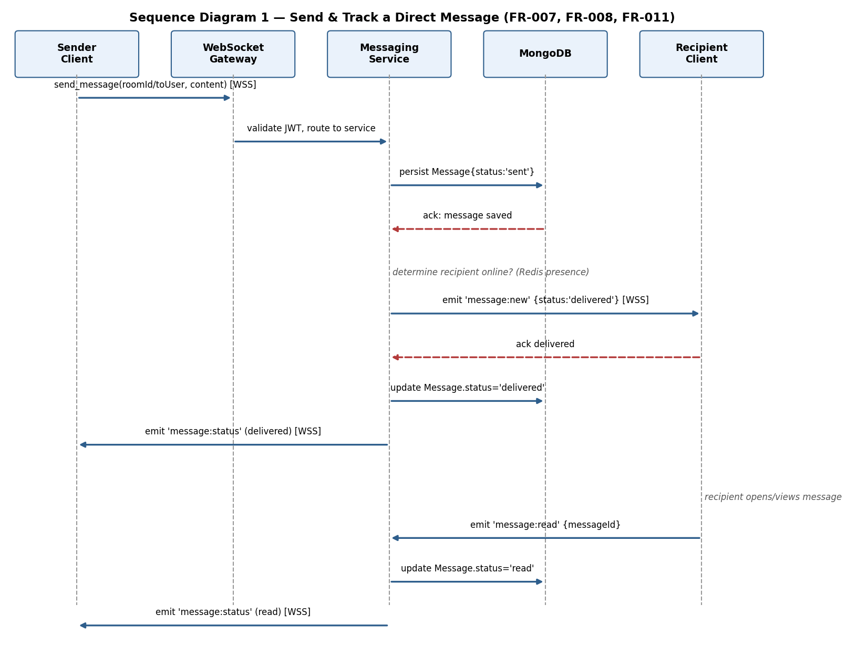
Figure 2 – Sequence Diagram 1: Send & Track a Direct Message (FR-007, FR-008, FR-011)
This flow shows the sender's message being persisted with status 'sent' before any delivery acknowledgement is sent back (SRS Section 6.2 data-safety requirement), then the Messaging Service checking Redis presence to decide whether to deliver immediately, and finally the status transition sent → delivered → read being pushed back to the sender in real time over the WebSocket Gateway.
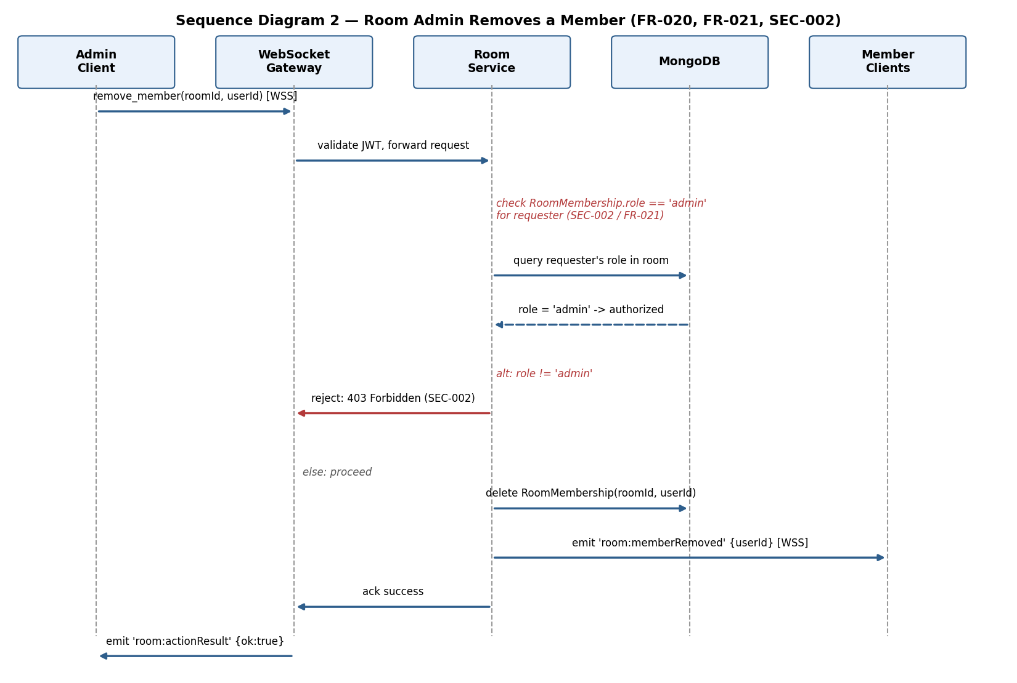
Figure 3 – Sequence Diagram 2: Room Admin Removes a Member (FR-020, FR-021, SEC-002)
This flow shows the Room Service checking the requester's RoomMembership.role before acting: the alt fragment shows the action rejected with an authorization error when the requester is not an admin, and only proceeding to delete the membership and broadcast the change when the requester is confirmed as admin.

3.2 API Design

3.2.1 REST API
Method & Path | Request Body | Response | Requirement(s)
POST /api/auth/register | { username, email, password } | 201 { userId } / 400 validation error | FR-001, FR-002, SEC-001
POST /api/auth/login | { usernameOrEmail, password } | 200 { token } / 401 invalid credentials | FR-003
GET /api/messages/:conversationId?page=&pageSize= | — | 200 { messages[], nextPage } / 401 / 403 | FR-018, SEC-004
GET /api/rooms/:roomId/messages?page=&pageSize= | — | 200 { messages[], nextPage } / 401 / 403 | FR-018, FR-015, SEC-004
All REST endpoints except /api/auth/register and /api/auth/login require a valid Bearer JWT (Authorization header); the JWT Auth Middleware returns 401 for a missing/expired/invalid token before the request reaches a service (SEC-004).

3.2.2 WebSocket (Socket.IO) Events
Event (client→server) | Payload | Server→client Event(s) | Requirement(s)
message:send | { toUserId | roomId, content } | message:new, message:status | FR-007, FR-008, FR-012 to FR-014
message:read | { messageId } | message:status | FR-011
typing:start / typing:stop | { conversationId | roomId } | typing:update | FR-010
room:create | { name } | room:created | FR-012
room:join / room:leave | { roomId } | room:memberJoined / room:memberLeft | FR-013
room:promote | { roomId, userId } | room:memberPromoted / error | FR-019, SEC-002
room:removeMember | { roomId, userId } | room:memberRemoved / error | FR-020, FR-021, SEC-002
(connect / disconnect) | JWT in handshake auth payload | presence:update | FR-004 to FR-006

3.3 Error Handling
Error handling follows one consistent convention across both the REST API and WebSocket events, so a single client-side error handler can cover both channels:
- REST errors return a JSON body { error: { code, message } } with the matching HTTP status (400 validation, 401 unauthenticated, 403 unauthorized, 404 not found, 429 rate-limited, 500 unexpected).
- WebSocket errors are emitted on a dedicated 'error' event with the same { code, message } shape, rather than silently dropping the client's request, so the UI can always show feedback (supports the Usability quality attribute in SRS Section 6.4).
- Authorization failures (SEC-002, SEC-004) always return code AUTH_FORBIDDEN / AUTH_INVALID_TOKEN and are logged server-side per SEC-006, without leaking whether a resource exists (e.g. a non-member is told the room action is forbidden, not that the room itself does not exist).
- Validation failures (e.g. FR-001 duplicate username, FR-016 removing the last admin) return code VALIDATION_FAILED with a field-level message and change nothing in the database (supports the Reliability quality attribute).
- Unexpected server errors are caught by a top-level Express error middleware and Socket.IO error boundary, logged with a correlation ID, and returned to the client as a generic INTERNAL_ERROR without internal detail.

3.4 Other Design Sections

3.4.1 Data Design
The persisted schema design reuses the entities already defined in SRS Appendix B (User, Room, RoomMembership, Message) unchanged; RoomMembership.role is the single source of truth read by the Room Service's authorization check in Sequence Diagram 2.

3.4.2 Concurrency and Idempotency
Because a client may retry a message send after a dropped connection (SRS reliability requirement, Section 6.4), each outgoing message carries a client-generated idempotency key; the Messaging Service deduplicates on that key before persisting, so a retried send cannot create a duplicate message.

3.4.3 Testability Hooks
Each service exposes its socket event handlers as plain functions that take a parsed, already-authenticated payload, independent of the live Socket.IO transport, so the unit tests described in the Test Plan (Section 5.4) can call them directly with mocked sockets.

4. Design-Level Traceability Matrix
This matrix extends SRS Appendix C with the Architecture/Design references now available at this stage; Code and Test Case references remain TBD until Deliverable 4.
Requirement ID | Brief Description | Architecture Ref | Design Ref
FR-001 | Unique user registration | Auth & Presence Service (2.2) | POST /api/auth/register (3.2.1)
FR-004 | WebSocket JWT handshake check | JWT Auth Middleware (2.2, 2.4) | connect/disconnect events (3.2.2)
FR-007 | Send direct message | Messaging Service (2.2) | message:send event; Sequence Diagram 1 (3.1)
FR-012 | Create room | Room Service (2.2) | room:create event (3.2.2)
FR-014 | Broadcast group message | Room Service, WebSocket Gateway (2.2) | message:send event (3.2.2)
FR-020 | Admin removes a member | Room Service (2.2) | room:removeMember event; Sequence Diagram 2 (3.1)
SEC-002 | RBAC on room-admin actions | Security Architecture (2.4) | Sequence Diagram 2 (3.1)
SEC-003 | Sanitize message content (XSS) | Messaging/Room Service (2.4) | Error Handling – VALIDATION_FAILED (3.3)
SEC-004 | Reject expired/invalid JWTs | JWT Auth Middleware (2.4) | REST/WebSocket auth errors (3.2, 3.3)

