April 7, 2015

Rhea Lauzon // Jeff Bayntun // Michael Chimick // Julian Brandrick

4O

Data Communications (Comp 4985)

Comm Audio -- testing

Contents

Test Cases 2

Figures 3

Figure 1 3

Figure 2 3

Figure 3 4

Figure 4 4

Figure 5 5

Figure 6 5

Figure 7 6

Figure 8 6

# Test Cases

|  |  |  |  |  |
| --- | --- | --- | --- | --- |
| Test Number | Test | Tool / Application | Expected Outcome | Pass / Fail |
| 1 | Server loads and accepts clients | StreamingServer.exe |  | Pass (fig. 1) |
| 2 | Server can drop sessions | StreamingServer.exe |  | Pass (fig. 1) |
| 3 | Server can handle multiple clients | StreamingServer.exe |  | Pass (fig. 1) |
| 4 | Server relays playlist to multiple clients | StreamingServer.exe |  | Pass (fig. 2) |
| 5 | Server relays user list to multiple clients | StreamingServer.exe |  | Pass (fig. 2) |
| 6 | Server relays currently playing song to multiple clients | StreamingServer.exe |  | Pass (fig. 3) |
| 7 | Server continually streams songs on multicast to clients | StreamingServer.exe |  | Pass (fig. 3) |
| 8 | Server accepts and completes TCP download requests from playlist | StreamingServer.exe |  | Pass (fig. 4) |
| 9 | Server accepts and completes unicast streaming requests for songs | StreamingServer.exe |  | Pass (fig. 4) |
| 10 | Client can connect to server | Qt client,  StreamingServer.exe |  | Pass (fig. 2) |
| 11 | Client receives user/playlist from server | Qt client,  StreamingServer.exe |  | Pass (fig. 2) |
| 12 | Client displays error message if unable to connect | Qt client,  StreamingServer.exe |  | Pass (fig. 8) |
| 13 | Client can have voice chat with another client in the list | Qt client,  StreamingServer.exe |  | Pass (fig. 7) |
| 14 | Client can request TCP download of song from playlist | Qt client,  StreamingServer.exe |  | Pass (fig. 5) |
| 15 | Client can request streaming song from playlist | Qt client,  StreamingServer.exe |  | Pass (fig. 6) |
| 16 | Client gracefully handles server dropping | Qt client,  StreamingServer.exe |  | Pass (N/A) |

# Figures

## Figure 1

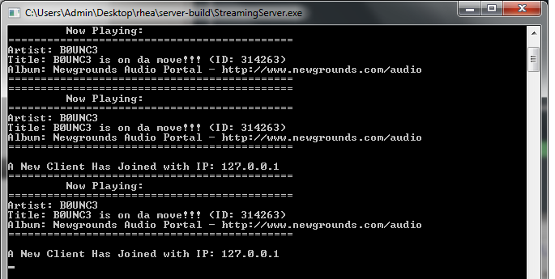

Server playing multiple songs, accepting multiple clients

## Figure 2

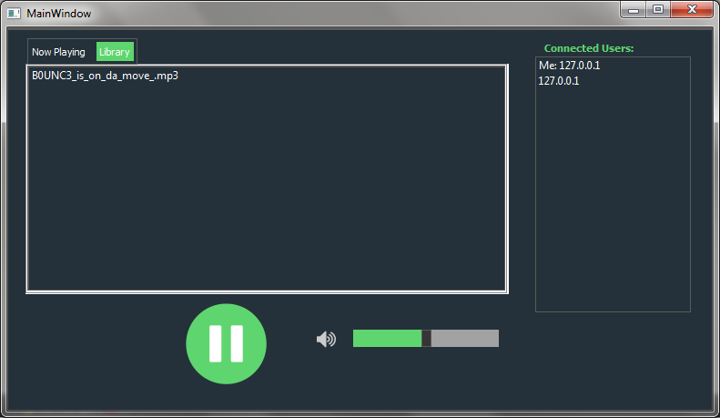

Client displaying server playlist and user list

## Figure 3

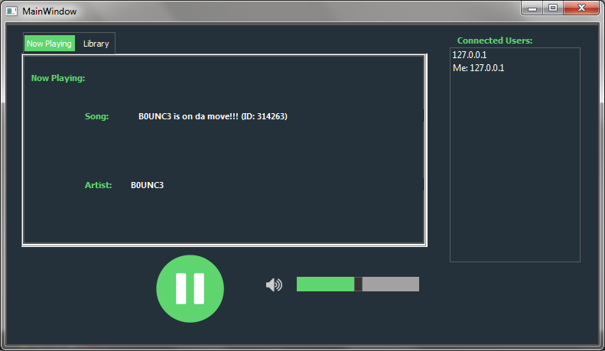

Client displaying now playing song

## Figure 4

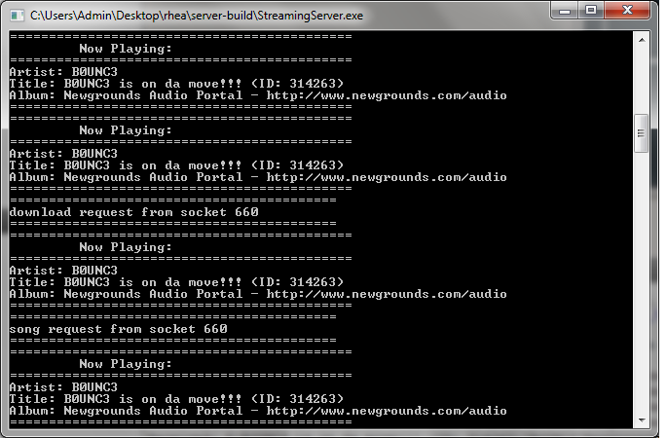

Server accepting download and unicast requests

## Figure 5

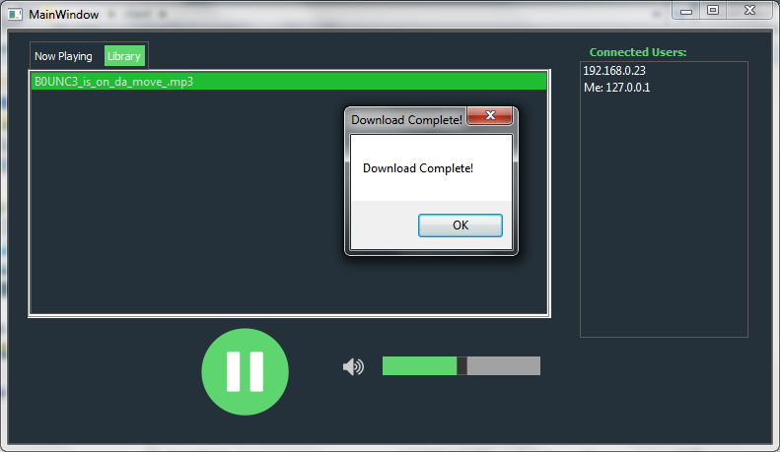

Client downloading a song from the server

## Figure 6

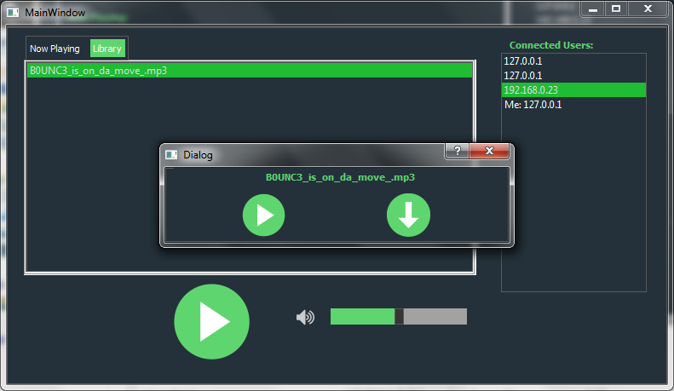

Client making a unicast request

## Figure 7

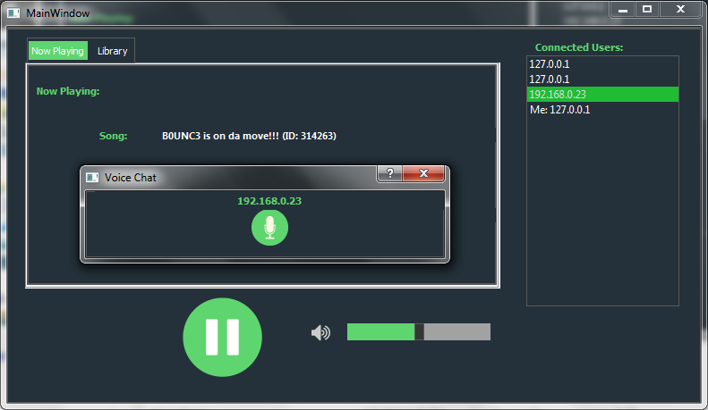

Client starting a voice chat

## Figure 8

// place screenshot here, you may need to resize it a bit to fit it on the page

Client unable to connect message