April 8, 2015

Rhea Lauzon // Jeff Bayntun // Michael Chimick // Julian Brandrick

4O

Data Communications (Comp 4985)

Comm Audio – User Guide

Contents

User Interface 2

Start Menu 2

Server Input Field 2

Connect Button 2

Hub Menu 3

Pause Button 3

Volume Slider 3

List of Users 3

Now Playing Tab 3

Library Tab 3

Use Cases 4

Connect to the Server 4

Pause the Current Song 4

Change the Music Volume 5

View the Title and Artist of the Current Song 5

Start a Voice Chat 5

Unicast a Song from the Server Library 6

Download a Song from the Server Library 6

Appendix 7

Client 7

Figure 1 7

Figure 2 8

Figure 3 8

Figure 4 9

Figure 5 9

Figure 6 10

Figure 7 10

Server 11

Figure 17 11

# User Interface

This section describes all the menus in the user interface.

## Start Menu

The Start Menu is the first menu to appear once the program is run, and is merely used as a prompt for the server information. (See Figure 1)

### Server Input Field

Located in the center of the menu, the Server Input Field is an input field for the server address, it accepts domain names or dotted ip addresses.

### Connect Button

Located below the Server Input Field, the Connect Button submits the Server Input Field and attempts to connect to a server.

## Hub Menu

The Hub Menu is where all the functionality of the application is performed. (See Figure 2)

### Pause Button

Located in the lower center, the Pause Button pauses the current song until the button is clicked again. (See Figure 3)

### Volume Slider

Located to the right of the Pause Button, the Volume Slider manipulates the volume of the current song being played. (See Figure 3)

### List of Users

Located on the right side, the List of Users displays a list of the other clients connected to the same server. Clicking any user on this list will display the Start Voice Chat dialog. (See Figure 4)

#### Voice Chat Button

The Voice Chat dialog has a single button that will initiate a voice chat with the selected user. (See Figure 4)

### Now Playing Tab

Accessed by clicking the Now Playing tab in the top left, this displays the Title and Artist of the Current Song being played. (See Figure 3)

### Library Tab

Accessed by clicking the Now Playing tab in the top left, this displays the list of songs stored on the Server. Clicking any of these songs will display the Server Library dialog. (See Figure 5, 6)

#### Unicast Button

The left button on the Server Library Dialog, this requests the server to stream the selected song. (See Figure 6)

#### Download Button

The right button on the Server Library Dialog, this requests to download the selected song from the server onto the local machine. Once the download has completed, it will display the Download Completed message box. (See Figure 6, 7)

# Use Cases

This section describes all the use cases that a user can utilize.

## Connect to the Server

Assuming the pre-existing conditions:

* The program is running.
* The Start Menu is displayed

To connect to a server the user must type a valid server address into the Server Input Field, and then click the Connect Button. If the address is correct, the user will connect to the server, the Hub Menu will be displayed and the Current Song on the server will be output through the local speakers. (See Start Menu)

## Pause the Current Song

Assuming the pre-existing conditions:

* The program is running.
* The Connect to a Server use case has been completed
* The Hub Menu is displayed

To pause the current song, the user must click the Pause Button. The Current Song will be paused until it is clicked again. (See the Pause Button section)

## Change the Music Volume

Assuming the pre-existing conditions:

* The program is running.
* The Connect to a Server use case has been completed
* The Hub Menu is displayed

To change the music volume, the user must utilize the Volume Slider. The new volume will persist until it is changed again. (See the Volume Slider section)

## View the Title and Artist of the Current Song

Assuming the pre-existing conditions:

* The program is running.
* The Connect to a Server use case has been completed
* The Hub Menu is displayed

To view the title and artist of the current song, the user must select the Now Playing tab, where it will be displayed in the center of the screen. (See the Now Playing Tab section)

## Start a Voice Chat

Assuming the pre-existing conditions:

* The program is running.
* The Connect to a Server use case has been completed
* The Hub Menu is displayed

To start a voice chat, the user must select another user on the List of Users to display the Voice Chat Dialog. Then clicking the Voice Chat Button on the displayed dialog will commence a voice chat with the selected user. Note that the mutual voice chat won’t take place until the selected user has also completed the Start a Voice Chat use case. (See the List of Users section)

## Unicast a Song from the Server Library

Assuming the pre-existing conditions:

* The program is running.
* The Connect to a Server use case has been completed
* The Hub Menu is displayed

To unicast a song from the server library, the user must click the Library tab to display the server library. Then the user must select a song on the list to display the Server Library dialog. The user must then click the Unicast Button to unicast the selected song. (See the Library Tab section)

## Download a Song from the Server Library

Assuming the pre-existing conditions:

* The program is running.
* The Connect to a Server use case has been completed
* The Hub Menu is displayed

To download a song from the server library, the user must click the Library tab to display the server library. Then the user must select a song on the list to display the Server Library dialog. The user must then click the Download Button to download the selected song. Once the download is complete, the Download Completed message box will be displayed. (See the Library Tab section)

# Appendix

This section provides figures of reference for the other sections.

## Client

This section shows all of the figures relating to the Comm-Audio client.

### Figure 1

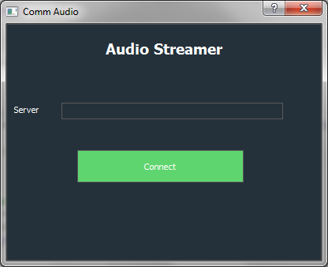

The Start Menu

### Figure 2

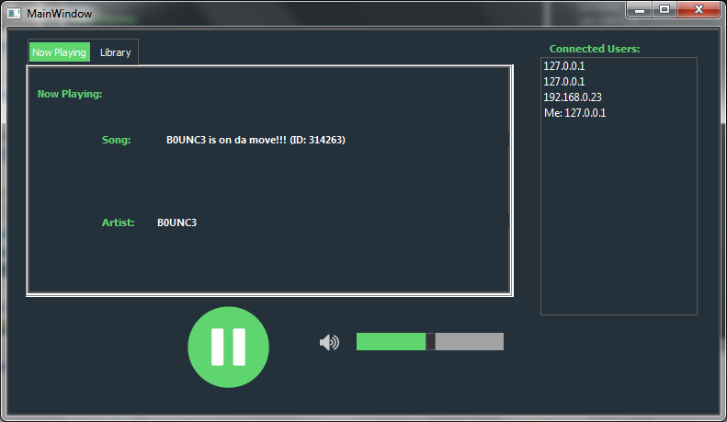

The Hub Menu, with the Now Playing tab selected

### Figure 3

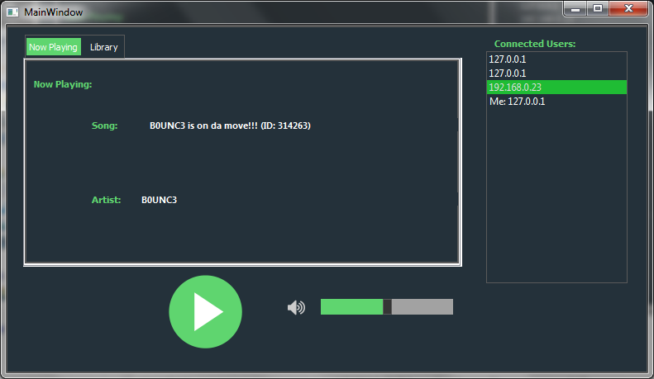

The Hub Menu, with the current song being paused

### Figure 4

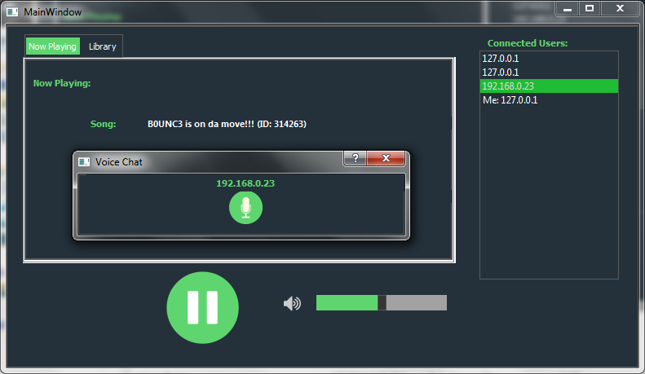

The Start Voice Chat prompt after clicking a user from the List of Users.

### Figure 5

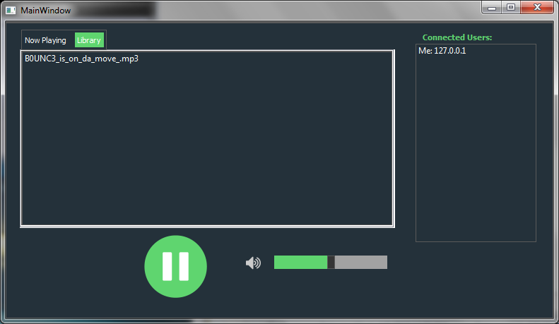

The Hub Menu, with the Library tab selected

### Figure 6

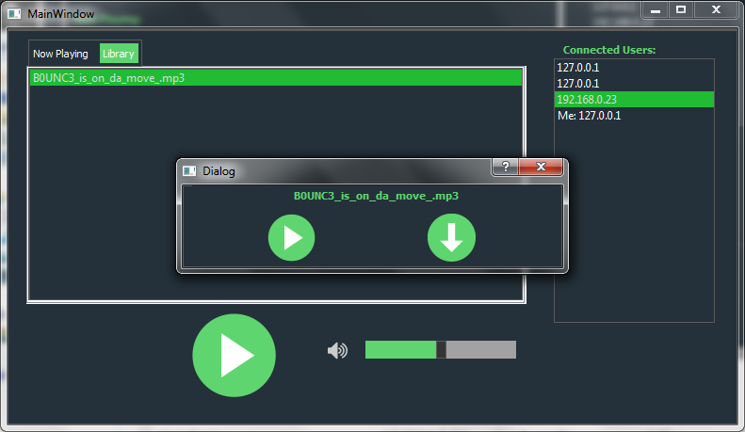

The dialog to access the Unicast and Download features

### Figure 7

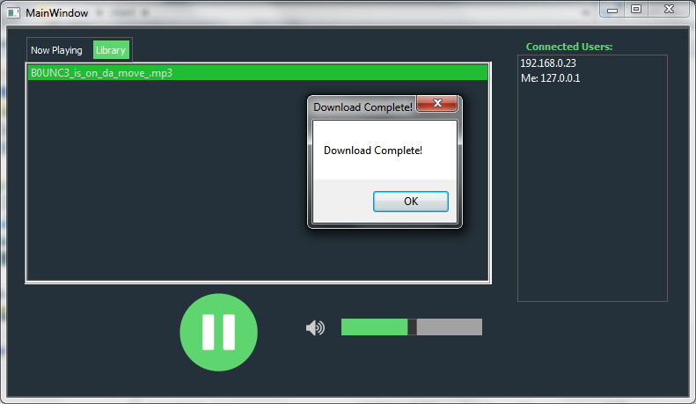

The Download Complete message box

## Server

This section shows all the figures relating to the Comm-Audio server.

### Figure 17

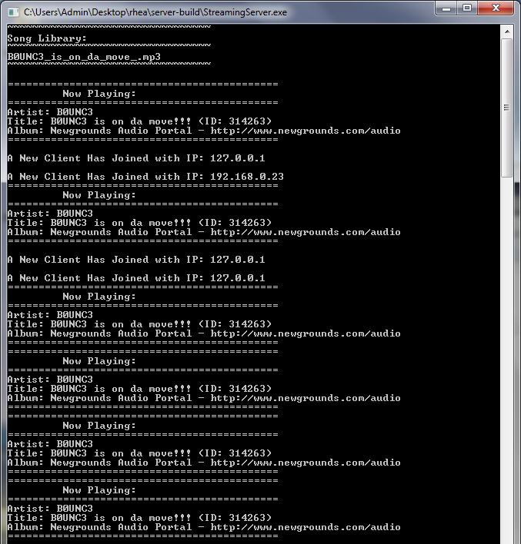

The Server through client interaction