V3 drone scheduling beginner notes
V3 chooses which drone should deliver each package, either now or after returning and charging. Read the flow first, then follow the function notes. A forecast is an estimate; it is not a real departure.
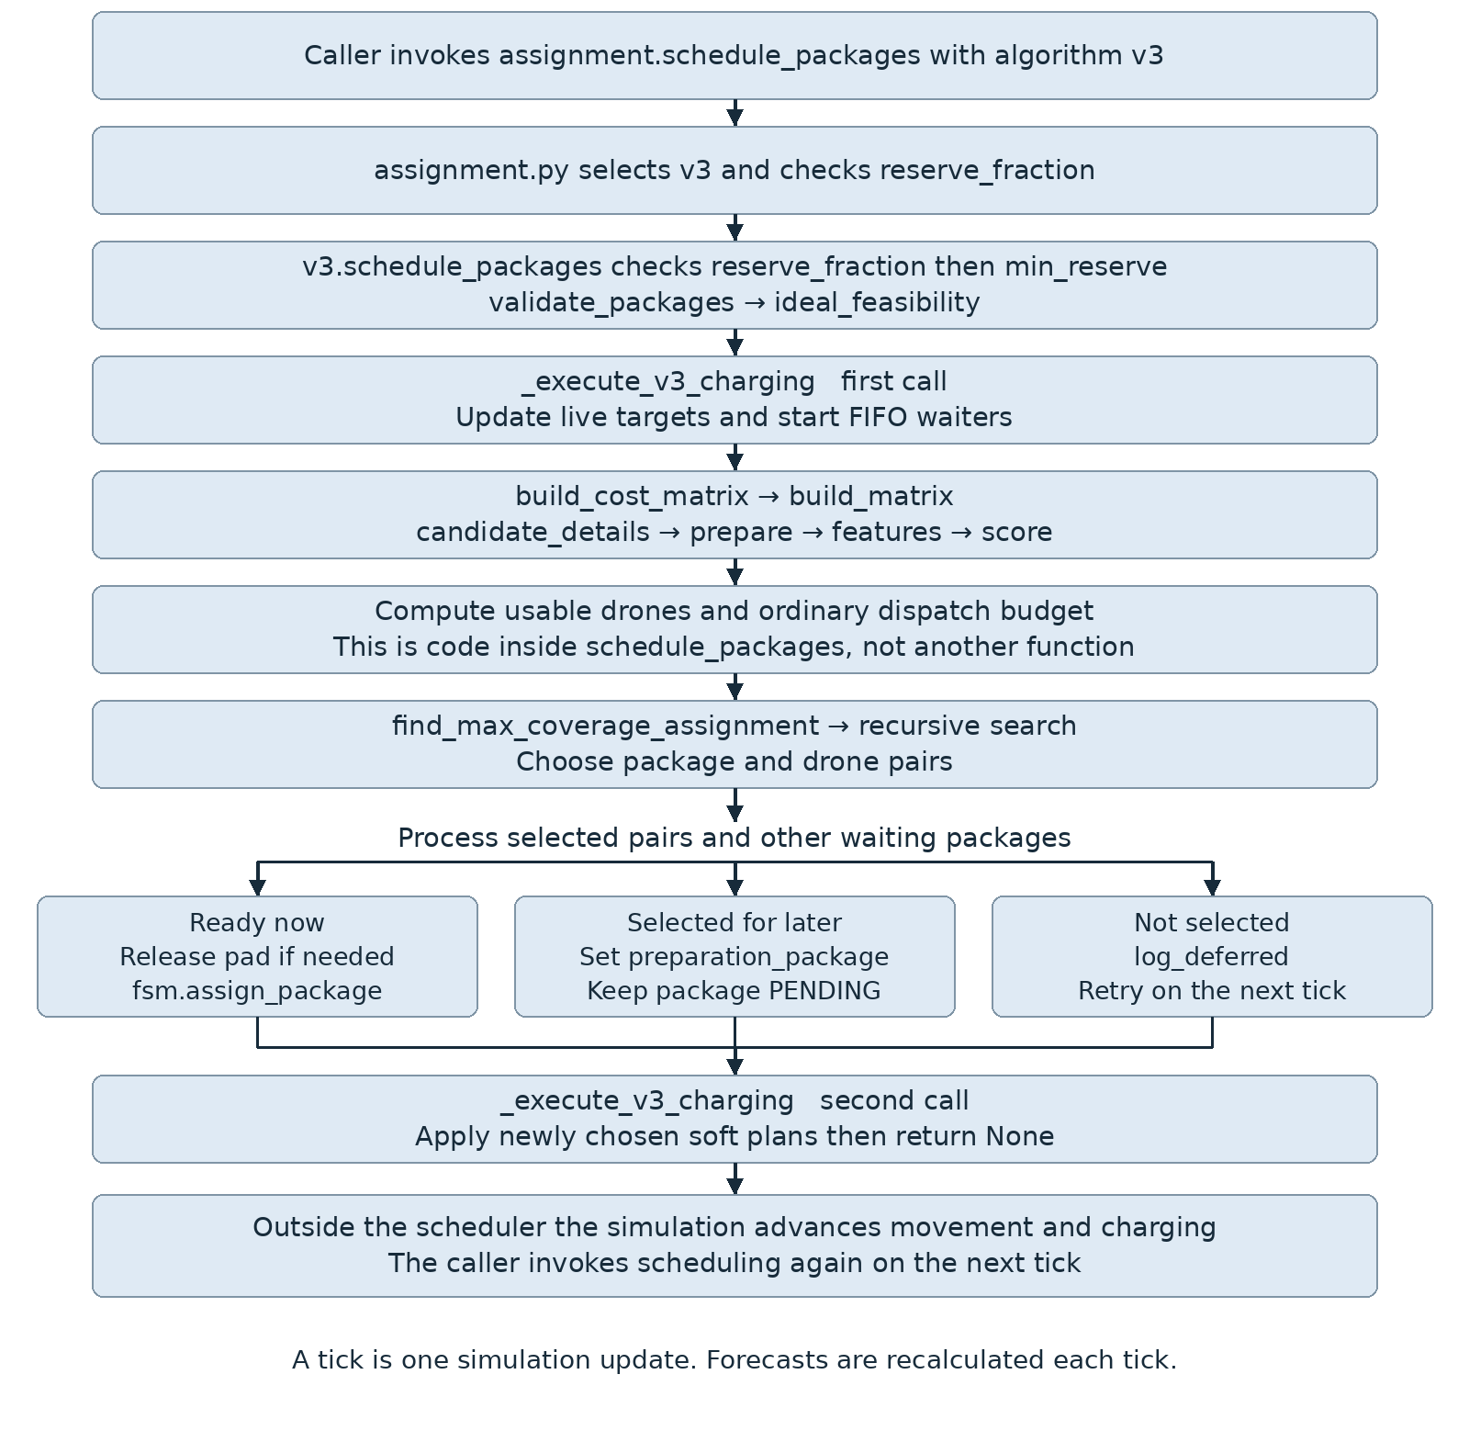

Inputs and the first checks
Think of the base as a school delivery desk and charging pads as a few shared sockets. V3 considers both the drones waiting at the desk and the drones that will return later.
A parameter is information given to a function. A return value is information sent back. A dictionary stores named values. None means no value was returned. A side effect means the function changed an existing drone, package, pad, or log. An underscore marks an internal helper. FIFO means first in first out: the longest-waiting drone is served first. Coverage means the number of packages selected.

Names used throughout these notes
drones: {drone ID: DroneState}; packages or all_packages: {package ID: PackageState}. A drone stores position, battery, capacity, status and current package. A package stores position, weight, request time, deadline, status and decision_history.
charging_pads: {pad ID: drone ID or None}. sim_time: current simulated seconds. candidate: a dictionary describing one possible drone/package pair. features: its measured cost inputs. plan: preparation details. slack: deadline minus predicted arrival time.

Imports and file roles
assignment.py imports the algorithm modules to route calls. v3.py imports math for finite numbers and distances; DroneState and BASE from drone_sim; travel/energy helpers from physics; assign_package from fsm; matrix, validation and logging from common; the optimizer; and forecast helpers/constants from v3_charging. That charging file imports physics and FULL_CHARGE_TIME from charging.py. An import makes existing code available; it does not run a mission.

Enter the V3 scheduler
assignment.schedule_packages(drones, packages, sim_time, charging_pads, algorithm,
reserve_fraction=None, min_reserve=None)
For algorithm="v3", _algorithm_module returns the V3 module; unknown names raise ValueError. The facade validates the reserve fraction and calls v3.schedule_packages with the same states. That function checks that min_reserve is a nonnegative integer, not a Boolean. Both scheduling functions normally return None; their useful work is changing state.

Check the battery reserve setting
_reserve_fraction(value)
None uses 0.11, meaning 11% of battery capacity. The number must be finite and between 0 and 1. This battery margin is different from min_reserve, the count of drones kept available. Returns the checked fraction; invalid settings raise ValueError.

Check waiting requests
validate_packages(drones, packages, sim_time) → ideal_feasibility(package, drones, sim_time)
Validation ignores future or already owned requests. Invalid numeric data or negative weight is rejected; a passed deadline is expired. ideal_feasibility asks whether even an ideal departure from base can meet the deadline, carry at most 2.5 kg, and fit the round trip within a fleet battery capacity. Validation returns None and changes request status/reason. ideal_feasibility returns (True, None) or (False, reason); rejection also marks assigned_drone=-1.

Build predictions and compare candidates
The matrix is a set of lists: for each waiting package, list the drones that could serve it. It is a comparison structure, not a flight command.

Build the V3 matrix
build_cost_matrix(drones, packages, sim_time, package_plans=None,
charging_pads=None, reserve_fraction=None)
Calls common.build_matrix with V3 candidate, feature, score and prepare functions. package_plans can attach plan details; the normal V3 scheduler does not pass prebuilt plans. Returns (matrix, pending_packages). The matrix includes candidates, all candidate logs and plans.

Fill the shared matrix
build_matrix(drones, packages, sim_time, candidate_fn, feature_fn, score_fn,
package_plans=None, prepare_candidates=None)
For each arrived, unowned PENDING package, calls candidate_fn for every drone, then prepare. Keeps candidates without reasons/policy_reason and calls feature_fn. Uses largest feasible distance and average fleet flight time to call score_fn. Lambda wrappers supply V3 context. Returns (matrix, pending). Each feasible candidate gains features, score_components and cost.

Predict one possible delivery
candidate_details(drone, package, sim_time, allowed, plan=None, algorithm="v3",
all_packages=None, drones=None, charging_pads=None, reserve_fraction=None)
allowed lists accepted states; all_packages supplies current jobs; drones/pads describe the fleet. Calls _project_state_at_base, trip helpers, _package_charge_target, _charge_duration, then _candidate_pad_wait. Adds these delays to now to predict departure and arrival; calls _return_charging_forecast for finite departures. Rejects unavailable states, excess weight, negative projected battery, capacity overflow or late arrival. plan/algorithm are compatibility inputs. Returns a candidate dictionary with reasons, times, battery targets, slack and return-charging fields. An empty reasons list means the physical checks passed; policy filtering still follows.

Apply package urgency and congestion rules
prepare(candidates, package) inside build_cost_matrix
Uses the earliest arrival among physically valid candidates. A package is urgent if that arrival leaves at most 15 seconds of slack. Marks immediate departures. Blocks an ordinary immediate departure only when it will need return charging, forecast demand is at least twice the pad count, and forecast return pad wait exceeds 60 seconds. Returns None; writes urgent, requires_dispatch and policy_reason into candidates.

Convert a forecast into cost inputs
calculate_predictive_assignment_features(drone, package, candidate, sim_time)
Measures deadline pressure, energy relative to predicted launch battery, distance, past flight time and preparation delay. Carries congestion and return clustering from the forecast. charging_risk is recorded but is not a separate term in the V3 score. Returns a features dictionary; does not assign the package.

Give a candidate a cost
calculate_predictive_assignment_score(features, max_distance, avg_flight_time, sim_time, deadline)
Adds deadline ×10, energy ×3, normalized distance ×1, utilization balance ×2, preparation delay ×2, congestion ×3 and return clustering ×2. For urgent packages, the last two penalties are reduced to one quarter. Normalization puts different distances/workloads on comparable scales. Lower cost is preferred after coverage and urgency. Returns a dictionary containing total score and its named components.

Charging helpers in detail
These helpers live in assignment_algorithms/v3_charging.py. Forecast helpers calculate numbers without physically charging a drone. Times below are seconds; battery values use the simulator scale.

Choose enough battery for a job
_package_charge_target(drone, package, reserve_fraction)
Estimates round-trip battery from base, adds the reserve fraction of capacity, and caps the target at capacity. The cap means the full desired margin is not always achievable. Returns one target battery number.

Choose a future return charging target
_future_charge_target(drone, battery_at_base, packages, sim_time, reserve_fraction)
If preparation_package still names a valid waiting request, uses its package target. Otherwise requests full recovery charging below 20% capacity; at or above 20%, keeps the projected battery unchanged. Returns one desired battery number for the forecast.

Predict the next return to base
_project_state_at_base(drone, all_packages, reasons)
For DELIVERY, estimates the remaining current delivery and return. For RETURNING, estimates the remaining return using the actual payload, including an aborted load. At-base states start with zero travel delay. Missing package data or unsupported states add a reason. Returns (time_to_base, battery_at_base); can also append to the supplied reasons list.

Estimate how long charging takes
_charge_duration(capacity, battery, target_battery)
Divides missing battery by the linear charging rate. A full charge takes FULL_CHARGE_TIME=2400 seconds. No missing energy means zero charging delay. Returns a nonnegative charging duration.

Estimate a shared socket wait
_candidate_pad_wait(candidate, time_to_base, battery_at_base, target_battery,
drones, charging_pads, all_packages=None, sim_time=0.0, reserve_fraction=None)
Returns zero if charging is unnecessary or the candidate is already charging. Otherwise estimates when occupied pads become free. Adds current waiters and returning drones that need charging; sorts by queue-entry time, then drone ID. Simulates allocation to the earliest-free pad and measures this candidate's wait after arrival. An unknown pad owner cannot be assumed to leave. Returns waiting seconds, or infinity if charging is required but no pad is available. The forecast does not change real pad owners.

Predict congestion after the new delivery
_return_charging_forecast(drone, package, dispatch_time, launch_battery,
drones, packages, charging_pads, sim_time, reserve_fraction)
Estimates new mission return time/battery and whether battery will be below 20% capacity. Counts other charging demand and charging-needing returns near that time. A return collision means arrivals within 30 seconds, not aircraft physically hitting each other. If charging will be needed, reuses the pad-wait forecast and calculates congestion penalties. Returns a dictionary: predicted_return_time/battery, needs_return_charging, return_pad_wait, charging_demand, return_collisions, congestion_cost and return_collision_cost.

Choose jobs and update real state

Execute live charging decisions
_execute_v3_charging(drones, packages, sim_time, charging_pads, reserve_fraction)
Handles empty available drones at base. Refreshes soft-plan targets, clears stale preparation IDs, releases pads at target battery, and starts waiters on free pads in FIFO order, then drone ID. Runs before and after matching so new plans affect charging. It allocates pads, not battery. Returns None; changes drone targets, status, wait markers and pad ownership. Battery rises later through charging.update_charging in the simulation.

Calculate the ordinary departure budget
This is a block inside v3.schedule_packages, not a separate function. Healthy drones exclude FAILED/QUARANTINED. Usable drones must be empty, unowned, physically at base, in an available state and at least 20% charged. Effective reserve is min(min_reserve, healthy count minus one), bounded below by zero. Ordinary budget is usable count minus effective reserve, bounded below by zero. Urgent immediate departures may exceed that budget; future plans do not count as immediate departures. min_reserve defaults to 2; zero disables this budget constraint.

Find a matching for the whole fleet
find_max_coverage_assignment(matrix, pending_packages, dispatch_budget=None, cost_first=False)
V3 passes its budget and cost_first=True. The nested search tries each feasible drone for a package, and also tries skipping the package. A selected drone cannot be selected twice. It favors more packages, then more urgent packages, then lower cost, then minimum/total slack. Bounds and remembered states skip unpromising choices. The 50,000-search-step cap means a large problem is not guaranteed an exhaustive optimum. Returns a list of (package, candidate) pairs, possibly empty or None if no complete choice was recorded before the search cap.
Nested search inputs: idx is the next package; current_assignment is the trial list; assigned_drones prevents duplicates; coverage, min_slack, total_slack and total_cost measure the trial; departures counts immediate launches. search returns None and updates the saved best result in its enclosing function.

Commit ready selections and keep future plans soft
The scheduler clears old preparation IDs, then visits selected pairs. It stores the target and plan. If dispatch_time is now, it frees any charging pad and calls assign_package. Otherwise it sets preparation_package and records a forecast; the package stays PENDING and unowned. Nearly unchanged repeated forecast logs are suppressed. Unselected requests are logged for retry. The final charging call applies these new soft plans.

Assign a physical mission
fsm.assign_package(drone, package, sim_time, algorithm="v2", plan=None)
V3 supplies algorithm="v3" and its plan. Sets package status ASSIGNED and assigned_drone; sets drone status DELIVERY, target coordinates, payload and current_package. Appends the assignment decision. This prepares a real mission but does not move the drone. Returns None; changes drone/package state and the decision history.

Record a retry
log_deferred(package, sim_time, algorithm, data, reason)
data is the package's matrix record. Appends a DEFERRED entry with time, reason, candidates and preparation details. It does not reject or physically assign the package. Returns None; changes only the decision history.

Travel calculations and one small example
The imported physics helpers below supply V3 forecasts. BASE is the pickup location; the code uses 10 pixels per meter. Drop-off time determines deadline success; the return trip still matters for energy and later availability.
Function and inputs | How it works and what it returns
calculate_delivery_time(drone, package) | Distance from the drone to the package divided by loaded speed. Returns outbound seconds.
calculate_mission_time(drone, package) | Remaining loaded delivery plus empty return to BASE. Returns round-trip seconds.
calculate_required_battery(drone, package) | Adds loaded outbound and empty return consumption. Returns mission battery required, without an extra reserve.
calculate_mission_distance(drone, package) | Adds drone-to-package and package-to-base distance. Returns meters.
calculate_speed(payload) | Payload reduces speed from 12 m/s toward 8.4 m/s at 2.5 kg. Returns meters per second.
calculate_battery_consumption(time, payload) | Time multiplied by a payload-dependent rate; full-load endurance is 1500 seconds. Returns battery depletion, not watt-hours.
pixels_to_meters(distance_pixels) | Divides pixel distance by 10. Returns meters.

Follow one forecast by hand
Illustration only: now is 100 s; return takes 20 s; pad wait is 30 s; charging takes 40 s. Departure is predicted at 190 s. Delivery takes 25 s, so arrival is 215 s. With a deadline of 230 s, slack is 15 s. If 215 s is the earliest feasible arrival, the package is urgent. A selected drone cannot leave at 100 s; V3 stores a soft plan and checks it again next tick.
Battery illustration: capacity is 100 and the new round trip needs 12 battery units. With reserve_fraction=0.11, the target is 23 units, capped at capacity. This desired battery margin is separate from keeping two usable drones at the base.

What happens after scheduling
simulation.run_simulation_step advances movement and charging, checks telemetry, and updates delivery/return outcomes. V3 forecasts use nominal travel calculations, while actual motion and safety checks can be affected by wind. Forecasts are estimates, not guaranteed arrivals. V3 uses its own charging execution; it does not call V2's manage_charging_infrastructure or plan_fleet_preparation. There is no fixed send three then wait rule.
Code reading order: swarm_drone/assignment.py; assignment_algorithms/v3.py; v3_charging.py; common.py; optimizer.py; then swarm_drone/physics.py and fsm.py. All algorithm paths are inside swarm_drone/assignment_algorithms/.

