**PROJECT – 1**

**Working With S3**

* Learning Outcomes
* Able to Work with S3 Environment
* Able to create S3 buckets
* Uploading data objects in S3
* Able to Work with Versioning
* Enabling Static Website Hosting
* Deleting objects from S3
* Deleting S3 bucket

Login into AWS free trail account

* Open the link : <https://aws.amazon.com/free/>
* Sign in with the credentials

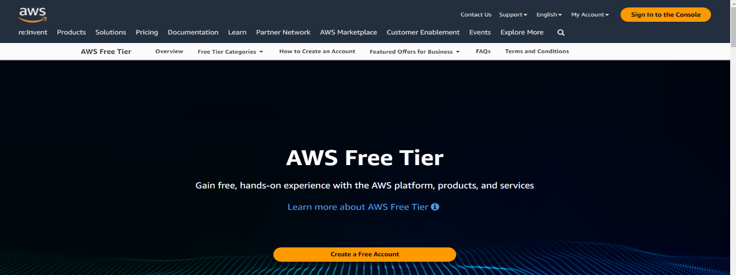

Login with your credentials

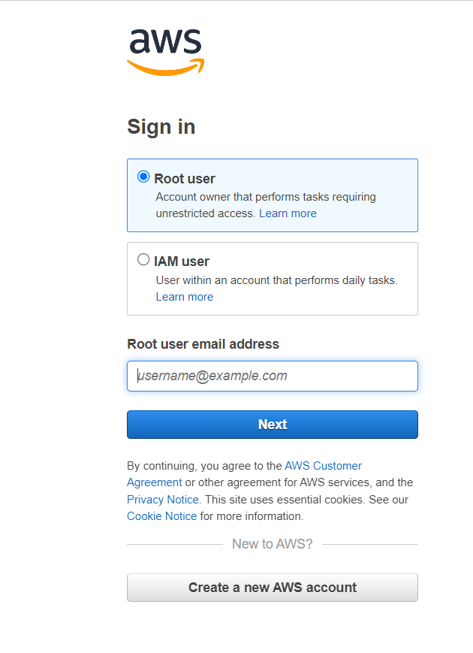

Amazon S3 :

* S3 is a safe place to store the files.
* It is Object-based storage, i.e., you can store the images, word files, pdf files,
* etc.
* The files which are stored in S3 can be from 0 Bytes to 5 TB.
* It has unlimited storage means that you can store the data as much you want.
* Files are stored in Bucket. A bucket is like a folder available in S3 that stores the
* files.
* S3 is a universal namespace, i.e., the names must be unique globally. Bucket
* contains a DNS address. Therefore, the bucket must contain a unique name to
* generate a unique DNS address.

Amazon Simple Storage Service (Amazon S3) is an object storage service that offers industry-leading scalability, data availability, security, and performance.

Customers of all sizes and industries can use Amazon S3 to store and protect any amount of data for a range of use cases, such as data lakes, websites, mobile applications, backup and restore, archive, enterprise applications, IoT devices, and big data analytics.

Amazon S3 provides management features so that you can optimize, organize, and configure access to your data to meet your specific business, organizational, and compliance requirements.

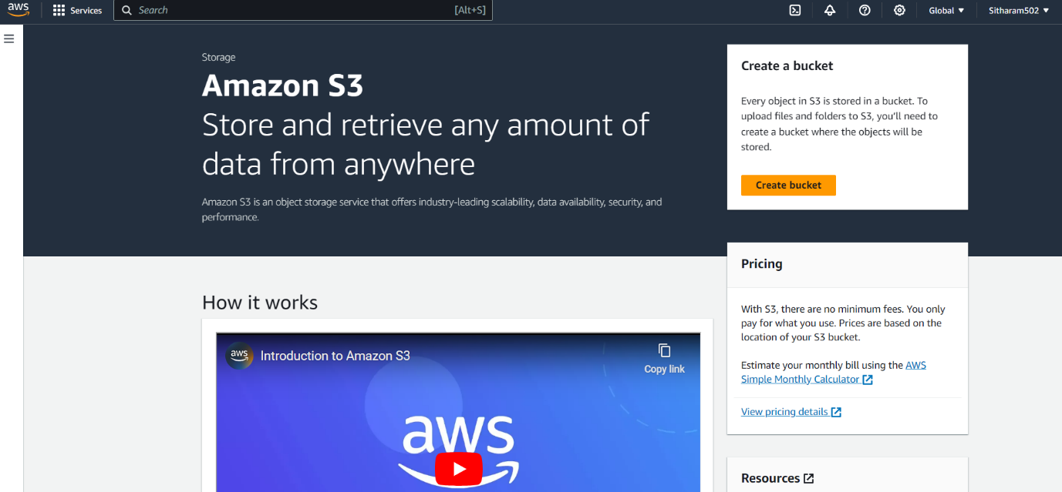

Bucket :

* Buckets are a universal namespace, i.e., the bucket names must be unique.
* If uploading of an object to S3 bucket is successful, we receive a HTTP 200 code.
* S3, S3-IA, S3 Reduced Redundancy Storage are the storage classes.
* Encryption is of two types, i.e., Client Side Encryption and Server Side Encryption.
* Access to the buckets can be controlled by using either ACL (Access Control List) or bucket policies.
* By default buckets are private and all the objects stored in a bucket are also private.
* Create A bucket

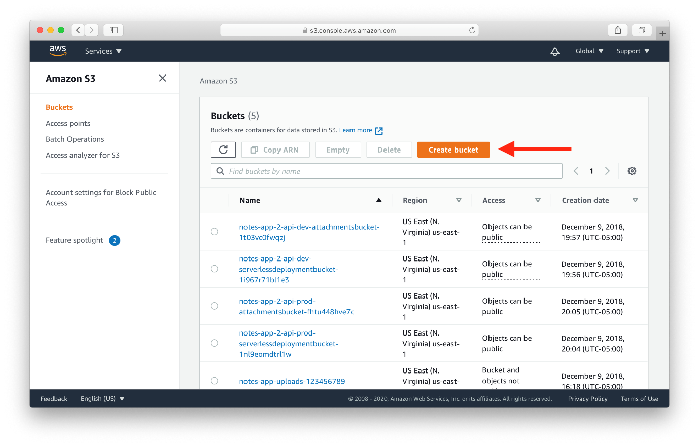

* Give the bucket name , region and Enable ACLs in object Ownership.

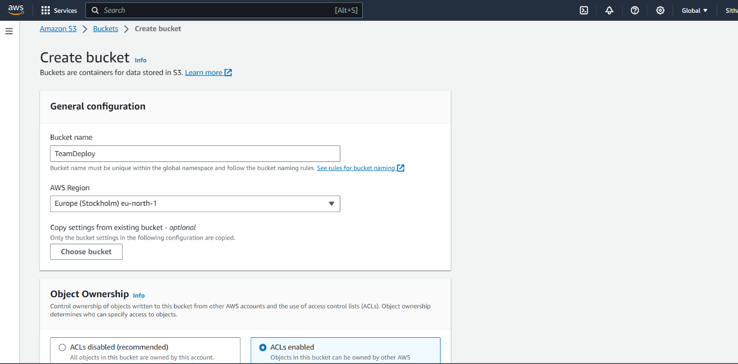

* Deselect the block public access

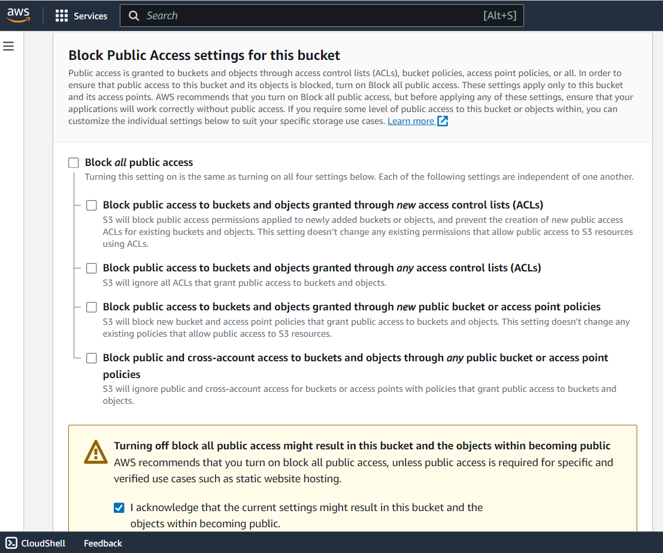

Versioning :

Versioning is a means of keeping the multiple forms of an object in the same S3 bucket.Versioning can be used to retrieve, preserve and restore every version of an object in S3 bucket.

For example, bucket consists of two objects with the same key but with different version

ID's such as photo.jpg (version ID is 11) and photo.jpg (version ID is 12).

* Enable Versionig

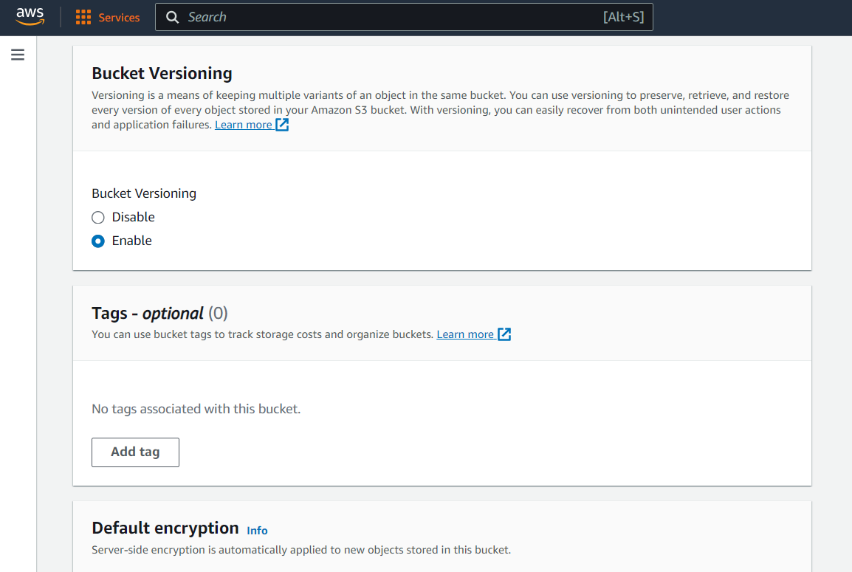

* Click on the Create bucket

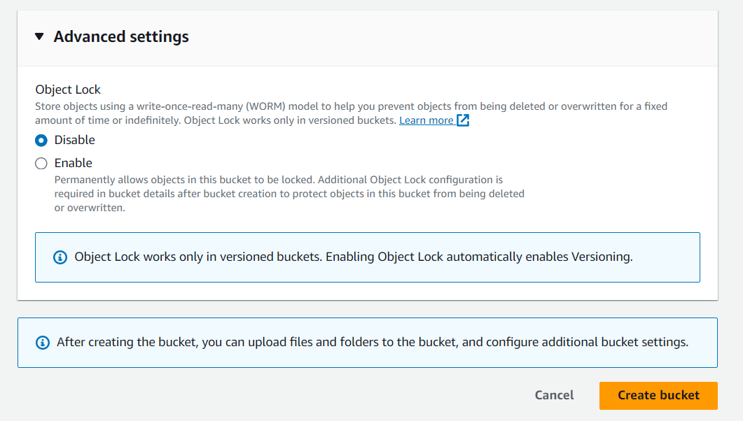

* Now the bucket was created succesfully

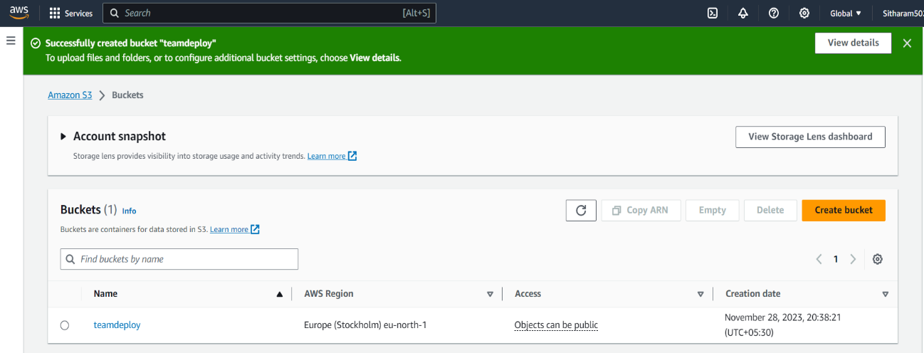

* Select the bucket then go to objects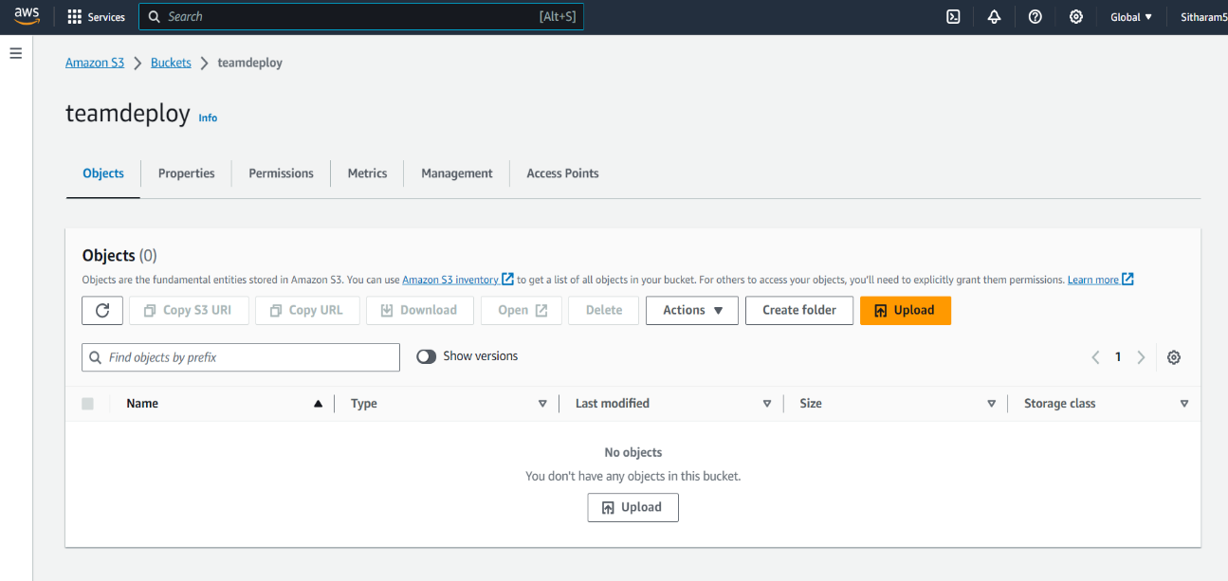
* Upload the files which was present in the desktop
* Drag into the object location

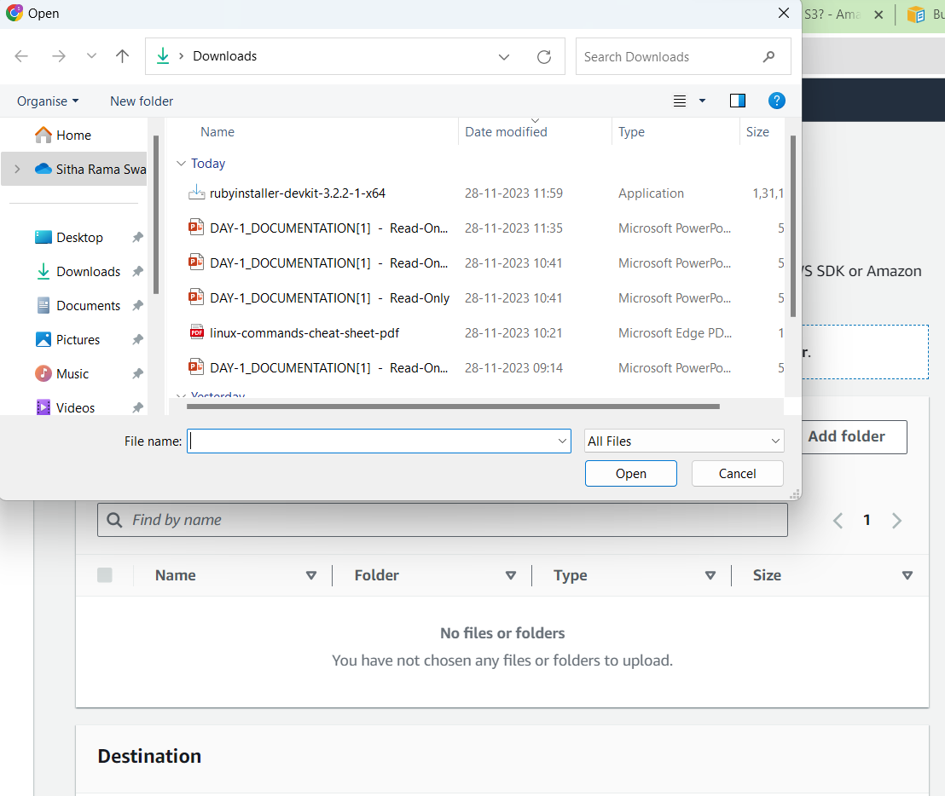

* Then click on upload

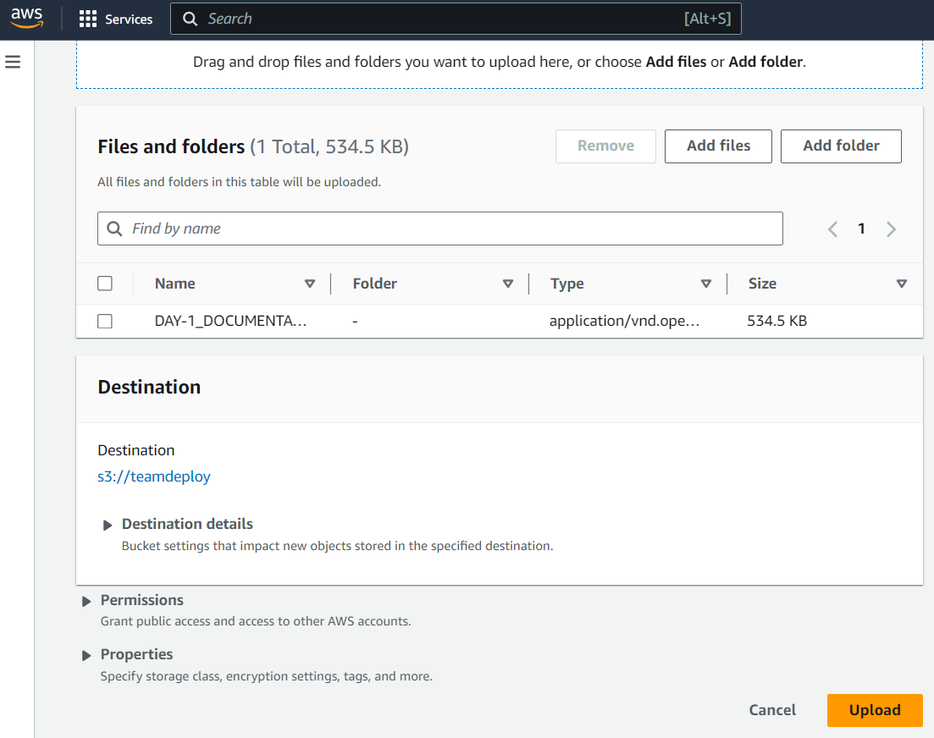

* The files are uploaded succesfully

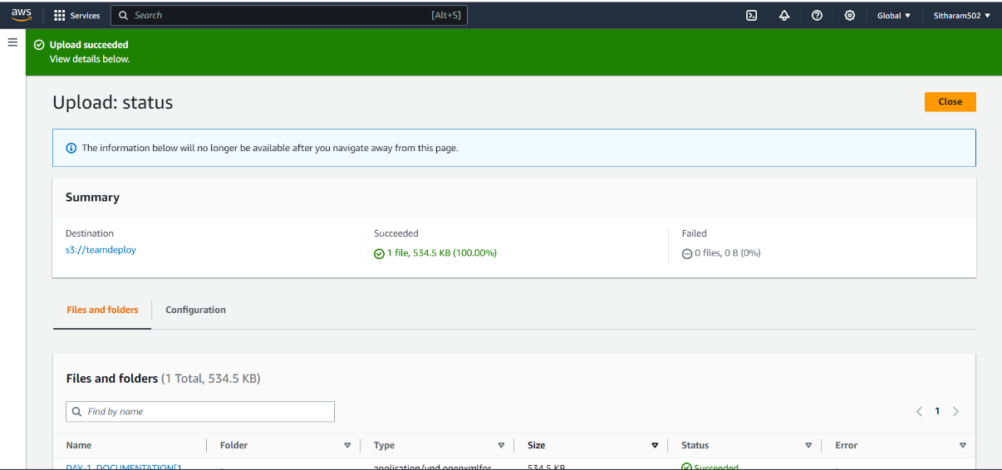

* Select an object and click on actions

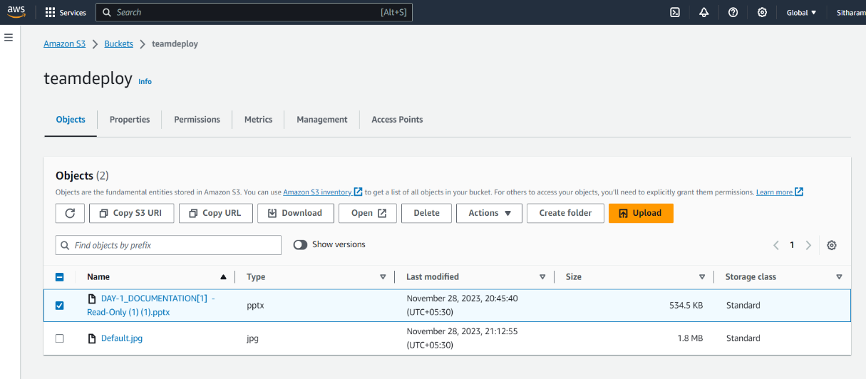

* Click on “Make public using ACL”

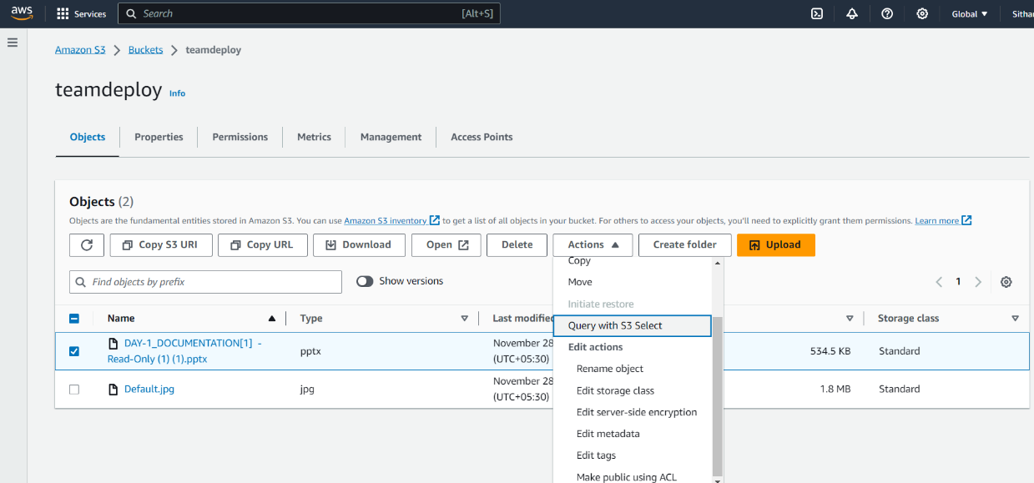

* The object is successfully edited to public access

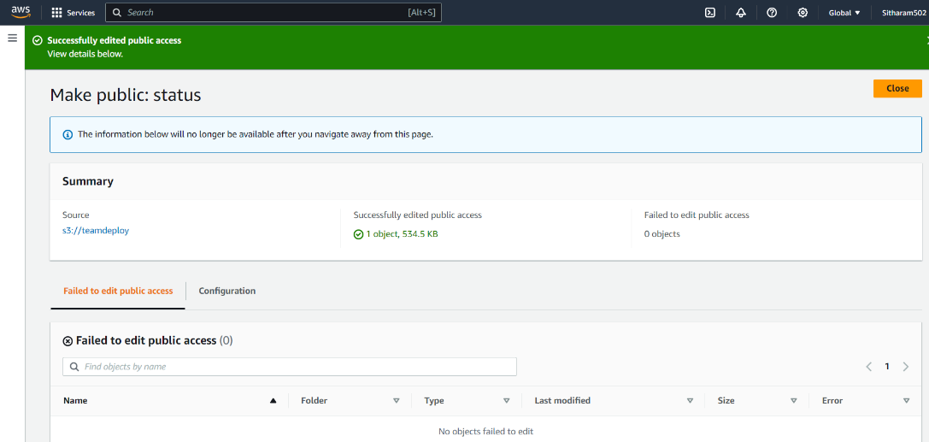

* Go to the properties of that object
* In that an object URL will be there by clicking on that URL ,if that object is in the format of JPGE or HTML files those can be viewed on the browser otherwise they can be downloaded to our local system

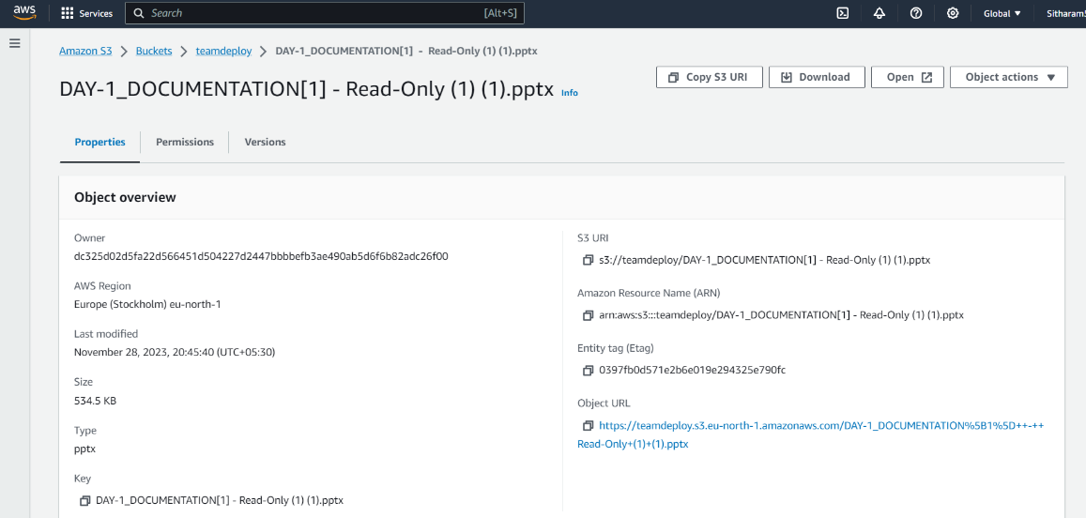

* In the versions we can see the versions of that particular object

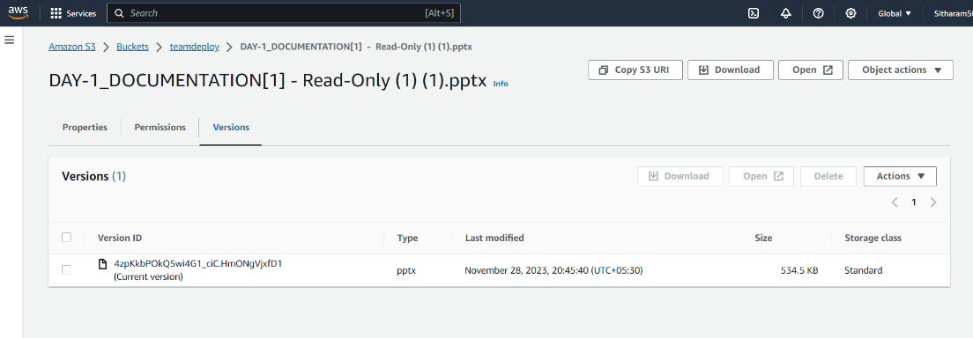

**Terminate the Objects and Buckets**

When we try to delete the buckets with out deleting the objects in it.Its gives an exception that the bucket is not empty

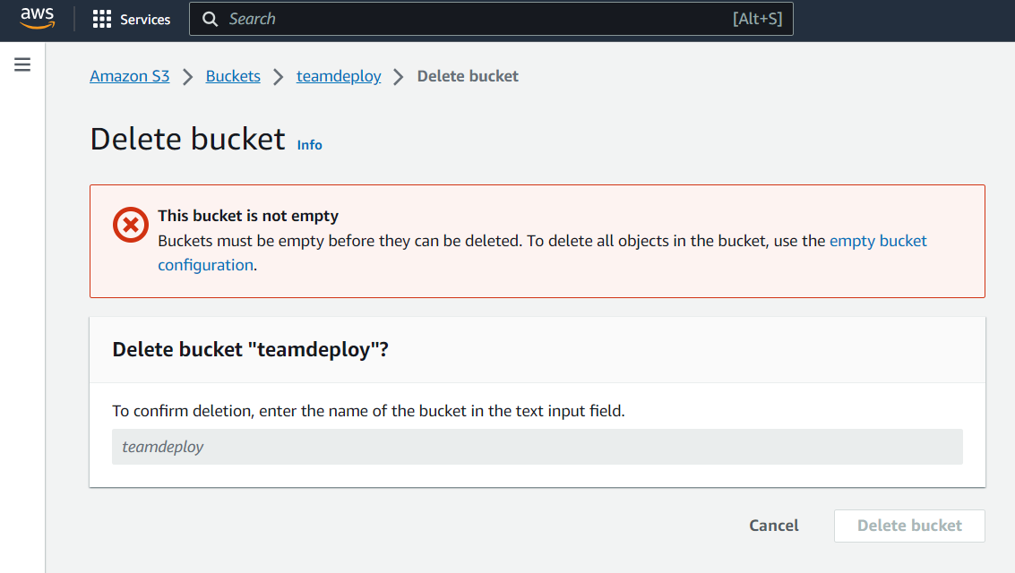

* Select all the files and click on delete
  + Type delete and delete the objects

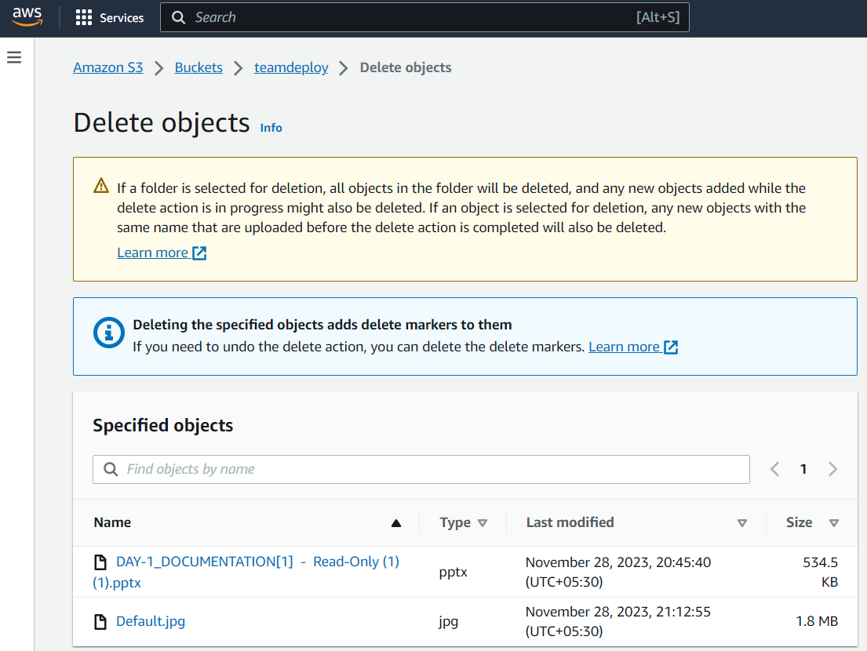

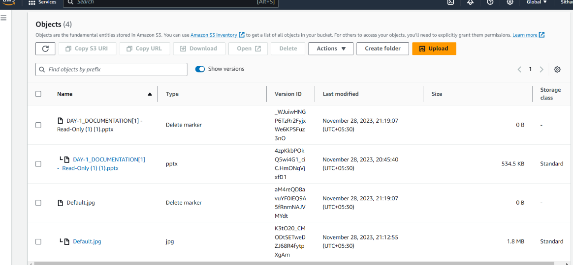

* + The objects are deleted permenantly
* Go to s3 section then delete the bucket

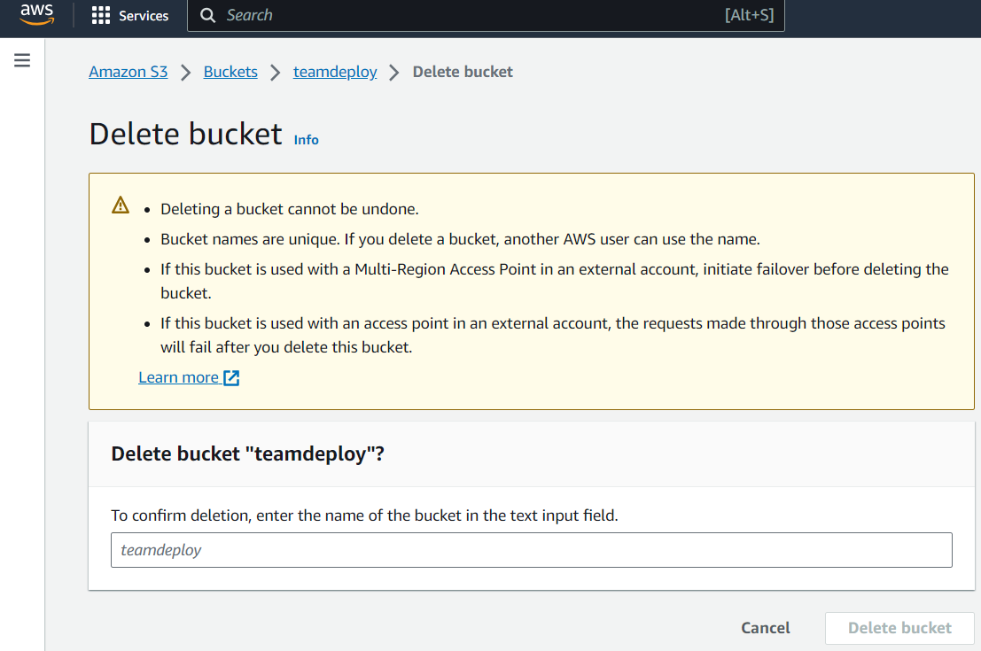

* + Buckets and objects are terminated