

|  |  |  |  |  |
| --- | --- | --- | --- | --- |
| 33 Alexander Malinov Blvd. Sofia 1729, Bulgaria |  | Tel.: + 359 2 809 98 50 |  | Team Griffin |

Team Griffin Test Status report

Testing Base Modules and front-end functionalities from Telerik ACADEMY LEARNING SYSTEM (TALS)

# 1. Test cases

|  |  |  |
| --- | --- | --- |
| Area | Module | Test Cases Count |
| Admin | Additional Documents | 28 |
| Admin | Calendar | 24 |
| Admin | Candidate Correlations | 18 |
| Admin | Candidate Entry Exam | 11 |
| Admin | Candidates | 38 |
| Admin | Check-In Devices | 24 |
| Admin | Cleanup Operations | 11 |
| Admin | Events | 28 |
| Admin | Feedback Reports | 11 |
| Admin | Files | 18 |
| Admin | Moved Lectures | 26 |
| Admin | Pages | 14 |
| Admin | Polls | 28 |
| Admin | Searched Words | 22 |
| Admin | Settings | 14 |
| Admin | Training Rooms | 25 |
| Front End | Navigation | 41 |
| Front End | User Settings | 60 |

|  |  |
| --- | --- |
| Priority | Number of test cases |
| 1 | 38 |
| 2 | 248 |
| 3 | 101 |
| 4 | 38 |

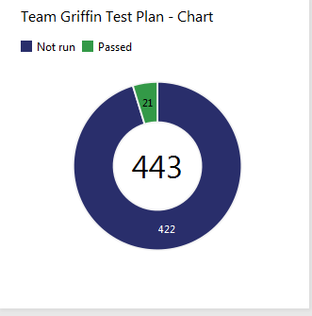

# 2. Automated Tests

|  |  |  |  |
| --- | --- | --- | --- |
| Tool | Automated Tests Count | Pass | Fail |
| Test Studio | 26 | 26 | 0 |
| Testing Framework | 23 | 22 | 1 |

# 3. Found Bugs

|  |  |  |
| --- | --- | --- |
| Module | Bugs Found | Severity |
| Training Rooms | 9 | Midium |
| Application for Software Academy | 1 | Critical |
| User Settings | 2 | Midium |
|  |  |  |